Working Group on the Right to Development
The eighteenth annual session

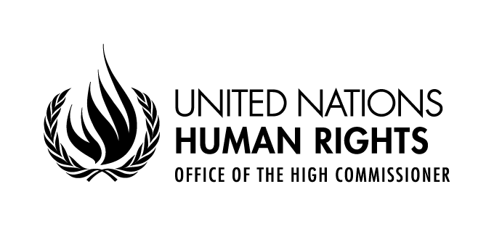

Opening statement by
Ms. Kate Gilmore
United Nations Deputy High Commissioner for Human Rights

Geneva 3 April 2017
Palais des Nations, Salle XVI

Excellencies,
Distinguished delegates,
Ladies and gentlemen,
I am very pleased to welcome you to the eighteenth session of the Working Group on the Right to Development.
The High Commissioner for Human Rights, who is currently in New York, would have very much liked to attend this opening meeting today. He asked me to assure you of his continued and full support to this Working Group in its efforts aimed at the promotion and respect for the right to development.
The right to development, which was recognized as a human right by the international community more than thirty years ago, has its roots in the period of decolonisation and in the quest for economic, not just political independence. As such, the Declaration on the Right to Development is an acclamation of freedom and independence and a re-assertion of the equality of all nations, all peoples and all individuals. Surely, the attainment of self-determination is a prerequisite for the full enjoyment of economic, social and cultural freedoms and a voice in decision making.
Under this vision, the human rights of all were to be fully protected, and economic development was to be achieved through the creation of a more collaborative and cooperative vision of global economic relations, including respect for the interests of developing states in these relations.
One dominant theme of the right to development is therefore the creation of fairer economic conditions for all countries, and in which developing countries can genuinely exercise their economic autonomy without being subject to the hegemonic interests of dominant states.
Most importantly, however, the right to development situates the human person as the central subject, and not just an object, of development.
Principle 3 of the Rio Declaration on Environment and Development subsequently made it clear that the right to development had to be constructed in line with the concept of sustainable development, by spelling out that the right to development must be fulfilled so as to equitably meet developmental and environmental needs of present and future generations, a principle reiterated in the Vienna Declaration and Programme of Action, and, ultimately in the 2030 Agenda.
Now, the international community has embarked on the implementation of the 2030 Agenda. As the preamble puts it, this Agenda is a plan of action for people, planet and prosperity, but also for peace and partnership. It comprises the three dimensions of sustainable development, the economic, social and environmental.
As with the Declaration on the Right to Development, the 2030 Agenda for Sustainable Development, together with the Paris Agreement and the Addis Ababa Action Agenda call for a strong global partnership for sustainable development, for realizing the bonum commune of this international community.
Yet, we are witnessing worrying trends, a growing drive to economic protectionism, unilateralism and nationalism, ultimately a rejection of the community interests and a threat to universal human rights, which are at its core.
Conflicts continue to cause immense suffering and to force unprecedented numbers of people to flee their homes. 2016 was the warmest year on record globally and the changing climate causes massive environmental harm in many areas of our planet, including drought and other extreme weather events. In particular, countries in southern Africa and in the Horn of Africa are struggling with catastrophic drought.
We as an Office are particularly concerned about the rhetoric of nationalism and exclusion. We are gradually moving away from an international system of collaboration back to one of mere co-existence, defined by continuous competition for power and resources. In particular in some countries with massive inflows of migrants and refugees, populist leaders build on fear and a sense of insecurity, not least economic insecurity, to gather ever increasing constituencies. They portray a vision of a better past, without offering any real solutions. They attack the most vulnerable, while shielding the powerful actors, most responsible for global, negative and economic decline.
The right to development has not envisaged this path. It envisages rather a system of interdependence, solidarity, mutual interest and cooperation and observance and realization of all human rights for all. The right to development clearly establishes a link between development and human rights. It stipulates that development is itself a human right and it recognizes that development is about rights, about empowerment, agency, freedom, equality and the fair distribution of the benefits of development.
The idea of the right to development is clearly at the core of the 2030 Agenda for Sustainable Development. Like the right to development, the SDGs affirm equality, that no one shall be left behind and they recognize the role and responsibilities of States, the private sector and of the international community for development.
I am therefore particularly pleased that this year’s Working Group session includes an interactive dialogue with experts on the implementation and realization of the right to development, including the implications of the 2030 Agenda for Sustainable Development, and a possible engagement with the high-level political forum. This is a welcome opportunity to strengthen the cooperation between this Working Group and other parts of the United Nations Development system.
We also welcome the establishment of the mandate of a Special Rapporteur on the Right to Development and I congratulate H.E. Mr. Saad Alfarargi to his appointment. This new independent mechanism, working closely with this Working Group, will surely provide new momentum to the discussions by injecting essential expertise on the implementation and realization of the right to development.
In conclusion I would like to reiterate the full support of the Office to this Working Group and to the full realization of the right to development. I wish you all success in your deliberations and look forward to a substantive outcome.

Thank you very much.

