Agenda 4.4 - Interactive dialogue with experts on the implementation and realization of the right to development, including the implications of the 2030 Agenda for Sustainable Development
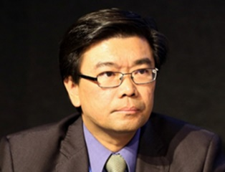
Mr. Vicente Yu
Mr. Vicente Paolo B. Yu III served as the Deputy Executive Director of the South Centre, the intergovernmental policy research institution of developing countries, and currently coordinates the Centre’s programme on global governance, climate change, investment, taxation, South-South cooperation, and sustainable development issues. His substantive policy work includes overseeing the policy research and analysis and the provision of technical policy research, analysis, and capacity building by the South Centre to developing country governments on a wide range of multilateral development-related issues, including on the right to development, international environmental law, development economics, international climate change policy, and South-South cooperation. He obtained his political science (with honors) and law degrees from the University of the Philippines, and his master of laws degree (with honors, specializing in international trade law and international environmental law) from Georgetown University where he was a Fulbright Scholar. Prior to joining the South Centre, he worked for Friends of the Earth International (FOEI) and was a Staff Attorney and head for Research and Policy Development of the Legal Rights and Natural Resources Center (LRC) in the Philippines. He has taught law at the University of the Philippines. He has published papers and articles on issues relating to trade and environment, energy policy, mining policy, sustainable development, environmental policy, climate change policy, South-South cooperation, and indigenous peoples' rights.
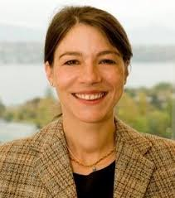
Ms. Regina Asariotis
Ms. Regina Asariotis is Senior Legal Affairs Officer and Chief of the Policy and Legislation Section (Trade Logistics Branch) in the Division on Technology and Logistics of UNCTAD, where she is responsible for the Secretariat’s work in the field of transport law and policy. Substantive areas of work range from international commercial transport law to environmental regulation, maritime and supply-chain security, and implications of climate change for maritime transport, with particular focus on climate change impacts and adaptation for ports and related coastal transport infrastructure. Regina is also the UNCTAD focal point for the Right to Development. Before joining the United Nations in 2001, Regina was a Senior Lecturer in Law at the University of Southampton, and member of the University's Institute of Maritime Law, where she taught international maritime and trade law for more than 10 years. She holds a law degree from the University of Augsburg, an LL.M from the University of Southampton and a Dr.jur. from the University of Hamburg and is a Barrister (England & Wales) and Attorney at Law (Greece), as well as Member of the Chartered Institute of Arbitrators (CIArb).
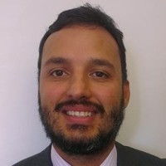
Mr. Raul Torres
Raul Torres is a Counsellor in the Development Division of the WTO, working on issues concerning the international trade integration of Landlocked Developing Countries and implementation of the 2030 Sustainable Development Agenda. He started his career working for Venezuela's Ministry of Foreign Trade (Instituto de Comercio Exterior) and joined the WTO in 1996 to work on issues related to Anti-dumping, Subsidies and Countervailing Measures, Safeguards, and State Trading Enterprises, including advising Dispute Settlement panels. He has contributed to books on the WTO and the Multilateral Trading System and published articles on Anti-dumping, WTO Dispute Settlement, small economies, landlocked developing countries, the 2030 Agenda and duty free zones. Mr. Torres holds a degree in law from Universidad Católica Andrés Bello (Caracas) and an LL.M. from Georgetown University.
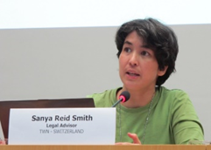
Ms. Sanya Reid Smith
Ms. Smith is a Legal Advisor and Senior Researcher at the Third World Network, an international coalition specializing in development issues and North-South affairs. Ms. Smith is an expert analyst on the implications of trade agreements on economic and social sectors and various policies in developing countries. She has been a resource person on the implications of trade and investment treaties at various United Nations conferences.

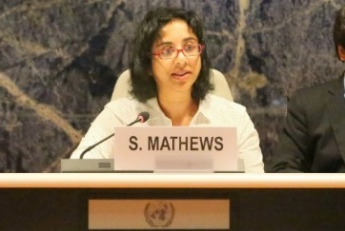
Ms. Susan Mathews
Ms. Mathews is a lawyer and has worked with the Office of the High Commissioner for Human Rights for about 12 years. Her expertise is in development and human rights and for the past 5 years she has built the trade and investment portfolio in the Office. In the past year she has been involved in a project on digital trade and human rights in Africa with the United Nations Economic Commission for Africa (UNECA) and the Friedrich Ebert Stiftung, Geneva Office.

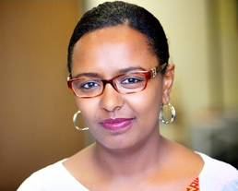
Ms. Meskerem Geset Techane
Ms. Techane is a human rights lawyer with over 15 years of experience at the national and international level. She previously held the position of High Court Judge in Ethiopia and Deputy Director of the Institute for Human Rights and Development in Africa (IHRDA). She has worked closely with African human rights mechanisms, served as an expert member in different Working Groups of the African Commission on Human and Peoples’ Rights, and collaborated with the various Special Rapporteurs of the Commission and was extensively commissioned as an expert by various UN institutions. Her dedicated service to women and girls has earned her an award for outstanding pro bono legal aid, and the Ethiopian Women Lawyers Association prize for remarkable contribution. Ms. Techane holds a Bachelor of Laws (LL.B) from the Addis Ababa University and a Master of Laws (LL.M) from the University of Pretoria. She is currently a Doctoral Fellow at the Human Rights Center of University of Padova and a Member of the Working Group on the issue of discrimination against women in law and in practice. She has published on issues of women’s rights and human rights in Africa, and authored training manuals for lawyers, judges and law enforcement officers on women’s rights and gender justice.
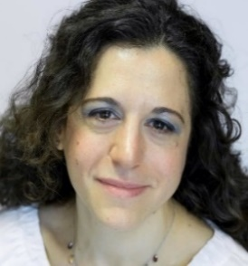
Dr. Chiara Mariotti
Dr. Mariotti is Inequality Policy Manager at Oxfam GB. Since 2016, she has led the policy work on solutions to inequality to support the Even It Up (inequality) campaign at Oxfam GB. She has been a Visiting Fellow of the Atlantic Fellows Programme at International Inequalities Institute in the London School of Economics and Political Science. Her current areas of work include research and advocacy on the IMF’s inequality agenda and research, and alliance-building around alternative economic paradigms as a solution to inequality. Dr. Mariotti is a development economist trained at the School of Oriental and African Studies in London. She has taught economics and research methods at SOAS, Bath University and Greenwich University. Working at the Chronic Poverty Advisory Network based at Overseas Development Institute, she was one of the authors of the 2015 Chronic Poverty Report and has published research on Ethiopia, Viet Nam, Ecuador and Cambodia. Dr. Chiara Mariotti is a development economist trained at the School of Oriental and African Studies in London. Her PhD research looked at the involuntary resettlement of tribal people to be displaced by a mega-dam in Andhra Pradesh, India; extracts from her thesis have appeared in edited books and academic journals. She has taught economics and research methods at SOAS, Bath University and Greenwich University. After the PhD she joined the Chronic Poverty Advisory Network based at Overseas Development Institute, where she worked on policies to eradicate chronic poverty, especially social protection, private sector development, macroeconomic policies and pro-poor growth. She was one of the authors of the 2015 Chronic Poverty Report and has published research on Ethiopia, Viet Nam, Ecuador and Cambodia. In 2016, she joined Oxfam GB to be part of the Even It Up (inequality) campaign, which she supports leading the policy work on solutions to inequality. Current areas of work include research and advocacy on the IMF’s inequality agenda and research and alliance-building around alternative economic paradigms as a solution to inequality.

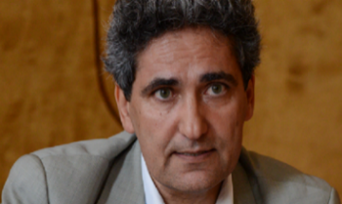
Mr. Melik Özden
Melik Özden is the Director of CETIM (Europe-Third World Centre) in Geneva. He has been involved in the associative environment for many years, and has advocated for the effective implementation of human rights for peoples and citizens. He has published numerous articles and educational publications on economic, social and cultural rights and on the functioning of UN human rights mechanisms, in particular the Human Rights Council. His publications include “The Right to Development”, “The Right to Education”, “The Right to Non-Discrimination”, “The Right to Social Security”, “The right to work”, “The right to health”, “The Right to Land”, “Impunity of transnational corporations”. These publications are published and distributed in three languages (French, English and Spanish) worldwide.

