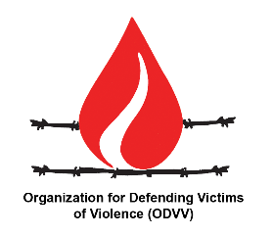
Organization for Defending Victims of Violence (ODVV)
Reply to

Call for comments and textual suggestions: Draft Convention on the Right to Development

Dear Members of the Working Group on the Right to Development
Following the call for input on NGOs with ECOSOC consultative status to submit comments and textual suggestions on the draft convention on the right to development ODVV would like to repeat the recommendations offered in ODVV’s oral intervention in 21st session of the Working Group:

The Organization for Defending Victims of Violence reiterated that unilateral coercive measures prevented the attainment of all Sustainable Development Goals and violated all human rights. ODVV made two recommendations on Articles 14 and 15 of the Convention, emphasizing that Article14 needs to specifically prohibit the use of “unilateral coercive measures” (UCM)s rather than generally prohibiting “coercive measures” and in Article 15 a specific “compensation mechanism” should be defined to compensate for the losses of all those whose human rights, especially the right to life and the right to health, are systematically violated by UCMs.

It is to be mentioned that ODVV recommendation on article 15 is offered in line with the recommendation suggested by the late Special Rapporteur on UCMs Mr. Idriss Jazairy, (A/HRC/36/44) in order to promote accountability and reparations for UCM victims.

It is also recommended that the sanctioning countries are hold responsible for providing the financial resources necessary for the establishment of such a mechanism and remedy to the victims of their foreign policies.

