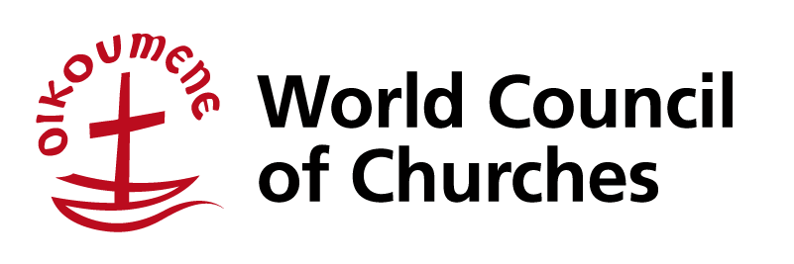
150 route de Ferney, PO Box 2100
CH-1211 Geneva 2, Switzerland
Phone: +41 22 791 6111 Fax: +41 22 791 0361
Email: infowcc@wcc-coe.org www.oikoumene.org
Direct phone: +41 22 791 6031 Direct e-mail: Peter.Prove@wcc-coe.org
Commission of the Churches on International Affairs

Comments on the Draft Convention on the Right to Development

The World Council of Churches (WCC), a fellowship of 349 churches in over 110 countries working for global justice, peace and unity, welcomes the Draft Convention on the Right to Development to implement the United Nations (UN) Declaration on the Right to Development adopted in 1986 that seeks to place people at the centre of the development process so that development improves “the well-being of the entire population and of all individuals on the basis of their active, free and meaningful participation in development and in the fair distribution” of benefits.

COVID-19 and other signs of the times
The COVID-19 pandemic and its consequences, the climate emergency, gaping socio-economic inequalities linked to heightened globalization, racism, the undermining of democracy through authoritarian politics of fear and hate, and the ambiguous consequences of digitalization are among the key megatrends currently shaping the world in significant ways. In particular, the pandemic has triggered an unprecedented global economic crisis that has severely impeded the attainment of the sustainable development goals and deepened pre-existing disparities. As churches we are profoundly concerned that the impacts are being disproportionately felt by low-income countries, impoverished communities, and disadvantaged groups, women and Indigenous Peoples included.

The WCC believes that the principles of justice, equity, participation, transparency, and accountability together with international cooperation and solidarity – which are at the heart of the Right to Development – are essential for responding to the aforementioned challenges. Therefore, we find incredibly relevant and timely the draft convention which clearly addresses the necessity for joint international action to tackle the human rights consequences of global events and economic arrangements.

International cooperation and global solidarity in a time of intertwined health, economic and ecological crises
The COVID-19 pandemic has sent a strong reminder that we all live together in a common economic, social, and ecological home as well as exposed the fact of our mutual vulnerability and intrinsic interdependence as human beings. At the same time, the pandemic underscores the urgent need as well as presents an incredible opportunity for working together and deepening relationships within and across countries.

We, therefore, strongly affirm Article 3 of the draft convention which recognizes that the fulfilment of the right to development entails “an enabling national and international environment created through a spirit of unity among individuals, peoples, States and international organizations, encompassing the union of interests, purposes and actions and the recognition of different needs and rights to achieve common goals; this principle includes the duty to cooperate” to create a financial and economic architecture conducive to the realization of the right to development.

In the current context of a rampaging pandemic and economic recession that has claimed millions of lives and impoverished hundreds of millions more, operationalizing the right to development calls for debt relief and cancellation for low- and middle-income countries suffocated by debt payments as well as an overhaul of the global tax system so as to free up and mobilize resources to respond to the health emergency, support livelihoods and revitalize the economy. The international investment regime must also be redesigned so that foreign direct investments can help finance development and enable a just and sustainable recovery.

The promotion of an equitable multilateral trading system that recognizes the principle of special and differential treatment for developing countries and the sharing of technologies and knowledge has become more critical in a time of pandemic: relevant patents and intellectual property rights must be waived, export restrictions on medical products and vaccines lifted, and science and know-how on vaccine production disseminated widely so that all people may have access to life-saving vaccines.

Overall, we believe the draft convention adds value to existing conventions and frameworks by addressing unjust global trade and financial structures that are at the root of poor development and by recognizing that system-wide transformation requires coherence, coordination, and a spirit of solidarity among all states and across a wide range of actors founded on common values and aims.

20 August 2021

Peter Prove
Director, Commission of the Churches on International Affairs
World Council of Churches

See https://www.oikoumene.org/resources/documents/calling-for-an-economy-of-life-in-a-time-of-pandemic-a-joint-message-from-the-wcc-wcrc-lwf-and-cwm.
See https://www.oikoumene.org/resources/documents/call-to-overcome-global-injustice-and-inequity-to-defeat-the-global-covid-19-pandemic.

