_unlogo United Nations

**General Assembly - Human Rights Council**

**Office of the High Commissioner for Human Rights**

**Our work to help countries make sure people with disabilities get their rights**

**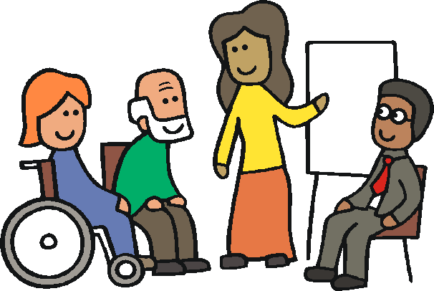**

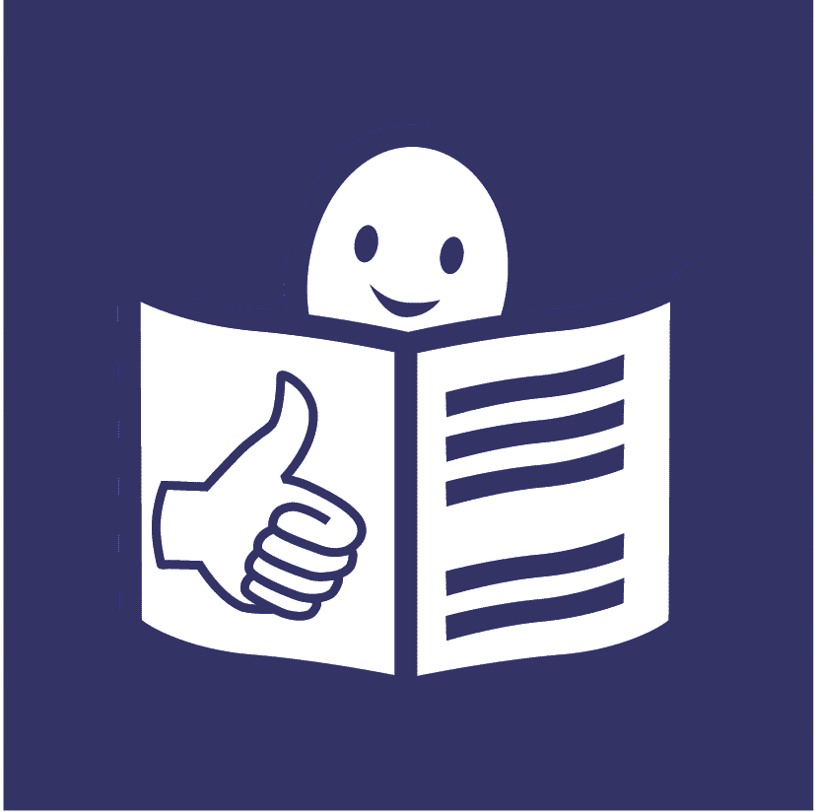

**Who are we?**

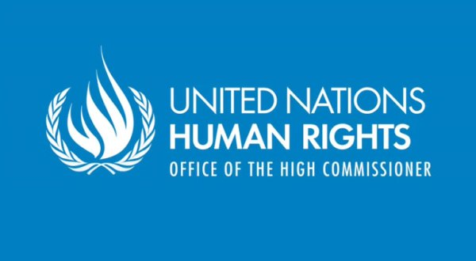

We are called the **Office of the High Commissioner for Human Rights**.

_unlogo

We are part of the United Nations (UN).

**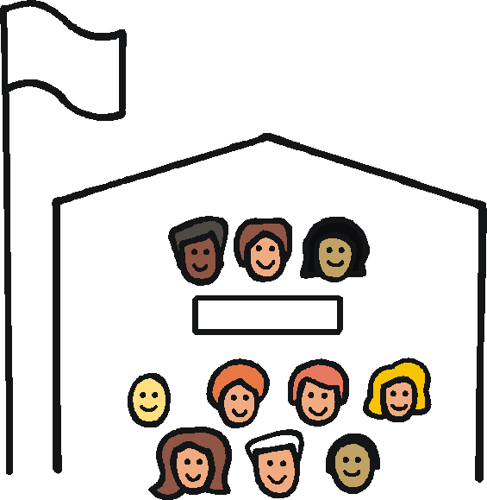**

The United Nations is a group of countries that work together to make the world a better and safer place.

**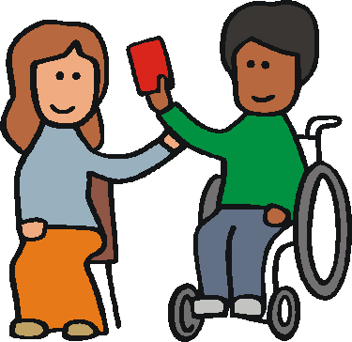**

Our job is to make sure everyone in the world is treated fairly and gets their human rights.

E:\images\To zip\staff.wmf

Human rights are rights that everyone should have, like the right to work and have a family.

**What is this report about?**

Lots of countries have agreed to make life better for people with disabilities.

****

They agreed to make sure people with disabilities are treated fairly and have the same rights as everyone else.

Now each country has to make this happen.

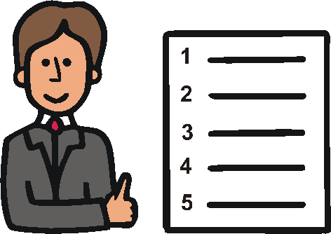

This means they need to make good laws and plans and do things in the right way.

**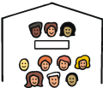**

This report is about some work the United Nations and other groups are doing to help with this.

**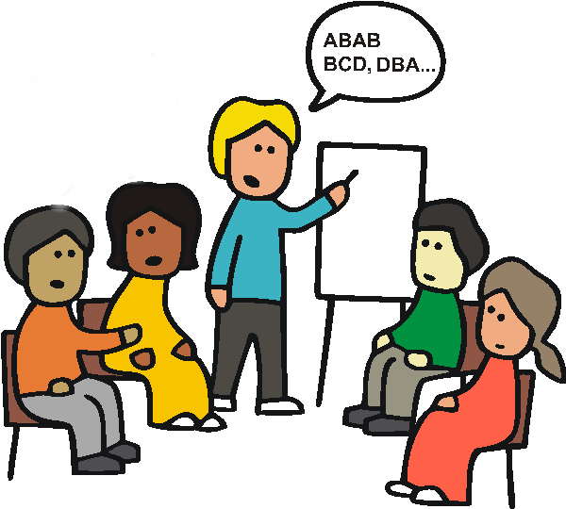**

We are helping countries in lots of ways, like:

* giving them advice and training
* helping them make good laws and plans
* helping people with disabilities have a say

**Some of the work that has been done in different parts of the world**

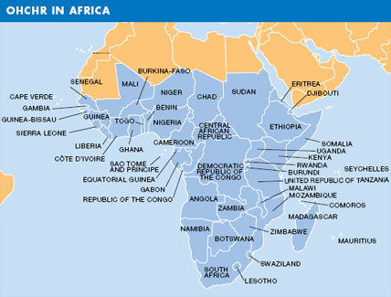

**1. Countries in Africa**

**Some of the work that has been done**

**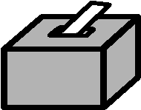**

**Cameroon**

* Making it easier for people with disabilities to vote.

****

**Côte d’Ivoire and Guinea-Bissau**

* Helping the government agree to make sure people with disabilities get their rights.

****

**Côte d’Ivoire, Ethiopia, Senegal and Uganda**

* Advice and training for the government about how to make sure people with disabilities get their rights.

**Liberia**

* Helping make a plan about the work that needs to be done for people with disabilities.
* Helping people check how well the work is going.

E:\images\To zip\meeting room.wmf

**Niger**

* Having events and meetings to tell people about the rights of people with disabilities.



**Sierra Leone**

* Helping the government make a new law to make life better for people with disabilities.

**Southern Africa**

* **E:\images\To zip\meeting room.wmf**Helping lots of groups work together to see what needs to be done for people with disabilities.
* Helping people with disabilities have a say in this work.

**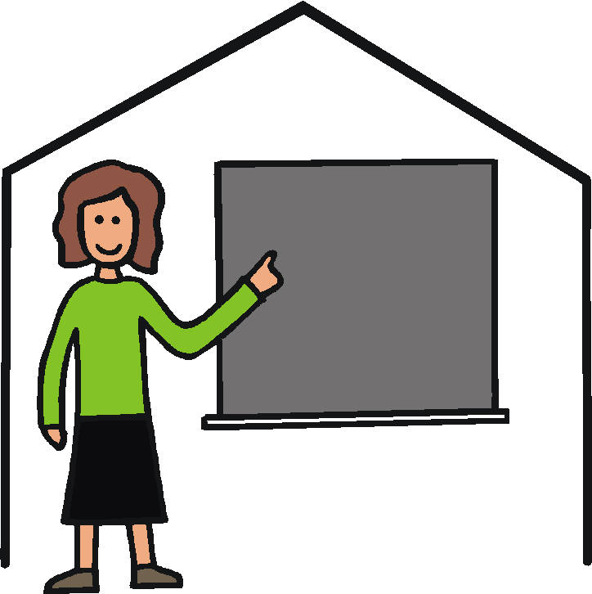Sudan and Togo**

* Helping make schools better for children with disabilities.



**Uganda and South Africa**

* Looking at the laws and rules to see what needs to change.

Like the mental health laws in Uganda.

****

**Mozambique**

* Helping to get better information about people with disabilities.

This will help people make better laws and plans.

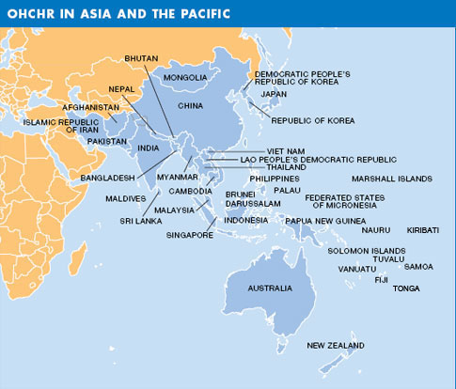**2. Countries in the Asia-Pacific**

**Some of the work that has been done**

****

**Cambodia and Papua New Guinea**

* Advice and training to help the government know what they need to do for people with disabilities.

****

**Timor-Leste**

* Support for people with disabilities and disability groups to know their rights and check how the government is doing.



**Cook Islands, Fiji, Vanuatu and Papua New Guinea**

* Helping get good laws and rules.
* ****Doing more to help people with disabilities have a job.
* Getting better information about the number of people with disabilities.

E:\images\To zip\access.wmf**Indonesia**

* Working to make cities easier for people with disabilities to live in.

**E:\images\To zip\meeting room.wmf**

**Viet Nam**

* Supporting people with disabilities to help make new laws and plans.

**Other work in this part of the world**

A lot more work is happening to make sure people with disabilities get their rights.

There is a big plan about people with disabilities for countries to follow.

****

Work is happening to:

* make good plans and rules
* make things like transport and information easier for everyone
* ****get better information about people with disabilities

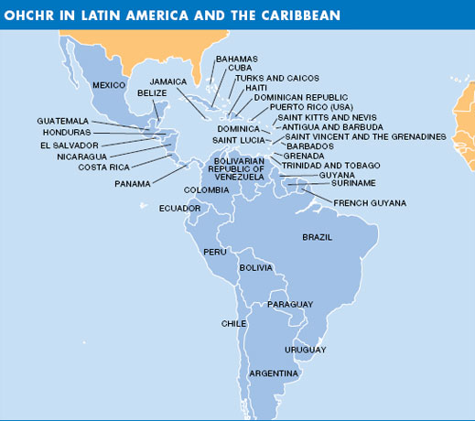**3. Countries in Central and South America and the Caribbean**

**Some of the work that has been done**



**Colombia and Haiti**

* Supporting the government with their laws and plans about people with disabilities.

****

**Guatemala**

* Helping the government know more about the rights of people with disabilities.



**Paraguay and Honduras**

* Helping make a big new plan about the rights of people with disabilities.



**Costa Rica**

* Helping make it easier for people with disabilities to have a job.

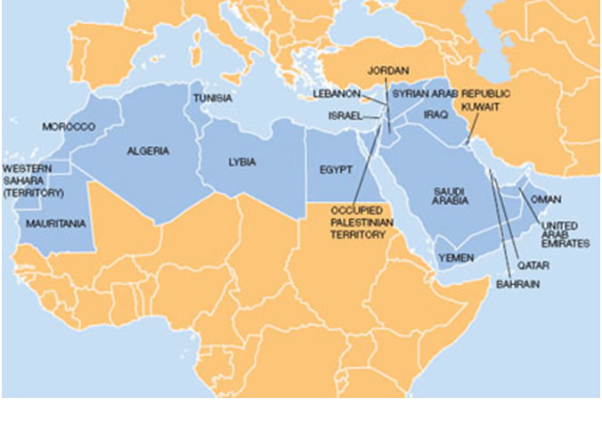**4. Countries in the Middle East and North Africa**

**Some of the work that has been done**

**Libya and Iraq**

* Supporting the government to agree to make sure people with disabilities get their rights.

****

**Iraq**

* Working with disability groups to see what changes are needed to the laws.



**Occupied Palestinian Territories**

* Making sure the main government plan talks about the rights of people with disabilities.



* Helping more people know about the rights of people with disabilities.
* Helping to make lots of things easier for people with disabilities, like going to school and getting a job.

**Tunisia**

* Helping make lots of things easier for people with disabilities, like:
* ****getting a job
* going to school
* speaking up about their rights

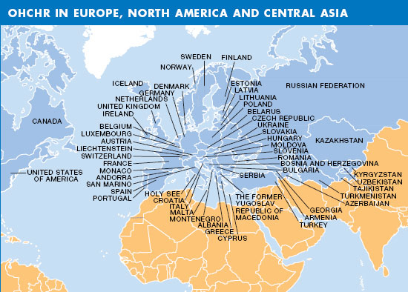

**5. Countries in Europe and Central Asia**

**Some of the work that has been done**

**Serbia and other parts of Europe**

* Doing more to help people with disabilities live in their own homes near other people.

At the moment, many people live in homes far away from other people.

****

**Georgia and Macedonia**

* Supporting the government to agree to make sure people with disabilities get their rights.

**Kosovo**

* Support to make good laws about treating everyone fairly.

**Moldova**

* ****Helping get new laws about the rights of people with disabilities.
* Helping get better rights for people with mental health needs who live in hospitals.

****

* Helping make lots of things better for people with disabilities, like education and the law.

**The Russian Federation**

* Helping more people know what needs to happen for people with disabilities to get their rights.
* Helping make schools better for children with disabilities.

**Ukraine**

* E:\images\To zip\access.wmfHelping get better laws about treating everyone fairly.
* Working to make everything easier for people with disabilities to be part of.

**Other work that has been done**

* Helping countries in Africa and Asia make better laws about work.

This will help make it easier for people with disabilities to get a job.

****

**What we think needs to happen**

Countries should work more with the United Nations and people with disabilities.

They need to:

* ****agree to make sure people with disabilities get their rights
* make the right laws and rules
* make sure people with disabilities can have a say in this work

This is an easy-to-read version of a report on supporting countries to make sure people with disabilities get their rights (A/HRC/26/24) written by   
the Office of the United Nations High Commissioner for Human Rights.

This does not mean that the Office of the United Nations High Commissioner for Human Rights agrees to everything written in this document.

This easy to read document was written to the European standards for making information easy to read and understand. www.easy-to-read.eu