_unlogo United Nations

**General Assembly - Human Rights Council**

**About the Special Rapporteur on the rights of persons with disabilities**

**This is a person who will help make the rights of people with disabilities happen**

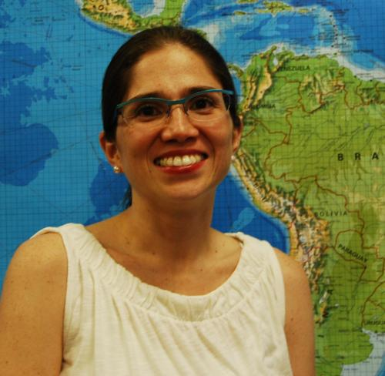

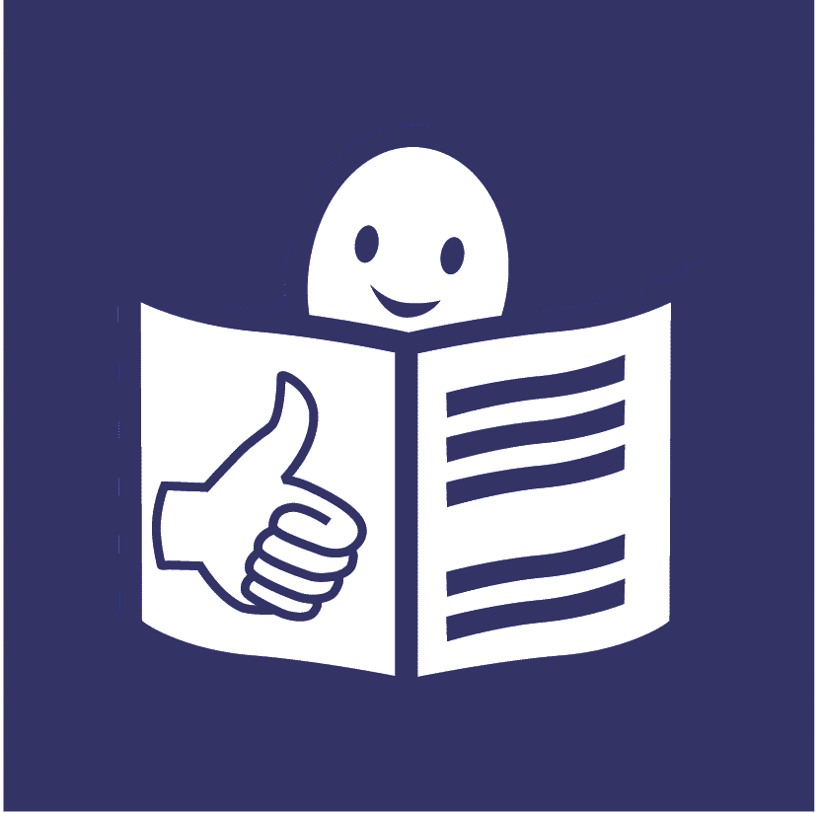

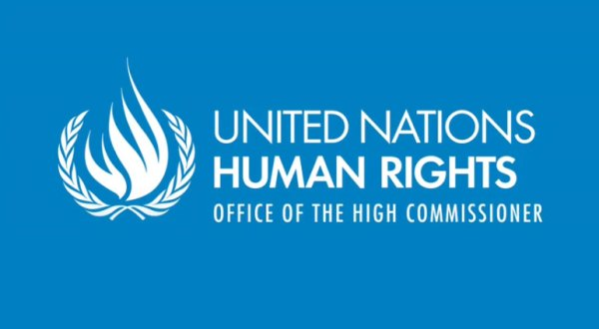**Who are we?**

We are called the **Human Rights Council**.

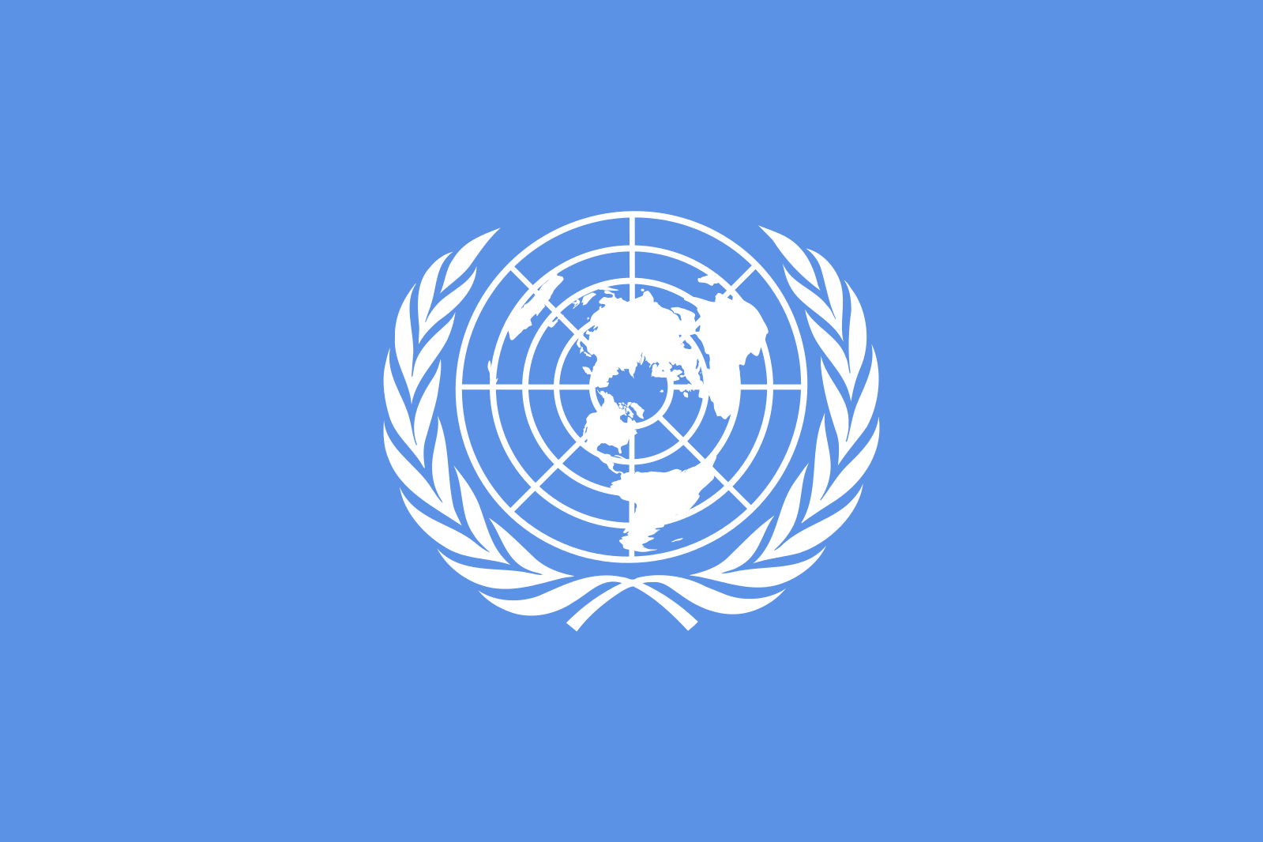

We are part of the United Nations (UN).

**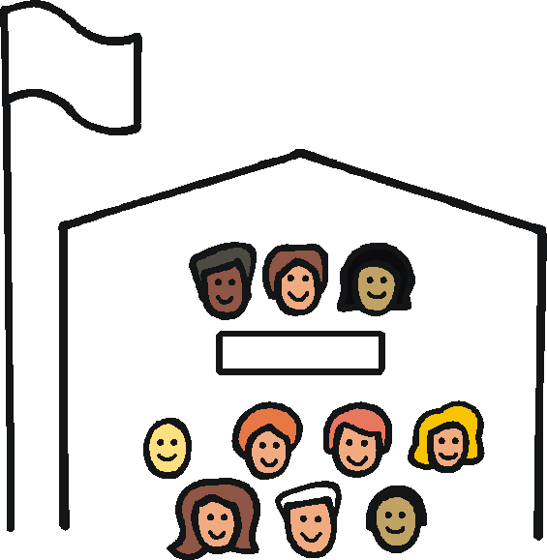**

The United Nations is a group of countries that work together to make the world a better and safer place.

**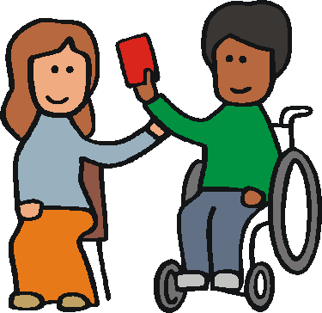**

Our job is to make sure everyone in the world is treated fairly and gets their human rights.

E:\images\To zip\staff.wmf

Human rights are rights that everyone should have, like the right to work and have a family.

**What is this report about?**

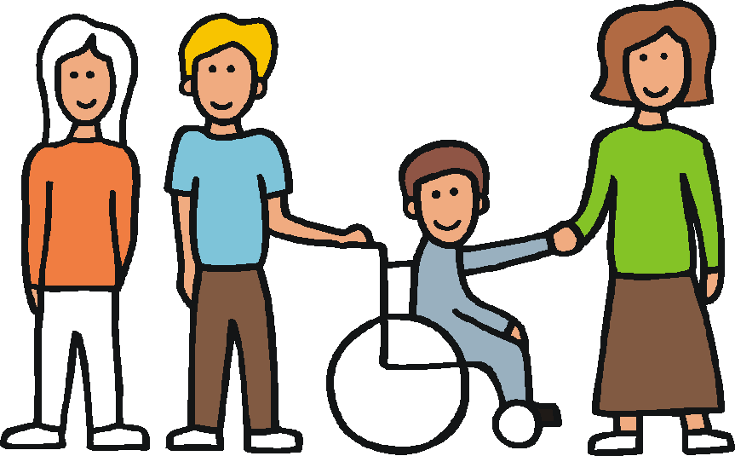

This report is about a new person who will help make the rights of people with disabilities happen.

Her name is Catalina Devandas-Aguilar.

Her job is called Special Rapporteur.

She started on 1 December 2014.

She will work for us for 3 years.

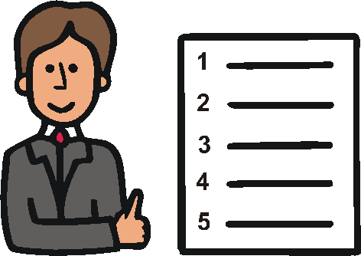

This report tells you more about what she will do.

**Why do we need this person?**

Lots of countries have agreed to make life better for people with disabilities.

They made a document about this.

The document is called

The UN Convention on the Rights of Persons with Disabilities.



Now countries have to do what this document says.

**E:\images\To zip\services.wmf**They have to make sure

people with disabilities:

* get their rights
* are treated fairly
* can do the same things as everyone else

Lots of good work is happening with this already.

But there are still many problems for people with disabilities in the world.

This need to change so that people with disabilities can have a better life.

E:\images\To zip\organisation.wmf

The Special Rapporteur will help with this work.

She will work with lots of people and groups around the world.

**E:\images\To zip\services.wmf**

She will help them make the rights of all people with disabilities happen.



She will help us all think about what we need to do.

**The main things the Special Rapporteur will work on**

The Special Rapporteur will work on a few main things first.



She will work to:

* make sure people with disabilities can have a say in plans and decisions and make their own choices

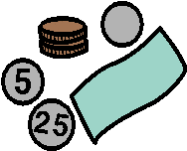

* stop people with disabilities being poor



* make it easier for people with disabilities to do things like go to school or get a job



* help change the way people think about people with disabilities

**What the Special Rapporteur will do**

**1. Work with other people and groups**

E:\images\To zip\organisation.wmf

The Special Rapporteur will work with:

* people with disabilities
* governments
* other groups

She will help people in different countries work closer together.

She will help everyone share good ideas about how to make things better for people with disabilities.

**2. Get information about people with disabilities**

She will help get information

about what things are like

for people with disabilities.

She will help share this information.

**What the Special Rapporteur will do**

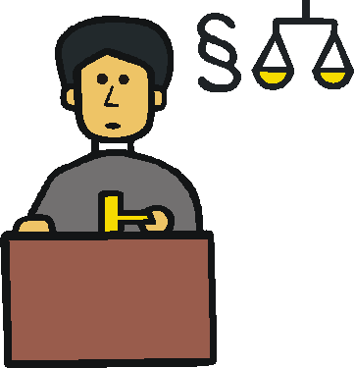**3. Help countries change their laws and the way they do things**

Many people with disabilities are not allowed to do things like:

* make their own choices
* vote



And many things are still hard

for people with disabilities to do, like travel or get a job.

This needs to change so that people with disabilities are treated fairly.

The Special Rapporteur will:

* support countries with advice and training
* visit countries to see what is happening

**What the Special Rapporteur will do**

**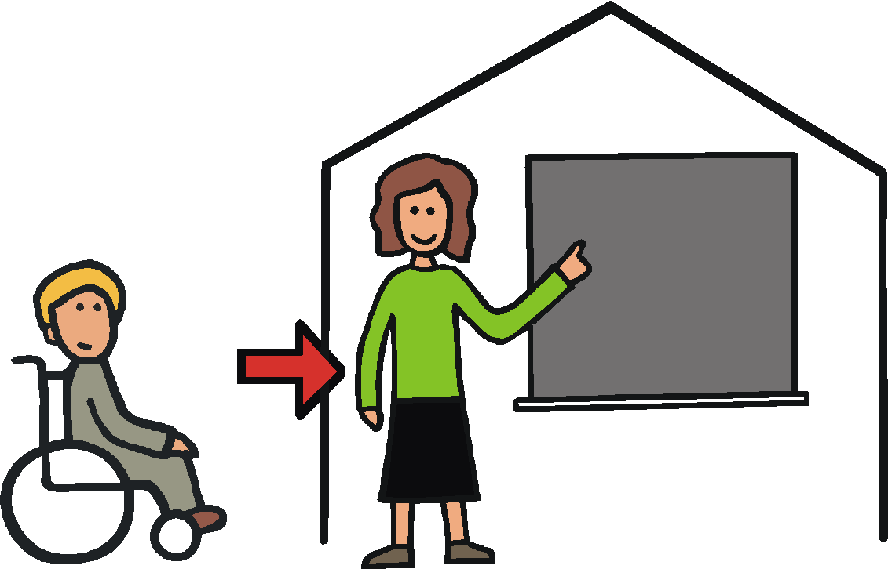**

**4. Say what should happen**

The Special Rapporteur will say what she thinks needs to happen to make sure people with disabilities are treated fairly.

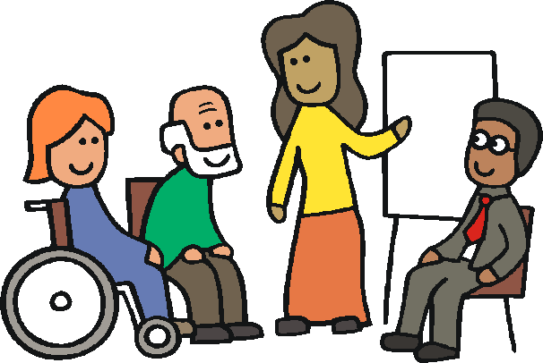

**5. Help countries get the right advice, support and training to do this work**

**6. Help people think better things about people with disabilities**

And tell more people with disabilities about their rights.



**7. Help the United Nations and the groups we work with do the right things**



**8. Write reports every year about how her work is going**

**What the Special Rapporteur wants to happen**

Here are some of the things the Special Rapporteur wants to happen.

E:\images\To zip\organisation.wmf

1. Everyone to work together to make life better for people with disabilities.



1. A better life for people with disabilities in all parts of the world.

This means that

people with disabilities in poorer countries should have a good life too.



1. People to think about the rights of people with disabilities when they make plans and decisions.

**E:\images\To zip\meeting room.wmf**These are plans and decisions about disability and other things.

People with disabilities should have a say

in these plans and decisions.

**How the Special Rapporteur will do her work**

**E:\images\To zip\services.wmf**

1. She will think about what all people with disabilities need.

This means everyone, like children, older people, women and girls.

****

2. She will make her work easy for people with disabilities to take part in.

This means making meetings, information and other things easy.

**What the Special Rapporteur has already done**

The Special Rapporteur hasstarted working with different groups.

**E:\images\To zip\meeting room.wmf**She has asked for all countries to agree to make life better for people with disabilities.

She has asked for people with disabilities to be part of big plans and decisions about the world.

Pictures The Picture Communication Symbols ©1981–2013 by DynaVox Mayer-JohnsonLLC.  All Rights Reserved Worldwide.  Used with permission.