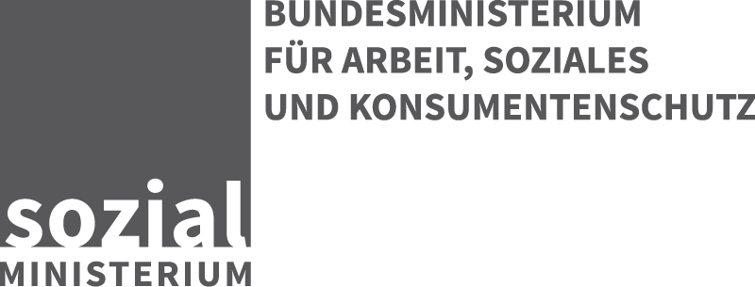

Question 1:
The legal instrument of coordinating the Austrian disability policy is the Federal Disability Act. According to this act, four bodies/organisations/persons have to be mentioned, who are representing persons with disabilities (PWD) at national level:

1. The Austrian National Council for Persons with Disabilities (ÖAR - “Österreichische Arbeitsgemeinschaft für Rehabilitation”) is the umbrella organisation of associations for PWD in Austria (www.oear.or.at) and has to support the economic, social and cultural interests of PWD. Regarding to § 50 of this act the Austrian Ministry for Labour, Social Affairs and Consumer Protection (Social Ministry) is obliged to support this association by state aid.

2. The Federal Disability Advisory Board, which has an advisory function to the minister in all fundamental matters of disability. All important NGOs dealing with matters of PWD, especially also the umbrella organisation mentioned above, are members of this board.

3. Independent Monitoring Committee for the Implementation of the UN Convention on the Rights of Persons with Disabilities (CRPD):
The members of the Committee are appointed by the Minister for social affairs with due regard to the proposals by the ÖAR:
a. Four representatives of disabled people’s organizations
b. One representative of a NGO in the field of human rights
c. One representative of a NGO in the field of international development
d. One representative of academia.

The members of the Committee are independent and not bound by any directives or orders. Actually 6 of all (substitute) members are disabled (blind, deaf or wheelchair users).

Based on the unlimited application of the Convention for all parts of the State, the Committee cooperates in particular with the “authorities of the Länder that are to be established or named” in accordance with § 13 Para 8 Federal Disability Act.

The chair of the Monitoring Committee is also a member of the Federal Disability Advisory Board.

4. The Disability Ombudsman (“Bundesbehindertenanwalt” -
www.behindertenanwalt.gv.at): He is responsible for advice and assistance of PWD, who feel discriminated in the purpose of the Federal Disability Equality Act or the Disability Employment Act. For these reasons the ombudsman can hold consultation hours and days in his office and in the whole Federal Territory. The Ombudsman, who is independent and not bound to instructions is appointed for four years and has to draw up an annual report.
Furthermore the ombudsman can do research on the issue of discrimination of people with disabilities, announce reports or publish recommendations. Also the co-operation and networking with other actors and public relations, in particular for awareness-raising for the needs of persons with disabilities are a part of his activities. He is also a member of the Federal Disability Advisory Board.
Questions 2 - 4:
In addition to the answer of question 1 see further information about ÖAR at http://www.oear.or.at/english/the-organisation and about the Monitoring Committee at http://monitoringausschuss.at/dokumente/documents-in-english/ “Rules of Operation”.
NGOs were and are involved in the conception and monitoring of the National Action Plan on Disability 2012-2020 (Strategy of the Austrian Federal Government for the Implementation of the UN Disability Rights Convention - NAP). The supervision of the NAP is carried by a supervisory group in which the Disability Ombudsman and the Monitoring Committee on the implementation of the CRPD in Austria as well as the representatives of people with disabilities and civil society are involved.

Question 5:
With regard to the national implementation and monitoring of the CRPD, according to Article 33 Austria has established the following structure:

The focal point of the federal government is the Social Ministry. The Länder have established their own focal points for their sphere of responsibility created by the federal structure in accordance with Article 33 para 1 CRPD.

The functioning of the Austrian coordination mechanism is ensured by the Social Ministry with the involvement of the Federal Disability Advisory Board. The Social Ministry pays particular attention to the involvement of civil society called for in Article 33 paragraph 3.

In December 2008 a monitoring mechanism in accordance with Article 33 para 2 CRPD was created on the federal level (Monitoring Committee, § 13 Federal Disability Act).

At regional level in most of the Länder also Monitoring Committees were established, but with differences in their status of independence. At local level in some towns also Action Plans in cooperation with local NGOs were created.

Question 6:
The attached National Action Plan on Disability 2012-2020 with its 250 measures is the Austrian strategy in implementing the CRPD and improving the conditions of living of PWD.

