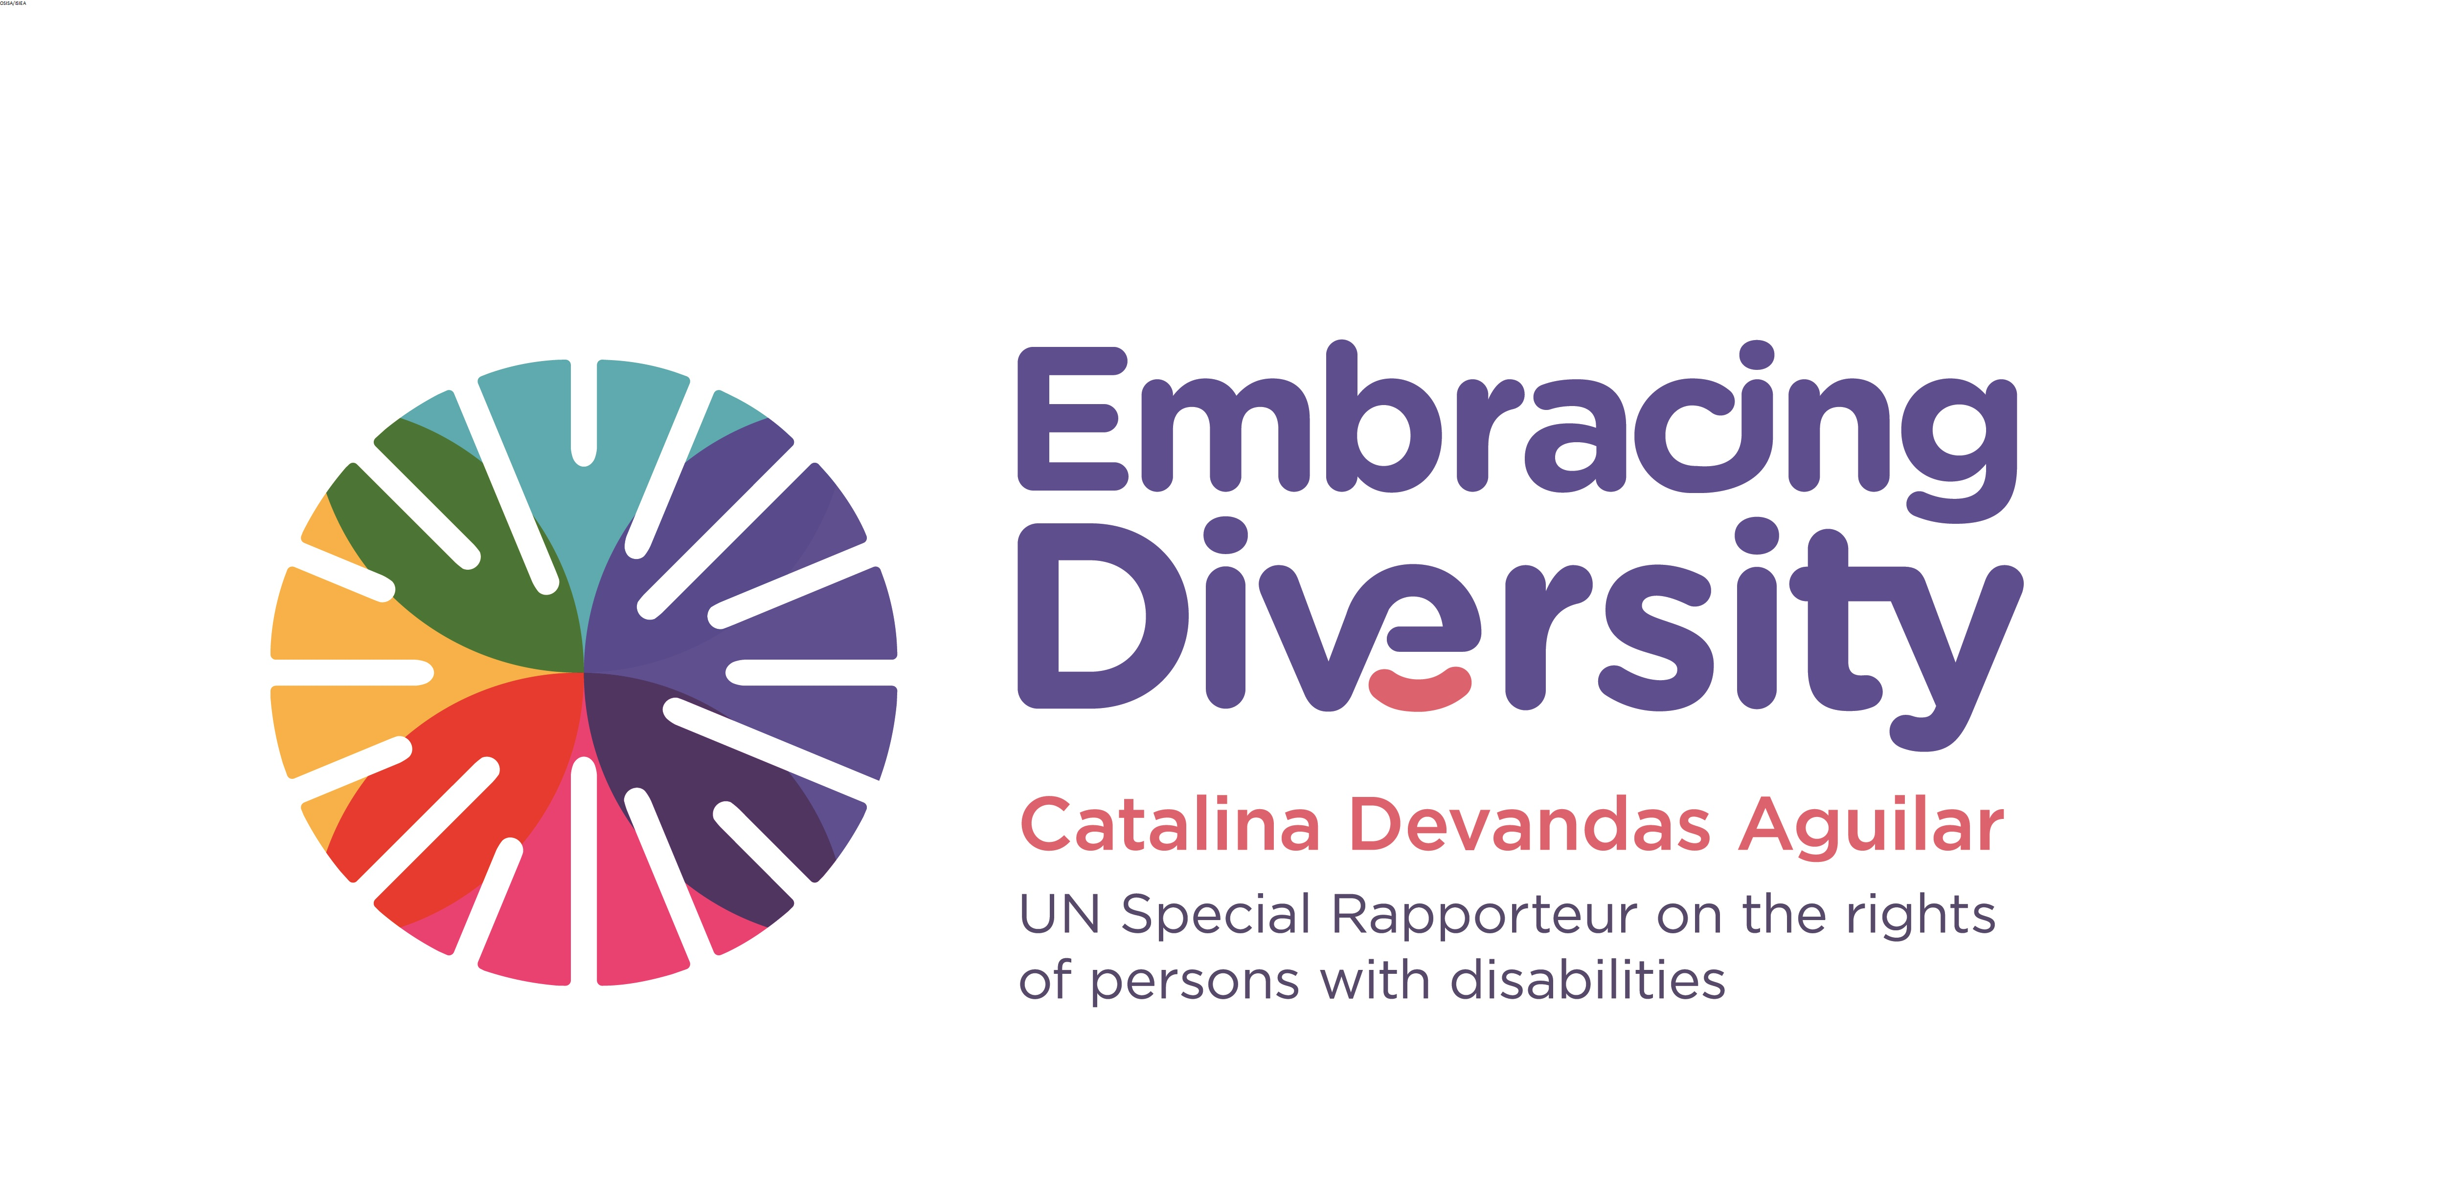

Regional Expert meeting on support services for persons with disabilities

6-7 September 2016
Addis Ababa- Ethiopia

Concept Note

- Introduction
The UN Special Rapporteur on the Rights of Persons with Disabilities, Ms. Catalina Devandas Aguilar, is hosting a Regional Expert meeting on support services for persons with disabilities on 6-7 September 2016 in Addis Ababa (Ethiopia), with the support of the Government of Finland, the African Disability Forum, and the Open Society Initiative for Southern Africa (OSISA)/ Open Society Initiative for Eastern Africa (OSIEA).
As outlined in her first report to the Human Rights Council (A/HRC/28/58), the Special Rapporteur aims to contribute to the development of knowledge and standards on the rights of persons with disabilities, focusing on thematic issues that have emerged as a priority, through participation, dialogue and consultation with key stakeholders. She also aims to facilitate cooperation and build bridges between initiatives and stakeholders across the world (especially South-South cooperation), with a view to create platforms for the exchange of good practices and lessons learned.
In her thematic reports on the right to social protection of persons with disabilities (A/70/297) and on participation of persons with disabilities in decision-making processes (A/HRC/31/62), the Special Rapporteur underscored the vital role played by support services in enabling active citizenship and inclusion in the community for persons with disabilities. Additionally, in her engagement with different stakeholders, including through expert meetings (e.g., expert meeting on deprivation of liberty on the basis of disability, September 2015), she highlighted that the provision of support services is a prerequisite for the realisation of the rights of persons with disabilities. Nonetheless, certain unaddressed issues - such as how to implement support services in contexts of limited resources, specifically in low and middle-incomes countries; or how to ensure 'choice and control' for persons with disabilities over the provision of such services - prevent persons with disabilities to fully enjoy their right of live in the community with choices equal to others.
- Context
Support services are essential for enabling persons with disabilities to exercise and enjoy their fundamental rights on an equal basis with others. Support enables persons with disabilities to exercise their individual autonomy and to make their own choices, participate in public and political life, and live independently and be included in the community. Support also enables them to access education, health and employment on an equal basis with others. Provision of different types of support services is a crucial aspect for moving away from a medical approach towards a human rights-based approach to disability.
Support both as a right and as a precondition to substantive equality is recognized in different human rights instruments and general comments. The Convention on the Rights of Persons with Disabilities (CRPD) embodies support as a crosscutting obligation of State Parties. Article 4(1) requires States to provide support services, assistive technologies, mobility aids and other forms of assistance to ensure and promote the full realization of human rights and fundamental freedoms for persons with disabilities. The provision of support is further mentioned in article 9 on accessibility, article 12 on legal capacity, article 19 on living independently and being included in the community, article 13 on access to justice, article 20 on mobility, and article 24 on education, among others. The broader definition of discrimination of the CRPD, which includes reasonable accommodation, reminds States that the failure to provide the necessary and appropriate modifications and adjustments to guarantee to persons with disabilities the enjoyment or exercise on an equal basis with others of all their human rights and fundamental freedoms amounts to discrimination.
The Committee on the Rights of Persons with Disabilities, in its interaction with States Parties during their country report reviews, has called upon them to provide support to persons with disabilities in different aspects of life, arguing that such support promotes not only inclusivity and independence, but also acts as a measure to combat stereotypes regarding the capabilities of persons with disabilities. More specifically, in its general comment no. 1 on equal recognition before the law, the Committee recommended that States Parties provide support to persons with disabilities to enable them to exercise their legal capacity and to ensure that such support respects the rights, will and preference of such persons.
Moreover, in its general comment no. 5 on persons with disabilities (para 33), the Committee on Economic, Social and Cultural Rights has recognized that support services and adequate standard of living are interconnected, and that the provision of necessary support services to persons with disabilities, including assistive devices, increases their level of independence in their daily living and to exercise their rights.
In their efforts to fulfil their obligation to provide support to persons with disabilities, practice shows that States have adopted various support models and systems. Several challenges persist, such as a “paternalistic approach” to the provision of services, or the use of discriminatory eligibility criteria. In the context of low and middle-income countries, the allocation of resources and the design of sustainable support models remain great challenges. It is therefore necessary to identify positive experiences and good practices to foster existing efforts to provide support services to persons with disabilities.

- Objectives and expected outcomes
This two-day expert meeting will convene approximately 25 participants, including academics, policy makers, representative organizations of persons with disabilities, and representatives from the African Commission on Human and Peoples’ Rights.
The specific goals for the meeting are to:
- Identify gaps and challenges in the implementation of support services for persons with disabilities in Africa;
- Identify CRPD-compliant good practices for the implementation of support services for persons with disabilities in Africa;
- Provide a platform to identify and devise concrete solutions for the implementation of support services for persons with disabilities in Africa.
The findings of the meeting will inform the Special Rapporteur’s forthcoming report on support services for persons with disabilities, which will be presented at the 34th session of the Human Rights Council in March 2017.
- Methodology
The meeting will be organized in two main sessions.
- Session one (day one) will focus on the normative framework provided by the CRPD and on the identification of key challenges to implement support services for persons with disabilities.
- Session two (day two) will focus on mapping positive advances in designing support models in different African countries, innovative ways of administering and funding support services for persons with disabilities, and reviewing proposals of designing CRPD-compliant support services for persons with disabilities in low- and middle-income countries.
A facilitator will moderate the discussions throughout the meeting. Selected experts will be required to make short presentations during the day. Interview style panels will be adopted to facilitate the session on ‘mapping forms of support in different countries’ in order to maximize time and exchanges. Pre-identified questions will be used to guide all the thematic discussions.
The meeting will be held in English, with simultaneous interpretation in French. Captioning will be provided during the meeting. Other accessibility arrangements will be provided upon request.

Ms. Catalina Devandas Aguilar took office as the first Special Rapporteur on the Rights of Persons with Disabilities on 1 December 2014, following Human Rights Council resolution 26/20. She is mandated, inter alia, to develop a regular dialogue and consult with States and other stakeholders to identify and promote good practices relating to the realization of the rights of persons with disabilities; gather and exchange information and communications with States on alleged human rights violations; and make recommendations on how to promote and protect the rights of persons with disabilities. In this framework, the Special Rapporteur reports annually to the Human Rights Council and the UN General Assembly.
CRPD/C/DEU/CO/1, para 42; CRPD/C/SWE/CO/1, para 44; CRPD/C/AUT/CO/1, para 39; CRPD/C/BEL/CO/1, para 39.
For instance in its concluding observations to El Salvador, the Committee on the rights of persons with disabilities recommended the adoption of measures to prevent persons with disabilities from being hidden or isolated from society or being separated from their families and social circles, including through granting their families the necessary support services.

