Training module on SDG 11:

Sustainable Cities and Communities (in-person training)

*Advance version*

Facilitator’s Outline

Handout: Extended Character Stories: A day in the life

Handout: Implementation Challenge Info Cards

# Facilitator’s Outline

|  |  |
| --- | --- |
| **Module Title:**  **Training Module on SDG 11 - Sustainable Cities and Communities (in-person training)** | |
| **Description** | The United Nations Human Rights Office developed a comprehensive resource package aimed at supporting the work of policymakers who are engaged in the implementation of the Sustainable Development Goals for the 2030 Agenda, or in the implementation of disability-related policies.  The [SDG-CRPD resource package](https://www.ohchr.org/EN/Issues/Disability/Pages/sdg-crpd-resource.aspx) is composed of the following components:   * **Policy Guidelines** are detailed documents aiming at supporting policymakers in the development of laws, policies and programmes following the Sustainable Development Goals, under the guidance of the Convention on the Rights of Persons with Disabilities (CRPD). The Policy Guidelines include: a comprehensive first component - Foundations for Inclusive Sustainable Development Goals - which reviews key concepts, including the human rights based approach to disability, cross-cutting issues and structural requirements to create an enabling legal, policy and programme environment, as set out in SDGs 10 (Reducing Inequalities), 16 (Peace, Justice and Strong Institutions) and 17 (Partnerships for the Goals); guidelines covering SDG 1 (No Poverty), SDG 3 (Good Health and Well-Being), SDG 4 (Quality Education), SDG 5 (Gender Equality), SDG 8 (Decent Work and Economic Growth), and SDG 11 (Sustainable Cities and Communities); thematic briefs related to food and nutrition, water and sanitation, rural areas, research and innovation, tourism and climate change and disaster risk reduction. * **Human Rights Indicators** for the Convention on the Rights of Persons with Disabilities, which identify key markers to assess the enjoyment of rights under each article of the CRPD, and track progress in its implementation. * **Data Sources Guidance**, which provides concrete examples of where data is being collected to inform the human rights outcome indicators. * **Training materials**, which include a facilitator guide and a set of Power-Point® slides, to support in-person and online trainings on the different components of the Policy Guidelines, as well as a general module dedicated to the SDG-CRPD resource package itself. * **Videos**, which give a brief overview of the topics covered in the Policy Guidelines, as well as one video that introduces the SDG-CRPD resource package itself and its components.   This training module focuses on SDG 11 - inclusive cities and communities |
| **Length** | 8 hours including breaks. Schedule one hour for set-up. |
| **Date & Time** | [write here date and time of the training] |
| **Facilitator(s)** | [Write the name of facilitators here]  ***\*\*Note to Facilitators: Everything in italics (below) is the script of what you should say to participants. Adapt it to your own style.***  While it might not always be possible, it is advisable that facilitators team-up with persons with disabilities to deliver trainings in one or more sessions. They can participate as experts or share their experiences, to illustrate contexts, barriers, and/or actions recommended.  In preparation for facilitating this module it is important that you familiarize yourself with the Foundations for Inclusive Sustainable Development Goals and Policy Guideline on SDG 11 available at <https://www.ohchr.org/EN/Issues/Disability/Pages/sdg-crpd-resource.aspx>.  In addition, you should assess the needs of participants and identify how familiar they are with the content. To do so, you should review Part 2 of the [Evaluation Handbook](https://www.ohchr.org/Documents/Publications/EvaluationHandbookPT18.pdf).  This training will be more effective if participants are able to make connections between the theoretical and technical content of the module, and their own particular contexts. That is why most activities include a debrief with open questions to support learning. Therefore, it is important that you are prepared to link participants’ responses and offerings to the content of the module and specific concepts, to build on their comments when explaining content. |
| **Objectives** | By the end of the module, participants will be able to:   * Identify and use the various components of the United Nations Human Rights Office’s SDG-CRPD resource package. * Better understand the current situation in terms of the barriers people with disabilities face in cities and urban settlements. * Identify concrete steps that policymakers can take to guarantee inclusive cities and communities in the process of implementing SDG 11 with a disability rights lens. * Obtain additional information to support the implementation of measures to ensure inclusive cities and communities in their own context. * Learn how to obtain additional information to support implementation of inclusive cities and communities, in their context. |
| **Participants** | Number of participants: 30   * Intended participants: Policymakers and public officials working in various agencies that play a role in the realization of the SDGs or in the development and implementation of disability-related policies, particularly as they relate to urban development. * Facilitators should have the following considerations when preparing to give this training:   + Among participants, there are differences of experience working on policy implementation related to the rights of persons with disabilities.   + Among participants, there are different levels of knowledge about the Convention on the Rights of Persons with Disabilities, the Sustainable Development Goals and/or the 2030 Agenda.   + Whether participants have disabilities and what specific accommodations are needed for them to participate fully.   + English may not be the participants first language.   + Participants may not be attending the training by choice. |
| **Materials** | * [Foundations for Inclusive Sustainable Development Goals: key concepts and structural requirements](https://www.ohchr.org/EN/Issues/Disability/Pages/sdg-crpd-resource.aspx) * [Policy Guideline SDG 11](https://www.ohchr.org/EN/Issues/Disability/Pages/sdg-crpd-resource.aspx) * [Powerpoint Presentation on SDG 11](https://www.ohchr.org/EN/Issues/Disability/Pages/sdg-crpd-resource.aspx) * [Video SDG 11](https://www.ohchr.org/EN/Issues/Disability/Pages/sdg-crpd-resource.aspx) * Flipcharts (4 total):   + Two blank flipcharts: One flipchart with the heading “Parking Lot” for people to write any questions that arise throughout the training that may not be directly related to the topic; one flipchart with the heading “Resources” for participants to share any resources they may have.   + One flipchart to leave up throughout the training with the title: “Core pillars for all policies” and a list with the following items:     - Non-discrimination on the basis of disability (addressing intersectionality and-diversity of persons with disabilities)     - Participation     - Accessibility     - Support for persons with disabilities - Assistive technology and support services     - Awareness raising   + One flipchart to leave up throughout the training with the title: “Structural requirements for creating an enabling environment” and a list with the following items:     - Governance     - Participation     - Non-discrimination legislation & policy     - Accountability     - Capacity building     - International Cooperation * ACTIVITY SPECIFIC   + HANDOUT: A Day In The Life: Extended Character Stories   + HANDOUT: Implementation Challenge Info Cards * Markers and others writing implements * Crayons, color pencils * Play-Doh * Old magazines and scissors * Masking tape * Blank writing paper |
| **Additional support resources for facilitators** | * [Training guide on the Convention on the Rights of Persons with Disabilities](https://www.ohchr.org/Documents/Publications/CRPD_TrainingGuide_PTS19_EN%20Accessible.pdf) * [CRPD training package](https://www.ohchr.org/EN/Issues/Disability/Pages/TrainingmaterialCRPDConvention_OptionalProtocol.aspx) * [Evaluation Handbook](https://www.ohchr.org/Documents/Publications/EvaluationHandbookPT18.pdf) * [OHCHR Training booklet](http://acnudh.org/wp-content/uploads/2011/11/slitoolkit.pdf), “Share, learn, innovate!” * [OHCHR Manual on Human Rights Training Methodology](https://www.ohchr.org/Documents/Publications/training6en.pdf) * [UNESCAP Disability-Inclusive meetings](https://www.unescap.org/resources/disability-inclusive-meetings-operational-guide) |
| **Logistics** | * [Describe here any specific logistical, set-up, or needs for the training, such as important numbers, contacts, etc.] * Make sure you address any specific accessibility needs for facilitators and participants (this may include physical accessibility, availability of Sign Language interpreters, audio description, etc.) |

| **Section** | **Agenda & Activities** | **SLIDE** |
| --- | --- | --- |
| **Welcome and Intro**  (35 min)  Start time: 00:00  *Facilitator’s name* | PURPOSE: Connect and engage participants, help everyone see who is in the room so they can focus, set the expectation for participation and give the facilitator a first “read” of the group  Set the seats in a U shape with the facilitator in front of the room.   * *I’d like to welcome everyone to the space. I would also like to get to know more about you, and for you to learn more about who else is in this training. For that, I would like to ask each of you to introduce yourself for exactly one minute (I will be keeping time). Share a little bit about who you are and* ***What’s something you really like about the place you live?*** *We won’t follow any particular order; whomever feels moved to do so, come to the front of the room and introduce yourself. I will tell you when your time is up.* * Move your seat to leave the front of the room open for each participant to step up. Be rigorous with calling time for each participant; this will bring humor to the task and will also make sure that everybody begins on equal ground. Facilitators go last. * After everybody (including facilitators) have gone, ask: *“What did you notice about the group? What caught your attention about what others shared?”* | Slide1: Policy Guideline on sustainable cities and communities - SDG 11  Slide 2: Welcome! |
| **Overview, Objectives and Agenda Review**  (10-15 min)  Start time: 00:35  *Facilitator* | PURPOSE: Engage and prepare participants by helping them understand the context and purpose of the session and by providing some information on what’s coming to reduce anxiety.   * *Today we are all here for the purpose of learning what it means to live in inclusive cities through a disability-rights lens. The United Nations Human Rights Office developed a comprehensive resource package aimed at supporting the work of policymakers who are engaged in the implementation of the Sustainable Development Goals for the 2030 Agenda or in the implementation of disability-related policies.* * *Our objectives for today are to:*    + *Become familiar with the resource package and its components.*   + *Implement tools to support policy makers to understand the situation of persons with disabilities.*   + *Gain an understanding of the current situation of people with disabilities in cities and communities*   + *Identify concrete steps that policymakers can take to guarantee accessible cities and communities in the process of implementing SDG 11 through a disability rights lens.*   + *Learn how to obtain additional information for implementation of inclusive cities and communities in your context.* * *To work on these objectives, we will be engaging in various activities, together and individually.*   *The* [*SDG-CRPD resource package*](https://www.ohchr.org/EN/Issues/Disability/Pages/sdg-crpd-resource.aspx) *is composed of the following components:*   * ***Policy Guidelines,*** *are detailed documents aiming at supporting policymakers in the development of laws, policies and programmes following the Sustainable Development Goals, under the guidance of the Convention on the Rights of Persons with Disabilities (CRPD). The Policy Guidelines include: a comprehensive first component - Foundations for Inclusive Sustainable Development Goals - which reviews key concepts, including the human rights based approach to disability, cross-cutting issues and structural requirements to create an enabling legal, policy and programme environment, as set out in SDGs 10 (Reducing Inequalities), 16 (Peace, Justice and Strong Institutions) and 17 (Partnerships for the Goals); guidelines covering SDG 1 (No Poverty), SDG 3 (Good Health and Well-Being), SDG 4 (Quality Education), SDG 5 (Gender Equality), SDG 8 (Decent Work and Economic Growth), and SDG 11 (Sustainable Cities and Communities); thematic briefs related to food and nutrition, water and sanitation, rural areas, research and innovation, tourism and climate change and disaster risk reduction.* * ***Human Rights Indicators*** *for the Convention on the Rights of Persons with Disabilities, which identify key markers to assess the enjoyment of rights under each article of the CRPD, and track progress in its implementation.* * ***Data Sources Guidance****, which provides concrete examples of where data is being collected to inform the human rights outcome indicators.* * ***Training materials****, which include a facilitator guide and a set of PowerPoint® slides, to support in-person and online trainings on the different components of the Policy Guidelines, as well as a general module dedicated to the SDG-CRPD resource package itself.* * ***Videos****, which give a brief overview of the topics covered in the Policy Guidelines, as well as one video that introduces the SDG-CRPD resource package itself and its components.* * *While all the policy guidelines support each other, today’s session will be focused on Inclusive Cities and communities.*   Agenda Review:   * *To start we’ll look at the concept of disability, then we’ll explore the data that informs the guidelines, and finally we will work on identifying the specific elements that are needed for policymakers and other actors to ensure the proper implementation of SDG 11.* * *At this time, we would like to ask you to do what you need to do to be as present as possible in this space, by removing distractions, taking care of yourself, and supporting the participation of others. We invite you to use everything for your own learning!*   Address here any logistical issues: information about where the bathrooms are, whether the session is being recorded or not, instructions on working with interpreters, etc.   * *We have put up two flipcharts: In one, you can write any questions that arise that may not be directly related to the topics of today’s session. We’ll be reviewing them during breaks and provide answers. The second flipchart is for you to share any resources you might have with other participants. We invite your wisdom into this room!*   *Any questions before we move on?*   * Make sure to answer questions from participants and clarify any of the information needed | Slide 3: Objectives for the session  Slide 4: What's in the CRPD-SDG resource package?  Slide 5: Agenda |
| **Understanding Disability & Ableism**  **(Optional)**  (30-45 min)  Start time: 00:50  *Facilitator* | PURPOSE: To provide a conceptual framework about disability and ableism from which the analysis in the rest of the session follows.  **NOTE:** If you are facilitating this training as a stand-alone training, make sure to include this activity. If you’re doing a series of trainings with other modules, you only need to do this activity once, at the beginning of the series.  Form trios of people, randomly, and ask them to face each other.   * *I would like to ask you to get comfortable. Close your eyes if you feel like it, or just lower your gaze, and think back to your youth for a moment. I would like to ask you to think back to when you were between 8 and 12 years old.* (PAUSE) *Please think back – specifically - about what was your idea of disability then. What messages did you receive from TV, newspapers, family, peers? What feelings did you have associated with disability?* (PAUSE). * *What stories do you remember that involved people with disabilities at that time of your life? Maybe you had a relative with a disability… how did your family talk about it? Did you have any classmates with disabilities? Teachers?* (PAUSE) * *Now please turn to the persons in your trio and share some of what you remembered, discuss what you notice in common, and come up with a list of words that you associated with disability during that time of your lives.*   Gather the list from each group in a flipchart paper. Invite honesty. Things that will be listed will include fear, illness, pity, sadness, etc. Connect what’s in the list to how disability has been understood, and how that translates into exclusion or inclusion in society. For example:   * *Historically, disability has been understood as a “curse” and as a “burden”. This translates in the use of terms such as “invalid” or “handicapped” and in policies of segregation. Since it views people with disabilities as “objects of charity”, people with disabilities are seen as less than human. Because they’re seen as a burden to society, schemes of institutionalization are put in place and places such as asylums and segregated settings are built. Additionally, because people with disabilities are expected to be at home, places or leisure, public transportation, public housing and services are not built or designed with accessibility in mind.* * *Another pervasive view is that having an impairment is seen as a defect, something to fix or cure. Disability is considered purely a health issue and a person’s identity is limited to their impairment. This is reflected in the creation of specific places to hold people with disabilities such as psychiatric hospitals, private rehabilitation centers, etc.* * *Under the CRPD, disability is a manifestation of human diversity and results from the interaction between a person’s impairment and the barriers in the environment that prevent their full participation in society. This means that States should remove barriers that prevent persons with disabilities from participating fully in society. In the case of cities and other communities, this means ensuring available and accessible housing, and public services such as transportation, as well as ensuring assistive technology.* * *Despite the significant advances in the recognition of the rights of persons with disabilities at international and national levels, the deeply rooted negative perceptions about the value of their lives continue to be a prevalent obstacle in all societies. Those perceptions are engrained in what is known as* ***ableism*** *- a value system that considers certain typical characteristics of body and mind as essential for living a life of value. Based on strict standards of appearance, functioning and behavior, ableist ways of thinking consider the disability experience as a misfortune that leads to suffering and disadvantage, and invariably devalues human life. As a result, it is generally assumed that the quality of life of persons with disabilities is very low, that they have no future to look forward to, and that they will never live happy and fulfilling lives. Ableism leads to social prejudice, discrimination against, and oppression of, persons with disabilities, as it informs legislation, policies and practices. Ableist assumptions lie at the root of discriminatory practices.*” (Cite to report of the UN Special Rapporteur on the rights of persons with disabilities on the impact of ableism in medical and scientific practice, [A/HRC/43/41](https://undocs.org/en/A/HRC/43/41); OHCHR report on awareness-raising, [A/HRC/43/27](https://undocs.org/en/A/HRC/43/27)) * *Now, after learning all this information, turn to a person next to you and share initial learnings or reflections.* | Slide 6: What did you think about disability when you were 8 - 12 years old?    Slide 8: Ableism |
| **BREAK**  (20 min)  Start time: 01:35  *Facilitator* | PURPOSE: For participants and facilitators to take a moment away and come back together.   * TAKE A BREAK! * Be back in 20 minutes | Slide 9: Break! |
| **Data Contest**  (30-45 min)  Start time: 01:55  *Facilitator* | Create teams of four people and prepare a prize for the winner (it can be symbolic or a UN publication or a snack, you can be creative!) - Ask each team to pick a team name and explain that you’re having a contest. The team with most points takes the prize.   * After each question is answered, show the slide with the correct answer and give substantive information about the topic. You can review the policy guideline for more details. There are questions has bonus points that involve contextualizing the situation to the participants’ own country/region. * Be sure to maintain high energy for this activity. Determine how you will know which group gets the first answer. Options can include, ringing a bell, saying a specific word, clapping, yelling their team name, etc. In a flipchart, keep points for each team after each answer. * ***Question 1*** *- By 2050, what is the percentage of people with disabilities who will be living in urban areas? (5 points)*   + *A. 25%*   + ***B. 15% (correct)***   + *C. 2%*   **Expanded Answer: *Of the 6.25 billion people predicted to be living in urban areas by 2050, an estimated 15%, or 937 million, will be persons with disabilities****. Cities and human settlements can impede or enable inclusion of persons with disabilities, depending on how they are planned and built. Many persons with disabilities face a widespread lack of accessibility to the built environment, such as housing and public buildings and spaces, transportation, urban services, information and communications. This lack of accessibility contributes greatly to the marginalization of persons with disabilities, and results in disproportionate rates of poverty and exclusion. Women and girls with disabilities often experience a lack of participation in urban planning processes, and additional barriers in accessing the urban environment and services, such as safety concerns in the use of public spaces or transport.*  ***Bonus point:*** *If a member of your team knows the percentage of persons with disabilities who live in the main city of their country.*   * ***Question 2 -*** *What is the percentage of persons with disabilities, of 8 developing countries, who stated that transportation services are not accessible? (5 points)*   + ***A. 36% (correct)***   + *B. 65%*   + *C. 19%*   ***Expanded Answer:*** *Persons with disabilities face restrictions, or are completely excluded from, transportation services.* ***Data from 8 developing countries show that 36% of persons with disabilities consider transportation services not accessible.*** *According to a survey conducted in Australia, major obstacles for persons with disabilities using public transportation are: steps to get in or out of vehicles, barriers in getting to stops or stations, lack of seating, difficulty seating or difficulty standing, pain or discomfort when sitting, fear or anxiety, inaccessible doors to get in and out of vehicles, and inadequate access to toilets. Whenever accessibility is considered in transportation, the focus has often been on wheelchair-users only. However, other persons with disabilities also require accessibility features, such as audio or visual signaling. In addition, public policies tend to focus on mass transportation to which many persons with disabilities cannot access, even when accessibility requirements are met. Multi-modal transportation that might be available and individual assistive products and technologies, are usually disregarded.*  ***Bonus point:*** *If a member of your team can name two features that improve the accessibility of the public transportation in their country or region.*   * ***Question 3 -*** *Based on data from 8 developing countries, what is the percentage of persons with disabilities who report that recreational facilities are not accessible to them?**(5 points)*    + *A. 56%*   + *B. 17%*   + ***C. 40% (correct)***   **Expanded Answer:** *Once buildings, facilities and public spaces are constructed, retrofitting for accessibility can be inefficient or not feasible, leaving in place barriers for persons with disabilities that are difficult to remove. The inaccessibility of public spaces in cities restricts the autonomy and mobility of persons with disabilities. This results in multiple impacts on their life, including their social and economic participation. Available data from 8 developing countries shows that, on average, almost 40% of persons with disabilities consider recreational facilities inaccessible (UNDESA 2018).*  ***Bonus point:*** *if a member of your team can name one accessible recreational facility in their country and explain what makes it accessible.*   * ***Question 4 -*** *What are the three criteria for improving accessibility of existing buildings? (5 points)*   + *A. Usability, ramps, Braille signs*   + *B. Preservation, usability, public/private nature.*   + ***C. Visitability, adaptability and feasibility (correct)***   ***Expanded Answer:***  ***Visitability****: Visitability refers to a building that meets three requirements. These are: at least one entrance with no steps into the main floor, wide enough doors and hallways that allow for wheelchair users to access common areas, and one wheelchair accessible bathroom on the main floor. Visitability enables all people to visit the house or building but does not require the entire building to be accessible.*  ***Adaptability****: While not all private and public housing units are initially constructed to accommodate persons with disabilities, the design of the housing should allow for adaptations later on, as needed. For example, a bathroom may originally include a bathtub. The adaptability of the bathroom design would allow for the bathtub to be removed at low-cost and provide space to add in a ‘roll-in shower’.*  ***Feasibility:*** *standards in buildings allow for exceptional accessibility measures to be implemented where technical restrictions preclude general accessibility standards. Feasibility standards should be applied on an exceptional basis and constructors should be held to strict scrutiny. For example, presenting documentation that proves that no safe technical solutions can be implemented because of characteristics of the building. In those cases, urban planning law enforcement agencies can authorize the use of alternative standards such as ‘assisted ramps’ (those that require support from a third person to use them safely), ‘removable ramps’ (ramps that can be removed to avoid blocking circulation), and ‘stair lifts’ (electronic device that allow for wheelchairs to climb stairs), among others.*  ***5 Bonus points:*** *if a member of your team gives an example of how to apply these criteria to an existing building in their country.*   * ***Question 5:*** *Two members of your team have to share policies or practices in their countries that are aimed at guaranteeing inclusive and sustainable cities and communities for persons with disabilities. (10 points)*   Announce the winner team in a celebratory way and give them the prize. You can tell them that they are now officially “champions of social protection that is inclusive of persons with disabilities” in their country.   * *Now I would like to invite you to find someone from a different team and share with them, for a few minutes, something you learned, or that surprised you, in this activity.* | **Slide 10: Welcome to the data contest!**  **Slide 11: Question1**  **Slide 13: Question 2**  Slide 16: Question 3 and chart  Slide 18: Question 4  Slide 19: Question 5- challenge  **Slide 20: In pairs discuss** |
| **Drawing Our Cities**  (1 hr)  Start time: 02:40  *Facilitator* | **Materials:**   * Flipchart paper for each group * Markers, pencils, crayons, play-doh, old magazines and scissors to make a collage * Tape and glue   **Instructions:**  Create six groups of 3-5 of participants from the same city or region if possible. If there are people with disabilities in the group, make sure they are assigned to various groups.  Consider accessibility for the exercise depending on the participants and adjust the instructions accordingly. Give participants various options such as scribing, naming, drawing, collaging using different textures.  Give each group a flipchart, paper and markers, pencils, crayons, old magazines and scissors, play-doh, depending on the materials that allow more options to groups and take into account accessibility needs.  **Part 1: The ideal city**   * *To expand our discussion of sustainable cities and communities we are going to begin with an exercise that asks you to graphically represent your ideal city or community.* * *First, I would like for you to get into groups of 3-5 people with others from your same city or region.* * *In your groups, please represent the ideal city for accessibility. You can assign someone to draw or scribe or use a range of materials. Consider infrastructure, transportation, housing, services and so on.* * *No need to be very detailed. Have your discussion in general terms. You will have fifteen minutes for this exercise. Are there any questions before we begin?*   **Gallery Round:**  At the end of the 15 minutes:   * *Please post your cities onto the walls so that others can see. Now, please move around the room to find out what other groups created and what was included. What do you notice? We’ll take between five and seven minutes for this. When you’ve seen all the different drawings please return to your group.*   **Debrief:**  These are some questions you may ask   * *How was it to draw your ideal city? What did you think about? What did you include? What did other groups include that might have been different from your group?* * *What makes this ideal? What pieces did you add that make this an ideal city for accessibility?”* * *What do you notice? Is what you drew in your ideal city also in your city at home?*   Make sure to include here a reference to the progression from human support to systems that support a person’s mobility in cities and communities (shown in graphic below). Find ways to keep referencing to this progression through the session.  An infographic depicting integrating individual mobility at different levels in the transport system. The graphic shows colored concentric circles surrounding a central circle. The circles have text in them, starting from the center: "human support", "assistive technologies: including information and communication technologies", "Point-to-point transportation: accessible taxi, disability-specific transport, adapted vehicles", "Accessible flexible line transport: combined with point-to-point transportation (paratransit, flexilines)", "Accessible mass transportation: train, subway, buses, etc.", "Accessible inter-urban and long-distance options".  **Part 2: Our current cities/communities**   * + *Now, in your same groups and using the materials available, please create a map of a city that is similar to the cities or places where you currently live. Create it however it makes sense to your group.*   + *We will not do a gallery round after this activity but we will be using these maps later today.*   + *You will have about ten minutes for this activity. You don’t need to be very detailed, just make a map with general elements. Any questions about what you will be doing?*   **Debrief:**  At the end of the 10 minutes:   * + *What are differences you noticed between the first and second maps? What did you notice when creating the map of your actual city?*   + *Who, in your community, deals with urban planning and management, housing and public transportation?* | Slide 21: Activity: What is the ideal city?  Slide 22: Gallery Round: What is the ideal city?  slide 23: the progression of supports  Slide 24: Our cities as they are today? |
| **LUNCH BREAK**  (60min)  Start time:  03:40  *Facilitator* | Breaks are important spaces for participants to continue exchanging and processing information. If possible, create a communal experience where people can informally exchange with each other. | Slide 25: Lunch Break! |
| **Video Showing**  (10 min)  Start time: 04:40  *Facilitator* | *I am going to play a short video for you to watch. In the next activity we will go deeper into the information shared in this video. As you watch/listen pay attention to the different characters highlighted and the issues shared and proposed.*   * **Play the SDG11 - Video** [SDG-CRPD resource package](https://www.ohchr.org/EN/Issues/Disability/Pages/sdg-crpd-resource.aspx) | Slide 26: Short video |
| **Implementa-tion Challenge Part 1: A Day in The Life…**  (1 hr)  Start time: 04:50  *Facilitator* | **Materials:**   * HANDOUT: Extended Character Stories - A day in the life of...   **Instructions:**   * *Now we will use the city maps you created (second map). Please go back to your groups.*   Each group will receive “A Day in the Life” expanded story for the characters: Groups 1&4- Alicia; Groups 2 &5 - Chao Fah and Artit; Groups 3&6- Aminata and Julius. In addition, each group receives a cutout of their characters to place and move around their map.   * *Each group has been assigned a character and has been given an expanded story for that character. As a group you will use your map and the “Day in the Life…” stories to take your character through your city.* * *As you go through the city, discuss the following questions:*   + *What are the needs of your character?*   + *In what ways is your city accessible or inaccessible for them?*   + *Based on what you’ve learned so far, what would be needed in terms of urban planning and accessibility for them to improve their current situation?* * *As you engage this activity I will also come around with “speed bumps” - which are events that will change your character’s day. When I give you a speed bump, please discuss: what would be needed to add this new event to your character’s day?* * *Any questions before we begin?*   **Speed bumps:**  These are the “speed bumps” you will give to each character; ask each group to discuss what would be needed to add this new event to their character’s day. Give the following events to the corresponding groups:   * **Alicia:** Once a week, Alicia has to go to the medical center and get physical therapy. Once a month, on Sundays, Alicia and her family go visit their grandparents who live in the next town and take inter-city transport. * **Chao Fah and Artit:** Today Chao Fah came down with a really bad cold and doesn’t feel like he can go to work. Chao Fah and Artit love music and they heard of a really good free concert happening in the main museum. * **Aminata & Julius:** Julius wheelchair breaks. Aminata is offered a job as a waitress twice a week. | Slide 27: Implementation Challenge: A day in the life |
| **Implementa-tion Challenge Part 2: Debrief**  (30 min)  Start time: 05:50  *Facilitator* | **Debrief:**  When the groups have all made it through their character’s day including the speed bump, or time has run out.   * + *I would like to invite everyone back to the large group so that we can discuss this activity. How was this experience for you? What did you learn?*   + *What made it hard for your character to go through their day?*   + *What already existed that supported them to go through their day?*   + *What new realizations or understandings do you have after this activity?*   + *Are you thinking about anything new that you hadn’t considered before?* |  |
| **BREAK**  (20 min)  Start time: 06:20  *Facilitator* | PURPOSE: For participants and facilitators to take a moment away and come back together.   * TAKE A BREAK! * Be back in 20 minutes | Slide 28: Break! |
| **Implementa-tion Challenge Part 3: Application**  (1 hr)  Start time: 06:40  *Facilitator* | **Materials:**   * Pre-printed info cards for categories * Flipcharts for each group * Pre-printed graphic on a flipchart to post in front of the room   An infographic depicting the main areas of intervention to realise SDG11. The graphic shows three colored circles around a central statement which says "Inclusive cities and communities". Each circle has an icon and the central statement has an icon of a city. One circle has an icon of a house, it says "Accessible Housing", the next circle has an icon of a train, it says "Inclusive transportation systems", the next circle has an arch that says "Inclusive public spaces."  **Instructions:**  Create groups of 3-4 people and make sure to mix participants  so they are in a group with someone new. Each group receives the info cards for the categories as well as a flipchart to write their actions for each category. Ask groups to divide their flipcharts into three parts, one per each category: Accessible housing, Inclusive public spaces, and inclusive transportation systems.   * + In your small groups, *think about what was difficult for your character, or what supported them.* * *Based on what you learned in the previous activity, what actions under each category can ensure that a city or community is inclusive of persons with disabilities?* * *Pick one action from each of the categories and discuss the following questions with your group.*    + *Who has the power to do it in your country or region?*   + *What are the first three things that would be needed for this action to be implemented?*   + *What role could you have in the process of making these actions real?* * *Now I invite you to move around the room, individually, and look at what other groups have written. Are there similarities or differences? When you’ve had a chance to explore each group please find a spot in the large group. You’ll have about five minutes for this activity.*     **Large group debrief (25 min)**   * *What were some of the actions you saw on the flipcharts?* * *What did you learn?*   Make relevant references to the Policy Guideline as it connects to people’s answers and reflections. | Slide 29: Implementation Challenge: What do our cities need?  Slide 30: In small groups  Slide 31: In small groups  Slide 32: Implementation Challenge |
| **Wrap-up & Next Steps**  (10 min)  Start time: 07:40  *Facilitator* | * Answer any final questions from participants * [Summarize the session outcomes] * [Remind them of next steps, including follow-up materials] * [Share evaluation form] * [Address any logistical issues]   [Share any thanks or recognitions due - to interpreters, support staff, etc.] | Slide 33: Next Steps |
| **Closing Circle**  (5-10 min)  Start time: 07:50  *Facilitator* | **Instructions:**  Have people stand in a circle  *For closing, I would like to ask each of you to name one commitment you’re making to ensure your cities and communities become more inclusive. Who in your specific context can hold you accountable for it?* | Slide 34: Closing Circle |
| **Logistics wrap-up**  *Trainer* | PURPOSE: After participants have left, wrap up the training space and download artifacts for later use.   * Email participants follow-up documents, including any of the following, as applicable:   + Evaluation Form Link   + Slides   + Other handouts * Finalize any logistical issues | Slide 35: Thank You! |

# A day in the life of...

**Alicia**

Alicia is a young girl and with a physical disability. She gets around in a manual wheelchair. Her family lives in public housing and she lives in the public housing unit with her parents and three siblings. Their apartment is inaccessible, as they live in the second floor of a building with no elevator. They informed the housing authorities about Alicia’s mobility needs when they applied for housing, but they were informed that they did not have accessible units available for them. Alicia needs assistance to fulfill her basic needs, such as hygiene and food. In addition, the school said they could not take Alicia because they did not have the budget to provide for a personal assistant to support her in class. Therefore, Alicia doesn’t attend school like her siblings. A distant relative gave her a computer and the family has a basic internet plan.

**Alicia’s Day**

6:00-7:00 am - her mother wakes her up and, with the help of one of her siblings, they take her to the bathroom, shower and dress her. They bring her back to her room and sit her in bed, while they all get ready for school and work.

7:00-7:30 am - Alicia’s father and siblings have breakfast before they go to school and work. Alicia’s mother does the dishes; she stays home because she is Alicia’s main caregiver.

7:30-8:00 am - Alicia’s mother gives breakfast to Alicia.

8:00-12:00 - Alicia is in her room using the computer while her mother does all the house chores. Her mother helps her once to go to the bathroom.

12:00-4:00 pm - Alicia’s mother fixes and gives Alicia her lunch and they watch TV for some time. After that, Alicia goes back to her computer and also rests. Alicia’s mother takes her to the bathroom again.

4:00-5:00 pm - Alicia’s siblings arrive home and they carry her down the stairs so she can be outside for a little while before they have to sit down and do homework.

5:00-7:00 pm - Alicia’s father arrives home and spends some time with Alicia.

7:00-8:00 pm - Alicia’s parents and siblings have dinner.

8:00-8:30 pm - Alicia’s mother brings her dinner and gives it to her.

8:30-9:00 pm - Alicia’s father takes Alicia to the bathroom, brushes her teeth and gets her ready for bed.

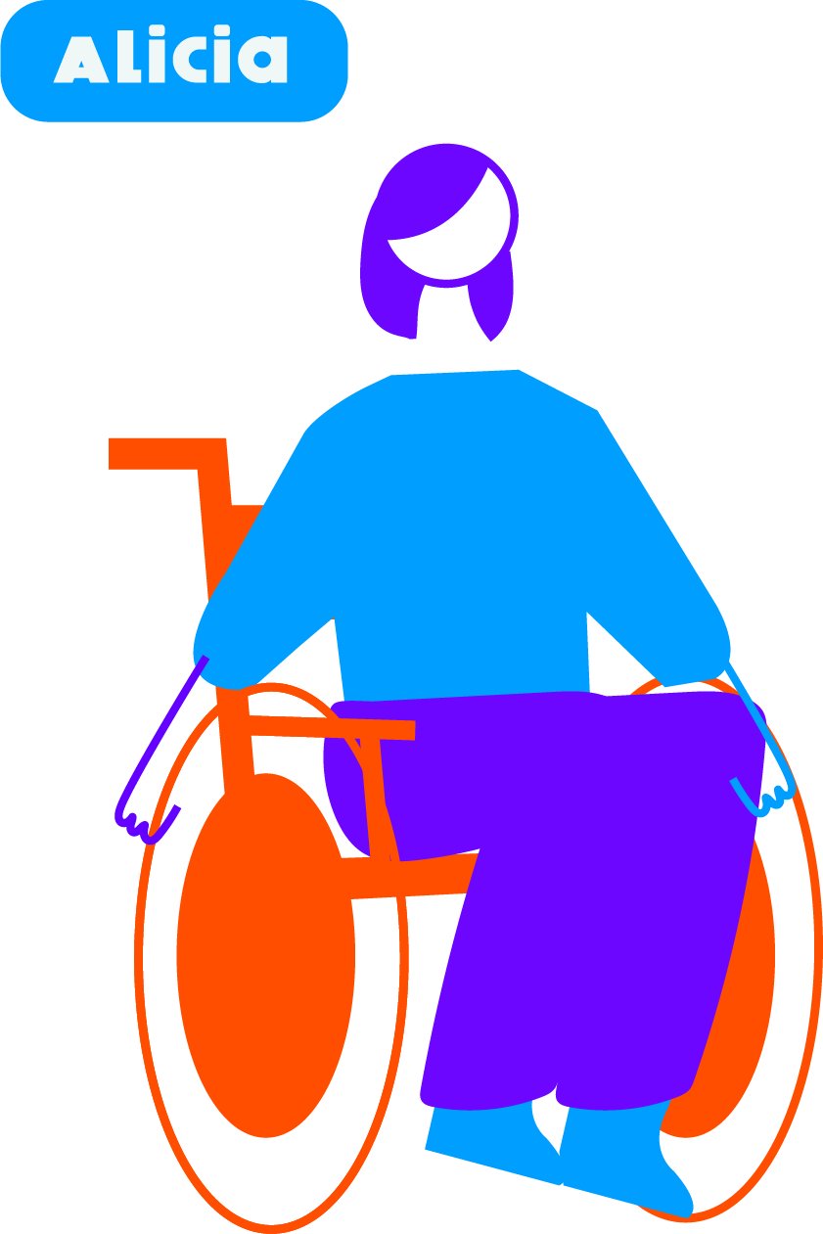

**Chao Fah and Artit**

Chao Fah is a young man who is blind. He lives with his brother who works as a night guard and comes home at 6:00 am. Chao Fah has been working in the same factory for 5 years. When there was an opening, he convinced the boss to hire his friend Artit, a wheelchair user, who lives a block away. He told the boss that he would help Artit learn his tasks and would help him get to work, as they live next door to each other. Artit is an only child and lives with his aging parents. They receive a small pension, and with Artit’s salary, they are barely able to cover their expenses. Artit cannot afford to pay for a personal assistant so Chao Fah helps him every morning. They didn’t use to have any trouble with their schedule and always arrived on time, at 9 am. But now the bus route is longer, and they have been struggling to arrive on time, which made the boss give them a warning.

**Chao Fah and Artit’s day**

6:00-7:00 am - Chao Fah wakes up, gets ready for work and has breakfast when he can.

7:00-8:00 am - Chao Fah arrives to Artit’s place and helps him get showered and dressed. Artit has to take some fruit with him for breakfast.

8:00-9:00 - Chao Fah pushes Artit’s wheelchair and they go to the bus stop. They usually ride on the street because the sidewalk has a lot of barriers. They always have to ask for help getting on the bus and sometimes the bus is too full, and they have to wait for the next one.

9:00-12:00 - Chao Fah and Artit work in their respective stations. Chao Fah has to take Artit to the reception desk.

12:00-1:00 pm – Usually, Chao Fah and Artit take turns bringing lunch to each other.

1:00-5:00 pm - Chao Fah and Artit work in their respective stations. At 5 pm Chao Fah picks up Artit and they get ready to take the bus home.

5:00-7:00 pm - Chao Fah and Artit go to the bus station and, again, have to ask for help to get on the bus. When they arrive, Chao Fah takes Artit home and helps him change and get in bed, because Artit’s parents can’t do it on their own. Artit’s mother will bring him food later.

7:00-9:00 pm - Chao Fah goes home, fixes dinner and listens to free audiobooks. He goes to bed at 10pm.

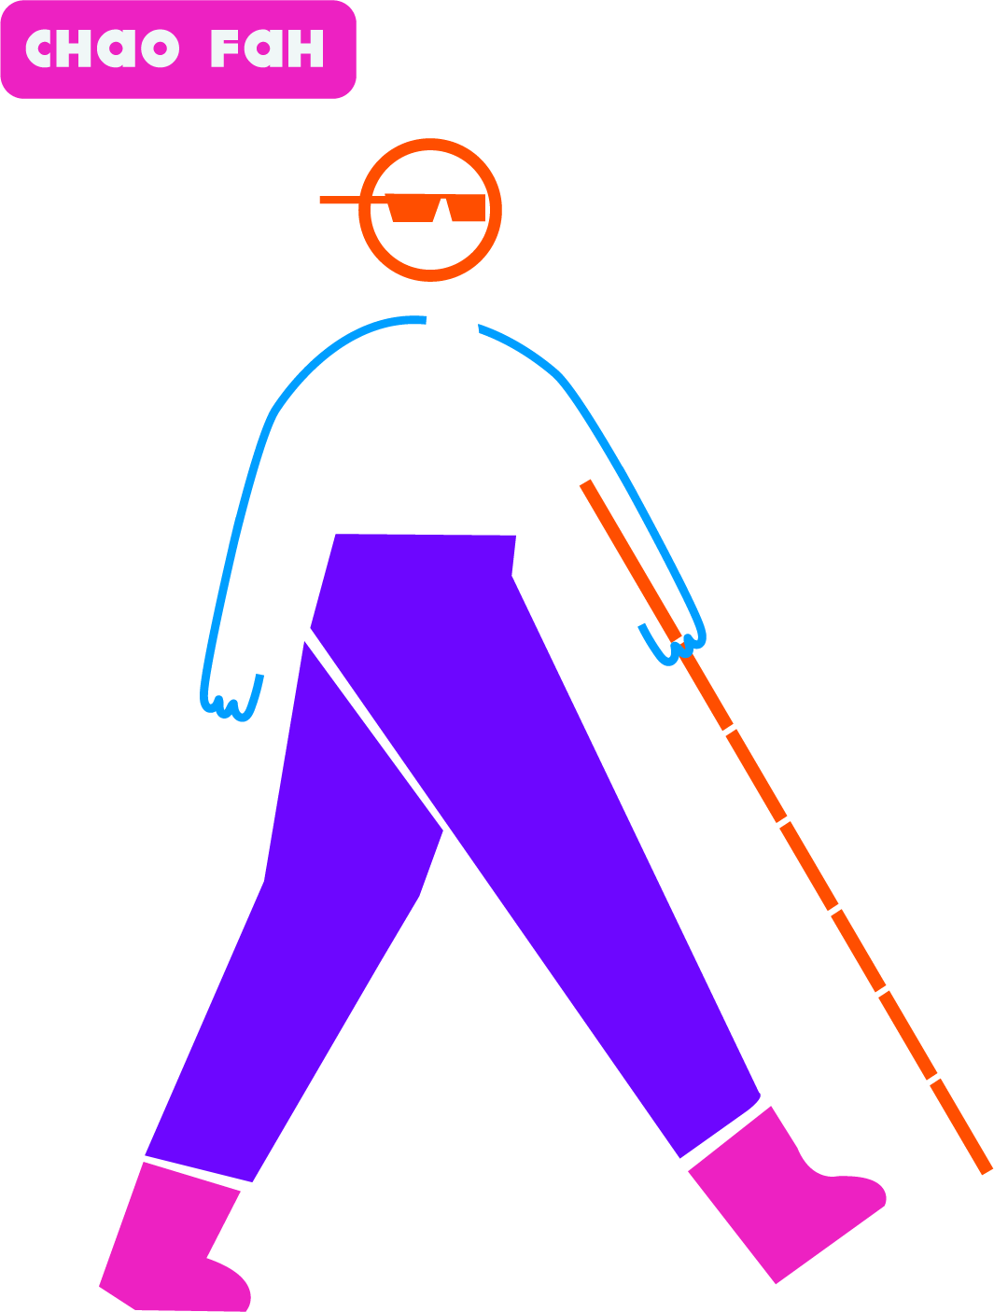

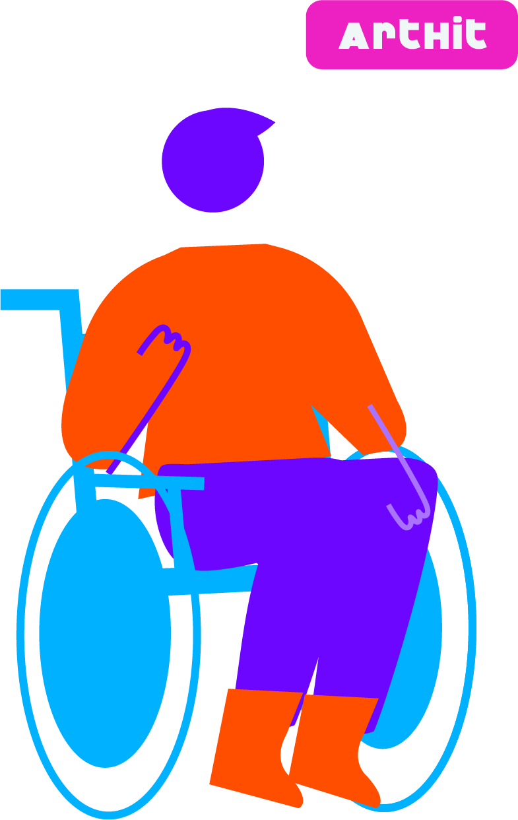

**Aminata & Julius**

Aminata married when she was 17 years old to a man much older than her. Her husband became very abusive after they had Julius – their son - who was born with an impairment. Julius uses a wheelchair. Aminata’s husband blames her for Julius’ condition. He has never let her have her own money, or study; he yells at her on a regular basis and humiliates her. They have been married for 10 years and Julius is now 7 years old. She has a good friend and neighbor who gave her the number for a helpline for domestic violence. She gave her the address to the women’s resource center where she could go to a support group meeting. Because she’s Julius only caregiver, she hasn’t been able to go to the center. Nevertheless, a month ago, her husband physically abused her and also hit Julius in the head. He threatened to kill them both. The next day, when her husband was at work, Aminata packed a bag and went to the resource center to ask for help. Unfortunately, they told her that all the shelters were full and none of them could take her with a child in a wheelchair. All they could do was give her some money for food, and connect her to legal resources. Afraid and disheartened Aminata and Julius did not return home. They were able to pay for a room for a while but are now living in the streets.

**Aminata and Julius’ day**

6:00-9:00 am - as soon as the sun comes out, Aminata and Julius wake up so they don’t get told to leave the place where they sleep. They go to the resource center every morning and they let them shower there. The guard helps her carry Julius’s wheelchair.

9:00-12:00 Aminata goes to the job center to see if there are any jobs she can do but, unfortunately, none of them allow her to take Julius and the ones available are only full-time. Other days Aminata goes to the public school to see if they accept Julius, but they won’t take them without an address.

12:00 - Aminata and Julius go to a community kitchen to eat. It’s far, and they don’t have money to take the bus.

1:00-6:00 pm - They go around different places in the city. Sometimes to a park, and sometimes they have to beg for money.

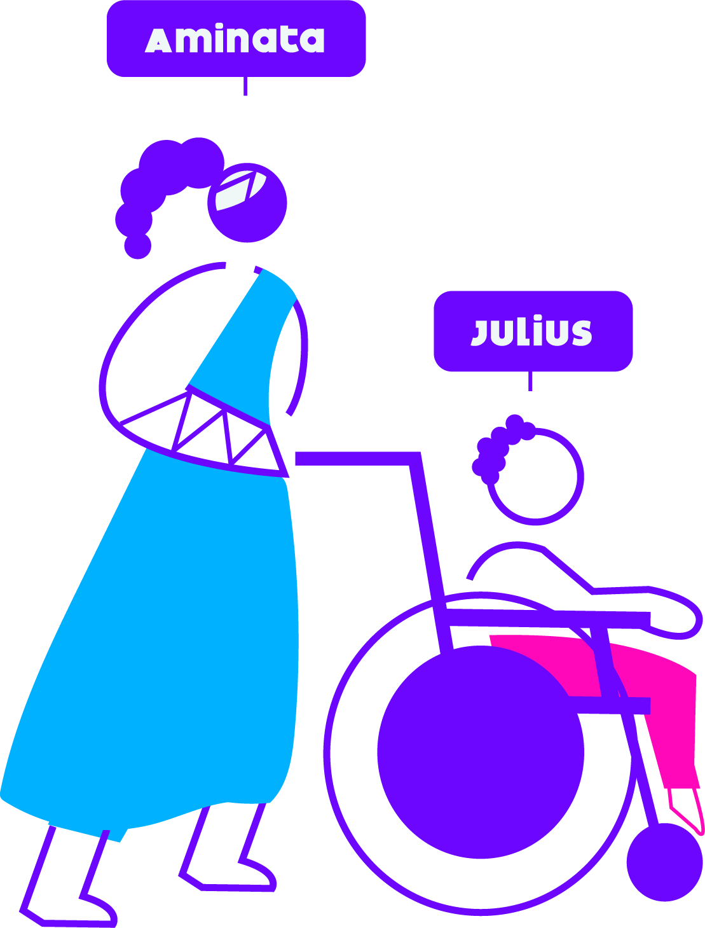

# Implementation Challenge Info Cards

| **Accessible housing** | | | |
| --- | --- | --- | --- |
| SDG 11 Icon: Sustainable Cities and Communities11.1: By 2030, ensure access for all to adequate, safe and affordable housing and basic services and upgrade slums | | | |
| Ensure that planning and construction legislation incorporates accessibility standards that apply to housing | Ensure persons with disabilities have access to public housing on an equal basis with others. | Adopt a strategy to upgrade slums while providing low-cost practical interventions to meet minimum standards of accessibility | Address homelessness of persons with disabilities, particularly by ensuring the accessibility of homeless shelters and emergency support services |
| * CRPD indicators 9.1, 9.3, 9.10, 9.11, 28.1, 28.2, 28.6, 28.7, 28.9, 28.17, 28.12, 28.14, 28.19, 13.1, 13.2, 13.4, 13.6, 13.14, 13.16, 16.15, 16.18 | | | |

| **Transportation systems inclusive of persons with disabilities** | | |
| --- | --- | --- |
| SDG 11 Icon: Sustainable Cities and Communities11.2: By 2030, provide access to safe, affordable, accessible and sustainable transport systems for all, improving road safety, notably by expanding public transport, with special attention to the needs of those in vulnerable situations, women, children, persons with disabilities and older persons | | |
| Ensure access to appropriate assistive products and technologies to facilitate individual mobility and access to transportation | Increase access to public transportation for persons with disabilities through the application of accessibility standards and measures that cover additional disability-related costs of travel | Ensure the availability of accessible point-to-point transportation and implement accessible flexible transportation lines |
| * CRPD indicators 20.1, 20.2, 20.3, 20.11, 20.12, 20.19, 20.20, 20.21, 28.1, 28.20, 28.21, 28.27, 1/4.14, 1/4.27, 19.31, 9.1, 9.2, 9.7, 9.8, 9.9, 9.18, 9.22 | | |

figure III

**Integrating individual mobility at different levels**



Accessible inter-urban and long-distance options

Accessible mass transportation

train, subway, buses, etc.

Accessible flexible line transport

combined with point-to-point transportation (paratransit, flexilines)

Point-to-point transportation

accessible taxi, disability-specific transport, adapted vehicles

Assistive technologies

including information and communication technologies

Human support

|  |  |  |  |
| --- | --- | --- | --- |
| **Inclusive public spaces** | | | |
| SDG 11 Icon: Sustainable Cities and Communities11.7: By 2030, provide universal access to safe, inclusive and accessible, green and public spaces, in particular for women and children, older persons and persons with disabilities | | | |
| Promote the accessibility of public spaces by establishing, monitoring and enforcing relevant accessibility standards | Develop a strategy to improve accessibility of public spaces that involves participation of persons with disabilities and their representative organizations | Increase the accessibility of buildings and facilities open to the public through application of accessibility standards and developing incentives to encourage accessibility improvements of small businesses in renovation processes | Collect and analyse data on the accessibility of public spaces and facilities open to the public to measure progress |
| * CRPD indicators: 9.1, 9.3, 9.17, 9.7, 9.20, 9.23 | | | |