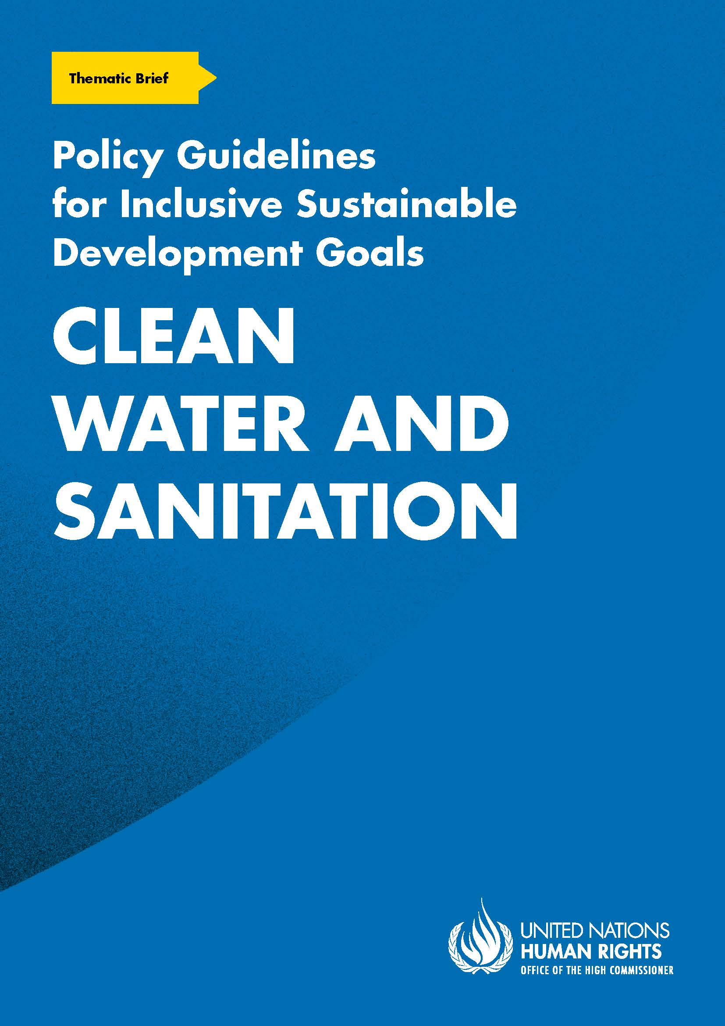
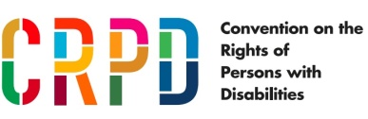
ADVANCE VERSION
© 2020 United Nations
The Policy Guidelines for Inclusive Sustainable Development Goals are a component of the SDG- CRPD Resource Package, developed by the Office of the United Nations High Commissioner for Human Rights (OHCHR). This is an advance version of the SDG-CRPD Resource Package. A final version will be issued upon completion of OHCHR review processes.
The designations employed and the presentation of the material herein do not imply the expression of any opinion whatsoever on the part of the Secretariat of the United Nations concerning the legal status of any country, territory, city or area, or of its authorities, or concerning the delimitation of its frontiers or boundaries.
Symbols of United Nations documents are composed of capital letters combined with figures. Mention of such a figure indicates a reference to a United Nations document.
Photography by Christian Tasso. The photographs featured within the Policy Guidelines were taken as part of the European Union project, Bridging the Gap II – Inclusive Policies and Services for Equal Rights of Persons with Disabilities, and were produced with the financial support of the European Union. They appear courtesy of the International and Ibero-American Foundation for Administration and Public Policies.
The Policy Guidelines for Inclusive Sustainable Development Goals were produced with the financial support of the European Union. Its contents are the sole responsibility of OHCHR and do not necessarily reflect the views of the European Union.
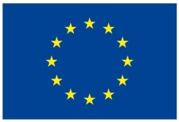
Ensure availability and sustainable management of water and sanitation for all.

Contents
1. What is the situation? 6
2. What needs to be done? 7
3. DO’s and DON’Ts 12
4. Additional Resources 16
5. Key Concepts Annex 17

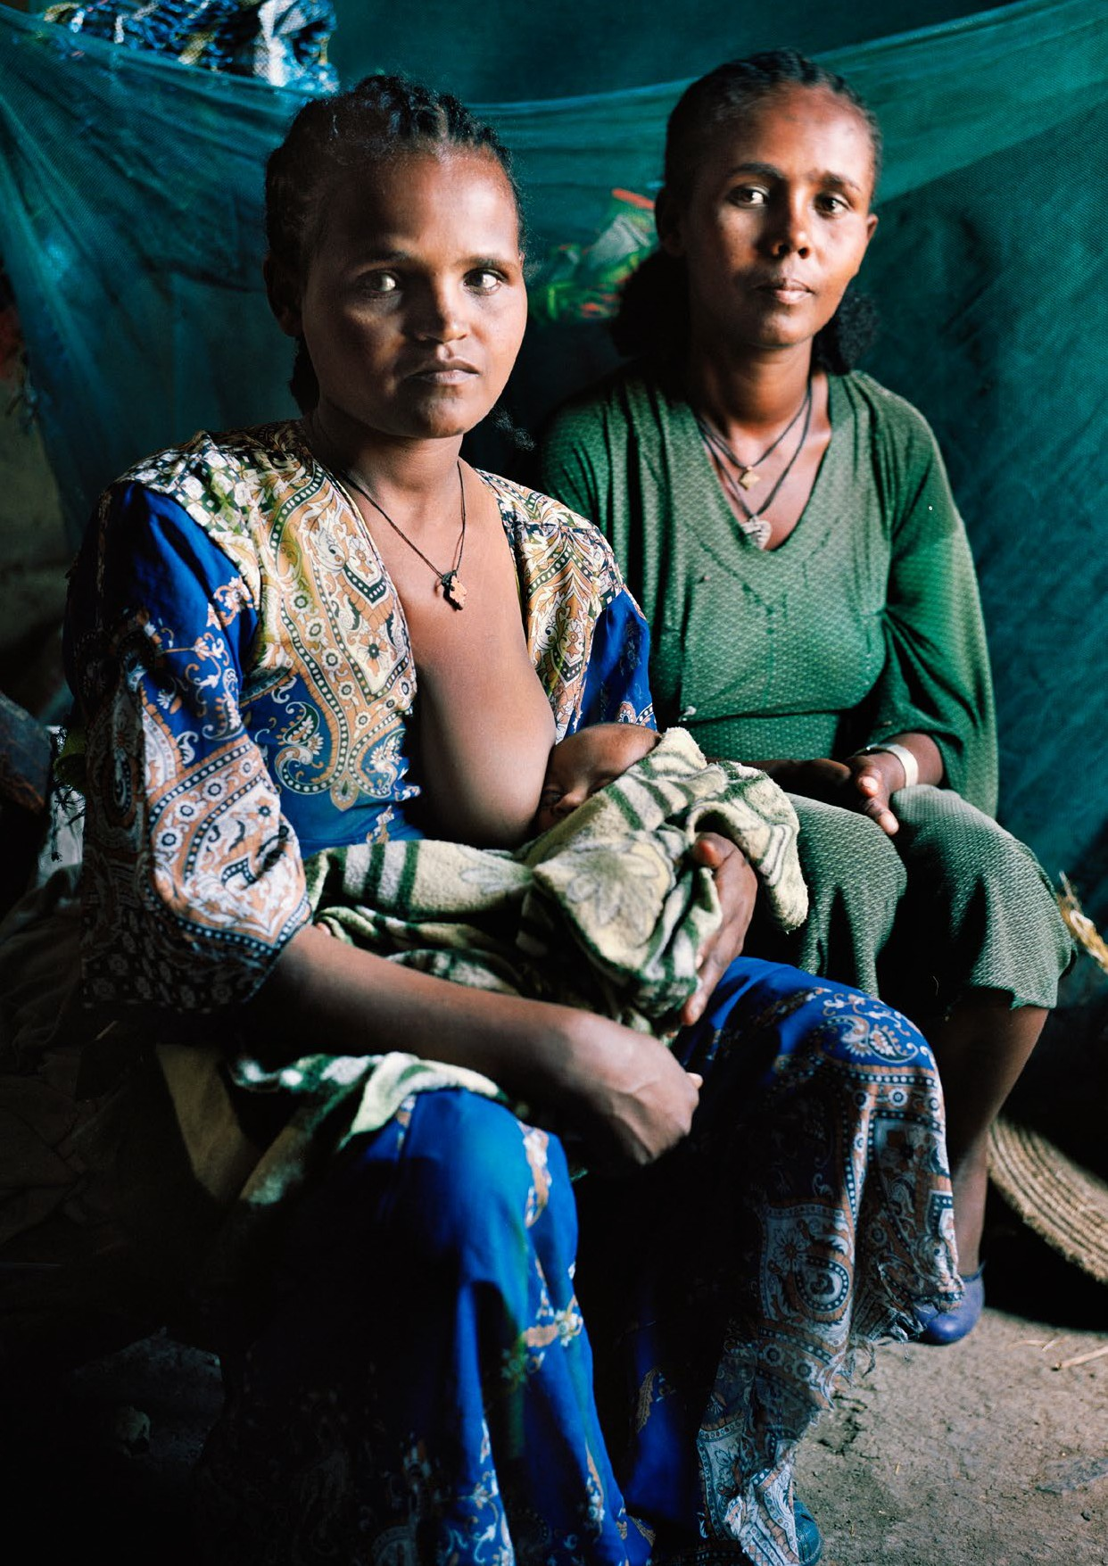

1. What is the situation?
Persons with disabilities are disproportionately affected by limited access to drinking water, sanitation and hygiene (WASH) facilities and services. While statistical data are scarce, available data demonstrate the current inequalities and barriers faced by persons with disabilities as set out in figure I.
Figure I
Selected global data on access to water, sanitation and hygiene for persons with disabilities
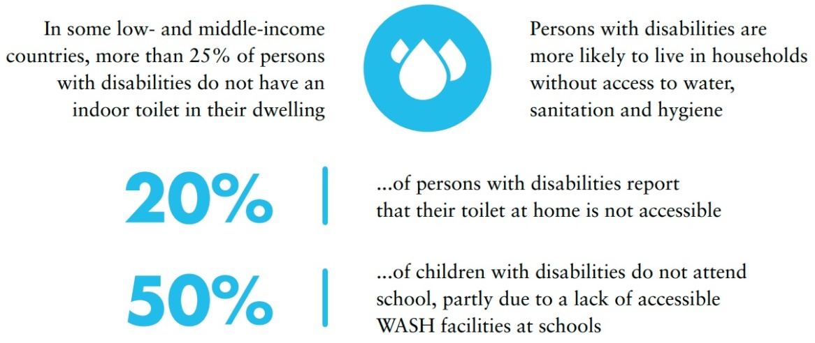
Source: United Nations Department of Economic and Social Affairs, UN Disability and Development Report – Realizing the SDG by, for and with persons with disabilities, 3 April 2019
Beyond households, persons with disabilities are often excluded from the design, delivery and use of mainstream WASH services and programmes. For example, sanitation demand creation programmes (such as Open Defecation Free campaigns) often fail to consult with persons with disabilities or to effectively respond to their requirements. There is a lack of accessible WASH facilities in public places and institutions, which prevents persons with disabilities from participating in education, employment and other areas of social life. Hygiene information is often developed without considering the hygiene management or communication requirements of all persons with disabilities.
Lack of, or limited access to, WASH carries serious consequences for persons with disabilities, especially since they already experience greater risk and increased consequences of ill health. Lack of safe and independent access to WASH at home affects the sense of dignity, privacy and confidence of persons with disabilities and renders them more dependent on family members. Persons with disabilities find themselves excluded from, or restricted in, many other areas of life (such as employment, education or recreation) due to the lack of accessible WASH facilities and services. For interventions that require universal coverage, such as ending open defecation, excluding persons with disabilities undermines their success and contributes to social exclusion.

Exclusion from WASH is caused by a range of factors or barriers, including:
- Attitudes, stigma and discrimination relating to disability and WASH – for example, the belief that persons with disabilities may contaminate shared water sources; or that persons with disabilities are incapable of contributing to WASH-planning decisions.
- Physical barriers in the design of WASH facilities, equipment and surrounding environments – for example, taps that cannot be easily reached or turned; or latrines that require a person to squat without any support.
- Inaccessible WASH communication materials and formats – for example, complex written information that is difficult to read or understand; or spoken communications provided without sign language interpretation.
- Policy and institutional factors – for example, the lack of budget allocation to implement inclusive WASH policies; lack of disability-related data to inform programming.
Women and girls with disabilities experience barriers to WASH relating to both gender and disability. Women and girls with disabilities may be expected to perform household WASH duties, even if their facilities are inaccessible. Those who care for family members with disabilities experience additional WASH challenges, such as increased labour in fetching water or performing hygiene tasks. Girls with disabilities may leave school early if dignified menstrual hygiene management facilities are inaccessible to them.

2. What needs to be done?
Access to WASH for persons with disabilities can be improved through a range of simple measures. The costs of these measures are low, as long as inclusion is built into plans early on. The benefits of inclusive WASH extend beyond persons with disabilities to all members of the community (for example, accessible hygiene information benefits persons with low literacy; accessible public toilets benefit pregnant women, older persons and persons with injuries or ill health).
Removing the barriers faced by persons with disabilities requires stakeholders within and outside the government to take coordinated action. National accessibility standards or guidelines relating to WASH infrastructure and information can guide the design of contextually adapted accessible WASH facilities in a range of private and public settings, or the retrofitting of accessibility features to existing facilities. Mainstream water and sanitation programmes can be extended to reach persons with disabilities, e.g. by incorporating accessible technology options and support mechanisms within efforts to achieve universal household sanitation coverage. Hygiene and other WASH information can be translated and delivered in accessible formats. Training and community awareness campaigns can be designed to address disability-related stigma and discrimination.
Implementing these measures requires enhanced coordination across sectors and increased resource mobilization, especially to reach those in rural and remote areas. International development and humanitarian assistance often include dedicated funds for WASH but might overlook the requirements of persons with disabilities. Disability markers can contribute to assessing inclusion and to the tracking of funds benefiting persons with disabilities.

Government administrative units with disability expertise or with disability focal points are better equipped to implement inclusive WASH policies. The involvement of individual persons with disabilities and organisations of persons with disabilities (OPDs) in policy design and implementation is essential to ensure their requirements are taken into account.

Main areas of intervention to realise Sustainable Development Goal 6
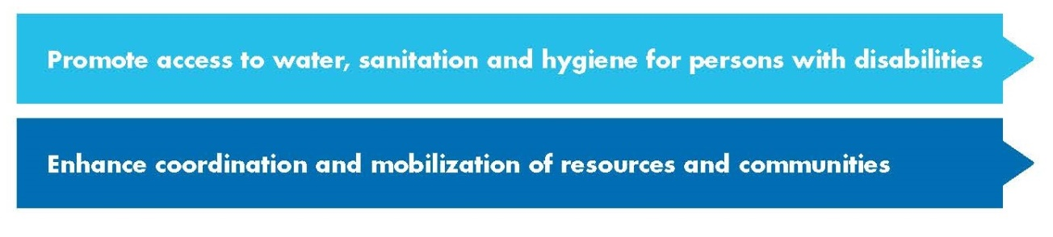

Promote access to water, sanitation and hygiene for persons with disabilities
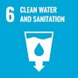 | - By 2030, achieve universal and equitable access to safe and affordable drinking water for all  - By 2030, achieve access to adequate and equitable sanitation and hygiene for all and end open defecation, paying special attention to the needs of women and girls and those in vulnerable situations
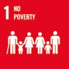 | 1.4 By 2030, ensure that all men and women, in particular the poor and the vulnerable, have equal rights to economic resources, as well as access to basic services, ownership and control over land and other forms of property, inheritance, natural resources, appropriate new technology and financial services, including microfinance
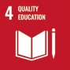 | 4.a Build and upgrade education facilities that are child, disability and gender sensitive and provide safe, non-violent, inclusive and effective learning environments for all
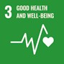 | 3.9 By 2030, substantially reduce the number of deaths and illnesses from hazardous chemicals and air, water and soil pollution and contamination
Develop WASH accessibility standards in line with universal design principles |  | - Develop and apply national accessibility standards or guidelines, based on universal design principles, that cover all aspects of WASH delivery, including water points, latrines, handwashing facilities, menstrual hygiene management facilities and hygiene information and communication  - Integrate accessible WASH standards into relevant sector codes and frameworks, including in relation to domestic construction, government offices, public spaces and buildings (e.g. markets, museums), schools and healthcare facilities
Expand the access to WASH facilities, services and supplies | - Apply accessibility standards or universal design principles to the design and location of public/institutional WASH facilities (or the retrofitting of existing facilities), including in schools, healthcare facilities and marketplaces  - Extend the access to household WASH through the promotion or provision of accessible WASH technologies, inclusive demand-creation programmes, and pro-poor or disability-specific WASH assistance mechanisms  - Support outreach services or community-based mechanisms to provide WASH support, training or personal assistance to persons with disabilities, as required (e.g. in water distribution, hygiene management supplies, hygiene information delivery)  - Expand social protection measures to cover expenses related to disability-specific hygiene management (e.g. commodes, toilet aids, bathing aids, continence management materials, related support services)
Ensure the access of persons with disabilities to hygiene and other WASH information | - Ensure that hygiene and other WASH or health promotion materials and campaigns are inclusive of, and accessible to, persons with disabilities (e.g. on basic hygiene, menstrual hygiene management or hygiene measures for disease/infection prevention)  - Ensure that hygiene education provided in mainstream schools, community health centres and others, reaches persons with disabilities and takes into account their requirements, including by providing support and age-appropriate reasonable accommodation  - Ensure hygiene education is provided in facilities attended only by persons with disabilities, where they continue to exist (e.g. residences for persons with disabilities, daycare centres or special schools)  - Deliver training for parents and caregivers on how to guide children with disabilities on hygiene self-care practices, including menstrual hygiene management and disability-specific hygiene management
Adopt awareness- raising measures to combat stigma against persons with disabilities in the use of WASH |  | - Undertake training of community health workers and other relevant public workers on the requirements of persons with disabilities to accessing WASH (accessibility, reasonable accommodation and support), to enhance their skills and challenge negative attitudes or prejudices  - Develop community-based interventions to raise awareness about the access to WASH by persons with disabilities and challenge stigma and negative practices  - Integrate awareness-raising measures into sanitation and hygiene promotion programmes to mitigate risks of harm to persons with disabilities
Related CRPD indicators: 8.2, 9.3, 9.17, 19.13, 19.24, 19.26, 19.37, 24.11, 28.2, 28.8,28.12, 28.20, 28.21

Enhance coordination and mobilization of resources and communities
6.b Support and strengthen the participation of local communities in improving water and sanitation management
6.a By 2030, expand international cooperation and capacity-building support to developing countries in water- and sanitation-related activities and programmes, including water harvesting, desalination, water efficiency, wastewater treatment, recycling and reuse technologies
Increase resource allocation and mobilization for disability-inclusive WASH policies | - Increase resource collection and allocation for inclusive WASH policies, including through taxes, duties and/or levies, international cooperation and public/private partnerships.  - Enhance resource mobilization for WASH programmes and projects, particularly to reach persons with disabilities in rural and remote areas
Ensure that international cooperation resources for WASH fund disability- inclusive and/or disability-specific WASH interventions | - Ensure that WASH-related international development and humanitarian assistance programmes include disability-inclusive and accessible WASH components, as well as associated budget allocation, including targeted interventions for persons with disabilities, where required  - Establish disability markers for international development and humanitarian assistance programmes related to WASH

Integrate policies and mechanisms on inclusive WASH in public procurement, health and community-based programmes and networks | - Include accessibility and aspects of disability inclusion (e.g. support provision and reasonable accommodation, as required) in public procurement  - Ensure coordination between WASH programmes and disability support services, including those relating to assistive technologies and rehabilitation  - Ensure the engagement of providers of support services (e.g. personal assistance) for persons with disabilities in WASH programmes at the local level
Establish processes in WASH policy design and management to include the views of persons with disabilities and technical expertise related to their requirements | - Consult with and involve organisations of persons with disabilities at the national and sub-national level in the design, implementation and monitoring of WASH policies and accessibility standards  - Consult with and involve persons with disabilities at the local level in the design, implementation and monitoring of WASH policies, including in WASH coordination committees or other steering mechanisms  - Involve sub-national government disability focal points in the design and implementation of inclusive WASH policies, including coordination among stakeholders  - Collect evidence on access to WASH by persons with disabilities, to inform policy and programming, including through research directly with persons with disabilities and collection of disability-disaggregated WASH data
Related CRPD indicators: 1/4.21, 9.17, 9.18, 28.14, 32.3 and 32.11

3. DO’s and DON’Ts
DO | DO NOT
Legislation, policy and programmes
Review WASH legislation, policies and standards to ensure the accessibility and inclusiveness of WASH infrastructure and services and protection against disability-based discrimination | Maintain legal and policy frameworks which:  - are not inclusive of persons with disabilities  - do not protect against discrimination on the basis of disability  - assume that accessible WASH infrastructure is prohibitively expensive
Adopt a twin-track approach by enhancing the inclusiveness of mainstream WASH programmes and interventions and by developing programmes targeting persons with disabilities, when necessary | Exclude persons with disabilities from mainstream WASH programmes, nor adopt practices that lead to segregated services or perpetuate stigma.
Adopt measures to ensure the access to adapted WASH technologies (e.g. accessible toilet products, easy-turn taps, tactile markers), hygiene supplies (e.g. continence management products, bedpans) and support services, as required | Focus only on inclusion in mainstream WASH programmes, while ignoring the requirements of persons with disabilities for specific assistive technologies, hygiene supplies or support services relating to WASH
Adopt measures to ensure universal household sanitation coverage programmes are inclusive and meet the requirements of persons with disabilities (e.g. by addressing awareness, availability and affordability of accessible sanitation equipment) | Maintain programmes (e.g. Open Defecation Free campaigns) which could stigmatise or cause distress for persons with disabilities, particularly where sanitation options are not available, accessible or affordable to persons with disabilities
Governance and inter-institutional coordination
Facilitate the involvement of government disability focal points and other public agencies working on disability, to engage with WASH agencies | Restrict inclusive WASH policymaking exclusively to WASH or disability-related technical departments

DO | DO NOT
Adopt measures to require accessibility from WASH-related contractors throughout supply chains (e.g. in public procurement) | Engage with other relevant public and private actors for the implementation of WASH policies (e.g. constructors, drinking water service providers) without introducing mandatory accessibility requirements
Coordinate, share information and establish referral links among WASH agencies and other public agencies delivering services to persons with disabilities (e.g. in health, assistive devices or social services) | Assume that the WASH-related requirements of persons with disabilities can be met by WASH or disability services alone
Allocate a budget for disability-inclusive WASH within the budgets of relevant public agencies (e.g. education departments/schools, health departments/healthcare facilities) | Expect budget allocations to disability-specific agencies or services to also cover costs of mainstreaming disability-inclusive WASH across other sectors or agencies
Practice and implementation
Facilitate accessibility audits or other consultative processes with persons with disabilities at the local level, to support the application of accessible WASH standards to local contexts | Apply standard accessible technical designs to all WASH facilities without first testing to ensure appropriateness for local user groups and adapting designs as necessary
Apply mandatory accessible WASH requirements for new construction (e.g. quotas for accessible toilets in new schools, apartment buildings, public places) | Rely on accessibility standards to be adopted voluntarily
Integrate disability-inclusive WASH actions and standards into the performance and quality frameworks of education, health and other sectors, in line with national standards | Maintain parallel WASH implementation and monitoring frameworks across different sectors that do not incorporate accessibility standards
Promote the involvement of persons with disabilities in WASH decision-making forums, such as local committees or stakeholder groups | Assume that persons with disabilities do not have relevant contributions to add to WASH decision-making forums

DO | DO NOT
Ensure the availability and affordability of accessible WASH equipment and supplies, including through market-based mechanisms (e.g. cost subsidies, research and development grants, competitions) or social assistance programmes | Overlook the availability and affordability of accessible WASH equipment and supplies to persons with disabilities, particularly those living in rural areas or lower-income households
Ensure that WASH programmes consider the requirements of diverse persons with disabilities, including across different genders and types of disability | Restrict disability-inclusive WASH efforts to only one population segment (e.g. persons with limited mobility)
Information, communication and awareness-raising
Disseminate hygiene information to persons with disabilities in accessible formats, across urban and rural areas, including by working with disability networks and including persons with disabilities wherever hygiene information is provided (e.g. schools) | Assume that persons with disabilities are accessing hygiene information from mainstream campaigns or the school system
Disseminate hygiene information that is adapted to meet disability-specific hygiene management requirements (e.g. covering accessible handwashing, bathing and menstrual hygiene management equipment, sanitising assistive devices, continence management and strategies for persons providing personal hygiene support) | Assume that mainstream/standard hygiene information will be relevant to all persons with disabilities
Adopt awareness-raising measures (campaigns, training, etc.) to address attitudinal barriers, stigma and discrimination against persons with disabilities in designing and accessing WASH services. | Overlook existing negative stereotypes, prejudice and discrimination against persons with disabilities in accessing WASH services when designing and implementing policy interventions
Training
Train and provide technical support to public officials across relevant agencies (e.g. health, education, local government) on disability- inclusive WASH and working with persons with disabilities | Provide training or technical support on disability-inclusive WASH exclusively to public officials working in disability-focused agencies or programmes

DO | DO NOT
Participation
Facilitate the involvement of OPDs, in all their diversity, in legislation, policy design and development and outreach mechanisms | Overlook the key inputs and support that OPDs can provide to ensure the effectiveness of policies
Support the capacity of OPDs to analyse and engage on WASH issues, in line with their organizational priorities | Expect all OPDs to have technical expertise on disability-inclusive WASH
Research and data collection and disaggregation
Collect and disaggregate data by sex and disability at the household and individual level, in order to assess individual access to WASH by persons with disabilities | Assume that household-level data suffice in assessing access to WASH by persons with disabilities, nor that they indicate that all members of a household have access to a WASH facility (e.g. household WASH facilities might not be accessible to persons with disabilities or persons with disabilities may lack assistive devices to facilitate their use)
Facilitate research or consultation with individual persons with disabilities and OPDs to understand their experiences of accessing WASH, including barriers that limit access and strategies that enable access | Facilitate research that overlooks the specific experiences of persons with disabilities, or that fails to generate evidence to inform effective strategies for including persons with disabilities in WASH
Accountability
Monitor and report the availability of accessible WASH facilities to persons with disabilities within households, schools, healthcare facilities and other public places (e.g. by using the expanded UNICEF/WHO Joint Monitoring Programme survey questions) | Overlook inequalities in access to WASH by persons with disabilities within WASH monitoring and reporting frameworks

4. Additional Resources

Disability-inclusive WASH programming
Pryor, Wesley and others. The Case for Investment in Accessible and Inclusive WASH. WASH Technical Paper. TP/04/2018 (New York: UNICEF, 2018).
United Nations Children’s Fund. Guidance note: Disability Inclusive WASH Practices – Including people with disabilities in UNICEF Water, Sanitation and Hygiene (WASH) Programming (New York, 2016).

Disability-inclusive WASH in humanitarian settings
IASC Task Team on inclusion of Persons with Disabilities in Humanitarian Action. Guidelines: Inclusion of Persons with Disabilities in Humanitarian Action. chap.18, Water, Sanitation and Hygiene (Inter-Agency Standing Committee, 2019).
United Nations Children’s Fund. Guidance: Including Children with Disabilities in Humanitarian Action – WASH (2017).

Disability-inclusive WASH in COVID-19 response
World Health Organization. Disability Considerations during the COVID-19 Outbreak (2020).

5. Key Concepts Annex
Below are key foundational concepts referred to throughout the Policy Guidelines for Inclusive Sustainable Development Goals (SDG). The guide below is designed as a quick reference and refresher for readers as they use the guidelines. It is recommended that the guideline “Foundations for inclusive Sustainable Development Goal Implementation: Key concepts and structural requirements” is read prior to, or together with, other guidelines, for a deeper understanding of the required foundations for inclusion.

Concepts
Ableism considers certain typical characteristics of body and mind as essential for living a life of value. Ableist perspectives view impairments as undesired, which leads to unconscious bias, prejudice, discrimination and exclusion. Ableism is usually behind negative perceptions and stereotypes about persons with disabilities. See also Foundations Guideline, section 1.3
Accessibility is the quality that allows persons with disabilities to access and enjoy physical environments, transportation, facilities, services, information and communications, including new technologies and systems. When planning for accessibility, the principles of universal design should be used. See also Foundations Guideline, section 2.2.
Assistive technology, devices and mobility aids are external products (devices, equipment, instruments, software), specially produced or generally available, that maintain or improve an individual’s functioning and independence, participation, or overall well-being. Examples of assistive devices and technologies include wheelchairs, prostheses, hearing aids, visual aids and specialized computer software and hardware that improve mobility, hearing, vision, or the capacity to communicate. See also Foundations Guideline, section 2.3.
Awareness-raising actions are those that aim at informing about rights and changing negative attitudes towards persons with disabilities. They include training, campaigns, mass-media communications and more. Awareness-raising activities should target persons with disabilities and others and should involve persons with disabilities in their design and delivery. See also Foundations Guideline, section 2.5.
Barriers: Disability results from the interaction between persons with impairments and the barriers in the environment around them. Barriers can be broadly categorised into the following:
- Environmental barriers: those that are imposed by the context. They can be sub-categorized as:
- Physical barriers: such as the presence of steps, preventing access for someone using a wheelchair, or others with mobility difficulties.
- Communication barriers: such as the barriers to participation for a sign language user in a meeting if sign language interpreters are not provided, or the barrier to accessing information experienced by blind persons with written text, if accessible formats are not provided.
- Policy barriers: such as educational systems that prevent the enrolment of children with disabilities in their local school.
- Attitudinal barriers: such as the belief that persons with disabilities cannot learn or work. Attitudinal barriers can lead to apathy or inertia towards addressing other barriers. Attitudinal barriers can lead to apathy or inertia towards addressing other barriers.
In order for persons with disabilities to fully participate and access opportunities for development, the barriers that limit their participation should be systematically addressed. Persons with disabilities themselves are experts on identifying barriers and the solutions to overcome them. See also Foundations Guideline, section 1.1.
Disability assessment is the process of collecting information about persons with disabilities, in their context, for the purposes of policymaking and planning, budget allocation and to determine eligibility to certain benefits and entitlements. A disability assessment can also be used solely for the purpose of providing services such as rehabilitation or education. See also Foundations Guideline, section 3.2.2 and Policy Guideline on SDG 1.
Disability determination refers to the official decision (using assessment findings) about whether someone is identified as a person with disability, often also categorized according to their functional ability. In some countries, this can become an official status, symbolised by a disability card, registration, or similar, which can provide access to various services and benefits. There are often additional and/or different processes to determine eligibility for different types of social protection, insurance, health and support services. See also Foundations Guideline, section 3.2.2 and Policy Guideline on SDG 1.
Disability discrimination is described in the Convention on the Rights of Persons with Disabilities (Article 2) as “any distinction, exclusion or restriction on the basis of disability which has the purpose or effect of impairing or nullifying the recognition, enjoyment or exercise, on an equal basis with others, of all human rights and fundamental freedoms in the political, economic, social, cultural, civil or any other field. It includes all forms of discrimination, including denial of reasonable accommodation.” See also Foundations Guideline, section 2.1.
Disability mainstreaming is the process of ensuring that the rights of persons with disabilities are embedded in all policy, assessing policy implications for persons with disabilities, and ensuring their meaningful participation. It is the way of making the concerns and experiences of persons with disabilities an integral dimension of the design, implementation, monitoring and evaluation of policies and programmes in all political, economic and societal spheres so that persons with disabilities have equal benefits, and inequality is not perpetuated. The ultimate goal is to achieve equality of outcomes and foster an inclusive culture. Disability mainstreaming should be combined with disability-specific actions (see Twin-Track Approach). See also Foundations Guideline, section 3.2.1.
Extra-cost of disability refers to the higher expenditure of persons with disabilities and their households, when compared to the rest of the population. Extra-costs commonly stem from specific goods and services (e.g. mobility aids, personal assistance, accessible housing) and/or lack of access to general goods and services (e.g. more expensive health insurance, using taxis where public transport is not accessible). Disability extra-costs affect different policies. For more information, access the Centre for Inclusive Policy’s videos, “Understanding disability extra costs” and “Addressing disability extra costs”. See also Policy Guideline on SDG 1.
International cooperation is the interaction of persons or groups of persons representing various nations and diverse international and regional organisations striving towards the common goal of realizing the rights of persons with disabilities and the Convention on the Rights of Persons with Disabilities. Persons with disabilities, the organisations that represent them, and policymakers, collaborate through their ministries of international affairs, to receive technical and financial support from international organisations and development banks. Financial support designated for international cooperation shall not be used for measures contrary to the Convention on the Rights of Persons with Disabilities and shall be planned to be substituted with national funds, to ensure policy continuation. Technical cooperation among countries with similar realities is important to identify effective solutions. See also Foundations Guideline, section 8.
Intersectional discrimination refers to situations where discrimination is occurring on the basis of multiple and intersecting factors, including sex, gender, ethnicity, age, caste, class, faith, sexual orientation or any other characteristic. Persons with disabilities also have a gender identity, may come from an indigenous group, be young, old, a refugee or living in poverty. See also Foundations Guideline, section 5.3.
Legal capacity is the right to autonomously make legally valid decisions. Some countries restrict the right for adults with disabilities to manage their own financial affairs, including ownership of property, choose where to live and work, and manage their relationships, health and wellbeing. Restricting or denying this right is against the Convention on the Rights of Persons with Disabilities and has negative effects across all policies. See also Foundations Guideline, section 5.5.
Organisations of persons with disabilities are led, directed, and governed by persons with disabilities. They are established at the local, national, regional or international level to promote and/ or defend the rights of persons with disabilities. A clear majority of the membership of such organisations should be recruited among persons with disabilities themselves. See also Foundations Guideline, section 2.4.
Participation of persons with disabilities refers to the action of allowing and enabling persons with disabilities to take part directly, or through organizations of persons with disabilities, in decision- making processes, including the design, implementation, monitoring and evaluation of policies. To do this, persons with disabilities should be closely consulted and actively involved in all decision-making processes, by being invited to give their opinions and take part in implementation processes.
Participation is an obligation to be met under the Convention on the Rights of Persons with Disabilities for all aspects of policy. “Nothing about us, without us” is the motto that promotes this obligation, and it means that no policy should be developed or implemented without persons with disabilities. See also Foundations Guideline, sections 2.4 and 4.
Persons with disabilities include those who have long-term physical, psychosocial, intellectual or sensory impairments which, in interaction with various barriers, may hinder their full and effective participation in society on an equal basis with others. Hence, persons with disabilities are persons with impairments who experience barriers that restrict their participation. See also Foundations Guideline, section 1.2.
Reasonable accommodation refers to modifications or adjustments made for a person with disability who requires them in a particular case, to facilitate participation on an equal basis with others. Reasonable accommodation must be provided on demand - that is, entities responsible for providing it cannot deny it by saying that they are progressively implementing measures. If arbitrarily denied, this constitutes discrimination.
Some examples include adjustments to the school hours of a student, extended breaks to rest, acquisition of computer software to read screens, a foldable ramp to overcome step(s) or providing a sign language interpreter in a work meeting. See also Foundations Guideline, sections 2.1 and 5.2.
Support for persons with disabilities encompasses a wide range of formal and informal interventions, including live assistance and intermediaries, mobility aids and assistive devices and technologies. It also includes personal assistance; support in decision-making; communication support, such as sign language interpreters and alternative and augmentative communication; mobility support, such as assistive technology or service animals; living arrangements services for securing housing and household help; and community services. Persons with disabilities may require support to perform daily life activities and/or use general services, such as health, education and justice, on an equal basis with others. See also Foundations Guideline, section 2.3.
Supported decision-making is a type of support given to persons with disabilities in relation to legal decisions. This mechanism guarantees that: (i) persons with disabilities exercise their legal capacity (see above) and can make their own decisions in every aspect of life; and (ii) their decisions are not replaced by the decisions of guardians or others. Supported decision-making is voluntary and can include informal and formal support arrangements. For example, a person with disability may choose a trusted person to support them in making certain types of legal decisions. They may also resort to peer support or self-advocacy networks. Some persons with disabilities may access support to help in the communication of their will and preference. See also Foundations Guideline, section 5.5.
Twin track approach is a strategy to develop policies that:
- systematically mainstreams the interests and rights of persons with disabilities in policy design and implementation, across all sectors and areas of life
- adopts targeted policy and programming measures aimed specifically at persons with disabilities
The balance between mainstreaming strategies and targeted support strategies should be tailored to address the needs of specific communities. See also Foundations Guideline, section 3.2.1.
Universal design is the design and composition of products, environments, programmes and services so that they can be accessed, understood and used to the greatest extent possible by all people, regardless of their age, size, ability or disability, and without the need for adaptation or specialized design. The principles of universal design facilitate accessibility, including for persons with disabilities. See also Foundations Guideline, section 2.2.
The Washington Group Short Set is a set of six questions on functioning, designed to be used within national censuses and surveys. The questions are designed to provide comparable data cross- nationally, for populations living in a variety of cultures, with varying economic resources. While not exhaustive, the basic actions represented in this set of six questions are those that are most often found to limit an individual, and result in participation restrictions. The information that results from the use of these questions will (a) represent the majority of, but not all, persons with limitation in basic actions, (b) represent the most commonly occurring limitations in basic actions, and (c) be able to capture persons with similar difficulties across countries. See also Foundations Guideline, section 3.5.
Office of the United Nations
High Commissioner for Human Rights (OHCHR)
Palais de Nations
CH 1211 Geneva 10 – Switzerland
Email: disability@ohchr.org
Website: www.ohchr.org

