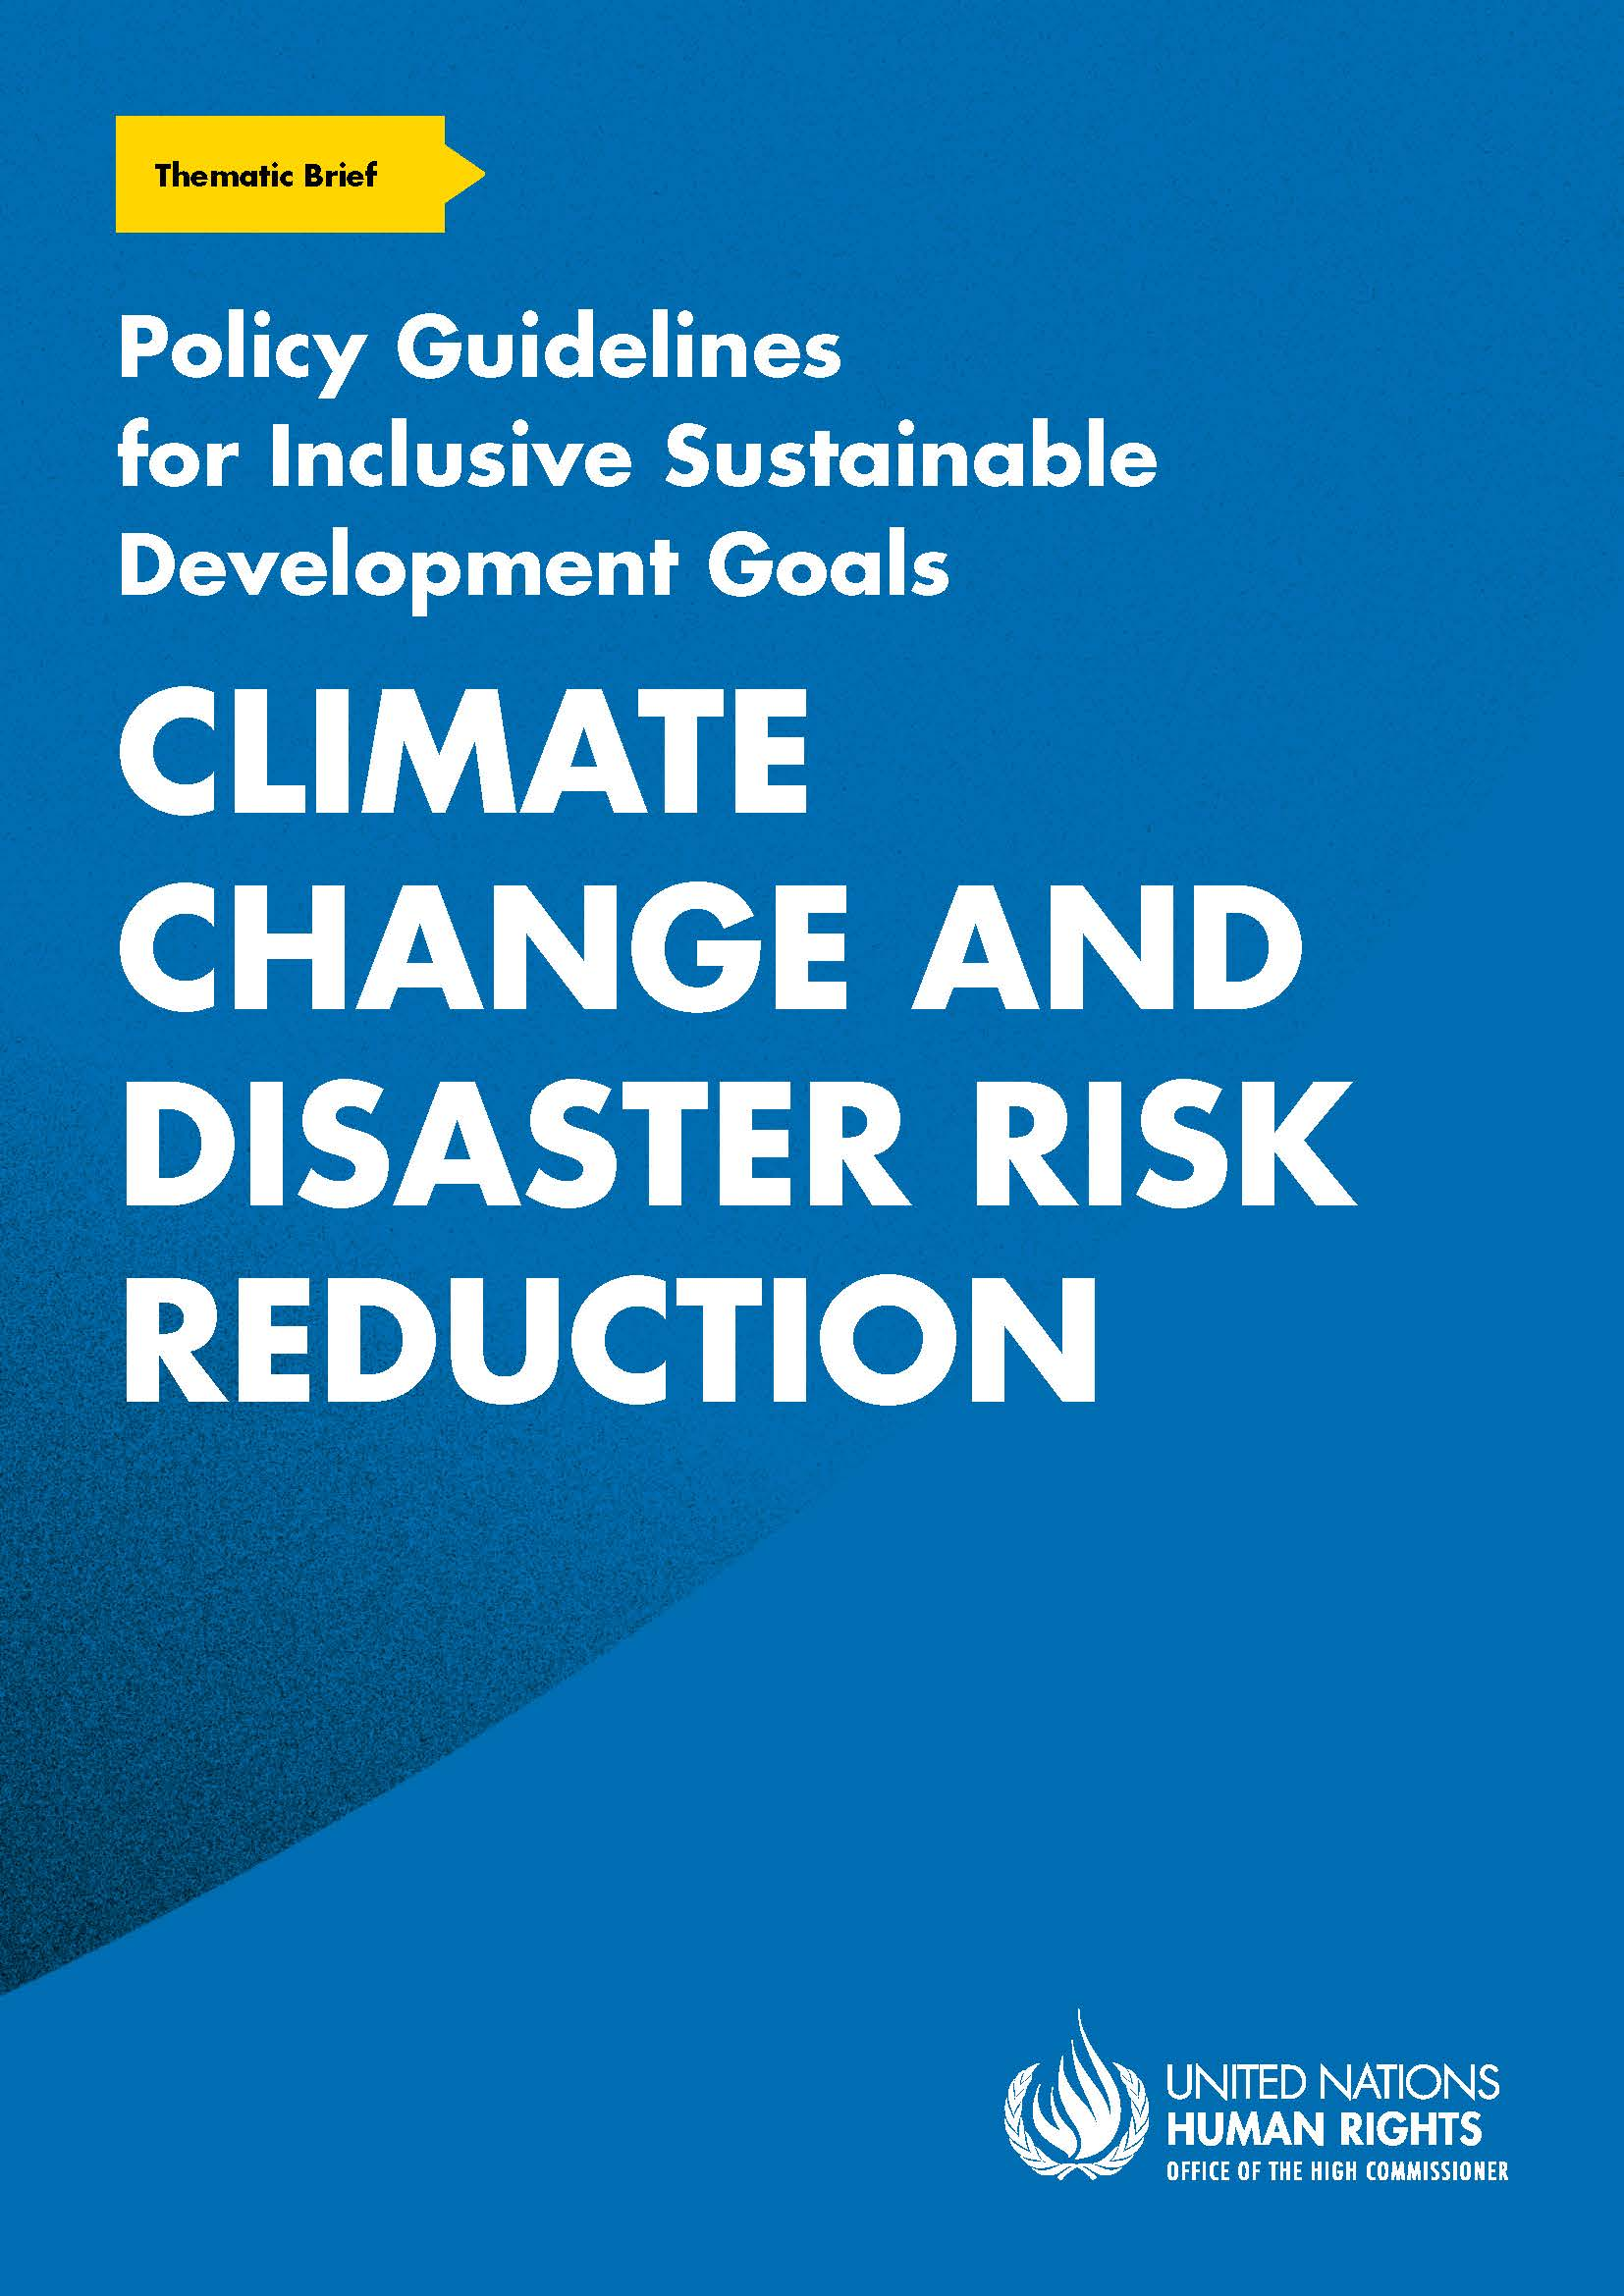
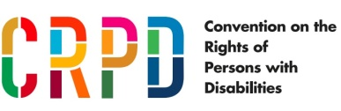
ADVANCE VERSION
© 2020 United Nations
The Policy Guidelines for Inclusive Sustainable Development Goals are a component of the SDG- CRPD Resource Package, developed by the Office of the United Nations High Commissioner for Human Rights (OHCHR). This is an advance version of the SDG-CRPD Resource Package. A final version will be issued upon completion of OHCHR review processes.
The designations employed and the presentation of the material herein do not imply the expression of any opinion whatsoever on the part of the Secretariat of the United Nations concerning the legal status of any country, territory, city or area, or of its authorities, or concerning the delimitation of its frontiers or boundaries.
Symbols of United Nations documents are composed of capital letters combined with figures. Mention of such a figure indicates a reference to a United Nations document.
Photography by Christian Tasso. The photographs featured within the Policy Guidelines were taken as part of the European Union project, Bridging the Gap II – Inclusive Policies and Services for Equal Rights of Persons with Disabilities, and were produced with the financial support of the European Union. They appear courtesy of the International and Ibero-American Foundation for Administration and Public Policies.
The Policy Guidelines for Inclusive Sustainable Development Goals were produced with the financial support of the European Union. Its contents are the sole responsibility of OHCHR and do not necessarily reflect the views of the European Union.
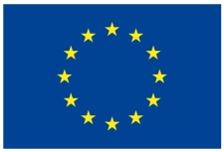
Take urgent action to combat climate change and its impacts.

Contents
1. What is the situation? 6
2. What needs to be done? 7
3. DO’s and DON’Ts 14
4. Additional Resources 19
5. Key Concepts Annex 20

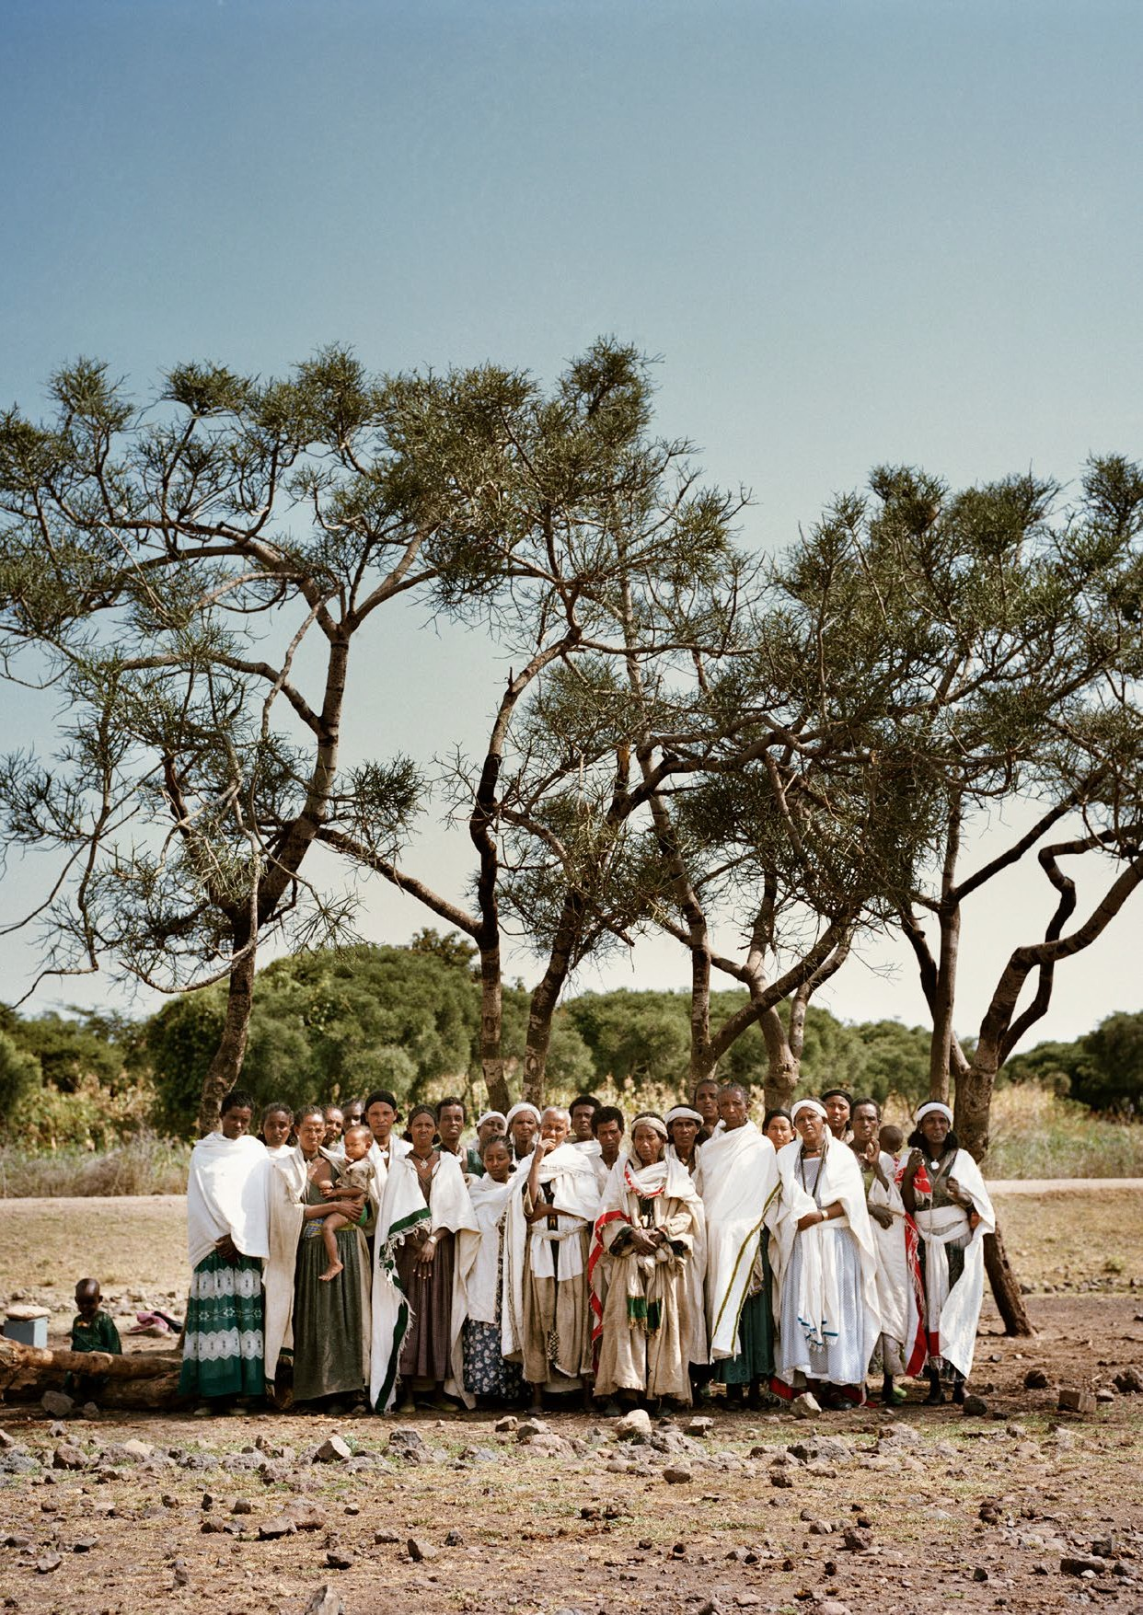

1. What is the situation?
Persons with disabilities are amongst the groups most at risk of climate-related hazards and disasters, yet they continue to be neglected in policies, planning and coordination across preparedness, response and recovery. They are largely excluded from climate adaptation and mitigation decision- making and efforts, which can build individual and community resilience. Moreover, emergency responders and humanitarian actors are generally unaware of the heightened vulnerability of persons with disabilities and of how to meet their requirements.
The charts presented in figures I, II and III, below, from the United Nations International Strategy for Disaster Reduction (2014), illustrate the lack of participation of persons with disabilities in key decision-making and community preparedness measures.
Figure I
Community disaster management processes: Participation by persons with disabilities
Source: United Nations International Strategy for Disaster Reduction, Living with Disability and Disasters: UNISDR 2013 Survey on living with disabilities and disasters - key findings (2014).
Figure II
Awareness of disaster management plans in own city/ town/community by persons with disabilities
Source: United Nations International Strategy for Disaster Reduction, Living with Disability and Disasters: UNISDR 2013 Survey on living with disabilities and disasters - key findings (2014).
Furthermore, evacuation rates are generally lower for households which include members with disabilities, compared to other households, and less than half of emergency and disaster relief sites are accessible for persons with disabilities. As a result, death rates during disasters may be higher among persons with disabilities. For example, the death rate among persons with disabilities was twice the death rate of the rest of the population during the 2011 earthquake and tsunami in Japan.
Figure III
Perception of ability to evacuate, in the event of a disaster, of persons with disabilities
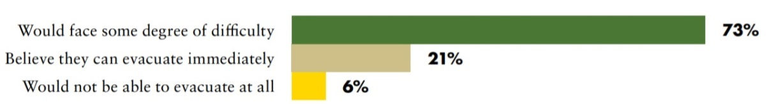
Source: United Nations International Strategy for Disaster Reduction, Living with Disability and Disasters: UNISDR 2013 Survey on living with disabilities and disasters - key findings (2014).
Physical, communicational, attitudinal and institutional barriers impede the recovery of persons with disabilities. Destroyed infrastructure and services, including schools, hospitals, roads and transportation, may re-emerge in an ad-hoc manner but not be accessible. A lack of focus on the accessibility of humanitarian assistance; limited opportunities for economic development, livelihood and skills training; loss of supports and assistive devices - all contribute to further marginalise persons with disabilities and make them less resilient to the impacts of disasters and climate change.
Education and information about climate change and disaster risk reduction vary across the world and climate change continues to be subject to scepticism and misconceptions, by both government sectors and the wider public. There is a lack of accessible information and training for children and adults with disabilities concerning climate action, generally, and to plans and protocols applicable to them in the event of climate-related hazards and emergencies, in particular.
Low- and middle-income countries are most at risk and disproportionately impacted by climate change; their economies are more dependent on agriculture and climate-sensitive sectors, they have less capital to invest in adaptation and recovery measures, and their generally warmer climates render them more exposed to extreme weather events. Persons with disabilities are overrepresented in low- and middle-income countries and are commonly not counted within research, programming, resource allocation and data collection, nor do they participate in decision-making related to international cooperation aimed at strengthening resilience and sustainability. Climate change impacts the effective enjoyment of the human rights of persons with disabilities, including the rights to life, health, food, water and sanitation, housing and decent work.

2. What needs to be done?
Response to climate-related hazards and disasters, and mitigation of their impact, requires cross- sector engagement. Achievement of the Sustainable Development Goals requires interventions beyond emergency response, to improve resilience among communities, including poverty reduction strategies, economic development measures to promote sustainable communities, infrastructure to reduce risk in cities, and the active involvement of persons with disabilities to address existing barriers and avoid the creation of new ones. Furthermore, when recovering from disasters, the principle of building back better should guide the work, improving existing conditions without creating new barriers.

Main areas of intervention
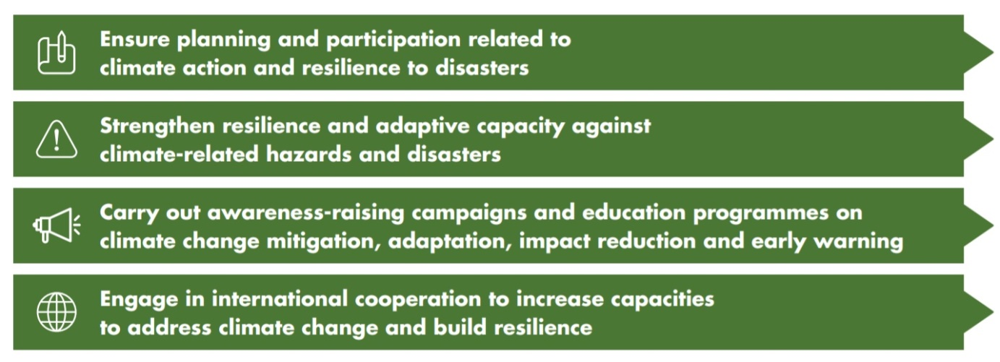

Ensure planning and participation related to climate action and resilience to disasters

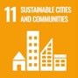 | 11.5 By 2030, significantly reduce the number of deaths and the number of people affected and substantially decrease the direct economic losses relative to global gross domestic product caused by disasters, including water-related disasters, with a focus on protecting the poor and people in vulnerable situations  11.b By 2020, substantially increase the number of cities and human settlements adopting and implementing integrated policies and plans towards inclusion, resource efficiency, mitigation and adaptation to climate change, resilience to disasters, and develop and implement, in line with the Sendai Framework for Disaster Risk Reduction 2015-2030, holistic disaster risk management at all levels
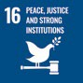 | 16.7 Ensure responsive, inclusive, participatory and representative decision-making at all levels
Ensure disability inclusion across all policies/ strategies related to climate action and disaster risk reduction |  | All actions and efforts should be inclusive of persons with disabilities, in all their diversity (mainstreaming), with targeted strategies (disability–specific) to:  - identify the barriers that persons with disabilities, including women and girls with disabilities, face  - assess their requirements  - map the availability of resources to meet requirements  - carry out impact assessments for improved planning and policymaking related to preparedness and emergency response, reconstruction, and the just transition to a low carbon economy
Ensure the inclusion and participation of persons with disabilities in all decision-making related to climate action and resilience to disasters |  | Persons with disabilities and their representative organizations should participate in all related decision-making, including:  - consultations  - design, monitoring and evaluation of programs/policies  - awareness-raising and education  - research and data collection  - resource mobilization
CRPD related indicators: 11.1-7, 11.19, 11.20, 11.21
Strengthen resilience and adaptive capacity against climate-related hazards and disasters

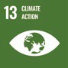 | 13.1 Strengthen resilience and adaptive capacity to climate-related hazards and natural disasters in all countries
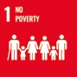 | 1.5 By 2030, build the resilience of the poor and those in vulnerable situations and reduce their exposure and vulnerability to climate-related extreme events and other economic, social and environmental shocks and disasters
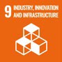 | 9.4 By 2030, upgrade infrastructure and retrofit industries to make them sustainable, with increased resource-use efficiency and greater adoption of clean and environmentally sound technologies and industrial processes, with all countries taking action in accordance with their respective capabilities
 | 16.b Promote and enforce non-discriminatory laws and policies for sustainable development
Ensure inclusive social protection |  | Establish social protection systems inclusive of persons with disabilities that are compatible with their right to work and employment, and which:  - support building household resilience  - are flexible and adaptable to emergencies and humanitarian situations  - are coordinated with humanitarian interventions to provide more effective, efficient and sustainable responses to persons with disabilities  - promote sustainable consumption and production patterns and guard against the loss of income, livelihood and supports linked to disasters, and the just transition to greener economies
Support livelihoods and just  transition to a low carbon  economy |  | Remove physical, communicational, legal and attitudinal barriers for persons with disabilities to access workplaces, business and financial services, technology, land and labour mobility  Ensure accessible and inclusive vocational and job training to ensure that persons with disabilities (particularly women and girls with disabilities) benefit from skills development in new and emerging low carbon sectors

Invest in sustainable infrastructure and services and remove barriers for persons with disabilities | Identify and increase the numbers of accessible infrastructure and services at all phases of emergencies: mitigation, preparedness, response and recovery.  Ensure the accessibility of information and communications to ensure that persons with disabilities can access public services, including health, shelter, education, survivor assistance and access to justice.  Reform laws, policies and practices which deny or limit access, on an equal basis with others, to persons with disabilities (particularly women with disabilities) to own land, engage in financial transactions, sign contracts, benefit from social protection programmes, etc.
CRPD related indicators: 11.16, 11.26, 28.3, 28.4, 28.5, 28.6, 28.7, 28.8, 28.9

Carry out awareness-raising campaigns and education programmes on climate change mitigation, adaptation, impact reduction and early warning

 | 13.3 Improve education, awareness-raising and human and institutional capacity on climate change mitigation, adaptation, impact reduction and early warning
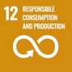 | 12.8 By 2030, ensure that people everywhere have the relevant information and awareness for sustainable development and lifestyles in harmony with nature
 | 16.10 Ensure public access to information and protect fundamental freedoms, in accordance with national legislation and international agreements
Accessible and inclusive information and campaigns |  | Ensure that all information and campaigns about climate action, disaster risk reduction and emergency management are available and disseminated in accessible formats and languages  Ensure that awareness-raising campaigns and information on climate action and disasters give visibility to the specific risks faced by persons with disabilities
Training and education |  | Integrate accessible learning about climate change and disasters into curricula for students and teachers, within the national education system and non-formal learning spaces.
Capacity building for climate and humanitarian actors, and for persons with disabilities and their representative organizations |  | Ensure systematic training of urban planners, emergency responders, humanitarian actors and development partners on how to meet the requirements of persons with disabilities in all phases of emergencies.  Ensure training to empower persons with disabilities, in all their diversity, to engage in climate action and disaster preparedness. Specifically include women and girls, older persons, youth, indigenous persons, migrants, persons living in rural areas and their representative organisations.
CRPD related indicators: 11.6, 11.9, 11.19, 8.6, 9.18, 32.12

Engage in international cooperation to increase capacities to address climate change and build resilience

  - Implement the commitment undertaken by developed-country parties to the United Nations Framework Convention on Climate Change to a goal of mobilizing jointly $100 billion annually by 2020 from all sources to address the needs of developing countries in the context of meaningful mitigation actions and transparency on implementation and fully operationalize the Green Climate Fund through its capitalization as soon as possible
  - Promote mechanisms for raising capacities for effective climate change-related planning and management in least developed countries and small island developing States, including focusing on women, youth and local and marginalized communities
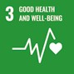 | 3.d Strengthen the capacity of all countries, in particular developing countries, for early warning, risk reduction and management of national and global health risks
 | 11.c Support least developed countries, including through financial and technical assistance, in building sustainable and resilient buildings utilizing local materials
 | 9.a Facilitate sustainable and resilient infrastructure development in developing countries through enhanced financial, technological and technical support to African countries, least developed countries, landlocked developing countries and small island developing States
Provide technical and financial assistance which prioritises disability inclusion |  | Ensure that the inclusion of persons with disabilities in projects and programming of international cooperation is prioritised, including in activities relating to research, capacity building, technology transfer, etc.
Ensure the participation of persons with disabilities |  | Reach out to, and meaningfully include, persons with disabilities and their representative organizations in all related decision-making, including:  - Consultations  - design, monitoring and evaluation of programs/policies  - research  - awareness-raising  - data collection  - resource mobilization

Increase funding devoted to persons with disabilities within international cooperation on climate change and disaster risk reduction | Systematise data collection and disaggregation by disability in the context of international cooperation related to climate change and disaster risk reduction, including within impact assessments.  Introduce a policy marker to track disability inclusion across all international cooperation projects, including those relating to climate action and disaster risk reduction, e.g. the disability marker of the Development Assistance Committee of the Organisation for Economic Co-operation and Development (OECD-DAC disability marker).
CRPD related indicators: 32.3, 32.7, 32.14, 32.15, 11.20
Action on reducing disaster and climate risk must also take into account the Sendai Framework for Disaster Risk Reduction 2015 – 2030, as there are many synergies. The infographic in Figure IV shows the links between the two frameworks and it is recommended that both are referred to.
Figure IV
Synergies between the Sendai Framework for Disaster Risk Reduction and the Sustainable Development Goals
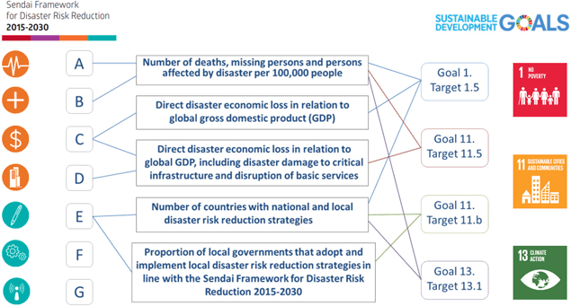

Source: Prevention Web, Integrated monitoring of the global targets of the Sendai Framework and the Sustainable Development Goals

3. DO’s and DON’Ts
DO | DO NOT
Governance, inter-institutional coordination
Adopt a cross-sector approach in policymaking by appointing and involving disability focal points at the national and local government levels, for disability-inclusive climate action and disaster risk reduction.  At the national government level, this could include ministries of social development, health, finance, water and sanitation, infrastructure; organizations of persons with disabilities (OPDs), and other actors relevant to emergency response.  At the local government level, this could include provincial disaster management offices, social protection agencies, humanitarian actors, civil society, OPDs, disability-focused non- governmental organizations and private actors. | Proceed with an isolated or siloed approach by restricting actions related to climate action and disaster risk reduction to specific technical departments or sectors.  Exclude OPDs, disability-focused organisations and other civil society actors from engaging in policymaking.
Establish councils/committees/emergency management structures for strengthened coordination and cooperation on disaster risk reduction and climate action, with membership inclusive of persons with disabilities and their representative organizations. | Engage in coordination efforts without persons with disabilities, who have the first- hand experience and expertise to inform preparedness, response, recovery and mitigation of climate-related hazards and disasters.

DO | DO NOT
Practice and implementation
Adopt emergency plans inclusive of persons with disabilities throughout the emergency cycle which address:  Accessible warning systems and evacuation protocols  Inclusive and accessible shelter, including emergency and temporary shelter  Inclusive and accessible WASH, health and rehabilitation services, education, livelihood generation, distribution of food and non-food items, cash transfers and family reunification  Specific measures to prevent and protect against violence  Support for live assistance, assistive devices and technologies | Overlook persons with disabilities across any phase of the emergency cycle, nor underestimate the fact that they are disproportionately impacted and rendered vulnerable in emergency situations.
Ensure that, in building back better, recovery measures are designed to create more resilient communities and infrastructure, which are inclusive of persons with disabilities and which prioritise investment in inclusive and community-based services at the local level, such as education, health care and rehabilitation. | Reproduce nor create new barriers for persons with disabilities in developing and designing services and infrastructure, in recovery and in rebuilding.
Identify and analyse the requirements and capacities of persons with disabilities in all their diversity: women, children, older persons, indigenous persons, migrants and refugees, persons belonging to specific impairment groups (blind, deaf, deafblind, persons with psychosocial and intellectual impairments), among others. | Assume that persons with disabilities, including women and girls, are a homogeneous group with the same requirements.  Assume that persons with disabilities do not have capacities and that resources, training and other resilience-building initiatives will not benefit them as much as others.

DO | DO NOT
Information, communication and awareness-raising
Adopt accessible awareness-raising measures (campaigns, training, information, educational curricula in formal and non-formal settings, etc.) on climate action and disaster risk reduction that are inclusive of persons with disabilities.  Include information and awareness-raising to eliminate negative stereotypes and discrimination. | Assume that information on climate change and disaster risk reduction reaches across all groups equally.  Assume that awareness-raising campaigns cannot reproduce negative stereotypes and prejudices against persons with disabilities, such as portraying them as helpless.
Disseminate information in accessible formats and languages and reach out to persons with disabilities about resources and services in emergency situations, including access to shelter, food and non-food items, assistive devices, health, family tracing, violence prevention, livelihood support, etc. | Limit the provision of information to written text, without presenting information in multiple communication formats such as audio, visual (with audio description), plain language, among others; preventing that information on services and resources reach persons with disabilities with different impairments.
Training
Carry out training on the barriers persons with disabilities face and effective measures for their inclusion for emergency responders, civil defence personnel, personnel of coordination mechanisms and other relevant actors; designed and implemented with the participation of persons with disabilities and their representative organisations. | Assume that emergency responders and other humanitarian actors are aware of the requirements and rights of persons with disabilities across all phases of emergencies and of how to ensure their access to services on an equal basis with others.
Carry out training for persons with disabilities, in all their diversity, to raise awareness and enhance their resilience and adaptive capacity in situations of risk and humanitarian emergencies. Empower OPDs to engage in public decision-making on climate action and disaster risk reduction. | Leave persons with disabilities without the necessary information, knowledge and skills to prepare for an emergency or to engage in emergency response and recovery.

DO | DO NOT
Provide capacity building to OPDs to engage in policy and strategy development related to climate action/DRR. | Assume that OPDs have the skills and experience necessary to engage with the relevant policy and strategy development actors nor that they will always have a ‘seat at the table’.
Participation
Ensure the meaningful participation of persons with disabilities in the planning, design, implementation, monitoring and evaluation of plans and strategies about climate-related hazards, disaster risk reduction, the environment and the just transition to a low- carbon economy. | Develop nor implement these plans without involving persons with disabilities, as they can better identify existing risk factors and present the barriers they face, for increased effectiveness of undertaken measures.
Promote and ensure that dialogues on climate action, just transitioning to a green economy and disaster risk reduction, involving public authorities, the private sector/businesses and other stakeholders, include persons with disabilities and their representative organisations. | Consider nor tolerate the view that persons with disabilities are passive recipients of climate action and disaster risk reduction measures, who have nothing to contribute to the sustainable development and transition to a low carbon economy.  Underestimate the views and expertise of persons with disabilities for better-informed decision-making and more effective actions to leave no one behind.
Ensure the participation of persons with disabilities, including women and girls with disabilities, and their representative organisations in the planning, design, implementation, monitoring and evaluation of plans and strategies for recovery, including building back better from disasters. | Develop nor implement these plans without involving persons with disabilities, including women and girls with disabilities, as they can better identify the barriers they face and the requirements for a more inclusive society.
Data collection and disaggregation
Institutionalise the collection and use of sex, age and disability disaggregated data , across all sectors, to better inform planning and monitoring concerning the adverse effects of climate change and disasters (e.g. related to mortality and health impacts). | Assume existing data collection suffices to capture, assess and improve the situation of persons with disabilities in the context of climate change and disasters.  Limit data collection and disaggregation by disability to disability-specific surveys.

DO | DO NOT
Assessment and planning
Make disability inclusion a priority in programme/project design on climate action and disaster risk reduction carried out by international cooperation, humanitarian and development actors. | Assume that international cooperation, humanitarian and development actors are aware of the requirements and experiences of persons with disabilities.
Ensure equal opportunities for persons with disabilities to access emerging or upgraded green jobs, by providing stimulus packages targeting them for skills development and training for low carbon sectors (e.g. jobs in the renewable energy sector, conservation agriculture, green urban design, etc.), with particular attention to women and youth with disabilities. | Engage in the transition to a low-carbon economy without including employment strategies and incentives in the emerging economies to benefit persons with disabilities, in all their diversity.
Ensure budget is specifically allocated for the inclusion of persons with disabilities in all climate action and disaster risk reduction programmes. | Assume that budget only needs to be allocated for disability-specific programmes.

4. Additional Resources
CBM Global. The 4Ps for including persons with disabilities within Climate Change Plans, 2020.
CBM and Handicap International. Charter on the Inclusion of Persons with Disabilities in Humanitarian Action, 2020.
Department for International Development. Disability and Climate Resilience Research Report, 2018.
Inter-Agency Standing Committee. IASC Guidelines: Inclusion of Persons with Disabilities in Humanitarian Action, 2019.
International Labour Organization. ILO Policy Brief: Persons with disabilities in a just transition to a low-carbon economy, 2019.
United Nations, General Assembly. Resolution adopted by the General Assembly on 3 June 2015- 69/283. Sendai Framework for Disaster Risk Reduction 2015-2030. 23 June 2015. A/RES/69/283.
United Nations, Human Rights Council. Analytical study on the promotion and protection of the rights of persons with disabilities in the context of climate change – Report of the Office of the United Nations High Commissioner for Human Rights. 22 April 2020. A/HRC/44/30.
United Nations, Human Rights Council. Human rights and climate change. 23 July 2019. A/HRC/ RES/41/21.
United Nations Children’s Fund, Including Children with Disabilities in Humanitarian Action. New York: UNICEF, 2017.
United Nations Department of Economic and Social Affairs – Disability, UN Disability and Development Report - Realizing the SDG by, for and with persons with disabilities, 3 April 2019.
United Nations Office for Disaster Risk Reduction, Living with Disability and Disasters: UNISDR 2013 Survey on living with disabilities and disasters - key findings. Geneva: UNISDR, 2014.

5. Key Concepts Annex
Below are key foundational concepts referred to throughout the Policy Guidelines for Inclusive Sustainable Development Goals (SDG). The guide below is designed as a quick reference and refresher for readers as they use the guidelines. It is recommended that the guideline “Foundations for inclusive Sustainable Development Goal Implementation: Key concepts and structural requirements” is read prior to, or together with, other guidelines, for a deeper understanding of the required foundations for inclusion.

Concepts
Ableism considers certain typical characteristics of body and mind as essential for living a life of value. Ableist perspectives view impairments as undesired, which leads to unconscious bias, prejudice, discrimination and exclusion. Ableism is usually behind negative perceptions and stereotypes about persons with disabilities. See also Foundations Guideline, section 1.3
Accessibility is the quality that allows persons with disabilities to access and enjoy physical environments, transportation, facilities, services, information and communications, including new technologies and systems. When planning for accessibility, the principles of universal design should be used. See also Foundations Guideline, section 2.2.
Assistive technology, devices and mobility aids are external products (devices, equipment, instruments, software), specially produced or generally available, that maintain or improve an individual’s functioning and independence, participation, or overall well-being. Examples of assistive devices and technologies include wheelchairs, prostheses, hearing aids, visual aids and specialized computer software and hardware that improve mobility, hearing, vision, or the capacity to communicate. See also Foundations Guideline, section 2.3.
Awareness-raising actions are those that aim at informing about rights and changing negative attitudes towards persons with disabilities. They include training, campaigns, mass-media communications and more. Awareness-raising activities should target persons with disabilities and others and should involve persons with disabilities in their design and delivery. See also Foundations Guideline, section 2.5.
Barriers: Disability results from the interaction between persons with impairments and the barriers in the environment around them. Barriers can be broadly categorised into the following:
- Environmental barriers: those that are imposed by the context. They can be sub-categorized as:
- Physical barriers: such as the presence of steps, preventing access for someone using a wheelchair, or others with mobility difficulties.
- Communication barriers: such as the barriers to participation for a sign language user in a meeting if sign language interpreters are not provided, or the barrier to accessing information experienced by blind persons with written text, if accessible formats are not provided.
- Policy barriers: such as educational systems that prevent the enrolment of children with disabilities in their local school.
- Attitudinal barriers: such as the belief that persons with disabilities cannot learn or work. Attitudinal barriers can lead to apathy or inertia towards addressing other barriers. Attitudinal barriers can lead to apathy or inertia towards addressing other barriers.
In order for persons with disabilities to fully participate and access opportunities for development, the barriers that limit their participation should be systematically addressed. Persons with disabilities themselves are experts on identifying barriers and the solutions to overcome them. See also Foundations Guideline, section 1.1.
Disability assessment is the process of collecting information about persons with disabilities, in their context, for the purposes of policymaking and planning, budget allocation and to determine eligibility to certain benefits and entitlements. A disability assessment can also be used solely for the purpose of providing services such as rehabilitation or education. See also Foundations Guideline, section 3.2.2 and Policy Guideline on SDG 1.
Disability determination refers to the official decision (using assessment findings) about whether someone is identified as a person with disability, often also categorized according to their functional ability. In some countries, this can become an official status, symbolised by a disability card, registration, or similar, which can provide access to various services and benefits. There are often additional and/or different processes to determine eligibility for different types of social protection, insurance, health and support services. See also Foundations Guideline, section 3.2.2 and Policy Guideline on SDG 1.
Disability discrimination is described in the Convention on the Rights of Persons with Disabilities (Article 2) as “any distinction, exclusion or restriction on the basis of disability which has the purpose or effect of impairing or nullifying the recognition, enjoyment or exercise, on an equal basis with others, of all human rights and fundamental freedoms in the political, economic, social, cultural, civil or any other field. It includes all forms of discrimination, including denial of reasonable accommodation.” See also Foundations Guideline, section 2.1.
Disability mainstreaming is the process of ensuring that the rights of persons with disabilities are embedded in all policy, assessing policy implications for persons with disabilities, and ensuring their meaningful participation. It is the way of making the concerns and experiences of persons with disabilities an integral dimension of the design, implementation, monitoring and evaluation of policies and programmes in all political, economic and societal spheres so that persons with disabilities have equal benefits, and inequality is not perpetuated. The ultimate goal is to achieve equality of outcomes and foster an inclusive culture. Disability mainstreaming should be combined with disability-specific actions (see Twin-Track Approach). See also Foundations Guideline, section 3.2.1.
Extra-cost of disability refers to the higher expenditure of persons with disabilities and their households, when compared to the rest of the population. Extra-costs commonly stem from specific goods and services (e.g. mobility aids, personal assistance, accessible housing) and/or lack of access to general goods and services (e.g. more expensive health insurance, using taxis where public transport is not accessible). Disability extra-costs affect different policies. For more information, access the Centre for Inclusive Policy’s videos, “Understanding disability extra costs” and “Addressing disability extra costs”. See also Policy Guideline on SDG 1.
International cooperation is the interaction of persons or groups of persons representing various nations and diverse international and regional organisations striving towards the common goal of realizing the rights of persons with disabilities and the Convention on the Rights of Persons with Disabilities. Persons with disabilities, the organisations that represent them, and policymakers, collaborate through their ministries of international affairs, to receive technical and financial support from international organisations and development banks. Financial support designated for international cooperation shall not be used for measures contrary to the Convention on the Rights of Persons with Disabilities and shall be planned to be substituted with national funds, to ensure policy continuation. Technical cooperation among countries with similar realities is important to identify effective solutions. See also Foundations Guideline, section 8.
Intersectional discrimination refers to situations where discrimination is occurring on the basis of multiple and intersecting factors, including sex, gender, ethnicity, age, caste, class, faith, sexual orientation or any other characteristic. Persons with disabilities also have a gender identity, may come from an indigenous group, be young, old, a refugee or living in poverty. See also Foundations Guideline, section 5.3.
Legal capacity is the right to autonomously make legally valid decisions. Some countries restrict the right for adults with disabilities to manage their own financial affairs, including ownership of property, choose where to live and work, and manage their relationships, health and wellbeing.
Restricting or denying this right is against the Convention on the Rights of Persons with Disabilities and has negative effects across all policies. See also Foundations Guideline, section 5.5.
Organisations of persons with disabilities are led, directed, and governed by persons with disabilities. They are established at the local, national, regional or international level to promote and/ or defend the rights of persons with disabilities. A clear majority of the membership of such organisations should be recruited among persons with disabilities themselves. See also Foundations Guideline, section 2.4.
Participation of persons with disabilities refers to the action of allowing and enabling persons with disabilities to take part directly, or through organizations of persons with disabilities, in decision- making processes, including the design, implementation, monitoring and evaluation of policies. To do this, persons with disabilities should be closely consulted and actively involved in all decision-making processes, by being invited to give their opinions and take part in implementation processes.
Participation is an obligation to be met under the Convention on the Rights of Persons with Disabilities for all aspects of policy. “Nothing about us, without us” is the motto that promotes this obligation, and it means that no policy should be developed or implemented without persons with disabilities. See also Foundations Guideline, sections 2.4 and 4.
Persons with disabilities include those who have long-term physical, psychosocial, intellectual or sensory impairments which, in interaction with various barriers, may hinder their full and effective participation in society on an equal basis with others. Hence, persons with disabilities are persons with impairments who experience barriers that restrict their participation. See also Foundations Guideline, section 1.2.
Reasonable accommodation refers to modifications or adjustments made for a person with disability who requires them in a particular case, to facilitate participation on an equal basis with others. Reasonable accommodation must be provided on demand - that is, entities responsible for providing it cannot deny it by saying that they are progressively implementing measures. If arbitrarily denied, this constitutes discrimination.
Some examples include adjustments to the school hours of a student, extended breaks to rest, acquisition of computer software to read screens, a foldable ramp to overcome step(s) or providing a sign language interpreter in a work meeting. See also Foundations Guideline, sections 2.1 and 5.2.
Support for persons with disabilities encompasses a wide range of formal and informal interventions, including live assistance and intermediaries, mobility aids and assistive devices and technologies. It also includes personal assistance; support in decision-making; communication support, such as sign language interpreters and alternative and augmentative communication; mobility support, such as assistive technology or service animals; living arrangements services for securing housing and household help; and community services. Persons with disabilities may require support to perform daily life activities and/or use general services, such as health, education and justice, on an equal basis with others. See also Foundations Guideline, section 2.3.
Supported decision-making is a type of support given to persons with disabilities in relation to legal decisions. This mechanism guarantees that: (i) persons with disabilities exercise their legal capacity (see above) and can make their own decisions in every aspect of life; and (ii) their decisions are not replaced by the decisions of guardians or others. Supported decision-making is voluntary and can include informal and formal support arrangements. For example, a person with disability may choose a trusted person to support them in making certain types of legal decisions. They may also resort to peer support or self-advocacy networks. Some persons with disabilities may access support to help in the communication of their will and preference. See also Foundations Guideline, section 5.5.
Twin track approach is a strategy to develop policies that:
- systematically mainstreams the interests and rights of persons with disabilities in policy design and implementation, across all sectors and areas of life
- adopts targeted policy and programming measures aimed specifically at persons with disabilities
The balance between mainstreaming strategies and targeted support strategies should be tailored to address the needs of specific communities. See also Foundations Guideline, section 3.2.1.
Universal design is the design and composition of products, environments, programmes and services so that they can be accessed, understood and used to the greatest extent possible by all people, regardless of their age, size, ability or disability, and without the need for adaptation or specialized design. The principles of universal design facilitate accessibility, including for persons with disabilities. See also Foundations Guideline, section 2.2.
The Washington Group Short Set is a set of six questions on functioning, designed to be used within national censuses and surveys. The questions are designed to provide comparable data cross- nationally, for populations living in a variety of cultures, with varying economic resources. While not exhaustive, the basic actions represented in this set of six questions are those that are most often found to limit an individual, and result in participation restrictions. The information that results from the use of these questions will (a) represent the majority of, but not all, persons with limitation in basic actions, (b) represent the most commonly occurring limitations in basic actions, and (c) be able to capture persons with similar difficulties across countries. See also Foundations Guideline, section 3.5.

Office of the United Nations
High Commissioner for Human Rights (OHCHR)
Palais de Nations
CH 1211 Geneva 10 – Switzerland
Email: disability@ohchr.org
Website: www.ohchr.org

