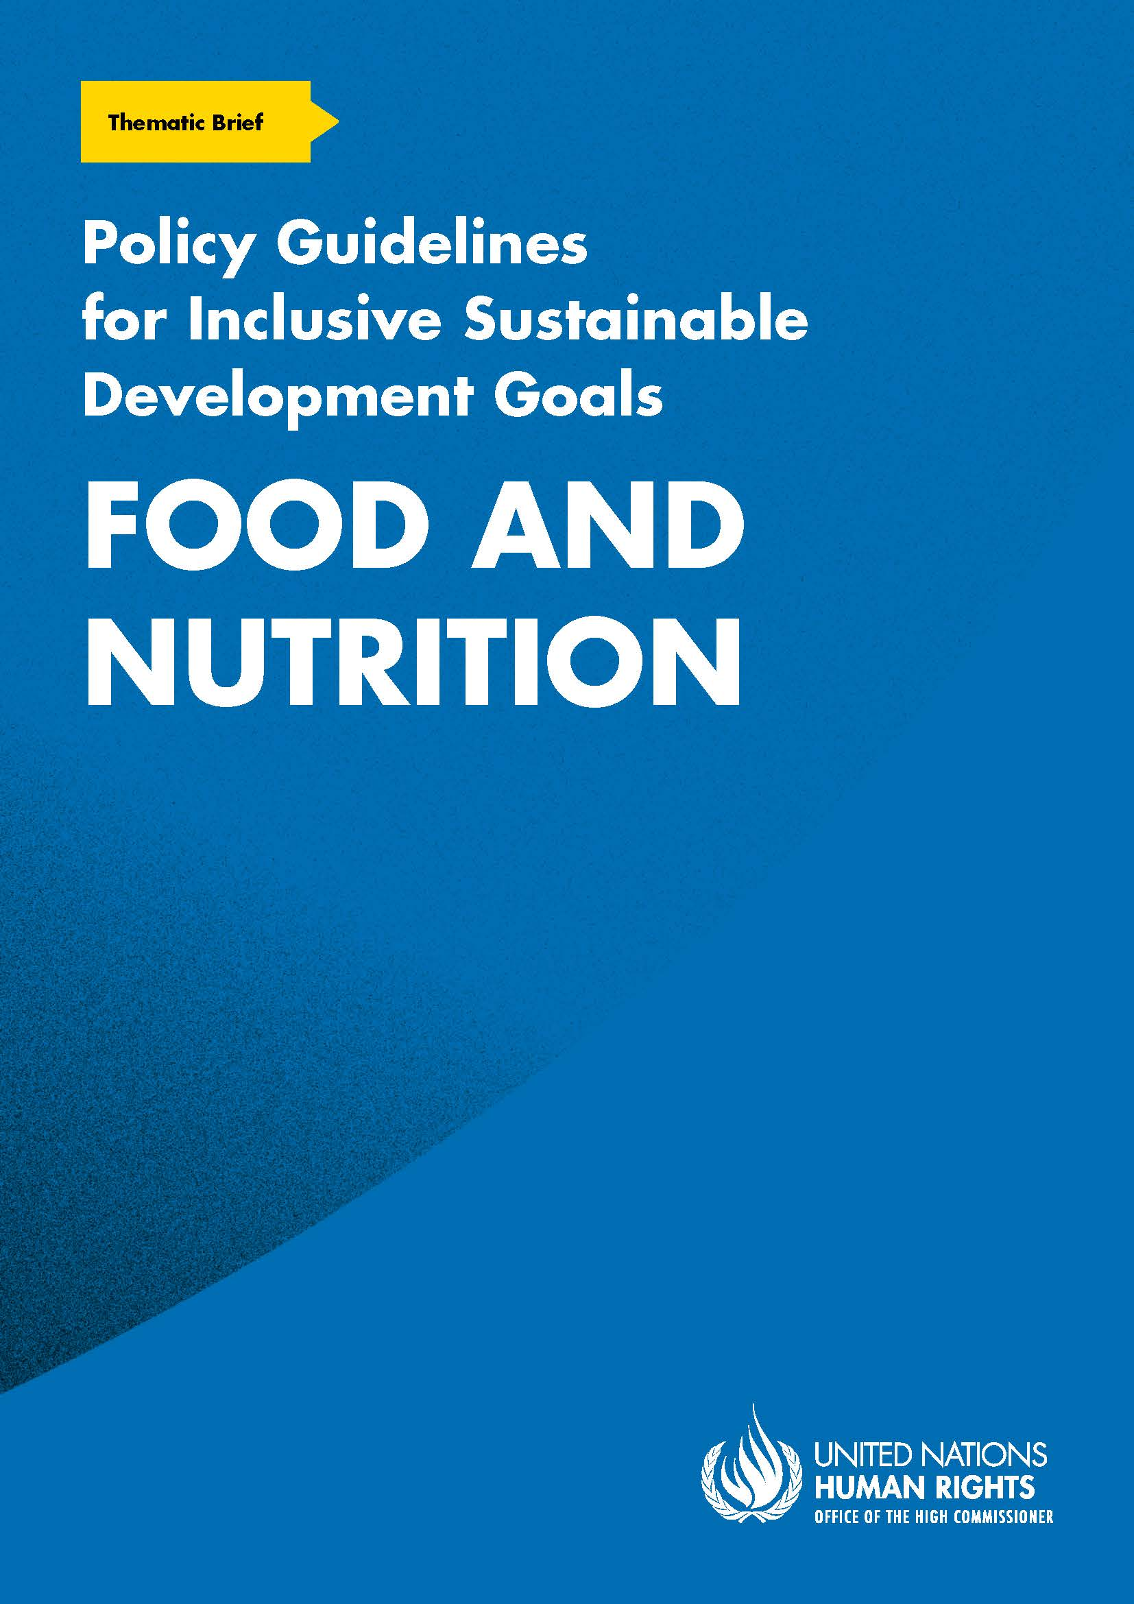
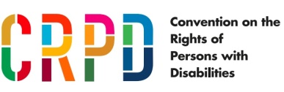
ADVANCE VERSION
© 2020 United Nations
The Policy Guidelines for Inclusive Sustainable Development Goals are a component of the SDG- CRPD Resource Package, developed by the Office of the United Nations High Commissioner for Human Rights (OHCHR). This is an advance version of the SDG-CRPD Resource Package. A final version will be issued upon completion of OHCHR review processes.
The designations employed and the presentation of the material herein do not imply the expression of any opinion whatsoever on the part of the Secretariat of the United Nations concerning the legal status of any country, territory, city or area, or of its authorities, or concerning the delimitation of its frontiers or boundaries.
Symbols of United Nations documents are composed of capital letters combined with figures. Mention of such a figure indicates a reference to a United Nations document.
Photography by Christian Tasso. The photographs featured within the Policy Guidelines were taken as part of the European Union project, Bridging the Gap II – Inclusive Policies and Services for Equal Rights of Persons with Disabilities, and were produced with the financial support of the European Union. They appear courtesy of the International and Ibero-American Foundation for Administration and Public Policies.
The Policy Guidelines for Inclusive Sustainable Development Goals were produced with the financial support of the European Union. Its contents are the sole responsibility of OHCHR and do not necessarily reflect the views of the European Union.
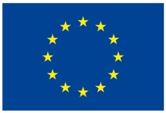
End hunger, achieve food security and improved nutrition and promote sustainable agriculture.
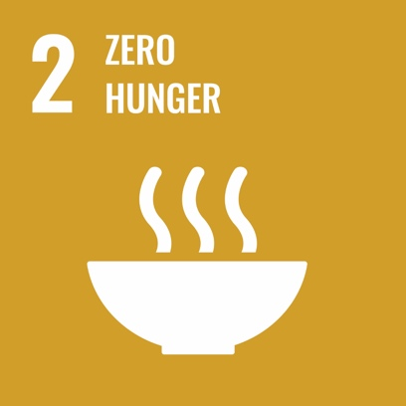
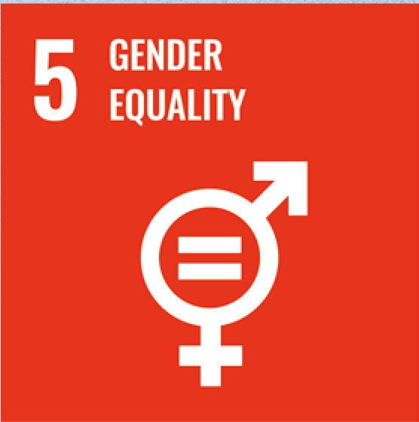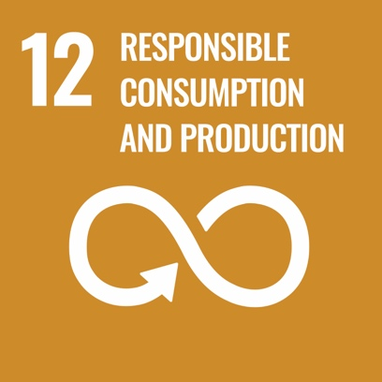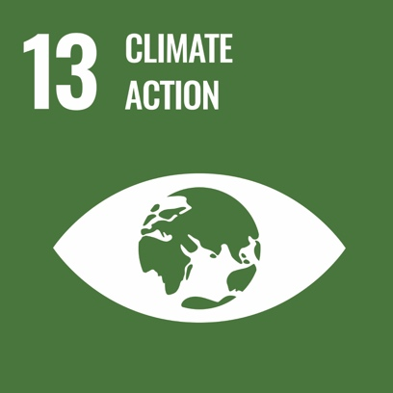

Contents
1. What is the situation? 6
2. What needs to be done? 9
3. DO’s and DON’Ts 15
4. Additional Resources 19
5. Key Concepts Annex 20

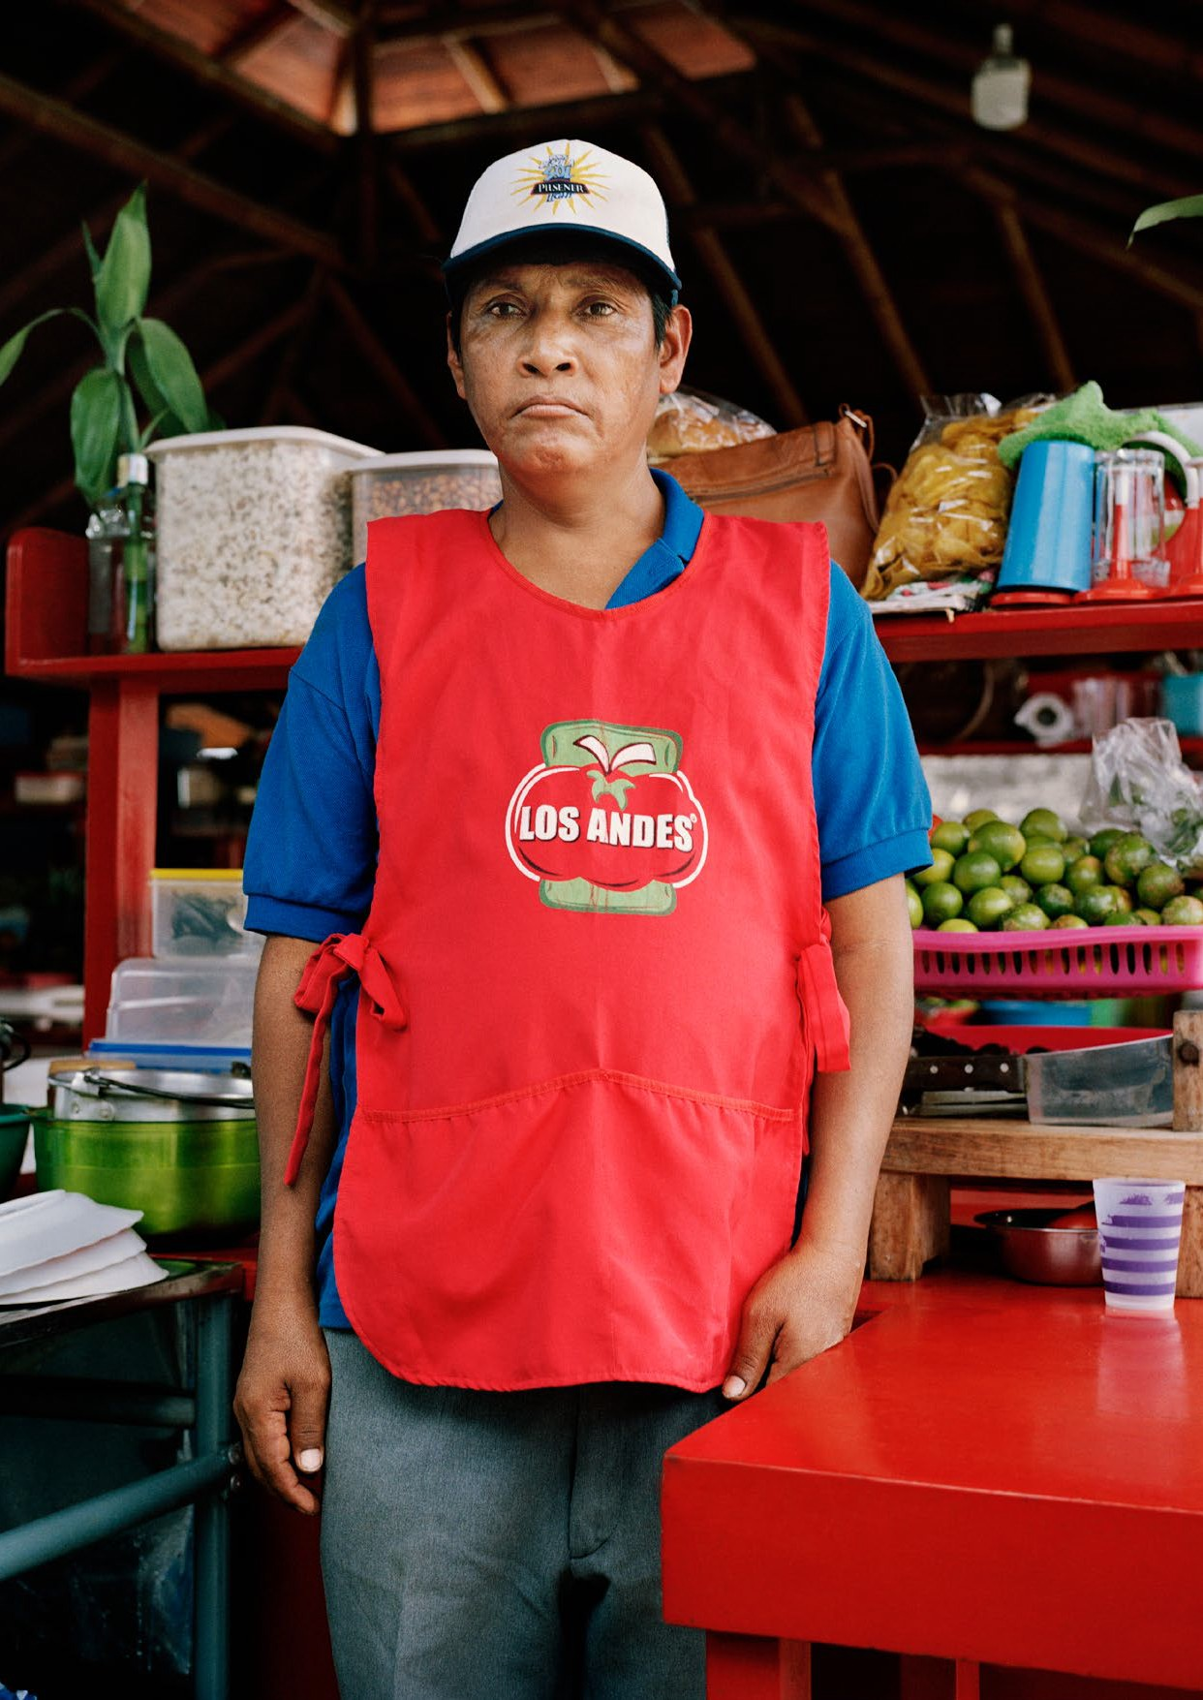

1. What is the situation?
Persons with disabilities experience barriers to accessing food, good nutrition and being agents of food production. More than 820 million people worldwide do not have enough food to eat and about 2 billion people experience moderate or severe levels of food insecurity. Among these populations, persons with disabilities experience a greater risk of:
  - malnutrition (meaning they are more at risk of undernutrition and overnutrition and their associated health conditions)
  - food insecurity (meaning that they lack secure access to sufficient amounts of safe and nutritious food for growth and development and to lead an active and healthy life)
The graph in figure I shows the percentage of persons or households who did not always have food to eat, by disability status.
Figure I
Percentage of persons or households who did not always have food to eat, by disability status
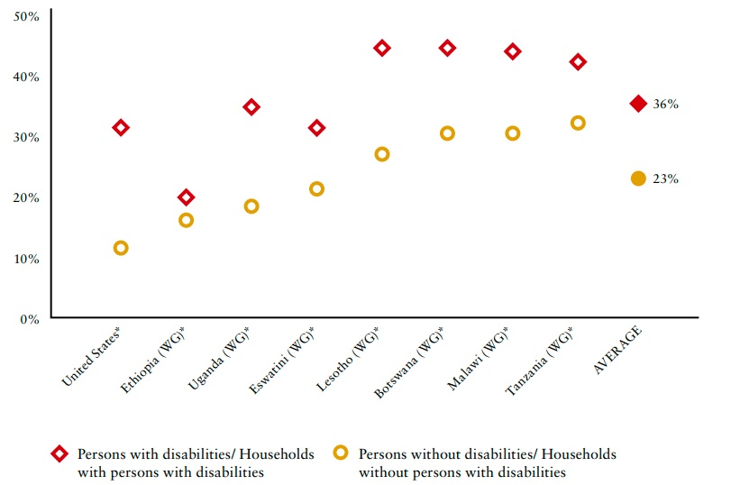
Source: United Nations Department of Economic and Social Affairs, UN Disability and Development Report - Realizing the SDG by, for and with persons with disabilities, 3 April 2019, p. 41, Figure II.7.

Persons with disabilities and their households are among the populations with the least access to food and nutrition, and among those experiencing higher rates of poverty. On account of higher rates of unemployment and lower earnings in employment, they have less available income to spend on food. Where persons with disabilities do benefit from social protection measures, these are often insufficient, as they commonly do not cover disability-related extra costs, hence pushing expenditure on food and nutrition further down the list of spending priorities.
Where food assistance programmes exist, information may not be accessible nor disseminated to persons with disabilities, or they may be deemed ineligible to participate because they benefit from disability-specific social protection measures. Persons with disabilities also face barriers on account of inaccessible designs of food products and packaging, supermarkets, food distribution sites or distribution modalities, and lack of accessible transportation, including in situations of risk and humanitarian emergencies. Infants, children and youth with disabilities are less likely to benefit from school-based nutrition programmes because they are less likely to attend school.
While the disparity in access to food by persons with disabilities is particularly dramatic in low- and middle-income countries, the tendency is also noted in high-income countries, as exemplified by the graph in figure II, relating to the European Union.

Figure II
Proportion of persons under ‘food poverty’ in the European Union, by disability (Eurostat 2016)
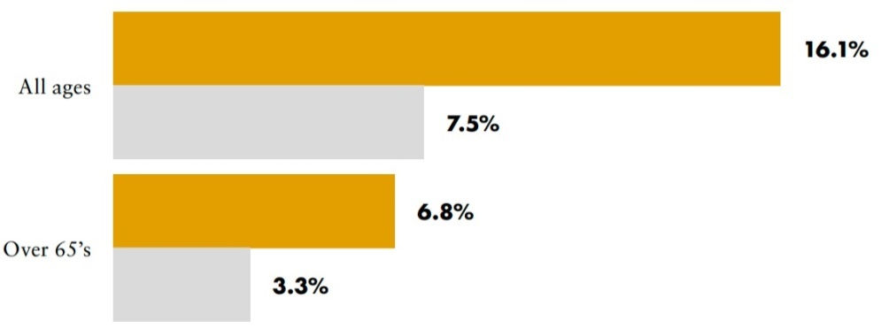
Source: Mitzi Waltz and others, Disability, Access to Food and the UN CRPD: Navigating Discourses of Human Rights in the Netherlands, Social Inclusion, vol. 6, No. 1(2018), pp. 51-60.
Both children and adults with disabilities may encounter further barriers to their nutrition due to factors linked to their individual identities, as well as environmental, attitudinal and institutional contexts. Stigma and discrimination, linked to sociocultural beliefs and attitudes, also underlie decisions taken within families, institutions, food programmes and humanitarian settings (such as camps), to deny or provide less nutritious food to persons with disabilities, compared to others. Table 1 summarises the key factors which affect access to nutrition programming for persons with disabilities.

Table 1

Factors affecting access to nutrition programming for persons with disabilities (Holden and Corby, 2019)
Individual | Environmental | Attitudinal | Institutional
Intersecting and compounding forms of discrimination and disadvantage, with barriers differing depending on type and severity of impairment, and: Universal factors (fixed aspects of one’s identity regardless of setting), including age, gender, disability and health status.  Contextual factors (more complex and changeable factors and those that vary by setting), including language, caste, migration and refugee status, family status.  Note: Girls with disabilities may more often be underweight than boys with disabilities due to culturally determined gender preferences. | Physical barriers to access at health and education services and facilities e.g. a lack of ramps, adjustable beds, wheelchairs and accessible sanitation facilities.  Centralisation of specialist health and nutrition centres and specialised staff in urban areas.  Long and difficult journeys to clinics, particularly in rural and remote areas.  Accessibility of communications, e.g. difficult understanding radio messages, or TV not captioned or sign language for deaf or hard of hearing people, or information only in text for people with visual impairments.  Lack of contextualised and standardised screening tools for disability | Poor knowledge of parents and caregivers which may affect diet and feeding practices.  Stigma, negative attitudes and discrimination from health workers.  Social and cultural attitudes which devalue the lives of people with disabilities, leading to harmful and neglectful feeding and health seeking practices. | Lack of national guidelines and disability specific guidance for nutrition programming.  Lack of age-, gender- and impairment- disaggregated data on access to nutrition programming.  Lack of technical expertise around nutrition programming from a disability perspective.  Lack of training and awareness in early identification and intervention.  Suboptimal care and lack of follow up.

Source: Jenny Holden and Nick Corby, Disability and nutrition programming: evidence and learning, Disability Inclusion Helpdesk Report No.6, (London: Disability Inclusion Helpdesk, 2019).
Note: Terms as presented by the source.

The graph in figure III shows the gender gap between men and women with access to food, compared to the gender gap between men and women with disabilities with access to food.
Figure III
Gender gap: Difference in percentage points between the proportion of men and women with access to food, by disability status (Eurostat)
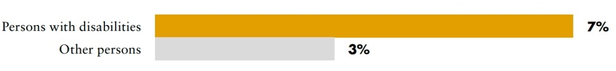
Source: United Nations Department of Economic and Social Affairs, UN Disability and Development Report - Realizing the SDG by, for and with persons with disabilities, 3 April 2019, p. 39.
Food security is critically dependent on shifting food production systems away from industrialisation, to mitigate climate-induced shocks and climate change; and on supporting small-scale food producers to engage in resilient and sustainable farming systems. Today, 500 million small farms worldwide provide up to 80 per cent of food consumed in a large part of the developing world. Persons with disabilities are overrepresented in low- and middle-income countries and in rural areas, where there is a higher reliance on on-farm activities; having a person with disability in the household increases the likelihood of food insecurity. Investing in small farms and farmers with disabilities is an important way to increase food production and to contribute to food security and nutrition in their households.
Persons with disabilities face multiple barriers to engaging in the food production sector: laws, policies and customs may inhibit their access to and control over land, property and natural and productive resources, based on their disability and gender. They may also be prohibited from signing a contract or accessing financial services to obtain credit, loans and other assets necessary to develop land, invest in seeds, fertilizer, pesticides, equipment machinery and other technologies. In addition, support services for farmers (through training, subsidies, grants and programmes) to reduce their exposure to economic, social and environmental risks commonly exclude farmers with disabilities, thus failing to capitalise on their potential and capacity to strengthen economic returns to their farms, households and communities.

2. What needs to be done?
Improving access to food, nutrition and engagement in food production for persons with disabilities requires addressing the barriers they experience as producers and consumers of food. These include:
  - Barriers to accessing food, including distribution chains, delivery methods, information about food delivery and societal prejudice
  - Barriers to sufficient nutrition, including the availability of food of adequate quality in adequate quantities, administered in an acceptable manner
  - Barriers to equitable participation in the food production chain

Figure IV
Key actions to achieving zero hunger
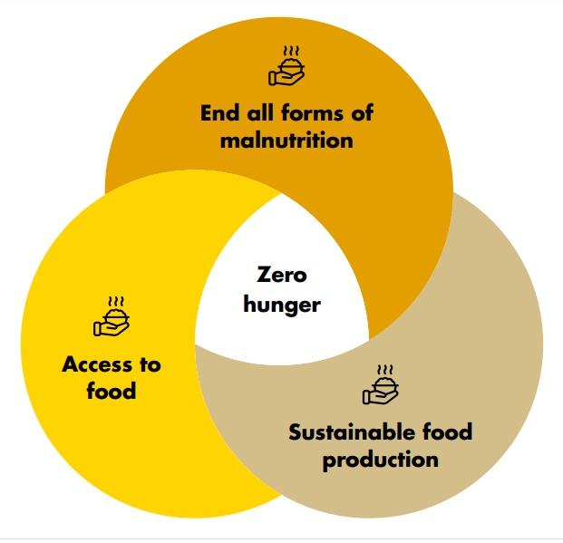

Main areas of intervention
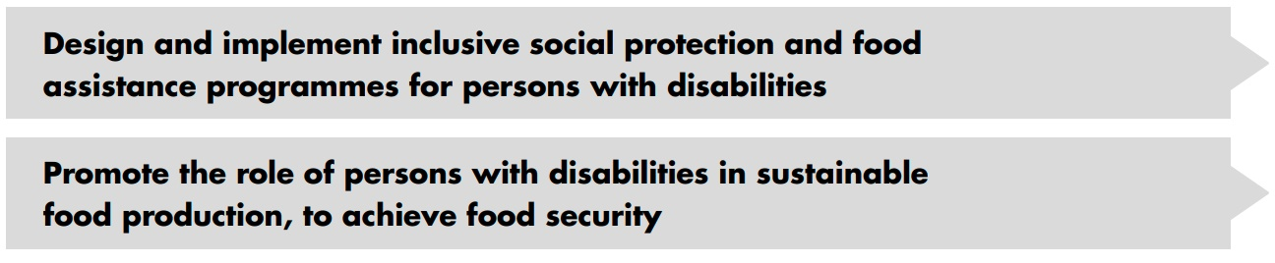

Design and implement inclusive social protection and food assistance programmes for persons with disabilities

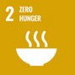 | 2.1 By 2030, end hunger and ensure access by all people, in particular the poor and people in vulnerable situations, including infants, to safe, nutritious and sufficient food all year round  2.2 By 2030, end all forms of malnutrition, including achieving, by 2025, the internationally agreed targets on stunting and wasting in children under 5 years of age, and address the nutritional needs of adolescent girls, pregnant and lactating women and older persons

Implement laws and policies to secure access to food and nutrition by persons with disabilities | Explicitly recognise in law and policy frameworks the right of persons with disabilities to food, on an equal basis with others, and implement disability- specific and disability-inclusive nutrition and food programmes  In consultation with persons with disabilities and their representative organizations, take specific measures to tackle prejudice and harmful practices, and to eliminate customs and practices which impede persons with disabilities, including women and girls with disabilities, from accessing and fully benefitting, on an equal basis with others, from social protection and food assistance programmes - including restrictions to legal capacity  Explicitly recognise, in law and policy frameworks, the right of persons with disabilities to food, on an equal basis with others  Implement inclusive social protection programmes which target persons with disabilities in food assistance programmes, and ensure complementarity across wider social protection programmes and links with nutrition and health services. Ensure social protection programmes which incorporate food and nutrition security for persons with disabilities, including through:  - Food transfers: in-kind food supplementation  - School meal programmes  - Food assistance for assets  - Cash-based transfers (cash, vouchers)
Undertake effective strategies for food distribution and delivery, to ensure the nutrition of persons with disabilities | Implement accessibility and universal design standards across food assistance programmes.  Require food assistance programmes to take into account the dietary and nutritional requirements and digestive capacities of persons with disabilities (e.g. by making adapted utensils, assistive devices, support in eating, etc., available for children and adults with disabilities for the purposes of eating); and the provision of reasonable accommodation in food distribution services.

Carry out awareness-raising and training to ensure access to food and nutrition for persons with disabilities | Develop training programmes to address the requirements of persons with disabilities concerning food and nutrition, directed to:  - policymakers and staff/volunteers of food assistance and distribution (or related) programmes  - the private sector working in the food system and industry  - planning and response staff and other humanitarian actors  - health care professionals, including nutrition workers and those working in schools, prisons and residential institutions (where such institutions remain)  Ensure capacity building and training to empower all groups of persons with disabilities, including women and girls with disabilities, to engage in decision- making on food security and nutrition, social protection and food assistance services.  Carry out awareness-raising initiatives, with and through networks of representative organizations of persons with disabilities and disseminate accessible information on food assistance programmes (including on eligibility, application, assessment, delivery of services and complementarity with other social protection programmes).  Establish coordinated referral mechanisms for persons with disabilities to access support services.

CRPD indicators: 25.26, 25.27, 6.8, 6.12, 28.1, 28.3, 28.4, 28.5, 28.10, 28.11, 28.13, 28.14, 28.28, 28.29, 28.30

Promote the role of persons with disabilities in sustainable food production, to achieve food security
  - By 2030, double the agricultural productivity and incomes of small-scale food producers, in particular women, indigenous peoples, family farmers, pastoralists and fishers, including through secure and equal access to land, other productive resources and inputs, knowledge, financial services, markets and opportunities for value addition and non-farm employment
  - By 2030, ensure sustainable food production systems and implement resilient agricultural practices that increase productivity and production, that help maintain ecosystems, that strengthen capacity for adaptation to climate change, extreme weather, drought, flooding and other disasters and that progressively improve land and soil quality
2.A Increase investment, including through enhanced international cooperation, in rural infrastructure, agricultural research and extension services, technology development and plant and livestock gene banks in order to enhance agricultural productive capacity in developing countries, in particular least developed countries

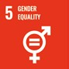 | 5.A Undertake reforms to give women equal rights to economic resources, as well as access to ownership and control over land and other forms of property, financial services, inheritance and natural resources, in accordance with national laws
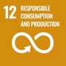 | 12.A Support developing countries to strengthen their scientific and technological capacity to move towards more sustainable patterns of consumption and production
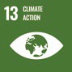 | 13.2 Integrate climate change measures into national policies, strategies and planning
Implement laws and policies to ensure and promote the role of persons with disabilities in achieving sustainable food production |  | Explicitly ensure access by persons with disabilities to land and other productive resources and financial services in law/policy  Remove provisions in laws and regulations and eradicate customs and practices which impede persons with disabilities from signing contracts, accessing financial services and owning/inheriting land, property, resources and assets, including restrictions of legal capacity  In consultation with persons with disabilities and their representative organizations, adopt coordinated national strategies targeting poverty, hunger eradication and climate action which provide incentives and resources to small-scale farmers, including family-farming approaches inclusive of persons with disabilities  Adopt policies inclusive of workers with disabilities to promote decent job creation in agriculture  Ensure synergies across social protection and interventions in agriculture, forestry, fishery and livestock production, to improve access to resources (such as microfinance schemes), infrastructure and technology by persons with disabilities, to improve the food security of their households
Carry out training and outreach to strengthen engagement by persons with disabilities in sustainable food production |  | Carry out accessible training programmes, inclusive of persons with disabilities, on agriculture, forestry, fishery and livestock production, with focus on accessible machinery; tools, technologies and infrastructure for agricultural innovation; and climate-smart solutions  Develop training to empower persons with disabilities, in all their diversity, to engage in decision-making on sustainable agriculture and food production  Provide opportunities for youth with disabilities to engage in agriculture and access productive resources such as land, credit and adequate social protection

Mobilise resources and international cooperation to enhance the participation of persons with disabilities in sustainable food production | Increase investment in methodologies and technologies to enhance the participation of persons with disabilities in sustainable agriculture by allocating resources to provide grants, subsidies, training, equipment, productive technologies and other forms of support specifically to persons with disabilities, particularly women and youth with disabilities.  Promote projects, initiatives, transfer and exchange of technology (through south-south, north-south and triangular cooperation), infrastructure and research to support small-scale food producers, including persons with disabilities, to enhance their food production and household food security. Ensure that international cooperation contributes to this end.  Introduce a policy marker (e.g. the disability marker of the Development Assistance Committee of the Organisation for Economic Co-operation and Development -OECD-DAC disability marker) to track disability-inclusion across all initiatives and spending that support small-scale food producers for sustainable agriculture.  Support the implementation of programmes to promote sustainable food production and food security, including food assistance for assets programmes and local and regional procurement of food, which target development activities for the whole community and enhance the resilience of local farmers, including farmers with disabilities.
CRPD indicators: 12.2, 28.12, 6.8, 27.12, 27.13, 32.1, 32.10

3. DO’s and DON’Ts
DO | DO NOT
Law, policy and programmes
Adopt laws and policies to recognise the right to food and to facilitate access to appropriate in-kind food assistance programmes and social protection for persons with disabilities, ensuring the complementarity of social protection instruments. | Create inconsistencies relating to eligibility across different social protection and in-kind food assistance programs, which may lead to restricted access to food and nutrition by persons with disabilities.  Adopt austerity measures which undermine access to food for persons with disabilities.
Adopt comprehensive emergency plans, inclusive of persons with disabilities, that apply guidelines and protocols for accessible food distribution sites and modalities (considering access, ration package size), including the provision of social support and assistive devices for eating. | Overlook persons with disabilities in designing protocols and planning for emergencies, including with respect to accessing food and maintaining nutrition and health in situations of risk and humanitarian emergencies.
Develop disability-specific and disability- inclusive mainstream food assistance programmes, taking into account the diversity of the local population, including gender, age and indigenous background, among others. | Apply homogenous standards of access, distribution, delivery, nutrition and dietary factors to meals and food within food assistance programmes.
Locate food distribution sites and facilities in accessible venues and provide options for food delivery for persons with disabilities within food assistance programmes, including during emergencies. | Apply blanket rules requiring persons with disabilities to attend food distribution sites in person to have access to food.
Practice and implementation
Support small scale food production and food security within marginalised communities, including producers with disabilities, by making grants, subsidies and natural and productive resources available to persons with disabilities, so they can engage in sustainable food production - with particular attention towards women, youth and older persons with disabilities. | Disregard or neglect the role of persons with disabilities in contributing to sustainable food production and food security in their households, communities and rural economies at large.  Exclude persons with disabilities from benefiting from agricultural and social protection interventions to boost their capacities to contribute to sustainable food production.

DO | DO NOT
Information, communication and awareness-raising
Develop awareness-raising and accessible information for persons with disabilities and their families, to:  - inform them about their right to food and nutritional requirements  - inform them of existing food security and nutrition programmes and services, as well as eligibility criteria  - support them in engaging in consultations on food security and nutrition, social protection and food assistance  - facilitate their engagement in sustainable food production (e.g. access to rural advisory services, accessible agricultural technologies, market information, information on producer associations that include farmers with disabilities) | Limit the provision of information to written text without presenting information in multiple communication formats (such as audio, visual with audio description or plain language), thereby preventing the reach of information and services to the full population of persons with disabilities.
Training
Develop capacity-building opportunities on how to address the requirements of persons with disabilities, including women and girls with disabilities, with respect to food and nutrition service provision. Audiences include:  - policymakers and staff and volunteers of food assistance and distribution programs  - emergency planning and response staff and other humanitarian actors  - healthcare professionals, including nutrition workers and those working in schools, prisons and residential institutions (where institutions remain) | Assume that all relevant actors are aware of the barriers faced by persons with disabilities, including women and girls with disabilities, in accessing food and nutrition, or that decision- makers are aware of the role they can play in contributing to strengthening food security.  Limit access to training and information on ensuring the inclusion of persons with disabilities across programming and decision- making to a restricted number of specific professionals.

DO | DO NOT
Carry out training programmes inclusive of small-scale producers with disabilities on available technologies, advisory services, information to facilitate their work and improve productivity, and available subsidies, grants and exemptions | Carry out training programs for small-scale producers without including those with disabilities, nor ignore their potential to contribute to sustainable food production.
Participation
Consult persons with disabilities and their families to identify the barriers they experience in accessing food, nutrition and related assistance programmes and services, including food distribution and delivery.  Ensure the participation of persons with disabilities, in particular youth and women with disabilities, in the planning, design, implementation, monitoring and evaluation of food, nutrition and sustainable food production policies, programmes and projects. | Develop these policies and plans without involving persons with disabilities.
Ensure the participation of persons with disabilities and their representative organizations in all areas of hunger eradication and nutrition programming, including training, awareness-raising, outreach, data collection and research. | Ignore the lived experiences of persons with disabilities as central to all efforts to eradicate hunger and malnutrition.

DO | DO NOT
Research and data collection and disaggregation
Institutionalise the collection of disability- disaggregated data with respect to nutrition, hunger and food assistance, delivery and distribution. | Continue to use data collection systems and methods which do not capture nor assess the situation of persons with disabilities in accessing food and nutrition.
Collect individual-level data to better assess the access to food and nutrition by each member of the household (while maintaining confidentiality of data), as well as coverage, reach and effectiveness of service provision or programmes for persons with disabilities. | Assume data by household suffices to assess access to food and nutrition by persons with disabilities, including for those households benefitting from food assistance and nutrition programmes and services.
Fund and promote research on nutrition, food security and sustainable food production in relation to persons with disabilities, taking into account the type of impairment, age and gender, across different contexts, to inform policies and programmes. | Develop strategies and policies based on limited research which does not explore the nutrition and access to food of persons with disabilities living in different geographical zones or in community or institutional settings; nor their age, gender or type of impairment.
Disseminate and share resources, data, research and technology within and across countries, to ensure the visibility, empowerment and engagement of persons with disabilities in sustainable food production, food security and utilisation, for optimal nutrition outcomes. | Inhibit the sharing and dissemination of knowledge, technology and research to find sustainable solutions to food insecurity.

4. Additional Resources
Holden, Jenny and Nick Corby. Disability and nutrition programming: evidence and learning. Disability Inclusion Helpdesk Report No.6. London: Disability Inclusion Helpdesk, 2019.
Inter-Agency Standing Committee. Guidelines: Inclusion of Persons with Disabilities in Humanitarian Action, 2019.
United Nations Children’s Fund, Including Children with Disabilities in Humanitarian Action: Nutrition. New York, UNICEF, 2018.
United Nations Department of Economic and Social Affairs. UN Disability and Development Report- Realizing the SDG by, for and with persons with disabilities, 3 April 2019.

5. Key Concepts Annex
Below are key foundational concepts referred to throughout the Policy Guidelines for Inclusive Sustainable Development Goals (SDG). The guide below is designed as a quick reference and refresher for readers as they use the guidelines. It is recommended that the guideline “Foundations for inclusive Sustainable Development Goal Implementation: Key concepts and structural requirements” is read prior to, or together with, other guidelines, for a deeper understanding of the required foundations for inclusion.

Concepts
Ableism considers certain typical characteristics of body and mind as essential for living a life of value. Ableist perspectives view impairments as undesired, which leads to unconscious bias, prejudice, discrimination and exclusion. Ableism is usually behind negative perceptions and stereotypes about persons with disabilities. See also Foundations Guideline, section 1.3
Accessibility is the quality that allows persons with disabilities to access and enjoy physical environments, transportation, facilities, services, information and communications, including new technologies and systems. When planning for accessibility, the principles of universal design should be used. See also Foundations Guideline, section 2.2.
Assistive technology, devices and mobility aids are external products (devices, equipment, instruments, software), specially produced or generally available, that maintain or improve an individual’s functioning and independence, participation, or overall well-being. Examples of assistive devices and technologies include wheelchairs, prostheses, hearing aids, visual aids and specialized computer software and hardware that improve mobility, hearing, vision, or the capacity to communicate. See also Foundations Guideline, section 2.3.
Awareness-raising actions are those that aim at informing about rights and changing negative attitudes towards persons with disabilities. They include training, campaigns, mass-media communications and more. Awareness-raising activities should target persons with disabilities and others and should involve persons with disabilities in their design and delivery. See also Foundations Guideline, section 2.5.
Barriers: Disability results from the interaction between persons with impairments and the barriers in the environment around them. Barriers can be broadly categorised into the following:
- Environmental barriers: those that are imposed by the context. They can be sub-categorized as:
- Physical barriers: such as the presence of steps, preventing access for someone using a wheelchair, or others with mobility difficulties.
- Communication barriers: such as the barriers to participation for a sign language user in a meeting if sign language interpreters are not provided, or the barrier to accessing information experienced by blind persons with written text, if accessible formats are not provided.
- Policy barriers: such as educational systems that prevent the enrolment of children with disabilities in their local school.
- Attitudinal barriers: such as the belief that persons with disabilities cannot learn or work. Attitudinal barriers can lead to apathy or inertia towards addressing other barriers. Attitudinal barriers can lead to apathy or inertia towards addressing other barriers.
In order for persons with disabilities to fully participate and access opportunities for development, the barriers that limit their participation should be systematically addressed. Persons with disabilities themselves are experts on identifying barriers and the solutions to overcome them. See also Foundations Guideline, section 1.1.
Disability assessment is the process of collecting information about persons with disabilities, in their context, for the purposes of policymaking and planning, budget allocation and to determine eligibility to certain benefits and entitlements. A disability assessment can also be used solely for the purpose of providing services such as rehabilitation or education. See also Foundations Guideline, section 3.2.2 and Policy Guideline on SDG 1.
Disability determination refers to the official decision (using assessment findings) about whether someone is identified as a person with disability, often also categorized according to their functional ability. In some countries, this can become an official status, symbolised by a disability card, registration, or similar, which can provide access to various services and benefits. There are often additional and/or different processes to determine eligibility for different types of social protection, insurance, health and support services. See also Foundations Guideline, section 3.2.2 and Policy Guideline on SDG 1.
Disability discrimination is described in the Convention on the Rights of Persons with Disabilities (Article 2) as “any distinction, exclusion or restriction on the basis of disability which has the purpose or effect of impairing or nullifying the recognition, enjoyment or exercise, on an equal basis with others, of all human rights and fundamental freedoms in the political, economic, social, cultural, civil or any other field. It includes all forms of discrimination, including denial of reasonable accommodation.” See also Foundations Guideline, section 2.1.
Disability mainstreaming is the process of ensuring that the rights of persons with disabilities are embedded in all policy, assessing policy implications for persons with disabilities, and ensuring their meaningful participation. It is the way of making the concerns and experiences of persons with disabilities an integral dimension of the design, implementation, monitoring and evaluation of policies and programmes in all political, economic and societal spheres so that persons with disabilities have equal benefits, and inequality is not perpetuated. The ultimate goal is to achieve equality of outcomes and foster an inclusive culture. Disability mainstreaming should be combined with disability-specific actions (see Twin-Track Approach). See also Foundations Guideline, section 3.2.1.
Extra-cost of disability refers to the higher expenditure of persons with disabilities and their households, when compared to the rest of the population. Extra-costs commonly stem from specific goods and services (e.g. mobility aids, personal assistance, accessible housing) and/or lack of access to general goods and services (e.g. more expensive health insurance, using taxis where public transport is not accessible). Disability extra-costs affect different policies. For more information, access the Centre for Inclusive Policy’s videos, “Understanding disability extra costs” and “Addressing disability extra costs”. See also Policy Guideline on SDG 1.
International cooperation is the interaction of persons or groups of persons representing various nations and diverse international and regional organisations striving towards the common goal of realizing the rights of persons with disabilities and the Convention on the Rights of Persons with Disabilities. Persons with disabilities, the organisations that represent them, and policymakers, collaborate through their ministries of international affairs, to receive technical and financial support from international organisations and development banks. Financial support designated for international cooperation shall not be used for measures contrary to the Convention on the Rights of Persons with Disabilities and shall be planned to be substituted with national funds, to ensure policy continuation. Technical cooperation among countries with similar realities is important to identify effective solutions. See also Foundations Guideline, section 8.
Intersectional discrimination refers to situations where discrimination is occurring on the basis of multiple and intersecting factors, including sex, gender, ethnicity, age, caste, class, faith, sexual orientation or any other characteristic. Persons with disabilities also have a gender identity, may come from an indigenous group, be young, old, a refugee or living in poverty. See also Foundations Guideline, section 5.3.
Legal capacity is the right to autonomously make legally valid decisions. Some countries restrict the right for adults with disabilities to manage their own financial affairs, including ownership of property, choose where to live and work, and manage their relationships, health and wellbeing.
Restricting or denying this right is against the Convention on the Rights of Persons with Disabilities and has negative effects across all policies. See also Foundations Guideline, section 5.5.
Organisations of persons with disabilities are led, directed, and governed by persons with disabilities. They are established at the local, national, regional or international level to promote and/ or defend the rights of persons with disabilities. A clear majority of the membership of such organisations should be recruited among persons with disabilities themselves. See also Foundations Guideline, section 2.4.
Participation of persons with disabilities refers to the action of allowing and enabling persons with disabilities to take part directly, or through organizations of persons with disabilities, in decision- making processes, including the design, implementation, monitoring and evaluation of policies. To do this, persons with disabilities should be closely consulted and actively involved in all decision-making processes, by being invited to give their opinions and take part in implementation processes.
Participation is an obligation to be met under the Convention on the Rights of Persons with Disabilities for all aspects of policy. “Nothing about us, without us” is the motto that promotes this obligation, and it means that no policy should be developed or implemented without persons with disabilities. See also Foundations Guideline, sections 2.4 and 4.
Persons with disabilities include those who have long-term physical, psychosocial, intellectual or sensory impairments which, in interaction with various barriers, may hinder their full and effective participation in society on an equal basis with others. Hence, persons with disabilities are persons with impairments who experience barriers that restrict their participation. See also Foundations Guideline, section 1.2.
Reasonable accommodation refers to modifications or adjustments made for a person with disability who requires them in a particular case, to facilitate participation on an equal basis with others. Reasonable accommodation must be provided on demand - that is, entities responsible for providing it cannot deny it by saying that they are progressively implementing measures. If arbitrarily denied, this constitutes discrimination.
Some examples include adjustments to the school hours of a student, extended breaks to rest, acquisition of computer software to read screens, a foldable ramp to overcome step(s) or providing a sign language interpreter in a work meeting. See also Foundations Guideline, sections 2.1 and 5.2.
Support for persons with disabilities encompasses a wide range of formal and informal interventions, including live assistance and intermediaries, mobility aids and assistive devices and technologies. It also includes personal assistance; support in decision-making; communication support, such as sign language interpreters and alternative and augmentative communication; mobility support, such as assistive technology or service animals; living arrangements services for securing housing and household help; and community services. Persons with disabilities may require support to perform daily life activities and/or use general services, such as health, education and justice, on an equal basis with others. See also Foundations Guideline, section 2.3.
Supported decision-making is a type of support given to persons with disabilities in relation to legal decisions. This mechanism guarantees that: (i) persons with disabilities exercise their legal capacity (see above) and can make their own decisions in every aspect of life; and (ii) their decisions are not replaced by the decisions of guardians or others. Supported decision-making is voluntary and can include informal and formal support arrangements. For example, a person with disability may choose a trusted person to support them in making certain types of legal decisions. They may also resort to peer support or self-advocacy networks. Some persons with disabilities may access support to help in the communication of their will and preference. See also Foundations Guideline, section 5.5.
Twin track approach is a strategy to develop policies that:
- systematically mainstreams the interests and rights of persons with disabilities in policy design and implementation, across all sectors and areas of life
- adopts targeted policy and programming measures aimed specifically at persons with disabilities
The balance between mainstreaming strategies and targeted support strategies should be tailored to address the needs of specific communities. See also Foundations Guideline, section 3.2.1.
Universal design is the design and composition of products, environments, programmes and services so that they can be accessed, understood and used to the greatest extent possible by all people, regardless of their age, size, ability or disability, and without the need for adaptation or specialized design. The principles of universal design facilitate accessibility, including for persons with disabilities. See also Foundations Guideline, section 2.2.
The Washington Group Short Set is a set of six questions on functioning, designed to be used within national censuses and surveys. The questions are designed to provide comparable data cross- nationally, for populations living in a variety of cultures, with varying economic resources. While not exhaustive, the basic actions represented in this set of six questions are those that are most often found to limit an individual, and result in participation restrictions. The information that results from the use of these questions will (a) represent the majority of, but not all, persons with limitation in basic actions, (b) represent the most commonly occurring limitations in basic actions, and (c) be able to capture persons with similar difficulties across countries. See also Foundations Guideline, section 3.5.

Office of the United Nations
High Commissioner for Human Rights (OHCHR)
Palais de Nations
CH 1211 Geneva 10 – Switzerland
Email: disability@ohchr.org
Website: www.ohchr.org

