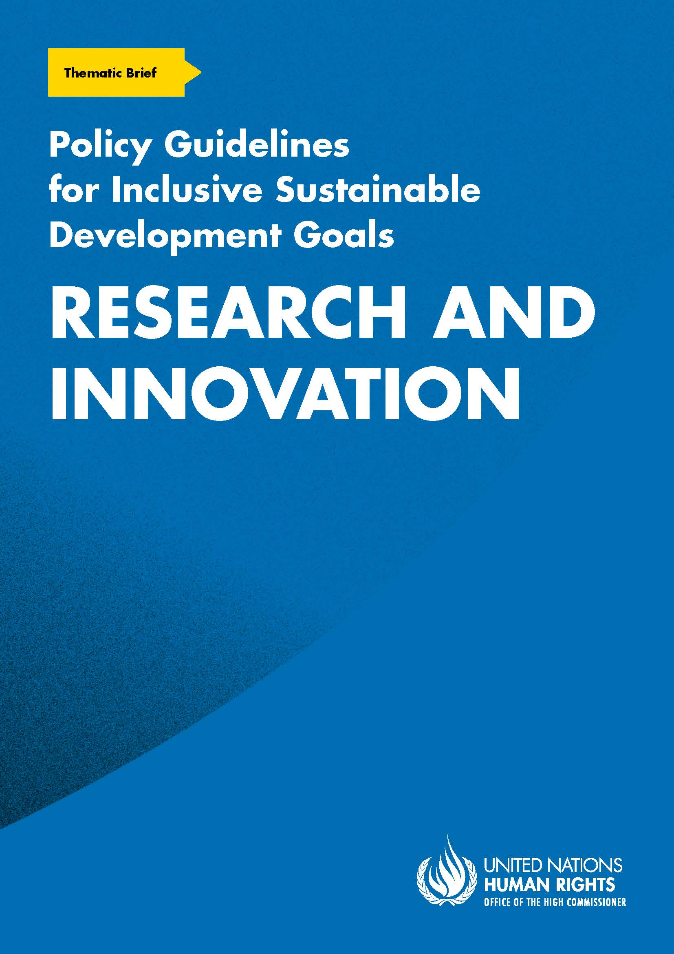
ADVANCE VERSION
© 2020 United Nations
The Policy Guidelines for Inclusive Sustainable Development Goals are a component of the SDG- CRPD Resource Package, developed by the Office of the United Nations High Commissioner for Human Rights (OHCHR). This is an advance version of the SDG-CRPD Resource Package. A final version will be issued upon completion of OHCHR review processes.
The designations employed and the presentation of the material herein do not imply the expression of any opinion whatsoever on the part of the Secretariat of the United Nations concerning the legal status of any country, territory, city or area, or of its authorities, or concerning the delimitation of its frontiers or boundaries.
Symbols of United Nations documents are composed of capital letters combined with figures. Mention of such a figure indicates a reference to a United Nations document.
Photography by Christian Tasso. The photographs featured within the Policy Guidelines were taken as part of the European Union project, Bridging the Gap II – Inclusive Policies and Services for Equal Rights of Persons with Disabilities, and were produced with the financial support of the European Union. They appear courtesy of the International and Ibero-American Foundation for Administration and Public Policies.
The Policy Guidelines for Inclusive Sustainable Development Goals were produced with the financial support of the European Union. Its contents are the sole responsibility of OHCHR and do not necessarily reflect the views of the European Union.
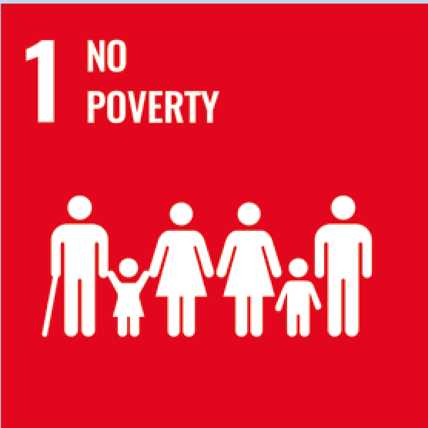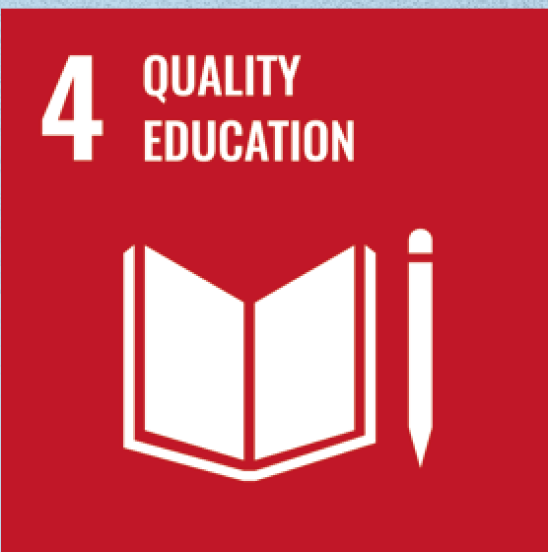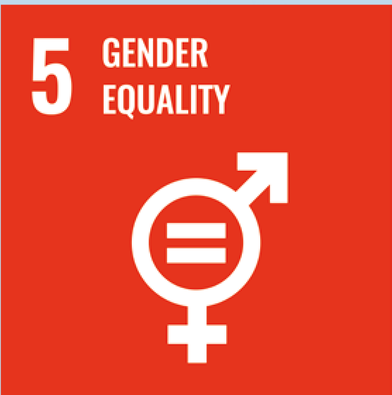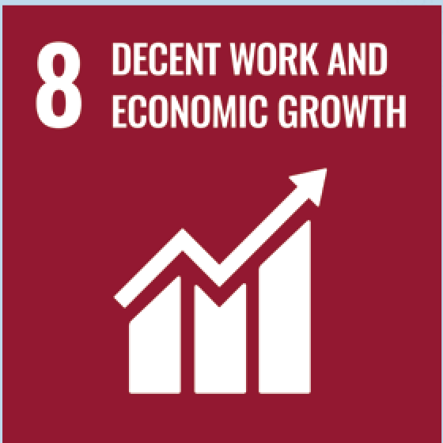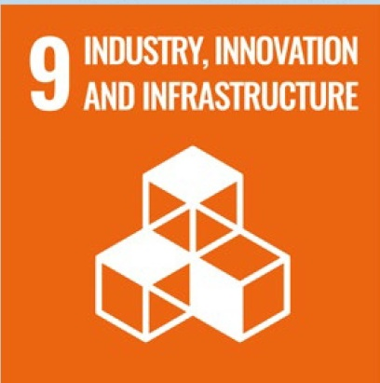

Contents
1. What is the situation? 6
2. What needs to be done? 8
3. DO’s and DON’Ts 17
4. Additional Resources 22
5. Key Concepts Annex 23

1. What is the situation?
Research and innovation play a key role in achieving sustainable development, leading to better outcomes for all people. However, most initiatives and policies governing research and innovation continue to prioritise economic growth and output (whereas benefits rarely reach marginalized communities, including persons with disabilities) and act to reinforce economic inequality.
Furthermore, there is an evidence gap regarding development approaches that ensure the equal participation of persons with disabilities across the world. For example: when making assistive devices and technologies available and affordable; or when combating widespread prejudice towards persons with disabilities (necessary to strengthen participation at home, school, the workplace and in the community).
Persons with disabilities continue to be excluded from development initiatives, including research and innovation. Although persons with disabilities make up 15 per cent of the world’s population, only 2 per cent of aid projects were targeted to persons with disabilities, between 2014-2018; and only 2 per cent of private funding on human rights was directed to persons with disabilities (see Figure I).
Figure I
Proportion (%) of aid projects and private funding targeting persons with disabilities
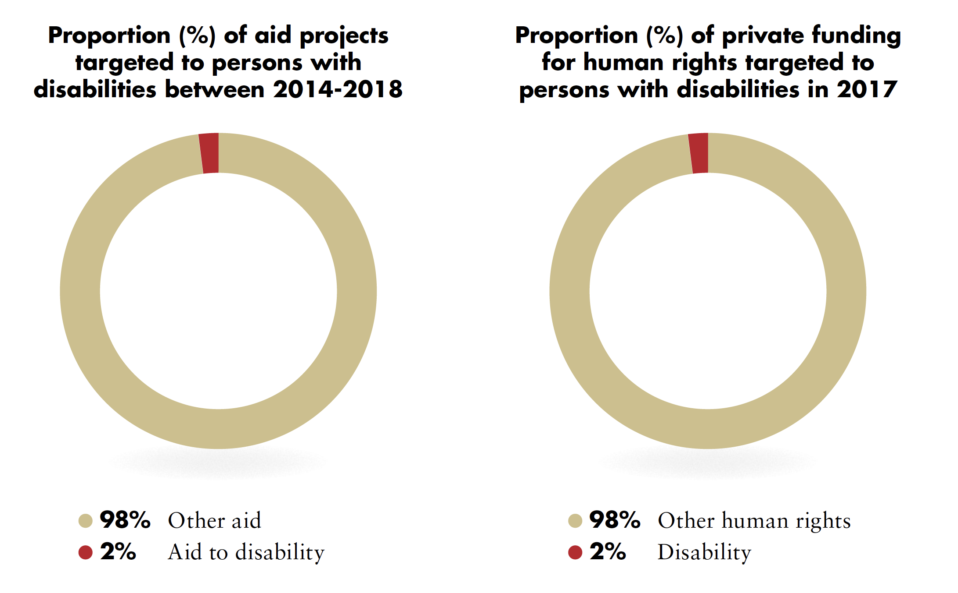
Source: Development initiatives based on OECD DAC CRS, as cited by Dan Walton, “Disability- Inclusive ODA: Aid data on Donors, channels, recipients”, Development Initiatives, 3 July2020; Candid and Human Rights Funders Network, “People with Disabilities 2017”,Advancing Human Rights: The State of Global Foundation Grantmaking, 2020
While projects and initiatives may aim to benefit the broader population and advance the development of society as a whole, if they are not inclusive of persons with disabilities, across the programme cycle, they may inadvertently widen the gap between persons with disabilities and the broader population. In addition, failure to consider the requirements of persons with disabilities can create new barriers to inclusion, further undermining their participation in society. Figure II represents the cycle of exclusion of persons with disabilities from research and development.

Figure II
Cycle of exclusion of persons with disabilities from research and development
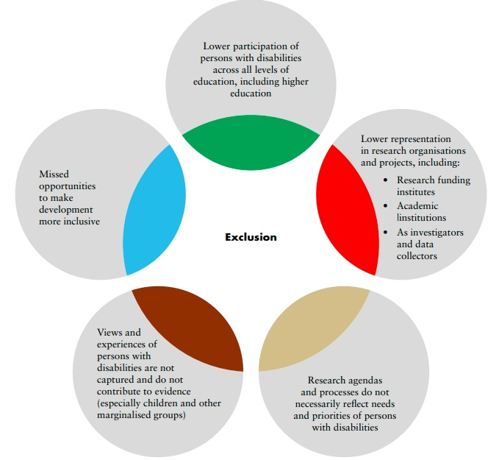
The OHCHR SDG-CRPD resource package includes a Data Sources Guidance for measuring progress in disability inclusion by providing examples of data sources. The guidance outlines that there are still gaps in data availability, with data collection methodologies yet to be fully implemented and data systems requiring further development. In the meantime, research can help bridge the data gap and inform policy and programme development. For example, community-driven data collection from organizations of persons with disabilities and other civil society organizations, as well as crowdsourcing of disability data, are innovative and important tools to address the gaps in data and information systems and to ensure that research findings reflect the lived experiences of those often excluded by mainstream approaches.

2. What needs to be done?
Research can drive the achievement of sustainable development and, in turn, the SDGs can shape research and innovation agendas (see Figure III), not only by promoting innovation but also by contributing to best practices for inclusive development, while navigating away from harmful development practices which might increase the marginalization of underrepresented groups.
Figure III
Research and innovation as drivers of the Sustainable Development Goals
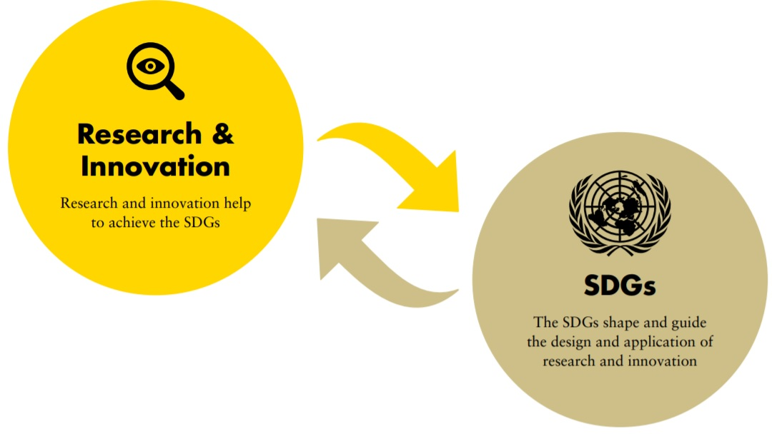
For persons with disabilities to benefit from sustainable development efforts, research institutions, decision-makers and practitioners across all disciplines require the knowledge and capacity to design, implement and share research and innovation initiatives that are inclusive of persons with disabilities. This includes setting inclusive research priorities, implementing inclusive research practices and using research findings to design sustainable solutions which promote individuals’ autonomy and independence, as well as more inclusive environments and societies.
SDG Goal 17 stresses that the collection of data, monitoring and accountability of the SDGs are crucial and that capacity-building support to low- and middle-income countries would significantly increase the availability of high-quality, timely and reliable data that is disaggregated by disability. Through strengthened partnerships and enhanced exchange of research and innovation, examples of inclusive development practices and innovative methodologies could serve as models from one sector (or country) to another.

Main areas of intervention to enable research and innovation inclusive of persons with disabilities
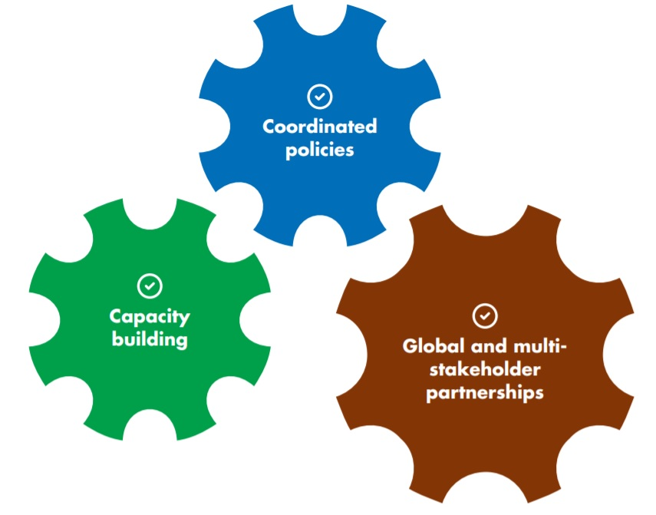

Coordinated policies to enable research and innovation that is inclusive of persons with disabilities

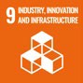 | 9.5 Enhance scientific research, upgrade the technological capabilities of industrial sectors in all countries, in particular developing countries, including, by 2030, encouraging innovation and substantially increasing the number of research and development workers per 1 million people and public and private research and development spending  9.b Support domestic technology development, research and innovation in developing countries, including by ensuring a conducive policy environment for, inter alia, industrial diversification and value addition to commodities
Carry out research and innovation that strengthens the inclusion of persons with disabilities |  | Adopt coordinated policies which recognise the role of research and innovation in realising the SDGs for all members of society, including persons with disabilities  Enable and provide incentives that foster research and the dissemination of technologies and drive innovation which benefits all members of the community, including persons with disabilities  Establish government agencies or councils responsible for inclusive research and innovation, which facilitates coordination across sectors and strengthens collaboration across government, industry, academia and communities, including persons with disabilities
Ensure the participation of persons with disabilities in research and innovation |  | Adopt measures which promote access to, and completion of, higher learning by persons with disabilities, including by making available grants and posts targeting researchers with disabilities  Apply participatory and emancipatory methodologies in undertaking research and innovation initiatives (from design to delivery), with the involvement of persons with disabilities, in all their diversity, and ensure the provision of reasonable accommodation to ensure their participation on an equal basis with others  Adopt ethical guidelines for research, which respect the informed consent (with the provision of support to express it, where necessary), confidentiality and privacy of participants and which upholds the principles and provisions of the CRPD  Engage persons with disabilities and their representative organizations in all decision-making related to research and innovation, including resource mobilisation and data collection; as members of research councils; and in the design, implementation, monitoring and evaluation of strategies and policies on research and innovation  Ensure that research outputs are accessible, available and returned to the disability community

Apply accessibility standards and universal design | Across all policies, protocols and guidelines relating to research and innovation initiatives, including:  - project design, implementation, monitoring and  - evaluation  - procurement  - consultations  - data colction  - information and awareness-raising  - creation of systems, products and services
Related CRPD Indicators: 1/4.6, 1/4.14, 1/4.21, 1/4.27, 9.1, 9.4, 9.6, 12.10, 20.2, 26.4, 26.7, 30.4, 31.2, 31.3, 31.9, 31.13, 31.14, 31.16 and 33.21.
The research cycle process needs to be inclusive of persons with disabilities and employ participatory and emancipatory approaches to empower persons with disabilities. A disability-inclusive approach to research, which intentionally includes persons with disabilities (including children with disabilities) throughout the research cycle (see Figure IV), is most likely to result in research projects and findings that reflect the requirements and priorities of persons with disabilities.
Figure IV
Disability-inclusion in the research cycle process
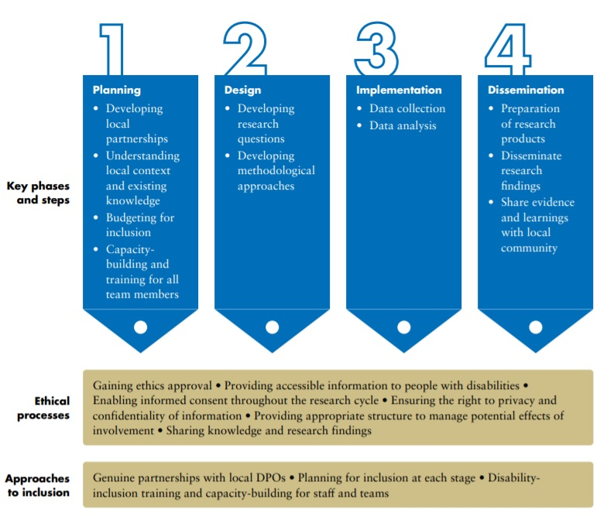
Source: Adapted from CBM-Nossal Partnership for Disability-inclusive Development and Research for Development Impact Network, Research for all: Making Development Research Inclusive of People with Disabilities (RDI Network, 2020).

Capacity building of stakeholders across sectors to enable research and innovation that is inclusive of persons with disabilities

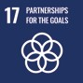 | 17.8 Fully operationalize the technology bank and science, technology and innovation capacity-building mechanism for least developed countries by 2017 and enhance the use of enabling technology, in particular information and communications technology
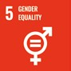 | 5.b Enhance the use of enabling technology, in particular information and communications technology, to promote the empowerment of women
 | 9.c Significantly increase access to information and communications technology and strive to provide universal and affordable access to the Internet in least developed countries by 2020
Capacity-building of stakeholders |  | Devise and deliver systematic training - for research councils; research, technology and innovation units across Ministries, industry and academia; procurement actors, etc., - on delivering research and innovation to achieve the SDGs, with the participation of marginalized groups and communities, including persons with disabilities and women and girls with disabilities  Ensure training and capacity building on:  - enhancing the use of technology and information and communications technologies (ICTs), to contribute to equitable and sustainable consumption and production by persons with disabilities and to promote their empowerment  - participatory and emancipatory research methodologies  - inclusive procurement  - the human rights-based approach to disability  - accessibility, universal design and the provision of reasonable accommodation  - data collection on persons with disabilities and disaggregation by disability, including on women and girls with disabilities
Enhance inclusive research and innovation across educational institutions |  | Invest in, promote and support multidisciplinary curricula and learning on inclusive research and innovation, across training and educational institutions, in all sectors - from design engineering to global policy. Curricula and learning should include:  - accessibility and assistive technology  - inclusive design and environments  - global technologies for disability and development  - research methods  - design thinking
Related CRPD Indicators: 1-4.18, 9.18, 12.2, 15/17.5, 20.15, 31.3, 31.8, 31.9, 32.1, 33.10 and 33.12

Global and multi-stakeholder partnerships to foster cross-sectoral research and innovation that is inclusive of persons with disabilities

17.16 Enhance the Global Partnership for Sustainable Development, complemented by multi-stakeholder partnerships that mobilize and share knowledge, expertise, technology and financial resources, to support the achievement of the Sustainable Development Goals in all countries, in particular developing countries
17.6 Enhance North-South, South-South and triangular regional and international cooperation on and access to science, technology and innovation and enhance knowledge sharing on mutually agreed terms, including through improved coordination among existing mechanisms, in particular at the United Nations level, and through a global technology facilitation mechanism
Strengthen partnerships for inclusion |  | Strengthen multi-stakeholder partnerships to develop research and innovation which is responsive to persons with disabilities, including:  - public/private partnerships  - global, regional and national collaboration  These partnerships should involve:  - policymakers  - international development actors  - persons with disabilities and their representative organizations  - higher education institutions, science and technology sectors and industry sector
Support and promote the sharing of disability- inclusive research and innovation resources |  | Facilitate the dissemination, sharing and fostering of knowledge, data, research, technology and innovation (including software, blueprints, research findings, etc.) across sectoral, public/private and industry divides, to achieve the SDGs  Mobilise and scale-up resources - from national budgets, international and private donors, development banks, etc. - allocated to research and innovation targeting social objectives that support the SDGs and are inclusive of persons with disabilities  Introduce a policy marker to track disability inclusion across all initiatives and spending concerning research and innovation - e.g., the disability marker of the Development Assistance Committee of the Organisation for Economic Co-operation and Development (OECD-DAC disability marker)
Related CRPD Indicators: 32.2, 32.7 and 32.15
Table I
Examples of how research and innovation contribute to achieving the SDGs for persons with disabilities

Research and innovation to: | Target | SDG
Develop affordable assistive technology and innovative modes of teaching and learning that enable persons with disabilities to participate in education, employment and other areas of life. | 1.4 By 2030, ensure that all men and women, in particular the poor and vulnerable, have equal rights to economic resources, as well as access to basic services, ownership and control over land and other forms of property, inheritance, natural resources, appropriate new technology and financial services, including microfinance
Eliminate coercive measures in health services, including in mental health services, and ensure quality, rights-based health services and support; identify and eliminate barriers to access and design more accessible and affordable health systems. | 3.8 Achieve universal health coverage, including financial risk protection, access to quality essential health-care services and access to safe, effective, quality and affordable essential medicines and vaccines for all
Design inclusive and accessible learning materials and software for students with disabilities; design innovative modes of teaching and learning, including digital learning; teacher and school leadership training for inclusive education. | 4.5 By 2030, eliminate gender disparities in education and ensure equal access to all levels of education and vocational training for the vulnerable, including persons with disabilities, indigenous peoples and children in vulnerable situations | 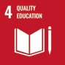
Develop microfinance products targeting persons with disabilities, including women and girls with disabilities. | 8.3 Promote development-oriented policies that support productive activities, decent job creation, entrepreneurship, creativity and innovation, and encourage the formalization and growth of micro-, small- and medium-sized enterprises, including through access to financial services | 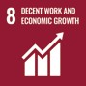

Develop awareness-raising strategies to combat prejudice and discrimination against persons with disabilities, including women and girls with disabilities, and including intersecting forms of discrimination relating to multiple layers of identity.  Design policies and programmes that ensure equal access to public and political life for women and girls with disabilities. | 5.1 End all forms of discrimination against all women and girls everywhere  5.5 Ensure women’s full and effective participation and equal opportunities for leadership at all levels of decision-making in political, economic and public life
Enhance the use of technology and ICTs to contribute to equitable and sustainable consumption and production, by persons with disabilities, and to promote their empowerment. | 9.1 Develop quality, reliable, sustainable and resilient infrastructure, including regional and transborder infrastructure, to support economic development and human well-being, with a focus on affordable and equitable access for all
Recognise the right to legal capacity of persons with disabilities and make supported decision-making mechanisms  - which uphold the autonomy, will and preferences of persons with disabilities - available across domains. | 10.3 Ensure equal opportunity and reduce inequalities of outcome, including by eliminating discriminatory laws, policies and practices and promoting appropriate legislation, policies and action in this regard
Develop guidance to improve access to justice by persons with disabilities, including women and girls with disabilities, and to enhance their participation in the administration of justice. | 16.3 Promote the rule of law at the national and international levels and ensure equal access to justice for all
Develop data disaggregation methodologies and capacity-building for national and local authorities (e.g. statistics offices, offices responsible for collecting administrative data, Ministries, municipalities) on systematic data collection and disaggregation by disability | 17.18 By 2020, enhance capacity-building support to developing countries, including for least developed countries and small island developing States, to increase significantly the availability of high- quality, timely and reliable data disaggregated by income, gender, age, race, ethnicity, migratory status, disability, geographic location and other characteristics relevant in national contexts

3. DO’s and DON’Ts
DO | DO NOT
Law, policy, and programmes
Adopt policies, and regulatory and governance frameworks that enable and provide incentives for fostering research, dissemination of technologies and innovation, to the benefit of persons with disabilities. | Sustain policies and regulations which are burdensome, inhibit research and innovation potential, or which narrow research, innovation and technology to economic growth and output.
Invest in, mandate and promote research to inform policy design in line with CRPD standards, with the involvement of the concerned groups of persons with disabilities. | Continue to invest, mandate or support research that maintains or develops practices contributing to the exclusion and marginalisation of persons with disabilities.
Reform public procurement systems to promote and favour research and innovation which is inclusive of, and accessible to, persons with disabilities, including vendors which promote disability inclusion in their own policies and practices. | Permit public procurement which disregards or ignores accessibility and usability requirements for persons with disabilities, or does not consider universal design.  Underestimate the impact procurement measures have on directing resources and practices, and on setting precedents for inclusion.
Utilise widely acknowledged standards and guidelines when it comes to accessibility, e.g. Universal Design guidelines, international standards on ICT such as WCAG 2.1, the European standard on accessibility requirements for ICT products and services EN 301 549 version 3.1. | Reinvent the wheel when it comes to accessibility standards; adopting new accessibility requirements fragments accepted practices and standards.
Adopt comprehensive strategies on research and innovation which address and coordinate a broad range of policy issues, and whose objectives are aligned with the Sustainable Development Goals to leave no one behind, including persons with disabilities. | Engage in fragmented approaches to research and innovation - through piecemeal policy measures - without an overarching expressed objective and commitment for research and innovation to the benefit of all members of society, including persons with disabilities.

DO | DO NOT
Adopt protocols and guiding principles which frame research and innovation, including:  - the recognition of research as an instrument for social change and for achieving the 2030 Agenda  - ensuring that research and innovation contribute to supporting low carbon economy and the environment  - to promote participatory and emancipatory approaches in research which prioritise the role of persons with disabilities, in all their diversity, in the areas that concern them  - ethical guidelines in accordance with the principles and provisions of the CRPD, developed in consultation with organizations of persons with disabilities including provisions on informed consent, privacy and confidentiality | Apply status quo approaches to research and innovation which:  - prioritise economic growth and perpetuate economic inequality to the detriment of those left furthest behind  - reproduce disadvantage and oppression  - hinder a low carbon economy and the environment  - are devoid of recognition to sustainability and engagement with society
Governance and inter-institutional coordination
Strengthen public/private partnerships and promote collaboration amongst policymakers, international development actors, persons with disabilities and their representative organizations, higher education institutions, science and technology sectors and industry, to ensure that research and innovation are responsive to issues impacting persons with disabilities. | Proceed with an isolated or siloed approach which sets priorities in sectoral isolation with minimal impact and sustainability.
Mobilise and scale-up resources allocated to research and innovation targeting social objectives that support the SDGs and are inclusive of persons with disabilities. | Concentrate resources according to economic gains and output, to the detriment of marginalized groups.

DO | DO NOT
Establish government agencies or councils specifically responsible for research and innovation, which:  - adopt measures to foster the participation of persons with disabilities among their personnel and membership  - systematically consult with and involve organizations of persons with disabilities, including of women and girls with disabilities, in the design, implementation, monitoring and evaluation of strategies and policies and on research and innovation that concerns them | Expect there to be coordination, coherence and commitment to research and innovation which is inclusive and serves all members of the community, without the adoption of an explicit objective for research and innovation to benefit all members of the society, including persons with disabilities.
Practice and implementation
Mandate participatory and emancipatory research methodologies to ensure that the design and delivery of research and innovation initiatives are led by, and respond to, the concerns of persons with disabilities, in all their diversity. | Overlook the lived experiences of individuals with disabilities and the transformative value of inclusive processes; nor consider them not central to research and innovation, in matters that impact or may impact them.
Ensure reasonable accommodation for researchers with disabilities, so that they may participate in activities on an equal basis with others. | Discriminate against researchers with disabilities by denying reasonable adjustments and modifications to environments, interactions and other practices which would secure their equal participation.
Provide adequate remuneration for the time and expertise of persons with disabilities taking part in research activities, based on the principle of equal pay for equal work. Expenses incurred by the individual related to research activities should also be covered, including costs of travel and personal assistance.  Remuneration and expenses should be foreseen in funding applications and budget planning of research projects. | Expect persons with disabilities to participate in research activities for free, on the basis that the research will serve their own interests.

DO | DO NOT
Information, communication and awareness-raising
Support the dissemination and sharing of resources, data, research and technology that promotes the inclusion of persons with disabilities across sectoral, public/private and industry divides. | Inhibit or overlook opportunities for the sharing and dissemination of knowledge, technology and research that promotes inclusion.
Ensure that all information and communication regarding research and innovation initiatives is provided in accessible formats and is inclusive in content. | Expect that persons with disabilities will be able to access information on research and innovations without its adaptation to diverse populations.
Training
Invest in training and capacity-building of stakeholders on disability-inclusive research and innovation, drawing on the lived experiences of persons with disabilities. | Overlook the opportunity to invest in training and capacity development on disability- inclusive research; nor deliver training without the input and participation of persons with disabilities, including women and girls with disabilities.
Participation
Engage in outreach and ensure the participation of persons with disabilities and their representative organizations in decision-making concerning research and innovation, particularly for inclusive sustainable development in line with the 2030 Agenda. | Overlook the lived experiences of persons with disabilities, nor consider them as not central to research and innovation in matters that impact or may impact them.
Accountability
Ensure that research findings are shared back with all stakeholders, including research participants at the community level, in a variety of accessible formats. | Overlook disseminating research findings with all stakeholders, including those who contributed to the research at the community level.

DO | DO NOT
Research and data collection and disaggregation
Institutionalise the collection of data and its disaggregation by disability and other categories, across all policy sectors concerning research and innovation. Disaggregate by disability to monitor and improve policies, programmes and investments. | Assume existing data collection suffices to capture, assess and improve the situation of persons with disabilities in the context of research and innovation projects.

4. Additional Resources
Anand, Manish and Shailly Kedia, Innovation Policy and Sustainable Development. Brief for GSDR 2015. New Delhi: The Energy and Resources Institute.
Arstein-Kerslake, A, and others. Introducing a human rights-based disability research methodology. Human Rights Law Review, vol. 00, (2020). p. 1–21.
Candid and Human Rights Funders Network. People with Disabilities 2017. Advancing Human Rights: The State of Global Foundation Grantmaking. 2020.
CBM-Nossal Partnership for Disability-inclusive Development and Research for Development Impact Network. Research for all: Making Development Research Inclusive of People with Disabilities. RDI Network, 2020.
Disability Human Rights Research Network, Protocol for Rights-based Disability Research in all Fields, 2018.
Holland, Alex, Yvette Maker and Anna Arstein-Kerslake. Working paper: Guidelines for producing accessible research outputs. Disability Research Initiative, University of Melbourne, 2018.
United Nations Conference on Trade and Development. New innovation approaches to support the implementation of the Sustainable Development Goals. New York; Geneva: United Nations, 2017.
United Nations Department of Economic and Social Affairs – Disability, UN Disability and Development Report - Realizing the SDG by, for and with persons with disabilities, 3 April 2019.
United Nations Development Programme. Innovation, 2020.
Walton, Dan. Disability-inclusive ODA: Aid data on donors, channels, recipients. Factsheet. Development Initiatives, 3 July 2020.
World Health Organization. Policy brief: Access to assistive technology, 2020.
World Health Organization. Global priority research agenda for improving access to high-quality affordable assistive technology, 2017.

5. Key Concepts Annex
Below are key foundational concepts referred to throughout the Policy Guidelines for Inclusive Sustainable Development Goals (SDG). The guide below is designed as a quick reference and refresher for readers as they use the guidelines. It is recommended that the guideline “Foundations for inclusive Sustainable Development Goal Implementation: Key concepts and structural requirements” is read prior to, or together with, other guidelines, for a deeper understanding of the required foundations for inclusion.

Concepts
Ableism considers certain typical characteristics of body and mind as essential for living a life of value. Ableist perspectives view impairments as undesired, which leads to unconscious bias, prejudice, discrimination and exclusion. Ableism is usually behind negative perceptions and stereotypes about persons with disabilities. See also Foundations Guideline, section 1.3
Accessibility is the quality that allows persons with disabilities to access and enjoy physical environments, transportation, facilities, services, information and communications, including new technologies and systems. When planning for accessibility, the principles of universal design should be used. See also Foundations Guideline, section 2.2.
Assistive technology, devices and mobility aids are external products (devices, equipment, instruments, software), specially produced or generally available, that maintain or improve an individual’s functioning and independence, participation, or overall well-being. Examples of assistive devices and technologies include wheelchairs, prostheses, hearing aids, visual aids and specialized computer software and hardware that improve mobility, hearing, vision, or the capacity to communicate. See also Foundations Guideline, section 2.3.
Awareness-raising actions are those that aim at informing about rights and changing negative attitudes towards persons with disabilities. They include training, campaigns, mass-media communications and more. Awareness-raising activities should target persons with disabilities and others and should involve persons with disabilities in their design and delivery. See also Foundations Guideline, section 2.5.
Barriers: Disability results from the interaction between persons with impairments and the barriers in the environment around them. Barriers can be broadly categorised into the following:
- Environmental barriers: those that are imposed by the context. They can be sub-categorized as:
- Physical barriers: such as the presence of steps, preventing access for someone using a wheelchair, or others with mobility difficulties.
- Communication barriers: such as the barriers to participation for a sign language user in a meeting if sign language interpreters are not provided, or the barrier to accessing information experienced by blind persons with written text, if accessible formats are not provided.
- Policy barriers: such as educational systems that prevent the enrolment of children with disabilities in their local school.
- Attitudinal barriers: such as the belief that persons with disabilities cannot learn or work. Attitudinal barriers can lead to apathy or inertia towards addressing other barriers. Attitudinal barriers can lead to apathy or inertia towards addressing other barriers.
In order for persons with disabilities to fully participate and access opportunities for development, the barriers that limit their participation should be systematically addressed. Persons with disabilities themselves are experts on identifying barriers and the solutions to overcome them. See also Foundations Guideline, section 1.1.
Disability assessment is the process of collecting information about persons with disabilities, in their context, for the purposes of policymaking and planning, budget allocation and to determine eligibility to certain benefits and entitlements. A disability assessment can also be used solely for the purpose of providing services such as rehabilitation or education. See also Foundations Guideline, section 3.2.2 and Policy Guideline on SDG 1.
Disability determination refers to the official decision (using assessment findings) about whether someone is identified as a person with disability, often also categorized according to their functional ability. In some countries, this can become an official status, symbolised by a disability card, registration, or similar, which can provide access to various services and benefits. There are often additional and/or different processes to determine eligibility for different types of social protection, insurance, health and support services. See also Foundations Guideline, section 3.2.2 and Policy Guideline on SDG 1.
Disability discrimination is described in the Convention on the Rights of Persons with Disabilities (Article 2) as “any distinction, exclusion or restriction on the basis of disability which has the purpose or effect of impairing or nullifying the recognition, enjoyment or exercise, on an equal basis with others, of all human rights and fundamental freedoms in the political, economic, social, cultural, civil or any other field. It includes all forms of discrimination, including denial of reasonable accommodation.” See also Foundations Guideline, section 2.1.
Disability mainstreaming is the process of ensuring that the rights of persons with disabilities are embedded in all policy, assessing policy implications for persons with disabilities, and ensuring their meaningful participation. It is the way of making the concerns and experiences of persons with disabilities an integral dimension of the design, implementation, monitoring and evaluation of policies and programmes in all political, economic and societal spheres so that persons with disabilities have equal benefits, and inequality is not perpetuated. The ultimate goal is to achieve equality of outcomes and foster an inclusive culture. Disability mainstreaming should be combined with disability-specific actions (see Twin-Track Approach). See also Foundations Guideline, section 3.2.1.
Extra-cost of disability refers to the higher expenditure of persons with disabilities and their households, when compared to the rest of the population. Extra-costs commonly stem from specific goods and services (e.g. mobility aids, personal assistance, accessible housing) and/or lack of access to general goods and services (e.g. more expensive health insurance, using taxis where public transport is not accessible). Disability extra-costs affect different policies. For more information, access the Centre for Inclusive Policy’s videos, “Understanding disability extra costs” and “Addressing disability extra costs”. See also Policy Guideline on SDG 1.
International cooperation is the interaction of persons or groups of persons representing various nations and diverse international and regional organisations striving towards the common goal of realizing the rights of persons with disabilities and the Convention on the Rights of Persons with Disabilities. Persons with disabilities, the organisations that represent them, and policymakers, collaborate through their ministries of international affairs, to receive technical and financial support from international organisations and development banks. Financial support designated for international cooperation shall not be used for measures contrary to the Convention on the Rights of Persons with Disabilities and shall be planned to be substituted with national funds, to ensure policy continuation. Technical cooperation among countries with similar realities is important to identify effective solutions. See also Foundations Guideline, section 8.
Intersectional discrimination refers to situations where discrimination is occurring on the basis of multiple and intersecting factors, including sex, gender, ethnicity, age, caste, class, faith, sexual orientation or any other characteristic. Persons with disabilities also have a gender identity, may come from an indigenous group, be young, old, a refugee or living in poverty. See also Foundations Guideline, section 5.3.
Legal capacity is the right to autonomously make legally valid decisions. Some countries restrict the right for adults with disabilities to manage their own financial affairs, including ownership of property, choose where to live and work, and manage their relationships, health and wellbeing.
Restricting or denying this right is against the Convention on the Rights of Persons with Disabilities and has negative effects across all policies. See also Foundations Guideline, section 5.5.
Organisations of persons with disabilities are led, directed, and governed by persons with disabilities. They are established at the local, national, regional or international level to promote and/ or defend the rights of persons with disabilities. A clear majority of the membership of such organisations should be recruited among persons with disabilities themselves. See also Foundations Guideline, section 2.4.
Participation of persons with disabilities refers to the action of allowing and enabling persons with disabilities to take part directly, or through organizations of persons with disabilities, in decision- making processes, including the design, implementation, monitoring and evaluation of policies. To do this, persons with disabilities should be closely consulted and actively involved in all decision-making processes, by being invited to give their opinions and take part in implementation processes.
Participation is an obligation to be met under the Convention on the Rights of Persons with Disabilities for all aspects of policy. “Nothing about us, without us” is the motto that promotes this obligation, and it means that no policy should be developed or implemented without persons with disabilities. See also Foundations Guideline, sections 2.4 and 4.
Persons with disabilities include those who have long-term physical, psychosocial, intellectual or sensory impairments which, in interaction with various barriers, may hinder their full and effective participation in society on an equal basis with others. Hence, persons with disabilities are persons with impairments who experience barriers that restrict their participation. See also Foundations Guideline, section 1.2.
Reasonable accommodation refers to modifications or adjustments made for a person with disability who requires them in a particular case, to facilitate participation on an equal basis with others. Reasonable accommodation must be provided on demand - that is, entities responsible for providing it cannot deny it by saying that they are progressively implementing measures. If arbitrarily denied, this constitutes discrimination.
Some examples include adjustments to the school hours of a student, extended breaks to rest, acquisition of computer software to read screens, a foldable ramp to overcome step(s) or providing a sign language interpreter in a work meeting. See also Foundations Guideline, sections 2.1 and 5.2.
Support for persons with disabilities encompasses a wide range of formal and informal interventions, including live assistance and intermediaries, mobility aids and assistive devices and technologies. It also includes personal assistance; support in decision-making; communication support, such as sign language interpreters and alternative and augmentative communication; mobility support, such as assistive technology or service animals; living arrangements services for securing housing and household help; and community services. Persons with disabilities may require support to perform daily life activities and/or use general services, such as health, education and justice, on an equal basis with others. See also Foundations Guideline, section 2.3.
Supported decision-making is a type of support given to persons with disabilities in relation to legal decisions. This mechanism guarantees that: (i) persons with disabilities exercise their legal capacity (see above) and can make their own decisions in every aspect of life; and (ii) their decisions are not replaced by the decisions of guardians or others. Supported decision-making is voluntary and can include informal and formal support arrangements. For example, a person with disability may choose a trusted person to support them in making certain types of legal decisions. They may also resort to peer support or self-advocacy networks. Some persons with disabilities may access support to help in the communication of their will and preference. See also Foundations Guideline, section 5.5.
Twin track approach is a strategy to develop policies that:
- systematically mainstreams the interests and rights of persons with disabilities in policy design and implementation, across all sectors and areas of life
- adopts targeted policy and programming measures aimed specifically at persons with disabilities
The balance between mainstreaming strategies and targeted support strategies should be tailored to address the needs of specific communities. See also Foundations Guideline, section 3.2.1.
Universal design is the design and composition of products, environments, programmes and services so that they can be accessed, understood and used to the greatest extent possible by all people, regardless of their age, size, ability or disability, and without the need for adaptation or specialized design. The principles of universal design facilitate accessibility, including for persons with disabilities. See also Foundations Guideline, section 2.2.
The Washington Group Short Set is a set of six questions on functioning, designed to be used within national censuses and surveys. The questions are designed to provide comparable data cross- nationally, for populations living in a variety of cultures, with varying economic resources. While not exhaustive, the basic actions represented in this set of six questions are those that are most often found to limit an individual, and result in participation restrictions. The information that results from the use of these questions will (a) represent the majority of, but not all, persons with limitation in basic actions, (b) represent the most commonly occurring limitations in basic actions, and (c) be able to capture persons with similar difficulties across countries. See also Foundations Guideline, section 3.5.

Office of the United Nations
High Commissioner for Human Rights (OHCHR)
Palais de Nations
CH 1211 Geneva 10 – Switzerland
Email: disability@ohchr.org
Website: www.ohchr.org

