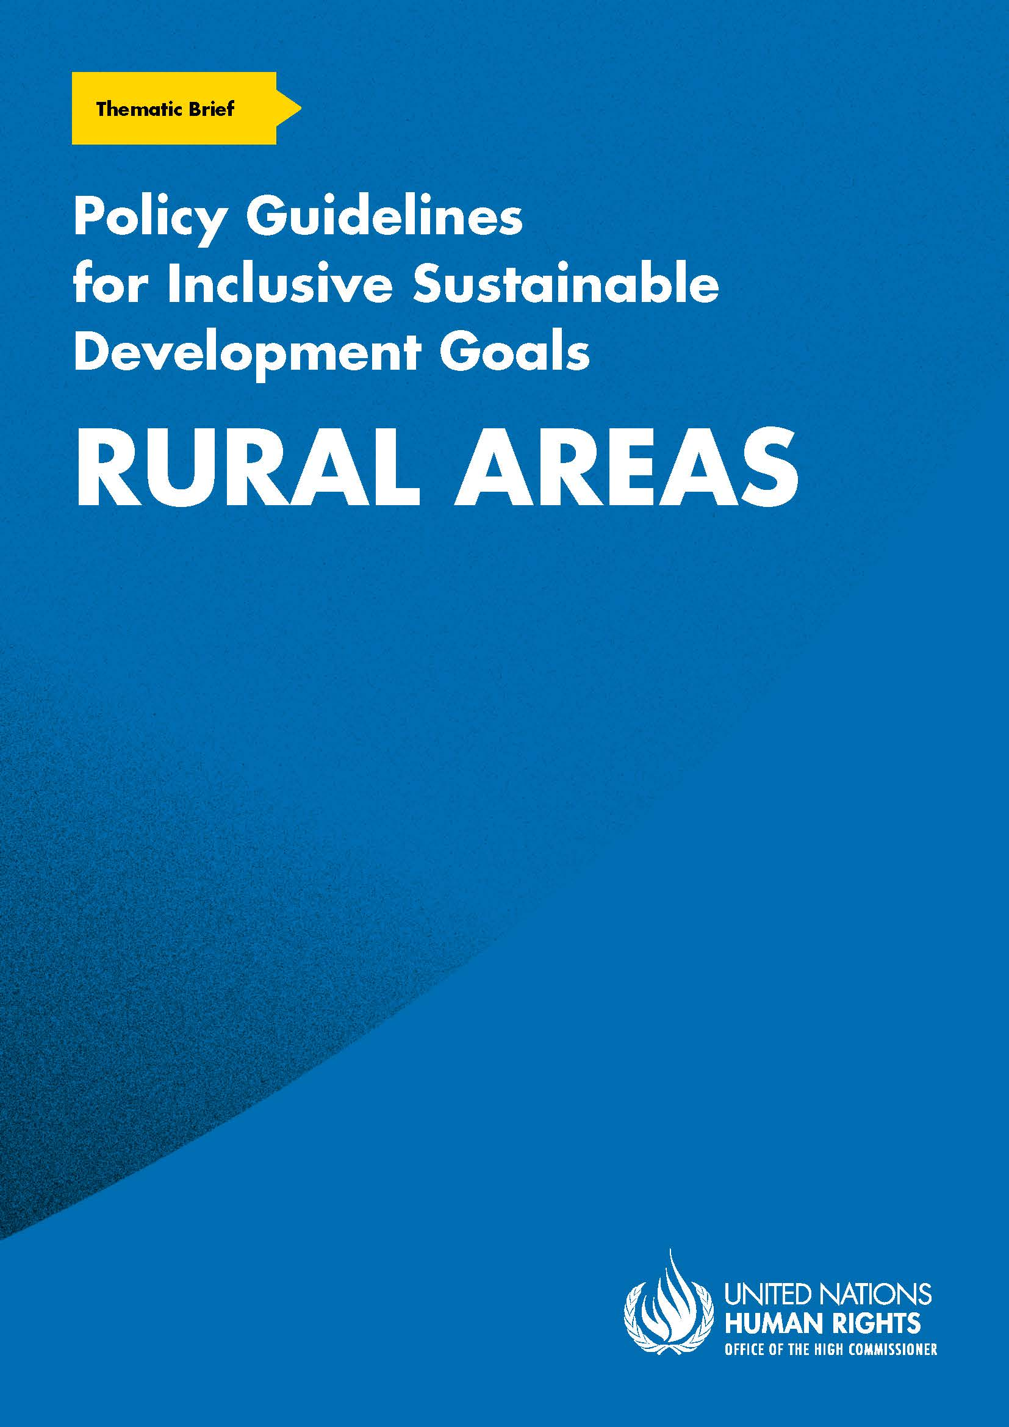
ADVANCE VERSION
© 2020 United Nations
The Policy Guidelines for Inclusive Sustainable Development Goals are a component of the SDG- CRPD Resource Package, developed by the Office of the United Nations High Commissioner for Human Rights (OHCHR). This is an advance version of the SDG-CRPD Resource Package. A final version will be issued upon completion of OHCHR review processes.
The designations employed and the presentation of the material herein do not imply the expression of any opinion whatsoever on the part of the Secretariat of the United Nations concerning the legal status of any country, territory, city or area, or of its authorities, or concerning the delimitation of its frontiers or boundaries.
Symbols of United Nations documents are composed of capital letters combined with figures. Mention of such a figure indicates a reference to a United Nations document.
Photography by Christian Tasso. The photographs featured within the Policy Guidelines were taken as part of the European Union project, Bridging the Gap II – Inclusive Policies and Services for Equal Rights of Persons with Disabilities, and were produced with the financial support of the European Union. They appear courtesy of the International and Ibero-American Foundation for Administration and Public Policies.
The Policy Guidelines for Inclusive Sustainable Development Goals were produced with the financial support of the European Union. Its contents are the sole responsibility of OHCHR and do not necessarily reflect the views of the European Union.
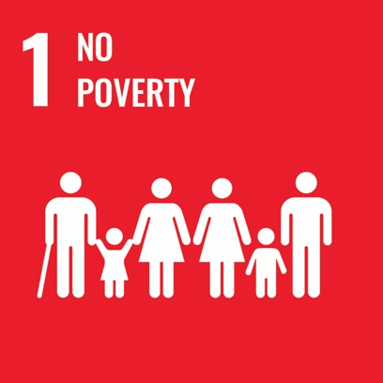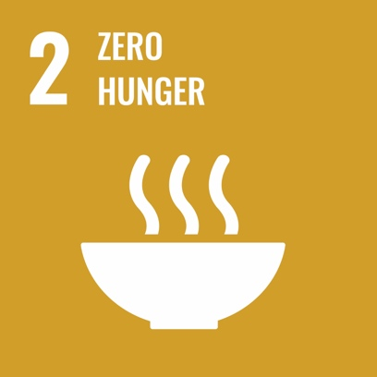
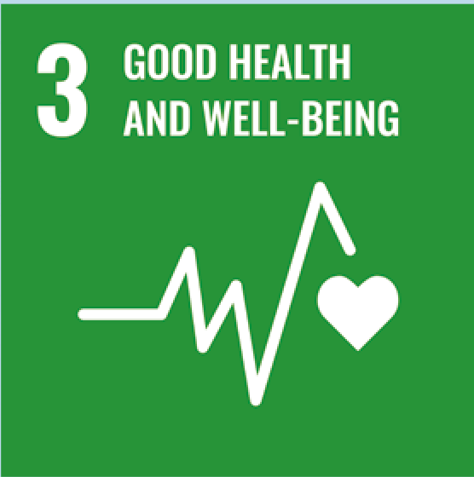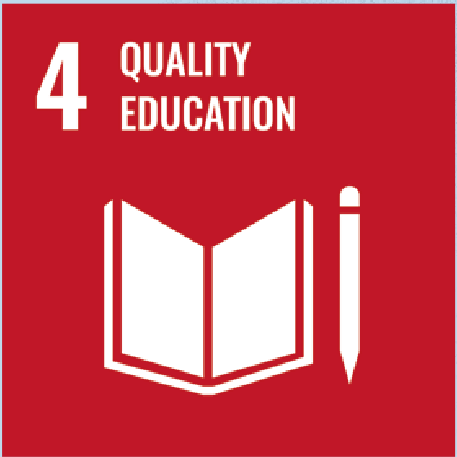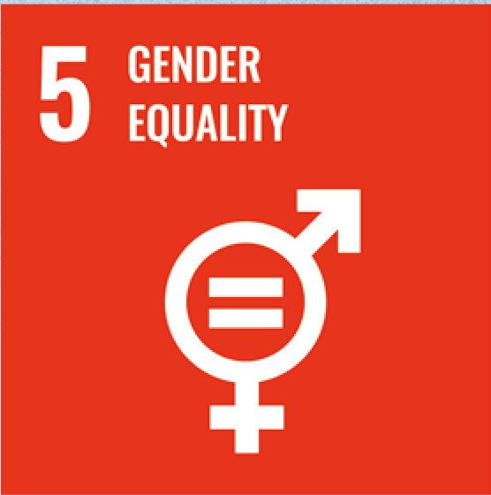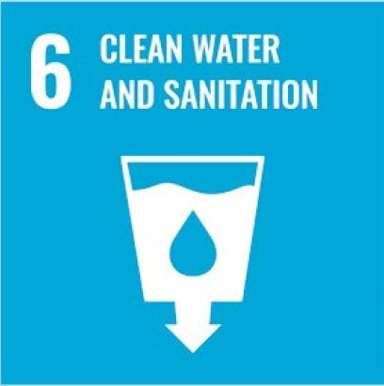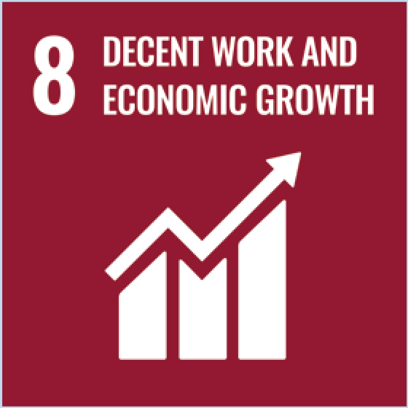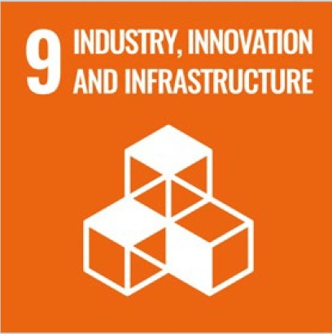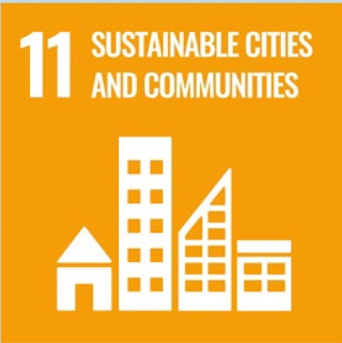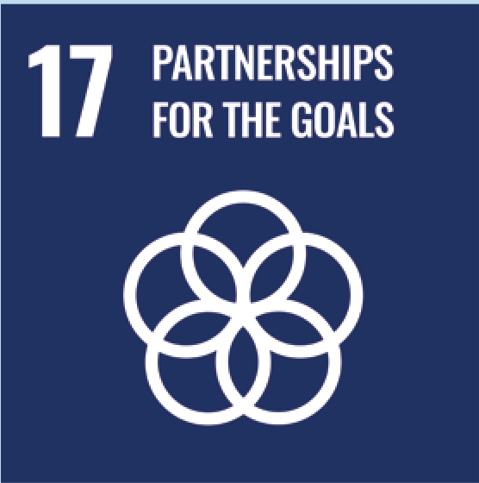

Contents
1. What is the situation? 6
2. What needs to be done? 7
3. DO’s and DON’Ts 15
4. Additional Resources 18
5. Key Concepts Annex 19

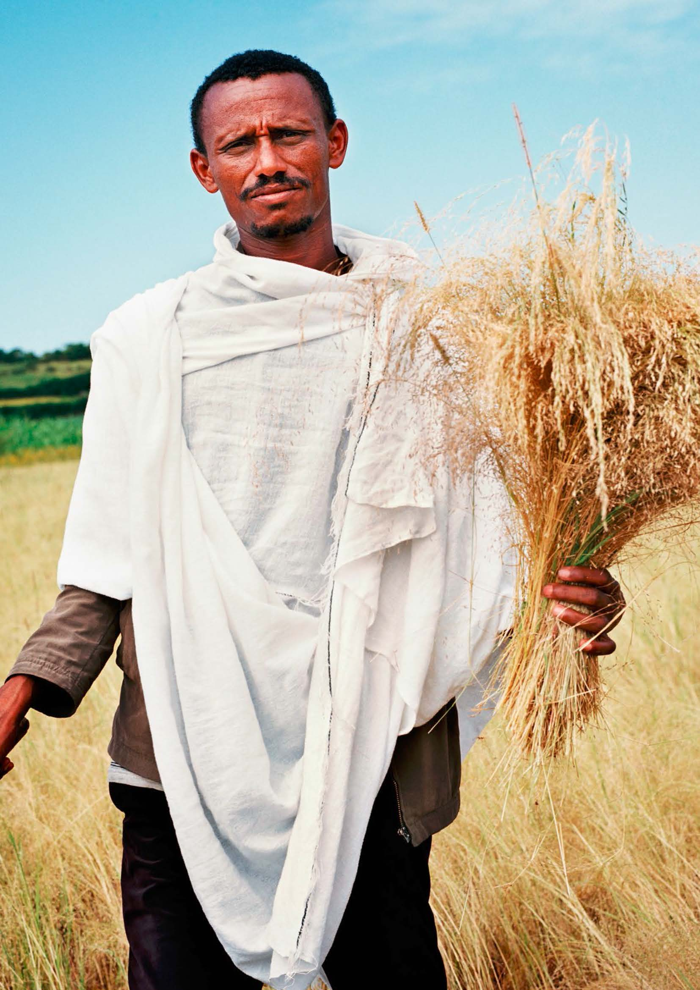

1. What is the situation?
Persons with disabilities make up approximately 15 per cent of the world’s population. Evidence shows that the impact of disability is exacerbated by poverty and by limited access to basic services such as information, education and healthcare.
Compared to those in urban areas, persons with disabilities in rural areas face greater barriers to accessing basic services, especially healthcare and rehabilitation services. Whilst data is scarce, community-driven evidence reveals that constraints exist, such as unaffordable transport fees and high costs for services such as healthcare and education. Other constraints include inaccessible physical infrastructure, transportation and information, as well as limited economic empowerment opportunities. These experiences (depicted in Figure I) serve to further marginalise and isolate persons with disabilities in rural areas from mainstream community life and, consequently, contribute to increased poverty and social exclusion.
Figure I
Barriers to accessing services faced by persons with disabilities living in rural areas
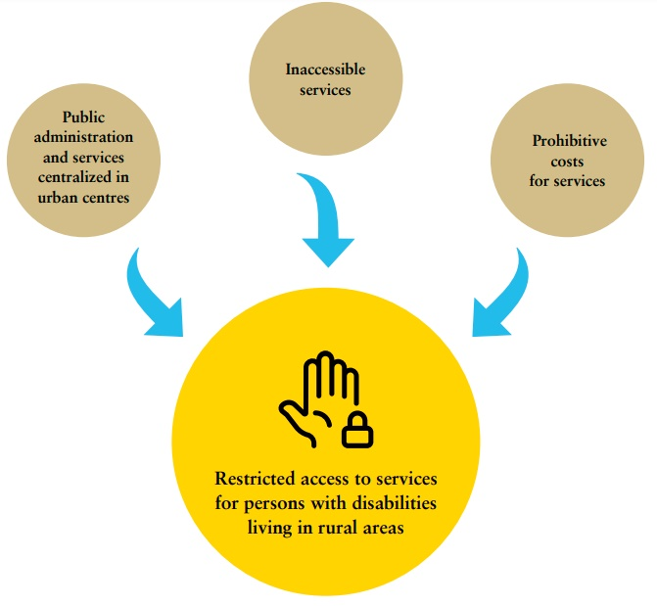

2. What needs to be done?
Disability inclusive development, as part of the Sustainable Development Goals (SDGs) implementation, requires serious consideration of persons with disabilities in rural areas and of the challenges they experience. A number of the SDG targets and/or their related indicators explicitly mention ‘rural areas’. For instance, the SDG indicators framework requires the collection of data “disaggregated, where relevant, by income, sex, age, race, ethnicity, migratory status, disability and geographic location.” This provides an entry point to implement disability-inclusive services and programs that address the requirements of persons with disabilities in rural areas.
This brief provides recommendations for policymakers and service providers, to ensure SDG implementation is inclusive of persons with disabilities living in rural areas.
Main areas of intervention for disability inclusion in rural areas
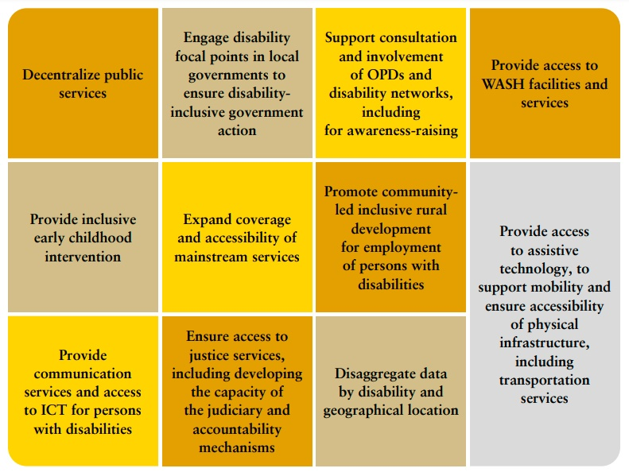

Decentralize public services
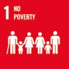 | 1.3 Implement nationally appropriate social protection systems and measures for all, including floors, and by 2030 achieve substantial coverage of the poor and the vulnerable
16.6 Develop effective, accountable and transparent institutions at all levels.
16.9 By 2030, provide legal identity for all, including birth registration
Ensure that public goods and services are available, sufficiently resourced and accessible to persons with disabilities in rural areas (e.g. post offices and services, civil registries, tax offices, public banking services).
Ensure the provision of disability-inclusive social protection services.
Related CRPD Indicators: 19.12, 19.13, 19.24, 19.35, 19.36, 19.37, 28.3, 28.4, 28.9, 28.10,
28.16, 28.17, 28.22, 28.23, 28.24 and 28.25.

Engage disability focal points in local governments to ensure disability-inclusive government actions
16.7 Ensure responsive, inclusive, participatory and representative decision-making at all levels.
Establish disability focal points to oversee the planning and implementation of disability-inclusive local policy design, including consultations with persons with disabilities in rural areas.
Encourage disability focal points to form collaborative partnerships with organisations of persons with disabilities (OPDs) and local leaders with disabilities.
Related CRPD Indicators: 33.1, 33.3 and 33.11

Support consultation and involvement of OPDs and disability networks, including for awareness-raising
 | 16.6 Develop effective, accountable and transparent institutions at all levels.
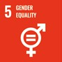 | 5.5 Ensure women’s full and effective participation and equal opportunities for leadership at all levels of decision-making in political, economic and public life.
Provide capacity-building support to OPDs, disability networks and leaders, including women and girls with disabilities, to enable them to effectively participate in consultations on decisions concerning issues relating to them.
Work with OPDs and disability networks to raise awareness and combat stereotypes and prejudice in rural areas, including for women and girls with disabilities.
Related CRPD Indicators: 1/4.9, 1/4.16, 1/4.17, 1/4.18, 1/4.29, 33.20

Provide access to WASH facilities and services
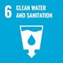 | 6.6 By 2020, protect and restore water-related ecosystems, including mountains, forests, wetlands, rivers, aquifers and lakes.
Provide disability-inclusive WASH facilities and services to persons with disabilities living in rural areas.
Ensure the dissemination of accessible WASH information.
Increase the number of disability-inclusive communal water points and accessible public toilet and handwashing facilities.
Ensure the provision of reasonable accommodation and support to persons with disabilities concerning water distribution services.
Related CRPD Indicators: 28.2, 28.8, 28.20, 28.21, 24.11

Provide inclusive early childhood intervention
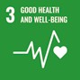 | 3.2 By 2030, end preventable deaths of newborns and children under 5 years of age, with all countries aiming to reduce neonatal mortality to at least as low as 12 per 1,000 live births and under-5 mortality to at least as low as 25 per 1,000 live births
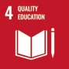 | 4.2 By 2030, ensure that all girls and boys have access to quality early childhood development, care and pre-primary education so that they are ready for primary education
Ensure inclusive and targeted early childhood development programmes, integrated into existing healthcare and education systems, including for women and girls with disabilities.
Ensure that early identification and assessment systems inform early intervention, to promote the inclusion of children with disabilities in early education and prevent impairment-related complications.
Provide adequate rehabilitation services and equipment, such as physiotherapy and assistive technologies (e.g. walking sticks, eyeglasses).
Ensure that assessments tailor early intervention measures to the child’s context and identity, including gender, and to the barriers they face.
Provide regular outreach and periodic check-ups, as part of extension services, to children with disabilities in rural areas, including girls with disabilities
Related CRPD Indicators: 8.2, 8.7, 24.4, 25.3, 20.2, 26.5

Expand coverage and accessibility of mainstream services
3.8 Achieve universal health coverage, including financial risk protection, access to quality essential health-care services and access to safe, effective, quality and affordable essential medicines and vaccines for all
3.c. Substantially increase health financing and the recruitment, development, training and retention of the health workforce in developing countries, especially in least developed countries and small island developing States
4.5 By 2030, eliminate gender disparities in education and ensure equal access to all levels of education and vocational training for the vulnerable, including persons with disabilities, indigenous peoples and children in vulnerable situations
Provide well-resourced services for health and education in rural areas to enable access to these services for all persons with disabilities, including women and girls with disabilities.
Ensure accessibility of facilities and information and communications technology (ICT) -including equipment (e.g. construction of health and school facilities, provision of interpreters in health centres and schools).
Related CRPD Indicators: 24.1, 24.10, 24.11, 24.27, 24.28, 24.29, 24.30, 25.1, 25.4, 25.16, 25.18, 25.19, 25.21 to 25.28

Promote community-led inclusive rural development for employment of persons with disabilities
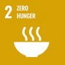 | 2.3 By 2030, double the agricultural productivity and incomes of small-scale food producers, in particular women, indigenous peoples, family farmers, pastoralists and fishers, including through secure and equal access to land, other productive resources and inputs, knowledge, financial services, markets and opportunities for value addition and non-farm employment
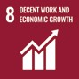 | 8.5 By 2030, achieve full and productive employment and decent work for all women and men, including for young people and persons with disabilities, and equal pay for work of equal value
Ensure that community-led development in rural areas is participatory and disability-inclusive.
Provide specific measures targeting persons with disabilities to increase their access to employment (including self-employment), with particular attention to agricultural development. For example:
- create income generation opportunities for rural persons with disabilities, including women and girls with disabilities, taking into account the disability-related barriers they face
- build upon the agro-technical, entrepreneurial and business skills of farmers with disabilities
- upgrade agricultural technologies to meet the specific requirements of workers with disabilities
- make rural advisory services relevant to farmers with disabilities
- make social protection systems responsive to the requirements of rural persons with disabilities
- promote the full participation of farmers with disabilities in decision-making processes around agriculture
Ensure the availability of financial services and aid for persons with disabilities, including women with disabilities and small producers in agriculture and farming.
Related CRPD indicators 27.3, 27.4, 27.6, 27.7, 27.13, 27.14, 27.15, 27.19, 27.20, 27.21, 27.23 and 27.25.

Provide access to assistive technologies, to support mobility and ensure accessibility of physical infrastructures, including transportation services
 | 1.4 By 2030, ensure that all men and women, in particular the poor and the vulnerable, have equal rights to economic resources, as well as access to basic services, ownership and control over land and other forms of property, inheritance, natural resources, appropriate new technology and financial services, including microfinance
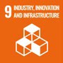 | 9.1 Develop quality, reliable, sustainable and resilient infrastructure, including regional and transborder infrastructure, to support economic development and human well-being, with a focus on affordable and equitable access for all
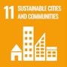 | 11.a Support positive economic, social and environmental links between urban, peri- urban and rural areas by strengthening national and regional development planning.
Use a person-centred approach to design mobility services in the community. For instance, ensure that access to mobility services (such as the provision of wheelchairs) is supported by relevant complementary services (such as wheelchair repair services, occupational therapists and accessible footpaths and roads).
Related CRPD indicators 9.7, 9.8, 9.9, 9.22, 9.24, 20.2, 20.3, 20.4, 20.6, 20.8, 20.19, 20.20, 20.21, 20.22 and 20.25

Provide communication services and access to ICT for persons with disabilities
1.4 By 2030, ensure that all men and women, in particular the poor and the vulnerable, have equal rights to economic resources, as well as access to basic services, ownership and control over land and other forms of property, inheritance, natural resources, appropriate new technology and financial services, including microfinance
Make communication services affordable and accessible for persons with disabilities in rural areas, particularly in isolated regions.
Ensure that measures to increase access are accompanied by measures to improve the digital literacy and digital protection of persons with disabilities (including at the local level), such as training, guidance and support.
Related CRPD Indicators: 9.5, 9.6, 9.12, 9.25 and 9.26.

Ensure access to justice services, including developing the capacity of the judiciary and accountability mechanisms
16.3 Promote the rule of law at the national and international levels and ensure equal access to justice for all
16.a Strengthen relevant national institutions, including through international cooperation, for building capacity at all levels, in particular in developing countries, to prevent violence and combat terrorism and crime
Provide affordable and disability-inclusive legal assistance services, at the local level, that are accessible to persons with disabilities in rural areas, including women and girls with disabilities.
Enable communications through a range of accessible modes and means, e.g. online, phone, post, Braille and sign language including interpreter services.
Review judicial procedures to ensure accessibility and participation of persons with disabilities from rural areas, including women and girls with disabilities (e.g. provision of procedural accommodations, accessible remote participation in proceedings, mobile clinics).
Provide training for judicial staff on ensuring access to justice for persons with disabilities, including through accessible communication, provision of procedural accommodations, recognition of legal capacity and by combating disability and gender stereotypes.
Related CRPD Indicators: 13.1, 13.4, 13.5, 13.6, 13.8, 13.12, 13.14 and 13.16.

Disaggregate data by disability and geographical location
17.18 By 2020, enhance capacity-building support to developing countries, including for least developed countries and small island developing States, to increase significantly the availability of high-quality, timely and reliable data disaggregated by income, gender, age, race, ethnicity, migratory status, disability, geographic location and other characteristics relevant in national contexts.
Collect disability-disaggregated data in programmes implemented in rural areas.
Ensure that administrative data held by local governments are disaggregated by geographical location and disability (including by impairment type), as well as age, sex and other socio-economic variables.
Make use of disaggregated data to identify gaps and strengthen policy design and implementation activities.
Consult and involve OPDs and disability networks in data collection, systematization and disaggregation.
Related CRPD Indicators: 31.1, 31.2, 31.3, 31.7, 31.9, 31.16 and 31.18.

3. DO’s and DON’Ts
DO | DO NOT
Governance, inter-institutional coordination
Encourage the appointment, within local governments, of disability focal points and enhance their capacity to develop inclusive policies, as well as disability-specific interventions which also consider gender and age perspectives. | Limit disability-related expertise to national or central governments; nor ignore local and community levels of government and the role they can play in ensuring disability inclusion in rural areas.
Plan and coordinate with local governments to decentralize public services (e.g. civil registries), ensuring the allocation of appropriate resources and capacity-building. | Maintain centralised public administration and social protection structures that prevent access to services and benefits by persons with disabilities in rural areas.
Coordinate with local governments to establish outreach mechanisms that ensure that public services and the social protection system proactively reach persons with disabilities in rural and remote areas. | Limit efforts to expand coverage of public services and social protection for persons with disabilities beyond urban centres.
Practice and implementation
Adopt measures and support projects for community-led inclusive rural development to foster employment and involvement of persons with disabilities, in particular women with disabilities, in both agriculture and non-farm work. | Underestimate the capacity of persons with disabilities in rural areas, including women and girls with disabilities, to participate in planning and engage in livelihood activities; nor leave their support requirements unattended.
Ensure the availability, across rural areas, of early childhood intervention and community- based support services that are inclusive of children with disabilities and their families. | Leave the requirements for early intervention and support of children with disabilities and their families unattended, nor rely on forms of institutionalisation that prompt family separation or encourage neglect or abandonment.

DO | DO NOT
Expand primary, secondary and continuing care, including specialized health care services, close to rural areas and provide for outreach measures and reasonable accommodation for persons with disabilities, including by providing incentives to health and rehabilitation professionals. | Limit the provision of health care in rural areas to primary health care, with referrals to urban centres for higher levels of care;  do not assume that it is feasible to rely on a passive approach, requiring persons with disabilities from rural areas to make requests; nor overlook the requirement for incentives to retain the health workforce in rural areas.
Implement measures to make education in rural areas inclusive of children with disabilities, including by training teachers, providing accessible materials and facilitating support, as required, and developing professional incentives to retain teachers. | Promote the referral of students with disabilities from rural areas to special schools and/or residential schools in urban areas; nor automatically prioritize referral to inclusive schools in urban areas without having exhausted alternatives to provide adequate support in local schools.
Information, communication and awareness-raising
Adopt measures to enhance accessibility in all its dimensions. For instance, coordinate access to assistive technologies for mobility with adaptations to the built environment (e.g. ramps, accessible footpaths, and tactile signage). | Overlook, nor leave uncoordinated, efforts to improve accessibility in all its dimensions.
Improve access for persons with disabilities in rural areas to ICT (e.g. internet, smartphones) and provide accessible guidance to ensure access to digital public services and  e-government. | Miss the opportunity provided by ICT to reach persons with disabilities in rural areas, facilitate administrative services, and enhance participation and access to information.
Participation
Support the development of organizations of persons with disabilities (OPDs), disability networks and leaders with disabilities at the local levels, to engage with interlocutors and be involved in policymaking and implementation | Design nor adopt policies that will impact persons with disabilities in rural areas without consulting or involving them, at the local and community levels.

DO | DO NOT
Data collection and disaggregation, and research
Ensure that data collection efforts adequately capture the situation of persons with disabilities in rural areas and disaggregate and analyse data considering sex, age, disability and geographical location. | Miss the opportunity to collect and analyse data inclusive of disability, geographical location and other characteristics, including data related to the informal economy, to better assess the situation of persons with disabilities in rural areas.
Develop satisfaction surveys on public administration and other services that target persons with disabilities in rural areas, ensuring that surveys are representative and enable comparison by sex, age and type of impairment. | Disregard accessibility and other specific concerns of persons with disabilities in satisfaction surveys about public administration and other services; nor limit data disaggregation and analysis of experiences of the diversity of persons with disabilities in rural areas.
Accountability
Establish legal assistance, at local and community levels, that is accessible and responsive to the requirements of persons with disabilities and recognizes their legal capacity. | Overlook the need to make legal aid available and accessible to persons with disabilities; nor accept substituted decision-making and representation (e.g. requiring interacting with a guardian).
Adopt measures to develop the capacity of legal practitioners and the justice system to be inclusive of persons with disabilities from rural areas and ensure the provision of procedural accommodations. | Limit access by persons with disabilities from rural areas to accessible complaint mechanisms (e.g. online or via mobile phones).

4. Additional Resources
Eskola, Tina. Empowering People with Disabilities for Rural Development. ILO, 2011.
Food and Agriculture Organization of the United Nations. Achieving the Sustainable Development Goals requires investing in rural areas. Policy Brief 3, October 2017.
Fundación ONCE and International Labour Organization Global Business and Disability Network.
Making the future of work inclusive of people with disabilities. 21 November 2019.
United Nations, Committee on the Rights of Persons with Disabilities. General comment No. 2 (2014), Article 9: Accessibility. 22 May 2014. CRPD/C/GC/2.
United Nations, Committee on the Rights of Persons with Disabilities. General comment No. 7 (2018) on the participation of persons with disabilities, including children with disabilities, through their representative organizations, in the implementation and monitoring of the Convention,
9 November 2018, CRPD/C/GC/7.
United Nations, Human Rights Council. Thematic study by the Office of the United Nations High Commissioner for Human Rights on right to access to justice under article 13 of the Convention on the Rights of Persons with Disabilities. 27 December 2017. A/HRC/37/25.
Special Rapporteur on the rights of persons with disabilities, CRPD Committee and Special Envoy of the Secretary-General on Disability and Accessibility. International principles and guidelines on access to justice for persons with disabilities. Geneva, August 2020.

5. Key Concepts Annex
Below are key foundational concepts referred to throughout the Policy Guidelines for Inclusive Sustainable Development Goals (SDG). The guide below is designed as a quick reference and refresher for readers as they use the guidelines. It is recommended that the guideline “Foundations for inclusive Sustainable Development Goal Implementation: Key concepts and structural requirements” is read prior to, or together with, other guidelines, for a deeper understanding of the required foundations for inclusion.

Concepts
Ableism considers certain typical characteristics of body and mind as essential for living a life of value. Ableist perspectives view impairments as undesired, which leads to unconscious bias, prejudice, discrimination and exclusion. Ableism is usually behind negative perceptions and stereotypes about persons with disabilities. See also Foundations Guideline, section 1.3
Accessibility is the quality that allows persons with disabilities to access and enjoy physical environments, transportation, facilities, services, information and communications, including new technologies and systems. When planning for accessibility, the principles of universal design should be used. See also Foundations Guideline, section 2.2.
Assistive technology, devices and mobility aids are external products (devices, equipment, instruments, software), specially produced or generally available, that maintain or improve an individual’s functioning and independence, participation, or overall well-being. Examples of assistive devices and technologies include wheelchairs, prostheses, hearing aids, visual aids and specialized computer software and hardware that improve mobility, hearing, vision, or the capacity to communicate. See also Foundations Guideline, section 2.3.
Awareness-raising actions are those that aim at informing about rights and changing negative attitudes towards persons with disabilities. They include training, campaigns, mass-media communications and more. Awareness-raising activities should target persons with disabilities and others and should involve persons with disabilities in their design and delivery. See also Foundations Guideline, section 2.5.
Barriers: Disability results from the interaction between persons with impairments and the barriers in the environment around them. Barriers can be broadly categorised into the following:
- Environmental barriers: those that are imposed by the context. They can be sub-categorized as:
- Physical barriers: such as the presence of steps, preventing access for someone using a wheelchair, or others with mobility difficulties.
- Communication barriers: such as the barriers to participation for a sign language user in a meeting if sign language interpreters are not provided, or the barrier to accessing information experienced by blind persons with written text, if accessible formats are not provided.
- Policy barriers: such as educational systems that prevent the enrolment of children with disabilities in their local school.

- Attitudinal barriers: such as the belief that persons with disabilities cannot learn or work. Attitudinal barriers can lead to apathy or inertia towards addressing other barriers. Attitudinal barriers can lead to apathy or inertia towards addressing other barriers.
In order for persons with disabilities to fully participate and access opportunities for development, the barriers that limit their participation should be systematically addressed. Persons with disabilities themselves are experts on identifying barriers and the solutions to overcome them. See also Foundations Guideline, section 1.1.
Disability assessment is the process of collecting information about persons with disabilities, in their context, for the purposes of policymaking and planning, budget allocation and to determine eligibility to certain benefits and entitlements. A disability assessment can also be used solely for the purpose of providing services such as rehabilitation or education. See also Foundations Guideline, section 3.2.2 and Policy Guideline on SDG 1.
Disability determination refers to the official decision (using assessment findings) about whether someone is identified as a person with disability, often also categorized according to their functional ability. In some countries, this can become an official status, symbolised by a disability card, registration, or similar, which can provide access to various services and benefits. There are often additional and/or different processes to determine eligibility for different types of social protection, insurance, health and support services. See also Foundations Guideline, section 3.2.2 and Policy Guideline on SDG 1.
Disability discrimination is described in the Convention on the Rights of Persons with Disabilities (Article 2) as “any distinction, exclusion or restriction on the basis of disability which has the purpose or effect of impairing or nullifying the recognition, enjoyment or exercise, on an equal basis with others, of all human rights and fundamental freedoms in the political, economic, social, cultural, civil or any other field. It includes all forms of discrimination, including denial of reasonable accommodation.” See also Foundations Guideline, section 2.1.
Disability mainstreaming is the process of ensuring that the rights of persons with disabilities are embedded in all policy, assessing policy implications for persons with disabilities, and ensuring their meaningful participation. It is the way of making the concerns and experiences of persons with disabilities an integral dimension of the design, implementation, monitoring and evaluation of policies and programmes in all political, economic and societal spheres so that persons with disabilities have equal benefits, and inequality is not perpetuated. The ultimate goal is to achieve equality of outcomes and foster an inclusive culture. Disability mainstreaming should be combined with disability-specific actions (see Twin-Track Approach). See also Foundations Guideline, section 3.2.1.
Extra-cost of disability refers to the higher expenditure of persons with disabilities and their households, when compared to the rest of the population. Extra-costs commonly stem from specific goods and services (e.g. mobility aids, personal assistance, accessible housing) and/or lack of access to general goods and services (e.g. more expensive health insurance, using taxis where public transport is not accessible). Disability extra-costs affect different policies. For more information, access the Centre for Inclusive Policy’s videos, “Understanding disability extra costs” and “Addressing disability extra costs”. See also Policy Guideline on SDG 1.

International cooperation is the interaction of persons or groups of persons representing various nations and diverse international and regional organisations striving towards the common goal of realizing the rights of persons with disabilities and the Convention on the Rights of Persons with Disabilities. Persons with disabilities, the organisations that represent them, and policymakers, collaborate through their ministries of international affairs, to receive technical and financial support from international organisations and development banks. Financial support designated for international cooperation shall not be used for measures contrary to the Convention on the Rights of Persons with Disabilities and shall be planned to be substituted with national funds, to ensure policy continuation. Technical cooperation among countries with similar realities is important to identify effective solutions. See also Foundations Guideline, section 8.
Intersectional discrimination refers to situations where discrimination is occurring on the basis of multiple and intersecting factors, including sex, gender, ethnicity, age, caste, class, faith, sexual orientation or any other characteristic. Persons with disabilities also have a gender identity, may come from an indigenous group, be young, old, a refugee or living in poverty. See also Foundations Guideline, section 5.3.
Legal capacity is the right to autonomously make legally valid decisions. Some countries restrict the right for adults with disabilities to manage their own financial affairs, including ownership of property, choose where to live and work, and manage their relationships, health and wellbeing.
Restricting or denying this right is against the Convention on the Rights of Persons with Disabilities and has negative effects across all policies. See also Foundations Guideline, section 5.5.
Organisations of persons with disabilities are led, directed, and governed by persons with disabilities. They are established at the local, national, regional or international level to promote and/ or defend the rights of persons with disabilities. A clear majority of the membership of such organisations should be recruited among persons with disabilities themselves. See also Foundations Guideline, section 2.4.
Participation of persons with disabilities refers to the action of allowing and enabling persons with disabilities to take part directly, or through organizations of persons with disabilities, in decision- making processes, including the design, implementation, monitoring and evaluation of policies. To do this, persons with disabilities should be closely consulted and actively involved in all decision-making processes, by being invited to give their opinions and take part in implementation processes.
Participation is an obligation to be met under the Convention on the Rights of Persons with Disabilities for all aspects of policy. “Nothing about us, without us” is the motto that promotes this obligation, and it means that no policy should be developed or implemented without persons with disabilities. See also Foundations Guideline, sections 2.4 and 4.
Persons with disabilities include those who have long-term physical, psychosocial, intellectual or sensory impairments which, in interaction with various barriers, may hinder their full and effective participation in society on an equal basis with others. Hence, persons with disabilities are persons with impairments who experience barriers that restrict their participation. See also Foundations Guideline, section 1.2.
Reasonable accommodation refers to modifications or adjustments made for a person with disability who requires them in a particular case, to facilitate participation on an equal basis with others. Reasonable accommodation must be provided on demand - that is, entities responsible for providing it cannot deny it by saying that they are progressively implementing measures. If arbitrarily denied, this constitutes discrimination.
Some examples include adjustments to the school hours of a student, extended breaks to rest, acquisition of computer software to read screens, a foldable ramp to overcome step(s) or providing a sign language interpreter in a work meeting. See also Foundations Guideline, sections 2.1 and 5.2.
Support for persons with disabilities encompasses a wide range of formal and informal interventions, including live assistance and intermediaries, mobility aids and assistive devices and technologies. It also includes personal assistance; support in decision-making; communication support, such as sign language interpreters and alternative and augmentative communication; mobility support, such as assistive technology or service animals; living arrangements services for securing housing and household help; and community services. Persons with disabilities may require support to perform daily life activities and/or use general services, such as health, education and justice, on an equal basis with others. See also Foundations Guideline, section 2.3.
Supported decision-making is a type of support given to persons with disabilities in relation to legal decisions. This mechanism guarantees that: (i) persons with disabilities exercise their legal capacity (see above) and can make their own decisions in every aspect of life; and (ii) their decisions are not replaced by the decisions of guardians or others. Supported decision-making is voluntary and can include informal and formal support arrangements. For example, a person with disability may choose a trusted person to support them in making certain types of legal decisions. They may also resort to peer support or self-advocacy networks. Some persons with disabilities may access support to help in the communication of their will and preference. See also Foundations Guideline, section 5.5.
Twin track approach is a strategy to develop policies that:
- systematically mainstreams the interests and rights of persons with disabilities in policy design and implementation, across all sectors and areas of life
- adopts targeted policy and programming measures aimed specifically at persons with disabilities
The balance between mainstreaming strategies and targeted support strategies should be tailored to address the needs of specific communities. See also Foundations Guideline, section 3.2.1.
Universal design is the design and composition of products, environments, programmes and services so that they can be accessed, understood and used to the greatest extent possible by all people, regardless of their age, size, ability or disability, and without the need for adaptation or specialized design. The principles of universal design facilitate accessibility, including for persons with disabilities. See also Foundations Guideline, section 2.2.
The Washington Group Short Set is a set of six questions on functioning, designed to be used within national censuses and surveys. The questions are designed to provide comparable data cross- nationally, for populations living in a variety of cultures, with varying economic resources. While not exhaustive, the basic actions represented in this set of six questions are those that are most often found to limit an individual, and result in participation restrictions. The information that results from the use of these questions will (a) represent the majority of, but not all, persons with limitation in basic actions, (b) represent the most commonly occurring limitations in basic actions, and (c) be able to capture persons with similar difficulties across countries. See also Foundations Guideline, section 3.5.

Office of the United Nations
High Commissioner for Human Rights (OHCHR)
Palais de Nations
CH 1211 Geneva 10 – Switzerland
Email: disability@ohchr.org
Website: www.ohchr.org

