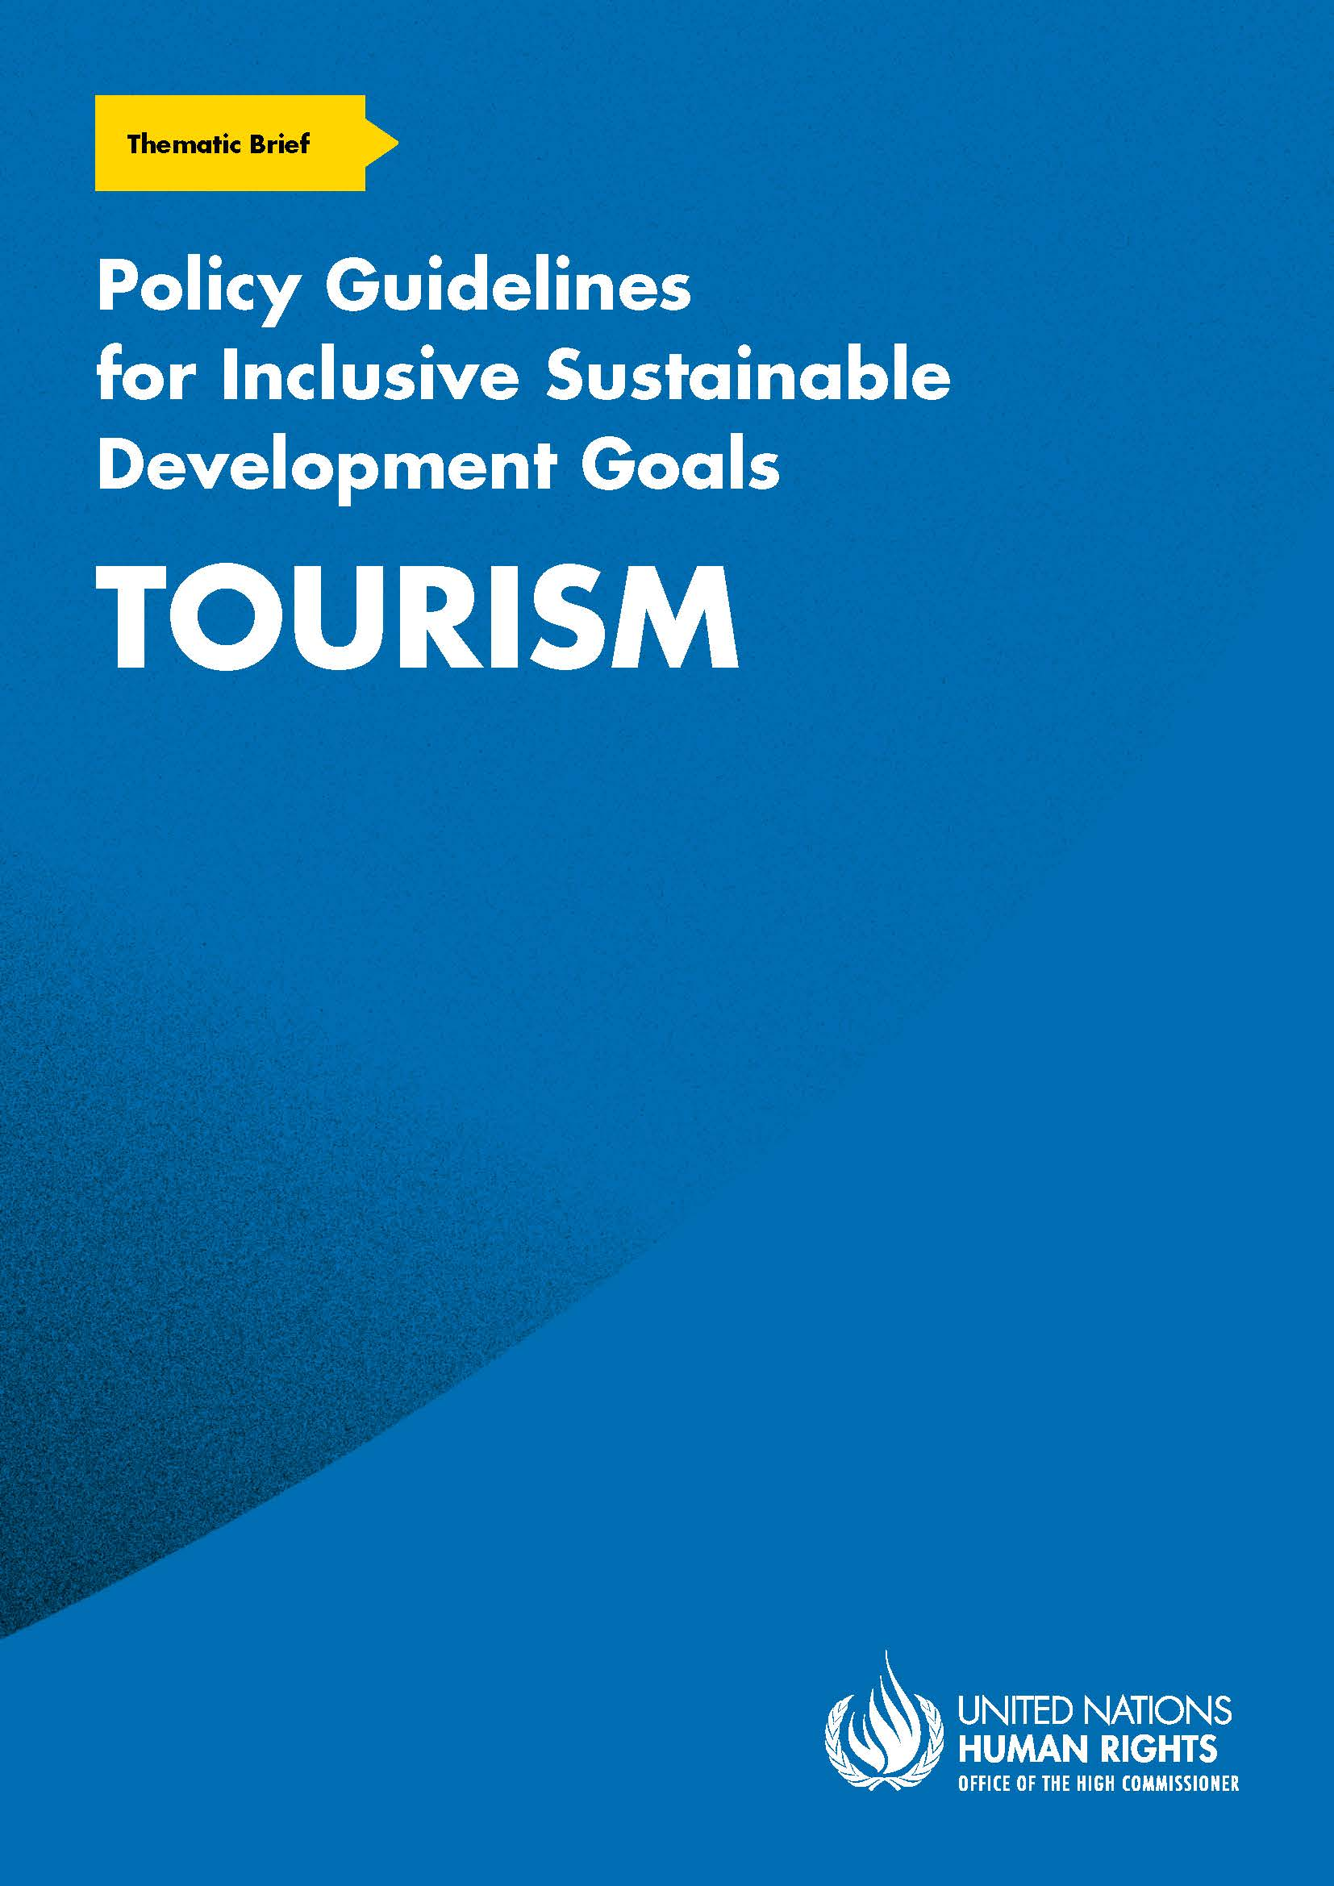
ADVANCE VERSION
© 2020 United Nations
The Policy Guidelines for Inclusive Sustainable Development Goals are a component of the SDG- CRPD Resource Package, developed by the Office of the United Nations High Commissioner for Human Rights (OHCHR). This is an advance version of the SDG-CRPD Resource Package. A final version will be issued upon completion of OHCHR review processes.
The designations employed and the presentation of the material herein do not imply the expression of any opinion whatsoever on the part of the Secretariat of the United Nations concerning the legal status of any country, territory, city or area, or of its authorities, or concerning the delimitation of its frontiers or boundaries.
Symbols of United Nations documents are composed of capital letters combined with figures. Mention of such a figure indicates a reference to a United Nations document.
Photography by Christian Tasso. The photographs featured within the Policy Guidelines were taken as part of the European Union project, Bridging the Gap II – Inclusive Policies and Services for Equal Rights of Persons with Disabilities, and were produced with the financial support of the European Union. They appear courtesy of the International and Ibero-American Foundation for Administration and Public Policies.
The Policy Guidelines for Inclusive Sustainable Development Goals were produced with the financial support of the European Union. Its contents are the sole responsibility of OHCHR and do not necessarily reflect the views of the European Union.
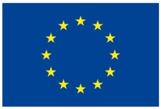
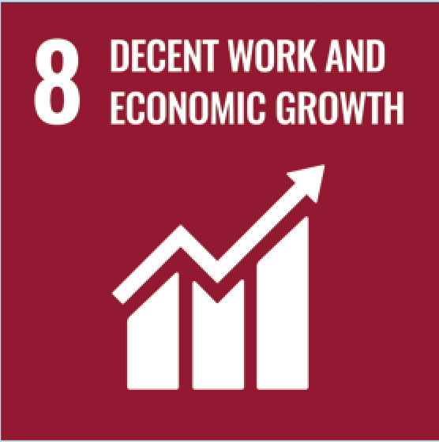
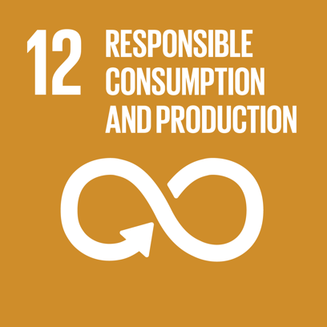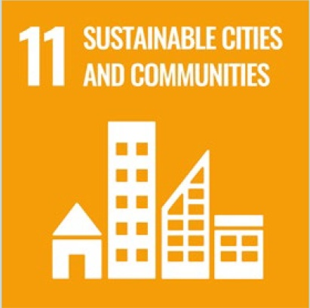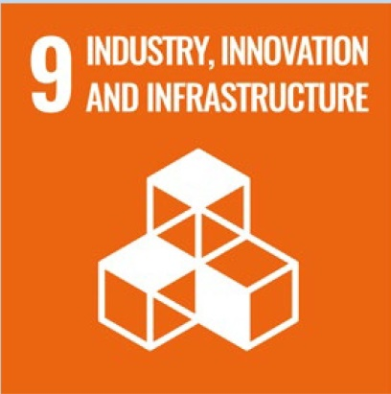

Contents
1. What is the situation? 6
2. What needs to be done? 9
3. DO’s and DON’Ts 14
4. Additional Resources 18
5. Key Concepts Annex 19

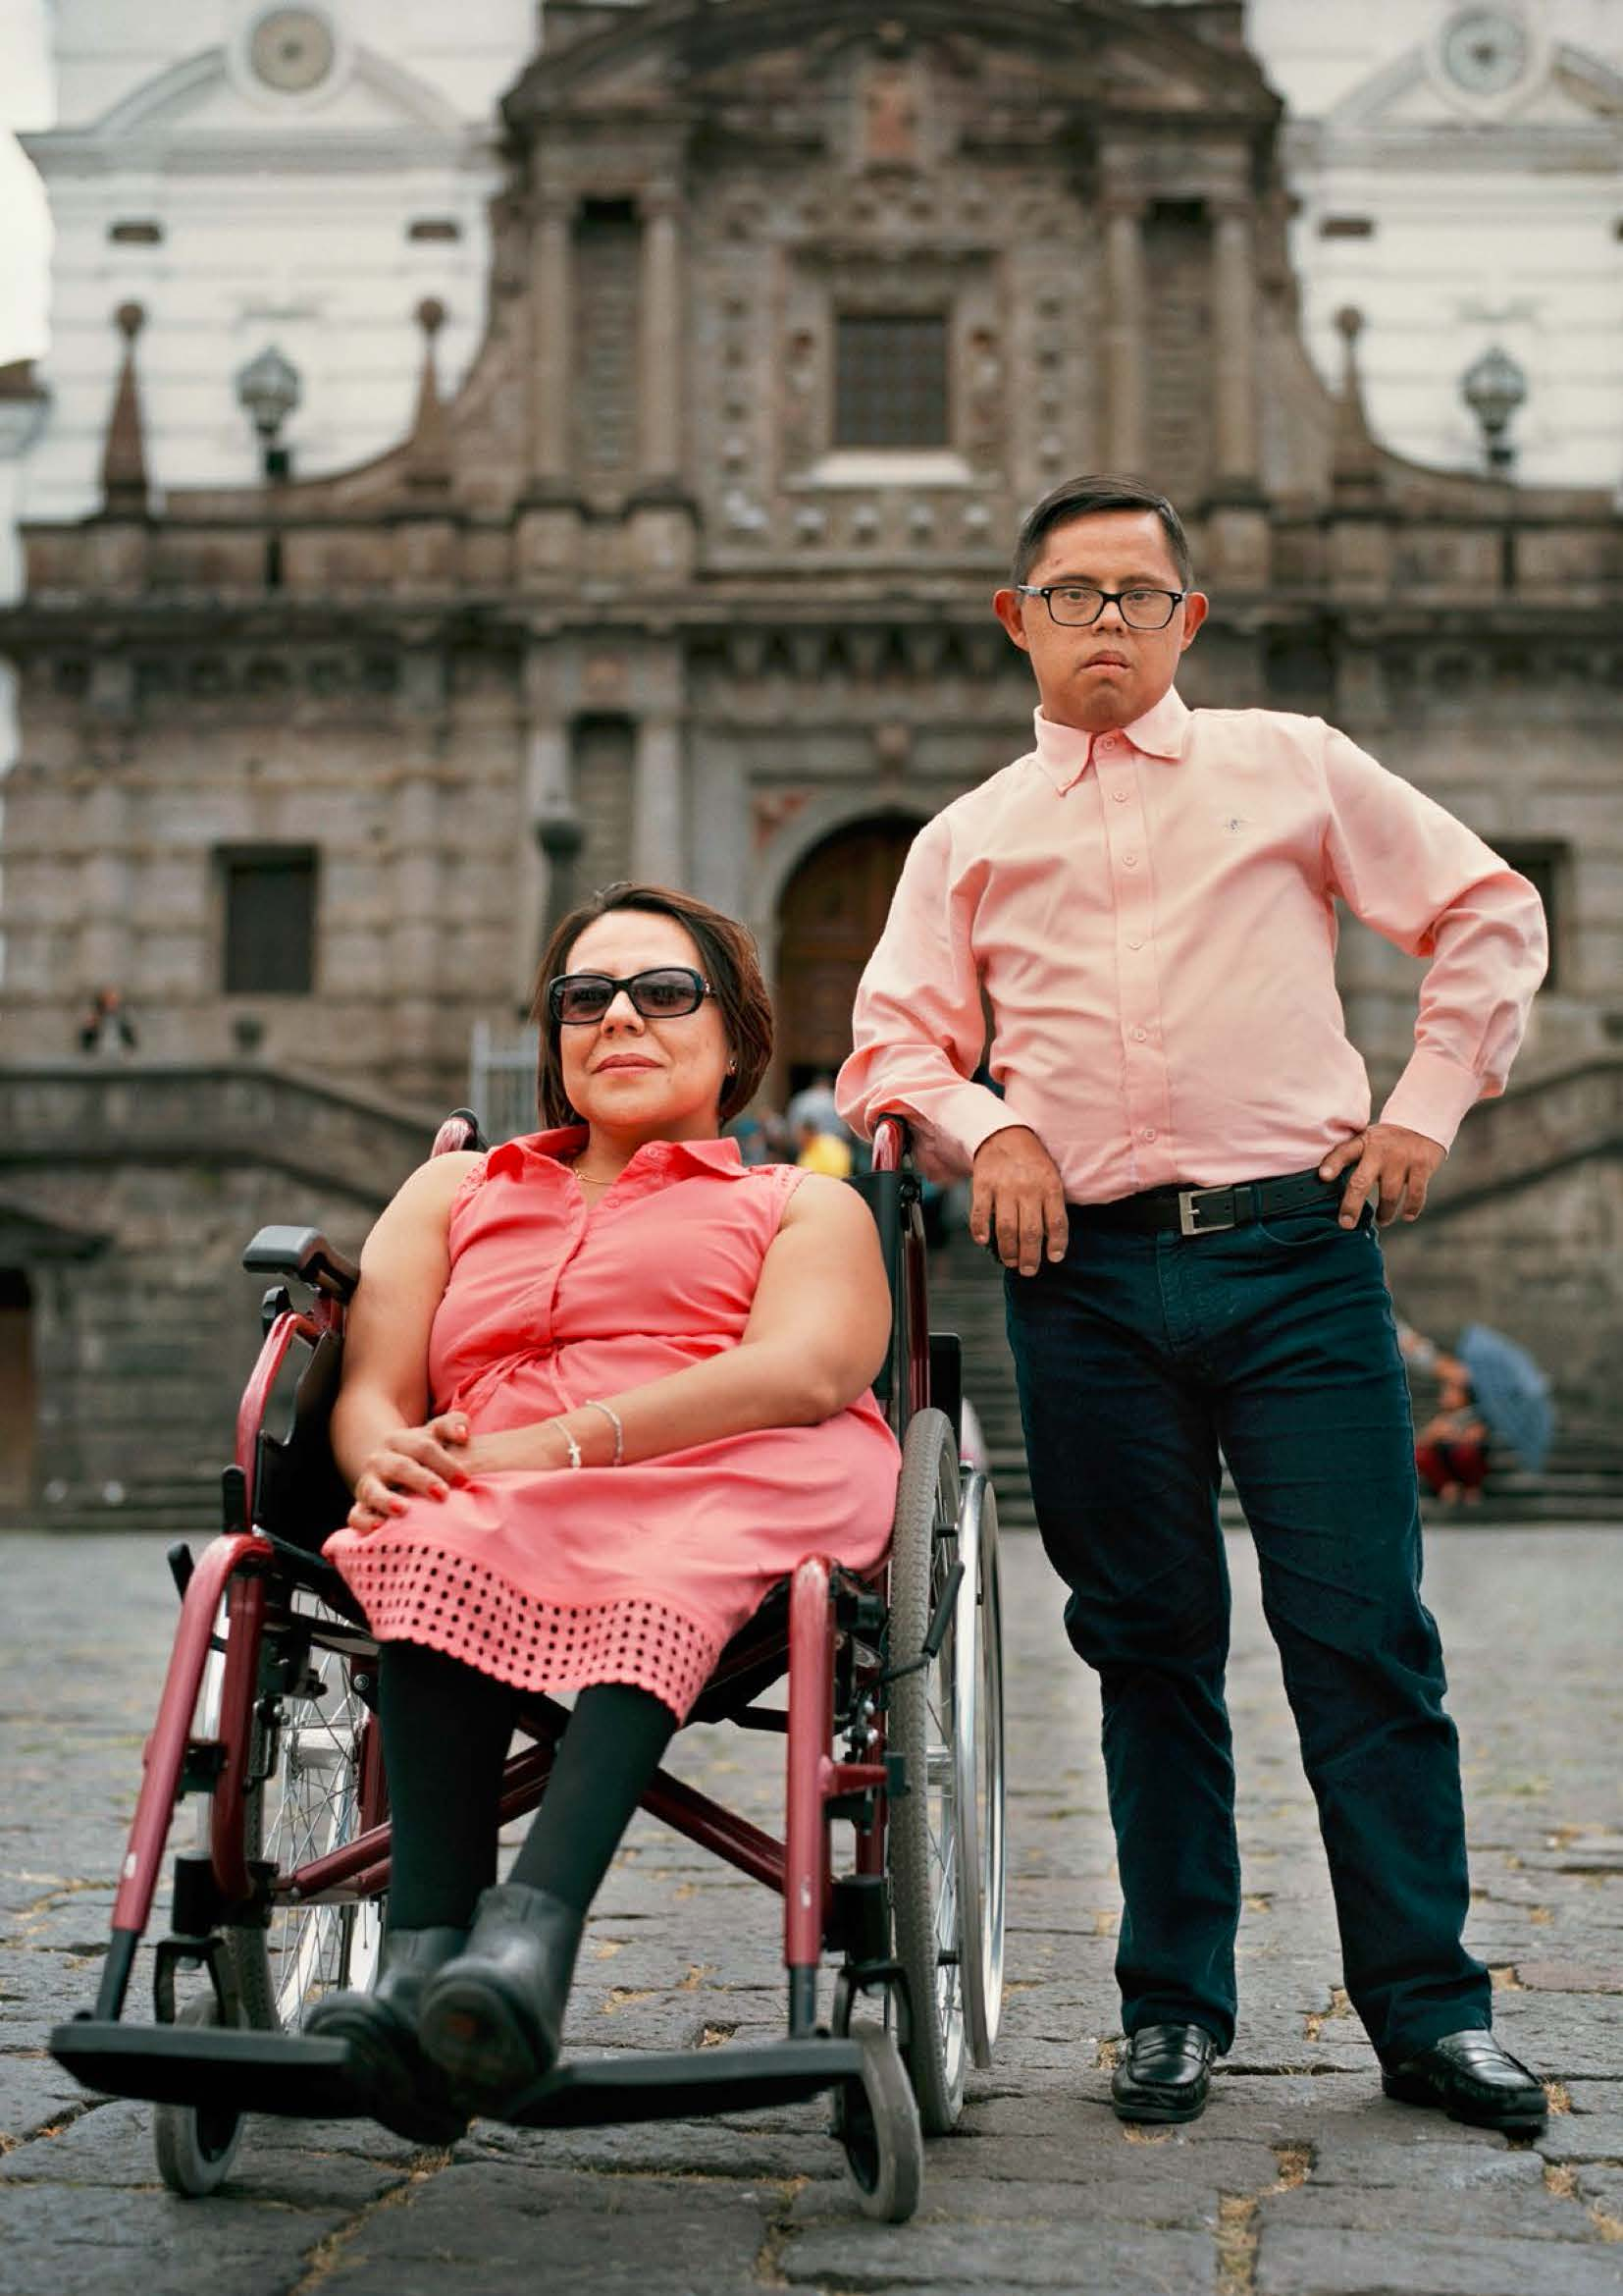

1. What is the situation?
The tourism sector can play an important role in national development as a generator of income - such as foreign exchange income – for all, including persons with disabilities. To contribute to an implementation of the Sustainable Development Goals (SDGs) that is inclusive of persons with disabilities, the tourism sector should promote opportunities for persons with disabilities:
  - through employment and self-employment within the tourism sector; and
  - as consumers and users of tourism products and services
With respect to job creation, any national or local strategy on tourism should ensure that job creation benefits persons with disabilities on an equal basis with others (or even preferentially, as a specific measure to counter structural exclusion from the labour market). Measures for employment and self-employment of persons with disabilities are specifically addressed under the Policy Guideline on SDG 8.
This brief focuses on the work opportunities available for persons with disabilities in the tourism sector, as well as on persons with disabilities as consumers of tourism products and services and users of tourism infrastructure. This topic, labelled as “accessible tourism,” “inclusive tourism” and “tourism for all”, among others, has received increased attention and aims to ensure the usability of tourism products and services by persons with disabilities, as well as the fulfilment of their specific access requirements.
Given the lack of international standards and unified measuring systems, statistical and research data on persons with disabilities as workers and consumers of the tourism industry are scarce.

Available data and practices concerning persons with disabilities and accessible tourism indicate that:
- Persons with disabilities, particularly those from developed countries, increasingly engage in tourism.
- Persons with disabilities do not commonly travel alone. Estimations in the European Union indicate that they travel with two companions, making this target group attractive to the industry (European Commission, DG Enterprise and Industry, Economic impact and travel patterns of accessible tourism in Europe – final report (2014)).
- Older persons with disabilities who have a stable income – namely those who worked through their active years – have more leisure time and availability to travel and are a growing cohort of consumers of accessible tourism.
- The demand for accessible tourism services is increasing, resulting in an overall higher quality of tourism where destinations respond effectively.
- The accessibility of tourism facilities, sites and services benefits all persons, beyond persons with disabilities.
- Accessible tourism is a great business opportunity and contributes to the Gross Domestic Product of a country.
- Market performance is 25 to 35 per cent lower in destinations with insufficient accessibility.
- Accessible tourism decreases the vulnerability of destinations to seasonality by improving demand for tourism in off- and mid-season periods.

- Accessible tourism requires a comprehensive set of international standards so that all destinations offer equal access worldwide.
Data from national contexts are illustrative of the size, contribution and potential of “accessible tourism for all” for national development. In Australia, the accessible tourism market reaches 1.3 million people and accounts for 3.2 billion Australian dollars annual expenditure. When taking into account the companions of tourists with disabilities, these numbers reach 3.4 million people and 8 billion Australian dollars, for domestic travel (Pavkovic and others, Inclusive Tourism: Economic Opportunities. University of Technology Sydney Institute for Public Policy and Governance, 2017).
In the United Kingdom of Great Britain and Northern Ireland, Visit England estimates that groups of tourists which include a person with disability spent 12.4 billion pounds sterling in 2013, which represents 20 per cent of the total yearly expenditure on day and overnight trips. Research from 2018 suggests that 430,000 persons with disabilities did not travel for holidays due to the lack of accessibility, entailing a missed opportunity for 116.7 million pounds sterling expenditure.
Similarly, in Spain, there is a potential demand for accessible tourism of up to 6 million people. Research undertaken in 2018 by Fundación Adecco showed that 56 per cent of persons with disabilities surveyed decided not to go on holiday in Spain due to the lack of accessible tourism options.
Besides these country data, the largest and most comprehensive study on the economic impact and travel patterns of accessible tourism was published by the European Union in 2014, and its findings for 2012 can be found below.
2012 European Union’s “Accessible Tourism for all” in numbers:
- Accessible tourism generated 786 billion euros, including indirect and induced contribution.
- Accessible tourism generated 394 billion euros of total economic contribution in terms of Gross Domestic Product.
- A total of 8,711,000 people were employed in the region to provide this economic output.
- On average, 2.2 companions travel with persons with disabilities.
- A total contribution of 1,109,740 million euros was made for the Gross Domestic Product by people with access needs, including persons with disabilities and companions.
- Improved accessibility could increase the total contribution by up to 40 per cent and employ up to 12 million people.
Source: European Commission, DG Enterprise and Industry, Economic impact and travel patterns of accessible tourism in Europe – final report (2014).
Available estimates indicate a constant rise in demand for accessible tourism in the European Union with a growth rate of 1.98 per cent per year for older persons and 0.12 per cent for persons with disabilities, as set out in Figure I.

Figure I
Current and future demand for EU’s accessible tourism by EU27 countries from 2012-2020
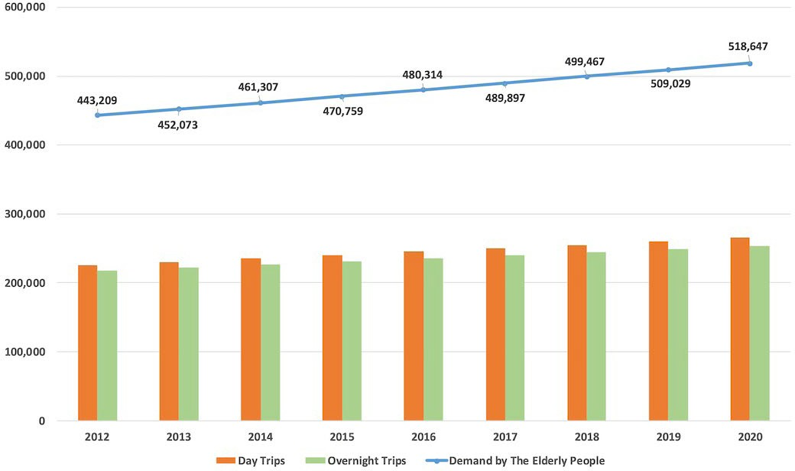
Source: European Commission, DG Enterprise and Industry, Economic impact and travel patterns of accessible tourism in Europe – final report (2014)
Ultimately, for a large proportion of persons with disabilities, financial barriers remain the most important obstacle to travelling. In addition to the general lower socio-economic situation of many persons with disabilities when compared to persons without disabilities, which may make travel a less viable option, tourism-related expenditures are often higher for persons with disabilities, especially if they need to be accompanied by a personal assistant or book accessible accommodation (which is often more expensive). In order to address this issue, many countries have established, in law and policy, benefits to reduce costs for low-income people, including persons with disabilities.
In addition, some persons with disabilities report a fear of travelling due to uncertainties about accessibility and availability of necessary services, or of prejudice they may encounter while travelling. Inclusive tourism agents are increasingly common - they guide persons with disabilities and their families, by identifying accessible lodging and providing disability-specific guidance to overcome known barriers.

2. What needs to be done?
The SDG framework explicitly refers to tourism within two goals: Goal 8 on decent work and Goal 12 on responsible consumption and production. In addition, Goal 11 on sustainable cities is key, as cities and metropolitan areas serve as hubs for tourists and are important tourist destinations. Table 1 outlines some of the opportunities for persons with disabilities across these three SDGs.

Table I

Opportunities created by inclusive tourism for persons with disabilities across SDGs 8, 12 and 11
Opportunity for persons with disabilities | SDG Target | SDG
Job creation in the tourism sector can increase employment opportunities for persons with disabilities. | 8.9 By 2030, devise and implement policies to promote sustainable tourism that creates jobs and promotes local culture and products | 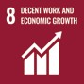
While mainly focused on environmental sustainability, defining tools to monitor sustainable tourism creates the opportunity to consider the impact on persons with disabilities, including in the tourism workforce and as tourists. | 12.b Develop and implement tools to monitor sustainable development impacts for sustainable tourism that creates jobs and promotes local culture and products | 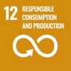
Cities are important tourism destinations for persons with disabilities, as they commonly offer more accessible tourism opportunities than rural tourism. | 11.2 By 2030, provide access to safe, affordable, accessible and sustainable transport systems for all, improving road safety, notably by expanding public transport, with special attention to the needs of those in vulnerable situations, women, children, persons with disabilities and older persons  11.7 By 2030, provide universal access to safe, inclusive and accessible, green and public spaces, in particular for women and children, older persons and persons with disabilities | 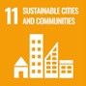

Main areas for intervention to realise the Sustainable Development Goals in relation to inclusive tourism
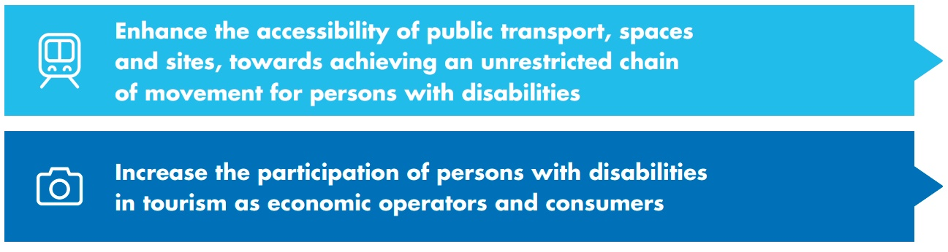

Enhance the accessibility of public transport, spaces and sites, towards achieving an unrestricted chain of movement for persons with disabilities
 | 8.9 By 2030, devise and implement policies to promote sustainable tourism that creates jobs and promotes local culture and products
  - By 2030, provide access to safe, affordable, accessible and sustainable transport systems for all, improving road safety, notably by expanding public transport, with special attention to the needs of those in vulnerable situations, women, children, persons with disabilities and older persons
  - By 2030, enhance inclusive and sustainable urbanization and capacity for participatory, integrated and sustainable human settlement planning and management in all countries
11.7 By 2030, provide universal access to safe, inclusive and accessible, green and public spaces, in particular for women and children, older persons and persons with disabilities
Put in place regulatory frameworks for the accessibility of safe public transport modes and infrastructure, sites and spaces, including cultural and touristic sites and facilities |  | - Adopt legislation that addresses the accessibility of transport modes and infrastructures (train stations, airports)  - Adopt national accessibility standards applicable to public sites and spaces, including cultural and touristic sites and facilities  - Adopt accessibility criteria for public procurement processes, to prioritise accessible solutions  - Provide training, to all involved parties, on the accessibility of spaces, sites and transport modes for persons with disabilities  - Ensure the consultation of persons with disabilities and their representative organizations in the design and implementation of policies and regulatory frameworks

Put in place mechanisms to ensure compliance with mandatory accessibility standards for public transport, sites and spaces, including cultural and touristic infrastructure | - Introduce a transparent independent monitoring framework with the participation of organizations of persons with disabilities  - Introduce dissuasive sanctions for operators not complying with national accessibility standards
Related CRPD indicators: 9.2, 9.3, 9.17, 9.18, 9.22, 9.23, 30.2

Increase the participation of persons with disabilities in tourism as economic operators and consumers
8.3 Promote development-oriented policies that support productive activities, decent job creation, entrepreneurship, creativity and innovation, and encourage the formalization and growth of micro-, small- and medium-sized enterprises, including through access to financial services
8.9 By 2030, devise and implement policies to promote sustainable tourism that creates jobs and promotes local culture and products
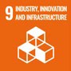 | 9.1 Develop quality, reliable, sustainable and resilient infrastructure, including regional and transborder infrastructure, to support economic development and human well-being, with a focus on affordable and equitable access for all
 | 11.2 By 2030, provide access to safe, affordable, accessible and sustainable transport systems for all, improving road safety, notably by expanding public transport, with special attention to the needs of those in vulnerable situations, women, children, persons with disabilities and older persons
Ensure the accessibility of information and communication related to national and local tourism services and campaigns, with targeted efforts to disseminate information about accessible and sustainable tourism
Take steps to facilitate the movement of persons with disabilities across regions and borders through mutual recognition of disability status, to stimulate the participation of persons with disabilities in culture, sport, leisure and transport, including parking
Include disability-inclusion criteria in public policies and legislation related to tourism and provide incentives for the inclusion of persons with disabilities throughout the public and private tourism sector

Raise awareness and promote incentives amongst public and private tourism operators on accessible tourism | - Promote the training of tourism operators to remove attitudinal barriers against tourists with disabilities and promote a better understanding and catering of their requirements  - Promote initiatives for inclusive and accessible tourism, as well as the dissemination and exchange of good practices among tourism operators
Take targeted measures to promote the employment of persons with disabilities, including women with disabilities, in the tourism and hospitality sector | - Engage experts with disabilities to improve the accessibility and inclusiveness of the tourism and hospitality sector  - Include a disability conditionality in the support schemes available for the development of the tourism sector  - Use public procurement legislation to stimulate the businesses of the tourist and hospitality sector enterprises that comply with the disability-inclusion criteria
Collect disaggregated data concerning the participation of persons with disabilities, both as economic operators and as consumers within the tourism sector, to identify gaps and further develop policies and initiatives to enhance their employment opportunities, as well as their consumer experience as tourists
Related CRPD indicators: 30.3, 30.7, 30.9, 30.10, 30.13, 30.19, 30.22
The United Nations World Tourism Organization and ‘Accessible tourism for all’
The United Nations World Tourism Organization has led the promotion of “accessible tourism” and its General Assembly adopted two sets of recommendations, namely the Recommendations on Accessible Tourism for All (2013) and the Recommendations on Accessible Information in Tourism. The United Nations World Tourism Organization also published a series of awareness-raising and technical manuals on making the entire tourism value chain accessible (see Additional Resources).

Enhancing accessibility throughout the tourism chain
Figure II presents the components of the tourism chain and the key elements regarding the inclusion of persons with disabilities, based on the United Nations World Tourism Organization Recommendations on Accessible Tourism.

Figure II
Components of the tourism chain and key elements regarding the inclusion of persons with disabilities
Tourism destination management | - Accessible tourism strategy led by the tourism-related authority  - Guidance on accessibility and universal design for accurate promotion of services
Planning, tourism information and advertising | - Information on the accessibility of services and facilities (e.g. web- based reservation systems)  - Accessible customer service and information on support services (e.g. repair of assistive devices)
Urban and architectural environments | - Reserved parking, sidewalks and unloading points usable by persons with disabilities  - Alternative modes of communication and signage (Sign Language, Braille)  - Design for horizontal and vertical mobility (corridors, ramps, elevators) and access to WASH facilities
Modes of transportation and stations | - Accessible transportation services and related information  - Available and quality support services (e.g. assistance for wheelchair users in airports)  - Equipped rest stops for ground transportation at regular intervals
Accommodation, food service and conventions | - Accessible rooms and customer services and welcoming of live assistance (e.g. guide dogs)  - Accessibly designed and equipped restaurants (e.g. menus and WASH facilities)  - Accessible conference facilities, equipment (e.g. audio induction loop) and services
Activities in natural and cultural settings, cultural events and shopping | - Accessible facilities, information materials and equipment regarding museums, theatre, cinema, sports centres, natural spaces, beaches, etc.  - Training of customer services personnel
Source: World Tourism Organization, Recommendations on Accessible Tourism (Madrid: UNWTO, 2013)
European Union Disability Card
To stimulate cross-border travel of persons with disabilities across the European Union, the European Union Disability Card is currently being piloted. This card recognises disability status across participating countries and provides the same benefits to persons with disabilities coming from other European Union countries as to residents in the country, in access to culture, sport, leisure and transport.
Since 1998, the European Union has also implemented the parking card for persons with disabilities, that gives a number of parking rights to its holders in other European Union countries.

3. DO’s and DON’Ts

DO | DO NOT
Legislation, policy and programmes
Adopt tourism legislation and/or policy and regulatory frameworks that incentivise the inclusion of persons with disabilities throughout the tourism sector, in close consultation with organizations of persons with disabilities | Leave efforts to address inclusiveness and accessibility within the tourism sector to the market, including to tourism operators  Rely on the tourism market alone (including operators) to address inclusion and accessibility
Integrate the diverse tiers of the tourism supply chain in policy design, to ensure consistency and that all elements (e.g. reservation, accommodation, transport) are connected and easily accessed, including by fostering public- private cooperation and business-to-business relationships | Address in isolation the different tiers of the tourism supply chain and/or the different sectors involved (e.g. tackling accessibility of public monuments without addressing the transportation to reach them)
Practice and implementation
Promote the employment of persons with disabilities within the tourism sector, including by ensuring protection against disability-based discrimination and by adopting specific measures benefitting persons with disabilities (e.g. employment quotas) (See Policy Guideline on SDG 8, section 5.1.2) | Overlook the opportunity to promote the employment of persons with disabilities, nor possible discriminatory practices against persons with disabilities in the tourism sector
Employ persons with disabilities as expert advisors and trainers for the development of accessible tourism and stimulate the creation of tourism enterprises run by persons with disabilities | Limit the employment opportunities within accessible tourism to persons with physical impairments, while ignoring the diversity of persons with disabilities
Adopt regulations and monitoring mechanisms to ensure that air travel companies provide quality accessible services and assistance to passengers with disabilities, including women and girls with disabilities | Overlook the barriers and discriminatory practices that passengers with disabilities face when seeking access to air travel services

DO | DO NOT
Information, communication and awareness-raising
Ensure that printed material, digital documents, audio-visual content, websites, applications and signage are accessible, including considerations of usability, legibility and readability | Overlook the importance of accessible information to the progress of accessible tourism
Develop and promote awareness-raising measures to:  - sensitize the tourism sector and local communities on the importance of ensuring accessibility  - promote good practices and initiatives for inclusive and accessible tourism (e.g. awards and distinctions to private initiatives) | Assume that private and public decision- makers will actively seek information on why and how to enhance inclusiveness and accessibility for persons with disabilities, nor take for granted that the local population within tourism destinations will embrace accessibility by default
Systematize and disseminate, in accessible formats, information on the accessibility features of tourist sites and attractions, hotels and other types of accommodation, restaurants and other facilities and services, based on the accessibility standards certification system and related indicators | Limit the dissemination of available data on accessibility related to the tourism sector to promotional information by service providers, nor overlook the need to inform the public on the compliance with accessibility standards
Training
Develop and promote the training of decision- makers and staff, particularly of customer services, to remove attitudinal barriers against tourists with disabilities and cater to their requirements, including through the provision of support services | Disregard nor underestimate the importance of the skills and knowledge of tourism sector personnel to enhance the level of satisfaction of tourists with disabilities, nor limit training opportunities to specific staff devoted exclusively to persons with disabilities

DO | DO NOT
Research and data collection and disaggregation
Develop and promote, in cooperation with the private sector tourism value chain, data collection methods (e.g. surveys) to assess the satisfaction, behaviour patterns and economic contribution of tourists with disabilities | Disregard the need to collect and/or systematise essential information to identify gaps in service provision and further develop tourism opportunities for persons with disabilities, increasing their total economic contribution
Accessibility standards, monitoring and certification
Adopt and promote mandatory accessibility standards applicable throughout the tourism sector (e.g. hotels, restaurants, museums, art galleries), which cover the accessibility for persons with disabilities and the principle of universal design and are monitored and accompanied by dissuasive sanctions for violations | Limit accessibility standards and measures to the physical accessibility of facilities and transportation, as this measure does not cater to the needs of all potential customers
Enhance to the maximum extent possible the accessibility of natural and historical sites for persons with disabilities, without jeopardizing their integrity and historical relevance | Automatically invoke monumental integrity, historical relevance or any other protected status to justify inaction in terms of accessibility
Promote financial and other incentives (including information on the profitability of accessible tourism) for tourism products and service providers, destination management organizations, trade associations and others to engage in, and gain ownership of, accessible tourism practices, as well as to consult and involve organizations of persons with disabilities | Do not rely on monitoring and enforcement of mandatory standards as the sole measure for service providers to ensure accessibility

DO | DO NOT
Develop and promote a standardised system to assess and certify the accessibility features of tourist sites and attractions, hotels and other types of accommodation, restaurants and other facilities and services. Certification systems should rely on standards as the basis of certification indicators (ISO 21902 Tourism and related services — Accessible tourism for all — Requirements and recommendations is expected to be adopted in the course of 2020) | Promote the development of multiple accessibility assessment and certification systems, as this leads to the dissemination of poor and misleading promotional information and of services for tourists with disabilities that are not fully accessible
Promote accessibility information, integrated into general tourism promotional materials and websites, infrastructure, products and services, which are made accessible (including interface and information/sales terminals, PDF documents, audio-visual platforms and applications) | Disseminate accessibility and disability-related information only in separate promotional materials; nor develop travel applications or install interface sales terminals at airports without taking into account their accessibility for persons with disabilities
Ensure persons with disabilities bear the same or lower rates as other persons in accessing tourism-related services and are not forced to resort to more expensive products or services | Allow for service providers to charge extra to persons with disabilities based on accessibility-related costs, nor limit the ensuring of accessibility to more expensive products or services

4. Additional Resources
European Commission, DG Enterprise and Industry. Economic impact and travel patterns of accessible tourism in Europe - Final report. (2014).

International Civil Aviation Organization. Manual on Access to Air Transport by Persons with Disabilities (Montréal, 2013).
Pavkovic, Lawrie, Farrell, Huuskes, Ryan. Inclusive Tourism: Economic Opportunities. University of Technology Sydney Institute for Public Policy and Governance, 2017.
United Nations, Committee on the Rights of Persons with Disabilities. General comment No. 2 (2014) Article 9: Accessibility. 22 May 2014. CRPD/C/GC/2.
World Tourism Organization. Manuals on Accessible Tourism for All (2016).
World Tourism Organization. Recommendations on Accessible Information in Tourism (Madrid: UNWTO, 2016).
World Tourism Organization. Recommendations on Accessible Tourism (Madrid: UNWTO, 2013).
World Tourism Organization, Fundación ONCE and European Network for Accessible Tourism.
Reopening tourism for travellers with disabilities: how to provide safety without imposing unnecessary obstacles.

5. Key Concepts Annex
Below are key foundational concepts referred to throughout the Policy Guidelines for Inclusive Sustainable Development Goals (SDG). The guide below is designed as a quick reference and refresher for readers as they use the guidelines. It is recommended that the guideline “Foundations for inclusive Sustainable Development Goal Implementation: Key concepts and structural requirements” is read prior to, or together with, other guidelines, for a deeper understanding of the required foundations for inclusion.

Concepts
Ableism considers certain typical characteristics of body and mind as essential for living a life of value. Ableist perspectives view impairments as undesired, which leads to unconscious bias, prejudice, discrimination and exclusion. Ableism is usually behind negative perceptions and stereotypes about persons with disabilities. See also Foundations Guideline, section 1.3
Accessibility is the quality that allows persons with disabilities to access and enjoy physical environments, transportation, facilities, services, information and communications, including new technologies and systems. When planning for accessibility, the principles of universal design should be used. See also Foundations Guideline, section 2.2.
Assistive technology, devices and mobility aids are external products (devices, equipment, instruments, software), specially produced or generally available, that maintain or improve an individual’s functioning and independence, participation, or overall well-being. Examples of assistive devices and technologies include wheelchairs, prostheses, hearing aids, visual aids and specialized computer software and hardware that improve mobility, hearing, vision, or the capacity to communicate. See also Foundations Guideline, section 2.3.
Awareness-raising actions are those that aim at informing about rights and changing negative attitudes towards persons with disabilities. They include training, campaigns, mass-media communications and more. Awareness-raising activities should target persons with disabilities and others and should involve persons with disabilities in their design and delivery. See also Foundations Guideline, section 2.5.
Barriers: Disability results from the interaction between persons with impairments and the barriers in the environment around them. Barriers can be broadly categorised into the following:
- Environmental barriers: those that are imposed by the context. They can be sub-categorized as:
- Physical barriers: such as the presence of steps, preventing access for someone using a wheelchair, or others with mobility difficulties.
- Communication barriers: such as the barriers to participation for a sign language user in a meeting if sign language interpreters are not provided, or the barrier to accessing information experienced by blind persons with written text, if accessible formats are not provided.
- Policy barriers: such as educational systems that prevent the enrolment of children with disabilities in their local school.

- Attitudinal barriers: such as the belief that persons with disabilities cannot learn or work. Attitudinal barriers can lead to apathy or inertia towards addressing other barriers. Attitudinal barriers can lead to apathy or inertia towards addressing other barriers.
In order for persons with disabilities to fully participate and access opportunities for development, the barriers that limit their participation should be systematically addressed. Persons with disabilities themselves are experts on identifying barriers and the solutions to overcome them. See also Foundations Guideline, section 1.1.
Disability assessment is the process of collecting information about persons with disabilities, in their context, for the purposes of policymaking and planning, budget allocation and to determine eligibility to certain benefits and entitlements. A disability assessment can also be used solely for the purpose of providing services such as rehabilitation or education. See also Foundations Guideline, section 3.2.2 and Policy Guideline on SDG 1.
Disability determination refers to the official decision (using assessment findings) about whether someone is identified as a person with disability, often also categorized according to their functional ability. In some countries, this can become an official status, symbolised by a disability card, registration, or similar, which can provide access to various services and benefits. There are often additional and/or different processes to determine eligibility for different types of social protection, insurance, health and support services. See also Foundations Guideline, section 3.2.2 and Policy Guideline on SDG 1.
Disability discrimination is described in the Convention on the Rights of Persons with Disabilities (Article 2) as “any distinction, exclusion or restriction on the basis of disability which has the purpose or effect of impairing or nullifying the recognition, enjoyment or exercise, on an equal basis with others, of all human rights and fundamental freedoms in the political, economic, social, cultural, civil or any other field. It includes all forms of discrimination, including denial of reasonable accommodation.” See also Foundations Guideline, section 2.1.
Disability mainstreaming is the process of ensuring that the rights of persons with disabilities are embedded in all policy, assessing policy implications for persons with disabilities, and ensuring their meaningful participation. It is the way of making the concerns and experiences of persons with disabilities an integral dimension of the design, implementation, monitoring and evaluation of policies and programmes in all political, economic and societal spheres so that persons with disabilities have equal benefits, and inequality is not perpetuated. The ultimate goal is to achieve equality of outcomes and foster an inclusive culture. Disability mainstreaming should be combined with disability-specific actions (see Twin-Track Approach). See also Foundations Guideline, section 3.2.1.
Extra-cost of disability refers to the higher expenditure of persons with disabilities and their households, when compared to the rest of the population. Extra-costs commonly stem from specific goods and services (e.g. mobility aids, personal assistance, accessible housing) and/or lack of access to general goods and services (e.g. more expensive health insurance, using taxis where public transport is not accessible). Disability extra-costs affect different policies. For more information, access the Centre for Inclusive Policy’s videos, “Understanding disability extra costs” and “Addressing disability extra costs”. See also Policy Guideline on SDG 1.

International cooperation is the interaction of persons or groups of persons representing various nations and diverse international and regional organisations striving towards the common goal of realizing the rights of persons with disabilities and the Convention on the Rights of Persons with Disabilities. Persons with disabilities, the organisations that represent them, and policymakers, collaborate through their ministries of international affairs, to receive technical and financial support from international organisations and development banks. Financial support designated for international cooperation shall not be used for measures contrary to the Convention on the Rights of Persons with Disabilities and shall be planned to be substituted with national funds, to ensure policy continuation. Technical cooperation among countries with similar realities is important to identify effective solutions. See also Foundations Guideline, section 8.
Intersectional discrimination refers to situations where discrimination is occurring on the basis of multiple and intersecting factors, including sex, gender, ethnicity, age, caste, class, faith, sexual orientation or any other characteristic. Persons with disabilities also have a gender identity, may come from an indigenous group, be young, old, a refugee or living in poverty. See also Foundations Guideline, section 5.3.
Legal capacity is the right to autonomously make legally valid decisions. Some countries restrict the right for adults with disabilities to manage their own financial affairs, including ownership of property, choose where to live and work, and manage their relationships, health and wellbeing.
Restricting or denying this right is against the Convention on the Rights of Persons with Disabilities and has negative effects across all policies. See also Foundations Guideline, section 5.5.
Organisations of persons with disabilities are led, directed, and governed by persons with disabilities. They are established at the local, national, regional or international level to promote and/ or defend the rights of persons with disabilities. A clear majority of the membership of such organisations should be recruited among persons with disabilities themselves. See also Foundations Guideline, section 2.4.
Participation of persons with disabilities refers to the action of allowing and enabling persons with disabilities to take part directly, or through organizations of persons with disabilities, in decision- making processes, including the design, implementation, monitoring and evaluation of policies. To do this, persons with disabilities should be closely consulted and actively involved in all decision-making processes, by being invited to give their opinions and take part in implementation processes.
Participation is an obligation to be met under the Convention on the Rights of Persons with Disabilities for all aspects of policy. “Nothing about us, without us” is the motto that promotes this obligation, and it means that no policy should be developed or implemented without persons with disabilities. See also Foundations Guideline, sections 2.4 and 4.
Persons with disabilities include those who have long-term physical, psychosocial, intellectual or sensory impairments which, in interaction with various barriers, may hinder their full and effective participation in society on an equal basis with others. Hence, persons with disabilities are persons with impairments who experience barriers that restrict their participation. See also Foundations Guideline, section 1.2.
Reasonable accommodation refers to modifications or adjustments made for a person with disability who requires them in a particular case, to facilitate participation on an equal basis with others. Reasonable accommodation must be provided on demand - that is, entities responsible for providing it cannot deny it by saying that they are progressively implementing measures. If arbitrarily denied, this constitutes discrimination.

Some examples include adjustments to the school hours of a student, extended breaks to rest, acquisition of computer software to read screens, a foldable ramp to overcome step(s) or providing a sign language interpreter in a work meeting. See also Foundations Guideline, sections 2.1 and 5.2.
Support for persons with disabilities encompasses a wide range of formal and informal interventions, including live assistance and intermediaries, mobility aids and assistive devices and technologies. It also includes personal assistance; support in decision-making; communication support, such as sign language interpreters and alternative and augmentative communication; mobility support, such as assistive technology or service animals; living arrangements services for securing housing and household help; and community services. Persons with disabilities may require support to perform daily life activities and/or use general services, such as health, education and justice, on an equal basis with others. See also Foundations Guideline, section 2.3.
Supported decision-making is a type of support given to persons with disabilities in relation to legal decisions. This mechanism guarantees that: (i) persons with disabilities exercise their legal capacity (see above) and can make their own decisions in every aspect of life; and (ii) their decisions are not replaced by the decisions of guardians or others. Supported decision-making is voluntary and can include informal and formal support arrangements. For example, a person with disability may choose a trusted person to support them in making certain types of legal decisions. They may also resort to peer support or self-advocacy networks. Some persons with disabilities may access support to help in the communication of their will and preference. See also Foundations Guideline, section 5.5.
Twin track approach is a strategy to develop policies that:
- systematically mainstreams the interests and rights of persons with disabilities in policy design and implementation, across all sectors and areas of life
- adopts targeted policy and programming measures aimed specifically at persons with disabilities
The balance between mainstreaming strategies and targeted support strategies should be tailored to address the needs of specific communities. See also Foundations Guideline, section 3.2.1.
Universal design is the design and composition of products, environments, programmes and services so that they can be accessed, understood and used to the greatest extent possible by all people, regardless of their age, size, ability or disability, and without the need for adaptation or specialized design. The principles of universal design facilitate accessibility, including for persons with disabilities. See also Foundations Guideline, section 2.2.
The Washington Group Short Set is a set of six questions on functioning, designed to be used within national censuses and surveys. The questions are designed to provide comparable data cross- nationally, for populations living in a variety of cultures, with varying economic resources. While not exhaustive, the basic actions represented in this set of six questions are those that are most often found to limit an individual, and result in participation restrictions. The information that results from the use of these questions will (a) represent the majority of, but not all, persons with limitation in basic actions, (b) represent the most commonly occurring limitations in basic actions, and (c) be able to capture persons with similar difficulties across countries. See also Foundations Guideline, section 3.5.

Office of the United Nations
High Commissioner for Human Rights (OHCHR)
Palais de Nations
CH 1211 Geneva 10 – Switzerland
Email: disability@ohchr.org
Website: www.ohchr.org

