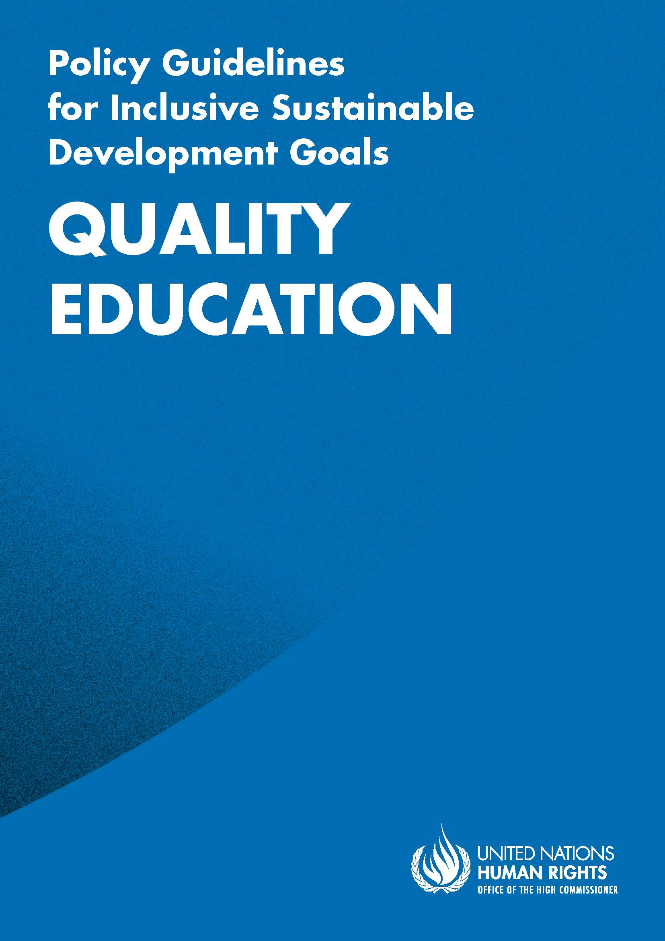
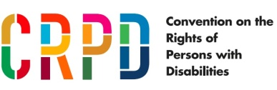
ADVANCE VERSION
© 2020 United Nations
The Policy Guidelines for Inclusive Sustainable Development Goals are a component of the SDG- CRPD Resource Package, developed by the Office of the United Nations High Commissioner for Human Rights (OHCHR). This is an advance version of the SDG-CRPD Resource Package. A final version will be issued upon completion of OHCHR review processes.
The designations employed and the presentation of the material herein do not imply the expression of any opinion whatsoever on the part of the Secretariat of the United Nations concerning the legal status of any country, territory, city or area, or of its authorities, or concerning the delimitation of its frontiers or boundaries.
Symbols of United Nations documents are composed of capital letters combined with figures. Mention of such a figure indicates a reference to a United Nations document.
Photography by Christian Tasso. The photographs featured within the Policy Guidelines were taken as part of the European Union project, Bridging the Gap II – Inclusive Policies and Services for Equal Rights of Persons with Disabilities, and were produced with the financial support of the European Union. They appear courtesy of the International and Ibero-American Foundation for Administration and Public Policies.
The Policy Guidelines for Inclusive Sustainable Development Goals were produced with the financial support of the European Union. Its contents are the sole responsibility of OHCHR and do not necessarily reflect the views of the European Union.
Ensure inclusive and equitable quality education and promote lifelong learning opportunities for all.
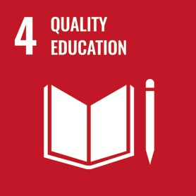

CONTENTS
IN BRIEF 6
1. What is the situation? 7
2. What needs to be done? 8
3. DO’s and DON’Ts 13
IN DEPTH 16
1. Introduction 17
2. Connection to other tools 17
3. Why is Goal 4 important for persons with disabilities? 17
4. Establishing and implementing an inclusive education system – actions applicable across all Goal 4 targets 19
4.1 Governance by the Ministry of Education 20
4.2 Legislation 22
4.3 Close consultation and active involvement of persons with disabilities 23
4.4 Awareness-Raising 23
4.5 Teachers and education staff 24
4.6 Budget Allocation 27
4.7 Data collection and disaggregation 27
4.8 Accountability and complaint mechanisms 29
5. Other key actions by target 29
5.1 Access to, and completion of inclusive quality education- Targets 4.1, 4.5 and 4.6 29
5.1.1 Adopt a non-rejection policy and prohibit admissions requirements 31
5.1.2 Foster inclusive learning environments 31
5.1.3 Ensure support, including through reasonable accommodation 33
5.1.4 Provide equally valid certification 35
5.1.5 Identify and address gaps in the education trajectory of students with disabilities 37
5.1.6 Collect data to monitor and enhance inclusion 39

5.2 Quality early childhood development, care and pre-primary education- Target 4.2 40
5.2.1 Provide awareness-raising, support services and training to parents and caregivers 42
5.2.2 Establish mechanisms for early identification and early intervention for inclusive early education 42
5.3 Access to higher education, including university, and availability of scholarships for persons with disabilities - Targets 4.3 and 4.b 43
5.3.1 Ensure accessibility and reasonable accommodation in admission procedures 43
5.3.2 Adopt specific measures to increase the number of persons with disabilities in tertiary education 44
5.4 Acquiring skills for employment, decent jobs and entrepreneurship by persons with disabilities – Target 4.4 45
5.4.1 Adopt measures to make mainstream vocational training inclusive of persons with disabilities 45
5.4.2 Adopt measures to provide in-job training or workplace learning 46
5.4.3 Implement capacity-building strategies for self-employment 47
6. Additional Resources 48
7. Key Concepts Annex 50

IN BRIEF
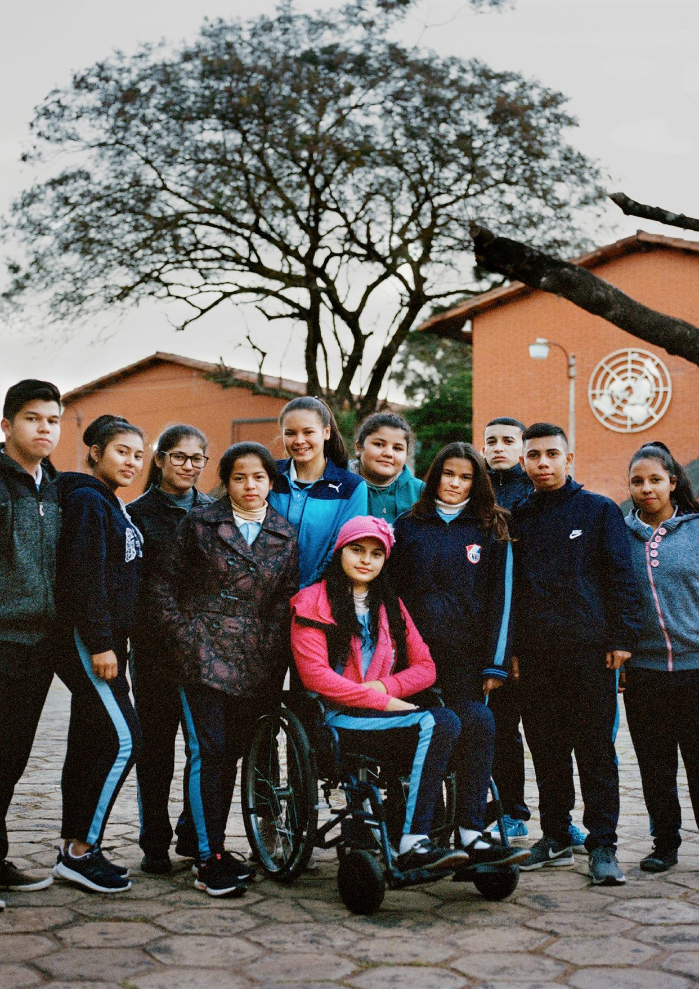

1. What is the situation?
Persons with disabilities are underrepresented in the education system. Estimates suggest that children with disabilities represent about 1 in 7 of all children who are out of school. Many of those who attend school are exposed to education systems that do not adequately support their learning requirements or are provided with lower quality education, including in segregated or special education.
The accessibility of educational infrastructure, materials and methods is a concern common to all levels of education. In this regard, data at the regional and global levels remain scarce. Crowdsourced accessibility data from several countries indicate that only 47 per cent of more than 30,000 educational facilities were considered accessible for wheelchair users (United Nations Department of Economic and Social Affairs, Disability and Development Report: Realizing the Sustainable Development Goals by, for and with persons with disabilities 2018 (New York: United Nations, 2019), p.87, fig. II.39).
Completion rates are lower among persons with disabilities when compared to persons without disabilities: 56 per cent compared to 73 per cent, for primary school (UNDESA, Disability and Development Report, 2019, p. 79, fig. II.29). Children with disabilities who do attend primary school are less likely than children without disabilities to complete their schooling. As such, children with disabilities are also less likely to pursue higher levels of education than their peers without disabilities.
Persons with disabilities are more likely to experience lower learning outcomes - the literacy rate among persons with disabilities has been estimated to be 54 per cent, compared to 77 per cent for other persons, as depicted in figure III. This percentage is even lower for women and girls with disabilities (UNDESA, Disability and Development Report, 2019, p. 83, fig. II.33).
figure i
Proportion of children with and without disability
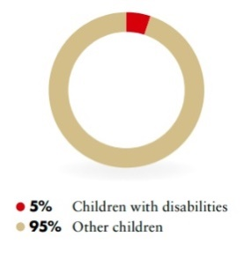
Source: United Nations Children’s Fund, The state of the world’s children: Children with disabilities (2013), p. 3
figure ii
Proportion of children out of school with and without disability
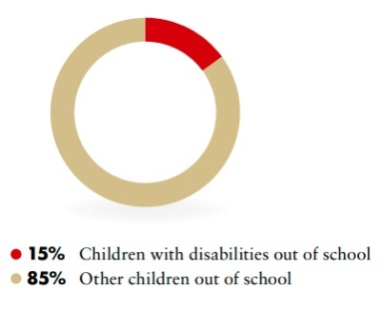
Source: Global Education Monitoring Report Team, Global education monitoring report, 2020: Inclusion and education: all means all (Paris: United Nations Educational, Scientific and Cultural Organization, 2020), p. 72, fig. 3.4)
figure iii
Literacy rates of persons with disabilities compared to broader population
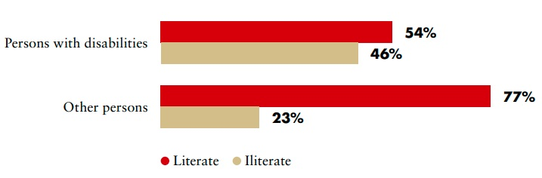
Source: UNDESA, Disability and Development Report, 2019, p. 83, fig. II.33

2. What needs to be done?
Implementing the Sustainable Development Goal (SDG) 4 requires putting in place an inclusive education system. This requires structural measures across all educational levels that relate to all of the SDG 4 targets and the principles and provisions of the Convention on the Rights of Persons with Disabilities (CRPD).
Inclusive Education is..
…the result of a process of continuing and proactive commitment to eliminating barriers impeding the right to education, together with changes to culture, policy and practice of regular schools to accommodate and effectively include all students (…) Inclusion involves a process of systemic reform embodying changes and modifications in content, teaching methods, approaches, structures and strategies in education to overcome barriers with a vision serving to provide all students of the relevant age range with an equitable and participatory learning experience and the environment that best corresponds to their requirements and preferences.
Source: United Nations, Committee on the Rights of Persons with Disabilities. General comment No.4 (2016) Article 24: Right to Inclusive Education. 2 September 2016. CRPD/C/GC/4. para. 11
figure iv
Main areas of intervention to realise Sustainable Development Goal 4
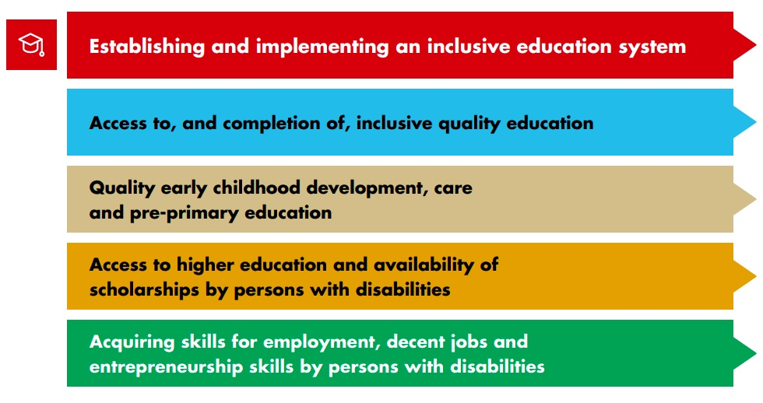
Establishing and implementing an inclusive education system – actions applicable across all targets of SDG 4
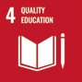
Ensure that the education of all students, including students with disabilities, is led and governed by the Ministry of Education.
Establish an inclusive education unit to lead national policies and plans to transition towards, and progress, inclusive education.
Establish coordination mechanisms that link the Ministry of Education with other Ministries, government disability focal points and other public bodies.
Enable collaboration between levels of government and support local governments to decentralise inclusive education.
Adopt legislation to recognise the right to inclusive education for all students – which prohibits disability-based discrimination and applies accessibility standards to learning environments – and prohibit violence, corporal punishment, harassment and bullying in the education system, including in the classroom, on the basis of disability.
Adopt, monitor and enforce accessibility standards.
Ensure the participation of persons with disabilities, particularly children, and their representative organizations in the design, implementation and monitoring of inclusive education policies and programmes.
Carry out awareness-raising campaigns and activities to promote inclusive education among all education stakeholders, teachers, parents and students, to combat negative stereotypes and attitudes against the inclusion of students with disabilities and to highlight the benefits of inclusive education for all.
Ensure that all future and existing teachers and teaching support staff undergo compulsory pre- service and in-service training on inclusive education methods and pedagogy, as an integral part of teacher-training curricula.
Contribute to inclusive school cultures by ensuring diversity and gender balance in the recruitment of teachers and teaching support staff.
Allocate budget to support inclusive education and ensure the disaggregation of expenditure, to track and account for gaps in the provision of services, materials and supports.
Strengthen the education management information system to engage in systematic data collection and disaggregation, ensure coordination of data systems with the national statistical office and support research to identify gaps in provision, with a view to strengthening the implementation of inclusive education.
Establish accessible mechanisms through the educational authorities, as well as independent accountability mechanisms for students, parents and representative organizations, to lodge complaints concerning the implementation of inclusive education, including claims of disability-based discrimination.
5.1 Access to, and completion of inclusive quality education
4.1 By 2030, ensure that all girls and boys complete free, equitable and quality primary and secondary education leading to relevant and effective learning outcomes
4.5 By 2030, eliminate gender disparities in education and ensure equal access to all levels of education and vocational training for the vulnerable, including persons with disabilities, indigenous peoples and children in vulnerable situations
4.6 By 2030, ensure that all youth and a substantial proportion of adults, both men and women, achieve literacy and numeracy
4.7 By 2030, ensure that all learners acquire the knowledge and skills needed to promote sustainable development, including, among others, through education for sustainable development and sustainable lifestyles, human rights, gender equality, promotion of a culture of peace and non-violence, global citizenship and appreciation of cultural diversity and of culture’s contribution to sustainable development
4.a Build and upgrade education facilities that are child, disability and gender sensitive and provide safe, non-violent, inclusive and effective learning environments for all
4.b By 2020, substantially expand globally the number of scholarships available to developing countries, in particular least developed countries, small island developing States and African countries, for enrolment in higher education, including vocational training and information and communications technology, technical, engineering and scientific programmes, in developed countries and other developing countries
4.c By 2030, substantially increase the supply of qualified teachers, including through international cooperation for teacher training in developing countries, especially least developed countries and small island developing States
  - Adopt a non-rejection policy and prohibit admissions requirements
  - Foster inclusive learning environments
  - Ensure support, including through reasonable accommodation
  - Provide equally valid certification
  - Identify and address gaps in the education trajectory of students with disabilities
  - Collect data to monitor and enhance inclusion
5.2 Quality early childhood development, care and pre-primary education
4.2 By 2030, ensure that all girls and boys have access to quality early childhood development, care and pre-primary education so that they are ready for primary education
Provide awareness-raising, support services and training to parents and caregivers
Establish mechanisms for early identification and early intervention for inclusive early education
5.3 Access to higher education, including university, and availability of scholarships for persons with disabilities
4.3 By 2030, ensure equal access for all women and men to affordable and quality technical, vocational and tertiary education, including university
4.b By 2020, substantially expand globally the number of scholarships available to developing countries, in particular least developed countries, small island developing States and African countries, for enrolment in higher education, including vocational training and information and communications technology, technical, engineering and scientific programmes, in developed countries and other developing countries
Ensure accessibility and reasonable accommodation in admission procedures
Adopt specific measures to increase the number of persons with disabilities in tertiary education
5.4 Acquiring skills for employment, decent jobs and entrepreneurship by persons with disabilities
4.4 By 2030, substantially increase the number of youth and adults who have relevant skills, including technical and vocational skills, for employment, decent jobs and entrepreneurship
Adopt measures to make mainstream vocational training inclusive of persons with disabilities
Adopt measures to provide in-job training or workplace learning
Implement capacity-building strategies for self-employment

3. DO’s and DON’Ts
DO | DO NOT
Law, policy and programmes
Establish, in legislation and policies, that no student with disability can be excluded from general education (non-rejection clause).  Inclusion should be ensured with age- appropriate peers | Include, in legislation or policies, restrictions or conditions for students with disabilities to access general education (e.g. making access dependent on meeting certain IQ standards/ general examination/assessment requirements, falling within or outside of categories of certain impairments, ‘within the scope of their possibilities’)
Establish an inclusive education unit within the Ministry of Education, to lead the implementation of inclusive education legislation and policies and to coordinate with other Ministries and stakeholders | Allocate the responsibility for the coordination of inclusive education to Ministries other than the Ministry of Education, for example, to the Ministry of Social Welfare
Ensure accessible schools by incorporating universal design principles and digital procurement standards in education infrastructure | Build school infrastructure, nor invest in digital procurement, without consulting with organizations of persons with disabilities (OPD).
Practice and implementation
Ensure that students with disabilities learn in safe and inclusive environments, free from violence and discrimination based on their impairment or language | Fail to raise awareness and to implement protocols against discrimination, violence, bullying and other behaviours, which contribute to hostile environments
Recognize the right of students to access support measures (including additional teaching support) and assistive technology, which contribute to inclusive learning | Segregate students under special education schemes (e.g. special schools, special classrooms within a school, isolated with a special education teacher in the classroom), in order to access support and assistive technology
Include reasonable accommodation as a non- discrimination measure, to provide for the individual requirements of students with disabilities. Create resource centres, with an appropriate budget, to provide support | Apply a ‘one size fits all’ approach, requiring students to conform or adapt to the school curricula and environment

DO | DO NOT
Ensure the provision of reasonable accommodation to examinations or assessments, to enable students with disabilities to participate | Apply a ‘one size fits all’ approach to the administration of examinations or assessments
Ensure that students who need individual education plans (with learning objectives and strategies tailored to their requirements) have them, which include individualized assessments | Establish general learning objectives as if students with or without impairments are a ‘one size fits all’ category, ignoring the individual strengths and challenges of each student
Ensure that students with disabilities have access to educational materials in multiple communication formats, according to their individual requirements | Require students to learn or study from materials that are not accessible to them, putting the burden of making materials accessible on the student, nor in environments that are not inclusive to them
Ensure that students with disabilities receive a certification of completion for all education levels, at an equal value to others, especially certification of completion of secondary education that allows the pursuit of higher education | Deny students with disabilities valid certification upon the completion of their studies, nor restrict their access to higher levels of education (e.g. certification of lesser value, on the basis of curricular adaptation)
Information, communication and awareness-raising
Raise awareness regarding inclusive education among parents, teachers, teachers’ unions, education management and staff | Replicate existing stereotypes on students with disabilities, that foster discrimination, violence and/or segregation
Training
Support teachers in using inclusive and flexible teaching strategies which maximise the participation and learning of all students | Condone approaches for teaching all students in the same way
Prepare all teachers to educate students with disabilities in their classes | Prepare mainstream and ‘inclusive’ or ‘special’ teachers separately
Engage support staff to work with teachers, as needed, to facilitate inclusive classrooms | Allocate support staff to work with students with disabilities, while teachers focus on students without disabilities

DO | DO NOT
Participation
Ensure that measures to enable the participation of persons with disabilities extend to the extracurricular and social activities connected to the school and the community | Overlook the requirements of persons with disabilities in the extracurricular and social activities connected to the school and the community
Data collection and disaggregation
Collect and systematise data disaggregation by disability, not only of the number of students that access and complete studies, but also of the number of children and youth with disabilities that are out of school and their educational trajectories, to identify and eliminate barriers and to strengthen their inclusion | Leave administrative data unprocessed, non-systematised and/or non-analysed
Accountability
Establish accessible accountability mechanisms, including administrative procedures and independent accountability mechanisms, to provide a forum for complaints on the right to inclusive education, including on disability- based discrimination | Limit the possibility of bringing complaints about non-inclusive education policies and practices, including disability-based discrimination, to the judiciary

IN DEPTH
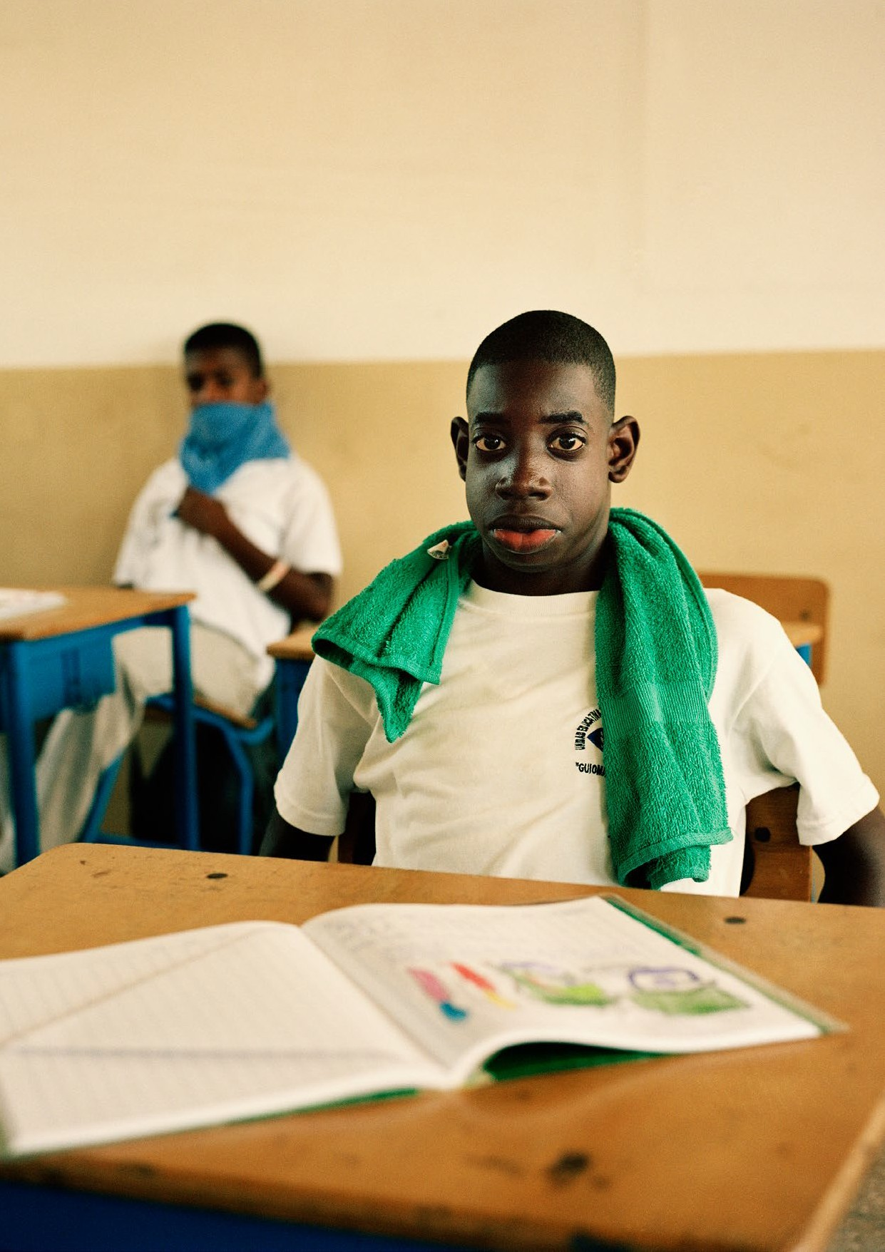

1. Introduction
This section provides detailed guidance for policymakers on measures that are required to implement the Sustainable Development Goal 4 (SDG 4) on Quality Education which ensure the inclusion of persons with disabilities.
Section 2 shows the connection between the Policy Guidelines to achieve SDG 4 with other resources, including the human rights indicators under the Convention on the Rights of Persons with Disabilities (CRPD) and other related tools.
Section 3 provides an overview of the situation of persons with disabilities in relation to education. Section 4 presents measures to establish and sustain an inclusive education system which cut across all SDG 4 targets.
Section 5 outlines the other key actions to ensure inclusive learning, aligned to specific SDG targets. When appropriate, targets have been considered together. For example, targets 4.1, 4.5 and 4.6 address equal access, completion and quality of learning outcomes for students with disabilities.
Targets 4.3 and 4.b address access to higher education, including universities. Target 4.4 focuses on the development and acquisition of skills for employment. While covered under SDG target 4.3, vocational training is, in this guide, addressed under target 4.4, given its centrality to skills development and employment.

2. Connection to other tools
  - CRPD Indicators: Article 24 (education)
  - Other related CRPD articles: 1-4, 5, 6, 7, 8, 9, 13, 16, 19, 25, 27, 28, 31
  - Data Sources Guidance: Article 24 and other related CRPD articles.
  - Training materials: Goal 4
  - Video: Goal 4

3. Why is Goal 4 important for persons with disabilities?
Compared to other children, children with disabilities are less likely to have ever attended school and more likely to be out of school. Barriers, at the school level, to enrolment and attendance include the stigmatisation of disability and negative attitudes towards the inclusion of children with disabilities in school; an inaccessible built environment; financial barriers and systemic barriers. These barriers result in the requirements of learners with disabilities not being met in their classrooms.
As a result, children with disabilities remain underrepresented, worldwide, across all levels of education. The Global education monitoring report, 2020: Inclusion and education: all means all estimates that children with disabilities comprise 15 per cent of all out-of-school children. Children with disabilities who do attend primary school are less likely than children without disabilities to complete it. As such, children with disabilities are also less likely to pursue higher levels of education. Across the globe, literacy among persons with disabilities is consistently lower than for persons without disabilities.
Girls with disabilities are less likely to attend and complete school, compared to boys with disabilities or other girls. The World Health Organization and World Bank, World Report on Disability 2011 (Geneva, 2011) found that 50.6 per cent of boys with disabilities completed primary school, compared with 61.3 per cent of boys without disabilities, while 41.7 per cent of girls with disabilities completed primary school, compared to 52.9 per cent of girls without disabilities. The same report found that women with disabilities spent less time in education overall, completing an average of 4.98 years of schooling, compared to 6.26 for other women and to 5.96 years for men with disabilities.
It has been established that early childhood development and education are key contributors to the successful completion of both primary and other levels of education (H. Yoshikawa and S. Kabay. The Evidence Base on Early Childhood Care and Education in Global Contexts (UNESCO, 2015). Likewise, encouraging the participation of children with disabilities in early childhood development and education improves access to primary and further education levels. However, available evidence suggests that, particularly in low-resource settings, there is limited availability of funding to enable the inclusion of children with disabilities in pre-primary education (World Report on Disability 2011, p. 219, table 7.2).
Limited current and reliable disaggregated data are available regarding children with disabilities and their participation in education, at all levels. UNICEF and the Washington Group finalised a Module on Child Functioning in 2016 that aims to identify children aged between 2 and 17 years who are at risk of functional difficulty and is beginning to be used in educational management information systems.
As a consequence of lower enrolment rates in primary and secondary education, persons with disabilities also experience lower enrolment and completion rates in tertiary education. The United Nations reported that, in 42 countries in 2012, an average of 24 per cent of the overall population completed tertiary education, compared to only 12 per cent of persons with disabilities (UNDESA, Disability and Development Report, 2019, p. 81, fig. II.31).
Currently, there is no general or disaggregated data on scholarships available to persons with disabilities, particularly regarding their enrolment in higher education and/or access to education for sustainable development and human rights (Target 4.b).
There is very little data on technical and vocational training and education (TVET) participation and outcomes for persons with disabilities. Where available to persons with disabilities, vocational training is often provided in segregated settings and not linked to the needs and quality requirements of the labour market. In low- and middle-income countries, an average of 42 per cent of persons with disabilities reported that they needed vocational rehabilitation to support their re-entry into the workforce. However, only 10 per cent of persons with disabilities reported that this need had been met (World Report on Disability 2011, p. 42, table 2.5).
Lower education completion rates lead to reduced access to qualifications and, thus, fewer opportunities to find employment and/or to develop a business. As a consequence, persons with disabilities have lower employment rates when compared to others. The World Report on Disability 2011 (Geneva, 2011) estimated that the employment rate for persons with disabilities was 44 per cent, compared to 75 per cent for others. Persons with disabilities also experienced higher inactivity rates, approximately 49 per cent compared to 20 per cent for others.
Accessible education infrastructure, or schools that have been built in accordance with universal design principles, ensure that everyone can reach and enter their school. The Global education monitoring report, 2020: Inclusion and education: all means all cites crowdsourced accessibility data from several countries (largely high-income) that indicate that only 47 per cent of more than 30,000 education facilities were considered accessible for wheelchair users. UNESCO reports that incorporating accessibility and universal design features into school infrastructure from the outset increases the total cost by 1 per cent while adapting it after completion can increase costs by 5 per cent or more.
Teacher pre- and in-service education are essential to ensure teachers are confident and skilled in the use of inclusive education teaching methodologies, including child-centred pedagogy that utilise differentiated instruction and the use of assistive technologies. However, as reported in the Global education monitoring report, 2020: Inclusion and education: all means all, few receive adequate preparation or professional development – 25 per cent of teachers in middle- and high-income countries reported a high need for professional development on teaching students with disabilities and, across ten sub-Saharan African countries, just 8 per cent of grade 2 and 6 teachers had received in-service training on inclusive education.
Lack of accessible curricula, environments and availability of reasonable accommodations and support in regular schools have led to segregated education for many students with disabilities. Separate “special schools”, or institutions for the education of persons with disabilities, are sometimes organised by impairment (e.g. schools for blind students, schools for deaf students). Students are segregated and expectations regarding learning outcomes may be different or lower.
Positive steps have sought to address the pervasive exclusion of persons with disabilities from regular education. In recent decades, many education systems, all over the world, began to integrate children with disabilities in regular schools. Integrated education is the use of separate classrooms specifically designated for students with disabilities, within the context of regular schools. Integration excludes some children with disabilities, particularly those with higher support requirements, and can lead to the segregation of students with disabilities within mainstream schools.
The CRPD and SDG 4 embrace the model of inclusive education. Article 24 of the CRPD, recognises inclusive education as the means to fulfil the right to education for persons with disabilities. From a rights perspective, inclusive education is accepted as the most suitable approach to guarantee universality and non-discrimination in the right to education. Sustainable Development Goal 4 is key and cannot be achieved for persons with disabilities without strengthening inclusive education systems that ensure the effective inclusion of students with disabilities.

4. Establishing and implementing an inclusive education system – actions applicable across all Goal 4 targets
Implementing Goal 4 under the CRPD entails putting in practice the model of inclusive education, throughout the education system. This requires structural measures that relate to all educational levels and pertain to all targets of Goal 4.
Inclusive Education is..
…the result of a process of continuing and proactive commitment to eliminating barriers impeding the right to education, together with changes to culture, policy and practice of regular schools to accommodate and effectively include all students (…) Inclusion involves a process of systemic reform embodying changes and modifications in content, teaching methods, approaches, structures and strategies in education to overcome barriers with a vision serving to provide all students of the relevant age range with an equitable and participatory learning experience and the environment that best corresponds to their requirements and preferences.
United Nations, Committee on the Rights of Persons with Disabilities. General comment No. 4 (2016) Article 24: Right to Inclusive Education. 2 September 2016. CRPD/C/GC/4. para. 11
Requirements of an inclusive education system that is capable of ensuring inclusive and equitable quality education to persons with disabilities are described in the following sections.

4.1 Governance by the Ministry of Education
figure v
The role of the Ministry of Education in Inclusive Education
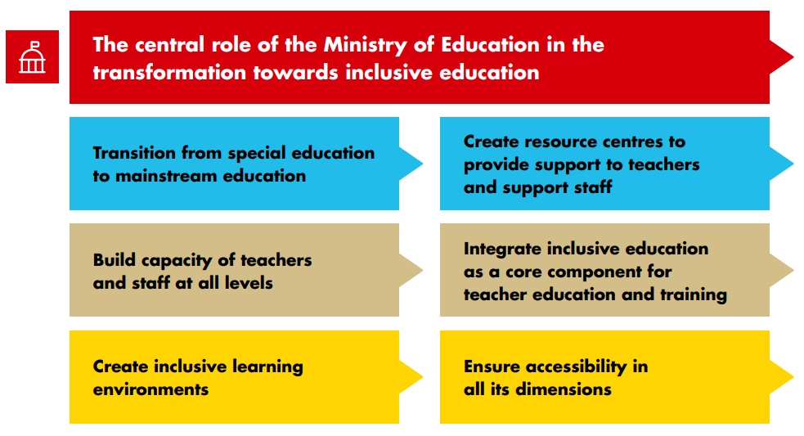

    - The Ministry of Education has a central role as the main governance body. This contributes to consistency, coherence and coordination throughout the education system, towards a common vision of inclusive education, across its diverse components. This includes ensuring inclusive pathways for students with disabilities throughout all educational levels and provision of competency frameworks, professional development on inclusive education pedagogy and support for the improvement of the working conditions of teachers.
    - The Ministry of Education is responsible for leading national policies and plans to transition and progress towards inclusive education, centralising responsibility for the continuous review and readjustment of inclusive education measures. An inclusive education unit established within the Ministry of Education can lead quality assurance on inclusive education, gathering data to inform the monitoring of inclusive education practice, policy and legislation.
    - Coordination mechanisms that link the Ministry of Education with other Ministries, government disability focal points and other public bodies are required to enable access to health services and social protection to students with disabilities. Led by the Ministry of Education, coordination with the Ministry of Health supports access to screening, assessment and rehabilitation services. Access to financial aid and other supports can be enhanced through coordination with the Ministry responsible for social protection.
    - Vertical collaboration between levels of government and support to local governments are key to ensure that the delivery of inclusive education is responsive to changing requirements at the school level. In many contexts, the education system distributes responsibilities amongst national governments (e.g. curriculum, funding, teacher training) and local governments (e.g. direct implementation). Local governments should be supported, as required, to deliver quality inclusive education throughout their geographical area of responsibility.
Governance and coordination for inclusive education
Inclusive Education Working Groups made up of representatives from ministries of education, health, social welfare and women and children, as well as OPDs, service providers, non-government organizations, faith-based organisations and other relevant civil society organisations are effective mechanisms for coordination, planning, monitoring and accountability for inclusive education in Central Java province (Munawir Yusuf, Erma Kumala Sari and Ravid Karsidi, Evaluation of The Inclusive Education Programme Implementation in Central Java province, Proceedings of the 3rd International Conference on Special Education (ICSE 2019) (Atlantis Press, 2019)).
Inclusive education must be led by the Ministry of Education
In many countries, public bodies such as the Ministry of Social Affairs or Welfare are responsible for the education of students with disabilities, e.g. through “special schools” for primary and secondary school-aged students, or through other programmes provided exclusively for persons with disabilities of higher ages. Such practices remain outside the education system and its curricula, pedagogy, quality standards, information management systems and oversight mechanisms. This separation of responsibility can promote and reinforce the segregation of persons with disabilities.
Where such practices exist, the accumulated experience of the professionals involved should be valued, assessed and oriented towards the development of resource centres for inclusive education, which provide support to the mainstream education system.
The Ministry of National Education of Colombia provides guidelines for inclusive education and works with national institutes for the blind and the deaf to create inclusive programmes. Regional education departments implement the policy. They carry out identification and enrolment campaigns for children with disabilities in coordination with other government entities, then develop progressive implementation plans (Global education monitoring report, 2020: Inclusion and education: all means all, p. 97).
Related CRPD Indicators: 24.1, 24.3, 24.6

4.2 Legislation
Recommendations
    - Overarching education legislation should explicitly embrace inclusive education in line with the CRPD (see definition) and recognize the right to inclusive education for all students, without exceptions. Legislation should protect the rights of students with disabilities and their families to choose the preferred type of education. Legislation should not include provisions or clauses allowing for the exclusion of students with disabilities from general education, e.g. based on impairments, where considered “appropriate” for the child (see section 5.1).
Related CRPD Indicator: 24.1, 24.2
    - Legislation should prohibit discrimination, violence, corporal punishment, harassment and bullying in the education system, including in the classroom, on the basis of disability.
Related CRPD indicators: 24.1, 24.9
    - Accessibility standards should be adopted, monitored and enforced. Provisions in legislation should:
      - make all education facilities (both public and private), of all levels, accessible for students with disabilities
      - ensure availability of accessible (or adapted) materials for students with disabilities
      - provide and ensure that learning environments are inclusive of students with disabilities
Related CRPD Indicators: 24.7, 24.8, 24.11 and 24.13

4.3 Close consultation and active involvement of persons with disabilities
Recommendations
The Ministry of Education should ensure the systematic participation of, and active consultation with, persons with disabilities, in all their diversity, their families and their representative organizations in the design, implementation and monitoring of inclusive education policies and programmes. In particular, children with disabilities have the right to be heard and to share their perspectives. This should occur at all levels, including at the individual (e.g. development of their individual education plan) and the collective levels, (e.g. through student councils).
Related CRPD indicators: 24.25, 7.14

4.4 Awareness-Raising
Many teachers, parents and students with disabilities remain unaware of the model of inclusive education and its benefits, as well as of the right to inclusive education. Parents of children with disabilities may remain sceptical or apprehensive about practices for inclusion, especially where support systems and resources are scarce. As such, they may not feel confident about enrolling their child in an inclusive school and continue to favour segregated special schools. On occasions, parents, both without and with children with disabilities, may even openly oppose changes towards inclusive education. Awareness-raising efforts play a critical role in fostering an environment that welcomes inclusive education and should be led by persons with disabilities.
Recommendations
Awareness-raising campaigns and activities should be systematically carried out to promote inclusive education among all education stakeholders, eliminate barriers (notably attitudinal barriers), improve inclusive education practices and promote children with disabilities starting school at the appropriate age.
Related CRPD indicators: 24.23, 8.2, 8.9
Awareness-raising through non-formal education
In Greece, the Association of Social Responsibility for Children and Youth runs an experiential non- formal education programme which promotes disability-awareness through an open and informative dialogue between primary and secondary school students and motivational speakers (young persons with disabilities), who coordinate and implement the programme. The main aim of the initiative is to fight ignorance and deconstruct stereotypes, in order to facilitate the inclusive education process. This association is striving for a barrier-free and rights-based inclusive society and strongly believes that education removes barriers for persons with disabilities and is the answer to social insensitivity, apathy and indifference. The speakers emphasise the role and importance of schools in developing social consciousness, eliminating prejudice and promoting the inclusion of socially vulnerable groups (European Agency for Special Needs and Inclusive Education and UNESCO, Inclusive Education in Action, European Agency for Special Needs and Inclusive Education, 2020).
Education for sustainable development and global citizenship
SDG Target 4.7 addresses the need to incorporate key content throughout the education process, in order to foster increased respect for individual human rights, inclusion and the promotion of sustainable development, by developing “the skills, values and attitudes that enable citizens to lead healthy and fulfilled lives, make informed decisions, and respond to local and global challenges through education for sustainable development (ESD) and global citizenship education (GCED)” (Incheon Declaration: Education 2030: Towards inclusive and equitable quality education and lifelong learning for all, para 9) (see box on Quality Education)
SDG Target 4.7 (United Nations, A/RES/70/1):
- By 2030, ensure that all learners acquire the knowledge and skills needed to promote sustainable development, including, among others, through education for sustainable development and sustainable lifestyles, human rights, gender equality, promotion of a culture of peace and non-violence, global citizenship and appreciation of cultural diversity and of culture’s contribution to sustainable development
In particular, human rights education and training on the rights of persons with disabilities, notably related to the Convention on the Rights of Persons with Disabilities, enables students to learn about diversity and inclusion and to better identify inequalities and disability-based discrimination. This also contributes to holding persons and institutions accountable, by submitting requests and complaints and engaging with the authorities – promoting the continuous improvement of their practices.
Related CRPD indicators: 8.6, 30.4

4.5 Teachers and education staff
4.c By 2030, substantially increase the supply of qualified teachers, including through international cooperation for teacher training in developing countries, especially least developed countries and small island developing States
This target addresses the need to increase and improve the teaching workforce and is thus key and applicable to all educational levels.
Building capacity of education sector staff, including teachers but also other school personnel, can challenge resistance linked to stigma and lack of experience and is key for the development and success of inclusive education.
Recommendations
The Ministry of Education should provide and promote:
    - Compulsory pre-service training for all future teachers on inclusive education methods and pedagogy (including on the accessibility of the classroom and school environment; use of augmentative and alternative modes, means and formats of communications; reasonable accommodation) as an integral part of general teacher training curricula, in coordination with education institutions that provide certifications for teaching – including tertiary institutions and universities.
    - Compulsory in-service training for teachers on inclusive education methods and pedagogy (including on the accessibility of the classroom and school environment; use of augmentative and alternative modes, means and formats of communications; reasonable accommodation), in coordination with relevant education actors, e.g. universities and teacher unions.
    - Gender-sensitive recruitment of teachers with disabilities to ensure diversity and gender balance within the education workforce.
    - Diverse and inclusive school cultures that promote, role-model and reward positive interactions between teachers with and without disabilities.
    - Recognition of teachers with disabilities and those with inclusive education experience, through promotion to leadership roles.
    - Support staff, as needed, to work with teachers, facilitating inclusive classrooms.
Related CRPD indicators: 24.6, 24.21, 24.22
See also Foundations Guideline, section 7 on “Capacity-building”.
Education support personnel deployed in the Cook Islands
The Cook Islands Inclusive Education Policy, introduced in 2002 and reviewed in 2011, focused on taking a more inclusive approach by transferring students with physical and learning disabilities from special units to mainstream schools. To achieve this, the policy recognized the role of support personnel, particularly teaching assistants. They received specialist training and many gained a New Zealand-issued Certificate in Teacher Aiding. Their role is to provide “one on one support to an individual child or support a small group within a class, depending on the level of need”. They work at all levels, from early childhood to secondary education. The assistants are meant to work with the teachers, to assure the best quality learning environment for students with certified special requirements. The ultimate responsibility and duty of care for all children remain with teachers – a supervisory teacher must be present at all times. Teachers write weekly plans based on the learning outcomes of the inclusive education programme and give assistants direction and opportunity for feedback (Global education monitoring report, 2020: Inclusion and education: all means all, p.150).
Teacher training for inclusion
The Callan Services for Persons with Disabilities is a partnership of stakeholders advocating for inclusion in Papua New Guinea. Among other activities, it established the Callan Inclusive Education Institute, to upgrade staff knowledge and skills at Inclusive Education Resource Centres – these raise awareness, screen for disabilities, provide rehabilitation and preparation for mainstream education and place children with disabilities in mainstream classrooms with long-term support. The institute also provides training for mainstream teachers and resource centre staff on how to work with, and train, mainstream teachers (Global education monitoring report, 2020: Inclusion and education: all means all, p. 147).
Diversity amongst teachers
In Nepal, educated individuals with visual impairments are actively recruited as teachers in mainstream schools. Out of the approximately 1,000 persons in Nepal with visual impairments and a university degree, around 400 worked as teachers in mainstream schools. A survey found that both students and principals perceived these teachers positively, despite some challenges in classroom management, support (e.g. materials in Braille), help with marking examinations or training in
the use of computers. Students reported that the teachers’ strengths were positive attitudes, good communication skills and more attention paid to social and moral lessons (Global education monitoring report, 2020: Inclusion and education: all means all, p. 152).
Learning together, teaching together
Many countries provide pre-service teacher training in separate general education and special education streams. This results in teachers who are prepared to teach students that fit certain pre-established criteria but are not prepared to teach a diverse range of students in an inclusive classroom.
For students to learn together, teachers must have a variety of skills to address the different requirements that a diverse range of students may have. All teachers must be prepared to teach all students and should receive continuous training to develop the skills required to reach students who require more support.
Bringing this mix of skills to the classroom requires pre-service training on inclusive education philosophies and approaches; strategies for working collaboratively with other teachers; teaching and learning materials for students with disabilities; teaching strategies that enable learning by students with diverse requirements. For example, Universal Design for Learning (UNICEF North Macedonia “Access to School and the Learning Environment II - Universal Design for Learning: Inclusive education booklet on the basic concepts of universal design for learning”) is a widely recommended strategy for reaching a variety of students.
Unifying pre-service education for teachers under one system can build common ground among teachers, as well as a platform for exchange, sharing and learning.

4.6 Budget Allocation
Recommendations
    - Allocate budget for the implementation of the different aspects of inclusive education and establish markers to track expenditure.
    - Budget expenditure for inclusive education should be disaggregated so that areas of priority and gaps are clear and comparable. Where there are transition plans from special education towards inclusive education for students with disabilities, budget allocations should be as disaggregated as possible by expenditure on materials, support and reasonable accommodations, to prevent gaps in the provision of support and allow for the comparison of expenditure across systems.
Related CRPD indicators: 24.14 and 24.24
See also Foundations Guideline, section 3.3.2 on “Disability markers”.
Evidence-based resource allocation to support inclusive education
Where countries have education management information systems that effectively identify children with disabilities, funding can be allocated to support inclusion. Fiji has recently commenced including disability data into its staffing formula, which allocates proportionately more staff to schools with students with relevant support requirements. The data system also enables special and inclusive education grants to go to schools, based on data from the students learning profiles (D. Mont and B. Sprunt, Adapting education management information systems to support inclusive education. In The SAGE Handbook of Inclusion and Diversity in Education, M. Schuelka and others, eds. 2019. pp.
249-262)

4.7 Data collection and disaggregation
The Ministry of Education should ensure that education data are collected and disaggregated by disability and covers all education services available, in both mainstream and special schools. Data should be collected on persons with disabilities enrolled, attending, completing, dropping out and out of school.
Recommendations
In order to monitor the inclusion of students with disabilities in education over time, the Ministry of Education should:
    - Establish policies and processes for identifying children with educational support requirements, including students with disabilities
    - Systematize administrative data in order to be able to retrieve and analyse it (for example, by improving the education management information system to enable disability disaggregation)
    - Coordinate closely with the national statistical office to ensure that all data collection systems are compatible, particularly regarding the identification modules in statistical operations (census, surveys, etc.). This enables measurement of enrolment ratios of students with disabilities out of the total population of persons with disabilities, which is estimated through censuses and household surveys.
    - Support research to understand the effectiveness of inclusive education, gaps and issues, and develop recommendations for improvements.
Related CRPD indicators: 24.27-24.30 and 31.2
See also Foundations Guideline, section 3.5 on “Data collection and disaggregation”.
Screening and identification
South Africa adopted a National Strategy on Screening, Identification, Assessment and Support in 2014, to provide standardized procedures. The policy, aligned with the Integrated School Health Policy, targets out of school children, as well as learners in mainstream and special schools who encounter learning barriers. Assessment and support are not based on predefined categories of disability but on the level and nature of learning requirements. At admission, teachers screen all children, record results in learner profiles and become case managers (Global education monitoring report, 2020: Inclusion and education: all means all, p.44).
Disability data in education management information systems
The evolution of Fiji’s education management information system is an instructive example of good practice in measuring disability-inclusive education. The system was expanded in 2013 to include a more sophisticated disability disaggregation toolkit based on the UNICEF and Washington Group Module on Child Functioning. Teachers receive a guidebook and training and are encouraged to complete a student learning profile for any child with significant functional difficulties and for those who consistently perform poorly. The form is completed with parents, taking clinical assessments into account when appropriate and agreeing on any need for targeted support.
Student-level information in the system is complemented with school information, including an accessibility audit. Involvement by organizations of persons with disabilities, students with disabilities and their families is encouraged. The system records information on the services needed and on those available (Global education monitoring report, 2020: Inclusion and education: all means all, p.84).

4.8 Accountability and complaint mechanisms
Recommendations
    - The Ministry of Education should establish independent, effective, accessible, transparent, safe and enforceable accountability and complaint mechanisms that allow students with disabilities, parents and other relevant persons to channel their feedback, requests and complaints. These may include cases of discrimination, lack of support, violence, harassment, corporal punishment, bullying, etc. Confidentiality and mandatory reporting processes are required and personnel should be trained in these. The Ministry of Education should establish sound administrative structures to provide timely and effective responses to the complaints.
    - An independent complaints mechanism should be available, to be utilised when previous steps failed or were not satisfactory for the complainant. The justice system should be prepared to address disability-based claims and to accommodate persons with disabilities. Independent monitoring mechanisms, including national human rights institutions, should monitor the progress of cases, identify structural gaps and promote remedial action, working together with the Ministry of Education.
    - In consultation with organizations of persons with disabilities, Ministries of Education should ensure that accessible information about the right to education and on how to challenge denial or violations is widely disseminated and publicized to persons with disabilities.
Related CRPD indicator: 24.26

5. Other key actions by target

5.1 Access to, and completion of inclusive quality education- Targets 4.1, 4.5 and 4.6
4.1 By 2030, ensure that all girls and boys complete free, equitable and quality primary and secondary education leading to relevant and effective learning outcomes
4.5 By 2030, eliminate gender disparities in education and ensure equal access to all levels of education and vocational training for the vulnerable, including persons with disabilities, indigenous peoples and children in vulnerable situations
4.6 By 2030, ensure that all youth and a substantial proportion of adults, both men and women, achieve literacy and numeracy
The general actions outlined in Section 4 are crucial for the achievement of targets 4.1, 4.5 and 4.6. In particular, target 4.1 highlights the completion of free, equitable and quality primary and secondary education, with a focus on ensuring relevant and effective learning outcomes, as well as fostering interpersonal and social skills and positive values and attitudes.
Quality Education
Whilst there are different approaches to “quality education” at an international level, there is consensus around three key aspects: the need for more (i) relevance, for greater (ii) equity of access and outcomes and for proper (iii) observance of individual rights. Quality relates to more than simply learning outcomes, although these may catalyse increased investment, innovation and inclusion.
We commit to quality education and to improving learning outcomes, which requires strengthening inputs, processes and evaluation of outcomes and mechanisms to measure progress ... Quality education fosters creativity and knowledge, and ensures the acquisition of the foundational skills of literacy and numeracy as well as analytical, problem-solving and other high-level cognitive, interpersonal and social skills. It also develops the skills, values and attitudes that enable citizens to lead healthy and fulfilled lives, make informed decisions, and respond to local and global challenges through education for sustainable development (ESD) and global citizenship education (GCED).
Source: UNESCO and others, Incheon Declaration Education 2030: Towards inclusive and equitable quality education and lifelong learning for all (2015). para. 9.
This section focuses on actions to strengthen both access to, and completion of, quality education by students with disabilities and on how to support them in achieving their learning outcomes.
figure vi
Actions to strengthen access, completion and learning outcomes for students with disabilities
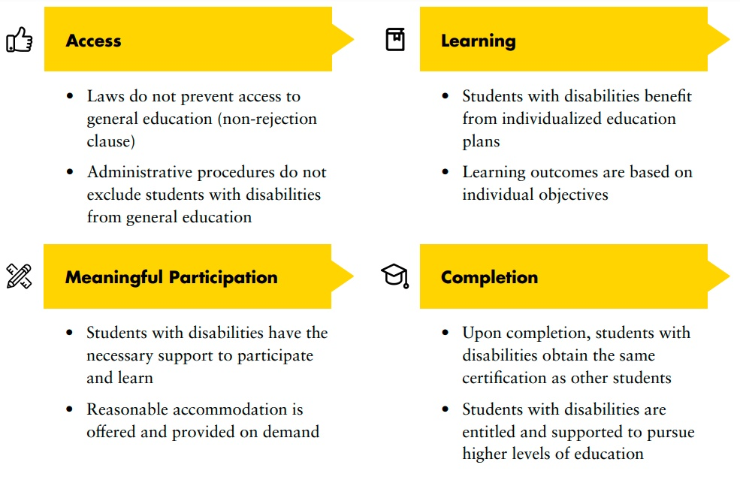

5.1.1 Adopt a non-rejection policy and prohibit admissions requirements
Children with disabilities are often denied access to general education through exception clauses in education legislation. These are made operational through administrative procedures, including exclusion on the basis of assessments of cognitive capacity (for example IQ testing), that automatically lead to referrals to special education schools.
Recommendations
Educational authorities should:
      - adopt a “non-rejection” clause (in law) and policy (in practice) which prohibits the denial of admission of a student with disability into mainstream schools. A “non-rejection policy” is a rule that prevents education systems from excluding students with disabilities from attending mainstream schools. It is a non-discrimination tool and it is expressly recognized in the CRPD.
      - prohibit admissions requirements which have the effect of excluding students with disabilities based on impairment, degree of impairment, the presumed potential of the individual or age limit on the completion of grades.
Related CRPD indicators: 24.1, 24.2

5.1.2 Foster inclusive learning environments
Currently, most general education systems and their evaluation methods are standardised to be applied to all students. Such an approach assumes that all students should fulfil the same uniform expectations in terms of performance. This approach ignores the great diversity of students and their learning methods, notably of children with intellectual and developmental disabilities.
Inclusive education requires that students with disabilities engage in education in general schools, on an equal basis with other students. This comes with the requirement that learning environments and curricula are universally designed and that teaching methods and assessments are flexible to adaptation, to meet the requirements of the diversity of learners, including children with disabilities.
Further, curricula for all students, including students with disabilities, should be reviewed to ensure coverage of the areas highlighted by the SDGs, in recognition that education is a key driver to achieving sustainable development.
SDGs Key thematic areas for education curricula and students with disabilities
SDGs 4, 5, 12 and 13, as well as SDG indicators (4.7.1, 5.6.2, 12.8.1 and 13.3.1), require education systems to include specific thematic areas in school curricula, throughout all levels of education.
These are:
- (i) global citizenship education
- (ii) sexual and reproductive health education
- (ii) education for sustainable development, including on gender equality, human rights and climate change (particularly on mitigation, adaptation, impact reduction and early warning)
These areas should be explicitly included in national education policies, curricula, teacher education, and student assessment. In particular, human rights education provides an important opportunity to include the rights of persons with disabilities.
Education systems should provide this content to all students in an inclusive manner, to ensure that students with disabilities equally benefit from them.
Recommendations
Education authorities should:
      - Ensure that the national curriculum reflects the diversity of learning requirements and allows for adaptations tailored to each learner, through the use of individual education plans - which outline goals and assessment processes – and the identification of reasonable accommodations and supports. Individual education plans should be developed with the participation of children with disabilities, in accordance with their age and maturity.
Related CRPD indicators: 24.7, 24.16
      - Promote inclusive learning environments where students with disabilities are not discriminated against based on their impairment or language or subjected to violence and can participate equally. This requires education authorities to prepare teachers appropriately and develop programmes which prevent violence, corporal punishment, harassment and bullying against persons with disabilities.
Related CRPD indicators: 24.9, 24.16
      - Ensure that all new school infrastructure utilises the principles of universal design and is accessible to all learners, including those with physical and sensory impairments.
Related CRPD indicators: 24.7, 24.8, 24.17, 24.19
      - Ensure that curricula for students with disabilities also covers the following themes, in accordance with the SDGs: global citizenship education, sexual and reproductive health education and education for sustainable development, gender equality, human rights and climate change.
Related CRPD indicators: 24.12, 8.6, 30.4

5.1.3 Ensure support, including through reasonable accommodation
Inclusive education is not just about placing students with disabilities with other children, but about ensuring that all support measures are properly in place to enhance their development and meaningful participation, enabling the achievement of their educational goals. When universal design conditions are met, many students with disabilities require few or no individual adaptations or support to participate in the general education system. For those persons with disabilities who may require it, inclusive education must provide adequate, continuous and personalized support.
Support as part of inclusive education systems
Distinction from reasonable accommodation
Support measures include providing learning support assistants; augmentative and alternative modes, means and formats of communication; specific learning tools; assistive and information technology; alternative/accessible formats; scholarships; transport assistance and financial resources. Support measures must be determined in collaboration with the student with disability and, where appropriate, with the parents or caregivers and relevant professionals.
Resource centres
Resource centres are centralized structures that provide services to mainstream education facilities, to support inclusive education. These services vary and can include technical support; resources to ensure support measures; support to teachers to enhance capability for inclusive teaching methods; pedagogic evaluation and support, including how to ensure the provision of reasonable accommodation. Resource centres are not segregated spaces where students with disabilities are taken for education. Centralized resource centres can facilitate the provision of reasonable accommodation. These centres can cover more than one education facility and can be a fast solution when undertaking a transition towards an inclusive education system, by building on the existing resources in the special education system (see box Transitioning from special education to inclusive education ).
How is “support” different from reasonable accommodation?
Supports , from the perspective of the CRPD, are measures that are part of the education system and can be institutionalized over time. Reasonable accommodations are anti-discrimination tools that aim to provide immediate responses to the requirements of students. Students, either through support systems or through reasonable accommodation, have the right to access the necessary tools for them to complete their studies. Support should be seen as an ongoing investment and reasonable accommodation as an emergency tool. As the system grows more inclusive, fewer reasonable accommodations will be required.
Reasonable accommodation in the context of education includes, among others, adjusted timetables to facilitate the participation of a student with disabilities; modifying the allocation of classrooms to ensure that the student with disability attends courses in an accessible room; allocation of longer time for students with disabilities to take exams; provision of assistive technology, including software, as required to ensure participation on an equal basis with others.
Meaningful participation of deaf and hard of hearing students in education
Many deaf persons express themselves through sign language. Sign language is, as every other language, a live and complex system of communication that uses visual gestures and signs (that depend on human interaction to develop) and involves the whole signing community. The use of sign language is also a cultural right of deaf persons and is essential to preserve and foster identity and community. The impact of limiting access to sign language for deaf children could have irreversible developmental consequences. In addition, forcing deaf children into oralist communities could lead to isolation and exclusion.
Meaningful participation in education for deaf students requires the opportunity to express themselves in the language they choose, including with a signing community, throughout their education process. In this line, deaf and hard-of-hearing students must be provided with the opportunity to learn sign language and to learn in sign language from fluent teachers. Measures must also be taken to recognize and promote the linguistic identity of the deaf community.
See United Nations, Committee on the Rights of Persons with Disabilities, General Comment No. 4 (2016) Article 24: Right to inclusive education, 2 September 2016, CRPD/C/GC/4. paras. 35(b), 35(c) and 58.
Recommendations
Education authorities should:
      - Provide students with the support measures they may require, to ensure inclusive learning (including assistive technology). Additional supports may include personal assistance during class and support teachers (the presence of additional support personnel in classrooms must not further marginalise students with disabilities).
Related CRPD indicator: 24.16
      - Ensure the provision of reasonable accommodations to provide for the individual requirements of students with disabilities, in all settings. To do so, centralised funds for reasonable accommodation and/or provision through resource centres can be practical options, noting that students with disabilities should learn in classrooms alongside their peers.
Related CRPD indicator: 24.1
      - Ensure accessibility of learning materials and means of communication, including through communication aids and assistive and information technology.
Related CRPD indicators: 24.11, 24.17, 24.30
      - Ensure the availability of education in national sign language, tactile sign language, tracking, tactile fingerspelling, print on palm, tadoma, Braille, speech, plain language, easy read and speech reading, as required by students.
Related CRPD indicators: 24.17, 24.18, 24.19
      - Ensure the provision of accessible life skills to all students with disabilities. Related CRPD indicator: 24.12
      - Plan and develop systems and services, including through the development of in-school or centralised resource centres.
Related CRPD indicators: 24.19, 24.20, 24.21

5.1.4 Provide equally valid certification
Students with disabilities should receive a certification of completion of education levels, of equal value to others, that enable them to pursue higher studies. Grade promotion, completion of an education level and quality of educational outcomes of children with intellectual disabilities must be interpreted in connection with their individual education plan and curricular adaptations (including for the related CRPD indicator 24.29).
Students with intellectual or developmental disabilities may be denied their certification of completion or provided with certification that is not of equal value to that of their peers, perhaps specifying that they had an individual education plan or curricular adaptations. As a result, once they complete primary or secondary school, these students may be denied the opportunity to pursue further studies of any kind, be it vocational, technical or at a university.
Recommendations
In this regard, education authorities should:
      - Ensure that the completion of an education level is guided by the individual education plans and achieved based on individualized assessments that respond to the plan.
Related CRPD indicator: 24.16
      - Ensure that the certification of completion is considered to be equally valid regardless of whether or not curricular adaptations or individualized goals are registered in the certification or diploma. It should enable persons with disabilities to pursue further studies.
Related CRPD indicators: 24.27, 24.28
      - Provide support to students with disabilities in transitioning to higher levels of education and employment.
Related CRPD indicators: 24.5, 24.27
Transitioning from special education to inclusive education
The CRPD calls for the implementation of an inclusive education system. Transforming an education system requires careful planning, policy development, time and sustained resources. The aim is to resource and build an inclusive education system that enables students with disabilities to access quality education together with all other students. Many students with disabilities can participate in existing regular education with few adjustments and supports. Other students, who may require higher support, also have the right to participate in regular education. It is important to note that whilst many systems are transitioning towards inclusive education, not all mainstream schools are currently able to ensure effective, safe and supportive environments for students with disabilities. Governments should provide the necessary support and reasonable accommodations for students to successfully transition within an enabling and safe environment, preventing exclusion and, ultimately, strengthening the inclusion process.
In order to move forward, the following key actions are required:
- Allow students with disabilities to enrol into a regular school (non-rejection policy)
Related CRPD indicators: 24.1, 24.2
- Develop an inclusive education plan that resources schools, trains teachers, establishes policy settings and provides relevant supports to enable students with disabilities to receive a quality education in regular schools
Related CRPD indicators: 24.3, 24.5, 24.14, 24.16, 24.21, 24.28
- Establish in-school or centralised resource centres for the provision of support to teachers and support staff on inclusive education, including for ensuring that reasonable accommodation is provided to students with disabilities in regular schools
Related CRPD indicators: 24.3, 24.18, 24.19, 24.20, 24.21
Special education has traditionally been the main source of practice and knowledge on how to support students with disabilities. This resource should not be left behind and transition plans should benefit from the accumulated experience of existing special education systems. It should be noted that not all practices in special education will be beneficial for inclusive education.
Teachers with and without impairments working in the special education system will contribute to improving inclusive education. All teachers should build their capacity on inclusive education and associated methodologies
Related CRPD indicators: 24.6, 24.21, 24.22
- Establish a mechanism to enrol students with disabilities coming from special education institutions into mainstream education, monitoring the transition to ensure that they have quality support and any necessary adjustments are made, to meet their individual requirements
Related CRPD indicators: 24.3, 24.7, 24.16
- Establish an accountability mechanism, enabling students with disabilities to claim the support and accommodation they may require
Related CRPD indicator: 24.26
Inclusive education is a right that every student with or without disabilities should be able to exercise. To that end, legislation should enable the above-mentioned actions. In addition, legislation should promote an inclusive education system and policies should ensure adequate resourcing, to avert reliance on special education structures such as special schools, separate classrooms, or settings exclusively for students with disabilities, including day care centres, vocational training centres, residential institutions and early childhood education centres.
Partnership between resource centres and mainstream schools
In Ho Chi Minh City, Viet Nam, blind students receive support for attending a mainstream school. Students who moved to the mainstream school reported missing the extracurricular activities and vocational training previously provided by the resource centre. In response, the centre and the school worked together, with the centre offering more support to the school, including through in-service teacher education (Global education monitoring report, 2020: Inclusion and education: all means all, p. 149).

5.1.5 Identify and address gaps in the education trajectory of students with disabilities
Children and youth with disabilities are more likely to be out of school than other children and youth of school age. When they encounter the school system, they may be put on various pathways depending on how the system approaches students with disabilities. This includes how the system views and measures the potential of students with disabilities and whether or not measures of support and inclusion are offered, provided and adapted to the individual student and their learning requirements. Many education systems continue to operate on built-in pathways of exclusion for students with disabilities, thus preventing successful completion.
In most systems, students without disabilities register, access, participate in activities and education programmes and complete their studies. In the same system, students with disabilities may fall into one of the common exclusionary trajectories shown in figure VII.
figure vii
Common exclusionary trajectories for children with disabilities
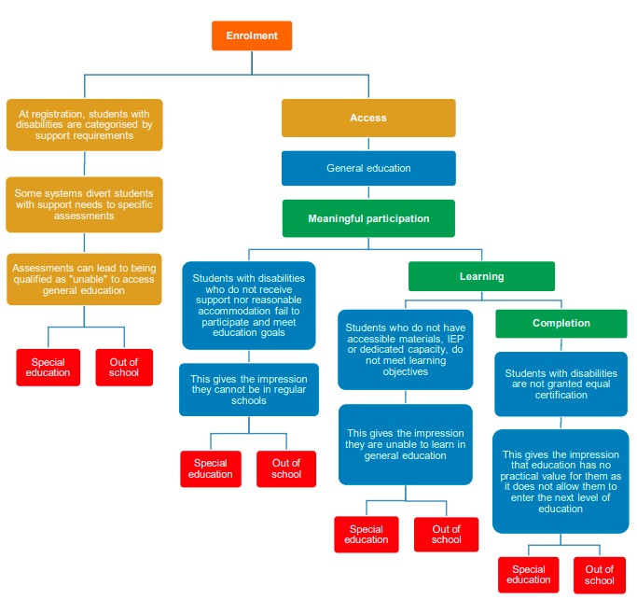
- Out of school children: data on out of school children with disabilities are required to enable the tracking of progress of their inclusion in education.
Action: Establish mechanisms to identify out of school students with disabilities and link them with relevant education services. This may include steps to overcome barriers to enrolment at the local school, linking them with accelerated education service providers, and/or implementing outreach programmes to enable learning from home.
- Pedagogic evaluation: at various times (often at the point of enrolment) schools may request that children with disabilities undergo a pedagogic evaluation (or a functional assessment, depending on the context). This can be useful in identifying educational support requirements and in informing the development of an individual education plan. However, the evaluation may sometimes be used to exclude students with disabilities from mainstream schools and divert them to special education, home schooling or social care institutions; or to selectively enrol only some students with disabilities in mainstream education settings, dependent on the perceived ability of the child to adapt to the existing context. In places where there are no pedagogic evaluations or similar mechanisms, students with disabilities may be diverted to special education or enrolled in mainstream education without the appropriate supports or reasonable accommodations.
Action: Do not use pedagogic evaluations (or functional assessments) as a basis to deny access to mainstream education settings. Evaluations should be used to identify education support requirements and reasonable accommodation provisions, to enhance participation of the student and to support the process of developing individual education plans.
- Obtain measures for support and inclusion: Individual education plans and provision of support and reasonable accommodation in general education. In many cases, education for students with disabilities is improved through the development of individual education plans. These often signal the provision of support measures or reasonable accommodation. Supports and accommodation should be available throughout each educational stage and particular attention should be paid during transitions to subsequent levels of education – students with disabilities and their families should be supported in communicating their support and reasonable accommodation requirements to the new educational setting.
Action: Ensure the provision of individual education plans, supports and reasonable accommodation as required by the individual student. Closely monitor the situation of students to adapt supports and to ensure resourcing is available to enable quality inclusive education. Monitor and support school attendance of students with disabilities to provide for a successful education process and to prevent exclusion or diversion from mainstream education.
- Reaching Completion, learning outcomes and transition. To ensure that inclusive education is focused beyond the enrolment of students with disabilities in mainstream classrooms, education systems should track data on the proportion of students with disabilities completing education levels, transitioning from early childhood settings to primary, primary to secondary, secondary to post-secondary and between special education and mainstream settings. Outcomes can be tracked through general curricular assessment mechanisms, as well as through the achievement of individual education plan goals.
Action: Regularly monitor data on students with disabilities related to learning outcomes, completion rates and transition rates.

5.1.6 Collect data to monitor and enhance inclusion
Well-developed information systems are key to measure steps towards achieving target 4.1. Governments must ensure that administrative data or education management information systems (EMIS) enable the tracking of individual trajectories of students with disabilities. Improvements to EMIS’s (including digitalization) are required in many countries, to facilitate data disaggregation and improve the use of data to support inclusive education.
Besides identifying disability, EMIS’s need to collect information such as the need for, and provision of, educational supports; use of accessible materials; barriers and transition of students between classes and settings. Data must be collected for students with disabilities both in mainstream education and special education.
In addition, education systems need to monitor beyond their administrative data and be able to implement policies that target all children with disabilities, including those who are out of school. This requires comparing EMIS data to national population-level data. Coordinating closely with the national statistical office to ensure compatibility of disability measurement across data collection systems is fundamental, particularly regarding disability identification modules in statistical tools (census, surveys, etc.), so that the overall inclusion of students with disabilities in schools can be assessed.
The SDG indicators related to targets 4.1, 4.5 and 4.6 require data on the enrolment of children and young persons at different grades and educational stages, as well as proficiency levels in literacy and numeracy (disaggregated by sex, disability and minority or indigenous background). Data on school facilities are required for SDG indicator 4.a.1, including on adapted infrastructure and materials for students with disabilities; this information is important for understanding environmental factors that act as barriers or enablers to enrolment and achievement.
In addition, CRPD indicators require measurements of: the proportion of students with disabilities benefiting from individual education plans, support measures and other accommodations; the proportion of deaf students receiving education in sign language; and measurements of other areas.
Recommendation
In this regard, the education authorities should:
- Collect data on enrolment and completion, disaggregated by disability status, and establish monitoring mechanisms in EMIS to ensure action upon irregularities within the trajectory of the student.
Related CRPD indicators: 24.11, 24.16, 24.17, 24.19, 24.28, 24.29, 31.7, 31.9

5.2 Quality early childhood development, care and pre-primary education- Target 4.2
4.2 By 2030, ensure that all girls and boys have access to quality early childhood development, care and pre-primary education so that they are ready for primary education
Early childhood interventions can be particularly valuable for children with disabilities, serving to strengthen their capacity to benefit from education and promoting their enrolment and attendance. All such interventions must guarantee respect for the dignity and autonomy of the child.
Governments are urged to ensure access to quality early childhood development, care and pre- primary education, through development and support of an appropriately trained workforce, together with the provision of support and training to parents and caregivers of young children with disabilities. If identified and supported early, young children with disabilities are more likely to transition into pre-primary and primary inclusive education settings.
UNICEF proposes a comprehensive overview and framework for early childhood development policies and programmes, which pertains to several SDG targets (see figure VII) and to all children. The framework goes beyond the education policy and highlights the need for coordination of all programmes (from different areas) that contribute to early childhood development, notably education, health and social policy. It addresses SDG target 4.2 in conjunction with other SDG targets that concern early childhood development. In doing so, it presents and links the different service delivery platforms providing services to pre-school age children.
Recommendations
For children with disabilities, measures addressing their requirements and supporting their early development must:
    - Be directed to enhancing the natural environment (parents and caregivers) of the child with disability, to make it supportive of their development
    - Aim at ensuring that children with disabilities always participate in inclusive settings with other children
    - Not only look to the medical output of the identification of the impairment and to intervention measures but also to the social development of the child, including by addressing attitudinal (and other) barriers that may hinder their participation
In the context of target 4.2, an inclusive early childhood education system, coordinated with other sectors, and awareness among parents of children with disabilities are fundamental. To achieve this, Governments should pay attention to the points presented in the following sections.
figure viii
UNICEF framework for early childhood development policies and programmes
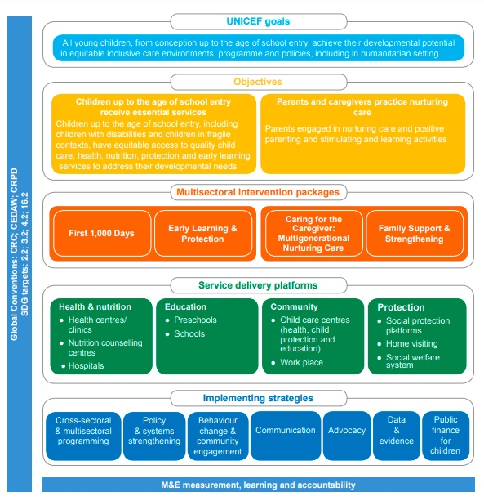
Source: UNICEF, UNICEF’s programme guidance for early childhood development (New York: United Nations Children’s Fund, 2017), p. 15, fig. 4.
Recommendations
For children with disabilities, measures addressing their requirements and supporting their early development must:
- Be directed to enhancing the natural environment (parents and caregivers) of the child with disability, to make it supportive of their development
- Aim at ensuring that children with disabilities always participate in inclusive settings with other children
- Not only look to the medical output of the identification of the impairment and to intervention measures but also to the social development of the child, including by addressing attitudinal (and other) barriers that may hinder their participation
In the context of target 4.2, an inclusive early childhood education system, coordinated with other sectors, and awareness among parents of children with disabilities are fundamental. To achieve this, Governments should pay attention to the points presented in the following sections.

5.2.1 Provide awareness-raising, support services and training to parents and caregivers
Parents and caregivers constitute the natural and primary environment of children in their first years of life. They provide for their early development through nutrition, care, protection, interaction, play, etc.; and interact with early education and other relevant services, including paediatric services. Their observations may trigger the search for services leading to early identification of impairments, which can lead to the timely access of early intervention services (see section 5.2.2.).
Recommendations
For parents and caregivers to be able to effectively fulfil their duties and this essential supportive role, it is key for Governments to:
      - Raise their awareness about disability, education and human rights
      - Establish mechanisms to provide them with specific information on early childhood development services
      - Develop counselling and support services
      - Promote their engagement with peer-support networks (family member organizations for persons with disabilities)
      - Promote collaboration between them and education, rehabilitation and social systems Related CRPD indicators: 7.15, 8.2, 8.6, 8.7, 23.10, 23.16, 24.23

5.2.2 Establish mechanisms for early identification and early intervention for inclusive early education
Historically, and notably in education, a focus on medical diagnosis has been used to exclude and segregate children with disabilities from their peers. Especially for those with intellectual and developmental impairments – who have been labelled as “uneducable”, “unable” or “disruptive”, among others – this lead to low expectations, which perpetuated discriminatory attitudes and practices.
Coordination among early childhood education authorities and other services (including health services) is key to enable that relevant information is behind decisions about learning requirements and the provision of educational (or other) support. Education authorities should be proactive in case-management, as not to leave all the burden of administrative tasks and coordination among agencies and services to parents and caregivers.
Recommendations
Establishing an early identification and assessment system for the development of early intervention for children with disabilities requires governments to ensure, among other things:
      - awareness-raising and dissemination of information on disability to parents and first-line staff of different sectors
      - clear procedures for referrals, when necessary
      - availability of a diversity of specialized services for assessment, including paediatric services and developmental screening
      - setting up networks among government, communities, education services and civil society organisations (including OPDs) to raise awareness, encourage and facilitate access to services and monitor early intervention programmes.
Related CRPD indicators: 8.2, 8.7, 24.4, 24.10, 24.23, 25.3

5.3 Access to higher education, including university, and availability of scholarships for persons with disabilities - Targets 4.3 and 4.b
4.3 By 2030, ensure equal access for all women and men to affordable and quality technical, vocational and tertiary education, including university
4.b By 2020, substantially expand globally the number of scholarships available to developing countries, in particular least developed countries, small island developing States and African countries, for enrolment in higher education, including vocational training and information and communications technology, technical, engineering and scientific programmes, in developed countries and other developing countries

5.3.1 Ensure accessibility and reasonable accommodation in admission procedures
Accessing higher education starts by having admission procedures that treat persons with disabilities equally. This means ensuring accessibility of, and having reasonable accommodation applied to, admissions procedures, e.g. admission exams in Braille or orally for blind persons (accessibility measure); more time for written exams as required (reasonable accommodation); information on admissions in easy to read formats for persons with intellectual disabilities (accessibility measure).
As noted in the General Comment No. 4 (2016), paragraph 12, learners with disabilities should receive support to ensure effective transitions from school to vocational or tertiary education and, finally, to work. Governments should ensure that the capacities and confidence of learners are developed and that they receive reasonable accommodation. In addition, equality regarding assessment, examination procedures and certification of their capacities and attainments should be guaranteed.
Recommendations
Education authorities should:
      - Raise awareness, amongst higher education institutions, of accessibility requirements
      - Enforce protocols and coordinate with all higher education institutions to ensure both accessibility and reasonable accommodation in admission procedures, throughout all courses and in exchange programmes.
      - Propose that education legislation establishes the obligation to offer both accessibility and reasonable accommodation in admission procedures for all technical, vocational and tertiary education institutions, including universities.
      - Establish admission procedures that are proportionate to, and consistent with, a student’s individual education plan, when appropriate.
Related CRPD indicators: 24.5, 24.20

5.3.2 Adopt specific measures to increase the number of persons with disabilities in tertiary education
While data are very scarce regarding persons with disabilities in tertiary education, persons with disabilities present lower completion rates in tertiary education when compared to other persons (UNDESA, Disability and Development Report, 2019, p. 81, fig II.31).
Specific measures focused on persons with disabilities are necessary to increase their participation in higher education, including in universities. Such measures are diverse and education authorities should promote, adopt, monitor and redesign them over time.
Recommendations
Education authorities, including technical, vocational and tertiary education institutions and universities, should consider, for instance:
- Adopting affirmative actions that favour persons with disabilities, e.g. quotas, reserving places in admission procedures for persons with disabilities; this directly contributes to increase their participation.
- Establishing, within public authorities on higher education and within universities, offices to provide support to students with disabilities.
- Developing scholarship programmes for persons with disabilities, to aid in covering the cost of education and/or the extra cost of living related to their disability.
- Developing policies and building capacity to support the development of individual education plans for persons with disabilities, if required.
- Establishing inclusive and diverse assessments and tests.
- Providing individualized support, including psychosocial support, to any person with disability that might need it, when transitioning to and/or at higher education.
- Establishing outreach measures to inform and advocate for opportunities for tertiary education for persons with disabilities, to identify potential candidates to higher education and to provide them with the necessary support to enrol in higher levels of education.
- Acting as a role model by employing persons with disabilities under their authority. Related CRPD indicator: 5.7, 24.5, 24.22, 24.23, 24.27
Promoting higher education for persons with disabilities
The University of Washington in Seattle, United States of America, developed the “Disabilities, Opportunities, Internetworking, and Technology (DO-IT)” programme, targeting both students with disabilities from high schools and faculty staff and academic administrators, with the objective of increasing the successful participation of persons with disabilities in postsecondary education and careers in science, technology, engineering and mathematics.

5.4 Acquiring skills for employment, decent jobs and entrepreneurship by persons with disabilities – Target 4.4
4.4 By 2030, substantially increase the number of youth and adults who have relevant skills, including technical and vocational skills, for employment, decent jobs and entrepreneurship
The transition from the education system to the world of work and employment poses several challenges and barriers to persons with disabilities. SDG Target 4.4 requires that youth and adults with disabilities are equipped with the relevant skills for this transition, in order to find a place in the economic life of the community – be it as employees or as self-employed.
See Policy Guideline on Goal 8.

5.4.1 Adopt measures to make mainstream vocational training inclusive of persons with disabilities
Technical and Vocational Education and Training (TVET) can play a key role in equipping persons with disabilities with the relevant skills to join the economic life of the community, either in dependent employment or in self-employment (see the following sections). However, TVET is not usually inclusive of persons with disabilities. Where persons with disabilities are able to access TVET, it is often in segregated settings and courses, which have lower quality standards. In addition, courses offered tend not to be connected to actual market requirements (see section 5.4.2).
Recommendations
In the area of TVET, ministries of education and labour should coordinate to:
      - Adopt a policy strategy to ensure that mainstream TVET is inclusive of persons with disabilities and connected to the requirements of employers in the open market, with measurable goals and timeframes and monitoring and evaluation mechanisms.
      - Ensure that eligibility criteria for TVET do not exclude persons with disabilities, e.g. by excessive request of educational certifications or work experience.
      - Ensure that teaching methods and materials are accessible to persons with disabilities, including individual education plans, and that they are provided with support and reasonable accommodation as required.
      - Ensure that assessment methods are inclusive and consistent with individual education plans (where relevant) so that trainees with disabilities are not prevented from demonstrating their capacity nor from completing and receiving certification for the training undertaken.
      - Make targeted training for persons with disabilities available, to support and facilitate their inclusion and retention in mainstream training (either before or in parallel with mainstream training).
      - Develop capacity-building programmes to enable the mainstream TVET workforce to support the inclusion of persons with disabilities.
Related CRPD indicators: 24.5, 24.20, 24.27, 27.3, 27.12
See Policy Guideline on SDG 8, section 5.2.1 on vocational and entrepreneurship training.

5.4.2 Adopt measures to provide in-job training or workplace learning
To establish a direct bridge between education and training of persons with disabilities and employment markets, programmes on workplace learning can prove helpful, including internships, traineeships, apprenticeships or industry attachments.
Recommendations
Education authorities, in coordination with other public agencies and the private sector, should:
      - Ensure the inclusion of persons with disabilities in any public programme of workplace learning, e.g. public sector apprenticeship system
      - Ensure that legal and policy frameworks provide for the inclusion of persons with disabilities in workplace learning schemes
      - Promote coordination among relevant stakeholders, e.g. training institutions, employers, organizations of persons with disabilities; including a common understanding on how to address disability;
      - Provide guidance, incentives and support to different stakeholders to include persons with disabilities in their workplace learning schemes.
Related CRPD indicator: 24.22, 27.3, 27.12

5.4.3 Implement capacity-building strategies for self-employment
In many countries, where inclusion of persons with disabilities in the open employment market is still low, self-employment may be the only realistic alternative which allows persons with disabilities to actively participate in economic life and obtain an income. It is important to support skills for initiating and developing businesses, such as entrepreneurship and financial skills, in inclusive settings.
Recommendations
Education authorities, in coordination with existing employment policies, should:
- Ensure that any training offered to promote entrepreneurship and develop related skills is inclusive of, and accessible to, persons with disabilities, by eliminating potential barriers and providing any required support.
- Include, within training on entrepreneurship, capacity building on financial and administration skills.
- Facilitate access to Information and Communication Technologies and other accessible technologies and provide training for entrepreneurship.
- Consider outreach measures to promote awareness of entrepreneurship and related training for persons with disabilities.
Related CRPD indicator: 24.23
See Policy Guideline on SDG 8, section 5.2 on self-employment.

6. Additional Resources
DED, Lda. UNICEF Inclusive education booklets and webinars (ENGLISH version), 1 January 2016.
Global Education Monitoring Report Team. Global Education Monitoring Report, 2020: Inclusion and education: all means all (Paris: UNESCO, 2020).
International Disability Alliance. What an inclusive, equitable, quality education means to us. Report of the International Disability Alliance (Geneva, 2020).
International Labour Office, Gender, Equality and Diversity. Inclusion of people with disabilities in vocational training: a practical guide (Geneva: International Labour Organization, 2013).
International Labour Organization. Making apprenticeships and workplace learning inclusive of persons with disabilities. Policy brief (Geneva, 2018).
International Labour Organization. Making TVET and skills systems inclusive of persons with disabilities. Policy Brief (Geneva, 2017).
Mont, Daniel and Beth Sprunt. Adapting education management information systems to support inclusive education. In The SAGE, Handbook of Inclusion and Diversity in Education, Matthew J. Schuelka, Christopher J. Johnstone, Gary Thomas and Alfredo J. Artiles, eds. SAGE Publications Ltd, 2019. pp. 249-262.
United Nations, Committee on the Rights of Persons with Disabilities. General Comment No. 4 (2016) on the right to inclusive education. 25 November 2016. CRPD/C/GC/4.
United Nations, Human Rights Council. Thematic study on the right of persons with disabilities to education, Report of the Office of the United Nations High Commissioner for Human Rights. 18 December 2013. A/HRC/25/29.
United Nations, Human Rights Council. Report on empowering children with disabilities for the enjoyment of their human rights, including through inclusive education, Report of the Office of the United Nations High Commissioner for Human Rights. 22 January 2019. A/HRC/40/27.
United Nations Children’s Fund. The right of children with disabilities to education: a rights-based approach to inclusive education. Position Paper. (Geneva: UNICEF Regional Office for Central and Eastern Europe and the Commonwealth of Independent States (CEECIS), 2012).
United Nations Children’s Fund Education Sector, Programme Division. Guide for Including Disability in Education Management Information Systems. Technical Guidance (2016).
United Nations Children’s Fund Programme Division. UNICEF’s Programme Guidance for Early Childhood Development (New York: UNICEF, 2017).
United Nations Department of Economic and Social Affairs. Disability and Development Report: Realizing the Sustainable Development Goals by, for and with persons with disabilities 2018. (New York: United Nations, 2019).
United Nations Educational, Scientific and Cultural Organization and others. Education 2030 - Incheon Declaration and Framework for Action for the implementation of Sustainable Development Goal 4. Ensure inclusive and equitable quality education and promote lifelong learning opportunities for all. ED-2016/WS/28. (Paris: United Nations Educational, Scientific and Cultural Organization, 2016).
United Nations Educational, Scientific and Cultural Organization Bangkok. Towards Inclusive Education for Children with Disabilities: A Guideline. (Bangkok, 2009).
United Nations Educational, Scientific and Cultural Organization International Institute for Educational Planning and United Nations Children’s Fund. On the road to inclusion: highlights from the UNICEF and IIEP Technical Round Tables on Disability-Inclusive Education Sector Planning (Paris: UNESCO-IIEP, 2019).
World Health Organization and World Bank. World Report on Disability 2011 (Geneva, 2011).
Yoshikawa, Hirokazu and Sarah Kabay. The Evidence Base on Early Childhood Care and Education in Global Contexts (United Nations Educational, Scientific and Cultural Organization, 2015).
Yusuf, Munawir, Erma Kumala Sari and Ravik Karsidi. Evaluation of The Inclusive Education Programme Implementation in Central Java Province. In Proceedings of the 3rd International Conference on Special Education (ICSE 2019), December 2019.

7. Key Concepts Annex
Below are key foundational concepts referred to throughout the Policy Guidelines for Inclusive Sustainable Development Goals (SDG). The guide below is designed as a quick reference and refresher for readers as they use the guidelines. It is recommended that the guideline “Foundations for inclusive Sustainable Development Goal Implementation: Key concepts and structural requirements” is read prior to, or together with, other guidelines, for a deeper understanding of the required foundations for inclusion.
Concepts
Ableism considers certain typical characteristics of body and mind as essential for living a life of value. Ableist perspectives view impairments as undesired, which leads to unconscious bias, prejudice, discrimination and exclusion. Ableism is usually behind negative perceptions and stereotypes about persons with disabilities. See also Foundations Guideline, section 1.3
Accessibility is the quality that allows persons with disabilities to access and enjoy physical environments, transportation, facilities, services, information and communications, including new technologies and systems. When planning for accessibility, the principles of universal design should be used. See also Foundations Guideline, section 2.2.
Assistive technology, devices and mobility aids are external products (devices, equipment, instruments, software), specially produced or generally available, that maintain or improve an individual’s functioning and independence, participation, or overall well-being. Examples of assistive devices and technologies include wheelchairs, prostheses, hearing aids, visual aids and specialized computer software and hardware that improve mobility, hearing, vision, or the capacity to communicate. See also Foundations Guideline, section 2.3.
Awareness-raising actions are those that aim at informing about rights and changing negative attitudes towards persons with disabilities. They include training, campaigns, mass-media communications and more. Awareness-raising activities should target persons with disabilities and others and should involve persons with disabilities in their design and delivery. See also Foundations Guideline, section 2.5.
Barriers: Disability results from the interaction between persons with impairments and the barriers in the environment around them. Barriers can be broadly categorised into the following:
- Environmental barriers: those that are imposed by the context. They can be sub-categorized as:
- Physical barriers: such as the presence of steps, preventing access for someone using a wheelchair, or others with mobility difficulties.
- Communication barriers: such as the barriers to participation for a sign language user in a meeting if sign language interpreters are not provided, or the barrier to accessing information experienced by blind persons with written text, if accessible formats are not provided.
- Policy barriers: such as educational systems that prevent the enrolment of children with disabilities in their local school.
- Attitudinal barriers: such as the belief that persons with disabilities cannot learn or work. Attitudinal barriers can lead to apathy or inertia towards addressing other barriers. Attitudinal barriers can lead to apathy or inertia towards addressing other barriers.
In order for persons with disabilities to fully participate and access opportunities for development, the barriers that limit their participation should be systematically addressed. Persons with disabilities themselves are experts on identifying barriers and the solutions to overcome them. See also Foundations Guideline, section 1.1.
Disability assessment is the process of collecting information about persons with disabilities, in their context, for the purposes of policymaking and planning, budget allocation and to determine eligibility to certain benefits and entitlements. A disability assessment can also be used solely for the purpose of providing services such as rehabilitation or education. See also Foundations Guideline, section 3.2.2 and Policy Guideline on SDG 1.
Disability determination refers to the official decision (using assessment findings) about whether someone is identified as a person with disability, often also categorized according to their functional ability. In some countries, this can become an official status, symbolised by a disability card, registration, or similar, which can provide access to various services and benefits. There are often additional and/or different processes to determine eligibility for different types of social protection, insurance, health and support services. See also Foundations Guideline, section 3.2.2 and Policy Guideline on SDG 1.
Disability discrimination is described in the Convention on the Rights of Persons with Disabilities (Article 2) as “any distinction, exclusion or restriction on the basis of disability which has the purpose or effect of impairing or nullifying the recognition, enjoyment or exercise, on an equal basis with others, of all human rights and fundamental freedoms in the political, economic, social, cultural, civil or any other field. It includes all forms of discrimination, including denial of reasonable accommodation.” See also Foundations Guideline, section 2.1.
Disability mainstreaming is the process of ensuring that the rights of persons with disabilities are embedded in all policy, assessing policy implications for persons with disabilities, and ensuring their meaningful participation. It is the way of making the concerns and experiences of persons with disabilities an integral dimension of the design, implementation, monitoring and evaluation of policies and programmes in all political, economic and societal spheres so that persons with disabilities have equal benefits, and inequality is not perpetuated. The ultimate goal is to achieve equality of outcomes and foster an inclusive culture. Disability mainstreaming should be combined with disability-specific actions (see Twin-Track Approach). See also Foundations Guideline, section 3.2.1.
Extra-cost of disability refers to the higher expenditure of persons with disabilities and their households, when compared to the rest of the population. Extra-costs commonly stem from specific goods and services (e.g. mobility aids, personal assistance, accessible housing) and/or lack of access to general goods and services (e.g. more expensive health insurance, using taxis where public transport is not accessible). Disability extra-costs affect different policies. For more information, access the Centre for Inclusive Policy’s videos, “Understanding disability extra costs” and “Addressing disability extra costs”. See also Policy Guideline on SDG 1.
International cooperation is the interaction of persons or groups of persons representing various nations and diverse international and regional organisations striving towards the common goal of realizing the rights of persons with disabilities and the Convention on the Rights of Persons with Disabilities. Persons with disabilities, the organisations that represent them, and policymakers, collaborate through their ministries of international affairs, to receive technical and financial support from international organisations and development banks. Financial support designated for international cooperation shall not be used for measures contrary to the Convention on the Rights of Persons with Disabilities and shall be planned to be substituted with national funds, to ensure policy continuation. Technical cooperation among countries with similar realities is important to identify effective solutions. See also Foundations Guideline, section 8.
Intersectional discrimination refers to situations where discrimination is occurring on the basis of multiple and intersecting factors, including sex, gender, ethnicity, age, caste, class, faith, sexual orientation or any other characteristic. Persons with disabilities also have a gender identity, may come from an indigenous group, be young, old, a refugee or living in poverty. See also Foundations Guideline, section 5.3.
Legal capacity is the right to autonomously make legally valid decisions. Some countries restrict the right for adults with disabilities to manage their own financial affairs, including ownership of property, choose where to live and work, and manage their relationships, health and wellbeing.
Restricting or denying this right is against the Convention on the Rights of Persons with Disabilities and has negative effects across all policies. See also Foundations Guideline, section 5.5.
Organisations of persons with disabilities are led, directed, and governed by persons with disabilities. They are established at the local, national, regional or international level to promote and/ or defend the rights of persons with disabilities. A clear majority of the membership of such organisations should be recruited among persons with disabilities themselves. See also Foundations Guideline, section 2.4.
Participation of persons with disabilities refers to the action of allowing and enabling persons with disabilities to take part directly, or through organizations of persons with disabilities, in decision- making processes, including the design, implementation, monitoring and evaluation of policies. To do this, persons with disabilities should be closely consulted and actively involved in all decision-making processes, by being invited to give their opinions and take part in implementation processes.
Participation is an obligation to be met under the Convention on the Rights of Persons with Disabilities for all aspects of policy. “Nothing about us, without us” is the motto that promotes this obligation, and it means that no policy should be developed or implemented without persons with disabilities. See also Foundations Guideline, sections 2.4 and 4.
Persons with disabilities include those who have long-term physical, psychosocial, intellectual or sensory impairments which, in interaction with various barriers, may hinder their full and effective participation in society on an equal basis with others. Hence, persons with disabilities are persons with impairments who experience barriers that restrict their participation. See also Foundations Guideline, section 1.2.
Reasonable accommodation refers to modifications or adjustments made for a person with disability who requires them in a particular case, to facilitate participation on an equal basis with others. Reasonable accommodation must be provided on demand - that is, entities responsible for providing it cannot deny it by saying that they are progressively implementing measures. If arbitrarily denied, this constitutes discrimination.
Some examples include adjustments to the school hours of a student, extended breaks to rest, acquisition of computer software to read screens, a foldable ramp to overcome step(s) or providing a sign language interpreter in a work meeting. See also Foundations Guideline, sections 2.1 and 5.2.
Support for persons with disabilities encompasses a wide range of formal and informal interventions, including live assistance and intermediaries, mobility aids and assistive devices and technologies. It also includes personal assistance; support in decision-making; communication support, such as sign language interpreters and alternative and augmentative communication; mobility support, such as assistive technology or service animals; living arrangements services for securing housing and household help; and community services. Persons with disabilities may require support to perform daily life activities and/or use general services, such as health, education and justice, on an equal basis with others. See also Foundations Guideline, section 2.3.
Supported decision-making is a type of support given to persons with disabilities in relation to legal decisions. This mechanism guarantees that: (i) persons with disabilities exercise their legal capacity (see above) and can make their own decisions in every aspect of life; and (ii) their decisions are not replaced by the decisions of guardians or others. Supported decision-making is voluntary and can include informal and formal support arrangements. For example, a person with disability may choose a trusted person to support them in making certain types of legal decisions. They may also resort to peer support or self-advocacy networks. Some persons with disabilities may access support to help in the communication of their will and preference. See also Foundations Guideline, section 5.5.
Twin track approach is a strategy to develop policies that:
- systematically mainstreams the interests and rights of persons with disabilities in policy design and implementation, across all sectors and areas of life
- adopts targeted policy and programming measures aimed specifically at persons with disabilities
The balance between mainstreaming strategies and targeted support strategies should be tailored to address the needs of specific communities. See also Foundations Guideline, section 3.2.1.
Universal design is the design and composition of products, environments, programmes and services so that they can be accessed, understood and used to the greatest extent possible by all people, regardless of their age, size, ability or disability, and without the need for adaptation or specialized design. The principles of universal design facilitate accessibility, including for persons with disabilities. See also Foundations Guideline, section 2.2.
The Washington Group Short Set is a set of six questions on functioning, designed to be used within national censuses and surveys. The questions are designed to provide comparable data cross- nationally, for populations living in a variety of cultures, with varying economic resources. While not exhaustive, the basic actions represented in this set of six questions are those that are most often found to limit an individual, and result in participation restrictions. The information that results from the use of these questions will (a) represent the majority of, but not all, persons with limitation in basic actions, (b) represent the most commonly occurring limitations in basic actions, and (c) be able to capture persons with similar difficulties across countries. See also Foundations Guideline, section 3.5.

Office of the United Nations
High Commissioner for Human Rights (OHCHR)
Palais de Nations
CH 1211 Geneva 10 – Switzerland
Email: disability@ohchr.org
Website: www.ohchr.org

