# Data sources for outcome indicators on Article 29:

# Participation in political and public life

United Nations Human Rights Office of the High Commissioner

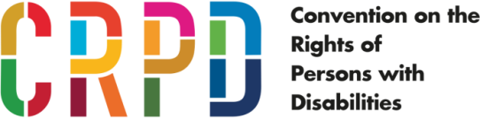

ADVANCE VERSION

© 2020 United Nations

The *Data Sources Guidance* is a component of the [SDG-CRPD Resource Package](https://www.ohchr.org/EN/Issues/Disability/Pages/sdg-crpd-resource.aspx) developed by the Office of the United Nations High Commissioner for Human Rights (OHCHR). This is an advance version of the SDG-CRPD Resource Package. A final version will be issued upon completion of OHCHR review processes.

The designations employed and the presentation of the material herein do not imply the expression of any opinion whatsoever on the part of the Secretariat of the United Nations concerning the legal status of any country, territory, city or area, or of its authorities, or concerning the delimitation of its frontiers or boundaries.

Symbols of United Nations documents are composed of capital letters combined with figures. Mention of such a figure indicates a reference to a United Nations document.

The *Data Sources Guidance* was produced with the financial support of the European Union. Its contents are the sole responsibility of OHCHR and do not necessarily reflect the views of the European Union.



## 29.27 Voter turnout disaggregated by sex, age, disability and electoral district for national, regional and local elections.

#### Level 1: Indicator for which data are already being produced and reported on in at least some countries

This information can be obtained through surveys designed to measure voting activity, as long as questions on disability are included. For example, in the United States of America, the Voter and Registration Supplement of the Census Bureau is added to the monthly Current Population Survey following national elections, in November of even‐numbered years. The Current Population Survey is a monthly representative survey of the American population, designed primarily to obtain employment information. It includes six questions to identify disability status - they are not the WG questions, but six yes or no questions about difficulties in core functional domains.

In the Voter and Registration Supplement, respondents are asked if they voted in the most recent election. If they respond affirmatively, they are assumed to have been registered, whereas non-voters are asked an additional question about whether they were registered. Dependent on these answers, respondents are then asked additional questions about the methods used for voting and registering, and nonparticipants are asked about the main reason why they chose to not participate, according to [this source](http://sites.nationalacademies.org/cs/groups/pgasite/documents/webpage/pga_180931.pdf). Table 1 presents the voter turnout for three past elections, disaggregated by disability and presenting the disability turnout gap.

**Table 1:** Disability and voter turnout in 2008, 2011 and 2016, Voting Research Supplement, United States of America

|  |  |  |  |
| --- | --- | --- | --- |
|  | 2008 | 2012 | 2016 |
| People without disabilities | 64.5% | 62.5% | 62.2% |
| People with disabilities | 57.3% | 56.8% | 55.9% |
| Disability turnout gap | -7.2% | -5.7% | -6.3% |
| *Source*: Lisa Schur, *Disability, Voter Turnout, and Polling Place AccessibilityUS Current Population Survey* (Rutgers University, 2017), p. 4. | | | |

The Voting Research Supplement also collects information on the voting method, disaggregated by disability, and on the gap between persons with and without disability, as presented in table 2.

**Table 2:** Voting Early or by Mail, by Disability Status, Voting Research Supplement

|  |  |  |  |
| --- | --- | --- | --- |
| How voted in 2016 | Disability | No Disability | Gap |
| At polling place on election day | 52.6% | 60.9% | -8.3% |
| At polling place before election day | 18.1% | 19.2% | -1.1% |
| By mail before election day | 28.4% | 18.6% | 9.8% |
| By mail on election day | 0.9% | 1.4% | 0.5% |
| *Source*: Lisa Schur, *Disability, Voter Turnout, and Polling Place AccessibilityUS Current Population Survey* (Rutgers University, 2017), p. 7. | | | |

## 29.28 Number and proportion of persons with disabilities eligible to vote, who submitted complaints during electoral processes and were provided remedies to exercise the right to vote, disaggregated by sex, age, disability and electoral district.

#### Level 3: Indicator for which acquiring data is more complex or requires the development of data collection mechanisms which are currently not in place

Each country has an election commission (or in some countries, like the United States of America, each state or province has a commission) where voters can submit complaints. A list of European commissions can be found at [fra.europa.eu](https://fra.europa.eu/en/publication/2014/indicators-right-political-participation-people-disabilities/complaints-accessible).

No reports were found that categorize public complaints by type, let alone disability, but that information could be collected and reported.

Other sources for data collection could be National Human Rights Institutions which may monitor complaints about elections, should they be mandated to consider complaints about alleged voting rights violations.

This indicator could also include the number of recommendations made by national and international observer groups, concerning the access for, and inclusion of, persons with disabilities and the proportion of recommendations complied with during the electoral process.

## 29.29 Proportion of persons who stand for elections (candidates) that are persons with disabilities, disaggregated by sex, age, disability, electoral jurisdiction, at all levels of government as compared to the proportion of persons with disabilities among the population (based on SDG 16.7.1)

#### Level 3: Indicator for which acquiring data is more complex or requires the development of data collection mechanisms which are currently not in place

[Link to the metadata related to this SDG indicator](https://unstats.un.org/sdgs/metadata?Text=&Goal=&Target=16.7" \o "https://unstats.un.org/sdgs/metadata?Text=&Goal=&Target=3.7)

According to the metadata, SDG Indicator 16.7.1 refers to “Proportions of positions (by age group, sex, persons with disabilities and population groups) in public institutions (national and local), including (a) the legislatures; (b) the public service; and (c) the judiciary, compared to national distributions.” However, the metadata for the indicator pertains only to the judicial branch.

Local government associations may collect this data. In the United Kingdom of Great Britain and Northern Ireland, a [Census of Local Authority Councillors in England](https://www.local.gov.uk/sites/default/files/documents/Councillors%27%20Census%202018%20-%20report%20FINAL.pdf) is regularly carried out, with a breakdown of councillors by long-term health problems or disabilities, age, ethnicity, gender, political group and region.

Computing this indicator through such a census would require all candidates to self-identify as having or not having a disability as part of filing for their candidacy. The United Kingdom of Great Britain and Northern Ireland offers candidates with disabilities additional financial support which provides an incentive to self-report, according to <https://www.gov.uk/access-to-elected-office-fund>.

In countries with a similar system, administrative records of candidates receiving such financial support could provide data for this indicator.

## 29.30 Proportions of positions (by sex, age, persons with disabilities and population groups) in public institutions (national and local legislatures, public service, and judiciary) compared to national distributions (SDG indicator 16.7.1)

#### Level 2: Indicator that can be produced with existing data but has not been reported on

The United Kingdom of Great Britain and Northern Ireland has a Civil Service Diversity and Inclusion Dashboard, from which Figure I was taken. This figure shows that, overall, 11.7 per cent of civil servants in 2019 had a disability.

**Figure I:** Representation of Disabled Staff by Grade, 2010-2019

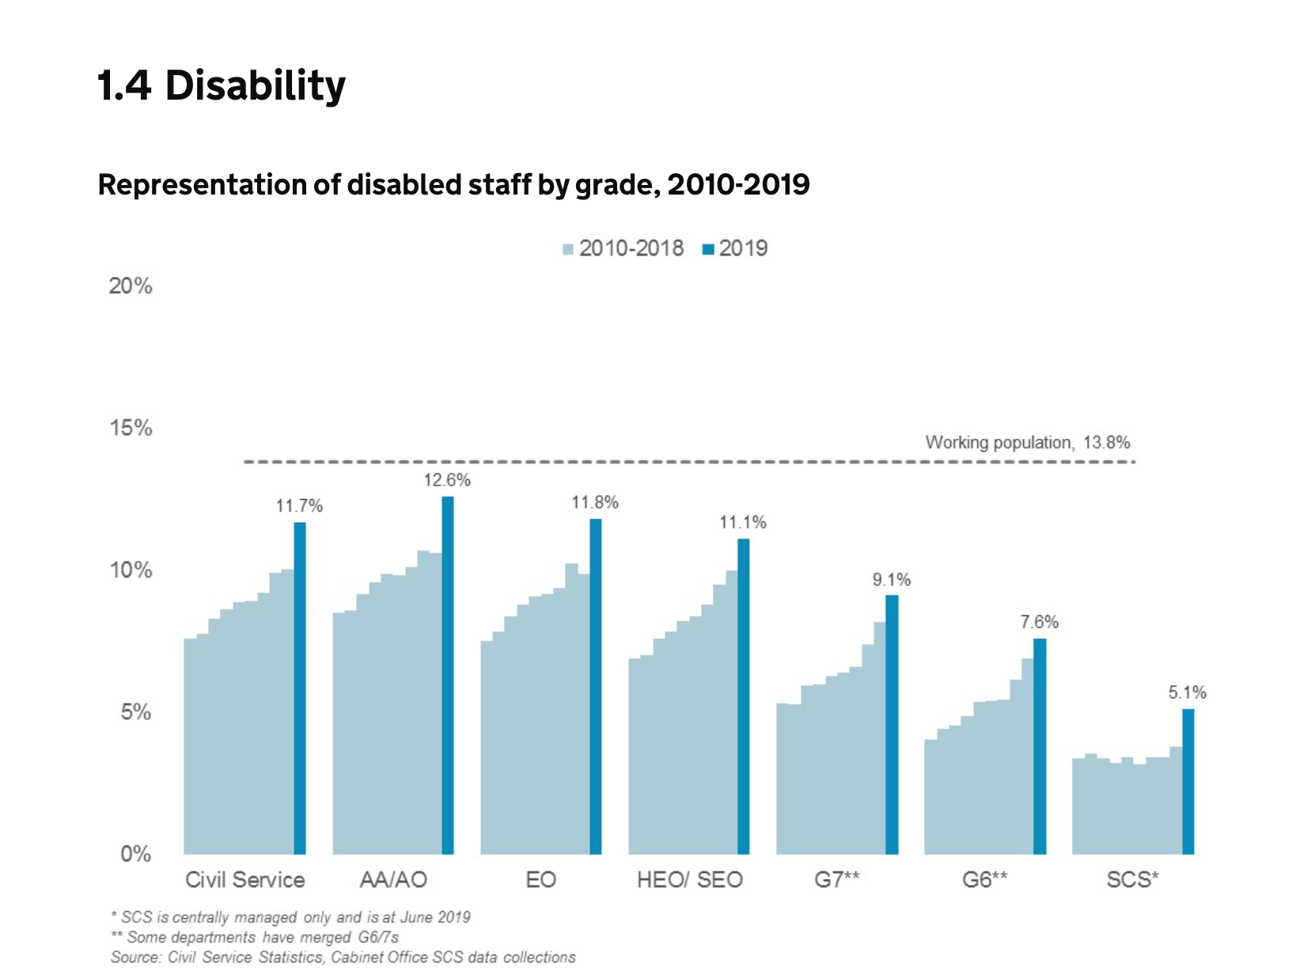

*Source*: GOV.UK, “Civil Service Diversity and Inclusion Dashboard”, 11 September 2019.

*Note:* Terms as presented by the source.

In addition, the Local Government Association regularly carries out a [Census of Local Authority Councillors in England](https://www.local.gov.uk/sites/default/files/documents/Councillors%27%20Census%202018%20-%20report%20FINAL.pdf), which breaks down councillors by age, ethnicity, gender, political group and region, as well as long-term health problems or disabilities.

[Canada also reports on employment equity in core public administration](https://www.local.gov.uk/sites/default/files/documents/Councillors%27%20Census%202018%20-%20report%20FINAL.pdf), by disability and gender.

SDG Indicator 16.7.1 refers to “Proportions of positions (by age group, sex, persons with disabilities and population groups) in public institutions (national and local), including (a) the legislatures; (b) the public service; and (c) the judiciary, compared to national distributions”. However, the metadata for this indicator pertains only to the judicial branch.

Computing this indicator asks all public employees to self-identify as has having or not having a disability as part of their personnel records. This can raise privacy concerns, as the European Union Agency for Fundamental Rights points out in the report [*The right to political participation for persons with disabilities: human rights indicators*](https://fra.europa.eu/sites/default/files/fra-2014-right-political-participation-persons-disabilities_en.pdf).

People’s right to privacy conflicts with mandatory reporting of disability status. Moreover, some people with functional difficulties, who would be identified as having a disability by tools such as the WG questions, may not self-identify as having a disability if simply asked to record their disability status on an administrative form.

The above-mentioned report does have information on parliamentarians who self-identified as having a disability, either in government sources, via requests for accommodations, or through information posted on their websites or other social media. However, these sources would not provide comprehensive information.

## 29.31 Number of organizations of persons with disabilities, disaggregated by kind of organization, constituency represented, total membership and registration status.

#### Level 3: Indicator for which acquiring data is more complex or requires the development of data collection mechanisms which are currently not in place

Agencies that administer registration processes have basic information about each organization, that could theoretically be compiled. However, this would not include non-registered organizations, and the degree of registration most likely varies significantly by country. Alternatively, other agencies or Non-Governmental Organisations may compile a list - for example, the [Japan International Cooperation Agency compiled a list for Ethiopia](https://www.jica.go.jp/activities/issues/social_sec/pdf/eth_annex_02.pdf).

Another approach would be to as ask questions about participation within a national disability survey or through a survey specifically targeting social participation. For example, a survey in the [United Kingdom of Great Britain and Northern Ireland reports on civic engagement](https://www.ons.gov.uk/peoplepopulationandcommunity/healthandsocialcare/disability/bulletins/disabilityandsocialparticipationengland/2018) and shows that it is actually higher among persons with disabilities, no doubt partly due to activities related to representative organizations of persons with disabilities.

However, the interpretation of this indicator requires careful analysis. An increase or decrease in the number of organizations may reflect various developments. For instance, new organizations may develop in areas where there were none, large organizations may divide, or smaller organizations may merge.

To get information on the size of memberships, the organizations would have to be surveyed.

## 29.32 Proportion of population who believe decision making is inclusive and responsive, by sex, age, disability and population group (SDG indicator 16.7.2) (idem 1-4.31).

#### Level 2: Indicator could be produced with straightforward additions or modifications to existing data collection efforts

[Link to the metadata related to this SDG indicator](https://unstats.un.org/sdgs/metadata/?Text=&Goal=&Target=16.7" \o "https://unstats.un.org/sdgs/metadata?Text=&Goal=&Target=3.7)

According to the metadata:

“There is no existing globally comparable official dataset on the “Proportion of population who believe decision-making is inclusive and responsive, by sex, age, disability and population group.” While a large number of countries have experience with measuring external political efficacy, there is large variability in the ways national statistics offices and government agencies in individual countries collect data on this concept, in terms of question wording and response formats, etc. This variability poses a significant challenge for cross-country comparability of such data.”

The [European Social Survey](http://www.europeansocialsurvey.org/docs/methodology/core_ess_questionnaire/ESS8_political_efficacy_final_template.pdf) included two questions to measure political efficacy in Round 8 of the survey:

1. How much would you say the political system in [country] allows people like you to have a say in what the government does?
2. And how much would you say that the political system in [country] allows people like you to have an influence on politics?

Data is available for sex and age but the European Social Survey does not include questions about disability. A sample of Round 8 results can be found in Table 3.

Users can download de-identified individual-level data or create tables through an online analysis tool available at [www.europeansocialsurvey.org](http://www.europeansocialsurvey.org/findings/topline.html).

**Table 3:** European Social Survey, Round 8

|  |  |  |  |  |  |  |  |  |  |  |  |
| --- | --- | --- | --- | --- | --- | --- | --- | --- | --- | --- | --- |
| *Political system allows people to have a say in what government does* | | | | | | | | | | |  |
| Country | | Czechia | | Germany | | Estonia | | Italy | | Norway | Poland |
| Not at all | | 26.6 | | 14.2 | | 36.1 | | 47.3 | | 3.1 | 30.1 |
| Very little | | 35.3 | | 35.4 | | 38 | | 42.5 | | 28.3 | 39.6 |
| Some | | 29.6 | | 38.0 | | 22.2 | | 9.0 | | 51.0 | 25.4 |
| A lot | | 7.5 | | 11.5 | | 3.3 | | 1.1 | | 16.1 | 4.1 |
| A great deal | | 1.0 | | 0.9 | | 0.4 | | 0.2 | | 1.6 | 0.8 |
| Total | | 100 | | 100 | | 100 | | 100 | | 100 | 100 |
| N= | | 2,234 | | 2,841 | | 1,996 | | 2,518 | | 1,534 | 1,620 |
| *Political system allows people to have influence on politics* | | | | | | | | |  | |  |
| Country | Czechia | | Germany | | Estonia | | Italy | | Norway | | Poland |
| Not at all | 33.5 | | 14.2 | | 38.2 | | 47.1 | | 4.8 | | 33.7 |
| Very little | 41.5 | | 35.0 | | 39.0 | | 43.8 | | 23.5 | | 40 |
| Some | 21.9 | | 36.4 | | 19 | | 7.8 | | 44.9 | | 22.9 |
| A lot | 2.9 | | 13.4 | | 3.3 | | 1.3 | | 23.5 | | 2.9 |
| A great deal | 0.2 | | 1 | | 0.5 | | 0.1 | | 3.4 | | 0.4 |
| Total | 100 | | 100 | | 100 | | 100 | | 100 | | 100 |
| N= | 2,251 | | 2,832 | | 2,007 | | 2,527 | | 1,535 | | 1,643 |
| *Source:* European Social Survey Round 8, ESS-ERIC; See <http://dd.dgacm.org/editorialmanual/ed-guidelines/format/tables.htm> | | | | | | | | | | | |