# Data sources for outcome indicators on Article 33:

# National implementation and monitoring

United Nations Human Rights Office of the High Commissioner



ADVANCE VERSION

© 2020 United Nations

The *Data Sources Guidance* is a component of the [SDG-CRPD Resource Package](https://www.ohchr.org/EN/Issues/Disability/Pages/sdg-crpd-resource.aspx) developed by the Office of the United Nations High Commissioner for Human Rights (OHCHR). This is an advance version of the SDG-CRPD Resource Package. A final version will be issued upon completion of OHCHR review processes.

The designations employed and the presentation of the material herein do not imply the expression of any opinion whatsoever on the part of the Secretariat of the United Nations concerning the legal status of any country, territory, city or area, or of its authorities, or concerning the delimitation of its frontiers or boundaries.

Symbols of United Nations documents are composed of capital letters combined with figures. Mention of such a figure indicates a reference to a United Nations document.

The *Data Sources Guidance* was produced with the financial support of the European Union. Its contents are the sole responsibility of OHCHR and do not necessarily reflect the views of the European Union.



## 33.20 Number of meetings among disability focal point and coordination mechanism, or cross-Ministerial or cross-departmental government committees or working groups related to CRPD implementation.

#### Level 2: Indicator that can be produced with existing data but has not been reported on

The government’s disability focal point and/or coordination mechanism can keep public records of all relevant meetings, showing the level of collaboration and engagement on CRPD implementation across government sectors and levels of government.

## 33.21 Number of persons or organizations seeking assistance from the independent monitoring framework about their rights under the CRPD and methods of redress, and proportion of referrals to the justice system of collective cases by the independent monitoring framework related to persons with disabilities.

#### Level 2: Indicator that can be produced with existing data but has not been reported on

The Independent Monitoring Framework will need to establish a system for registering complaints and monitoring their status, including whether they were referred to the justice system.

Referrals of group complaints should be classified by right/article invoked and disaggregated by sex, age, disability and other relevant criteria, in order to identify and further address trends impacting persons with disabilities belonging to the most marginalized groups.

For example, the Ombudsperson’s Office of Buenos Aires reports on the cases addressed by its unit on persons with disabilities in their annual report, including on the theme and proportion of cases related to each theme, as can be seen in the [2019 Annual report of the Defensoría del Pueblo de la Ciudad Autonoma de Buenos Aires](https://www.calameo.com/read/002682399fd0574b2e517), p. 39.

On indicator 33.22, another example of a data source related to enquiries and complaints is provided.

## 33.22 Where applicable, proportion of received complaints of individual or group complaints submitted to the mechanism(s) of the monitoring framework alleging breaches of the Convention that have been investigated and adjudicated; proportion of those found in favour of the complainant; and proportion of the latter that have been complied with by the government and/or duty bearer.

#### Level 2: Indicator that can be produced with existing data but has not been reported on

Not all independent monitoring frameworks designated under Article 33(2) of the CRPD have the mandate to consider complaints by individuals or groups. Where these bodies do have this mandate, individual and group complaints should be classified by right/article invoked and disaggregated by sex, age, disability and other relevant criteria, in order to identify and further address trends impacting persons with disabilities belonging to the most marginalized groups.

For example, the New Zealand Human Rights Commission publishes an [annual report](https://www.hrc.co.nz/files/6315/7655/2929/HRC_Annual_Report_2019_ONLINE.pdf) with information on complaints received. The Commission tracks the number of alleged cases of disability discrimination by type of disability, the nature of the complaint and its outcome. Figure I and II are part of the Commission’s 2019 Annual Report. They show that disability continues to be the most prevalent ground of enquiry and complaint, being cited in 171 of them.

**Figure I:** Alleged grounds of unlawful discrimination in enquiries and complaints raised with the New Zealand Human Rights Commission in 2018/2019

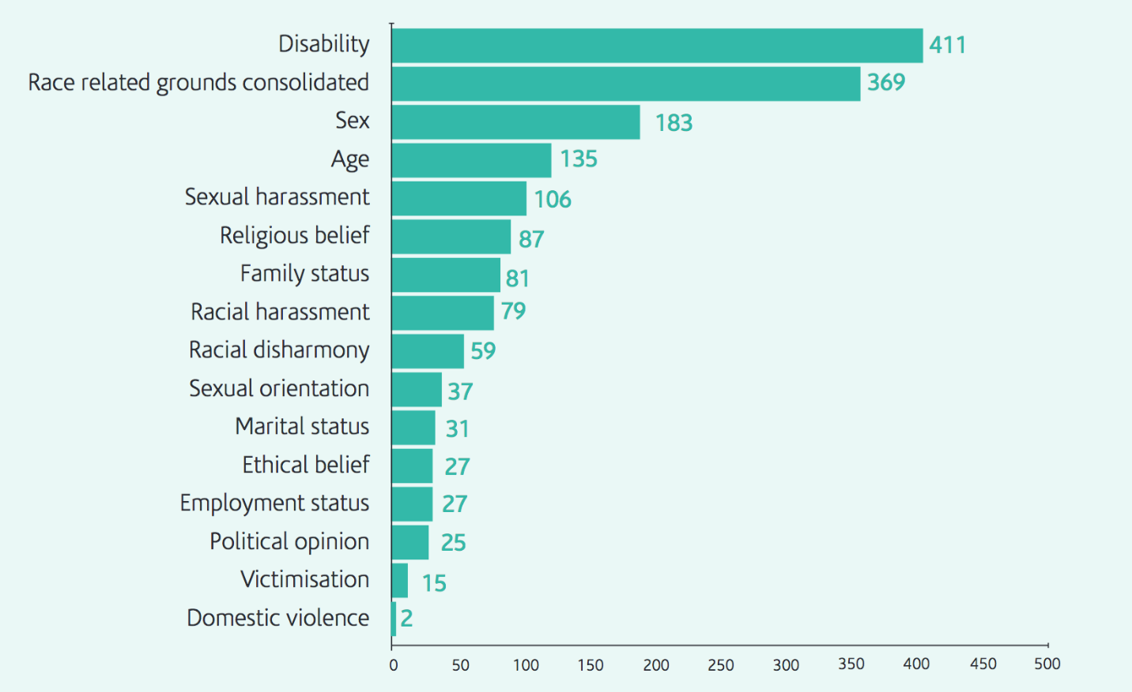

*Source*: Human Rights Commission and The Office of Human Rights Proceedings, *Annual Report 2018/19* (Aotearoa, 2019).

**Figure II:** Comparison of the number of enquiries and complaints by type of disability in 2018/19

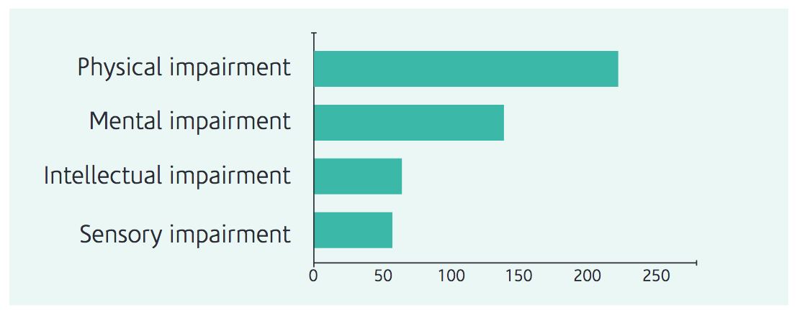

*Source*: Human Rights Commission and The Office of Human Rights Proceedings, *Annual Report 2018/19* (Aotearoa, 2019).

*Note*: Complaints may cite more than one sub-ground. Therefore, the total number of sub-grounds in the table does not reflect the total amount of enquiries and complaints on the ground of disability

Unia, the Inter-federal Centre for Equal Opportunities in Belgium, also publishes the number of complaints received related to the rights of persons with disabilities in its [annual report](https://www.unia.be/files/Documenten/Jaarrapport/Rapport_annuel_2019_AS.pdf), as well as in a [separate statistics report](https://www.unia.be/files/Documenten/Jaarrapport/2020_Rapport_chiffres_2019_DEF.pdf). The latter includes an analysis of cases opened by Unia based on the complaints received, per discrimination ground (including disability). It provides data on the number of new cases, the evolution over time, the areas to which the cases relate (employment, education, justice, transportation, etc) and disaggregation by gender of the complainant. An example from the 2019 report can be found in Figure III.

**Figure III:** New cases opened in 2019, by gender of the complainant, by theme

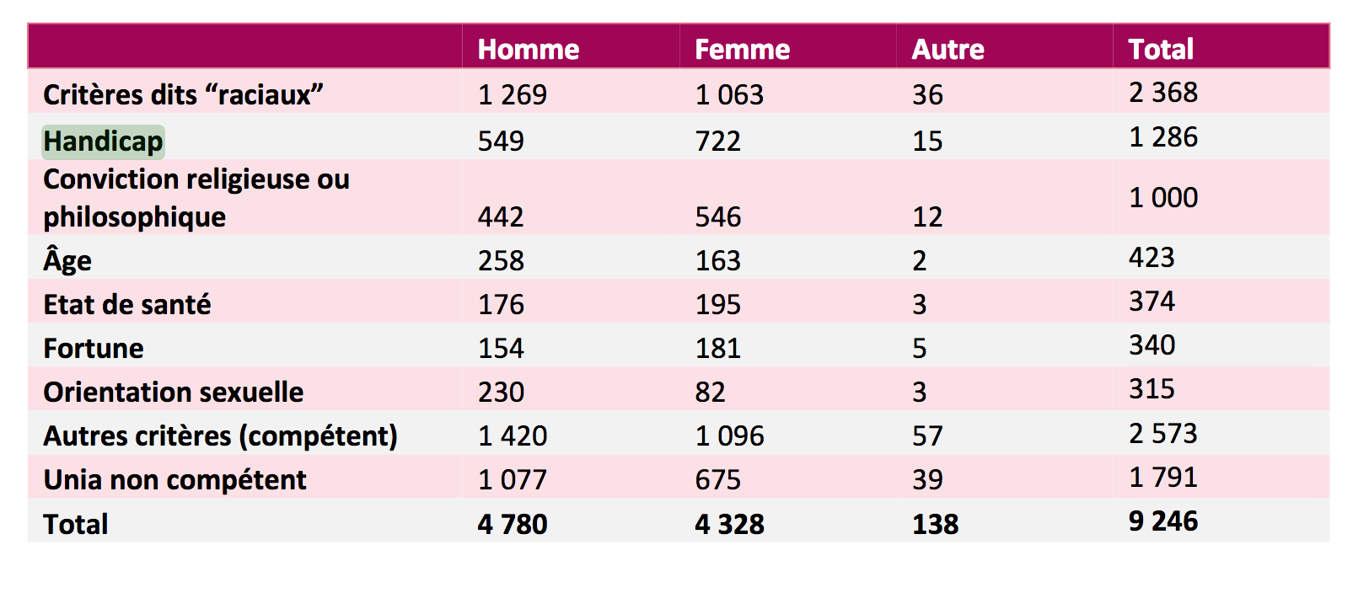*Source*: Unia, *Rapport chiffres 2019: Contribuer à une société plus égale pour tous* (Brussels, 2019), p.13.

## 33.23 Number of representative organizations of persons with disabilities participating in the independent monitoring framework, disaggregated by kind of organization, constituency represented among persons with disabilities and geographical location.

#### Level 2: Indicator that can be produced with existing data but has not been reported on

Participating in the independent monitoring framework would entail both being consulted by, and having an official role in, the independent monitoring framework.

In New Zealand, the government’s disability focal point keeps a [list of the organizations of persons with disabilities](https://www.odi.govt.nz/guidance-and-resources/disabled-peoples-organisations/) to which it, and government counterparts, reach out to for consultations.

See the indicator and [General Comment no 7 of the CRPD Committee](https://tbinternet.ohchr.org/_layouts/15/treatybodyexternal/Download.aspx?symbolno=CRPD/C/GC/7&Lang=en) for more guidance on the obligation to ensure the participation of organisations of persons with disabilities, encompassing a wide diversity of organizations, including underrepresented groups of persons with disabilities.

## 33.24 Number of representative organizations of persons with disabilities with a role in the work of the government disability focal point and/or coordination mechanism, disaggregated by kind of organization, constituency represented among persons with disabilities and geographical location.

#### Level 2: Indicator that can be produced with existing data but has not been reported on

The government’s disability focal point and/or coordination mechanism should keep records of the organisations of persons with disabilities with which it works, for example for consultations.

In Paraguay, the government’s disability focal point, Secretaría Nacional por los Derechos Humanos de las Personas con Discapacidad - [SENADIS](https://senadis.gov.py/index.php) -, through its consultative mechanism, Comisión Nacional de Discapacidad - [CONADIS](https://senadis.gov.py/index.php/conadis) -, keeps a [record of the organizations of persons with disabilities that cooperate with it](https://senadis.gov.py/application/files/5615/9975/0569/Exp._No_254A-19_j6e1e82o.pdf), which includes organizations covering particular constituencies of persons with disabilities.

It should be noted that the CRPD Committee calls on governments to consult widely with a diverse range of organizations of persons with disabilities, including organizations representing women and girls with disabilities, children and youth with disabilities and other underrepresented groups. For more information, consult the [CRPD Committee General Comment no 7](https://tbinternet.ohchr.org/_layouts/treatybodyexternal/Download.aspx?symbolno=CRPD/C/GC/7&Lang=en) on participation.