# Data sources for outcome indicators on Articles 1-4:

# Purpose, definitions, general principles, general obligations

United Nations Human Rights Office of the High Commissioner



ADVANCE VERSION

© 2020 United Nations

The *Data Sources Guidance* is a component of the [SDG-CRPD Resource Package](https://www.ohchr.org/EN/Issues/Disability/Pages/sdg-crpd-resource.aspx) developed by the Office of the United Nations High Commissioner for Human Rights (OHCHR). This is an advance version of the SDG-CRPD Resource Package. A final version will be issued upon completion of OHCHR review processes.

The designations employed and the presentation of the material herein do not imply the expression of any opinion whatsoever on the part of the Secretariat of the United Nations concerning the legal status of any country, territory, city or area, or of its authorities, or concerning the delimitation of its frontiers or boundaries.

Symbols of United Nations documents are composed of capital letters combined with figures. Mention of such a figure indicates a reference to a United Nations document.

The *Data Sources Guidance* was produced with the financial support of the European Union. Its contents are the sole responsibility of OHCHR and do not necessarily reflect the views of the European Union.



## 1-4.23 Number of remaining reservations and/or interpretative declarations to provisions of the CRPD.

#### Level 1: Indicator for which data are already being produced and reported on in at least some countries

The [United Nations Treaty Collection](https://treaties.un.org/Pages/ViewDetails.aspx?src=TREATY&mtdsg_no=IV-15&chapter=4&clang=_en) provides a country by country list of the signature, formal confirmation/accession or ratification of the Conventions, and reservations and declarations.

## 1-4.24 Number of judicial decisions from national high courts on the rights of persons with disabilities in line with the principles and provisions of the CRPD per year.

#### Level 2: Indicator that can be produced with existing data but has not been reported on

As all court decisions are filed, it is theoretically possible to review all such decisions and produce this indicator. Some national high courts’ databases of cases can be used to search the word “disability” or “CRPD” to ascertain, at a minimum, where decisions have been made, although a more detailed analysis would be required to determine compliance with the CRPD.

Beyond case databases, there may be categories of cases or petitioners. For example, the [Constitutional Court of Colombia](https://www.corteconstitucional.gov.co/lacorte/estadisticas.php) allows searches for cases according to theme, including measures in favour of persons with disabilities, accessibility, etc.

National Human Rights Institutions also commonly compile yearly jurisprudence, tracking the evolution of human rights standards with a qualitative assessment.

Arriving at comprehensive assessments of CRPD compliance may be difficult, but at least information on the extent to which high courts are considering these issues can be obtained. In Colombia, the Office of the Ombudsperson (Defensoría del Pueblo) monitors court decisions specifically issued by the Constitutional Court concerning constitutional rights, including the rights of persons with disabilities. Information about the rights of persons with disabilities in Colombia can be found under [the Observatory of the Constitutional Justice](https://observatorio.defensoria.gov.co/?_s=ojc&_a=5&_es=0).

## 1-4.25 Number of relevant legislation reformed to be harmonized with the CRPD and its provisions, disaggregated by topic.

#### Level 2: Indicator that can be produced with existing data but has not been reported on

Disability focal points in several countries publish compendiums of relevant legislation with periodical updates on amendments.

As examples, consult information from

* Bolivia (Plurinational State of): available at [fnse.gob.bo](https://fnse.gob.bo/wp-content/cache/wp-rocket/fnse.gob.bo/normativa-para-pcd/index.html_gzip)
* Spain: available at [www.boe.es](https://www.boe.es/biblioteca_juridica/codigos/codigo.php?id=125&modo=1&nota=0&tab=2)
* France: available at [www.gouvernement.fr](https://www.gouvernement.fr/handicap-ce-qui-change-en-2019-pour-les-personnes-handicapees)

Reports are sometimes available from National Human Rights Institutions or the United Nations. For example, the United Nations Development Programme (UNDP) Mexico published a [compendium on disability-related legislation](http://intranet.dif.df.gob.mx/transparencia/new/art_15/10/_anexos/05%20COMP%20LEGIS%20DISCA%20MARCO%20NORMATIVO%20MEXICO.pdf).

Information on legislation which has been aligned with the CRPD may also be found in state reports submitted to the CRPD Committee. For example, in Mexico’s State Party Report, submitted on 22 February 2018, it is reported that:

*“The 32 federative entities have passed legislation to protect the rights of persons with disabilities. Twenty-seven of those laws are in line with the content of the Convention, and the others are in the process of harmonization.”*

The Democratic People’s Republic of Korea also provided a list of relevant legislation. State reports to the CRPD Committee can be searched on the [CRPD Committee website](https://tbinternet.ohchr.org/_layouts/15/treatybodyexternal/TBSearch.aspx?Lang=en&TreatyID=4&DocTypeID=29).

It should be kept in mind that legal and policy reform related to the CRPD may not always be recognized as such or linked to the CRPD. It would be the role of the disability focal point, as well as of other stakeholders monitoring government actions (e.g. independent monitoring frameworks, organisations of persons with disabilities), to make those links and to track their progress in implementation of CRPD.

## 1-4.26 Number of persons with disabilities who have undergone a disability assessment and are in possession of disability certification, compared to statistical estimations of the number of persons with disabilities.

#### Level 1: Indicator for which data are already being produced and reported on in at least some countries.

The number of people who have undergone a disability assessment and the number of people deemed to qualify for certification are captured in the administrative data of relevant government programs. The denominator (number of persons with disabilities) is captured by censuses or other survey data. Below, examples for Viet Nam and Australia are presented.

### Viet Nam

Viet Nam reported in its initial report to the CRPD Committee (received 4 April 2018) that:

*“Based on disability determination results, persons with disabilities are granted disability certificates, which indicate the degree and type of disability…To date, 63 provinces and cities have provided a social monthly allowance to 896,644 persons with severe and moderate disability at least as specified in Decree 136/2013/ND-CP and Inter-Circular 29/2014/TTLT-BLĐTBXH-BTC.”*

The number of persons with disabilities is available from the Viet Nam National Survey on People with Disabilities conducted by the General Statistics Office in 2016 and 2017. The survey found that, based on the WG Short Set on Disability, 7 per cent of the population aged 2 years and older, i.e. 6,225,519 persons, are persons with disabilities, of which 671,659 are children with disabilities aged 2-17 and 5,553,860 are persons with disabilities aged 18 years and older. Survey results are available at [www.gso.gov.vn](https://www.gso.gov.vn/wp-content/uploads/2019/04/Baocao-nguoikhuyet-tat.pdf).

### Australia

Australia developed a report, [People with disability in Australia](https://www.aihw.gov.au/reports/disability/people-with-disability-in-australia/contents/people-with-disability), that brings together data from the 2018 Australian Bureau of Statistics’ (ABS) Survey of Disability, Ageing and Carers (SDAC) with administrative data from the Department of Social Services and the National Disability Insurance Agency and other departments. The report estimates there are 4.4 million people with a disability in Australia. Of these, 750,000 have been deemed eligible and receive Disability Support Pension (DSP) and 500,000 participate in the National Disability Insurance Scheme (NDS).

**Figure 1:** Key disability segments in the Australian population

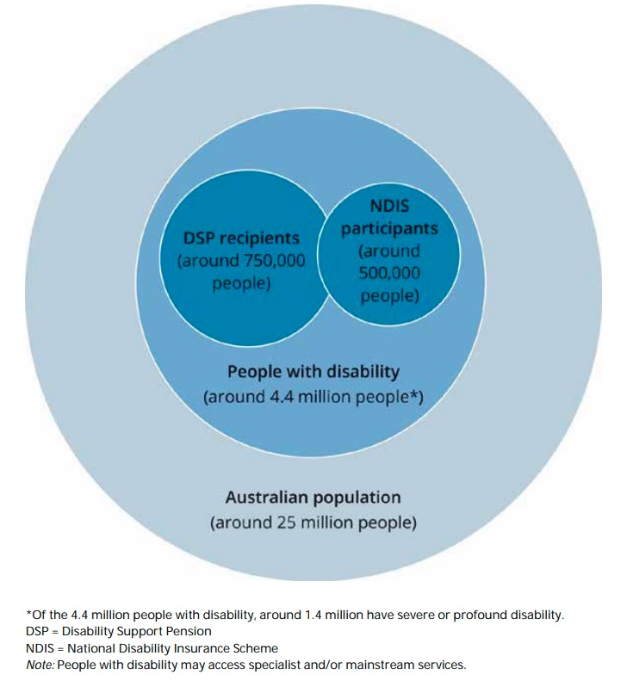

Source: Australian Institute of Health and Welfare, [*People with disability in Australia 2020*](https://www.aihw.gov.au/getmedia/ee5ee3c2-152d-4b5f-9901-71d483b47f03/aihw-dis-72.pdf.aspx?inline=true), p.11.

## 1-4.27 Number of concluded or on-going research projects funded by the State which featured participatory research, research co-led by persons with disabilities, or user led research on:- Universally designed goods, services, equipment and facilities; or- New technologies, including information and communication technologies, mobility aids, devices and assistive technologies

#### Level 3: Indicator for which acquiring data is more complex or requires the development of data collection mechanisms which are currently not in place.

Administrative records listing all state-funded research projects exist, with documentation as to the nature of those projects and including line-item expenditures. However, no examples of countries reporting on this indicator could be found. It would require an administrative review of all contracts and grants. Though not covering all research grants, records from national research councils would provide a good indicator. See, for example, the research covered by the United States of America National Research Council at [nationalacademies.org](https://www.nationalacademies.org/about).

However, to be practical, grant and contract forms and budgets would have to be modified to report on this indicator. Currently, no examples of such forms could be found.

## 1-4.28 Number and proportion of organizations of persons with disabilities taking part in consultation processes for the implementation of the CRPD, disaggregated by kind of organization of persons with disability, constituency represented among persons with disabilities and geographical location.

## *and*

## 1-4.29 Number and proportion of consultation processes/activities which involved organizations of persons with disabilities, disaggregated by kind of organization and constituency represented among persons with disabilities.

## *and*

## 1-4.30 Number of persons with disabilities and organizations benefitting from capacity building activities funded or provided by the State, disaggregated by sex, age, disability and geographical location.

#### Level 3: Indicators for which acquiring data is more complex or requires the development of data collection mechanisms which are currently not in place.

Consultation processes occur at many levels, from informal to formal, with a specific focus on the CRPD or, more broadly, on mainstream policy implementation. As the CRPD cuts across all sectors, in effect many policy consultation processes will have an impact on the implementation of the CRPD.

To respond to these indicators, countries will have to:

1. maintain a database of all registered Organizations of Persons with Disabilities (OPDs) being consulted;
2. record numbers of calls for consultation, numbers of consultation meetings and capacity building activities; and
3. keep an attendance record for all formal meetings.

Some governments have disability focal points, which would be the natural place for such information to be collected, with a confidential registry of OPDs that have been consulted for policy purposes. Several countries mention selected capacity building activities in their reports to the CRPD Committee; it would be possible to count the number of participants (with appropriate disaggregation) who attended those activities.

A centralized registry could help to support this effort. Online registries could do this automatically. Currently, South Africa asks individuals to identify as having a disability in attendance forms for all formal meetings, but not the name of any OPD that they might represent.

In all cases, personal data of individuals and the organizations they represent should remain protected and confidentiality and privacy upheld. Information reported should be anonymised and presented in terms of numbers relating to sex, age, constituency represented and geographical location. Any registries developed to track participation in consultations and activities should not be limited to organizations which are officially registered.

## 1-4.31 Proportion of population who believe decision making is inclusive and responsive, by sex, age, disability and population group (SDG indicator 16.7.2) (Idem 29.32).

#### Level 2: Indicator could be produced with straightforward additions or modifications to existing data collection efforts

[Link to the metadata related to this SDG indicator](https://unstats.un.org/sdgs/metadata/?Text=&Goal=&Target=16.7)

According to the metadata:

“*There is no existing globally comparable official dataset on the “Proportion of population who believe decision-making is inclusive and responsive, by sex, age, disability and population group.” While a large number of countries have experience with measuring external political efficacy, there is large variability in the ways national statistics offices and government agencies in individual countries collect data on this concept, in terms of question wording and response formats, etc. This variability poses a significant challenge for cross-country comparability of such data*.”

The [European Social Survey](http://www.europeansocialsurvey.org/docs/methodology/core_ess_questionnaire/ESS8_political_efficacy_final_template.pdf) included two questions to measure political efficacy in Round 8 of the survey:

1. How much would you say the political system in [country] allows people like you to have a say in what the government does?
2. And how much would you say that the political system in [country] allows people like you to have an influence on politics?

Data is available for sex and age but the European Social Survey does not include questions about disability. A sample of Round 8 results can be found in Table 1.

Users can download de-identified individual-level data or create tables through an online analysis tool available at [europeansocialsurvey.org](http://www.europeansocialsurvey.org/findings/topline.html).

**Table 1:** European Social Survey, Round 8

| *Political system allows people to have a say in what government does* | | | | | | | | | |  |
| --- | --- | --- | --- | --- | --- | --- | --- | --- | --- | --- |
| Country | | Czechia | | Germany | | Estonia | | Italy | Norway | Poland |
| Not at all | | 26.6 | | 14.2 | | 36.1 | | 47.3 | 3.1 | 30.1 |
| Very little | | 35.3 | | 35.4 | | 38 | | 42.5 | 28.3 | 39.6 |
| Some | | 29.6 | | 38.0 | | 22.2 | | 9.0 | 51.0 | 25.4 |
| A lot | | 7.5 | | 11.5 | | 3.3 | | 1.1 | 16.1 | 4.1 |
| A great deal | | 1.0 | | 0.9 | | 0.4 | | 0.2 | 1.6 | 0.8 |
| Total | | 100 | | 100 | | 100 | | 100 | 100 | 100 |
| N= | | 2,234 | | 2,841 | | 1,996 | | 2,518 | 1,534 | 1,620 |
| ***Political system allows people to have influence on politics*** | | | | | | | | |  |  |
| Country | Czechia | | Germany | | Estonia | | Italy | | Norway | Poland |
| Not at all | 33.5 | | 14.2 | | 38.2 | | 47.1 | | 4.8 | 33.7 |
| Very little | 41.5 | | 35.0 | | 39.0 | | 43.8 | | 23.5 | 40 |
| Some | 21.9 | | 36.4 | | 19 | | 7.8 | | 44.9 | 22.9 |
| A lot | 2.9 | | 13.4 | | 3.3 | | 1.3 | | 23.5 | 2.9 |
| A great deal | 0.2 | | 1 | | 0.5 | | 0.1 | | 3.4 | 0.4 |
| Total | 100 | | 100 | | 100 | | 100 | | 100 | 100 |
| N= | 2,251 | | 2,832 | | 2,007 | | 2,527 | | 1,535 | 1,643 |
| *Source:* European Social Survey Round 8, ESS-ERIC; See http://dd.dgacm.org/editorialmanual/ed-guidelines/format/tables.htm | | | | | | | | | | |