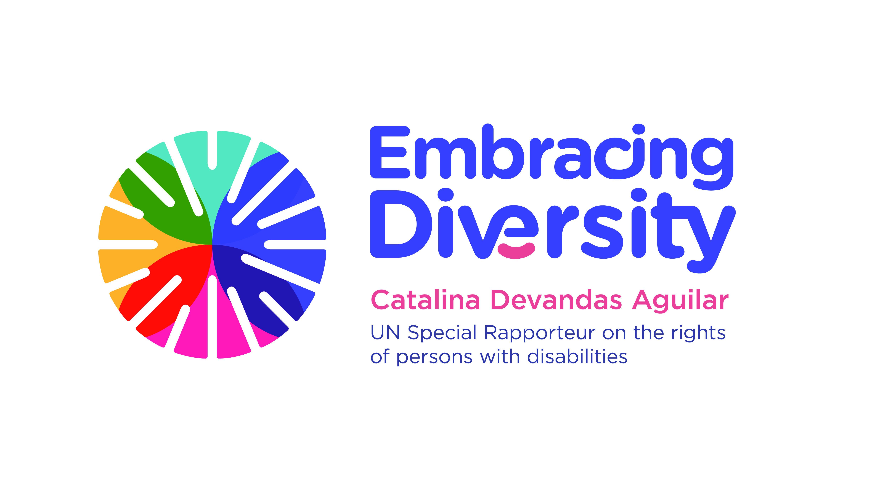english

**Expert Group Meeting on Bioethics and disability**

**16 and 17 September 2019**

Room 1-016, 1st floor

Palais Wilson, OHCHR

Geneva, Switzerland

**AGENDA**

**16 September 2019**

|  |  |  |
| --- | --- | --- |
| **Time** | **Session** | **Moderator/ Panelists** |
| 09.45-10.00 | **Arrival of participants and registration** |  |
| 10.00-10.15 | **Opening and welcome remarks**   * **Ms. Catalina Devandas Aguilar**, Special Rapporteur on the Rights of Persons with Disabilities |  |
| 10.15-10.30 | **Introduction of participants and objectives of the meeting** | Catalina Devandas |
| 10.30-11.15 | **Session 1: Presentation and discussion of background paper on bioethics and disability, written by Jackie Leach Scully and Tom Shakespeare** | Tom Shakespeare  Jackie Leach Scully (through Skype) |
| 11.15-11.30 | **Break** |  |
| 11.30-13.00 | **Session 2: Bioethics and disability**   * Why is bioethics important for the life of persons with disabilities? Why is the disability perspective relevant for bioethics? * What are the tensions between bioethics and disability rights? * What are the main contributions of the CRPD to the discussion about bioethics and disability? * How can we address the differences between the Global North and the Global South with regard to disability bioethics? | Moderator:  Alberto Vásquez  Panellists:  Laszlo Lovaszy  Alicia Ouellette |
| 13.00 - 14.30 | **Lunch break** |  |
| 14.30-16:00 | **Session 3: Notions of normality and quality of life**   * How to challenge the dominant assumption in bioethics that affectations to the “normal” functioning devalue human life? * How to evaluate the quality of life of persons with disabilities in the discussion about bioethics and disability? * How do persons with severe impairments evaluate the quality of their own lives? * How to combat stereotypes, prejudices and harmful practices relating to persons with disabilities, in the context of bioethics? | Moderator:  Tom Shakespeare  Panellists:  Rosemarie Garland-Thomson  Henriette Raventos Vorst |
| 16.00-16.15 | **Break** |  |
| 16:15-17:45 | **Session 4: Beginning of life: Prenatal diagnosis and disability-selective abortion**   * How to address the main challenges, gaps and potential areas of tension related to prenatal testing and disability-selective abortion? * How to promote the access of persons with disabilities to reproductive technologies on an equal basis to others? * How to ensure the informed consent of persons with disabilities in the context of prenatal diagnosis and disability-selective abortion? * How to promote the highest recognition of the rights of persons with disabilities in discussions related to prenatal diagnosis and disability-selective abortion? | Moderator:  Cristina Michels  Panellists:  Rupsa Malik  Anita Ghai  Paula Siverino Bavio |

**17 September 2019**

|  |  |  |
| --- | --- | --- |
| **Time** | **Session** | **Moderator** |
| 10.00-10.15 | **Recap of the first day** | Catalina Devandas |
| 10.15-11.30 | **Session 5: Controversial and/or irreversible treatments**   * How to address the informed consent of persons with disabilities in the context of controversial and/or irreversible treatments? * How to evaluate cases involving children with disabilities in the context of controversial and/or irreversible treatments? * How to address the main challenges, gaps and potential areas of tension related to controversial and/or irreversible treatments of persons with disabilities? * How to promote the highest recognition of the rights of persons with disabilities in discussions related to controversial and/or irreversible treatments? | Moderator: Victoria Lee  Panellists:  Tina Minkowitz  Teresa Blankmeyer |
| 11.30-11.45 | **Break** |  |
| 11.45-13.15 | **Session 6: Euthanasia and assisted suicide**   * How to address the main challenges, gaps and potential areas of tension related to euthanasia and assisted suicide of persons with disabilities? * How has legislation allowing euthanasia and assisted suicide impacted on persons with disabilities? * How to ensure palliative care available for everyone, including persons with disabilities? * How to promote the highest recognition of the rights of persons with disabilities in discussions related to euthanasia and assisted suicide? | Moderator:  Facundo Chávez  Panellists:  Trudo Lemmens  Scott Kim |
| 13.15-14.30 | **Lunch break** |  |
| 14.30-16.00 | **Session 7: Including ‘disability-rights perspective’ in bioethics agenda**   * How are persons with disabilities included in decision-making and public debate related to bioethics? * What should be the role of Ethical National Committees? * Could you share good practices for the implementation of disability inclusive bioethical work? * What collaborative strategies can we employ to promote the inclusion of disability rights perspective in bioethics agenda? | Moderator: Alicia Ouellette  Panellists:  Augustina Naami  Derrick Aarons |
| 16.00-16.15 | **Break** |  |
| 16.15-17.30 | **Session 8: Recommendations** | Moderator:  Alberto Vásquez |
| 17:30- 17:45 | **Closing remarks**   * **Ms. Catalina Devandas Aguilar**, Special Rapporteur on the Rights of Persons with Disabilities |  |