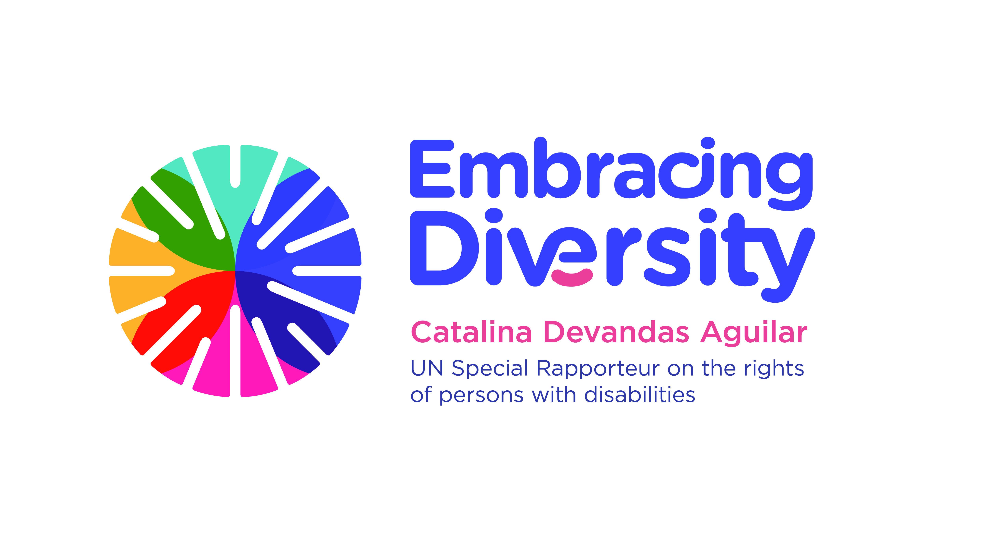english

**Expert Group Meeting**

**Bioethics and disability**

**16 and 17 September 2019**

Room 1-016, 1st Floor, OHCHR, Palais Wilson,

Quai Wilson 47,

1201 Geneva

**Concept Note**

1. **Introduction**

The UN Special Rapporteur on the rights of persons with disabilities, Ms. Catalina Devandas Aguilar is hosting an *Expert Group Meeting on bioethics and disability* on 16 -17 September 2019 in Geneva, with the support of the Government of Finland. The meeting will be held at the premises of the OHCHR in Palais Wilson, Room 1-016.

Pursuant to Human Rights Council resolution 35/6, the Special Rapporteur is mandated to develop a regular dialogue with civil society and other actors to identify, exchange and promote good practices related to the realization of the rights of persons with disabilities; gather and exchange information and communications with States on alleged human rights violations, and make recommendations on how to promote and protect the rights of persons with disabilities. In this context, she reports annually to the Human Rights Council and the General Assembly. The main findings of this *Expert Group Meeting* will inform the Special Rapporteur’s thematic report on bioethics and disability to the Human Rights Council in 2020.

During her mandate, the Special Rapporteur has published various reports related to bioethical issues, including the right to liberty and security; right to health; legal capacity reform and supported-decision making, and sexual and reproductive health and rights of girls and young women with disabilities. In all her reports, the Special Rapporteur has pointed out the necessity to change legislation, policies, and institutional frameworks so that they are inclusive of persons with disabilities. Beyond this, it is also imperative to embrace diversity through new attitudes and cultural change. This effort to reshape the way we see and interact with a disability is the foundation of all of the Special Rapporteur work.

1. **Context**

Bioethics considers the ethical, legal, and increasingly the societal issues raised by medicine and science. Its focus tends to be more on innovation and cutting-edge developments that raise novel ethical difficulties for healthcare, scientific research and society in general.

In this context, bioethics guides societies to decide which sorts of interventions and supports for disability that are morally good. Disability is also important for bioethics, as the diversity of human bodies is a central focus of its attention. The bioethical discourse not only reflects the prevailing cultural beliefs about disability but also can shape attitudes towards persons with disabilities.

Accordingly, bioethics is intrinsically linked to the lives of persons with disabilities, having direct and indirect effects on their lives. Recent advances in biomedicine have changed how disability is understood and the moral permissibility of using particular medical interventions to prevent disabling conditions before they happen, reducing their impact, or treating them once they occur.

Historically, international bioethics declarations have made little specific reference to persons with disabilities, except in the context of people who are deemed to “lack capacity to consent” to medical treatment or research. For example, Article 6 of the Council of Europe’s Convention on Human Rights and Biomedicine, (hereinafter, “Oviedo Convention”), points out that “where an adult does not have the capacity to consent to an intervention because of a mental disability, a disease or for similar reasons, the intervention may only be carried out with the authorization of his or her representative or an authority or a person or body provided for by law.” Additionally, Article 24 (3) of the UNESCO Universal Declaration of Bioethics and Human Rights notes that states should have special regard for those rendered vulnerable by disability, among other conditions.

Since the adoption of the Convention on the Rights of Persons with Disabilities (CRPD), there has been an extraordinary paradigm shift in the way persons with disabilities are perceived. From charity and attempts to “cure” disability, the international community has started to move towards a model that recognizes that social and environmental barriers are the main obstacles for the enjoyment of human rights by persons with disabilities. It is in that interaction between a person with an impairment and his or her environment where discrimination and rights violations arise, resulting in disability, and it is only by addressing those social aspects that persons with disabilities will be fully included in their communities.

In this framework, bioethics should consider disability as a complex socio-medical phenomenon, and recognize that it is possible to have a healthy and prosperous life with a disability if there are adequate supports available.

The CRPD contains provisions related to bioethical issues, including the right to life (Article 10), equal recognition before the law (Article 12), right not to be subjected to medical experimentation without consent (Article 15), respect for physical and mental integrity (Article 17), respect for home and the family (Article 23), the right to health (Article 25), and the right to habilitation and rehabilitation (Article 26).

Furthermore, the CRPD recognizes as general principles the respect for inherent dignity, individual autonomy including the freedom to make one's own choices, and independence of persons; full and effective participation and inclusion in society; respect for difference and acceptance of persons with disabilities as part of human diversity and humanity (Article 3). Moreover, there is an obligation of States to take into account the promotion of the human rights of persons with disabilities in all policies and programmes, including their active participation concerning issues relating to them; as well as to undertake research with a human rights-based approach, and to promote the use of new technologies suitable for persons with disabilities, giving priority to technologies at an affordable cost (Article 4).

The most common discussions on bioethics and disability has been related to life and death, including the ethics of using prenatal diagnosis, preimplantation genetic diagnosis and preconception screening to prevent the birth of children with disabilities; the reproductive rights of persons with disabilities; and issues at the end of life, such as assisted suicide, euthanasia and decisions about continuing medical treatment when a person is seriously ill or dying. Bioethics has also contributed to the discussion of healthcare policies, or the use of biomedical technologies to normalize "anomalous" bodies or minds, especially where parents make choices on behalf of their children.

Many debates in bioethics come down to contrasting views about the quality of life of persons with disabilities. For example, an assumed poor quality of life is the basis for arguments in favor of prenatal testing and selective termination of pregnancies affected by disabilities, as well as for voluntary euthanasia or assisted dying for people with disabilities. It is essential to break the strong cultural association between ‘having a significant impairment’ and ‘having a less valued life’.

On several occasions the bioethical discussions have had an impact or have been addressed by the international human rights system, in the work of the treaty bodies. For instance, the Committee on the Rights of Persons with Disabilities (CRPD) and the Committee on the Elimination of Discrimination against Women (CEDAW) has pointed out that “health policies and abortion laws that perpetuate deep-rooted stereotypes and stigma undermine women’s reproductive autonomy and choice, and they should be repealed because they are discriminatory.”[1]

In addition, the CRPD Committee called States parties to oppose the draft Additional Protocol to the Oviedo Convention, as it conflicts with the human rights of persons with disabilities recognised by the CRPD, in particular, with the right to equal recognition before the law, the right to liberty and security, the right to physical and mental integrity, and the right to health.[2] Moreover, recently, the CRPD Committee has request to a State to suspend, as a precautionary measure, the decision to withdraw life support for a man in vegetative state while the case is investigated on its merits.

When discussing bioethics and disability, it is essential to reflect that persons with disabilities are disproportionately represented in the lowest income groups in their countries. However, disability itself disproportionately affects populations that are already vulnerable for other reasons. They are more likely to live in poverty or be unemployed or to receive poor education and health care, because of inequalities in the way that resources are distributed.

Nevertheless, the dominant voices are probably discussing concerns which are currently most relevant for high-income countriesof the global North, or for the richest people in low and middle-income settings. In this context, one challenge is to promote that the voices of the most marginalized groups are paid attention in global discussions about bioethics and disability.

An additional challenge is how to build a collaborative dialogue between the disability and bioethics movements. Bioethics must acknowledge the limitations of its approach to disability, and efforts must be made to encourage more disability-inclusive bioethical work. In this line, it is important to evaluate the role of the national bioethics committees.

Finally, it is fundamental to discuss how to promote participation and active involvement of persons with disabilities in bioethical debates. There is currently a lack of representation of persons with disabilities in the development of bioethics law, regulation and governance at both national and international levels. Advancing the rights of persons with disabilities is only possible with their active participation. It is a condition to fulfill the promise of leaving no one behind of the 2030 Agenda for Sustainable Development.

**III. Objective and expected outcomes**

The main objective of the meeting is to explore the relationship between bioethics and disability and to discuss areas where potential tensions could emerge, including:

* Notions of normality and quality of life;
* Prenatal diagnosis and disability-selective abortion;
* Controversial and/or irreversible treatments; and
* Euthanasia and assisted suicide.

The specific objectives of the expert meeting are:

1. Discuss the particular human rights violations experienced by persons with disabilities in areas related to bioethics;
2. Analyze how to promote the highest recognition of the rights of persons with disabilities in discussions related to prenatal diagnosis and disability-selective abortion; controversial and/or irreversible treatments; euthanasia and assisted suicide.
3. Identify challenges to promote disability perspective in the bioethics agenda;
4. Share good practices to promote disability perspective in the bioethics agenda;
5. Analyze the role of states in discussions related to bioethics and disability

**IV. Methodology and participants**

The Expert Group Meeting will be held on 16 -17 September 2019 at Palais Wilson in Geneva. It will bring together approximately 25 experts on bioethics and/or disability rights from the UN human rights mechanisms, UN entities, organizations of persons with disabilities, and academia, with experience in the above-mentioned areas.

The meeting will be organized into four sessions each day, with a facilitator moderating the discussions for each session, based on pre-identified questions. Selected experts will be requested to make short presentations (maximum 5 min per speaker) to introduce the key issues under certain thematic areas.

In preparation for the meeting, we encourage experts to review the background paper on bioethics and disability, written by Jackie Leach Scully and Tom Shakespeare. At the same time, we encourage experts to reflect upon the relationship between bioethics and disability, and areas where potential tensions could emerge, as well as to identify good practices, examples, and lessons based on their expertise and practical experience.

The language of the meeting will be English (no interpretation into other UN languages is provided). English captioning will be provided throughout the meeting.

1. "Guaranteeing sexual and reproductive health and rights for all women, in particular women with disabilities" - Joint statement by the Committee on the Rights of Persons with Disabilities and the Committee on the Elimination of All Forms of Discrimination against Women. Adopted the 29 August 2018.
2. Statement by the Committee on the Rights of Persons with Disabilities calling States parties to oppose the draft Additional Protocol to the Oviedo Convention. Adopted at the CRPD 20th session (27 August - 21 September 2018).