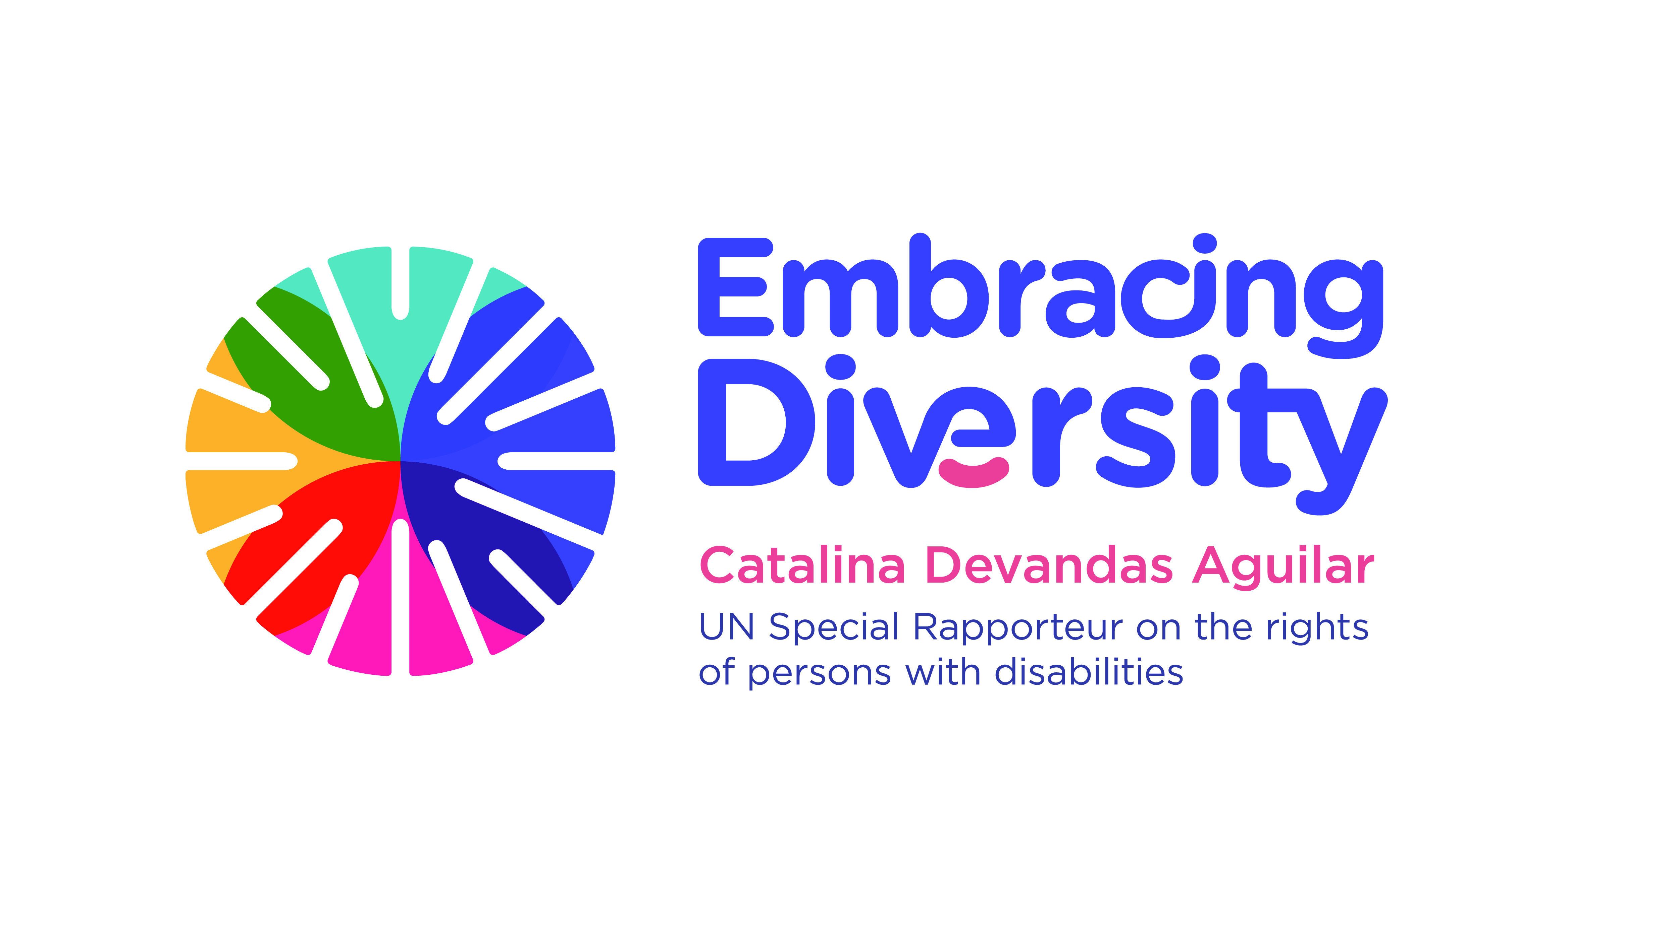english

**Expert Group Meeting on Bioethics and Disability**

**16 and 17 September 2019**

1st floor Conference Room

OHCHR-Palais Wilson, Geneva, Switzerland

**List of Participants**

1. **Mr. Derrick Aarons,** Bioethicist and physician, Member of the International Bioethics Committee, [aaronsderrick27@gmail.com](mailto:aaronsderrick27@gmail.com)
2. **Ms. Teresa Blankmeyer Burke,** Assistant Professor of Philosophy, Gallaudet University, [teresa.burke@gallaudet.edu](mailto:teresa.burke@gallaudet.edu)
3. **Ms. Lydia Brown**, [lydia@autistichoya.com](mailto:lydia@autistichoya.com)
4. **Mr. Facundo Chávez Penillas,** Human Rights and Disability Advisor, Office of the High Commissioner for Human Rights, [fchavezpenillas@ohchr.org](mailto:fchavezpenillas@ohchr.org)
5. **Ms. Catalina Devandas**, Special Rapporteur on the rights of persons with disabilities, [cdevandas@sr-disability.org](mailto:cdevandas@sr-disability.org)
6. **Ms. Rosemarie Garland-Thomson,** Professor of English and Bioethics, Emory University, [rgarlan@emory.edu](mailto:rgarlan@emory.edu)
7. **Ms. Anita Ghai,** Professor in the School of Human Studies, Ambedkar University, [anita.satypal@gmail.com](mailto:anita.satypal@gmail.com)
8. **Ms. Jackie Leach Scully,** Professor of Bioethics, Director, Disability Innovation Institute, Faculty of Arts & Social Sciences, University of New South Wales(participation through Skype), [jackie.scully@newcastle.ac.uk](mailto:jackie.scully@newcastle.ac.uk)
9. **Ms. Lindsay Lee**, World Health Organization,[lindsayevanslee@gmail.com](mailto:lindsayevanslee@gmail.com)
10. **Ms. Victoria Lee,** Human Rights Officer,Office of the High Commissioner for Human Rights, [vlee@ohchr.org](mailto:vlee@ohchr.org)
11. **Mr. Lászlo Lovászy Gabor,** Member of the CRPD Committee; Lecturer at the National University of Public Service, Faculty of Public Administration; Lecturer at University of Pécs, Faculty of Law, [lovaszy.laszlo.gabor@uni-nke.hu](mailto:lovaszy.laszlo.gabor@uni-nke.hu)
12. **Ms. Cristina Michels**, Human Rights Officer, Office of the High Commissioner for Human Rights, [cmichels@ohchr.org](mailto:cmichels@ohchr.org)
13. **Mr. Trudo Lemmens,** Professor and Scholl Chair in Health Law and Policy,University of Toronto, [trudo.lemmens@utoronto.ca](mailto:trudo.lemmens@utoronto.ca)
14. **Ms. Augustina Naami,** Lecturer at the Department of Social Work, University of Ghana, [anaami@ug.edu.gh](mailto:anaami@ug.edu.gh)
15. **Ms. Rupsa Mallik,** Director of Programs and Creation, CREA, [rmallik@creaworld.org](mailto:rmallik@creaworld.org)
16. **Ms. Tina Minkowitz,** Esq.,Center for the Human Rights of Users and Survivors of Psychiatry, [tminkowitz@earthlink.net](mailto:tminkowitz@earthlink.net)
17. **Ms. Alicia Ouellette,** President and Dean, Albany Law School and Professor of Bioethics at Union Graduate College and the Mount Sinai School of Medicine, [aouel@albanylaw.edu](mailto:aouel@albanylaw.edu)
18. **Ms. Henriette Raventos Vorst,** Professor of genetics and at the School of Biology, Universidad de Costa Rica, [henriette.raventos@ucr.ac.cr](mailto:henriette.raventos@ucr.ac.cr), [hraventos@gmail.com](mailto:hraventos@gmail.com)
19. **Ms. Paula Siverino Bavio,** Bioethicist and Member of the International Bioethics Committee, Buenos Aires, [paulasiverino@gmail.com](mailto:paulasiverino@gmail.com)
20. **Mr. Tom Shakespeare,** Professor of Disability Research, London School of Hygiene and Tropical Medicine, [Tom.Shakespeare@lshtm.ac.uk](mailto:Tom.Shakespeare@lshtm.ac.uk)
21. **Ms. Azin Tadjdini**, Associate Human Rights Officer, Office of the High Commissioner for Human Rights, [atadjdini@ohchr.org](mailto:atadjdini@ohchr.org)
22. **Mr. Alberto Vásquez Encalada**, Research coordinator, Office of the Special Rapporteur, [research@sr-disability.org](mailto:research@sr-disability.org)