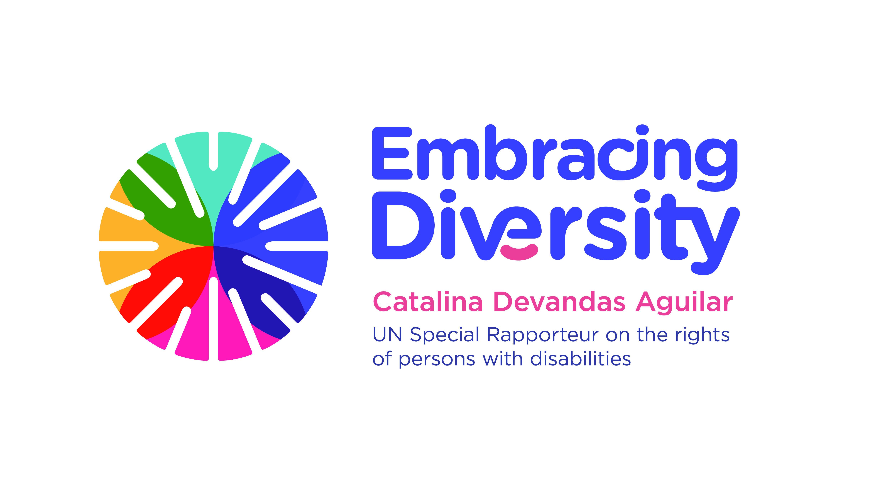english

**Expert Consultation on**

**Access to justice of persons with disabilities**

**21 February 2020**

OHCHR-Motta, Room RI-14

Geneva, Switzerland

**AGENDA**

|  |  |
| --- | --- |
| **Time** | **Session** |
| 10.00-10.30 | **Welcome, introduction of participants and objectives of the expert consultation**   * Ms. Catalina Devandas Aguilar, Special Rapporteur on the rights of persons with disabilities |
| 10.30-10.50 | **Presentation of the report and the draft international principles and guidelines on access to justice for persons with disabilities**   * Catríona Moloney, Centre for Disability Law and Policy of the NUI Galway |
| 10.50-11.10 | **Questions and answers** |
| 11.10-11.30 | **Break** |
| 11.30-13.00 | **Session 1: discussion on principles and related guidelines on:**   1. Right to equality before the courts and the right to a fair trial (right to be heard and to participate) 2. Accessibility of physical infrastructure 3. Right to information 4. Legal representation and legal aid 5. Right to non-discrimination |
| 13.00-14.30 | **Lunch** |
| 14.30-15.45 | **Session 2: discussion on principles and related guidelines on**   1. Presumption of innocence 2. Right to procedural, gender and age appropriate accommodations 3. Right to participation in administration of justice 4. Right to an effective remedy |
| 15.45-16.00 | **Break** |
| 16.00-17.15 | **Session 3: discussion on principles and related guidelines on**   1. Investigation and complaints 2. Monitoring mechanisms 3. Redress and reparation 4. Awareness raising and training programmes |
| 17.15-17.45 | **Moving forward: strategies and actions leading to the adoption of the principles and guidelines on access to justice of persons with disabilities** |
| 17.45-18.00 | **Closing remarks**   * Ms. Catalina Devandas Aguilar, Special Rapporteur on the rights of persons with disabilities |