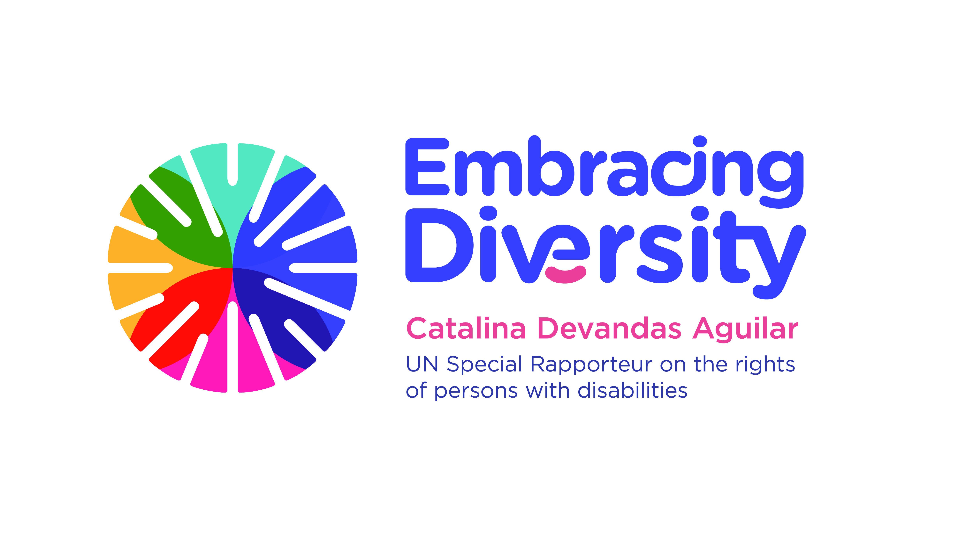english

**Expert Consultation on**

**Access to justice of persons with disabilities**

**21 February 2020**

OHCHR- Motta, Room RI-14

48, Avenue G. Motta, Geneva, Switzerland

**Concept Note**

1. **Introduction**

The UN Special Rapporteur on the Rights of Persons with Disabilities, Ms. Catalina Devandas Aguilar, is hosting an *Expert Consultation on access to justice of persons with disabilities*, with the financial support of the Government of Spain. The meeting will be held on 21 February 2020 at OHCHR-Motta building (Avenue Giuseppe Motta 48)in Geneva Switzerland, from 10.00 to 18h00*.*

Pursuant to Human Rights Council resolution 35/6, the Special Rapporteur undertakes this consultation as part of a set of initiatives aimed to develop a regular dialogue with relevant stakeholders to identify, exchange and promote good practices related to the realization of the rights of persons with disabilities; as well as to gather and exchange information and communications with States and make recommendations on how to promote and protect the rights of persons with disabilities.

Since the adoption of the Convention on the Rights of Persons with Disabilities (CRPD) in 2006, States have committed to remove the barriers that hinder access to justice to persons for persons with disabilities. The Sustainable Development Goals, in particular Goal 16, have reinforced this commitment. Moving forward and supporting States in the implementation of their obligations in this area, has been a priority in the agenda of the Special Rapporteur.

In November 2018, in collaboration with the Office of the High Commissioner for Human Rights (OHCHR), the Special Rapporteur hosted an expert group meetingto discuss the implementation of the rights to legal capacity and access to justice in the context of the administration of justice. During this meeting, experts from UN entities, regional mechanisms, national justice systems, judicial academies, training centers, civil society and academia stressed the need for the systematization of good practices on access to justice of persons with disabilities and the adoption of guidelines and protocolsfor those working in the administration of justice.

Following this meeting, in 2019, the Special Rapporteur commissioned a study aiming to identify, select and critically evaluate relevant principles, interventions and strategies to ensure effective access to justice of persons with disabilities on an equal basis with others to the Centre for Disability Law and Policy of the National University of Ireland, Galway. The study maps legislation, policy and practice developed or implemented at national, regional and international level to improve access to justice of people with disabilities, providing a systematization of all the different elements that would make a system CRPD-compliant and disability-inclusive. Based on the findings of the report, the National University of Ireland, Galway has prepared draft international principles and guidelines on access to justice for persons with disabilities.

**II. Objectives**

This Expert Consultation aims to discuss and validate the international principles and guidelines on access to justice of persons with disabilities, as well as to consider the best avenues to promote its endorsement and use by States to guide the implementation of their international obligations in relation to the administration of justice.

The specific objectives of the meeting are:

1. Review, identify gaps and validate the draft International principles and guidelines on access to justice of persons with disabilities;
2. Identify opportunities and strategies for the adoption of international guidelines on access to justice of persons with disabilities once validated and finalised; and
3. Coordinate actions to move forward with the access to justice agenda of persons with disabilities in different fora (e.g., General Assembly).

**III. Context**

The Convention on the Rights of Persons with Disabilities is the first international human rights instrument that explicitly refers to an effective access to justice for persons with disabilities. This encompasses the right to a fair trial, including equal access to and equality before the courts, and seeking and obtaining just and timely remedies for violations of human rights. According to article 13 (1) of the Convention, “States should take all appropriate measures to ensure effective access to justice for persons with disabilities on an equal basis with others, as both direct and indirect participants, and access to procedural and age-appropriate accommodations in all legal proceedings before, during and after trial”. Article 13 (2) of the Convention requires States to take measures to promote appropriate training for those working in the field of administration of justice.

Although access to justice is fundamental for the enjoyment and fulfilment of all human rights, States worldwide are struggling to implement it in practice. Many barriers prevent persons with disabilities from accessing justice on an equal basis with others, including restrictions to the exercise of legal capacity; lack of physical access to justice facilities such as courts and police stations; lack of accessible transportation to and from these facilities; obstacles to access to legal aid; lack of information in accessible formats; lack of gender- and age-appropriate accommodations to facilitate communication by persons with disabilities; negative attitudes questioning the abilities of persons with disabilities to participate at all phases of the administration of justice; and lack of training of professionals working on the justice field.

The Committee on the Rights of Persons with Disabilities has provided general guidance for the implementation of article 13 of the CRPD. It underscored that access to justice is inextricably linked to the recognition of legal capacity (general comment No. 1) and stressed the importance of the accessibility of buildings, services, information and communication for ensuring an effective access to justice (general comment No. 2). The Committee also outlined the barriers faced by women and girls with disabilities to gaining access to justice, including with regard to exploitation, violence and abuse, often owing to harmful stereotypes, discrimination and a lack of procedural and reasonable accommodations (general comment No. 3). Moreover, the Committee noted the essential nature of access to justice for persons with disabilities who seek to enforce their right to living independently in the community (general comment No. 5), and recalled that access to justice, including through the provision of legal aid to claimants in discrimination litigation, is essential to the rights to equality and non-discrimination (general comment No. 6). The Committee has also issued a number of recommendations for State parties in relation to access to justice.

In addition, in 2017 OHCHR prepared a report on the right of persons with disabilities to access to justice (A/HRC/37/25). In this study, OHCHR provided additional guidance to States Parties for the implementation of article 13 of the CRPD, identifying good practices and making recommendations. The study addresses standards related to accessibility and access to information; procedural and age-appropriate accommodations; the right to claim justice and stand trial; presumption of innocence; legal aid; and the right to an effective remedy. Based on this study, the Human Rights Council adopted in 2018 resolution 37/22 calling upon States to take effective and appropriate measures to remove all barriers preventing persons with disabilities from having effective access to justice on an equal basis with others, and to ensure the full enjoyment of equality and non-discrimination by persons with disabilities in the fields of equality and non-discrimination and access to justice.

Similarly, the General Assembly adopted in 2018 resolution 73/177 on human rights in the administration of justice, which calls upon States to take effective and appropriate measures to remove all barriers preventing persons with disabilities from having effective access to justice on an equal basis with others; and to ensure effective access to justice for persons with disabilities when investigating, prosecuting and punishing persons responsible for human rights violations and abuses committed against them. The resolution requests the Secretary-General to submit to the General Assembly at its seventy-fifth session a report on the latest developments, challenges and good practices in human rights in the administration of justice, including on the situation of persons with disabilities in the administration of justice.

**IV. Methodology and participants**

The Expert Consultation will bring together approximately 20 experts from UN entities, regional organisations, national justice systems, civil society, and academia, with a variety of expertise and perspectives.

In preparation for the meeting, we kindly request experts to read the Report on Access to Justice of Persons with Disabilities as well as the draft international principles and guidelines on access to justice of persons with disabilities, both prepared by the Centre for Disability Law and Policy of the National University of Ireland, Galway. Please note that both documents are confidential at this stage, and therefore should not be shared with anyone who is not directly involved in the Expert Consultation.

In particular, experts should focus on the draft *International principles and guidelines on access to justice of persons with disabilities* and reflect upon the gaps and challenges that persons with disabilities face in the area of access to justice, based on their expertise and practical experience. Experts should come **prepared with concrete comments and suggestions on the text**, as each principle and related guideline will be discussed in detail.

Written comments, including suggested new language, can also be submitted in advance by email to [sr.disability@ohchr.org](mailto:sr.disability@ohchr.org). The Special Rapporteur seeks feedback on the content and structure of the draft principles and guidelines, including gaps and possible overlaps.

The Expert Consultation will be held English only. No interpretation into other United Nations official languages will be provided.

We look forward to meeting you in Geneva soon!