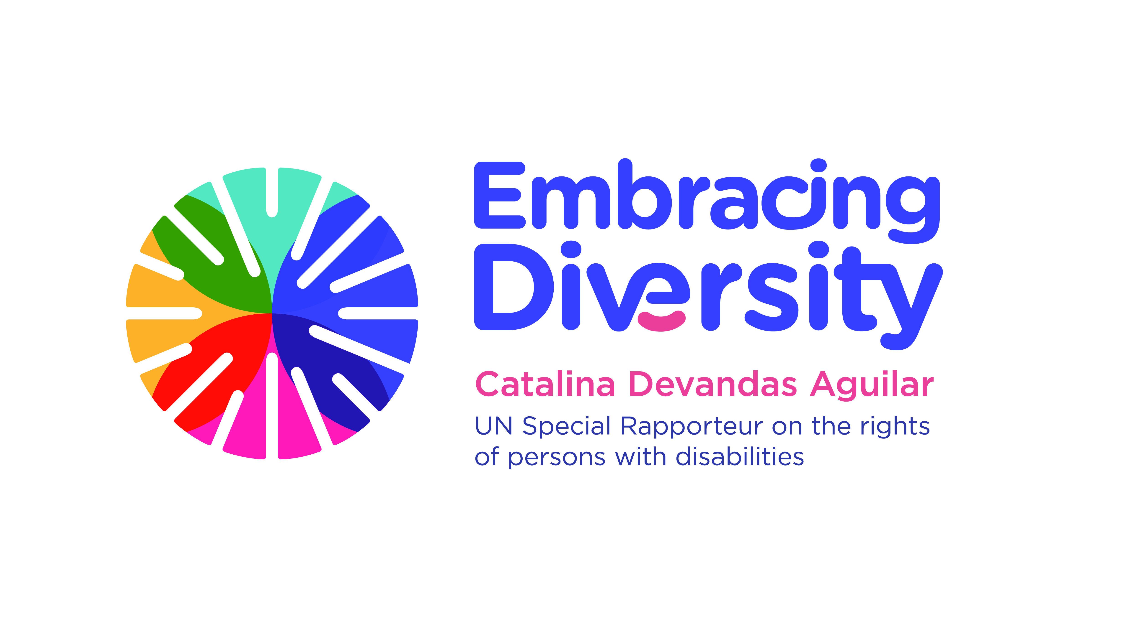english

**Expert Consultation on**

**Access to justice of persons with disabilities**

**21 February 2020**

OHCHR- Motta, Room RI-14

Avenue G. Motta, Geneva, Switzerland

List of participants

1. **Ms. Catalina DEVANDAS AGUILAR**, Special Rapporteur on the rights of persons with disabilities
2. **Ms. María del Carmen BARRANCO AVILES**, Director, Instituto de Derechos Humanos Bartolomé de las Casas, Universidad Carlos III, Madrid
3. **Ms. Julinda BEQIRAJ,** Senior Research Fellow, British Institute of International and Comparative Law
4. **Ms. Shatikha S. CHIVUSIA**, Commissioner, Kenya National Commission on Human Rights
5. **Ms. Muriel DECOT**, Secretary, European Commission for the efficiency of justice, Council of Europe
6. **Mr. Anselm ELDERGILL**, Judge, Court of Protection, London, UK
7. **Mr. Francisco Javier FORCADA MIRANDA**, General Council of the Judiciary of Spain
8. **Mr. Guillermo GARCÍA FERNÁNDEZ**, Attaché, Permanent Mission of Spain
9. **Mr. Klaus LACHWITZ**, Secretary General of the International Disability Alliance
10. **Ms. Victoria LEE,** Programme Manager, OHCHR-Geneva
11. **Mr. Mikko JORONEN**,Human Rights Centre of Finland
12. **Ms. Cristina MICHELS**, Human Rights Officer, OHCHR Special Procedures (Disability mandate)
13. **Ms. Catriona MOLONEY,** Lecturer in Disability Law, Centre for Disability Law and Policy, NUI Galway
14. **Ms. Dianah MSIPA,** Consultant, Disability and Human Rights Law and Policy, South Africa
15. **Mr. Andrés PÉREZ**, Human Rights Officer, OHCHR Rule of Law and Democracy Section
16. **Mr. Matt POLLARD**, Senior Legal Adviser & UN Representative, International Commission of Jurists
17. **Mr. Markus SCHEFER**, Member of the Committee on the Rights of Persons with Disabilities
18. **Ms. Sue SWENSON**, President, Inclusion International, and Member, International Disability Alliance
19. **Ms. Azin TADJDINI**, Associate Human Rights Officer, OHCHR Special Procedures (Disability mandate)
20. **Mr. Alberto VASQUEZ ENCALADA**, Research Coordinator, Office of the Special Rapporteur
21. **Ms. Carla VILLARREAL LOPEZ**, Office of the Special Rapporteur