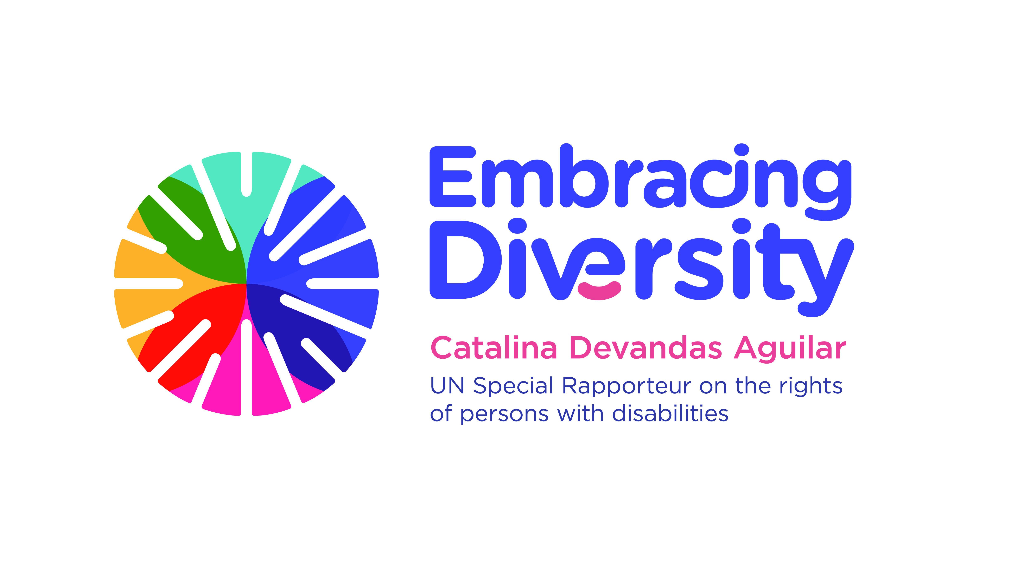english

**Expert Group Meeting**

**Persons with disabilities and the justice system: ensuring the rights to legal capacity and access to justice**

8 and 9 November 2018

OHCHR, Palais Wilson, Geneva, Switzerland

**Concept Note**

1. **Introduction**

The UN Special Rapporteur on the Rights of Persons with Disabilities, Ms. Catalina Devandas Aguilar and the Office of the United Nations High Commissioner for Human Rights (OHCHR) are hosting an *Expert Group Meeting on persons with disabilities and the justice system: ensuring the rights to legal capacity and access to justice.* The meeting will be held at the Palais Wilson in Geneva, Switzerland, on 8 and 9 November 2018.

The Special Rapporteur has a mandate to develop a regular dialogue with civil society and other stakeholders to identify, exchange and promote good practices related to the realization of the rights of persons with disabilities; gather and exchange information and communications with States on alleged human rights violations; and make recommendations on how to promote and protect the rights of persons with disabilities (Resolution 35/6). In this framework, in March 2018 the Special Rapporteur presented a report to the Human Rights Council focused on the right of persons with disabilities to legal capacity, aiming to provide guidance to States on how to guarantee this right to persons with disabilities.

In addition, based on Human Rights Council resolution 31/6, OHCHR prepared its annual study on the right to access to justice under article 13 of the Convention on the Rights of Persons with Disabilities (CRPD). This report sets forth the standards on equal and effective access to justice by persons with disabilities and provides guidance for the implementation of article 13, identifying good practices and making recommendations.

1. **Context**

Legal capacity is an indispensable condition for the full enjoyment of human rights. It implies being the holder of rights and obligations (legal standing), and the possibility of exercising those rights and obligations (legal agency). The evolving interpretation of the right to equal recognition as a person before the law implies that legal capacity is a universal attribute inherent to all persons by virtue of their humanity (see A/HRC/37/56).

Historically, persons with disabilities have been denied their legal capacity as both legal standing and legal agency. In most jurisdictions, the legal capacity of persons with disabilities can be restricted on the basis of having a medical condition or impairment, having made a decision perceived as poor, or being deemed to have deficient decision-making skills. Once their legal capacity is restricted in one or more areas of life, habitually persons with disabilities are put under a substituted decision-making regime such as guardianship or curatorship, where a legal representative is appointed to make decisions on their behalf, or where decisions are made by designated medical personnel or by a court. Persons with psychosocial disabilities, intellectual disabilities, dementia and autistic persons are particularly vulnerable to these regimes.

The consequences of the denial of and restrictions to the legal capacity of persons with disabilities are grave and pervade all aspects of life. Persons with disabilities under substituted decision-making regimes often lose their capacity to exercise all or almost all of their rights and have no control over decisions related to their lives, from entering into contracts to choosing where and with whom to live. Furthermore, in many jurisdictions, those who have not been formally placed under any form of substituted decision-making may also face restrictions in exercising their rights, as it is commonly assumed that they have no legal capacity or that they need a third person to validate their acts. All these practices perpetuate discrimination and exclusion against persons with disabilities, and pave the way to different forms of abuse, exploitation, coercion and institutionalization.

The Convention on the Rights of Persons with Disabilities introduces a paradigm shift in relation to the legal capacity of persons with disabilities. The Convention moves away from medical and paternalistic approaches to disability towards a human rights-based approach that considers persons with disabilities as rights holders, rather than as mere receivers of protection, rehabilitation or welfare. The Convention demands States parties to adopt all legislative, administrative and other measures that are necessary to give effect to the right to legal capacity, including measures to modify or abolish existing laws, regulations, customs and practices that constitute discrimination against persons with disabilities (art. 4).

Article 12 of the Convention enshrines the universal recognition of legal capacity and the provision of supports to exercise it. The Convention reaffirms the right of persons with disabilities to be recognized as persons before the law (art. 12.1) and recognizes their legal capacity on an equal basis with others in all areas of life (art. 12.2). Moreover, the Convention sets out the State obligation to provide persons with disabilities with access to support in the exercise of their legal capacity (art. 12.3), and stresses that safeguards must be put in place to ensure the respect for the rights, will and preferences of the individual who is availing themselves of that support (art. 12.4).

Legal capacity is inextricably linked to the right to access to justice. Deprivation of legal capacity, formally or de facto, leads to exclusion from judicial processes and has pervasive effects on the right of persons with disabilities to a fair trial under due process of law. Persons with disabilities may also be subjected to tests to assess their competence or fitness to stand trial that may lead to detention and treatment against their will, and commonly for durations that exceed the sentences ordered upon conviction. Furthermore, exclusions of criminal liability based on impairment, under the notions of “non-liability” or “insanity defence”,

usually result in persons with disabilities diverted from ordinary proceedings and subjected to security measures denying them the same due process guarantees as others (A/HRC/37/25).

While the recognition of the legal capacity of persons with disabilities is essential to ensure their access to justice, the justice system is indispensable for the protection and restoration of their legal capacity. In most jurisdictions, the law mandates courts to decide whether an individual has legal capacity or not. In this regard, courts have the possibility to ensure the direct application of article 12 of the Convention, particularly in monist countries where treaties are immediately incorporated into domestic law once they have entered into force. Indeed, in many countries courts are already applying standards of the Convention, challenging existing legislation that denies persons with disabilities the full recognition of legal capacity. Courts play also an important role in ensuring that persons with disabilities under substitute decision-making regimes or who have been denied or restricted of their legal capacity have access to effective remedies as well as adequate, effective and prompt redress and reparation. In addition, in countries which have made progress in the recognition of supported decision-making arrangements, courts are often mandated either to determine the scope of such arrangements, or to ensure that the proposed scope is suitable.

The Convention is the first international human rights instrument that enshrines an explicit right to access to justice. It encompasses the right to a fair trial, including equal access to and equality before the courts, and seeking and obtaining just and timely remedies for rights violations. States should take all appropriate measures to ensure effective access to justice for persons with disabilities on an equal basis with others, and access to procedural and age-appropriate accommodations in all legal proceedings before, during and after trial (art. 13.1). States should also take appropriate measures to ensure appropriate training for those working in the field of administration of justice (art. 13.2).

Against this background, it is essential to promote knowledge and awareness of the standards introduced by the Convention in relation to legal capacity and access to justice among actors within the judicial system, so that their work is compliant with the international human rights framework.

**III. Objective and expected outcomes**

The main purpose of the Expert Group Meeting is to discuss the implementation of the right to legal capacity and access to justice in the context of the administration of justice.

The specific objectives of the expert meeting are to:

1. Raise awareness regarding the human rights standards introduced by the Convention in relation to the rights to legal capacity and access to justice;
2. Identify gaps and challenges in the implementation of existing international and regional human rights frameworks in relation to the rights of persons with disabilities to legal capacity and access to justice.
3. Identify and share CRPD-compliant and innovative practices, based on the expertise of judges, for the full and equal recognition of legal capacity of persons with disabilities and supported decision-making regimes;
4. Identify and share good practices related to the provision of procedural and age-appropriate accommodations to persons with disabilities; and
5. Discuss the role of judicial academies and judicial training centres in ensuring appropriate training in accordance with the Convention for those working in the field of the administration of justice.

**IV. Methodology and participants**

The Expert Group Meeting will start on 8 November 2018 at 10 a.m.and end on 9 November 2018 at 6 p.m. It will bring together approximately 15 judges, actors within the judicial system and experts from UN entities, national justice systems, regional judicial/ quasi-judicial mechanisms, judicial academies, training centres, civil society and academia, with a variety of expertise, perspectives, and regional representation.

The meeting will be organised into sessions, with a facilitator moderating the discussions for each session, based on pre-identified questions. Selected experts may be requested to make short presentations or to introduce the key issues under certain thematic areas.

In preparation for the meeting, we encourage experts to reflect upon the gaps and challenges facing persons with disabilities in the area of legal capacity and access to justice, as well as to identify good practices, examples and lessons based on their expertise and practical experience.

The languages of the meeting will be English and Spanish (no interpretation into other UN languages). English captioning will be provided throughout the meeting.