Submission to Mrs Catalina Devandas-Aguilar, Special Rapporteur on the rights of persons with disabilities

DIWA Malawi

Ruth Kamchacha

ruthmalawi@gmail.com

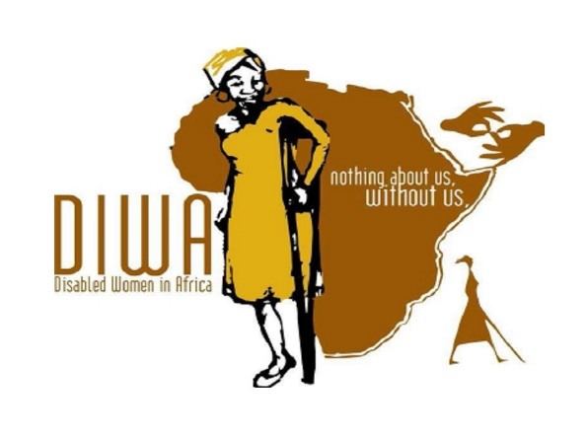
DIWA’s background
Disabled Women in Africa (DIWA) is an independent organisation of women and girls with disabilities that was established in Africa in 2002 in Tanzania and in 2012 in Malawi, which is currently its headquarters. DIWA also enjoys the membership of 12 organisations across Africa, both at the national and regional level, at work with Women. These partnerships include:
✓ Botswana: Botswana Federation of the Disabled ✓ Malawi: DIWODE ✓ Mauritius: Women with disabilities ✓ Mozambique: Associacao Macambicana de Mulheres Portadoras de Deficiencia, ✓ Rwanda: Rwanda Organisation of WWDs ✓ South Africa: South African Deaf Women Association ✓ Uganda: NUDIPU & NUWODU ✓ Zimbabwe: Disabled Women Support Organisation, Zimbabwe Down’s Syndrome, National Council of Disabled Persons, & ZWIDE
The organisations work together by sharing, capacity building, learning, research and advocating for issues concerning women and girls with disabilities.
The founder and Executive Director of DIWA, Mrs Rachel Kachaje, explains that the oppression and invisibility of women and girls with a wide range of disabilities, both in Malawi and at the regional level, prompted her and the co-founders (Maria Rantho & Beatrice Ncobo) to establish DIWA at a meeting in Tanzania in 2002, where they had been deliberating on women issues. This came out as a shared feeling and experience that there was no regional body representing women in Africa on disability but also lack of capacity of Women organisations to responding to issues affecting their lives, enjoyment and defending of their rights. DIWA focuses its work on women and girls with disability because it is a group of people that are found to experience greater discrimination than disabled men and non-disabled women, arising from the dual effect of their gender and disability.
DIWA’s vision state is: “African women and girls with disabilities enjoy their rights, influence their destiny and are free from any gender and disability based discrimination.”
Amongst our activities has been influencing and advocating for access to justice for persons with disabilities in Malawi.
DIWA has been engaging with the chief justice at judiciary level on issues of equality in accessing justice.
Specifically, DIWA conducted an access audit in the court and victim support units and it was analysed that indeed, there are a lot of barriers that prevents persons with disabilities from accessing justice either as offenders or witnesses. For more details see the link of the report below. As a result of this, DIWA made several engagements with the judicial on the matters raised and med strong recommendations.
https://www.makingitworkcrpd.org/sites/default/files/201907/DIWA%20Access%20Audit%20report%20Final%202016.pdf

Questionnaire on good practices to ensure effective access to justice for persons with disabilities (English)
- Please provide information on any existing good practices in legislation, policies and/or institutional measures taken in your country to ensure effective access to justice for persons with disabilities on an equal basis with others, as required by article 13 of the Convention of the Rights of Persons with Disabilities.
Malawi has the following legislations and policies on ensuring effective access to justice for persons with disabilities:
- The amended Constitution of Malawi
https://constitutions.unwomen.org/en/countries/africa/malawi?provisioncategory=35a3f684146b4c5c878a6a2db96a7d9a&provisioncategory=35a3f684
- Malawi National Policy on equalisation of opportunities
www.malawi.gov.mw/images/Publications/policy/Malawi%20National%20Policy%20on%20Equalisation%20of%20Opportunities%20for%20Persons%20with%20Disabilities.pdf
- The reviewed penal code-where amendment was done in response to the attacks and killing of persons with Albinism
https://www.nyasatimes.com/dpp-sensitize-malawi-prosecutors-newly-amended-penal-code-anatomy-act/
- The reviewed Anatomy Act where amendment was done in response to the attacks and killing of persons with Albinism.
https://edwinmauluka.blogspot.com/2016/06/parliament-pass-anatomy-act-amendment.html
- Currently under review the Disability Act-new issues on access to justice are being included
- The Child Care Justice Act-has issues of reasonable accommodation.
https://moj.gov.jm/sites/default/files/laws/Child%20Care%20and%20Protection%20Act_0.pdf
http://www.ilo.org/dyn/natlex/natlex4.detail?p_lang=en&p_isn=90369

- Please provide information on any existing good practices in place in your country, including strategies and guidelines, to facilitate the direct or indirect participation of persons with disabilities in judicial and other legal proceedings (e.g., as concerned parties, witnesses, jurors, judges, lawyers, experts.) including in the areas of:

- Recognition of the right to legal standing;
- Accessibility and access to information; the new Building at the moment are responding to public Building standards that reflect the accessibility standards specified. For instance the new Lilongwe court building, the other building in Blantyre and other small courts, however, the old one still needs to be renovated.

Malawi developed a National disability Mainstreaming Strategy to address gaps in the government overriding development strategies by championing the implementation of a comprehensive multi-sectoral plan to promote disability inclusive development at all levels. The document provides direction to the public and private sector on how to promote disability mainstreaming as a process towards equity and inclusive development. The strategy was launched in 2018.
The government is also supporting Local Councils to develop guidelines for mainstreaming disability to ensure inclusion at community level
Reviewing the Disability Act and policies to ensure issues of diversity of disability are well taken care of.

- Procedural, gender- and age-appropriate accommodations; there is court for minors/children in Lilongwe and necessary accommodation is provided.
- Provision of legal aid. The Ministry of Gender provides for free legal services-it has a lawyer representing the Ministry.
- Please provide information on any existing good practices in jurisprudence in your country related to the effective access to justice for persons with disabilities.
The Chief Justice in 2016 released a secular, he made directive that all cases of persons with Albinism should be resided by judges of higher jurisdiction. And there were also special courts that were allowed to sit for the cases not all courts.

- Please provide information on any existing good practices in your country to promote access to effective remedies and reparations in cases where the rights of persons with disabilities have been breached.
Malawi Human Rights Commission often conducts public enquiries , a Platform which finds out the root causes of violations and how pesons with disabilities feel about the Access to justice.

- Please provide information on any innovative initiatives that have been taken in your country to promote and ensure effective access to justice for persons with disabilities.
The following have been put in place:
- The launch of the national action plan on persons with albinism: which amongst others things is to prioritize protection and justice for persons with albinism.
- DIWA MOU with the Malawi police on urgency to respond to cases of persons with disabilities.
- Research on Access Audit done by DIWA and shared and made recommendation to the Ministry of Justice and Judiciary-some of the recommendations are responded to already such as the new buildings where accessibility issues are responded to.
- DIWA provided the court clerks, prosecutors and magistrates and judges with training in sign language interpretation and communication, the training made other judges to consider pursuing further long term training on sign language due to the gaps and challenges they face as magistrates in effective communication.

Ruth Mkutumula
Disabled Women in Africa.

