Check against delivery

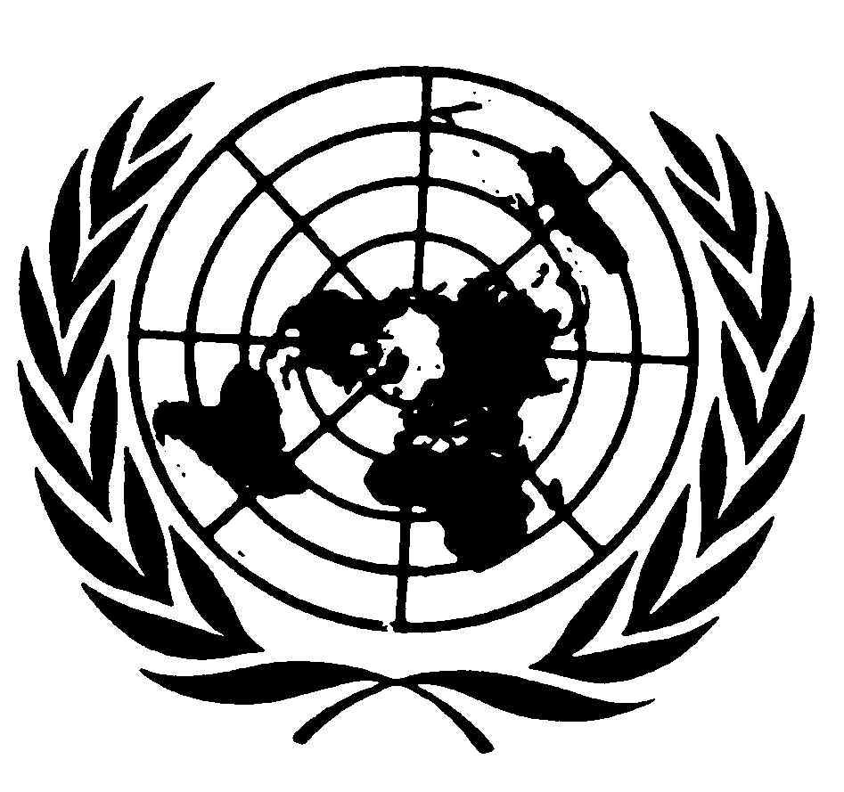

Statement by MR. GERARD QUINN,
UNITED NATIONS Special Rapporteur
on THE RIGHTS OF PERSONS WITH DISABILITIES

Seventy-fifth session of the General Assembly
Item 72 (c)

NEW YORK
22 October 2020

Ms. President,

Distinguished delegates and participants,

I speak to you today as the incoming United Nations Special Rapporteur on the rights of persons with disabilities.

I have the honour to present you a report - A/75/186 - on disability-inclusive international cooperation, which is the last thematic report of my predecessor. The report is available in accessible formats, including Easy-to-Read and Braille, in the room and upon request.

I cannot let the occasion go without commending the sterling work of my predecessor in this post – Catalina Devandas-Aguilar – who has really set a very high bar for the work of the UN Special Rapporteur on the rights of persons with disabilities. She shone a light on many complex issues and clarified rights and obligations in a field that is still relatively new. I hope to build on her work and pause here to honour her commitment.

As this is the beginning of my tenure, I am currently assessing various thematic priorities. I did signal early on, my interest in making sure the voice of persons with disabilities are heard loud and clear in how humankind responds to common existential threats including the COVID-19 pandemic, the scourge of armed conflicts, climate change, extreme poverty and the supporting role of regional actors.

I’m also keenly aware of many intersectional issues that have yet to receive the attention they deserve – for example the fate of indigenous peoples and disability I am sure we will have many constructive conversations as the thematic work of my mandate continues.

On a preliminary but important point, let me at the outset say that, as the Interprefy platform that we are using for this meeting is not fully accessible for persons with visual impairments, I wish to join Mr. Basharu - Chair of the United Nations Committee for Persons with Disabilities, - in calling upon the United Nations and States Parties to re-double their efforts to ensure that the right to accessibility and the obligation of ‘reasonable accommodation’ are fully met. I see this as part of the process of giving life to the United Nations Disability Inclusion Strategy (UNDIS) and General Assembly resolution 68/268.

As we speak, the COVID-19 pandemic continues to have a severe impact on the gains made in the past decades on the rights and inclusion of persons with disabilities. Times of crisis like these reveal where we are and how far we have to go.

As the United Nations Secretary-General has stressed, persons with disabilities are among those most affected by COVID-19. In some countries, evidence suggest that the majority of COVID-19 deaths have been persons with disabilities including especially older persons with disabilities.
Many persons with disabilities continue to find themselves in situations of heightened risks, which include segregated settings and institutions. These places – which should not exist in the first place - have been hit particularly hard.

Persons with disabilities have also been disadvantaged by the socioeconomic consequences of the pandemic and government responses. They have been cut off from support and services; many have dropped out of school or lost their jobs; some have become homeless, and millions around the world are at risk of poverty or extreme poverty, if they are not already experiencing it. The long-term mental health impact has yet to be fully gauged.

Now, more than ever, we need multilateral action to respond to the crisis appropriately and to ensure that there is a much more inclusive recovery for those who are among the farthest left behind.

In this context, it has to be emphasized that the need for disability-inclusive international cooperation is greater than ever. Without it, the slim gains already made are in jeopardy and the prospects ahead look dim.

But what does disability-inclusive international cooperation mean? I commend my predecessors’ report as a highly worthy contribution to this important debate. Let me summarize it in three core ideas.

First, it means that existing international cooperation, including development and humanitarian programmes, is inclusive of and accessible to persons with disabilities. This is actually a requirement of article 32 of the Convention on the Rights of Persons with Disabilities, which is the first human rights treaty to include a stand-alone provision on international cooperation.

Inclusion, in the context of international cooperation, demands overcoming structural barriers to enable persons with disabilities to participate in and benefit from existing international cooperation processes and outcomes on an equal basis with others. It requires a commitment to the inclusion of persons with disabilities, which should translate into mainstreaming disability into all international cooperation efforts.

Second, disability-inclusive international cooperation calls for a human rights-based approach to disability, as provided for in the Convention. All international cooperation efforts should move away from charitable and medical understandings of disability, and uphold and promote human rights norms and standards, such as non-discrimination, accessibility, participation and accountability.

Third, disability-inclusive international cooperation involves the meaningful participation of persons with disabilities in decision-making. They know best the barriers that they face and the impact that such barriers have on their lives. Persons with disabilities and their representative organizations must be consulted and actively involved at every level of the development, implementation and monitoring of international cooperation plans, programmes and projects.

I would only add from my perspective that this element of including the voice of persons with disability underpins legitimacy – as well as efficiency. The co-production of policy benefits all - including governments.

Distinguished delegates,

Since the adoption of the Convention on the Rights of Persons with Disabilities, national and multilateral agencies, the private sector and foundations have increased their efforts to include disability in their work. This is reflected in the inclusion of persons with disabilities in the 2030 Agenda for Sustainable Development and other important international commitments - a major milestone.

I see emphasis in the UN Sustainable Development Goals (SDGs) on systemic change as a highly useful tool in driving forward the ecosystem to ensure respect for the rights of persons with disabilities and am very pleased to see the UN Committee on the Rights of Persons with Disabilities reinforce many of its conclusions by invoking the UN SDGs.

However, the study prepared by my predecessor shows that international cooperation is not yet systematically taking into account the rights of persons with disabilities.

For example, despite the enhanced attention to disability inclusion, most donors with some exceptions do not have specific strategies, policies or guidelines that directly address the inclusion of persons with disabilities. We can do better.

Furthermore, the increased rhetoric on disability inclusion has not resulted in a significant growth in resource allocation. Although we do not have comprehensive comparative data, initial evidence suggests that disability-specific programmes are significantly underfunded, receiving on average less than 1 per cent of donor funding. We can do better.

Further, some donors continue to invest in programmes and projects contrary to the rights of persons with disabilities, such as the building and maintaining institutions, or the creation of segregated schools and classrooms. Of the $3.6 billion reported by donors as disability-relevant aid in 2018, only one quarter was used to promote disability inclusion or was fully compliant with the Convention. We can do better.

Distinguished delegates,

Unless international cooperation to support the rights and inclusion of persons with disabilities increases significantly, the international pledge to leave no one behind, in particular in the context of post-COVID-19 recovery, will not be met.

The report does not stop with problems and highlighting the same. To assist positive change, it outlines many practical actions States and donors can take to change this situation.

- First, we need to make a clear public commitment to disability inclusion by adopting a clear policy framework for the inclusion of persons with disabilities across all existing international cooperation efforts. States should mainstream disability inclusion into all international cooperation policies and programmes, and complement them with disability-specific initiatives.

- Second, we need to ensure a clear human rights based approach. For example, under no circumstances should international cooperation undermine the rights of persons with disabilities, segregate them, or create or exacerbate barriers.

- Third, we need to increase financial and technical assistance for disability inclusion. States should consider adopting targets for disability-specific funding and guidelines on inclusive budgeting.

- Fourth, and perhaps crucially in the long term, we need to step up close consultation and actively involve persons with disabilities and their organizations in all efforts related to international cooperation. States should consider implementing participatory funding models, as well as institutionalizing consultative forums or working groups linked to national cooperation agencies.

I would only emphasize again that the voice of persons with disabilities and their participation in the co-production of policy is crucial not only for legitimacy but also for efficiency.

- Fifth, we need to track development finance on disability inclusion. States should adopt and use the disability marker of the OECD Development Assistance Committee in all official development assistance to measure and monitor financing for disability inclusion. Trust but verify.

- Finally, we need to invest in capacity building. International cooperation agencies and donors need good in-house disability leaders and regular access to external technical support. The knowledge is out there - it needs to be harnessed.

Ms. President, Distinguished delegates and participants,

The COVID-19 pandemic and its socioeconomic consequences reveals the necessity for robust international cooperation. We have a shared responsibility to build back better for all.

There is an urgent need to establish accountability mechanisms to check that all COVID-19 response and recovery funds are reaching persons with disabilities.

I believe the recommendations contained in this report is a constructive contribution in helping the international community move forward on this path.

Thank you.
[END]

