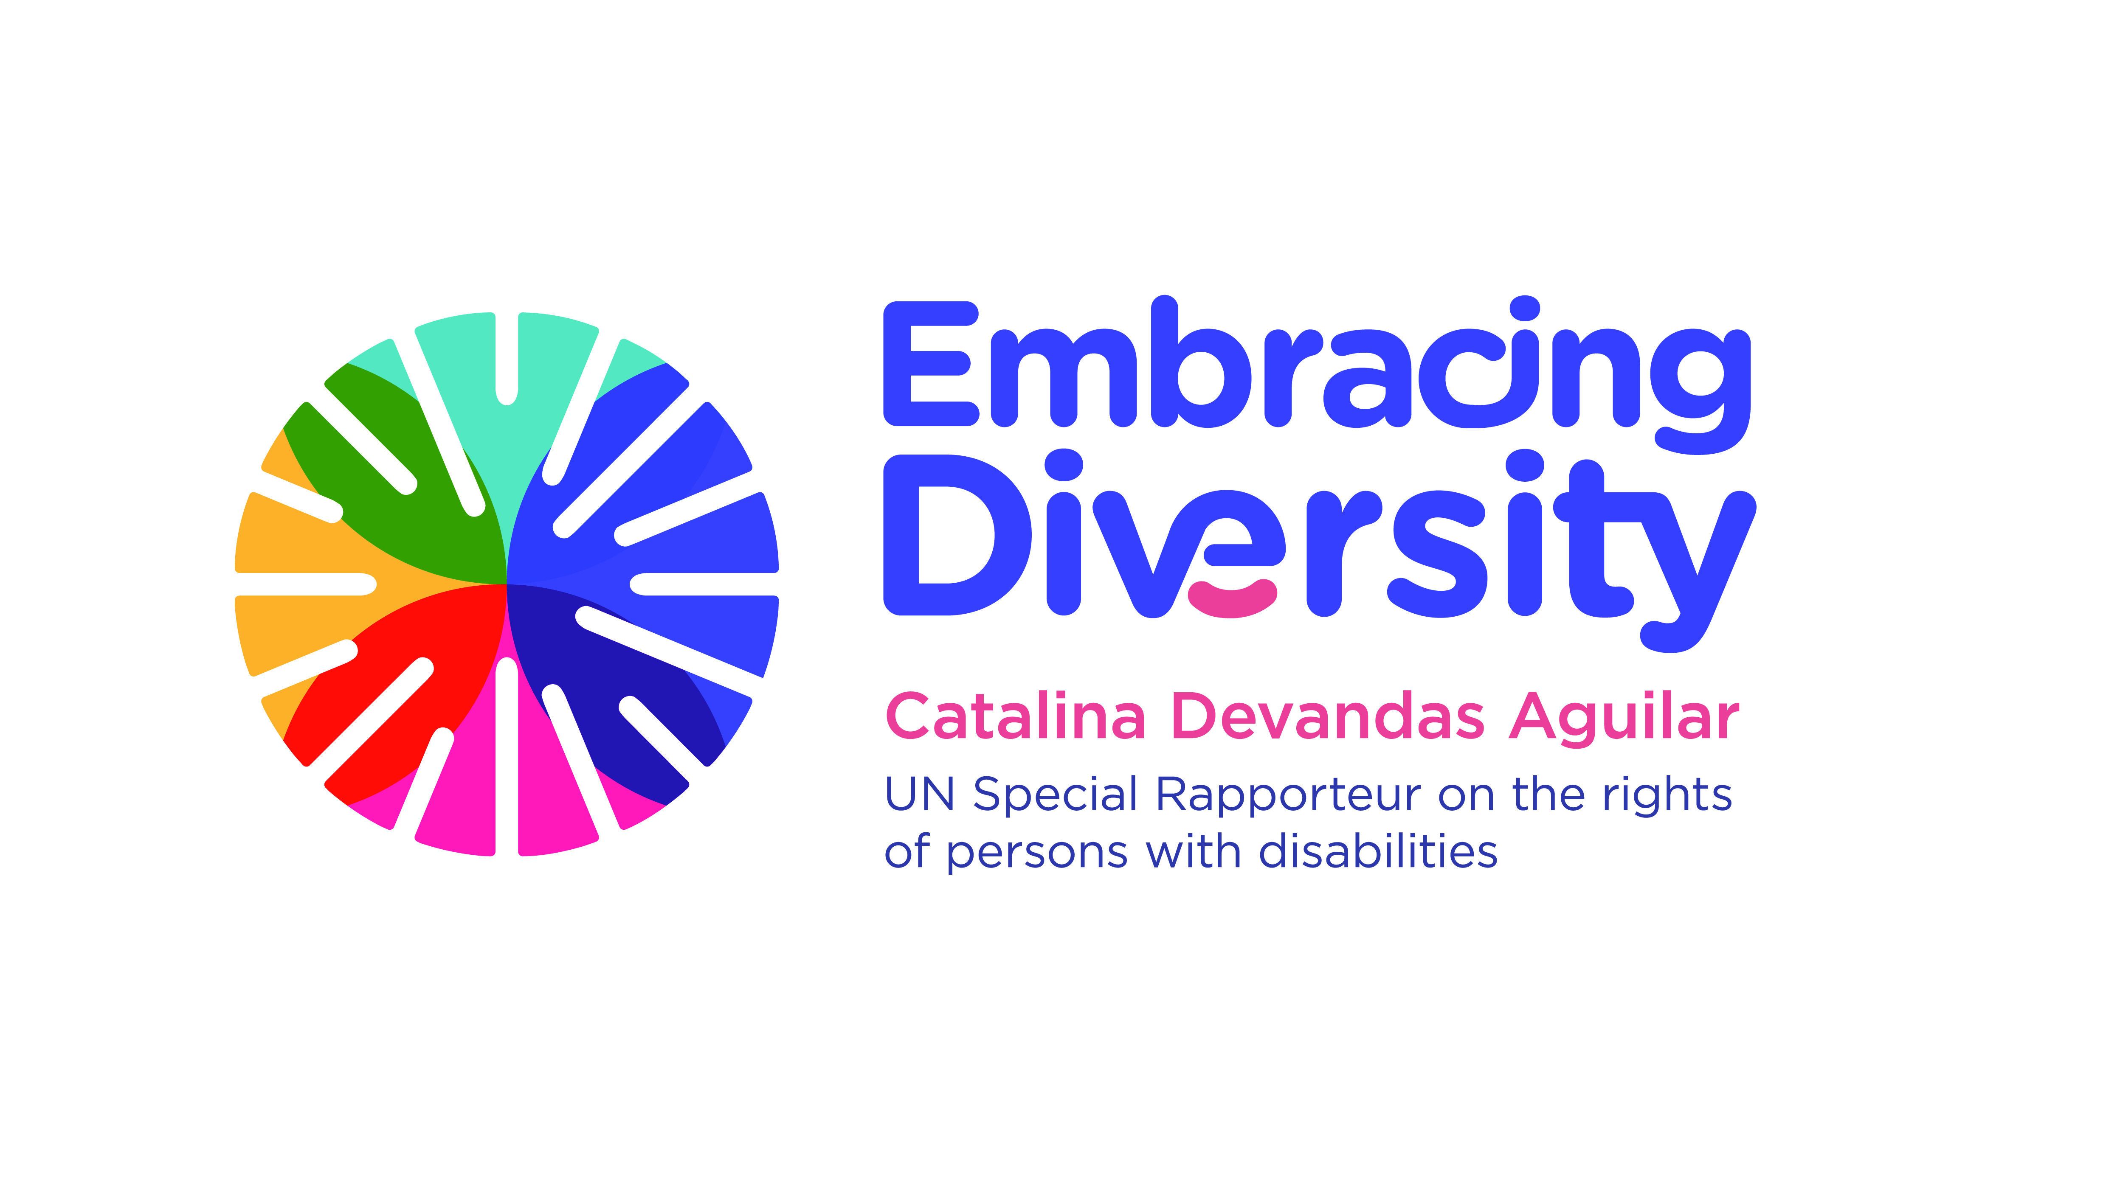english

**Expert Group Meeting**

**The right of persons with disabilities to the highest attainable standard of physical and mental health**

15 and 16 May 2018

Room XVI, Palais des Nations, Geneva, Switzerland

**Concept note**

1. **Introduction**

The UN Special Rapporteur on the Rights of Persons with Disabilities, Ms. Catalina Devandas Aguilar, with the support of the Government of Finland, is hosting an *Expert Group Meeting on the right of persons with disabilities to the highest attainable standard of physical and mental health* in Geneva (Switzerland) on 15-16 May 2018.

Human Rights Council resolution 35/6 mandates the Special Rapporteur to develop a regular dialogue with civil society and other stakeholders to identify, exchange and promote good practices related to the realization of the rights of persons with disabilities; gather and exchange information and communications with States on alleged human rights violations; and make recommendations on how to promote and protect the rights of persons with disabilities. In this framework, the Special Rapporteur reports annually to the Human Rights Council and the UN General Assembly.

The forthcoming report of the Special Rapporteur to the 73rd session of the General Assembly (October 2018) will focus on the right to health of persons with disabilities, aiming to identify global challenges and trends as well as legal and policy responses and good practices for ensuring their full and equal enjoyment of this right. For this purpose, the Office of the Special Rapporteur has developed a discussion paper related to the health status of persons with disabilities and the implementation of disability-inclusive health systems. Based on this paper, as well as replies to a questionnaire[1] sent to States, national human rights institutions, civil society organizations and networks, including organizations of persons with disabilities, the report of the Special Rapporteur will contain recommendations to guarantee the right of persons with disabilities to the highest attainable standard of health.

1. **Context**

The right to enjoy the highest attainable standard of physical and mental health is a fundamental human right recognised in numerous international instruments, including the Universal Declaration of Human Rights, the International Covenant on Economic, Social and Cultural Rights and the Convention on the Rights of Persons with Disabilities. It contains both freedoms and entitlements extending not only to timely and appropriate healthcare, but also to the underlying determinants of health, such as housing, food and nutrition, water and sanitation, housing, healthy occupational and environmental conditions, and access to health-related information and education.[2] The principles of equality and non-discrimination are central to the enjoyment of the right to health.

The Convention on the Rights of Persons with Disabilities, adopted on December 13, 2006, reaffirms that persons with disabilities have the right to the enjoyment of the highest attainable standard of health, without discrimination based on disability. Its Article 25 calls States Parties to take all appropriate measures to ensure access for persons with disabilities to health services that are gender-sensitive, including health-related rehabilitation, and highlights specific obligations that States must take to fulfil the right to health of persons with disabilities. The 2030 Agenda for Sustainable Development also provides an opportunity to improve the right to health of persons with disabilities.

Persons with disabilities can lead active, productive, long and healthy lives as anyone else. They have similar health care needs as the rest of the population, including for instance health promotion, preventive care, and treatment of acute and chronic illness.[3] Yet, evidence shows that persons with disabilities are often more vulnerable to developing ill health than the general population, as often they do not receive the health care and support they require. Consequently, they are, for example, at higher risk of developing secondary, co-morbid and age-related conditions; of being exposed to violence; of unintentional injury; and of greater rates of premature death.[4] Moreover, some persons with disabilities have specific healthcare needs, which usually national health care systems do not address.

In this regard, addressing inequalities in accessing and using healthcare services is central to improve the health status of persons with disabilities. Barriers to access these services include discrimination in accessing health insurance and services, the cost and unaffordability of the services; the unavailability of quality health services that meet the specific needs of individuals; lack of training of health professionals, and lack of physical and communication accessibility. Furthermore, persons with disabilities often experience many forms of human rights-violations in healthcare-settings, such as violence and abuse, ill-treatment, arbitrary detention and forced treatment. Women and girls with disabilities in particular are subjects to human rights violations in the area of sexual and reproductive health and rights[5].

**III. Objective and expected outcomes**

The specific objectives of the Expert meeting are:

1. Present the discussion paper on the situation of the right of persons with disabilities to the highest attainable standard of health;
2. Discuss the preliminary outline of the forthcoming report of the Special Rapporteur on the right of persons with disabilities to the highest attainable standard of health;
3. Identify gaps and challenges in the implementation of existing international and regional human rights frameworks in relation to the right of persons with disabilities to the highest attainable standard of health;
4. Identify CRPD-compliant practices for the equal enjoyment of the right of persons with disabilities to the highest attainable standard of health.
5. Inform the next thematic report of the Special Rapporteur to the General Assembly.

**IV. Methodology and participants**

The Expert Group Meeting will start at on **Tuesday 15 May 2018** at **15h00** and continue all day on 16 May 2018 (10h00-18h00). It will bring together approximately 20 experts from UN entities, organizations of persons with disabilities, civil society and academia, with a variety of expertise, perspectives, and regional representation.

The meeting will be organised into four sessions, with facilitator moderating the discussions throughout each session, based on pre-identified questions. Selected experts may be required to make short presentations or to introduce the key issues under certain thematic areas. They will be informed separately.

To prepare for the meeting, we encourage experts to read the discussion paper and to think about gaps and challenges in the area of the right of persons with disabilities to the highest attainable standard of health, as well as good practices, examples and lessons based on their expertise and practical experience.

The language of the meeting will be English only (no interpretation into other UN languages). International sign language interpretation and English captioning will be provided throughout the meeting.

1. See <http://www.ohchr.org/EN/Issues/Disability/SRDisabilities/Pages/StandardOHealth.aspx>.
2. Committee on Economic, Social and Cultural Rights, General Comment No. 14 (2000), E/C.12/2000/4.
3. World Health Organisation and World Bank, World Report on Disability, pp. 57-60.
4. Ibid.
5. Special Rapporteur on the rights of persons with disabilities, Sexual and reproductive health and rights of girls and young women with disabilities, A/72/133.