To the attention of:

Office of the United Nations High Commissioner
for Human Rights
United Nations Office at Geneva
CH – 1201 Geneva 10

Vienna, 30 June 2016
Ref: 2016-outgoing-000919

Subject: Human Rights Council Resolution 31/6
Dear Ms Sanghera,
The European Union Agency for Fundamental Rights (FRA) very much welcomes the opportunity to contribute to the preparation of a study on Article 5 of the Convention on the Rights of Persons with Disabilities (CRPD) by providing evidence from its research on the rights of persons with disabilities in the EU. All the publications mentioned in this submission can be downloaded from the FRA website.
Question 1: Have the countries in your region adopted legislation establishing disability as prohibited ground of discrimination, including denial of reasonable accommodation as discrimination?
At the EU level, Article 10 of the Treaty on the Functioning of the European Union requires the EU to combat discrimination based on disability when defining and implementing its policies and activities, and Article 19 grants it the power to adopt legislation to combat discrimination on the grounds of disability. Since 2010, this protection has been complemented by Article 21 of the Charter of Fundamental Rights of the European Union, which also prohibits discrimination on the grounds of disability. Furthermore, since accepting the CRPD in 2010 the EU is bound by its provisions, including Article 5, to the extent of its competence.
At the level of secondary legislation, discrimination on the grounds of disability has been prohibited in employment and occupation since the entry into force of the Employment Equality Directive in 2003. In addition to prohibiting discrimination, the Employment Equality Directive sets out in its Article 5 a duty to provide reasonable accommodation. The directive does not, however, state whether denial of reasonable accommodation is a form of discrimination.
The Employment Equality Directive has been transposed into the national laws of all EU Member States, making its standards directly applicable in national law. Should the proposed Equal Treatment Directive be adopted, it would extend the prohibition of discrimination on the grounds of disability and the duty to provide reasonable accommodation beyond the employment context in EU law.
Evidence collected by FRA shows, however, that many EU Member States have broadened the prohibition of discrimination on the grounds of disability and the accompanying duty to provide reasonable accommodation beyond the area of employment. In Belgium, Bulgaria, the Czech Republic, Cyprus, Ireland, the Netherlands, Slovenia, Spain and the United Kingdom, for example, the duty to provide reasonable accommodation beyond the employment context can be found in national non-discrimination legislation.
Some EU Member States, such as Austria, Ireland, and the Netherlands, have extended the concept of discrimination to include the denial of reasonable accommodation. Further information can be found in FRA’s Focus Paper on Implementing the UN CRPD – An overview of legal reforms in EU Member States, FRA’s Opinion on the situation of equality in the European Union 10 years on from initial implementation of the equality directives and in the report The legal protection of persons with mental health problems under non-discrimination law.
Hate crime is the most extreme form of discrimination. FRA’s focus paper on the Equal protection for all victims of hate crime: The case of persons with disabilities, highlights that, as of October 2014, 13 EU Member States explicitly recognise a disability-bias motivation in their criminal laws: Austria, Belgium, Croatia, Finland, France, Greece, Hungary, Lithuania, the Netherlands, Romania, Slovenia, Spain, and the United Kingdom.
Question 3: Do the countries in your region apply affirmative actions for combating structural discrimination against persons with disabilities?
In the area of employment and occupation, EU Member States have implemented affirmative action to combat structural discrimination against persons with disabilities. One strategy for increasing employment of persons with disabilities is to provide incentives for employers. In Portugal, for example, funding for public entities hiring women with disabilities has been extended. Similarly, the employment of persons with disabilities in Spain results in social security reductions for employers. Another strategy to increase the employment rate of persons with disabilities is the introduction of mandatory quotas. In Croatia, for example, employers with at least 20 employees are required to have 2-6% of their positions filled by persons with disabilities. Similar quotas are applied in other EU Member States, such as Bulgaria, Hungary, Cyprus, Malta and Slovenia.
In several EU Member States, such as Romania and Latvia, programmes and initiatives specifically assisting in the job search for persons with intellectual disabilities are in place. Some are national-level policies designed and implemented by governments or private companies, others are organised by civil society organisations and may focus on specific towns or cities.
Question 4: Do the countries in your region have laws, policies and strategies for combating discrimination against women and children with disabilities?
Children with disabilities:
At EU level, in addition to the prohibition of discrimination on the grounds of disability, the Charter of Fundamental Rights of the EU sets out the right of the child (Article 24). At the policy level, the EU Agenda for the Rights of the Child identifies children with disabilities as more vulnerable to violations of their rights and as requiring special protection. In addition, the European Disability Strategy 2010-2020 includes several provisions concerning children with disabilities.
Furthermore, FRA’s Handbook on European law relating to the rights of the child sets out European Union and Council of Europe law related to the rights of the child. The handbook also contains judgements of case-laws by the European Court of Human Rights and the Court of Justice of the European Union setting standards relating to children with disabilities.
At EU Member State level FRA’s report on Violence against children with disabilities shows that several EU Member States have policies and strategies addressing discrimination against children with disabilities. The Bulgarian National Strategy for the Child, for example, refers to children with disabilities in different sections on non-discrimination, accessibility and inclusion in mainstream schools. The German National Plan of Action of the Federal Government on the Protection of Children and Young Persons from Sexual Violence and Exploitation acknowledges the particular vulnerability of children with disabilities, but does not focus on or provide particular measures for this group. Other national policies addressing discrimination against children with disabilities can be found in FRA’s report on violence against children with disabilities.
Women with disabilities:
At EU level, the 2006 Recast Directive on equal treatment of women and men in employment and occupation specifically includes ‘disabled workers’ within its scope. On the policy side, the EU Strategic engagement for gender equality 2016-2019 pays particular attention to the specific needs of groups facing multiple disadvantages, including women with disabilities. Furthermore, the European Disability Strategy, a document identifying actions at EU level for the implementation of the Convention on the Rights of Persons with Disabilities, specifically calls upon recognising the diverse situation of women and children.
In addition, at Council of Europe level the Istanbul Convention on preventing and combating violence against women and domestic violence explicitly mentions disability as one of the protected grounds of discrimination. Currently, 14 EU Member States have ratified the Convention. In addition, accession is also under consideration for the European Union.
Question 5: Are the countries in your region monitoring and collecting disaggregated data on discrimination against persons with disabilities, including gender, age and impairment disaggregation?
Many of the core EU-wide social surveys, such as the European Labour Force Survey, the European Health and Social Integration Survey and the European Union Statistics on Income and Living Conditions, collect regular statistical data which can be disaggregated by disability (including severity of impairment), gender and age, among other characteristics. Moreover, several Eurobarometer surveys covering all 28 EU Member States focus on discrimination in the EU, including perceptions and experiences of discrimination on the grounds of disability.
In addition, large scale surveys conducted by FRA mainstream disability, such as the Violence against Women Survey, the European Union Minorities and Discrimination Survey, the European LGBT Survey and the forthcoming Fundamental Rights Survey. The data sets from the violence against women and LGBT surveys are available online using FRA’s data visualisation tool.
I hope the information provided is useful for the preparation of a study on Article 5 of the CRPD. FRA remains at your disposal to provide further information if necessary under disability@fra.europa.eu.
Yours sincerely,
Martha Stickings
Equality and Citizens’ Rights Department
cc: OHCHR Regional Office for Europe
FRA reports and information material on
the rights of persons with disabilities
FRA product |  | Short description | Languages  (in 2016)
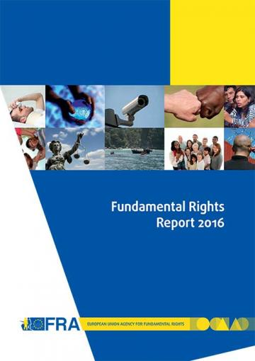 | Fundamental Rights Report 2016  Chapter 8: developments in the implementation of the Convention on the Rights of Persons with Disabilities  May 2016 | Five years on from the EU’s accession to the Convention on the Rights of Persons with Disabilities (CRPD), for the first time in 2015 a United Nations (UN) treaty body, the Committee on the Rights of Persons with Disabilities (CRPD Committee), reviewed the EU’s fulfilment of its human rights obligations. In its concluding observations, the CRPD Committee created a blueprint for the additional steps required for the EU to meet its obligations under the convention. At national level, the CRPD is driving wide-ranging change processes as Member States seek to harmonise their legal frameworks with the convention’s standards. | en  (summary en – fr)
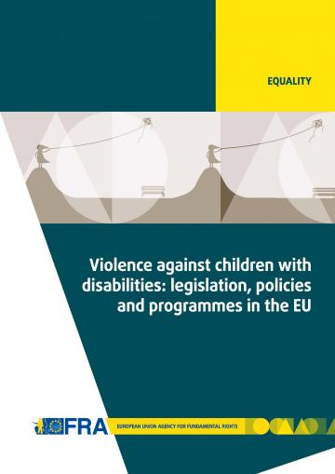 | Violence against children with disabilities: legislation, policies and programmes in the EU  December 2015 | The report outlines relevant international and European standards and reviews national legislation and policies addressing violence against children with disabilities. The report also explores the extent and different causes, settings and forms of such violence, and presents measures and initiatives to prevent it. | en
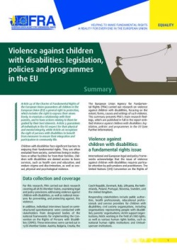 | Summary report:  Violence against children with disabilities: legislation, policies and programmes in the EU  December 2015 | This summary report presents the main research findings identified in the FRA report on Violence against children with disabilities: legislation, policies and programmes in the EU. The report gives a short summary of the key findings and outlines 10 key areas where policymakers and relevant stakeholders should concentrate their efforts to fight violence against children with disabilities, and to effectively protect them from abuse and exclusion across the EU. | bg - cs - da - de - en - fr - hr - it - lt - nl - pl - pt - sl - sv  (et - el - es - lv - hu - ro - sk - fi)
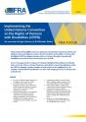 | Implementing the UN CRPD: An overview of legal reforms in EU Member States  May 2015 | The Focus paper outlines how Member States across the EU have reformed their laws and policies to meet their obligations under the CRPD. By bringing together examples of such reforms, it also highlights how the adoption of international commitments can drive wide-ranging processes of change at the national level. | en
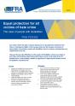 | Equal protection for all victims of hate crime - The case of people with disabilities  March 2015 | The paper discusses the difficulties faced by people with disabilities who become victims of hate crime, and the different legal frameworks in place to protect such victims in the EU’s Member States. It ends by listing a number of suggestions for improving the situation at both the legislative and policy levels. | en
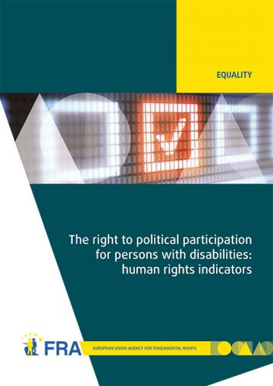 | The right to political participation for persons with disabilities: human rights indicators  May 2014 | The opportunity to be involved in political life, whether by standing for elected office, joining a political party, or following political news stories in the media, is at the heart of what it means to live in a democratic society. The report analyses data on the situation of political participation of persons with disabilities collected from across the 28 EU Member States by the FRA and the European Commission-funded Academic Network of European Disability Experts (ANED).  Data visualisation of the 28 human rights indicators is also available online. | en
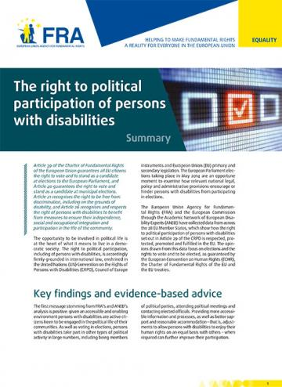 | Summary report:  The right to political participation of persons with disabilities  May 2014 | The human rights indicators presented in the report show that legal and administrative barriers, inaccessible processes and information, and a lack of awareness about political rights can deny persons with disabilities the opportunity to participate in the political lives of their communities. | bg - cs - da - de - en - et - el - es - fr - hr- it - lv - lt - hu - nl - pl - pt - ro - sk - sl - fi - sv
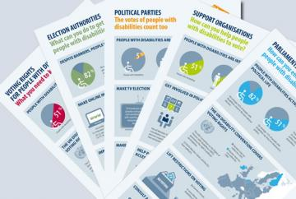 | Infographics on voting rights of people with disabilities  September 2014 | FRA has developed a family of five infographics to help raise awareness of the voting rights of people with disabilities. Each infographic targets a different audience and draws on FRA research into the right to political participation of people with disabilities. | bg - cs - da - de – en - et - el - es - fr - hr- it - lv - lt - hu - nl - pl - pt - ro - sk - sl - fi - sv
 | Legal capacity of persons with intellectual disabilities and persons with mental health problems  July 2013 | Equal recognition of persons before the law is a long-established human rights principle. Nevertheless, legal frameworks in many European Union (EU) Member States allow for the legal capacity of persons with intellectual disabilities and persons with mental health problems to be restricted or removed under certain conditions.  This report analyses the current legal standards on legal capacity across the EU, set against the backdrop of the experiences of interviewees who have had their legal capacity removed or restricted. The FRA report reveals the gap between the promise of the CRPD and the reality those with disabilities face in the EU every day, and, by so doing, hopes to contribute to closing it. | en - de - fr
 | Factsheet:  Legal capacity of persons with intellectual disabilities and persons with mental health problems  October 2013 | This factsheet presents the key challenges identified by the FRA report on Legal capacity of persons with intellectual disabilities and persons with mental health problems.  The entry into force of the CRPD has prompted discussions about the current legal frameworks governing legal capacity in the EU Member States, aiming at developing models based on supported decision making which promote the independence and autonomy of persons with disabilities. | bg - cs - da - de - en - et - el - es - fr - hr- it - lv - lt - hu - nl - pl - pt - ro - sk - sl - fi - sv
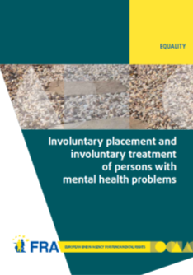 | Involuntary placement and involuntary treatment of persons with mental health problems  June 2012 | Involuntary placement and involuntary treatment of persons with mental health problems affects the most fundamental of rights, including the right to liberty and the right to freedom from torture. Strict safeguards at United Nations and European level attempt to limit undue interference with such rights.  This report analyses the shifting legal panorama and, informed by fieldwork in nine EU Member States on the actual experiences of those involuntarily placed and treated and other stakeholders, points to the need for a renewed discussion of compulsory placement and treatment in the EU. | en - de - fr
 | Factsheet:  Involuntary placement and involuntary treatment of persons with mental health problems  June 2012 | This factsheet presents the key challenges identified by the FRA report on Involuntary placement and involuntary treatment of persons with mental health problems. Mental health problems are experienced by about one in 10 European Union (EU) citizens. Many seek help voluntarily, but some may be placed in institutions or treated without their consent. This might affect their fundamental rights. | en - bg - da - de - el - fr - hu - lv - ro - sv
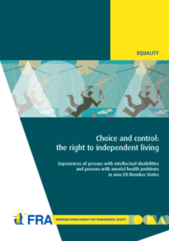 | Choice and control: the right to independent living  June 2012 | Article 19 of the United Nations Convention on the Rights of Persons with Disabilities establishes the right to live independently and be included in the community. Drawing on the findings of interview-based research with persons with mental health problems and persons with intellectual disabilities, this report examines how they experience the principles of autonomy, inclusion and participation in their day-to-day lives. | en - fr - de
 | Summary report: Choice and control: the right to independent living  June 2012 | This summary report presents the key findings identified in the FRA report on Choice and control: the right to independent living. The results show that although much has been done, more efforts are needed to ensure that persons with mental health problems and persons with intellectual disabilities have more choice and control over their lives and are included in the community on an equal basis with others. | en - da - el
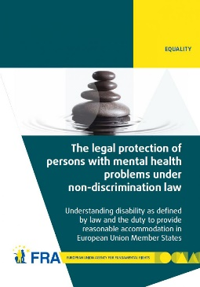 | The legal protection of persons with mental health problems under non-discrimination law  October 2011 | The report examines how disability is defined in international and European law and then explores the obligation to provide reasonable accommodation as contained in international and European standards. The report's findings show that in almost all EU Member States non-discrimination legislation does indeed protect persons with mental health problems. In most cases persons with mental health problems also benefit from reasonable accommodation measures, or other protection measures, in the employment context. | en - de - fr - da
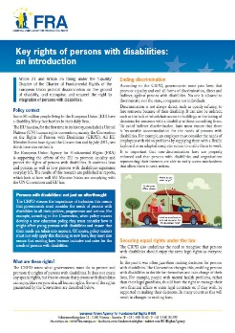 | Factsheet:  Key rights of persons with disabilities: an introduction  August 2011 | This factsheet describes some of the existing rights of people with disabilities, as set out under the UN Convention on the Rights of Persons with Disabilities (CRPD). The factsheet focuses in particular on ending discrimination, equal recognition by law, access to justice, the prevention of inhumane treatment, independent living and the right to political participation. | en - bg - de - el - fr - hu - lv - ro - sv
 | The right to political participation of persons with mental health problems and persons with intellectual disabilities  November 2010 | This report first recalls the international and European standards favouring the full participation of persons with intellectual disabilities and persons with mental health problems in the electoral process. The comparative law analysis then highlights the diverse approaches adopted in the EU Member States. In a majority of these, persons who have lost their legal capacity are automatically deprived of their right to political participation. | en  de - fr  non-verified language versions:  bg - cs - da - et - el - es - ga - hr- it - lv - lt - hu - mt - nl - pl - pt - ro - sk - sl - fi - sv
 | EASY READ  Violence against children with disabilities  December 2015 | This summary in easy read format looks at violence, where it happens, and why people are violent. It also looks at laws to protect children with disabilities from violence and what countries are doing to prevent this violence. | en
 | EASY READ  Laws about being able to make important decisions for yourself  October 2013 | This summary in easy read format provides information about FRA’s work on the right to equal recognition before the law. | en - de - fr
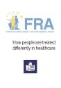 | EASY READ  How people are treated differently in healthcare  March 2013 | This summary in east read format provides information about FRA’s work on how people might be treated differently in healthcare and on multiple discrimination in healthcare. | en
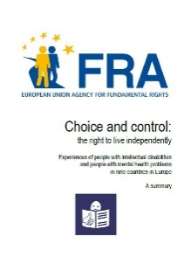 | EASY READ  Choice and control: the right to live independently - Experiences of people with intellectual disabilities  June 2012 | This summary in easy read format provides information about FRA’s work on the right to live independently. | en
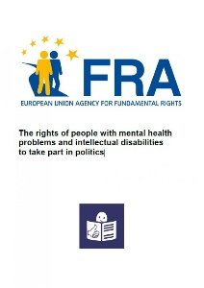 | EASY READ  The rights of people with mental health problems and intellectual disabilities to take part in politics  November 2010 | This summary in easy read format provides information about FRA’s work on the right to vote of persons with intellectual disabilities. | en

To order any of these publications visit:

https://bookshop.europa.eu/

See also the Report on the implementation of the UN Convention on the rights of persons with disabilities by the European Union.
‘The legal protection of persons with mental health problems under non-discrimination law – Understanding disability as defined by law and the duty to provide reasonable accommodation in European Union Member States’, FRA (2011), p. 29.
Ibid., p. 30.
Ibid., p. 25.
Portugal, Decree Law 131/2013 as the second amendment to the Decree-Law 290/2009, of 12 October, modified by Law 24/2011 of 16 June, extending some funding to public entities targeting at the development of employment and qualifying policies for people with disabilities (Decreto-lei 131/2013 que procede à segunda alteração ao Decreto-Lei n.º 290/2009, de 12 de outubro, alterado pela Lei n.º 24/2011, de 16 de junho, alargando a entidades de natureza pública alguns dos apoios para o desenvolvimento das políticas de emprego e apoio à qualificação das pessoas com deficiência e incapacidade), 11 September 2013.
Spain, Act No. 11/2013, on Measures to Support Entrepreneurs and Foster Economic Growth and Job Creation (Ley 11/2013, de 26 de julio, de medidas de apoyo al emprendedor y de estímulo del crecimiento y de la creación de empleo), BOE No 179, 27 June 2013.
Croatia, Regulation on determining quota for employment of persons with disabilities (OG, 44/14 and 2/15).
More information can be found in ’Implementing the United Nations Convention on the Rights of Persons with Disabilities (CRPD) – An overview of legal reforms in EU Member States’, (FRA) 2015, p. 12f, Fundamental Rights Report, (FRA) 2016, Chapter 2 Equality and non-discrimination, p. 68f, Chapter 8 Developments in the implementation of the Convention on the rights of persons with disabilities, p. 183 ff.
‘Choice and control: the right to independent living – Experiences of persons with intellectual disabilities and persons with mental health problems in nine EU Member States’, p. 28.
Ibid., p. 29.
Bulgaria, National Assembly (2008), National Strategy for the Child (2008-2018) (Национална стратегия за детето (2008-2018)), 12 February 2008.
Germany, Federal Ministry for Families, Senior Citizens, Women and Youth (Bundesministerium für Familie, Senioren, Frauen und Jugend, BMFSFJ) (2011).
Violence against children with disabilities: legislation, policies and programmes in the EU, FRA (2015), Section 2.2.
‘Fundamental Rights Report 2016’, FRA (2016), p. 175.
For more information see http://ec.europa.eu/eurostat/web/health/disability/data/database?p_p_id=NavTreeportletprod_WAR_NavTreeportletprod_INSTANCE_6WvWrQmmNi1v&p_p_lifecycle=0&p_p_state=normal&p_p_mode=view&p_p_col_id=column-2&p_p_col_count=1.
See in particular, section on prevalence of violence among women with disabilities or health problems, p. 186.

