INPUT FOR SR DISABILITY REPORT ON DISABILITY-
INCLUSIVE INTERNATIONAL COOPERATION*
From: DCDD (Dutch Coalition on Disability and Development)
To: Special Rapporteur on the rights of persons with disabilities (OHCHR)
* Given answers are based on the report commissioned by DCDD, called ‘An Untapped Potential’ (2019).
This document investigates disability inclusiveness in the Dutch development sector, including measures
taken by the Ministry of Foreign Affairs since The Netherlands ratified the UN CRPD. The full report can be consulted online:
https://www.dcdd.nl/wp-content/uploads/2019/11/An-Untapped-Potential.pdf
DCDD Input
(1) Please describe how your country’s international cooperation efforts, including international development aid, are inclusive of and accessible to persons with disabilities; and how is funding tracked and reported.
Analysis shows that there is a growing awareness within the Dutch government about the importance of disability inclusion in the development space, but attempts to explicitly address Article 32 of CRPD remain either absent or lacklustre. According to the Netherlands Institute for Human Rights, development programmes supported by the Dutch government structurally fail to take into account the rights of people with disabilities. Programmes in which disability is either mainstreamed or through which specific support is provided to people with disabilities, are estimated to represent less than 2% of the total Dutch Official Development Assistance (ODA) budget.
To put differently: 98% of the ODA budget seems to be allocated to programs that are likely to have a negative impact on equal opportunities for people with disabilities. Because there is no specific attention to disability mainstreaming in these programs, they might unintentionally maintain existing barriers or create new ones. Think of inaccessible information campaigns, construction of physical infrastructure and design of digital infrastructure without using the international accessibility guidelines, etc. The Ministry has important instruments in areas such as food security, education, employment, trade, water and sanitation, sexual and reproductive health, psychosocial support and emergency aid, in which people with disabilities could participate, provided that sufficient attention would be paid to mainstreaming disability.
Although reporting is considered important by the Dutch Ministry of Foreign Affairs, the use of standards and markers is very limited. The Netherlands is not using the OECD DAC Disability Marker; nor does it promote the use of the Washington Group Questions among its partners. While for various of its funding mechanisms partners are requested to report on questions related to ‘gender and inclusion’, in none of its reporting formats are there questions specifically focussed on disability inclusion or people with disabilities. Until now, there are no intentions expressed or commitments made by the Dutch Ministry of Foreign Affairs to include disability as part of reporting requirements, and coherent approaches to intersectionality are missing.

The most notable steps that the Ministry of Foreign Affairs has taken, since it ratified the CRPD, are:
- The establishment of the Voice Global Fund 2016-2024, through which projects of people with disabilities (and 4 other marginalized groups) are supported. Via this fund, approximately 1.5 million Euro per year goes to grassroots projects of people with disabilities. This is the only funding mechanism which has ‘people with disabilities’ as an explicit target group.
- The Accountability Fund (managed by the Dutch diplomatic missions, specifically designed for local CSOs), seems to be increasingly used by embassies to support disability projects.
- The Ministry has committed to the implementation of the IASC Guidelines on Inclusion of Persons with Disabilities in Humanitarian Action (following its endorsement of the Disability Charter in 2016). It started a dialogue with its Dutch humanitarian partners (the Dutch Relief Alliance) on the necessary steps to implement these guidelines, such as capacity building. However, it has not yet put a particular monitoring mechanism in place to assess the disability inclusiveness of its humanitarian aid spending.
- A study was recently commissioned by the Ministry regarding youth with disabilities and their transition from education to employment. It is not yet clear how the outcomes of this study will be translated into programmes and monitoring.
While the attention for disability inclusion is slowly increasing in some areas of development policy and humanitarian aid; such attention is still entirely absent in the Ministry’s international human rights policies and programmes as well as its trade policies (incl. international corporate social responsibility efforts). The inability of the Ministry of Foreign Affairs to successfully integrate and implement disability inclusion policies may be attributed to a lack of capacity. There is merely one focal person for CRPD appointed within the Ministry of Foreign Affairs; and even for this person, disability inclusion is not the core task of this position and remains an addition to other core activities in the field of development cooperation.
Several members of the House of representatives of the Dutch Parliament posed questions to the Minister on the inclusion of people with a disability within the Dutch trade and aid agenda, and filed several motions. The Minister of Foreign Trade & Development Cooperation delivered on her commitment to give insights on this matter through the letter “Nederlandse internationale inzet voor mensen met een beperking” to the House of representatives of the Dutch Parliament. The overview given in Figure 1 summarizes the programmes mentioned in that letter. The letter states that the overview the ministry provides is not exhaustive.
Figure 1. Overview of International Disability Programmes Supported by The Dutch Government.
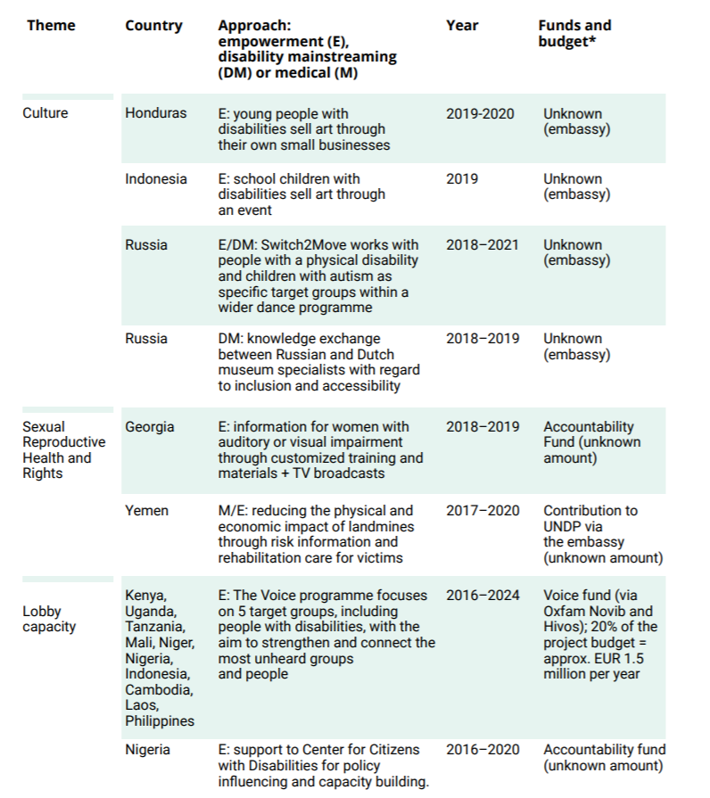
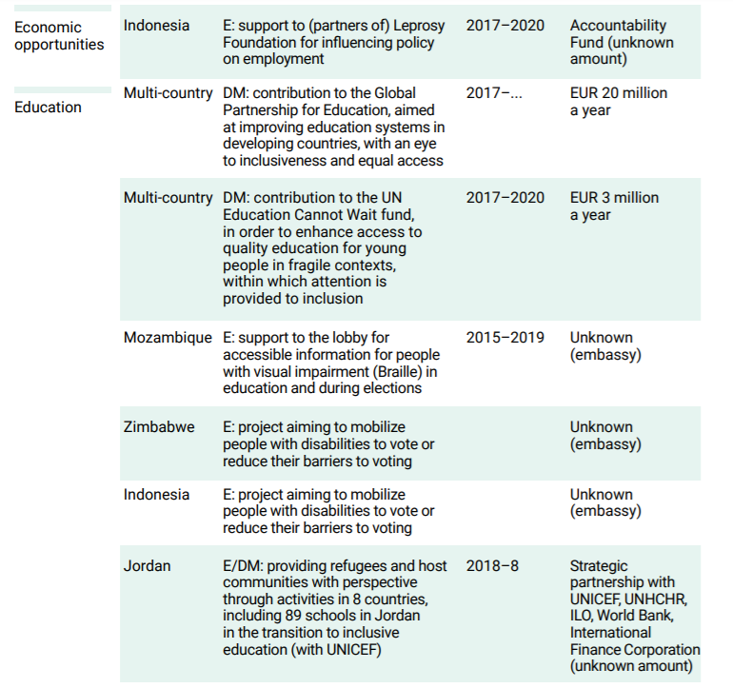
(2) Please describe how South-South and triangular cooperation support your country’s efforts to implement the rights of persons with disabilities, including by facilitating the exchange of innovative knowledge, skills and successful initiatives.
The Dutch government’s involvement in or support of international exchange to promote disability inclusion seems to be very limited. While, the Netherlands is part of the GLAD Network, it does not participate in the network actively. It is mostly Dutch CSOs (NGOs with a disability focus) that are taking the lead in facilitating South-South and triangular cooperation to enhance disability inclusion.
It is worth mentioning, however, that the Voice Global Fund (established by the Ministry of Foreign Affairs, 2016-2024) supports South-South learning as part of its funding mechanism. One example is the ‘Voices for Inclusion’ project. This project centralizes learning between different types of marginalized groups in 5 countries (Sierra Leone, Rwanda, Nigeria, Indonesia and Philippines) and explores whether collaboration between these groups generates more effective influencing of policy and practices.
(3) Please describe how your country coordinates, prioritizes and manages aid received from international cooperation in order to ensure that national development programmes are inclusive of and accessible to persons with disabilities.
/ Not relevant for the Netherlands.
(4) Please explain whether the Sustainable Development Goals resulted in increased international development aid benefitting persons with disabilities in your country and how.
The ratification of the CRPD (in 2016) followed the endorsement of the SDGs with its principle of ‘leave no one behind’ (in 2015); which makes that the two frameworks seem to mutually reinforce each other. Both are used by DCDD simultaneously to advocate for more disability inclusive international policies. There is growing awareness about the importance of disability inclusion and the often marginalized position of people with disabilities. This awareness is expressed in the policy note ‘Investing in Global prospects’ by the Dutch Ministry for Foreign Trade and Development Cooperation. In this note three explicit references are made to ‘leave no one behind’ as a guiding principle in the Dutch international development agenda.
The same policy note makes two references to people with disabilities. In relation to CSOs, the policy note mentions people with disabilities as one of the marginalized groups that require specific support. In relation to humanitarian interventions, people with disabilities are mentioned as an important target group requiring structural attention. Furthermore, Minister Kaag, in collaboration with the World Health Organization (WHO), has expressed the wish to pay more attention to psychosocial and mental health support for people experiencing trauma during emergencies. All these references and intentions to bring disability inclusion forward are a positive and welcomed step.

However, while ‘leave no one behind’ is often referenced by the Ministry of Foreign Affairs, any explicit reference to the CRPD itself and its relevance for the Netherlands remains absent, both in the development policy note and in the letter sent to the House of Representatives of the Dutch Parliament. Moreover, as mentioned above, these policy intentions have so far hardly been mainstreamed or translated into concrete action, so the actual benefit to people with disabilities in countries where the Dutch government provides development support remains lacklustre. And finally, the annual Dutch SDG progress reports (voluntary reviews) do not monitor on disability inclusion indicators. All of this seems to be in contrast with the stated ambition of the Dutch government to support people who are left behind.
(5) Please describe to what extent and how are persons with disabilities and their organizations involved and consulted in decisions related to international cooperation in your country, and how they can access international cooperation funds and grants (including legal requirements, procedures and challenges).
Whereas the Dutch Coalition on Disability and Development (DCDD) consists of organizations and individuals with specific expertise on disability inclusion, the coalition is only consulted twice a year by the Ministry of Foreign Affairs, and sometimes there is contact on ad hoc basis. These consultations focus on an exchange of information, experiences and ‘good practices’. DCDD or any other disability representatives are not involved by the Ministry (nor its embassies) in actual decision-making, programme development / assessment or policy development. Moreover, the Ministry of Foreign Affairs employs very few civil servants with a disability, either in The Hague or at its embassies – if they do exist, they do not play an active role in disability-related policy discussions.

For most Dutch disability organisations, which are relatively smaller in size and budget than many other Dutch NGOs, it is challenging to access the funding mechanisms of the Ministry of Foreign Affairs, as they cannot compete with the larger NGOs, or cannot handle the required minimum budget, and (due to limited awareness about disability inclusion in the sector) are rarely invited to join consortia of larger NGOs. Notable exceptions are the Voice Global Fund and the Accountability Fund, which specifically provide more flexible funding for smaller Southern-based organisations – these funds provide the best access for grassroots disability initiatives in the South (but limited access for Dutch-based disability NGOs).

(6) Please provide any information and statistical data available on disability-inclusive international cooperation in your country, including information related to the challenges and limitations of the international aid system to promote the rights of persons with disabilities.
There is very limited data available, since disability inclusion is not systematically monitored. The best available data can be found in the Untapped Potential Report, as summarized under question 1. The report proposed the following nine recommendations for the Dutch government, to take critical steps to implement the CRPD and Article 32 through its international cooperation programmes and policies:
1. Develop and disseminate a government memo on the implementation of CRPD article 32
2. Adopt the OECD DAC disability marker to track progress on disability inclusion
3. Facilitate empowerment (specific support) and inclusion (mainstreaming) simultaneously
4. Embed programmes in the local context
5. Enhance government capacity (human resources, knowledge and funding) on disability inclusion
6. Adopt an intersectional lens to address the multiple layers of exclusion
7. Become internationally engaged to learn and cooperate on disability inclusion globally
8. Realise the economic gains of disability inclusion
9. Start doing the work!
While these recommendations provide guidance on how to make headway on implementing Article 32, it is crucial to state that as long as people with disabilities are stigmatized and seen as incapable and people experience discomfort around them, it will remain a challenge to fully implement Article 32. DCDD feels that – even though awareness on disability inclusion started to grow – a lot of work is still needed to change mindsets within the Ministry of Foreign Affairs and the broader Dutch development sector, to increase understanding of disability, before inclusion can be truly embraced.

Contact details:
Lieke Scheewe Kim Brands
Coordinator & Policy Advisor DCDD Junior Lobby & Network Coordinator DCDD
l.scheewe@dcdd.nl k.brands@dcdd.nl

DCDD. (2019): “An Untapped Potential: How disability inclusive is the Dutch development sector? Steps taken since the ratification of UN CRPD”: https://www.dcdd.nl/wp-content/uploads/2019/11/An-Untapped-Potential.pdf
“Submission of the Netherlands Institute for Human Rights to the UN CRPD Committee” (2018, p.25): https://mensenrechten.nl/nl/publicatie/38664
This estimate is based on an overview which the Ministry of Foreign Affairs shared in a letter to Parliament in June 2019. The letter (in Dutch) can be found here: https://www.tweedekamer.nl/kamerstukken/brieven_regering/ detail?id=2019Z14004&did=2019D28805. See ‘Figure 1’ for further details on this overview. The Dutch government spends around 4 billion per year on ODA in total. DCDD estimates that 44 million goes to demonstrably disability inclusive and/or target group-oriented development programmes; which is 1% of the total ODA funds. However, as the Minister states in her letter, the overview they provided is not complete, which results in a final estimate of “less than 2%”.
See https://voice.global/
Ministry of Foreign Trade & Development Cooperation. (2019). Kamerbrief over Nederlandse internationale inzet voor mensen met een beperking. Letter from the Ministry of Foreign Affairs to the House of Representatives of the Dutch Parliament. Available at: https://www.rijksoverheid.nl/documenten/kamerstukken/2019/07/02/kamerbrief-over-nederlandse-internationale-inzet-voor- mensen-met-een-beperking . There are only few budget amounts mentioned in the letter. DCDD’s estimate of 44 million per year is made as follows: Via Voice Global Fund, 1.5 million per year goes to projects of people with disabilities. In addition, there are 10 projects through the embassies which do not appear to be large-scale projects, so it is estimated that this amounts to a maximum of 4 million together with Voice. This makes around 2% of the total budget for civil society programmes (210 million). The contribution to Global Partnership for Education is 20 million and to Education Cannot Wait 3 million; together with the other two inclusive multilateral programs mentioned in the letter, this is estimated to amount to a maximum of 40 million a year. That is about 1% of the total ODA budget of 4 billion per year. Total yearly budget of Dutch foreign aid and trade estimated to be more than four billion euros: https://www.rijksoverheid.nl/binaries/rijksoverheid/documenten/begrotingen/2018/09/18/hgis---nota-homogene- groepinternationale-samenwerking-rijksbegroting-2019/HGIS-nota_2019.pdf
https://gladnetwork.net
https://voice.global/grantees/voices-for-inclusion/
Ministry of Foreign Trade & Development Cooperation. (2019). Investing in Global Prospects. Available at: https://www.government.nl/documents/policy-notes/2018/05/18/investing-inglobal-prospects
Ministry of Foreign Trade & Development Cooperation. (2019). Kamerbrief over Nederlandse internationale inzet voor mensen met een beperking. Letter from the Ministry of Foreign Affairs to the House of Representatives of the Dutch Parliament. Available at: https://www. rijksoverheid.nl/documenten/kamerstukken/2019/07/02/kamerbrief-over-nederlandseinternationale-inzet-voor- mensen-met-een-beperking
https://www.dcdd.nl/wp-content/uploads/2019/11/An-Untapped-Potential.pdf

