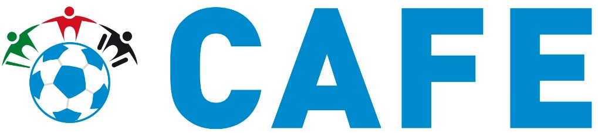

Centre for Access to Football in Europe
The European Football Hub
The Record Hall
16-16A Baldwin’s Gardens
London EC1N 7RJ
United Kingdom
21 July 2020
Dear Madam/Sir,

Subject: Human Rights Council resolution 43/L.34

In response to the letter concerning contributions and remarks to the OHCHR’s study on sports following article 30 of the Convention on Rights of Persons with Disabilities (CRPD), please find below the response from the Centre for Access to Football in Europe (CAFE). CAFE is a UEFA Football and Social Responsibility partner, providing advice and guidance on accessible and inclusive matchdays for disabled people. Due to CAFE working across Europe and beyond, I have not provided a country-specific response to the question below, but have provided information and examples of initiatives in football to improve opportunities for disabled people to take part and contribute to sports as spectators and employees.
Question
- Are persons with disabilities considered in sports beyond their role as sportspersons, including as referees, coaches, spectators, administrators, workers, volunteers in the sports industry, board members, among others?

UEFA and CAFE are committed to improving the matchday experience for all disabled spectators: https://youtu.be/xSat0y9YBvA.
In 2011, UEFA and CAFE published the Good Practice Guide to Creating an Accessible Stadium and Matchday Experience – Access for All to support UEFA’s 55 national football associations (NA) and their clubs in ensuring disabled spectators are able to enjoy an inclusive and accessible matchday experience alongside their fellow fans. The Guide is based on European accessibility standards (CEN/TR 15913) and applies to both new and existing stadia. It follows the full matchday journey of a disabled fan from finding information on a venue or club, designing quality accessible viewing areas, to ensuring emergency evacuation procedures include disabled spectators and VIP guests. Whilst the CEN/TR 15913 has been ratified by all EU members, the number of stadia that meet these standards is very low. Often, this is due to limited local building standards and regulations in accessibility, as well as limited understanding if the topic amongst decision makers.
In 2015, UEFA obliged its clubs to appoint a Disability Access Officer to support the provision of inclusive and accessible services and facilities and to collaborate with other club departments on relevant areas. This year, UEFA wrote to all its NAs to encourage the appointment of a National Disability Access Officer Coordinator to support nation-wide strategic improvements for disabled people through football. CAFE sees these two roles as major vehicles for changing the sporting landscape to include disabled people, not only as spectators or players, but also as volunteers, employees and board members.
Accessibility for disabled spectators has been embedded into bidding requirements for hosts of FIFA World Cups, UEFA European Championships and UEFA Club Competition Finals (men and women), including accessible viewing areas with adequate sightlines, audio descriptive commentary, assistive listening devices, accessible sanitary facilities, signage and wayfinding and transport routes to the stadium.
There is currently a huge gap in employment opportunities for disabled people within football and many of the disabled people who are employed are limited to roles in access and inclusion or CSR. In 2016, CAFE research found that only 19% of disabled people thought that clubs and NAs recognise the benefits of having disabled people as employees. 85% of disabled people would like to see disabled people appointed to a senior governance level within football.
CAFE recently published guidance on accessible recruitment and retention of disabled staff and proactively encourages UEFA’s national football associations and clubs to review their own practices in this area.
There is still far to go and CAFE is of the firm belief that until we see more disabled people in decision making roles in sport across the globe, progress in meeting the CRPD will be limited.

Please do not hesitate to contact me, CAFE’s Managing Director, should you wish to discuss this further or if you have any questions.
Yours sincerely,
Joanna Deagle
CAFE Managing Director
M: +44(0)7581 434328
E: joanna@cafefootball.eu
W: www.cafefootball.eu

