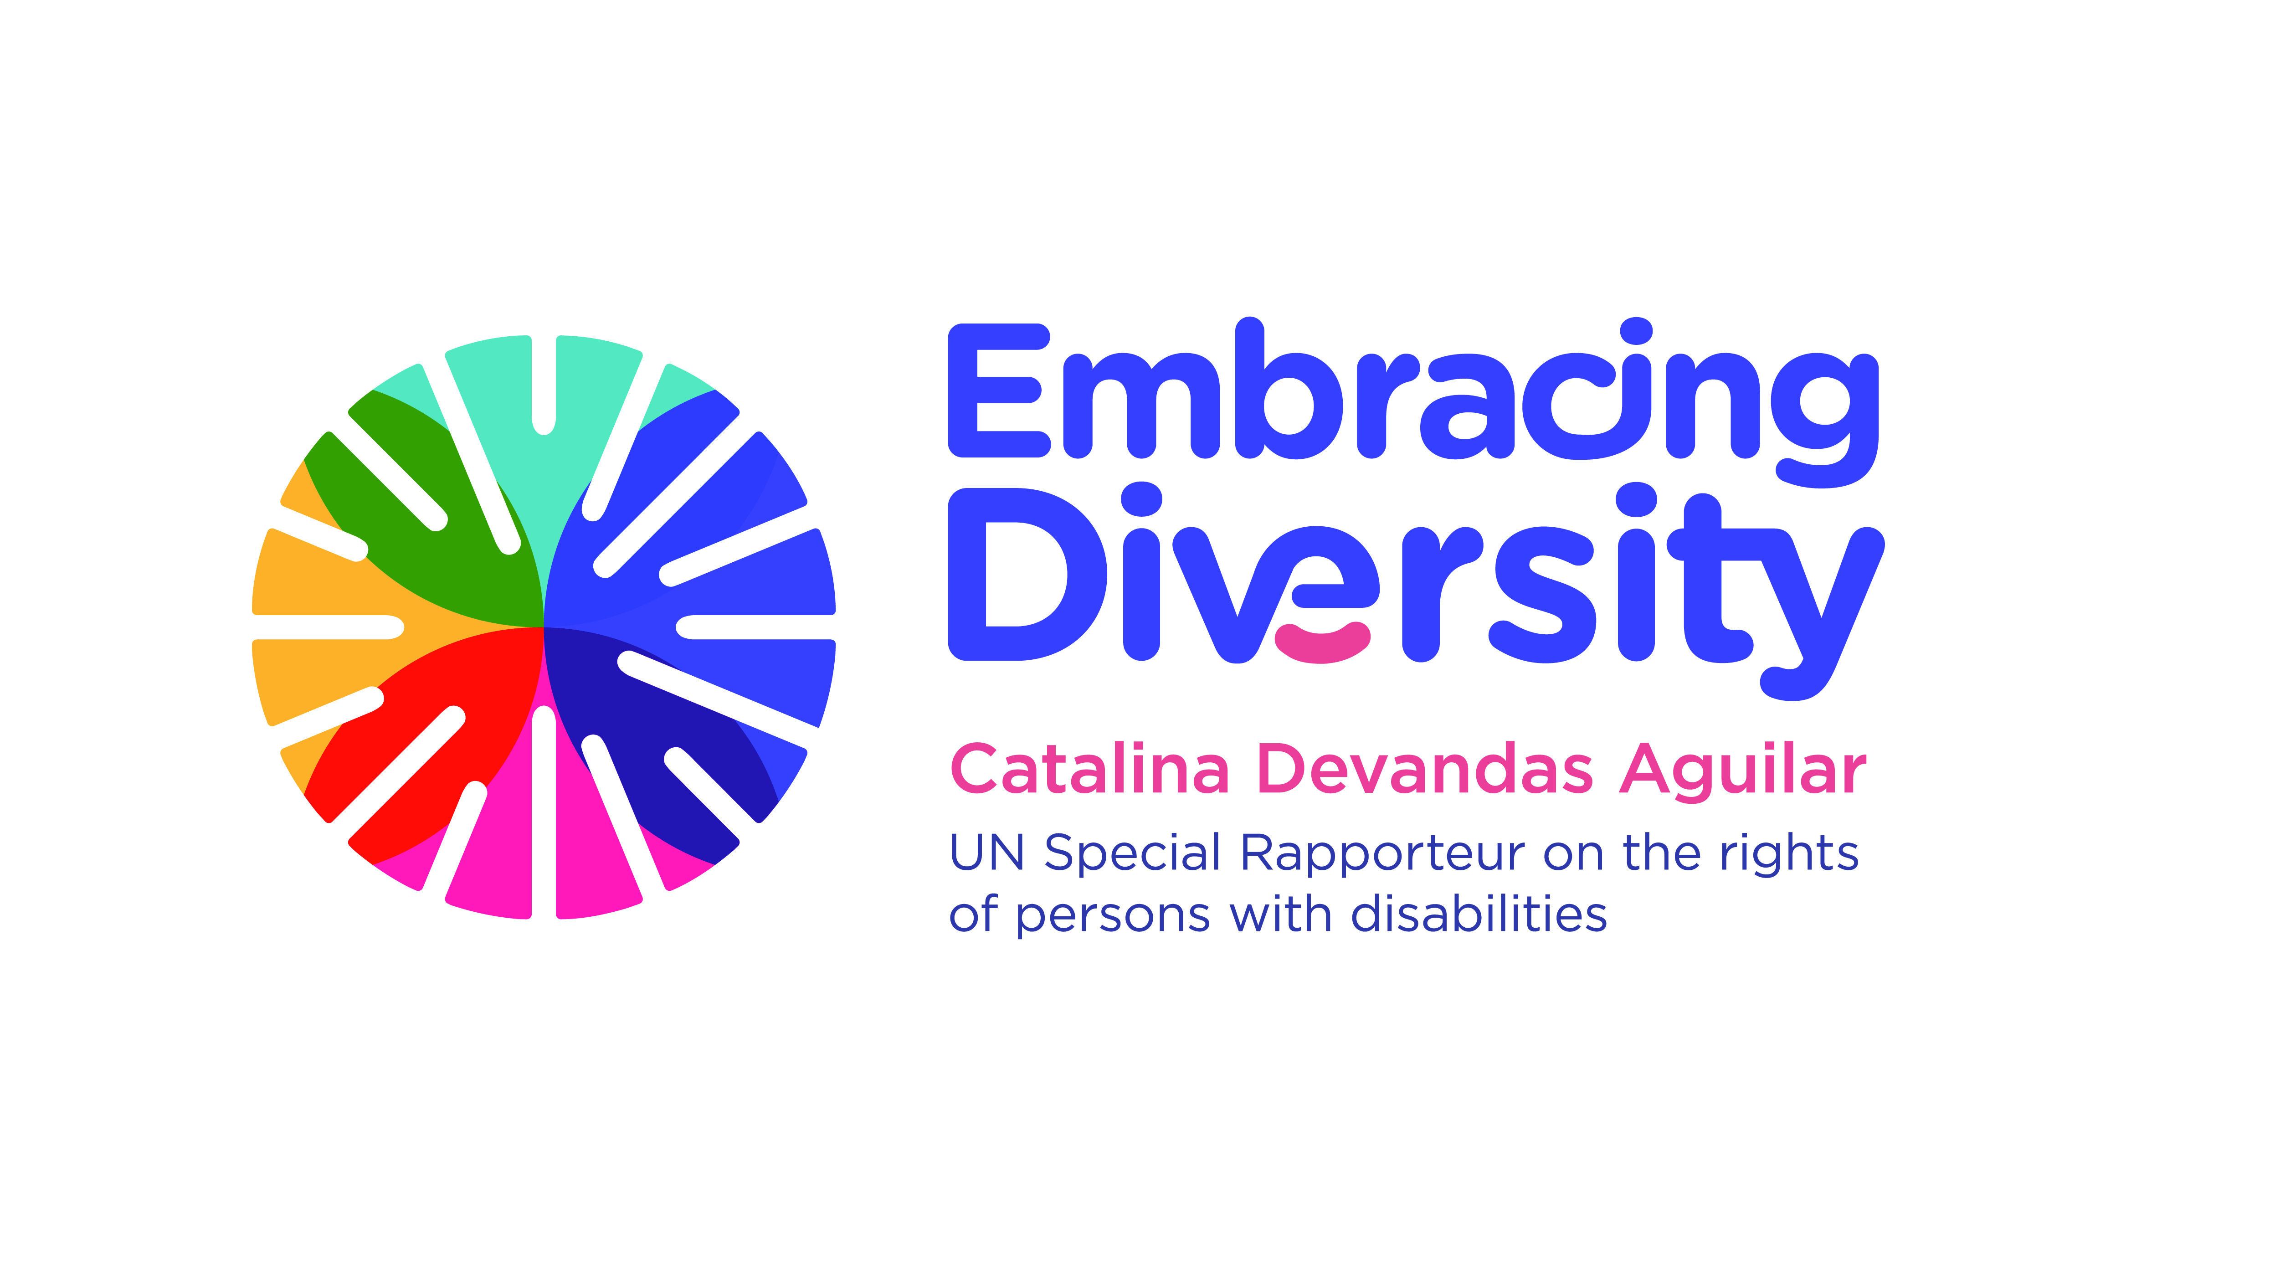english

**Expert Group Meeting**

**Intersections between women’s rights and the rights of persons with disabilities**

**19 March 2019**

UNICEF House, Danny Kaye space

3 UN Plaza, 10017 New York

**Concept Note**

1. **Introduction**

The UN Special Rapporteur on the rights of persons with disabilities, Ms. Catalina Devandas Aguilar is hosting an *Expert Group Meeting on the intersections between women’s rights and the rights of persons with disabilities* on 19 March 2019 at UNICEF House in New York. The meeting will be held at the Danny Kaye space on the ground floor, after you pass security.

Pursuant to Human Rights Council resolution 35/6, the Special Rapporteur is mandated to develop a regular dialogue with civil society and other actors to identify, exchange and promote good practices related to the realization of the rights of persons with disabilities; gather and exchange information and communications with States on alleged human rights violations, and make recommendations on how to promote and protect the rights of persons with disabilities. In this context, she reports annually to the Council and the General Assembly.

In her thematic reports, the Special Rapporteur always underscores the importance of ensuring a gender perspective in her work to promote the rights of persons with disabilities, highlighting that women and girls with disabilities encounter additional barriers that can prevent them from fully enjoying their human rights. In this context, in October 2017, the Special Rapporteur presented a report on *sexual and reproductive health and rights of girls and young women with disabilities* at the General Assembly, containing guidance, good practices and recommendations to States for the implementation of these rights ( A/72/133).

1. **Context**

Gender equality and disability rights are mutually reinforcing.[1] Nevertheless, for too long there has been neither a substantive inclusion of a gender perspective in disability policies,[2] nor of a disability-rights perspective reflected in policies promoting gender equality.[3]

The intersectional approach recognizes that women and girls do not experience discrimination as members of a homogenous group, but rather as individuals with multi-dimensional layers of identities and life circumstances. These include: age; disability; sex; sexual orientation or gender identity; ethnic, indigenous, national or social origin; race; political or other opinion; religion; refugee, migrant or asylum status; and poverty. The diversity of women and girls with disabilities also includes all types of impairments (including physical, psychosocial, intellectual or sensory conditions), women and girls with multiple disabilities and those with high level support needs.

The *Convention on the Elimination of All Forms of Discrimination against Women* (CEDAW), while not containing a specific provision on intersectional identities, establishes a comprehensive obligation to eliminate discrimination against women in all its forms, including multiple and intersectional discrimination. In this context, over the years the CEDAW Committee has issued several recommendations regarding the rights of women and girls with disabilities.

The *Convention on the Rights of Persons with Disabilitie*s (CRPD) addresses the rights of women with disabilities in a cross-cutting manner, adopting a twin-track approach. On one hand, it includes a specific article on women with disabilities (art. 6); on the other, it refers to them in the general principles and other substantive articles (arts. 3, 4, 8, 13, 16, 18, 23, 25 and 30). Article 6 of the CRPD recognizes that women with disabilities are subject to multiple discrimination and requires States to adopt measures to ensure their equal enjoyment of rights, as well as their advancement and empowerment. The CRPD Committee has consistently issued recommendations regarding women and girls with disabilities.

Women with disabilities are usually denied their right to legal capacity.[4] Their right to make autonomous decisions, to maintain control over their sexual and reproductive health, to found a family, to choose where and with whom to live, to integrity, to property and to control their own financial affairs are often violated through patriarchal systems of substituted decision-making.[5]

Women and girls with disabilities are disproportionately affected by different forms of gender-based violence,[6] including physical, sexual, psychological and economic violence; trafficking; abandonment and neglect; the removal or control of communication aids and the refusal to assist in communicating; the denial of personal mobility and accessibility; the refusal by caregivers to assist with daily activities; bullying; arbitrary deprivation of liberty; institutionalization;[7] and the exercise of control over them.[8] Furthermore, women and girls with disabilities are exposed to harmful practices, including forced sterilization,[9] forced abortion and forced contraception, which can constitute torture or cruel, inhuman or degrading treatment.[10]

Women and girls with disabilities also encounter challenges for accessing to justice, prevention mechanisms and response services for sexual and gender-based violence. They face barriers when reporting abuses, such as the lack of accessibility and procedural accommodations, the risk of being removed from their homes and institutionalized; stigmatization; fears with regard to single parenthood or losing child custody; the inaccessibility of violence prevention programmes; the fear of the loss of assistive devices, and the fear of further violence by those on whom they are dependent.[11] Moreover, their testimony, especially that of women with intellectual disabilities, is generally not considered credible, and they are therefore disregarded as competent witnesses.[12]

In addition, women and girls with disabilities usually have no control over their bodies, facing barriers to exercising their sexual and reproductive rights, including laws that restrict access to reproductive health goods and services without parental or spousal notice or authorization; lack access to skilled attendance during birth or emergency obstetric care; health professional refusal based on stereotypes to provide abortion or contraceptive services; criminal bans on abortion.

Women and girls with disabilities also face the absence of physical accessibility related to buildings and equipment;[13] the lack of information about sexual and reproductive health, which is frequently not provided in accessible formats;[14] communication barriers; relatives and caregivers acting as gatekeepers to information and services; the lack of accessible transportation; the affordability of services; and the isolation in institutions, camps, family homes or group homes. As a result, they are denied the essential information required to protect themselves from sexual abuse, unwanted pregnancy, and sexually transmitted infections, and to make informed decisions.

Since the adoption of the CRPD, there is a growing interest from States, experts and civil society to give more visibility and responses to the rights of women and girls with disabilities. The CRPD has also generated closer collaboration between women's rights and disability rights’ advocates. The women rights movement is paying more attention to the cumulative disadvantage experienced by women and girls with disabilities, and women with disabilities are increasingly participating in mainstream gender discussions. Communication and collaboration between UN human rights mechanisms, including the CEDAW and CRPD Committees, is increasing. This process has highlighted issues where a common ground still needs to be found to avoid undermining the overall human rights agenda, as it is in the case of abortion based on impairment.

Indeed, the CRPD Committee and the CEDAW Committee have taken important steps towards building a collaborative dialogue between the disability and the women's rights movements on the issue of abortion. In the framework of a discussion about whether a prenatal diagnosis of a disability should be considered as a justification for abortion in law, they have issued a joint statement declaring that States parties should decriminalize abortion in all circumstances and legalize it in a manner that fully respects the autonomy of women, including women with disabilities.[15] They also indicated that health policies and abortion laws that perpetuate deep-rooted stereotypes and stigma undermine women’s reproductive autonomy and choice, and thus should be repealed because they are discriminatory.[16]

In this regard, the Expert Group Meeting aims to build on these efforts to consolidate a shared agenda for addressing key concerns of the disability and the women´s rights movements, and to identify areas in which a greater disability or gender perspective is needed in order to ensure an adequate response for all parties. This requires exploring new ways of partnership, collaboration and coordination between the two movements.

Advancing the rights of women and girls with disabilities is an indispensable condition to achieve gender equality and to fulfill the promise of leaving no one behind of the 2030 Agenda for Sustainable Development. States, civil society and international organizations need to adequately respond to the gender and disability intersectionalities to effectively mainstream a gender perspective in disability policies and a disability-rights perspective in policies promoting women's equality. Tackling deep-rooted inequalities around gender and disability will benefit not only women and girls historically marginalized, but society as a whole.

**III. Objective and expected outcomes**

The main objective of the meeting is to promote dialogue between the disability and women’s rights communities and to discuss the intersections and areas where potential tensions between the rights of women and the rights of persons with disabilities could emerge.

The specific objectives of the expert meeting are:

1. Discuss the particular human rights violations experienced by women with disabilities, especially in the area of sexual and reproductive health and rights;
2. Identify challenges and share good practices to promote the inclusion of women’s rights considerations in the disability rights agenda;
3. Identify challenges and share good practices to promote the inclusion of a disability-rights perspective in the women’s rights agenda;
4. Analyze how to promote the highest recognition of the human rights of women and of persons with disabilities in discussions related to care and support, prenatal screening, and abortion.

**IV. Methodology and participants**

The Expert Group Meeting will be held on 19 March 2019 at UNICEF Headquarters. It will bring together approximately 25-30 experts on disability and/or women's rights from the UN human rights mechanisms, UN entities, organizations of persons with disabilities, women’s rights organizations and academia, with experience in the above-mentioned areas.

The meeting will be organized into four sessions, with a facilitator moderating the discussions for each session, based on pre-identified questions. Selected experts will be requested to make short presentations (maximum 5 min per speaker) to introduce the key issues under certain thematic areas.

In preparation for the meeting, we encourage experts to reflect upon the intersections and areas where potential tensions between the rights of women and the rights of persons with disabilities could emerge, as well as to identify good practices, examples, and lessons based on their expertise and practical experience.

The language of the meeting will be English (no interpretation into other UN languages is provided). International sign language interpretation and English captioning will be provided throughout the meeting.

1. Joint statement by the Committee on the Rights of Persons with Disabilities and the Committee on the Elimination of All Forms of Discrimination against Women, Guaranteeing sexual and reproductive health and rights for all women, in particular women with disabilities (2018), p. 1.
2. See, for example, CRPD/C/SWE/CO/1, para. 13, and CRPD/C/KOR/CO/1, para. 13.
3. See, for example, CRPD/C/AZE/CO/1, para. 16, and CRPD/C/ESP/CO/1, para. 21.
4. See, for example, CRPD/C/ARG/CO/1, para. 31.
5. CRPD Committee, general comment No. 3 (2016), para. 51.
6. See, for example, CRPD/C/SLV/CO/1, para. 37; CRPD/C/CZE/CO/1, para. 34; CRPD/C/AUS/CO/1, para. 16, and CRPD/C/CHN/CO/1 and Corr.1, paras. 57, 65 and 90. See also, A/67/227, para. 13.
7. See, for example, CRPD/C/HRV/CO/1, para. 23, and CRPD/C/SVK/CO/1, para. 55.
8. A/HRC/20/5, paras. 12-27.
9. See, for example, CRPD/C/MUS/CO/1, para. 29, CRPD/C/NZL/CO/1, para. 37, CRPD/C/MEX/CO/1, para.37.
10. A/HRC/32/ 32, para. 86.
11. See A/67/227, para. 59; A/72/133, para. 36.
12. A/72/133, para. 37.
13. See CRPD/C/PRY/CO/1 (2013) para. 59; CCPR/C/SLV/CO/6 (2010) para. 51.
14. Committee on the Rights of Persons with Disabilities, general comment No. 3 (2016), para. 40.
15. Joint statement by the Committee on the Rights of Persons with Disabilities and the Committee on the Elimination of All Forms of Discrimination against Women (CEDAW), Guaranteeing sexual and reproductive health and rights for all women, in particular women with disabilities (2018), p. 2. Available at: <https://www.ohchr.org/EN/HRBodies/CRPD/Pages/CRPDStatements.aspx>
16. Ibid.