UNIVERSITY OF YORK
Social Policy Research Unit

EVIDENCE FOR THE VISIT BY THE UN SPECIAL RAPPORTEUR ON EXTREME POVERTY TO THE UNITED KINGDOM

AUSTERITY AND CHILD OUTCOMES

Professor Jonathan Bradshaw CBE, FBA

AUSTERITY
In 2007 before the crisis public expenditure was 35.2% of GDP. There had been substantial investment in health, education and childcare. Unemployment was 5.3%, child and pensioner poverty rates were falling. The economy was growing steadily and living standards improving.

Then came the crisis and the Labour Government response was admirably anti cyclical. The uprating of benefits was maintained and brought forward; taxes on the better off were increased; public spending was allowed to increase to 40.1% by 2010. Unemployment rose to 7.9% in 2010, but child poverty and pensioner poverty continued to fall. Indeed the Child Poverty Act was put on the statute book with targets and monitoring in 2010.

Then there was the 2010 election and thanks partly to smart packaging of lies about Labour Government profligacy with the public finances, the coalition government was formed and immediately introduced a raft of so-called austerity measures. They were sold to us on the need to cut the deficit but the actual motive was to reduce public spending to the level of Japan and the US by 2020 to wrench our welfare state away from the European norm – from 40% of GDP on public spending to 34% or less by 2020 (see Figure 1).

Figure 1
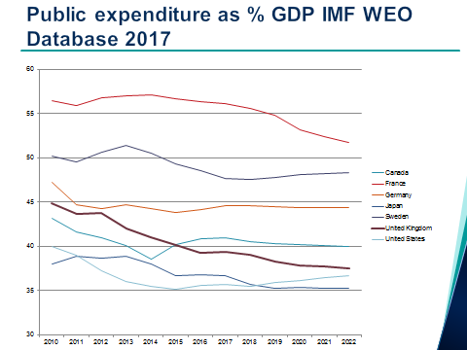

The coalition chose to reduce the deficit by taking 80% in spending and 20% in tax increases. In the event most of it has come in benefit cuts because they kept on making regressive cuts in direct taxes. Some benefits were abolished, working age benefits were uprated by less than inflation, then frozen. The Child poverty Act was abandoned (but now admirably rescued and strengthened in Scotland). Iain Duncan Smith even tried to abolish the notion of poverty. Limits to housing benefit were imposed including the bedroom tax. Public sector pay was frozen. Huge cuts were made in services particularly local government services. Having won the 2015 election George Osborn announced a whole new extra raft of cuts including emasculating universal credit, lowering the benefit cap and introducing the odious two child limit.

There have been many analyses of the cumulative distributional consequences of these measures - by the IFS, the Resolution Foundation and recently by Reed and Portes for the Human Right Commission, and spatially by Beattie and colleagues in Sheffield. The conclusions are clear: the lowest income deciles have had the biggest losses; the poorest local authorities have suffered the biggest revenue losses; the cuts have hit the incomes of families with children most. Poor lone parents are the biggest losers and rich pensioners have hardly been touched (See Figure 2). The notion that we are all in this together was a cynical lie by Osborn.

Figure 2:
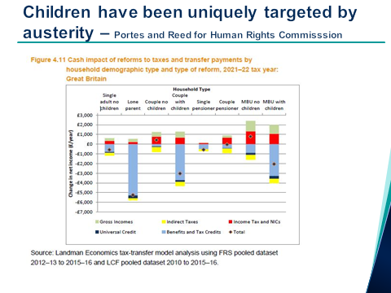
The really depressing thing is that there is more to come. The IFS have shown that 75% of the cuts announced in 2015 are yet to come (See Figure 3). By 2022 £40 billion will have been taken out of social benefits.

Figure 3:
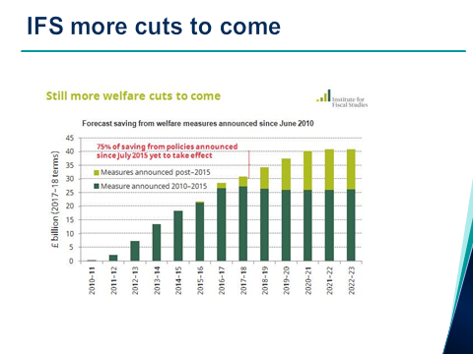
The impact of all this is all about you - in closed libraries and sure start centres, overflowing food banks, closed social care homes, hungry children, neglected old people, homeless people on the streets.. Child poverty is rising (see Figure 4 )and the IFS predict that all the gains made by Labour will be swept away by 2020 (see Figure 5 ). The safety net has been emasculated and child poverty gaps are rising (see Figure 6).

Figure 4:
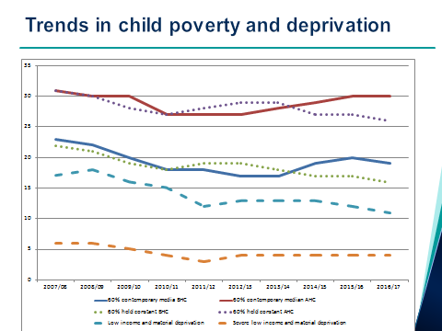

Figure 5:
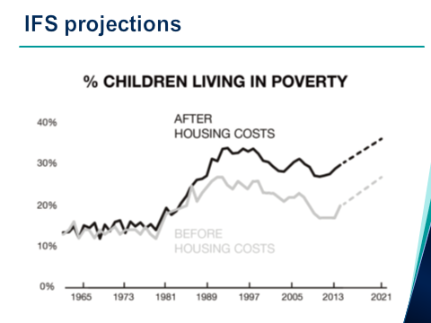
Figure 6:
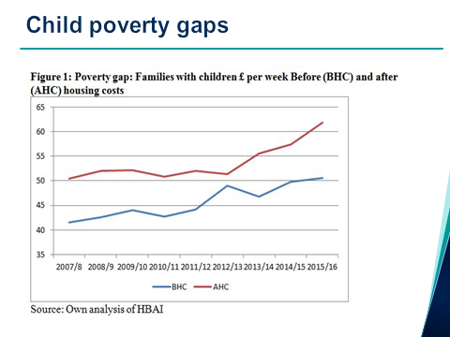

OUTCOMES FOR CHILDREN
The outcomes selected here are those where there is some evidence of deterioration that could be associated with austerity. Not all outcomes have been deteriorating – for example teenage fertility has continued to fall, obesity rates are not increasing and educational attainment levels have continued to improve.

After 2001 child homelessness had been falling sharply. Since 2009 it has been rising as has the proportion of homelessness acceptances involving children (see Figure 7). Much of this increase can be attributed to austerity. All the signs are that it will continue to increase as local rent limits in the private and social sector bite and as more people are affected by the delays in the payment of the housing element of universal credit.

Figure 7:
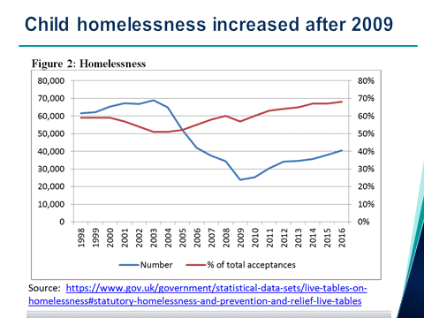

In 2015 and again in 2016 the infant mortality rate increased for the first time since 1985 (See Figure 8). It may not be the start of a trend but this increase follows a long period of decline and the rate has been increasing for the poorest children since 2010 (See Figure 9). UK infant mortality rates are already high compared to other rich EU and other countries and there is evidence that UK infant mortality has been diverging upwards from the general European pattern. Child deaths due to modifiable factors also increased from 2013 to 2017.

Figure 8:
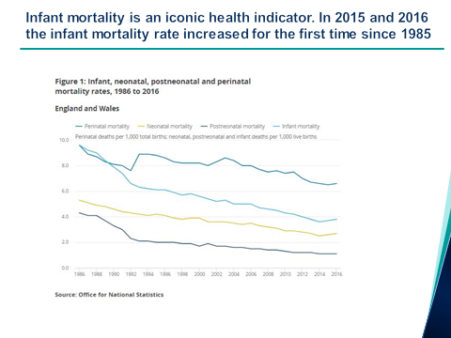

Figure 9:
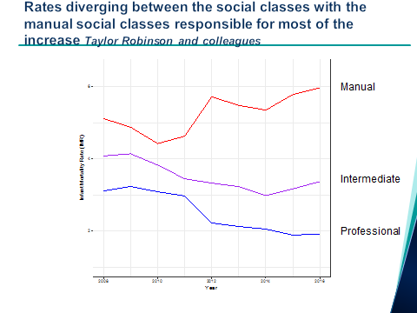.

The youth suicide rate has stopped falling (See Figure 10)

Figure 10:
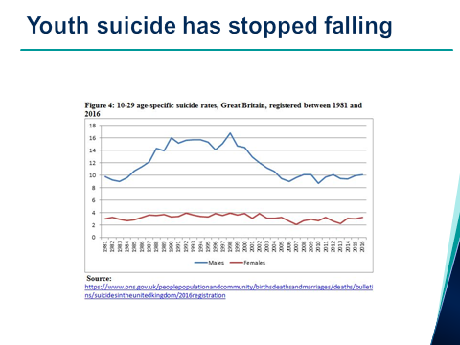

The number of looked after children in England had plateaued after 2002 but since 2010 it has been steadily increasing (See Figure 11). We can only draw tentative conclusions about this trend (and indeed all the trends in this paper). Children come into care for many reasons including parental mental illness, substance misuse and domestic violence. The trend may be a result of changes to practice following child protection scandals such as Victoria Climbie or as a result of recent child migration patterns. But there is also some evidence of an association between spatial deprivation and children looked after and more evidence at an individual level coming from the Born in Bradford cohort of an association between poverty and becoming looked after. There is also evidence that the increase in looked after children has been much greater in more disadvantaged areas.

Figure 11:
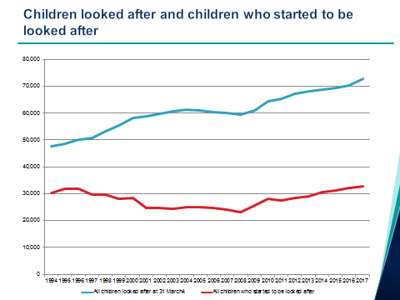

Although there is a good deal of concern over childhood obesity, obesity and overweight rates have not increased since the recession. However there has been a sharp increase in the hospital admissions of under 16 year olds with obesity as a primary or secondary diagnosis (see Figure 12) and inequalities in obesity rates have been widening (See Figure 13).

Figure 12:
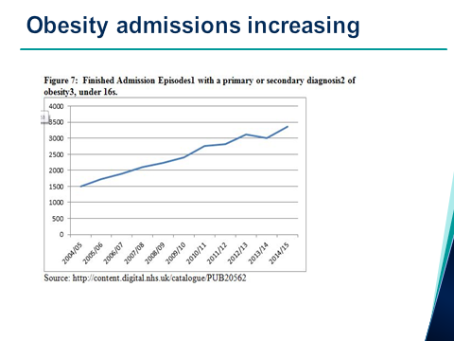
Figure 13:
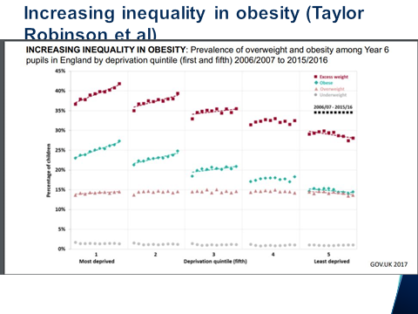

The mean happiness scores of 10-15 year olds have been falling (See Figure 14). This is data from the Understanding Society Youth Panel analysed for the Good Childhood reports. Understanding Society (US) replaced the British Household Panel Survey (BHPS). Data from the BHPS survey using the same question showed that mean happiness scores of 11 to 15 year olds improved significantly from 2001 to 2008. Unfortunately it is not possible to compare BHPS and US results because of a change in the sampling structure. But it clear from the US that there was no further improvement after 2009 and evidence of a statistically significant decline after 2011. The decline is more marked for girls than boys and the decline in happiness with school and with friends is statistically significant.

Figure 14:
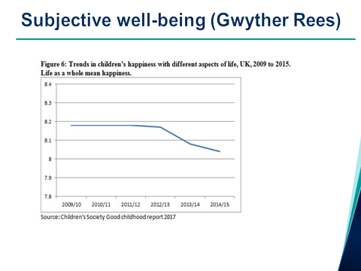

There is a growing concern with child and adolescent mental health and quite a lot of cross sectional evidence but unfortunately there is as yet no trend data that takes us into the recession years. Suicide and mental health are clearly linked to recession and there has been a 68% increase in the number of girls admitted to hospital for self-harming in the last decade.

There is some trend data on 10-15 year olds SDQ scores from Understanding Society. The Figure 15 below is derived from the latest ONS child well-being indicators Table 3.5. Total difficulties are increasing, particularly for girls.

Figure 15:
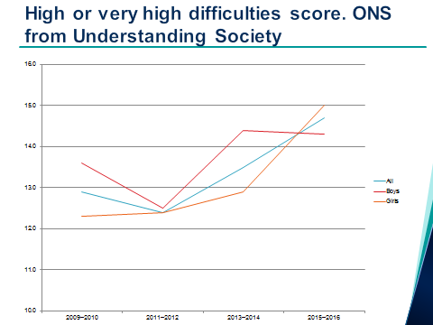

CONCLUSION
Austerity has targeted children and now child poverty is getting worse. A number of child outcomes are deteriorating. This not fair – pensioners living standards have continued to rise and pensioner poverty rates have fallen. It is not wise policy – latest estimate is that child poverty costs £29 billion – roughly the same amount that has been cut from social security spending.

This is not inevitable. There is an alternative. In Scotland there is not only a strengthened Child Poverty Act but a new Social Security Act with a social security charter and a duty on government to promote take-up.

This an update and extension of Bradshaw, J. (2017) The outcomes for children of austerity, Blog, http://jonathanbradshaw.blogspot.co.uk/2017/10/the-outcomes-for-children-of-austerity.html And Bradshaw, J. Chzhen, Y. and Main, G. (2017) Impact of the Recession on Children in the United Kingdom, Chapter 9 in (eds) Cantillon, B, Chzhen, Y, Handa, S. and B Nolan Children of Austerity: Impact of the Great Recession on Child Poverty in Rich Countries. Oxford: OUP. Published 13 April 2017. https://www.unicef-irc.org/publications/911/
http://sticerd.lse.ac.uk/case/_new/research/Social_Policy_in_a_Cold_Climate/Programme_Reports_and_event_information.asp
Bradshaw, J. (2017) Why the two child policy is the worst social security policy ever, Social Policy Association 50th Anniversary Blog 3. http://www.social-policy.org.uk/50-for-50/two-child-policy/
https://www.equalityhumanrights.com/sites/default/files/cumulative-impact-assessment-report.pdf
Bradshaw, J. and Bennett, F. (2017) ESPN Thematic Report on Progress in the implementation of the 2013 EU Recommendation on “Investing in children: Breaking the cycle of disadvantage” United Kingdom. file:///C:/Users/Jonathan/Downloads/UK_ESPN%20thematic%20report%20on%20Investing%20in%20Children.pdf
Bradshaw, J. and Keung, A. (2018) UK Child Poverty Gaps Still Increasing, http://www.cpag.org.uk/sites/default/files/uploads/UK%20child%20poverty%20gaps%20increasing%20again.pdf
https://academic.oup.com/jpubhealth/article/38/3/417/2239829/The-impact-of-economic-downturns-and-budget-cuts
https://theconversation.com/what-its-like-to-transition-on-to-universal-credit-85190
https://www.gov.uk/government/statistics/child-death-reviews-year-ending-31-march-2017
http://www.bmj.com/content/357/bmj.j2258
https://www.gov.uk/government/statistics/child-death-reviews-year-ending-31-march-2017
Bywaters, P. (2013) Inequalities in child welfare: Towards a new policy, research and action agenda, British Journal of Social Work advanced access 1-18 Baldwin, H. et al. (forthcoming) Antenatal factors associated with recorded maltreatment and admission to care. http://www.communitycare.co.uk/2017/02/28/children-poorest-areas-likely-enter-care-finds-study/
http://digital.nhs.uk/catalogue/PUB19109 https://www.rcpch.ac.uk/system/files/protected/page/SoCH%202017%20UK%20web%20updated.pdf
https://www.childrenssociety.org.uk/sites/default/files/the-good-childhood-report-2017_full-report_0.pdf Bradshaw, J. and Keung, L. (2011) ‘Trends in child subjective wellbeing in the UK’, Journal of Children’s Services, vol 6, no 1, pp 4-17.
Royal College of Nursing (2017) Child and adolescent mental health: key facts https://www.kingsfund.org.uk/blog/2017/01/conundrum-children-young-people-health https://www.childrenssociety.org.uk/sites/default/files/pcr090_mainreport_web.pdf http://www.bmj.com/content/354/bmj.i4631 https://www.theguardian.com/society/2017/sep/23/stress-anxiety-fuel-mental-health-crisis-girls-young-women
http://cpag.org.uk/content/impact-poverty

