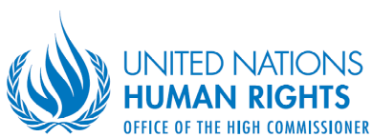
Office of the High Commissioner for Human Rights
Research and Right to Development Division
Human Rights and Economic and Social Issues Section
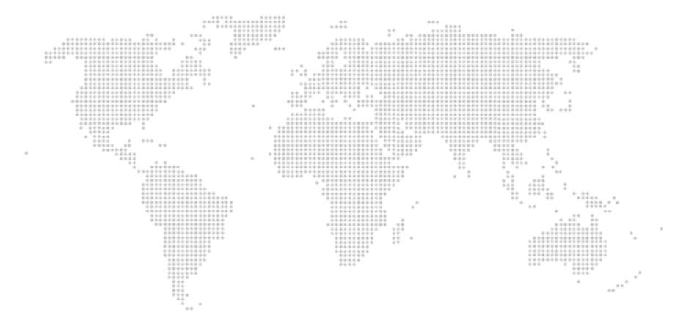

July 2014

OHCHR ESCR Bulletin
Bi-monthly update on economic, social and cultural rights

INTRODUCTION
Issued every two months, the OHCHR ESCR Bulletin aims at sharing news, activities, key events and new resources relevant to economic, social and cultural rights (ESCR), with a focus on the work of the UN Office of the High Commissioner for Human Rights (OHCHR). The Bulletin is edited by the Human Rights and Economic and Social Issues Section, Research and Right to Development Division (HRESIS/RRDD). For feedback and further information on the work of OHCHR as mentioned in this volume: escrbulletin@ohchr.org

The OHCHR ESCR Bulletin contains links and references to non-OHCHR material, websites and other online information. These are provided only as a convenience, and the inclusion of a link or reference does not imply any endorsement by OHCHR.

In this issue:
HIGHLIGHTS 2
ACTIVITIES IN THE FIELD 3
EVENTS 4
CASES, LEGISLATION & POLICIES 5
TOOLS / PUBLICATIONS / MULTIMEDIA 6

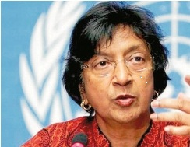
"Our primary concern must now be how we can advance the right to education, in order to facilitate the rights and strategic needs of girls and women. How can educational institutions help eliminate harmful stereotypes regarding the traditional roles of women and men? How can they best promote girls' rights to make free choices regarding their fields of study and careers, and how can they facilitate girls' enjoyment of rights in their personal lives as well as in the political and economic domains?"

Navi Pillay, UN High Commissioner for Human Rights

UN High Commissioner at CEDAW 7 July 2014, half a day discussion: http://goo.gl/dvxoZe

HIGHLIGHTS

The first General Comments issued by the Committee on the Rights of Persons with Disabilities

The Committee on the Rights of Persons with Disabilities has adopted on 11 April their two first General Comments. General Comment 1, on article 12 of the Convention on the Rights of Persons with Disabilities (CRPD) on equal recognition before the law, reaffirms that a person's status as a person with disability or the existence of an impairment must never be grounds for denying legal capacity. It underlines that legal capacity is indispensable for the exercise of civil, cultural, economic, political and social rights alike and acquires a special significance for persons with disabilities when they have to make fundamental decisions regarding e.g. their health, education and work. The General Comment stresses that States parties have an obligation to require all health and medical professionals (including psychiatric professionals) to obtain the free and informed consent of persons with disabilities prior to any treatment. In conjunction with the right to legal capacity, this means that States parties have an obligation not to permit substitute decision-makers to provide consent on behalf of persons with disabilities. General Comment 2, on accessibility, stresses the importance of accessibility for the enjoyment of economic, social and cultural rights such as the rights to education, health, housing, social security and protection and work.
- For more information: http://goo.gl/HR6EGI

New ILO Protocol to strengthen global efforts to eliminate forced labour

In June 2014, the International Labour Conference adopted a protocol to the ILO Forced Labour Convention No. 29 (1930) to address gaps relating to the prevention of forced labour. The Protocol strengthens the international legal framework by creating new obligations to prevent forced labour, to protect victims and to provide access to remedy. It requires governments to take measures to better protect workers, in particular migrant labourers, from fraudulent and abusive recruitment practices and emphasizes the role of employers and workers in the fight against forced labour.
- For more information: http://goo.gl/5lXoXq

New OP-ICESCR ratifications

Gabon (on 1 April 2014), Belgium (on 20 May) and Cape Vert (on 23 June) became the 13th, 14th and 15th countries to ratify the OP-ICESCR. OHCHR's Central Africa and Western Africa Regional Offices' efforts have been instrumental to the ratification in Gabon and Cape Vert, the two first African countries to become a party to the OP.

ACTIVITIES IN THE FIELD
Kyrgyzstan: OHCHR workshops on economic, social and cultural rights
HRESIS (DESIB/RRDD Geneva) and the Regional Office for Central Asia delivered three workshops on the content of economic, social and cultural rights and the corresponding State’s obligations to: 1) State authorities, 2) civil society and the NHRI and 3) focal points of UN agencies from 30 June to 4 July in Bishkek, Kyrgyzstan. The activity stemmed from the imminent review of the State by the Committee on Economic, Social and Cultural Rights and the need to strengthen national actors’ capacity to implement the upcoming recommendations. For more information, contact Stefania Tripodi (stripodi@ohchr.org) or Bahram Ghazi (bghazi@ohchr.org).
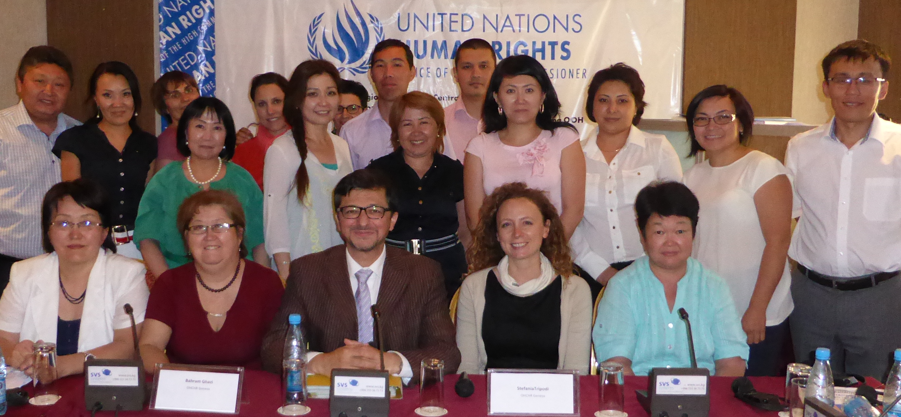

OHCHR Cambodia: New housing policy

In May 2014, the National Housing Policy was finally approved by the Royal Government of Cambodia, also thanks to the technical support of OHCHR-Cambodia. The law focuses primarily on families who have low and medium income and contains important mechanisms for increasing security of tenure for informal settlements and adequate housing for vulnerable groups. OHCHR-Cambodia continues to work with the Royal Government of Cambodia to establish new joint monitoring indicators in the land and housing sector for the period 2014-2018 negotiated through the Technical Working Group on Land (TWG) procedure. In the last few months, numerous violent forced evictions of vulnerable individuals, families and communities deemed to be illegal settlers living on rural land took place. OHCHR-Cambodia documented multiple incidents of discrimination and attacks made on indigenous communities claiming communal titles. Despite the Royal Government of Cambodia publicly pledging to provide at least ten communal land titles per year starting 2014, no indigenous community communal land titles have been issued this year.
- For further information please contact Benjamin Rutledge at brutledge@ohchr.org

OHCHR Mexico and civil society developed indicators for shadow reporting

OHCHR Mexico collaborated in the elaboration of indicators for the civil society alternative report on the progressive measures taken by the Mexican State to ensure due respect for the rights set forth in the Protocol of San Salvador, which was submitted on June 27, 2014 to the Organization of the American States. The report and indicators generation process on the rights to education, health and social security was coordinated by the University Human Rights Program of the National Autonomous University of Mexico and integrated the participation of seven prominent civil society organizations, two state universities, ECLAC and OHCHR Mexico.
- For further information and full report please contact Mila Paspalanova at mpaspalanova@ohchr.org or consult http://www.pudh.unam.mx/index_indicadores.html.

OHCHR Regional Office for Central Asia’s study on the right to adequate housing

OHCHR Regional Office for Central Asia conducted a study on the enjoyment of the right to adequate housing in Kazakhstan, Kyrgyzstan and Tajikistan between 2012 and 2014. The research focused on social housing, homelessness, informal settlements, forced evictions and the impact of housing policies on marginalized groups. The study identified gaps and challenges of existing national legislation and policies as well as their impact on the most disadvantaged and vulnerable groups. The recommendations aim at helping Governments implement their human rights obligations and raising awareness among civil societies and activists. The findings and recommendations of the research were widely disseminated to duty-bearers and rights-holders through two-page summaries.
- For more information, contact Laura Mancini at lmancini@ohchr.org.

EVENTS

RECENT EVENTS

Expert consultation: Human rights indicators for migrants and their families

On 8-9 April 2014, OHCHR, in collaboration with the World Bank’s Global Knowledge Partnership on Migration and Development (KNOMAD), UNICEF, ILO, and Migrant Forum in Asia, convened an expert consultation to develop a set of human rights indicators relevant to migrants and their families, with an initial focus on the rights to health, education, and decent work. The meeting aimed at spelling out the essential attributes of the rights enshrined in international instruments, and translate these rights into contextually relevant indicators and benchmarks for implementing and measuring the human rights of migrants.
- For more information: http://goo.gl/JEmKtL

HRC Side event on gender mainstreaming the United Nations Guiding Principles on Business and Human Rights
During the 26th session of the HRC, the Working Group on the issue of discrimination against women in law and in practice organized a side event on integrating a gender perspective into implementing the United Nations Guiding Principles on Business and Human Rights in cooperation with the Working Group on the issue of human rights and transnational corporations and other business enterprises. The discussion focused on the need to gender main-stream the Guiding Principles and to ensure accountability for gendered harms. It concluded that there should be more women leaders and fewer women victims. The two WGs will explore ways for further cooperation on this issue.
- For more information: http://goo.gl/4ZMn5J

FORTHCOMING EVENTS

Human Rights Council panel discussion on history teaching and memorialization processes

The Human Rights Council will hold, at its 27th session in September 2014, a panel discussion on history teaching and memorialization processes, with a view to contributing to the sharing of good practices in this area (see resolution 25/19 of 28 March 2014). This decision was adopted, taking into consideration the work undertaken by the Special Rapporteur in the field of cultural rights, who devoted two consecutive reports to the issue of historical and memorial narratives in divided societies, relating to a) history textbooks (A/68/296) and b) memorials and museums (A/HRC/25/49).
- For more information: http://goo.gl/oaSIib

CASES, LEGISLATION & POLICIES

South Africa: Court rules on public budgeting

On 5 May, the High Court of Pretoria delivered the judgment BEFA and Others v Minister of Basic Education and Others which relates to public budgeting and justiciability of economic and social rights. The judgment concerns the Department of Basic Education's failure to provide textbooks to students in Limpopo Province, which according to the Court infringed on their access to education. The Court found that the Parliament failed to allocate sufficient funding to the Department of Education. The judge then asked the Parliament to account to the South African Human Rights Commission for its budget decisions.
A review of the judgment by the O'Neill Institute: http://goo.gl/4rxeBz

Kyrgyzstan: the Parliament declassified city master plans
In July 2014 in Kyrgyzstan, the Parliament declassified city master plans. According to the amended law, master plans of cities and other localities are now open for public and available on official websites of local municipalities. ROCA has been advocating local and central level authorities of Kyrgyzstan to ensure increased transparency, effective and inclusive public participation and full respect of human rights in urban planning. During her visit to Kyrgyzstan in 2012, the High Commissioner advocated that urban development should be undertaken in the most transparent and consultative way, and all communities affected by a master plan should receive a copy of it and be consulted in this process before any urban development is implemented.
- For more information, contact Laura Mancini at lmancini@ohchr.org

TOOLS / PUBLICATIONS / MULTIMEDIA

Key Human Rights Council Reports
- The Working Group on the issue of discrimination against women in law and in practice’s latest thematic report to the HRC (A/HRC/26/39) focuses on women’s economic and social rights, with a focus on economic crisis. To achieve de facto equality, the WG believes that it is essential to adopt a transformative agenda to eliminate cultural and structural barriers and empower women throughout their life cycle, from childhood through adulthood to older age. To access the report: http://goo.gl/k9WCBF
- The Special Rapporteur on the right to education presented his report (A/HRC/26/27) to the Council addressing the issue of a holistic, human rights-based approach to the assessment of the educational attainments of students and on skills development. To access the report: http://goo.gl/iFcvgR
- The Special Rapporteur on the right to the highest attainable standard of physical and mental health also presented his report to the Council this session. His final thematic report (A/HRC/26/31) to the Council focused on healthy nutrition, unhealthy food and the problem of obesity, particularly for young people, which he described as a global epidemic. To access the report: http://goo.gl/979Oi4
- The Special Rapporteur on extreme poverty and human rights’ report (A/HRC/26/28) focuses on fiscal policies and human rights outlining how fiscal policies, and particularly taxation policies, are a major determinant in the enjoyment of human rights. To access the report: http://goo.gl/iEv0Bs
UNIRISD launches a resource platform on social protection and human rights
This platform provides expert legal and development resources on how to better align social protection and human rights. It targets policy makers, development practitioners and human rights advocates. It comprises three sections: 1) Framework for a human rights-based approach to social protection that provides a useful reference on the obligations created by existing human rights laws and standards; 2) Expert commentaries on human rights and social protection in practice; 3) Depository of legal cases in which human rights law has been used to achieve better social protection.
- For more information: http://goo.gl/pcR7g7

Guide on the Human Rights-Based Approach to Development and the Right to Participation

The Global Initiative for Economic, Social and Cultural Rights released the “Practitioners Guide on the Human Rights-Based Approach to Development and the Right to Participation”, on how to incorporate the right to active, free and meaningful participation in human rights based development. The Guide includes several case studies and lessons learned.
- The Guide is available at: http://goo.gl/yY89gq

Impact of austerity-driven health reforms on undocumented migrants: Medicos del Mundo’s reports
Medicos del Mundo has released two reports (in Spanish) on the harmful consequences of health reforms on undocumented migrants in Spain. The first report, entitled “Two Years Of Health Reform: More Human Lives in Play”, outlines the negative impacts of denial of healthcare as a result of Royal Decree 16/2012 in Spain. The second, “Access to Health among the Most Vulnerable”, has been produced by the International Network of Medicos del Mundo and offers an analysis of access to healthcare among the most vulnerable populations in eight European countries – Belgium, France, Germany, Greece, Holland, United Kingdom, Spain and Switzerland.
- The reports are available in Spanish: http://goo.gl/5ueTzG and http://goo.gl/f3OzA4

OHCHR launches the Ratification Dashboard
OHCHR has launched a comprehensive data visualization portal “OHCHR Ratification Dashboard” containing the latest status of ratification of 18 treaties and optional protocols. The dashboard allows users to view treaty ratification through interactive world and regional maps, downloadable in pdf format. Users can generate some statistical data such as number of State parties to a treaty, download the data in excel, and create filters to obtain a more tailored information on acceptance of individual communications procedure and inquiry procedure. Users can also view an aggregated map that shows the total number of treaties each member State has ratified.
- To access the dashboard, visit http://indicators.ohchr.org/ and for questions, contact OHCHR’s Human Rights Indicators Unit (hrindicators@ohchr.org).

Australia’s big four banks and land grabs: Oxfam report

Oxfam Australia released a report “Banking on Shaky Ground” on the links between Australia’s big four banks and land grabs. It includes evidence that ANZ, Westpac, National Australia Bank and the Commonwealth Bank have backed companies that have contributed to illegal logging, forced evictions, inadequate compensation, food shortages and child labour.
- For the report: http://goo.gl/QzZuhA

Economic and Social Rights after the Global Financial Crisis: new book

The book, edited by Aoife Nolan and published by Cambridge, focus on the interrelationship between contemporary and historic economic and financial crises, the responses thereto, and the resulting impact upon economic and social rights. Chapters examine the obligations imposed by such rights in terms of domestic and supranational crisis-related policy and law, and argue for a response to the crises that integrates these human rights considerations.
- For more information: http://goo.gl/ttMN7h

Evictions and displacement: the collateral damage of development?

- Miloon Kotari’s article in Displacement Research and Action Network: http://goo.gl/Ww5f53

Post-2015: Realizing substantive equality for women and girls demands financial policy changes

- Nathalie Margi’s article in Right In Finance: http://goo.gl/hiQqSB

India: farmers abandoned

- http://goo.gl/472PQh

Previous issues of the ESCR Bulletin are available at http://www2.ohchr.org/english/issues/escr/escr-general-info.htm

To subscribe, send blank email to: escrbulletin-subscribe@yahoogroups.com

To unsubscribe: escrbulletin-unsubscribe@yahoogroups.com

To request further information on the work of OHCHR as mentioned in this volume, write to: escrbulletin@ohchr.org

