Intersessional Workshop on Cultural Rights and the Protection of Cultural Heritage
14 June 2021 | 3PM – 5PM / 15 June 2021 | 10AM – 12PM & 3PM – 5PM (CEST)

Guidance note to register for the list of speakers and for sending video statements

This guidance note is for participants intending to register for the list of speakers. Please note that:
Participants must register for the event via Indico (https://indico.un.org/event/35903/); only those registered will receive the link to join the event, shortly before it starts.
- Due to time restrictions, all interventions must be limited to two minutes.
- Interventions may be made in any of the six UN languages (Arabic, Chinese, English, French, Russian and Spanish).
- The time available will allow for a maximum of 16 speakers to take the floor for each panel discussion. The Secretariat will draw up the list of speakers based on time of registration, ensuring participation of Member States and other stakeholders.
- Participants who are not registered on the list of speakers may be able to request the floor, once all registered speakers have taken the floor, and if time allows.
Each panel will include time for interactive debate, with interventions from participants. Oral interventions can be made either by:
- making a live statement through the online platform, during the event; or,
- sending a pre-recorded video message (refer to Annex I below on submitting the video); or,
- requesting the floor during the meeting, if time permits for additional speakers who did not register for the list of speakers prior to the start of the meeting.
Additional guidance for all of the above options is provided below.
Stakeholders who would like to make an intervention should let the Secretariat know as soon as possible, by indicating this on the registration form.
The list of speakers will close on 10 June 2021 in order to facilitate timely technical support for the interventions. After this time, it will still be possible to request the floor, provided there is time after all participants on the list of speakers have taken the floor (further information below).
Participants are encouraged to be as concise and succinct as possible, formulating their interventions with a view to contributing material to tools on the protection of cultural heritage in line with a human rights-based approach. All participants should ensure a sense of respect and tolerance throughout the discussion.

Making a live statement via the online platform, during the event
For participants or stakeholders registering to make a statement during the event, via the online platform, please:
- Register for the list of speakers (as indicated above)
- Send a copy of their statement to emuratoreaprosio@ohchr.org and speeches@un.org prior to the start of the session
Note that the statement should not exceed two minutes, otherwise in the interest of time, the moderator may move on to the next speaker.
Sending a pre-recorded video message

For participants or stakeholders sending a pre-recorded video message, please:
- Register for the list of speakers (as indicated above)
- Carefully read the guidance for submitting your video file to the Secretariat via WeTransfer in Annex I below.
- Consider including captioning for the video statement in order to enhance participation of persons with disabilities. Guidance on creating captions using YouTube is available in Annex II below.
- Be mindful of the audio and video quality.
- Send your video message, together with a transcript of your message in Microsoft Word or accessible PDF format to emuratoreaprosio@ohchr.org by Thursday 10 June at the latest, via WeTransfer (see Annex I below for further guidance). Should the Secretariat not receive your video message and transcript by this time, your message may be excluded from the list of speakers.
Note that the video file must not exceed two minutes, otherwise in the interest of time the video may be cut off after the first two minutes.

Requesting the floor during the event
Depending on time availability and technical capabilities, participants who did not register on the list of speakers prior to the event will be able to request the floor once all participants who are on the list of speakers have taken the floor.
To request the floor during the event, participants may use the ‘raise hand’ function on the online platform.

ANNEX I

GUIDELINES ON SENDING VIDEO MESSAGES VIA WETRANSFER
- Open a browser on the computer where the files you want to send are located. Go to https://wetransfer.com/.
In order to enhance participation of persons with disabilities, all stakeholders are encouraged to include captioning on the video statement, as well as to consider including sign language.

- Click on “Add your files” and select the following files:
  - Your video message (see below for specifications);
  - A transcript of your statement in Word or accessible PDF formats.

- On the “Email to” field, add: emuratoreaprosio@ohchr.org

- On the “Your email” field, add your own email.

- On the “Message field”, include:
  - The stakeholder/organization on behalf of which you will be speaking;
  - The panel for which you are sending the video message.

- Click on “Transfer”. You will be prompted to enter a verification code, which will be sent to your email a few moments later (remember to check the spam folder). Copy the verification code, paste it in the transfer windows and hit verify.

- Once the verification code has been entered, your files will be uploaded. This might take a few minutes. After that, your files will be sent to us automatically. You will receive an email confirming that your files were sent successfully. You will also receive a confirmation email once we have downloaded your files.

Please note that all video statements should be sent by 10 June 2021.

ANNEX II

GUIDELINES ON CREATING VIDEO CAPTIONS USING YOUTUBE (FOR PRE-RECORDED VIDEO MESSAGES)
The purpose of these guidelines is to explain how to use YouTube to caption video messages. We recommend its use as an example of a quick, simple and free solution to increase the accessibility of events, but stakeholders are encouraged to use any means of their choosing to add subtitles to video messages.
These guidelines only address how to create subtitles when a transcript of the video is available. YouTube also generates automatic captions, but this falls beyond the scope of these guidelines.
- Go to www.youtube.com and log in or sign up using a Google account.
- In the upper-right corner, click on the camera icon and select “Upload video”.
- Select the video file.
- The following screen appears. As the video will not be made public on YouTube, most details are not relevant. The only required fields are the title and the indication that the video is not meant for children. Complete them and click “Next”.
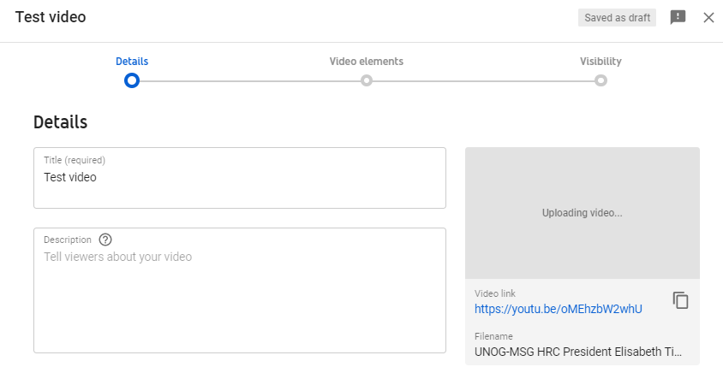
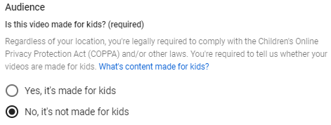
- Click “Next” on the “Video elements” tab. On the “Visibility” tab, select “Private” and click on “Save”.
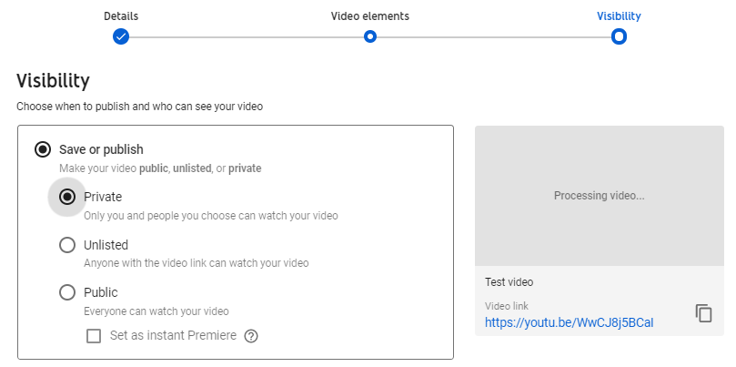
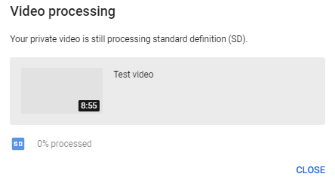
- After the video has finished uploading, it might be necessary to wait some minutes while it is being processed (capture below). Processing time depends on several factors, such as the format and size of the original file, as well as YouTube’s own upload traffic. As a rule of thumb, it can take around one minute of processing for each minute of video – and more than that for higher-resolution video. The progress bar is usually not linear: 0% takes a long time, and from there it jumps to almost completion. A few minutes at 0% does not mean that the processing is frozen.
- Go back to the dashboard by clicking on the icon on the upper-left side. On the left-hand column, select . Click on “Details” next to the video to caption. After that, select “Subtitles”.
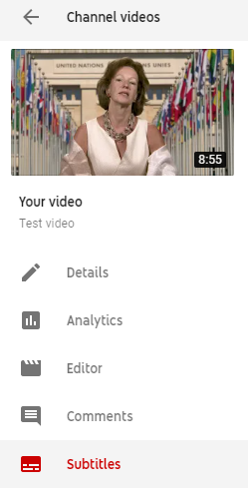

- Select “add” and then “Upload a file”. On the next screen, select “Transcript” as the file type. There might be a warning mentioning that “Uploading a file will overwrite this version of English”. This means that YouTube has already generated automatic captions for this video, which will now be overwritten.
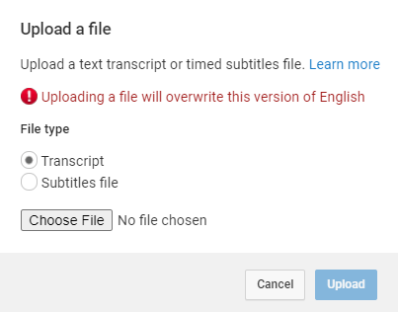
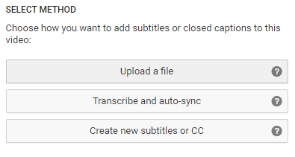

- Upload the transcript as a plain text (.txt) file. Using a Word document will not work properly. Before uploading it, edit the file so as to include only what is actually said in the video, without bullet points, headers or footnotes.
- The transcript will appear in the following box. Click on “Set timings”.
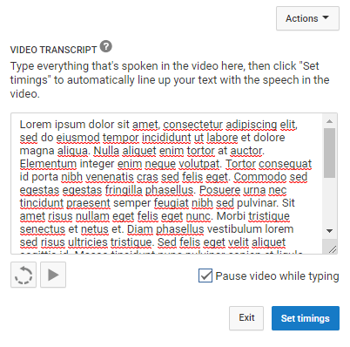
- YouTube will now transform the transcript in timestamped subtitles. For a 7-minute video, this takes 2 to 3 minutes on average. YouTube does not refresh the page automatically when this process has finished; so refresh the page after a few minutes to check whether it is finished (refreshing the page before it is complete does not reset the progress). When it is done, click on the draft.

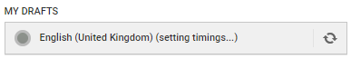
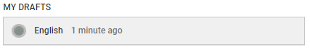
- It is possible to check and edit the subtitles at this stage, changing the wording or timing if needed. After this, click on “Save changes”.

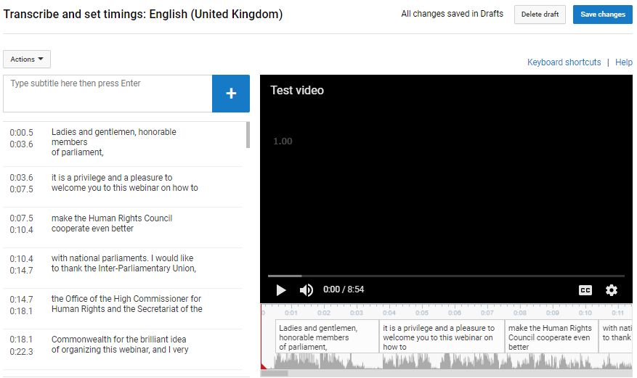

- Select again the edited subtitles. Click on “Actions” and download the captions as a .srt file. Save it with the same file name as the video, as shown in the capture below.

- To test it, open the video file using a player that supports subtitles, such as VLC Media Player. Provided that both files have the exact same name and are saved on the same folder, captions should be displayed automatically.
- Kindly upload the .srt subtitle file when uploading the video and related files on WeTransfer

