Coronavirus, COVID-19, and the Right to Education. Lessons to be learned.
(A contribution to Good Practices).
Berta Marco. Platform of NGOs on the Right to Education
Madrid, 22 May 2020

Introduction. The change of topic, an opportunity
Two days ago I received an e-mail of my Coordinator, Ignasi Grau, telling me that our Sp. Rapporteur, Miss Boly Barry, wanted to prepare its Annual Report (to be presented at the next Session (44th) of the Human Rights Council) on a theme that could vinculate the Coronavirus crisis with the Righ to Education. At the moment that I read these news I thought that this change was an opportunity. Why??? In my opinion, what we are been experiencing recently as a consequence of this terrible pandemic (coronavirus crisis), in a very short a time, is worthy of being communicate to the general public and also to be introduce as an additional topic in the current School Curricula. Science develop very quicky that’s why examples of the new Science revolutions in Physic, Chemistry, Medicine…could be interesting examples of the interactions Science - Society or Science-Technology- Society .

ADOPTING A FOCUS ON SCIENCE-TECHNOLOGY-SOCIETY
The story of the COVID-19 offers us an opportunity to introduce a few emerging topics into the Science Curricula. In this sense, we could propose the students of Secondary School a few lessons on the virus in general: morphology, infections, the common procedure for a cure, how to get better, Isolation, lock down, etc. The methodology has to be very active on the part of students. The contents should be built directly by the students reading scientific news from the current scientific magazines like New Scientist ( good for them to familiarise with good scientific magazines and to get used to read and trying to understand, some scientific current news).
The scientific lexicography of the topic has to be clearly defined by the students according to the scientific articles previously studied. Each of the new concepts associate to the topics have to be explained at the level of the citizenship because what we are looking for is the Public Understanding of Science.
A frequent stereotype of Science as a field is success. Science in the students books appeares as a field of study guided by creative minds that produce easily new discoveries. The way to change the stereotype is to animate students to go into the new topics, to accustom them to look for information in diferent resources in order to identify the more significative sides of the topic, including those that affects society or the public uses of Science.

AN EXAMPLE OF HOW TO INCORPORATE A NEW DIMENSION IN THE LEARNING OF SCIENCE: DISCOVERING THE “INTRINSIC INEQUALITY” IN THE WAY THE VIRUS COVID-19 INFECTS.
THERE ARE TWO MARKED SENTENCES (1,2) IN THE TEXT BELOW. I SUGEST TO INVITE STUDENTS TO INVESTIGATE BOTH CONTENTS.

- “Inequality in the infection of this virus: The virus prefers people in need”
The most important international scientific magazines, Nature or Science are publishing many articles on the emergence of the COVID-19 virus and its peculiar characteristics, the way it infects, and how to live in an atmosphere infected for this special and dangerous virus. But, little by litle, after considering in detail the structure of the virus (similar to the crown of the Sun), they are going into another topics like how it infects people, how to protect ourselves of the virus and so on. Reading carefully these articles, we discover one very important dimensión of the pandemic that the Nature magazine express in the title of one of its articles:

- “COVID-19 is a virus that discrimínate the poor, the most needed”.
“The pandemic has hit care homes, prisons and low-income communities hardest”.
“Respiratory pathogens spread like wildfire when people are in close contact. So it’s little wonder that almost all of the 150 biggest coronavirus outbreaks in the United States have been in prisons, nursing homes, veterans’ homes, psychiatric hospitals, meat-packing plants and homeless shelters, where people live or work side by side”.
The phenomenon can be seen worldwide. Singapore seemed to have almost contained its epidemic until it became clear that the virus had been spreading undetected among migrant workers living in overcrowded dormitories. Across Europe, homes for elderly people are among the worst hit. In Canada, 80% of reported deaths from COVID-19 have been in care homes”.
(Reference: Nature. EDITORIAL 19 MAY 2020.) https://www.nature.com/articles/d41586-020-01440-3

THE SAME TOPIC IN ANOTHER MEDIA:

SCIENCE. EDITORIAL (17 APR 2020 : 214)

“The moment to see the poor”

BY JOACHIM VON BRAUN, STEFANO ZAMAGNI, MARCELO SÁNCHEZ SORONDO
SCIENCE

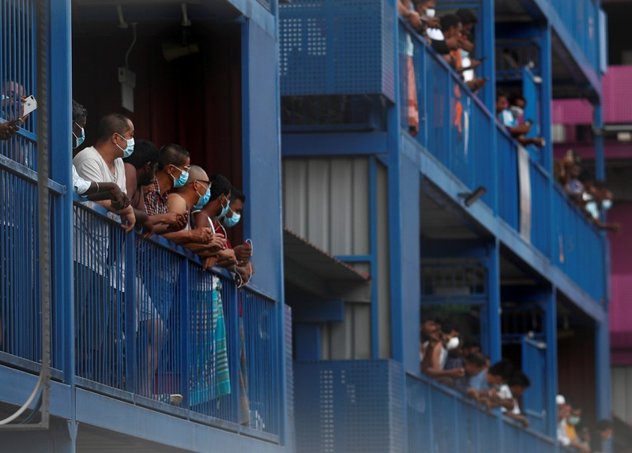
Migrant workers living in dormitories in Singapore were initially overlooked for coronavirus testing.Credit: Edgar Su/Reuters

A new eyes to contemplate the reality
The Right to Education is an essential right that allow every person to be aware of the reality around he/she. Our capacity tho get meaning of the reality depends on what we have leaned mainly through Education; there is a part that the person normally receives through the formal education (the established knowledge), and another one that comes from different sources: nature, taking with people, travelling, reading and so on. In any case the “sense”. In any case this dimensión (to get meaning of the things) has to be personally cultivated. Our reality is so rich that it is very difficult to catch the whole and the details of any item, at any time, of any object, by one person. The story of the pandemic is telling us that our lecture of the reality have to be deeper to discover the inequalities that its contents.
The infection of the CAVID-19 prefers the poor, chouses people in needs, is discriminatory.

ADDITIONAL INFORMATION: International Scientific Magazines:

Nature (Editated in Great Britain). https://www.nature.com/; CURRENT ISSUE : 21 May 2020
Science (Editado en USA. AAAS). https://www.sciencemag.org/

CURRENT Issue: 15 May 2020: https://www.sciencemag.org/collections/coronavirus?intcmp=sci_cov&_ga=2.63790191.195807434.1590078760-1656467424.1581098714
New Scientist: (Publish in the United Kingdom). Quite accesible to Secondary Students.
Current issue cover:
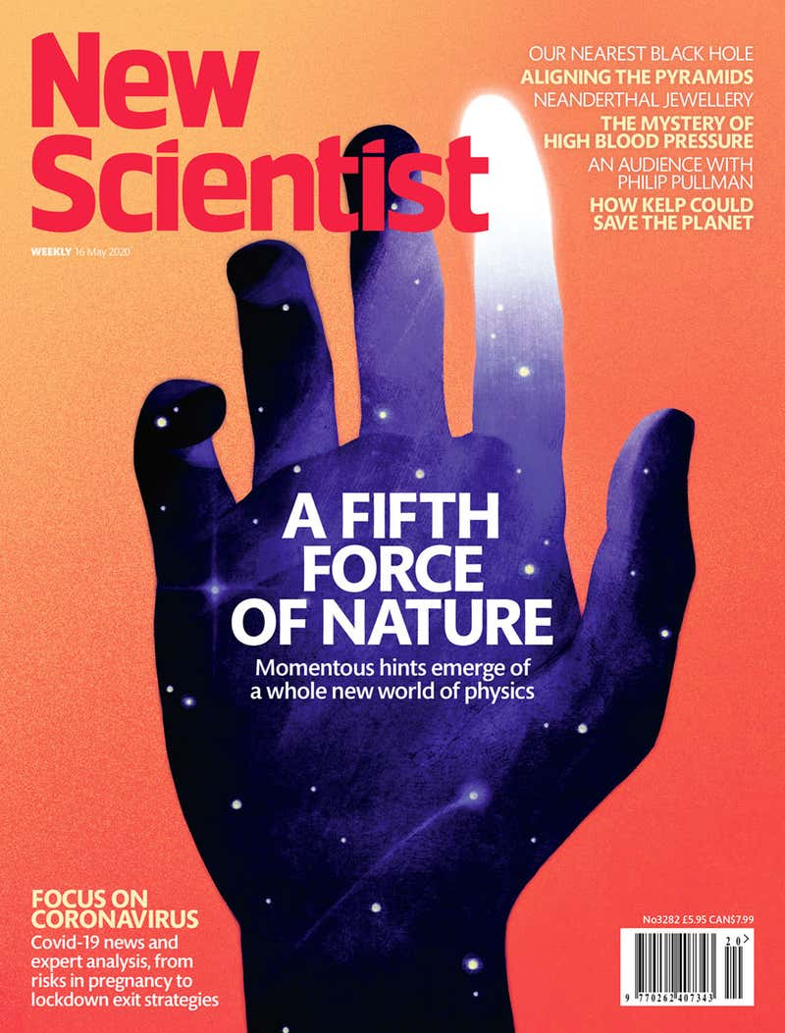

Doctor in Chemistry and Master in Scientific Journalism.
The Public Understanding of Science. Royal Society, London. Annual Report, 1985. The report starts with this sugesting sentence: “Science pervades our society”.

