Respuesta del Estado de Chile
Cuestionario del Relator Especial Relator Especial sobre la cuestión de las obligaciones de derechos humanos relacionadas con el disfrute de un ambiente sin riesgos, limpio, sano y sostenible
Mediante el presente documento, el Estado de Chile transmite sus respuestas a algunas de las preguntas del cuestionario del Relator Especial Relator Especial sobre la cuestión de las obligaciones de derechos humanos relacionadas con el disfrute de un ambiente sin riesgos, limpio, sano y sostenible relacionado a la contaminación del agua, la escasez de agua y las inundaciones.

Please provide examples of ways in which water pollution, water scarcity and floods are having adverse impacts on human rights. Adversely affected right could include, among others, the rights to life, health, water and sanitation, food, culture, livelihoods, non-discrimination, a safe, healthy and sustainable environment, and indigenous people’s rights.

Drinking water and sanitation sector in Chile is established in concessioned urban areas in charge of private operators (water companies), by law they have the obligation to supply for all users inside concessioned area the services that have to be continuous and to comply all the norms of quality of service, including water quality. This structure has let the sector to have high standars of performance indicators as coverage, quality of service and quality of water. Indeed drinking water coverage, sewerage coverage and wastewater treatment coverage are practically 100%.
However, in last years the efforts have been multiplied to keep this performance, because of Chile is living the worst drought in its history, which started 10 years ago. This coupled to climate change effects has meant to anticipate infraestructure construction and to find solutions by trying to avoid high tariff rises, for instance, public financing in Copiapó to build a desalination plant.
To protect a wide range of human rights, what are the specific obligations of States and responsabilities of businesses in terms of addressing water pollution, water scarcity and floods? Please provide specific examples of constitutional provisions, legislation, institutions, regulations, standards, policies and programmes that apply a rights-based approach to preventing, reducing, or eliminating water pollution, water scarcity and floods. Please include, inter alia, any instruments that refer directly to the right to a healthy environment and/or the rights to clean water and adequate sanitation.

In urban areas, water and sanitation sector has private companies to supply the services and a regulatory agency (SISS). The companies are obligated to give to users services with quality and continuity, complying all the norms and regulation. The poorest users receive a subsidy from the Government. In last years the regulation has accepted to charge in tariff investments in new infraestructure to give resilience to drinking water systems. The norms for drinking water quality was stablished by Ministry of Health, while the norms for treated wastewater have been established by different Ministrys (Ministry of General Secretary of Presidency, Ministry of Public Works and Ministry of Environment).
If your state is one of the 156 United Nations member States that recognizes the right to a safe, clean, healthy and sustainable environment, has this right contributed to preventing, reducing, or eliminating water pollution, water scarcity and floods? If so, how? If not, why not?

Aiming to give an integral and consistent look at the commitments and public policies developed by Chile, the Superintendence of Sanitary Services – SISS (regulatoty agency of water and sanitation sector) has made the “2030 Water and Sanitation Sector Agenda”, a long term plan which contains 12 projects to face the sector’s challenges. This 2030 Agenda was build in a broadly participatory process that started in 2017, in which more than 700 people were summoned in nine regions of the country, including representatives of civil society, business, academic, public sector and the water and sanitation sector itself. Thus, after two years of work and as a result of this co-construction process, the 2030 Water and Sanitation Sector Agenda arised in seek to address and resolve the challenges posed by the current water scenario in Chile, identifying the main problems and potential solutions, defining a roadmap to address them and outlining a work plan of 12 projects for the next ten years.
Besides, 2030 Agenda will openly promote alignment with other policies, plans, agreements, among others; which are considered in each of its work plans, since every Project has its respective work plan. Under a global context, there is the Agenda for the Sustainable Development Goals promoted by the United Nations, which has 17 goals and 169 targets that seek to stimulate development through a plan of action in favor of people, the planet and prosperity. Chile, as part of the 193 member countries of the UN, adopted this Agenda that will be implemented by all countries and stakeholders through a collaborative alliance.
In this context, the United Nations seeks to address the water challenge through Sustainable Development Goal No. 6. This OSD 6 calls for progress on water supply, sanitation, water quality, water efficiency and scarcity, integrated management of water resources, water and the environment, increased international cooperation and community participation in water and sanitation management. Thus, SDG 6 would naturally be the objective most related to the 2030 Water and Sanitation Sector Agenda, however, the holistic nature of water resources, including the role played by water utility companies, forces us to analyze how it interlinked with other objectives as follows:

Sustainable Development Goals and the Sanitation Sector
Central Tasks of the Sanitation Sector |  | Goals that depend on the sector |  | New Tasks
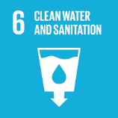 | 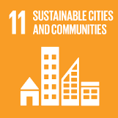 | 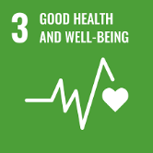 | 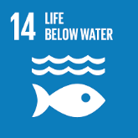 | 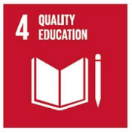 | 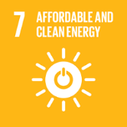
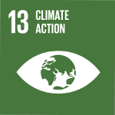 | 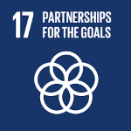 | 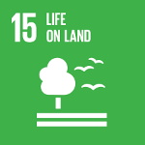 |  | 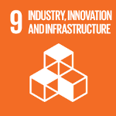 | 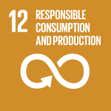
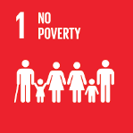
Figure 1: SDG and the Sanitation Sector (Own elaboration)

Please provide specific examples of good practices in preventing, reducing, or eliminating water pollution, water scarcity and floods. These examples may occur at the international, national, sub-national, or local level. Examples may involve water quality and quantity monitoring; guarenteeing procedural rights (e.g. public acces to water quality information, public participation in decisión-making about proposed users of water, access to remedies); water use and water quality legislation, regulations, standars, and policies; and initiatives to reduce water consumption and/or water pollution from specific sectors (e.g. agriculture, electricity generation, industry, transportation, domestic use). Where posible, please provide evidence related to the implementation, enforcement, and effectiveness of the good practices.

Due to water scarcity that has been accented by climate change effects, the Government has created a “National Bureau of Water“, where participate politicians, ministers, academics, institutions from public, private and civil society sector, in order to propose a plan to face the water crisis that the country is going through, and also includes instances of citizen participation. All the water sectors coincide about to take actions for improving the integrated water management.
Further, as mentioned above, water and sanitation sector has achieved coverages around 100% in drinking water, sewerage and wastewater treatment.
Moreover water and sanitation sector comply strict norms of both drinking water quality and treated wastewater quality that are discharge to rivers, lakes, sea, etc.

Please identify specific challenges that your government, business, or organization has faced in attempting to emply a rights-bases approach to address water pollution, water scarcity and floods and the impacts of these problems on human rights.

In current situation of drought and climate change, the main challenge of SISS is taking necessary actions for ensuring that the water and sanitation companies invest and build infraestructure to keep high standars of quality of service in this sector.
The government is taking actions to solve the basic services issue both in rural and urban areas in which there are people belonging to the poorest population groups, who live in illegal settlings that are located in stretches of land, named camps. Those camps where decreasing, but in las years started to increase because of a rise in immigration, which has been accented because of pandemic.
Please specify ways in which additional protection is provided (or should be provided) for populations who may be particularly vulnerable to water pollution, water scarcity and floods (e.g. women, children, persons living in poverty, members of Indigenous peoples and traditional communities, older persons, persons with disabilities, ethnic, racial or other minorities and displaced persons). How can these populations be empowered to protect and improve water quality and availability?

SISS is helding to Ministry of Housing and Urbanism to solve the issue of the illegal camps mentioned above, by moving those people to social households or by bulding social households in the same pieces of ground where the camps are.
The SISS rol consists of both acomplishing the extension of concessioned urban areas to include those stretches of land and taking part in the process to make feasible the water and sanitation services for the company in charge to supply them in that concessioned urban area.
Finally, vulnerable populations could be protected by increasing their binding citizen participation, especially in the processes of making decisions and also making norms, laws and regulations. Also, to improve the quality of citizen participation, public institutions could enhance public information access and transparency.

