Call for Inputs

Healthy Ecosystems and Human Rights: Sustaining the Foundations of Life

“Goals for conserving and sustainably using nature and achieving sustainability cannot be met by current trajectories, and goals for 2030 and beyond may only be achieved through transformative changes across economic, social, political and technological factors.”

Intergovernmental Science-Policy Platform on Biodiversity and Ecosystem Services. 2019. “Summary for policymakers of the global assessment report on biodiversity and ecosystem services.”

There is now global agreement that human rights norms apply to a broad spectrum of environmental issues, including biological diversity (the full range of life on Earth) and healthy ecosystems (the foundation upon which all life depends). The Special Rapporteur on human rights and the environment, Dr. David Boyd, is working to provide additional clarity regarding the substantive rights and obligations that are essential to the enjoyment of a safe, clean, healthy and sustainable environment. He has submitted reports on clean air, a safe climate, and good practices on the promotion and implementation of the right to a safe, clean, healthy and sustainable environment. He is now preparing a thematic report focusing on human rights and associated obligations related to healthy biodiversity and ecosystems. For that purpose, he is seeking inputs on the topic from States and stakeholders through responses to the brief questionnaire below.

Your replies will inform the Special Rapporteur’s analysis and contribute to his report, which will be presented to the General Assembly in October 2020.

Questionnaire

This submission is made by Forest Peoples Programme (UK), Natural Justice (South Africa), Asia Indigenous Peoples Pact Foundation (AIPP - regional), Swedbio at the Stockholm Resilience Centre (Sweden), and the ICCA Consortium (global) with additional contributions of evidence, case studies and information by Women4Biodiversity, Tebtebba Foundation, World Wildlife Fund (Indonesia), the Japan Civil Network for the UN Decade on Biodiversity and members of the CBD Alliance. The submission focuses on questions 5 (good practices), 6 (gaps and challenges), 7 (additional protections) and 8 (land and environment defenders).

A core reference for this submission was the Thematic Workshop on Human Rights as an enabling condition in the post-2020 Global Biodiversity Framework held in Chiang Mai, Thailand, in February 2020. Many of the cases mentioned in this submission were discussed during that workshop, and text proposals were formulated there as a contribution to the CBD post-2020 process towards a Global Biodiversity Framework.

5. Please provide specific examples of good practices in preventing, reducing, or eliminating harm to biodiversity and ecosystems, or restoring and rehabilitating biodiversity and ecosystems. These examples may occur at the international, national, sub-national, or local level. Where possible, please provide evidence related to the implementation, enforcement, and effectiveness of the good practices (e.g. measurable outcomes such as increases in terrestrial and marine protected areas, increases in Indigenous and Community Conserved Areas, declining rates of deforestation and poaching, or progress in the recovery of species that were previously threatened or endangered).

Many of the most targeted and effective actions being taken to address degradation and unsustainable use of the world’s natural resources are embodied in the actions and responses of local communities and of indigenous peoples. This submission seeks to highlight these diverse, local actions and highlight the need for additional support, scaling and sharing of such local solutions.

Education and learning

Effective action on the biodiversity crisis rests in part on sharing and learning from methods of living with nature that have positive human and nature outcomes. Indigenous peoples are consciously creating and expanding such areas of learning, which function both to find renewed pride and as occasions for others to increase their awareness and understanding.

- In Malaysia, Partners for Community Organisation in Sabah (PACOS) Trust with 22 village partners have set up community learning centres and community kindergartens where the teachers and students are the villagers themselves. Today, many of the centres also serve as libraries and spaces for community engagements and activities such as talks, village meetings, workshops, and relief centres.
- International Day of the World’s Indigenous Peoples is celebrated annually on August 9. Cultural and food festivals were organised in Suriname, Cambodia, and northeast India, while Vietnam and Timor-Leste held workshops on mother tongue and inter-generational learning. In Bangladesh and Nepal, roundtable discussions and meetings with government officials were organised. In the USA, there is a rise in appreciating the significance of celebrating Indigenous Peoples Day in place of Columbus Day. Around 10 states (i.e. Alaska, Louisiana, Maine, Michigan, Minnesota, Nevada, New Mexico, Oregon, South Dakota, Vermont Wisconsin) observe some version of Indigenous Peoples Day, along with more than 100 cities, including Washington D.C.
- In Russia, the first nomadic kindergarten was initiated by reindeer herders and their communities in Yakutia in 1992. The initiative was designed with the teachers moving with the herders as they traveled across the tundra. At that time, Yakutia was very autonomous (now, it is an autonomous okrug) from the Federal Government and the communities did what they considered necessary for their children. Local authorities supported the initiative and allocated money for teachers' salaries but all other expenses (e.g. transportation, gas, accommodation, study chum, special books, training consumables) were covered by the communities themselves. By the end of the 1990s, there were 7 nomadic schools in Yakutia. In the beginning of the 21st century, their initiative was gradually replicated in other Arctic regions of Russia i.e. the Yamal-Nenets and Khanty-Mansi Autonomous Districts, in the Republics Komi and Sakha and in the Arkhangelsk region. Since 2003, these schools began to receive small support from UNESCO and foreign foundations, thus popularising and raising the status of these schools, resulting in increased funding from within the regions and official authorities. The schools have shown excellent results and raised awareness about the significance of reindeer herders leading a nomadic lifestyle.,

IPLCs have undertaken wide-ranging activities to share their values and worldviews, both within their own communities and also through engagement with the wider public, including policy advocacy, to public communications and information campaigns, to educational programmes, including in mainstream school curricula (See Environmental leadership workshops for indigenous youth in Mountain Province, Philippines and Salmon Conservation, Indigenous Education, and Knowledge Co-production in Kamchatka in Annex 1). IPLCs are working to ensure that their diverse values are passed down to future generations, and that young people develop the skills needed to continue to raise awareness on these issues.

Creating and sustaining biodiversity

At the local level, indigenous peoples have practices and customs that are in many cases agro-ecological in nature and demonstrate how ecosystem-based approaches can be implemented locally. They are also usually very intricately linked with indigenous food systems. In the Philippines, indigenous communities, with support from civil society and the government, are moving towards strengthening and reviving their traditional agro-ecological practices. Since many ancestral lands and domains also overlap with existing forest cover, a co-benefit of indigenous food systems and traditional agro-ecological practices contribute to the conservation of biodiversity and ecosystems as well as reducing harm. The same can be seen throughout the world. (See also Pgaz K'Nyau Community Social Enterprise as Alternative Livelihoods for Young Generations, northern Thailand, Annex 1)

In comparison with mainstream models of production and consumption, local production systems – when they are based on secure land rights - provide far greater local social and economic benefits and tend to be far more favourable to biodiversity. A concerted shift towards supporting these kinds of systems would transform production systems towards greater sustainability and positively contribute to environmental protection and the realisation of human rights.

· Traditional coffee farms in the Sierra Norte de Puebla, Mexico, are reservoirs of biodiversity. They are also important sources of materials for handicrafts and local cuisine, which is promoted in inter-village food fairs organised by local youths.
· The Botanical Products Association of Liberia (BOTPAL) supports better livelihoods for its members through the development of non-timber forest products, and also facilitates their engagement in policy debates on sustainable forest management.
· In response to the increasing promotion of agro-chemicals and the threat of expansion of oil palm plantations, in 2016, the Alliance of the Indigenous Peoples of the Highlands self-declared the Krayan highlands in Borneo as an area for organic and traditional agriculture. Since then, they have been advocating for formal government recognition of this area as their ‘territory of life.’
· The Maori in Aotearoa/New Zealand offer an example of local sustainable land management. Their regional Iwi Environmental Management Plans bring together spiritual and natural resource concerns in overall environmental governance and incorporate the concept of guardianship over the sky, the sea, the land and sacred places (kaitaikitanga).
· The sulagad system of the Teduray-Lambangian peoples in Maguindanao, Southern Philippines. This system is a whole complex of traditional agroecological practices that in principle allows for customary sustainable use of resources and respect for spirits in nature. It includes the use of intercropping and rotational cropping, use of natural organic fertilizers, production good enough for the family and for sharing until the next harvest, among others.

One example of how the forest supports the food security and livelihoods of indigenous communities is the traditional agricultural system of rotational farming, a common practice by indigenous communities in tropical forest areas like Indonesia (both the islands of Papua and Borneo in Indonesia are areas with good forest cover that overlap more than 60-80% with Indigenous territories). When practiced in the traditional way whereby long fallow periods are followed, shifting cultivation allows for regeneration of forests and habitat for a broad range of biodiversity while providing for subsistence of communities. This system is also known as Jhum cultivation, the term used by indigenous peoples in the Chittagong Hill Tracts, and there it provides produce from a wide array of crops usually for subsistence. Indigenous women play a big role in Jhum cultivation, most notably in seed preservation. (See also Rotational Farming, Annex 2).)

In Indonesia, the dahas system among the Dayak Jalai indigenous peoples is a form of natural resource management that largely involves agroforestry. Some of the benefits of the dahas system that has been identified are reforestation, local knowledge sustainability, cultural regeneration, and a source of income.

In managing and sustainably using their territories and resources, indigenous peoples and communities are actively reducing harms and restoring ecosystems. Responding to alien invasive species is one such area where many IPLCs actively manage and control these species on their lands, either alone or in collaboration with scientists:

- IPLC communities in different parts of the world employ traditional controlled burning. This destroys invasive weed species, including seeds, and allows local fire-adapted species to regenerate and recover.
- In Australia, indigenous rangers have been working with NGOs and the government since 2014 to detect, monitor and control pond apple infestations in the Eastern Kuku Yalanji Indigenous Protected Area in Queensland.
- In Canada invasive alien species are cooperatively managed by the Council of the Haida Nation and the Government of Canada over their land and sea where they have successfully eradicated the North American rat.
- IPLCs are working with the Secretariat of the Pacific Regional Environment Program (SPREP) to prevent, control and manage invasive alien species across the Pacific Islands, with support from the Global Environment Facility (GEF). Invasive alien species are the most important cause of extinction of endemic species in the region, and their management is a necessary cost of trade and transport between islands. A Pacific-wide strategy has been developed that includes resources to support learning, reporting, and education, as well as the management of invasive alien species across the islands.

Collaborative approaches to management and control are particularly beneficial in that they can result in a more holistic approach to monitoring and management and in the development of innovative approaches. In addition, they can lead to improved mutual understanding and capacity-building. (See Controlling the invasive Gmelina and bringing back biodiversity, Annex 1).

Indigenous peoples also act directly to address threats to the integrity of their lands and resources, thereby protecting natural habitats from destruction (See Shipibo-Conibo people protect their territories from palm oil in the Peruvian Amazon, Peru, Annex 1). This role as guardians against external threats is closely linked to the increase in violence and threats directed at indigenous leaders and other land defenders in recent years (see Q8 herein).

· In Cambodia, since a private company received a 70-year lease to some 2,386 hectares of traditionally held land for rubber plantation and agricultural products, the Bunong indigenous communities who live there claim their ancestral lands, traditions and customs and their livelihood dependent on local ecosystems, are under threat. A report by the Cambodian Centre for Human Rights (CCHR) in 2018 reported that more than 800 families had been affected. After losing any hope of obtaining justice in Cambodia the communities successfully filed a lawsuit against the company, Socfin-KCD, under French law on the basis that the plantation is funded by the French firm, Bolloré. In October 2019, community representatives appeared for questioning at the Tribunal in Nanterre, France.
· In Belize, the Maya have mounted several court cases to defend their lands and ecosystems against degradation from oil exploration, road construction, and uncontrolled logging.
· In Kalimantan, Indonesia, the Dayak community of Naha Aruq is opposing logging on their lands without consent.
· In Sabah, Malaysia, villagers around the Telaga River in Pitas are fighting against mangrove conversion for intensive shrimp production.
· In Guyana, the Wapichan in Guyana have been waging a campaign over many years to safeguard their lands and forests from external threats, including from illegal mining.
· In Colombia, indigenous peoples are working to protect their lands and territories in the Cañamomo Lomoprieta Indigenous Resguardo from illegal extraction activities and are carrying out ecological restoration of damaged lands.

Many studies confirm the value of the lands of indigenous peoples for the conservation and sustainable use of biodiversity at the national, regional and local levels. Recent research shows in Canada, Brazil and Australia, native vertebrate species richness is higher in indigenous-managed areas than in all other areas, including protected areas. Indigenous-managed lands represent an important repository of vertebrate species richness in three of the six largest countries on earth. “These comparisons confirm that positive steps to maintain or enhance already existing values on Indigenous-managed lands have the potential to substantially advance global biodiversity conservation.”

Multiple studies have shown that deforestation rates are lower in areas where land rights are secure than in government-managed areas; and local participation in conservation management can improve biodiversity outcomes. A recent 2018 study concluded that “understanding the scale, location and nature conservation values of the lands over which indigenous peoples exercise traditional rights is central to implementation of several global conservation and climate agreements.”

In addition to documenting coverage of IPLC lands in relation to biodiversity, an important question is whether biodiversity on IPLC lands will be conserved into the future. Indigenous peoples strongly assert that the exercise of self-determination has historically delivered the best conservation outcomes. Evidence confirms that, while biodiversity is decreasing on all lands, it is declining less rapidly overall on indigenous peoples’ lands.

6. Please identify specific gaps, challenges and barriers that your government, business, or organization has faced in attempting to employ a rights-based approach to preventing, reducing, or eliminating harm to biodiversity and ecosystems.

We would like to draw attention to three specific areas of challenge: (i) non-recognition of rights; (ii) conservation practices which emphasize exclusion and ‘fortress’ protection of nature; and (iii) harmful subsidies to economic and agricultural systems which are incompatible with sustainable use of the planet’s resources.

Non-recognition of indigenous peoples’ rights

Right to land, territory, and resources: Many governments do not recognize the customary land rights of indigenous peoples. In Asia in particular, the default position is often that land belongs to the state. This poses a high risk for Indigenous Peoples to be displaced or denied access to and control of their traditional land. Even countries such as India, the Philippines and Cambodia who have laws and policies relating to land rights of Indigenous Peoples, the implementation is weak and ineffective.

An added factor are incoherent or contradictory laws, including the Indigenous Peoples Rights Act (IPRA) 1997 in the Philippines, and the Mining Act and National Integrated Protected Area System Law in the same country. These latter instruments contradict the protections found in the former, the Philippine Mining Act of 1995 liberalizes the Mining Industry with huge incentive to foreign companies and weak environmental and social protection including IP rights under IPRA while the National Integrated Protected Area System Law contains prohibitions and restrictions over indigenous peoples’ control over and use of their lands and resources.

The 2015-2028 Philippine Biodiversity Strategy and Action Plan (PBSAP) further states that “Mining claims and rights overlap with defined areas for PAs, ancestral lands including those planned for conservation areas that threaten ecological sustainability … Since the Supreme Court upheld key provisions of the Mining Act in 2004, there has been a heavy influx of mining activity and investment; as of 2013, about 339 Mineral Production Sharing Agreements within 602,012 ha had been issued (DENR-MGB, 2013). Since most of the country’s priority conservation areas sit on top of huge mineral reserves, many significant biodiversity areas are in conflict with prescribed land uses and management objectives.”

The Government of India attempted to use the most progressive law of the country popularly known as “Forest Rights Act (FRA)” to evict millions of Indigenous Peoples and other traditional forest dwellers in India. The Supreme Court Order of February 2029 to evict the at least 2 million Indigenous Peoples and Forest Dwellers was revoked in November 2019 due to strong movements of Indigenous Peoples and solidarity of the support groups. AIPP and IWGIA issued an Open Letter of Appeal to the Office of Prime Minister of India to support Indigenous Peoples’ demands.

Exclusionary conservation

Conservation policy at a global level increasingly recognises the role of IPLCs in biodiversity conservation and the need to respect IPLC rights. However, conservation policy, programmes and projects at the national and local levels in many countries too often remain based on outdated approaches and laws that reenforce ‘fortress conservation’ and the alienation of people from nature. This not only fails to support IPLCs to continue to play a role in conservation, but in too many cases still generates conflict with IPLCs, severe negative socio-economic impacts, and, too often, blatant human rights abuses.

We reject any form of conservation which tolerates human rights violations as a cost of achieving conservation outcomes and which sees indigenous peoples as a threat to biodiversity and the environment. Decades of work has shown that the creation of protected areas has too often seen the dispossession of IPLCs from their ancestral territories, a phenomenon that continues today. The zoning of such areas, a persistent practice that dates back to colonial times, has caused catastrophic cultural, physical and material harms to affected communities. Those charged with protecting these areas (‘eco-guards’) have repeatedly been complicit in abuses.

Conservation and human rights are not intrinsically opposed. There is mounting evidence that conservation based on respect for the rights of traditional owners of the lands is more effective than exclusionary protected areas. We need to see a transformation in conservation models for these recurring reports of abuse to cease. It must be a transformation that goes beyond damage limitation to one that is positively rights affirming and consistent with international human rights law, including the UN Declaration on the Rights of Indigenous Peoples, and environmental agreements such the Convention on Biological Diversity and the Agenda 2030 Goals. Large investments have been made in conservation projects during the past decades. While some have worked well for nature and people, there are too many cases where they have been ineffective and/or have violated the rights of indigenous peoples and local communities. A transformative redirection of biodiversity finance from large scale conservation agencies towards conservation led by indigenous peoples and local communities, that benefit nature and people at the same time, is needed.

In 2018, the European Union suspended the funding of the multi-million “Water Towers Protection and Climate Change Mitigation and Adaptation Programme” after the killing of a member of the Sengwer community by Kenya Forest Service guards in the Embobut Forest. The programme was seeking to protect groundwater supplies in the Mount Elgon and Cherangani Hills. However, there had been mounting reports of human rights abuses in the conservation areas, including forceful evictions of the Sengwer people. While the suspension of funding was welcomed by the Sengwer, they also argued that a real shift is needed in the Kenyan Government’s policy, away from coercive approaches and towards rights-based conservation methods in partnership with indigenous peoples. Funding partners have a crucial role to play in pushing for such policy shifts and ensuring accountability of implementing agencies.

Advocacy linked to biodiversity and conservation is leading to reforms in national protected areas systems in several countries, including Australia, Canada, and Russia (See Collaborative conservation, Annex 1) where responsive national frameworks have effectively sought to apply achievements of global policy. Similar evidence is present in Indonesia where recognition of ICCAs (Indigenous and Community Conserved Areas) in Protected Areas has led to positive outcomes - signposting where conservation practice is beginning to evolve.

Harmful incentives

Too often, national economic development models advance a growth-driven agenda which is at odds with sustainable use of limited resources. In some cases, government incentives designed to deliver economic growth contribute directly to environmental degradation. IPLCs around the world are working to raise awareness of harmful incentives. Examples include:

- The EU Renewable Energy Directive (RED 2009), which has driven palm oil imports to the EU by encouraging greater use of biofuels. IPLCs have raised awareness of the significant impacts that this Directive has had on their ways of life, lands and territories, and on biodiversity.,
- New subsidies for burning wood pulp which has the potential to increase deforestation of IPLCs’ lands and territories.
- Subsidies for fossil fuels. IPLCs are active in resisting fossil fuel expansion both on the ground and also at the global level. In one of the most recent examples, in March 2020, a US federal court struck down permits for the controversial Dakota Access Pipeline and ordered a comprehensive environmental review, as a result of action by the Standing Rock Sioux to defend their ancestral homeland from risks of oil spills.
- New subsidies for expansion of damaging extractive industries for energy transition in the so-called ‘Green New Deals', which are proposed transformational reforms to tackle climate change.
- New tax incentives in Colombia for biofuel production from oil palm and sugar cane, and policies in Peru to encourage biofuel plantations, industrial agriculture and mega-infrastructure projects in contradiction with Peru’s zero-deforestation pledges. IPLCs have been at the forefront of civil society efforts to mitigate the effects of these measures.
- Brazil subsidises deforestation-linked industries by an estimated US $14 billion per year while also spending US$ 158 million a year on preventing deforestation.
- The World Bank continues to prop-up the continued use of fossil fuels and – through development policy loans – to fund infrastructure in primary forests while also working to reduce deforestation through other initiatives.

7. Please specify ways in which additional protection is provided (or should be provided) for populations who may be particularly vulnerable to declining biodiversity and degraded ecosystems (e.g. women, children, persons living in poverty, members of Indigenous peoples and local communities, older persons, persons with disabilities, ethnic, racial or other minorities and displaced persons). How can these populations be empowered to protect and restore declining biodiversity and degraded ecosystems?

Recognition of tenure rights

Recognition of the tenure rights of communities and peoples is the single fastest and most effective means to empower them both to be able to exercise management authority and to have the means by which to revive, foster and (re)establish patterns of sustainable use and of conservation of customary resources. The IPBES assessment highlights that at least a quarter of the global land area is traditionally owned, managed, used or occupied by indigenous peoples. These areas include approximately 35 per cent of the area that is formally protected, and approximately 35 per cent of all remaining terrestrial areas with very low human intervention. In addition, a diverse array of local communities, including farmers, fishers, herders, hunters, ranchers and forest users, manage significant areas under various property and access regimes. Nature is generally declining less rapidly in indigenous peoples’ land than in other lands, but is nevertheless declining, as is the knowledge of how to manage it. The areas managed by IPLCs are facing growing resource extraction, commodity production, mining and transport and energy infrastructure. These impacts also challenge traditional management, the transmission of indigenous and local knowledge, the potential for sharing of benefits arising from the use of, and the ability of IPLCs to conserve and sustainably manage, wild and domesticated biodiversity that are also relevant to broader society.

In 2017 the African Court on Human and Peoples Rights delivered a landmark ruling that in evicting the Ogiek peoples from their ancestral Mau forest, the Kenyan government had violated several of their human rights. The Kenyan Government had sought to justify the Ogiek’s removal on environmental grounds. The Mau Forest is the largest closed canopy forest in Kenya and an important watershed, and the Government claimed that preserving the forest took priority over any claims to the land asserted by the Ogiek. The African Court disagreed. In acknowledging the Ogiek’s indigenous status, it also recognised their legal right to inhabit the forest and the vital role they play in protecting the natural resources and ecosystems. Specifically, the Court declared that the Ogiek were not responsible for the depletion of the Mau Forest, and its conservation could not be used to justify their eviction, or the denial of their rights to practice their traditional livelihoods. Unfortunately, three years down the line, little has been done towards implementation of the judgement, as is described in a recent report on the anniversary of the judgement.

Recognition of women’s rights in natural resource management

Women have developed unique bodies of knowledge, skills and experience related to plants, fish and animals, wild and domesticated, and their habitats. They have conservation and sustainability values. Yet, this has not always translated into shared power or an equal role in the formal management of such resources, nor the meaningful participation in the development of regulations that might have an impact on women and the biodiversity they use and benefit from.

In Indonesia, coastal areas are the living space where Indigenous and local women also manage ecological and economic assets for their families and communities. Women tend to fish and gather shells in tidal and mangrove areas. Those are resources that their livelihoods depend on. They are also small fish traders. Through sustainable use and local knowledge, they build their economic resilience and that of their families, and conserve nature. A few years ago, at a workshop on women leadership and marine conservation, women participants from communities and local governments alike in eastern Indonesia called for a new model of management that is based on economic and cultural rights, adopts customary use and recognizes the role and sovereignty of women as ‘ecological keepers.’ The contribution of women, pivotal in local farming and agroforestry regimes, and food systems, has either been ignored at formal decision-making level or disregarded in the development of policies that could promote sustainability and equity by securing tenure rights of women over resources and ensure their participation in policy-making.

Positive incentives

Investment in positive, local, diverse methods of resource use and conservation, and diversity in food systems and local economies, also acts to empower and advance the interests of those most dependent on such systems, and the conservation of local resources on which such systems depend. Positive incentives directed towards supporting vibrant local economies can be seen across the globe but need to be scaled up. Such incentives span a wide range of activities but tend to fall into two broad categories: mitigating climate change or other environmental issues, and supporting small-scale producers.

Positive incentive systems that aim to address environmental problems — such as Reducing Emissions from Deforestation and Forest Degradation (REDD+) and Payments for Ecosystems Services (PES) — can provide IPLCs with benefits, but their impacts have been mixed. The following examples demonstrate IPLCs’ engagement in working to ensure that positive incentives also benefit people:

- In Guyana, the REDD-funded Amerindian Land Titling project has — after concerted lobbying from indigenous communities —sought to deal with outstanding territorial claims and land title applications before climate investments go ahead.
- Colombia’s Vision Amazonia 2020 (also a REDD programme), contains a component for the extension of the title boundaries of indigenous land, though Amazonian indigenous peoples’ organisations have criticised it for failing to apply safeguards.
- In Peru, climate change related financing from the World Bank was linked to ambitious land titling and land rights objectives for indigenous peoples, and in those projects run by indigenous peoples’ organisations, impressive gains were made in registrations of titles between 2011 – 2018.

Positive incentives that are focused on supporting small-scale producers have the potential – with certain preconditions such as secure tenure rights – to safeguard IPLCs’ livelihoods and cultural identities while also protecting the biodiversity on their lands and territories. Good examples include:

- The Forest and Farm Facility in Yen Bai Province, Vietnam, supports the members of the Vietnam Farmers Union to grow cinnamon, star anise, plants for herbal medicine and mulberry for silkworm farms. Farmers market their products collectively and have worked together to learn and apply organic growing techniques. In 2019, a US$3.5 million cinnamon processing factory was completed so that the cooperatives could supply organic cinnamon to the global market. This level of investment for forest-based organic products protects biodiversity within the areas they are harvested.
- The Mountain Partnership Products Initiative, supported by the Food and Agriculture Organisation (FAO), works to promote native crops cultivated by small-scale farmers in remote areas, and has developed (with Slow Food) a voluntary product labelling scheme.
- The Non-Timber Forest Products Exchange Programme supports forest-based communities in Asia by helping them develop enterprises based on forest products. Efforts include assisting with a certification scheme for rattan production in Indonesia and marketing sustainable, handwoven eco-textiles in the Philippines and Indonesia.
- The International Partnership for the Satoyama Initiative, launched at CBD COP-10 and significantly expanded since then, supports the maintenance, revitalisation and strengthening of locally-evolved and adapted socio-ecological production landscapes and seascapes, including IPLCs’ efforts and project aimed at nurturing traditions and culture and maintaining ecosystems while improving local economies.

The protection of traditional knowledge, and the equitable sharing of benefits from the commercial use of genetic resources through ABS agreements can also constitute a powerful incentive, if such agreements take into account the customary values and procedures of the knowledge holders. As an example on 1 November 2019, following nine years of negotiations, the world’s first industry-wide benefit-sharing agreement was launched in South Africa between the Khoikhoi and San, and the South African rooibos industry. The agreement recognises the Khoikhoi and San peoples as the traditional knowledge holders to the uses of Rooibos and is the basis from which they will have access to benefits as a percentage contribution from the commercialisation of Rooibos.

Increase participation in decision-making processes of projects, including EIAs and SEIAs

Environmental impact assessments (EIA) and strategic environmental impact assessments (SEIA), if implemented adequately, are mechanisms through which human rights-based approaches can directly support the protection of ecosystems and biodiversity. However, participation processes and compliance with EIAs are at best uneven across the globe.

Research conducted by Natural Justice in Kenya in 2018 revealed significant challenges in the EIA process and legal compliance of license conditions: in 15 major projects, there were 36 incidences of legal non-compliance during construction or operations, without any action to remedy impacts. Some of these incidences included critical conditions related to mangrove destruction, ground water extraction, managing water pollution and accessing pastoralist migratory routes. These cases of legal non-compliance resulted in impacts on approximately 10,000 people. The reasons for such low rates of legal implementation and provision of remedies include a lack of transparency in project information and decisions, low public participation and inadequate consultation processes, and a lack of capacity of regulatory authorities. On 26 June 2019, Kenya’s National Environmental Tribunal handed down a judgement setting aside the issuance of a licence by the National Environmental Management Authority for the construction of a coal plant in Lamu. This judgement followed a challenge brought by Kenyan civil society organisations, on the basis of a flawed Environmental and Social Impact Assessment Process. While delivering the judgment, the chairperson stated that, “Public participation is the oxygen that gives life to an ESIA report”.

Legal empowerment of indigenous peoples and local communities

For many people around the world (the UN has estimated 4 billion), the law is an abstraction, or a threat, but not something they can use to exercise their basic rights. Lawyers meanwhile are costly, and often focused on formal court channels that are impractical for most people. When local communities remain largely and, in most instances completely unaware of environmental regulation, their ability to assist in ensuring compliance and holding authorities and business accountable is largely diminished. This has wide-ranging impacts on community livelihoods, ways of life and can lead to further impacts on their ecosystems. Legal empowerment approaches can assist communities in balancing the power asymmetries and, in doing so, prevent or minimise the impacts in human rights and biodiversity:
- Community paralegals offer in-depth legal support to affected community members to learn and apply the laws, monitor environmental degradation, approach authorities and institutions, file complaints and provide context specific solutions to problems. The aim of the community paralegal approach is to ensure that affected community members are in a stronger position to address similar problems themselves in the future
- Community protocols are instruments that facilitate culturally rooted, participatory decision- making processes within communities with the aim of asserting rights over communally managed lands and knowledge. They are based on the communities’ customary governance, norms and values, and draw on national and international law to set out clear terms and conditions to external parties for engaging and accessing local resources.
- Community audits (or “ground truthings”) are a methodology for comparing facts stated in official documents with the ground realities observed by a community regarding the environmental and social impacts of extractive or infrastructure projects. The evidence can be used in complaints directed to the relevant regulatory authority, appellate mechanism or judicial body. This method is useful for one-time investigations or the ongoing monitoring of impacts.

8. How do you safeguard the rights of individuals and communities working on biodiversity issues (potentially identified as environmental human rights defenders or land defenders)? What efforts has your Government made to create a safe environment for them to freely exercise their rights without fear of violence, intimidation, or reprisal?

Indigenous peoples and local communities, and civil society at large, are part of the constituency of change agents that need to be fully engaged in delivering the 2050 vision for biodiversity, and yet acting as change agents can - particularly for IPLCs - result in threats and loss of life. Those who defend the environment and land from encroachment, and who seek to maintain control over their territories, are often - and increasingly - at direct risk of intimidation, threats, criminalisation and even violence and murder.

The nature and underlying drivers of threats against environmental, land and human rights defenders reflect the drivers of biodiversity loss. The most recent 2019 data from global watchdog Frontline Defenders highlights that 40% of human rights defenders reported threatened or killed in that year were defending land, natural resources and environments against: “profit-driven exploitation of natural resources, combined with rampant corruption, weak governments and systemic poverty … and the belief that mega-projects are essential for development”. The Business & Human Rights Resource Centre has documented 572 attacks on Human Rights Defenders (HRDs) in 2019. Mining including illegal mining (143 attacks), agribusiness (85), waste disposal (51) and renewable energy (47) were the top five sectors that saw the most attacks in 2019. These same drivers, including unsustainable supply chains, corruption, extractive-based economic growth and rising demand for natural resources, are among those leading to worldwide loss in biodiversity.

Indigenous Women Human Rights Defenders (IWHRDs) are standing in the frontline of the Indigenous Peoples’ struggles and face many of the same challenges and threats of their male counterparts. IWHRDs face unique set of additional challenges and threats such as sexual violence, harassment of their children, discrimination within their communities and mainstream society just because they are women. They are also more vulnerable to harassment and maltreatment from state forces and armed groups just because they are Indigenous Women. Indigenous Children also become targets of the perpetrator when their mothers stand against the path of development aggressions. For example, the active role played by Ms. Nenita Condez (Lumad Indigenous Woman leader) in stopping the gold mining and rubber plantation projects in her area in the Mindanao, Philippines made her the target of the Military. Military also started to monitor the movement of her two daughters. Considering the imminent threats, AIPP supported Ms. Nenita and her three children (15 years old, 10 years old and 1 years and 7 months old) to relocate to a safer place.

Since the adoption of the UN Declaration on Human Rights Defenders (1998) initiatives have developed at local, national, regional and global levels. UNEP adopted an Environmental Defenders policy in 2018, and launched the ‘Environmental Rights Initiative’ in 2019, which provides support to individuals. 2019 also saw an agreement between OHCHR and UNEP to assist States and non-state actors to protect human rights, recognising the close link between environmental concerns and human rights. Focus is also increasingly on collective or communally-acting defenders. 2019 also saw the launch of a global indigenous peoples campaign against criminalisation, the emergence of the International Land Coalition led “Defend the Defenders Coalition”, and the Zero Tolerance Initiative.

The Zero Tolerance Initiative, a collaboration between indigenous peoples, afro-descendent communities and support organisations to address the root causes of violence calls for a range of urgent actions from States, businesses and investors to better protect land defenders, among others:
- “Recognise and respect the human rights of rural communities, and the collective rights of Afro-descendants and indigenous peoples, by implementing the UN Declaration on the Rights of Indigenous Peoples and the UN Declaration on the Rights of Peasants.”
- “Adopt, and appropriately resource, public policies to address the root causes of violence and intimidation, including: impunity and corruption, shrinking civic space; connections between legal and illegal economies; land trafficking; and organized land expropriations. Act positively to safeguard traditional livelihoods and the ecosystems on which they depend;”
- “Provide direct financial, technical and legal support for indigenous peoples, Afro-descendants, and other collective rights holders to defend their territories, including through issuing titles, land demarcation, and to develop capacity for monitoring, ground truthing and collective protection and risk prevention.”

Specific actions and measures are needed to ensure the safety of, and to avoid human rights violations of environmental human rights defenders and their community members. To address drivers of violation of their rights, specific actions and measures should include legislative protection and recognition of their territorial rights, knowledge, governance and sustainable management systems. Recognizing and protecting their governance and management systems is crucial not only in addressing the causes of human rights violations, but also in strengthening responsibility and duty towards nature, and encouraging their culture of nurture, use and care of biodiversity.

Further measures in support of environmental human rights defenders include:
- Providing support to IPLCs to effectively manage, own, use, and defend their territories
- Providing effective and timely remedy in cases where IPLCs and other environment and land defenders face threats, criminalisation and/or any form of violence
- Reviewing and revoke illegally issued land concessions and agricultural or other development permits on lands customarily owned, used or occupied by IPLCs

ANNEX 1: CASE STUDIES FROM THE LOCAL BIODIVERSITY OUTLOOKS 2nd Edition (upcoming publication)

* These have been drawn from a publication that will be launched in August 2020: Local Biodiversity Outlooks (2nd edition), perspectives of indigenous peoples and local communities on biodiversity targets and actions https://localbiodiversityoutlooks.net/

Education and knowledge sharing

Environmental leadership workshops for indigenous youth in Mountain Province, Philippines

By Josefa Cariño Tauli, Ibaloi-Kankanaey, Philippines

Many initiatives led by indigenous youth are contributing to achievement of the Aichi Biodiversity Targets, and when they are supported, they have the potential to effect and innovate positive change in their communities. This was made clear to us through a series of youth-led seminar-workshops on the role of indigenous youth in environmental leadership that we had organized for senior high school students in the municipalities of Besao and Sagada in the Cordillera Region, Philippines. This project was supported by Conservation International’s Indigenous Leaders’ Conservation Fellowship.

The workshops included sessions on the rich biodiversity of the Philippines, case study presentations on youth-led environmental projects in the country, and guidance on planning and managing environmental advocacy projects. Students were then grouped and tasked to come up with their own initiatives and to pitch these to the group.

Everyone came up with commendable plans providing solutions to environmental issues - from songs written in the indigenous language on the effects of climate change, to gardens and greenhouses for indigenous medicinal plants, to guided nature walks around the municipality.

The workshops revealed that indigenous youth participants had taken to heart their role as inheritors of the land, resources, knowledge and values passed on to them by their ancestors – knowledge and values which we rely on greatly for achieving our 2050 vision, and which has great potential in terms of innovative, culturally appropriate solutions to emerging environmental problems. This initiative is called Project ‘Tawid’, the Kankana-ey word for ‘heritage’—and many indigenous youths know and appreciate that our land, our resources, and our culture are our ancestral heritage, which we pass on to the next generations.

Salmon Conservation, Indigenous Education, and Knowledge Co-production in Kamchatka

By Tatiana Degai of Council of Itelmens “Tkhsanom”

Kamchatka peninsula on the North Pacific coast of Russia is home to twelve species of salmonid fish, including six species of Pacific wild salmon. It is the last region that acts as a global reserve and gene pool for salmon. Salmon form the wealth of Kamchatka and its peoples, and its sustainability determines the economic, spiritual and cultural domains of local life.

From 2004 to 2016, indigenous communities in Kamchatka concerned with salmon and their ecology worked actively on ethno-ecological education, together with the Ethno-Ecological Information Centre, “Lach” (an indigenous NGO). This involved educational programmes fostering awareness and understanding about contemporary threats to salmon and its environment:

Creative Ethno-Ecological Contests were organized to introduce children and their parents to the ancestral traditions of their ancestors related to respect for the environment. Several literary and art contests for Kamchatka children were organized. In their submissions, participants highlighted the problem of poaching in various regions of the peninsula vividly and referred to traditional subsistence fishing and the rational use of natural resources in their home areas. The organizers sought to ensure that the children collaborated with the elders in writing down traditional stories and legends related to salmon.

Through ethno-ecological youth camps and festivals, we also worked to raise awareness about environmental issues on the peninsula. During the camps, indigenous youth studied the biology and habitat of the salmon, monitored spawning rivers and the state of the environment, also enhancing knowledge-sharing between elders and youth. Salmon Keepers’ Festivals were organized in the villages after the camps, so that camp participants had a chance to share what they had learned with their families and friends.

Several ethno-ecological publications for children and their parents were produced and distributed to schools and libraries in Kamchatka. These publications brought together indigenous and scientific knowledge about salmon in an entertaining, educational way. They included activity books that introduce young readers to the world of salmon, its lifecycle, and its place in indigenous cultures and cultural values.

Species management

Controlling the invasive Gmelina and bringing back biodiversity

Venecio Lingbawan and Florence Daguitan

In the 1990’s, gmelina (Gmelina arborea) was promoted in our territory in Guinaang Pasil, Kalinga. It is fast growing they say and can be harvested as timber after 10 years. We planted these in the u’uma (rotational agricultural areas) and in the boboloy (residential areas) in the ba-ang. Baang is mainly planted with trees; fruit bearing including oranges, jackfruits, avocado, pomelo, some are dominated by coffee; bananas and forest tree species, eg, narra, obol, towol for building houses, and bamboos (bulo and kawayan). Planting these perennial crops earn the family the right of ownership over the baang and these are bequeathed to their next generation. But while privatized these can still be used as pasture lands, as grass also grow abundantly in most of the baang.

With the readily available seedlings and promise of cash, we planted more gmelina but we observed that almost nothing is growing underneath. As the gmelina grow their crown, we observed that there is decreased yield in our crops such as coffee and beans. We waited for the trees to be big enough for timber, cut these and removed the roots and replaced these with the trees that we find in our land since time immemorial. By 2015, the diverse trees were restored. We also realized that in the years that gmelina were abundant, some birds left our territories. When we cut the gmelina and the native trees were restored, we observed the return of the birds.

Collaborative conservation

World Heritage as a Tool to Heal Gunditjmara Country; Budj Bim Indigenous Protected Area, Australia

By Damein Bell, CEO, Gunditj Mirring Traditional Owners Aboriginal Corporation

The importance of our traditional homelands is inherent to our belief, culture, practice and life. The Gunditjmara community in southwest Victoria, Australia, knows that our ancestors engineered water channels, making barriers with the lava flow and stones to farm kooyang (eels) and fish. This practice continued for thousands of years to build our societies and our stone village sites. The invasion, colonisation and dispossession of our traditional homelands since the early 1800s by Europeans impacted greatly on our lives and culture, but the stone aquaculture systems stayed mostly in place.

From the 1980s, the Gunditjmara regained control over parts of the aquaculture system through recognition of our right to protect our cultural heritage, which included securement of a freehold title. This restored the Gunditjmara community’s sense of self-determination and pride. The Gunditjmara worked with government and archaeologists as partners, to document the engineered stone works along the Budj Bim Cultural Landscape, and to analyse and interpret how our cultural systems worked - how our ancestors had managed the hydrology of the Budj Bim systems and how the systems adapt during floods and droughts.

Over the past 40 years, our Gunditjmara community has continued to partner with universities and research organisations to produce technical scientific reports that are rich with contextual information on our ancestors and their practices. Weaving this new generation of science and reporting with our principles of self-determination and informed consent, the Gunditjmara community has increased its capacity to partner with the broader community and with government, and in this way to increase the area of country being returned to us.

We value the opportunity to manage and grow our country through the Indigenous Protected Area programme. This means that we are managing our country in line with IUCN standards. Additionally, in 2019 Budj Bim was accepted by the UNESCO World Heritage Committee for inscription.

Just as importantly, we have managed to keep working on country with our Elders, young ones and families, continuing our connection to Gunditjmara country. An immense body of our ancestral knowledge was lost through invasion, colonisation and dispossession of our Gunditjmara country, but we now have a platform to work with our traditional homelands and waters and to see how traditional Gunditjmara knowledge will transform and heal the country that we are culturally obliged to look after.

Indigenous Peoples’ Protected and Conserved Areas: The Pathway to Canada’s Target 1

IISAAK OLAM Foundation, Canada

In Canada, through the Pathways Initiative, indigenous peoples and governments are taking leadership together to establish Indigenous Protected and Conserved Areas (IPCAs). The Pathways Initiative is an initiative that recognises the integral role of Indigenous Peoples as leaders in conservation, and respects the rights, responsibilities and priorities of First Nations, Inuit and Metis Peoples. Canada’s Target 1, which was designed to relate to domestic application of Aichi Target 11, was a catalyst for the Initiative, which seeks to support collective and collaborative efforts to conserve nature for the benefit of all Canadians, in the spirit and practice of reconciliation. The Initiative has led to the establishment of the following key supporting mechanisms:

· The Indigenous Circle of Experts (ICE). ICE has been involved in an intense engagement process with Indigenous knowledge holders from across Canada. Guided by traditional ways of knowing and principles of mutual respect, reciprocity and models of Ethical Space, it has introduced and developed the concept of Indigenous Protected and Conserved Areas (IPCAs) in Canada. ICE’s 2018 report, We Rise Together, defines IPCAs as "Lands and waters where Indigenous governments have the primary role in protecting and conserving ecosystems through Indigenous laws, governance and knowledge systems.” The report provides 28 recommendations for ways that international organizations, governments, civil society, and other actors can support implementation of IPCAs in Canada.
· The IPCA Working Group. This was convened by the National Steering Committee for the Pathway to Canada Target 1 to enable further IPCA development across Canada following the release of the ICE report. The Working Group includes representation from federal, provincial, and territorial governments as well as the Assembly of First Nations.
· In the 2018 budget, the federal government committed $1.3 billion over the next five years to create new protected areas. 27 IPCA projects across Canada are expected to receive funding through this program, and there is potential for a second round of proposals. The federal government has also committed an additional $25 million over 5 years to support Indigenous Guardian programs, modelled on Australia’s Working on Country program, and as of 2019 there were more than 40 Indigenous Guardian programs in place across Canada.

Examples of Indigenous led-conservation in Canada include:

· An Indigenous-led UNESCO World Heritage Site, Pimachiowin Aki, was declared in the boreal forests of Manitoba and Ontario in 2018. Pimachiowin Aki is the first mixed UNESCO World Heritage Site in Canada, recognized for both its cultural and natural values. It covers 29,040 square kilometres.
· In December 2018, the Cree Nation on[AA1] northern Quebec announced its intention to seek protected status for 30% of its territory, a total area of 80,000 square kilometres.
· Tallurutiup Imanga, declared in August 2019, is Canada’s newest National Marine Conservation Area, covering 108,000 square kilometres. An Inuit Impact and Benefit Agreement established a cooperative management board and an Inuit Stewardship program for the area. Together with the 319,411 square kilometer Tuvaijuittuq marine protected area, Tallurutiup Imanga brings Canada’s total marine protected areas to 14%, exceeding the 2020 commitment of 10% of all marine waters.

Protecting natural habitats from destruction

Shipibo-Conibo people protect their territories from palm oil in the Peruvian Amazon, Peru

Federación de Comunidades Nativas del Ucayali y Afluentes (FECONAU) and Forest Peoples Programme (FPP)

The traditional lands of the Shipibo-Conibo indigenous community of Santa Clara de Uchunya in the Peruvian Amazon extend to more than 85,000 hectares. Historically, these lands have provided abundant game and fish, medicines, construction materials and clean water.

“We would go to our lands, to eat paiche and all kinds of fish from the lake. My father would hunt there, my grandparents would hunt there. We walked freely there…”

Luisa Mori González, President of the Mothers Club and community leader

However, only 218 hectares have been formally titled. Since 2012 the palm oil company Plantaciones de Pucallpa S.A.C (now Ocho Sur P SAC) has illegally acquired and deforested approximately 7,000 hectares of the untitled lands to convert them to palm oil plantations. This has brought a massive environmental impact, with loss of lands and animals, as well as contamination from the spraying of agricultural chemicals. It has also brought violence, with armed groups of land traffickers clearing forests and those who protest facing death threats and intimidation. At the same time, this ongoing dispossession is fundamentally corroding the community’s way of life and ability to survive on their lands.

Despite these threats, the community has made multiple efforts to hold the company to account. Plantaciones de Pucallpa was a member of the RSPO, and a formal complaint was made in 2015, which led to a ‘stop work’ order. The community have also appealed to the company's European financiers, the London Stock Exchange’s Alternative Investments Market, and various United Nations and regional human rights mechanisms, as well as launching a criminal case in Peru, which has resulted in a high-level investigation led by the Special Prosecutor for Organised Crime.

Despite the RSPO stop work order, suspension orders from the Ministry of Agriculture and Peruvian courts, and widespread condemnation from Peruvian forest and agricultural ministries, Ocho Sur P’s operations continue. There is a general failure of enforcement, and the company has avoided suspending work, and large fines, through selling off its assets to other new companies it has created and withdrawing from the RSPO and London Stock Exchange.

The community has also filed a ground-breaking constitutional lawsuit against the Peruvian Government for failing to process their land titling claim, which facilitated the company's land grab. The case was heard by the Constitutional Tribunal in September 2019, with judgement pending at the time of writing.

In December 2019 the community secured a major victory when the world’s largest sovereign wealth fund, the NBIM, took the decision to divest from Alicorp, a consumer goods company which investigations had shown were buying palm oil derived from Ocho Sur’s plantation.

Land defenders

Criminalisation of a Dayak community in Long Isun, Kalimantan, Indonesia
Forest Peoples Programme

“Dayaks can’t be separated from the forest, our lives are spent in the forest. Without her we lose our identity.”
Inui Yeq, spiritual leader, Long Isun

So-called ‘responsible logging’, which has been brought into the community as part of a larger conservation project, has caused serious conflict between Long Isun and a neighbouring community, Naha Aruq. This is primarily thanks to a flawed participatory mapping process carried out for the conservation project.

In 2014, the Long Isun community protested the initial entry onto their land of the Forest Stewardship Council (FSC) certified logging company PT Kemakmuran Berkah Timbers (KBT), including onto their ancestral grave sites. Community members halted logging tractors in order to force dialogue, in accordance with Dayak customary law.

However, in response, the police arrested village representatives in retaliation. One community member, Theodorus Tekwan, was jailed for 109 days – only to be released without charge. Tekwan noted of his arrest: “I remember boats full of police coming and surrounding me and my wife while we were in our garden … It was like they were arresting a terrorist.” On his eventual release Tekwan was intimidated into signing a document stating he had only spent one evening in jail. The criminalisation of Tekwan deterred the community from putting up any formal resistance for over two years, but the community has now continued their struggle, through engagement with the FSC over the lack of consent for certification of logging in their lands.

Communities in Pitas, Sabah, Malaysia fight to protect mangroves

The villages around the Telaga River in Pitas, Sabah, Malaysia depend on the local mangroves for their livelihoods, through farming, fishing and foraging. However, their way of life has been threatened by a shrimp project that is being promoted by the Malaysian Government, allegedly to reduce poverty in the area. The project, operated by Sunlight Inno Seafood Sdn Bhd, a joint venture between state-owned Yayasan Sabah and a private investment firm, had been dogged by controversies from the start.

Between 2012 to 2014 1,000 hectares of pristine mangrove forest were clear-felled to make way for the aquaculture project. The six affected communities, with a population of approximately 3,000, complained that the mass-clearance meant important breeding ecosystems for the species that they depend on were destroyed. Promises of jobs generally failed to materialise. After complaints from the villagers and environmentalists the company was fined for failing to obtain an Environmental Impact Assessment (EIA) report for the swamp clearing in 2013 and ordered to stop work until an EIA was submitted. However, to the consternation of villagers the subsequent EIA was approved in 2015.

Mastupang Somoi, Chairperson for a village action group noted in response that “the company do not have any approval to develop this area. We were not informed that this was an approved project.” As part of the land clearance the company stands accused of displacing villagers; of denying them their right to their customary lands and access to traditional areas of natural resources; of polluting wells and tributaries with soil and siltation; and of damaging sites that are sacred to the villagers.

The affected communities have come together – with the support of NGOs such as the Sabah Environmental Protection Association – to protect what is left of their mangroves. They wish to halt the further expansion of the project, and to ensure that the government support their own self-determined development. These communities are now focusing on developing a management plan to protect the remaining 2,500 hectares of mangrove.

Fostering local food systems

Pgaz K'Nyau Community Social Enterprise as Alternative Livelihoods for Young Generations, northern Thailand

Nutdanai Trakansuphakon*, Pgaz K'Nyau Association for Sustainable Development (PASD)

The Pgaz K’Nyau (Karen) practice rotational farming as a self-reliant economy for our own food consumption. But today, we also need cash incomes for our expenses in everyday life. PASD works with Pgaz K'Nyau communities on community social enterprise because today young people migrate to work in urban areas. Then the communities lose their young people, leaving a gap between elders and youth. Elders don’t have space to transmit their knowledge to the new generations. The concept of social enterprise is a great tool to sustain and improve the livelihoods of our indigenous people while still preserving cultural identity.
In Hin Lad Nai village, we started to design community social enterprise by young people and they are the owner of this brand. We started to think about how to use NTFPs - for example wild honey, tea, bamboo shoots and adding Pgaz K'Nyau knowledge and wisdom to run this brand.

We believe that our wisdom and traditional knowledge will ensure our brand to be sustainable. Hin Lad Nai branding and marketing of honey products don’t promote their products as better than other brands, but communicate the community story through the tasting of honey combined with how they have taken care of their forest based on their traditional knowledge. The honey created has diverse tastes: each bottle of honey does not have the same taste because these products are based on diverse flowers from the biological diversity in Hin Lad Nai ecosystem. The Hin Lad Nai honey brand, is spreading wide and creating a big impact on wider Thai society. People in the city like not only these good honey products, but also made by people coexisting very well between humans and nature.

Creating more and more added value to the diverse products is motivating young people to come back to their community, to play an important role in innovations and new types of occupation for themselves. They have created opportunities for younger generations willing to return home with hope and security in their futures in their home community.

From the sale of products, part of their income goes to a collective fund of the community: 20 baht for one bottle of honey, 20 cents from 1 kilo of tea leaves, etc. From Hid Lad Nai brand products, 30% of profits goes to the community cooperation collective fund. This fund is kept for collective activities , particularly caring and conserving our environment e.g. fire break and fire control in summer time, replanting or increasing local trees and plants for biodiversity, and for urgent needs such as serious cases to go to hospital, education for young people and follow up of government policies.

We try to upscale the Hin Lad Nai honey brand model by sharing with other Pgaz K'Nyau communities. The honey and coffee network has established a new Pgaz K'Nyau brand name linking five Pgaz K'Nyau communities from four provinces. Young leaders from these communities have designed a common plan to promote their new brand, established their governance board and strengthening their network for future sustainability goals of their self-reliant economy.

ANNEX 2: CASE STUDIES ASIAN INDIGENOUS PEOPLES PACT

1. The UN Declaration on the Rights of Indigenous Peoples:

Many Countries in Asia, except Bhutan and Bangladesh who abstained, supported the adoption of the UN Declaration on the Rights of Indigenous Peoples (UNDRIP). Despite this widespread support, there are only five countries in Asia; namely, Cambodia, Japan, Nepal, Philippines, and Taiwan that have officially recognized and are using the term Indigenous Peoples (or slightly different but equivalent terms like “Indigenous Nationalities” in Nepal. Already before, and after the adoption of the UNDRIP some representatives of Asia Governments issued statements declaring that there are no Indigenous Peoples in their countries, or that all their people are Indigenous. There is no enabling environment for millions of Indigenous Peoples to exercise their collective right to land, territories, and resources, and above all, the grabbing of Indigenous Peoples’ land and resources in the name of development and conservation remain unabated. So, the implementation of the UNDRIP is still very weak in the region.

Linked to the UNDRIP and its recognition of FPIC as a crucial safeguard for fundamental rights to be realised, in Asia there is little Free, Prior and Informed Consent (FPIC), and certainly rarely effective FPIC. Whenever there is a decision in identifying or expanding the protected areas in Thailand for example, in most of the cases, the government only calls for consultation or public hearing via online in which most of Indigenous Peoples can’t participate as they live in the remote area and do not have access to either electricity or the internet. The information is prepared only in the national language, and it comes in short notice. The law, policy or development is still a top down approach.

1. Rotational Agriculture/Shifting Cultivation: Rotational agriculture is the cultural heritage of indigenous communities and the source of livelihoods, biodiversity conservation and enhancement, and food security for millions of indigenous peoples in Asia. The traditional knowledge, cultural, spiritual, and nutritional values attached to these livelihood systems demonstrate that rotational agriculture is not merely a technique of land use but their way of life.

Understanding this agricultural system helps understand the holistic relation that communities have with the forest ecosystem, as forest is an integral part of the cultivation practices and the system itself sustains and maintains biodiversity. The lack of understanding and poor appreciation for a system that had made communities food secure and able to implement a sustainable and agroecological form of agriculture in their territories and safeguard themselves from economic crises has regrettably led to policy decisions that opted for licenses to convert these forests to oil palm and other plantations that have marginalized the communities and destroyed their food systems and sovereignty.

Asia Indigenous Peoples Pact (AIPP), International Work Group for Indigenous Affairs (IWGIA) and the Food and Agriculture Organization of the United Nations (FAO) undertook case studies on rotational agriculture in Bangladesh, Cambodia, India, Indonesia, Lao PDR, Nepal and Thailand on shifting cultivation in 2015. The research is available at http://www.fao.org/3/a-i4580e.pdf The case studies reaffirmed what indigenous peoples have been advocating for many years, that shifting cultivation is playing a significant role in providing livelihoods, enhancing biodiversity and ensuring food security to indigenous communities. The studies also reconfirmed that indigenous peoples’ life and culture are intricately linked to shifting cultivation. Also, the traditional shifting cultivation with the fallow cycle of 7 to 10 years is sustainable and does not lead to deforestation. Based on this publication, AIPP and IWGIA came out with a briefing paper.

There is stereotype attitude towards this traditional livelihood of Indigenous Peoples. In the context of climate change, shifting cultivation is considered as the contributor of Green House Gas Emission and consequently the cause of climate change in Thailand. In order to provide evidence that shifting cultivation is friendly to the climate and biodiversity, a case study was undertaken in Hin Lad Nai village and is accessible at https://www.iwgia.org/images/publications/0510_Karen_Community_Carbon_Footprint.pdf

Regarding the Hin Lad Nai village, there is a documentation available on how the communities were able to fight against the logging company and eviction threats due to the establishment of national park. Some of the documentations are accessible at:
- https://d3o3cb4w253x5q.cloudfront.net/media/documents/case_study_0049_thailand_en.pdf
- https://swed.bio/wp-content/uploads/2016/11/MEB-Pilot-Report-Thailand_2016.pdf

2. De Por Htoo or Umbilical Cord Tree

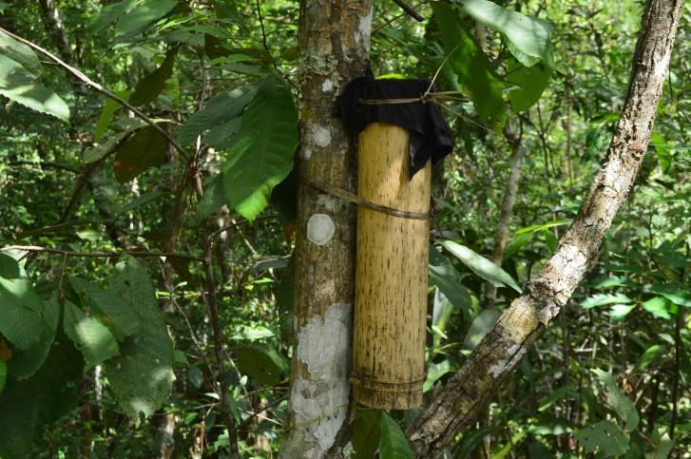
Photo Credit: AIPP

In Indigenous Karen culture in Thailand, when a new baby is born, the father of the baby will put the baby’s umbilical cord in the bamboo and tie it with the tree. The tree will become the sacred place where the soul/spirit of the baby resides, and no one is allowed to cut down the tree.

The tree has to be a naturally grown and healthy tree that can bear fruit. Father should know the name and the benefits of the tree and should transfer this knowledge to his child. This practice shows the spiritual relationship between indigenous peoples and forests. This practice of tree conservation among Karen Indigenous Communities in Thailand is called De Por Htoo (Umbilical Cord Tree)

3. Tagal System in Malaysia

With the declining fish stocks and species, the indigenous communities in Sabah, Malaysia decided to revive its indigenous governance and management system called the Tagal Hutan. The governance and management system involve the collective ownership and responsibility for the sustainable use of resources.

Partners of Community Organizations in Sabah (PACOS), a member of AIPP, was instrumental in reviving this system starting with inland fisheries among the Kadazandusun communities. Several community champions were mobilized and they revived the system, and the management covers hundreds of kilometers now. The system is so successful that the Sabah Fisheries Department has formally recognized the system under the Sabah Inland Fisheries and Aquaculture Enactment 2003.

Tagal means prohibition in the Kadazan language, while hutan means forest in Bahasa Malaysia. The system is now extended to conservation and protection of land, forest, water catchment and wildlife.

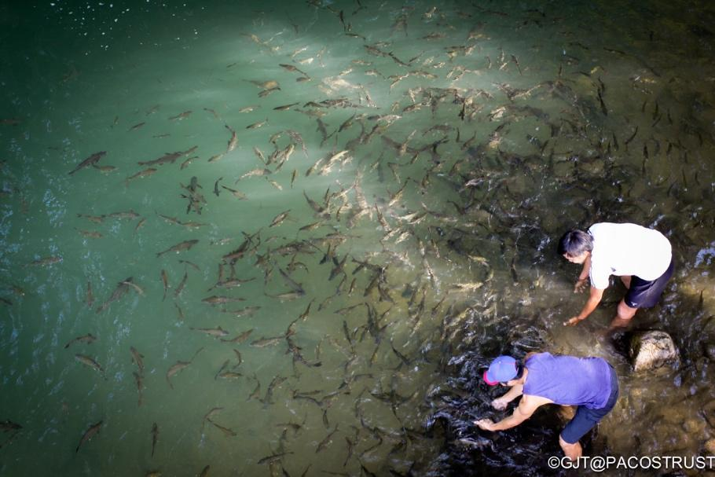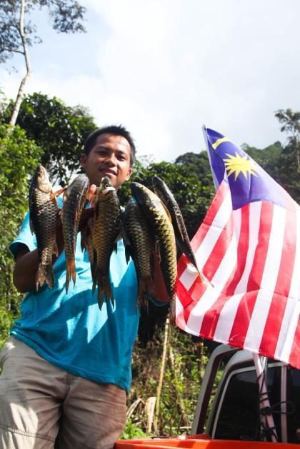

4. Community Mapping

Community mapping is a very important tool for indigenous peoples in Asia to manage their resources sustainably as well as to assert their rights to lands, territories, and resources. Community mapping has enhanced their resource management, food security and propagation of indigenous knowledge among several communities in Asia. In Thailand, Inter Mountain Peoples Education and Culture in Thailand Association (IMPECT), one of the AIPP members, has long been supporting community mapping in Thailand. IMPECT has so far supported community mapping in more than 80 villages in Northern Thailand. Indigenous peoples who have benefitted from the mapping initiative include: Akha, Dara-ang, Hmong, Kachin, Lahu, Lisu, Lua, Karen, Mien and Shan groups.

AIPP member organizations in India, Indonesia, Malaysia, and Vietnam are also mapping their lands, territories, and resources of indigenous peoples

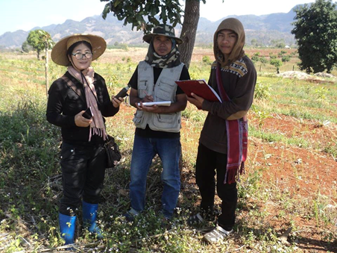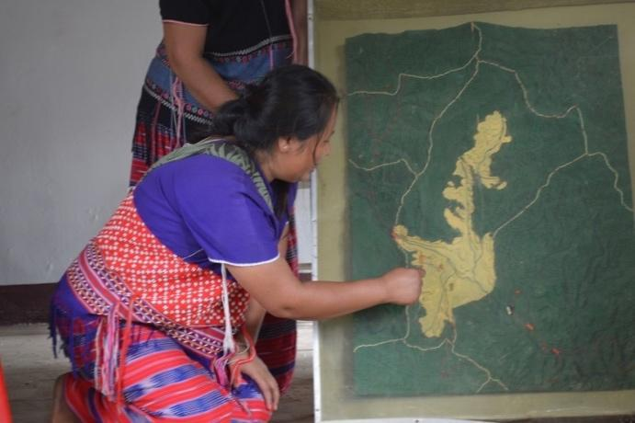

Pictures Credit: IMPECT

ANNEX 3: Indigenous Women’s Participation in Forest Landscape Restoration and Protection: A case of Paran Women Group, Narok County of Kenya
Written by Edna Kaptoyo / Women4Biodiversity

Indigenous women are playing relevant role in e forest landscape restoration that is also a water tower. They undertake this protection and restoration of forest ecosystems in a coordinated and collective manner as women groups. An example is Paran Women Group in Ololunga,Narok County of Kenya, who are part of Enkutuk Entim Community Forest Association(CFA) a collective community forest user group formed in 2005 that brings together women groups form Maasai and Ogiek communities bordering Mau forest in Narok county Kenya. The women groups form part of the 24 user groups, which is a platform bringing them together to voluntarily manage tree nurseries, plant trees in degraded forest, conduct environmental education in the community and schools and reduce poverty by investing in the community. The group has made significant contributions towards restoring Mau Forest and preserving its biodiversity, who have over the past 10 years helped restore part of Mau forest ecosystem , as well as introduced farm nurseries and ensuring each member household dedicates some land space for trees to practice farm forestry using their traditional knowledge of propagating indigenous seed species and where to grow and helped restore over 10,000ha of the land. They have initiative in the community of making briquettes as an alternative energy source so as to reduce deforestation from fuel wood demand and innovated the traditional cook-stove that is fuel efficient and uses briquette. The initiative has also increased awareness among community members on the importance of forest conservation among school children, with schools even greening their spaces.

Since 2016 Paran Women Group has been able to train more than 30 indigenous women groups from Kenya Narok county, West Pokot County and Marsabit County on tree nursery and planting, now they have vibrant tree nurseries that is supplying their community and schools with tree seedlings and are able to get income to support their households and protect their water catchment areas.

Despite the relevant role played by Indigenous women in protection of forest ecosystem, they are not yet still recognized as agents of change and space for their voice in decision making spaces including in forest related initiatives is minimal. Indigenous women still have challenges in accessing resources and other technical support to scale up these efforts that can be replicated in other areas.

They have been engaging with county government in dialogues to address other challenges like access to markets for their briquettes, more training on other livelihood options and advocating for the recognition of indigenous women’s contribution in forest protection and involvement in planning and implementation of initiatives.
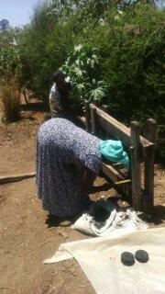

Photo (left): Paran Women group members making briquette (Photo credit: Naiyan Kiplagat)

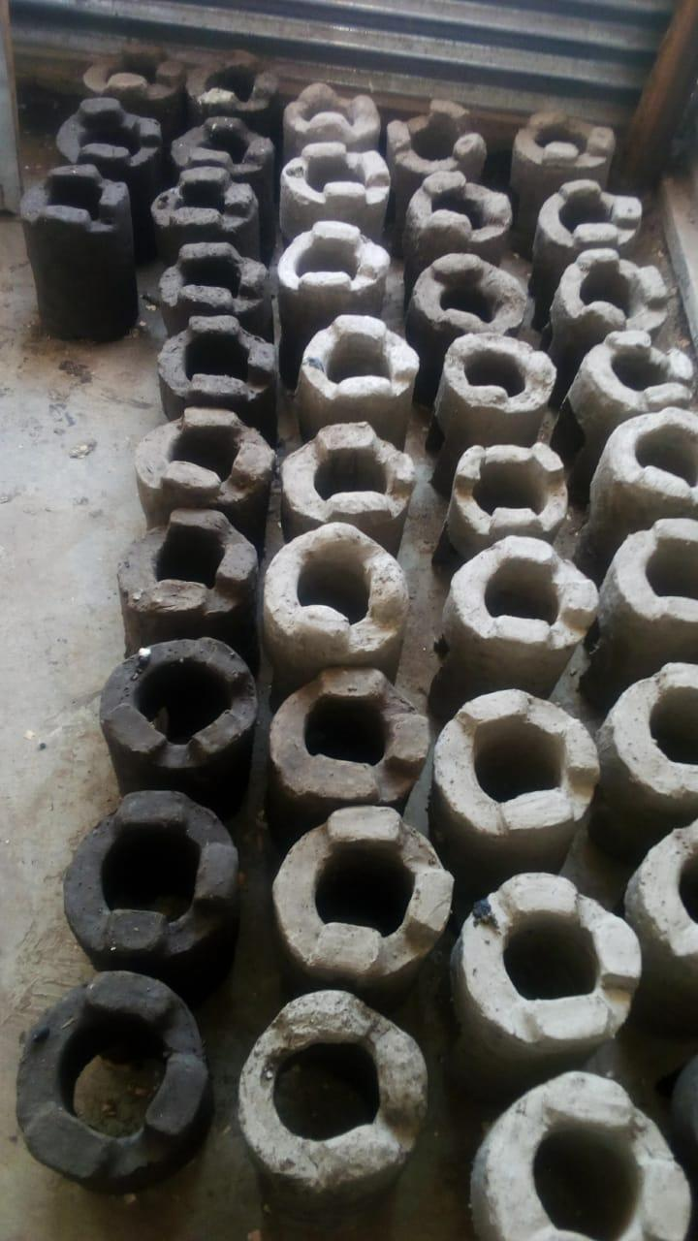
Photo (right): Paran Women Group traditional fuel efficient cookstoves (Photo credit: Naiyan Kiplagat)

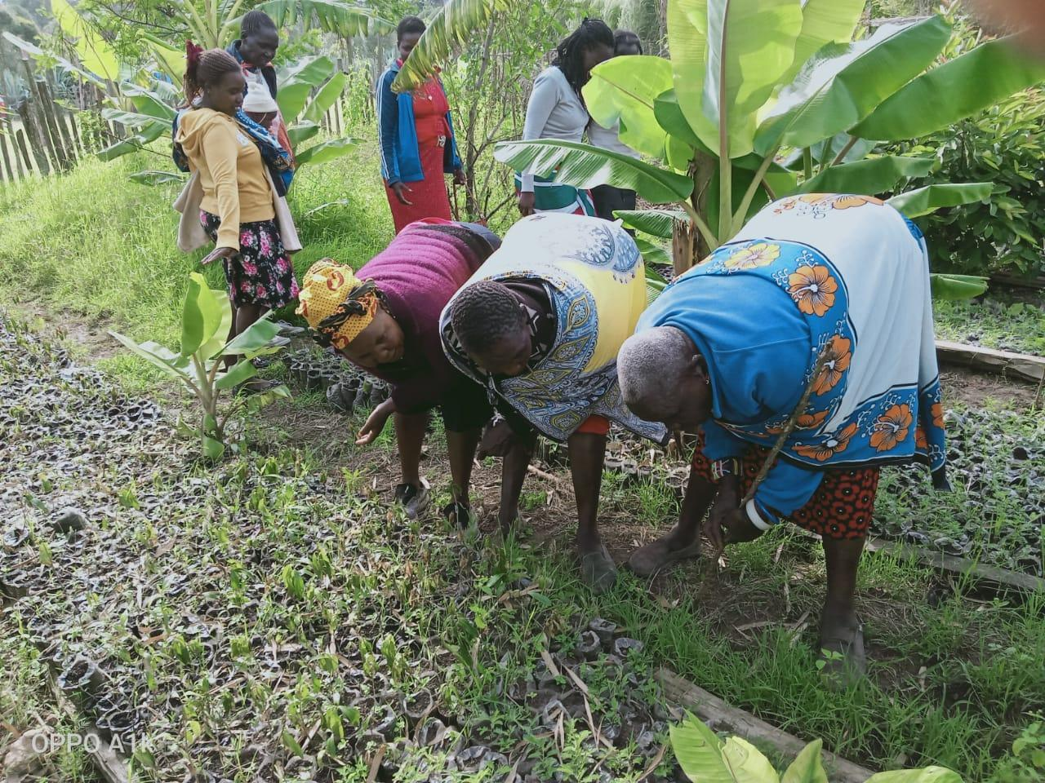
Photo: Paran Women Group members in their tree nursery from (Photo credit: Naiyan Kiplagat)

Protection of gourd seeds
Traditionally among Pokot indigenous peoples of Kenya, the gourd is an important plant that is used culturally to make storage items for milk and as ceremonial items e.g. gifts during weddings or for offerings.

With climate change the gourd which is usually found in the wild have become scarce and disappearing in some areas, hence Parakiror women group from West Pokot are preserving the seeds through transplanting them in homesteads' and sharing the seeds with other indigenous women’s groups from other communities.

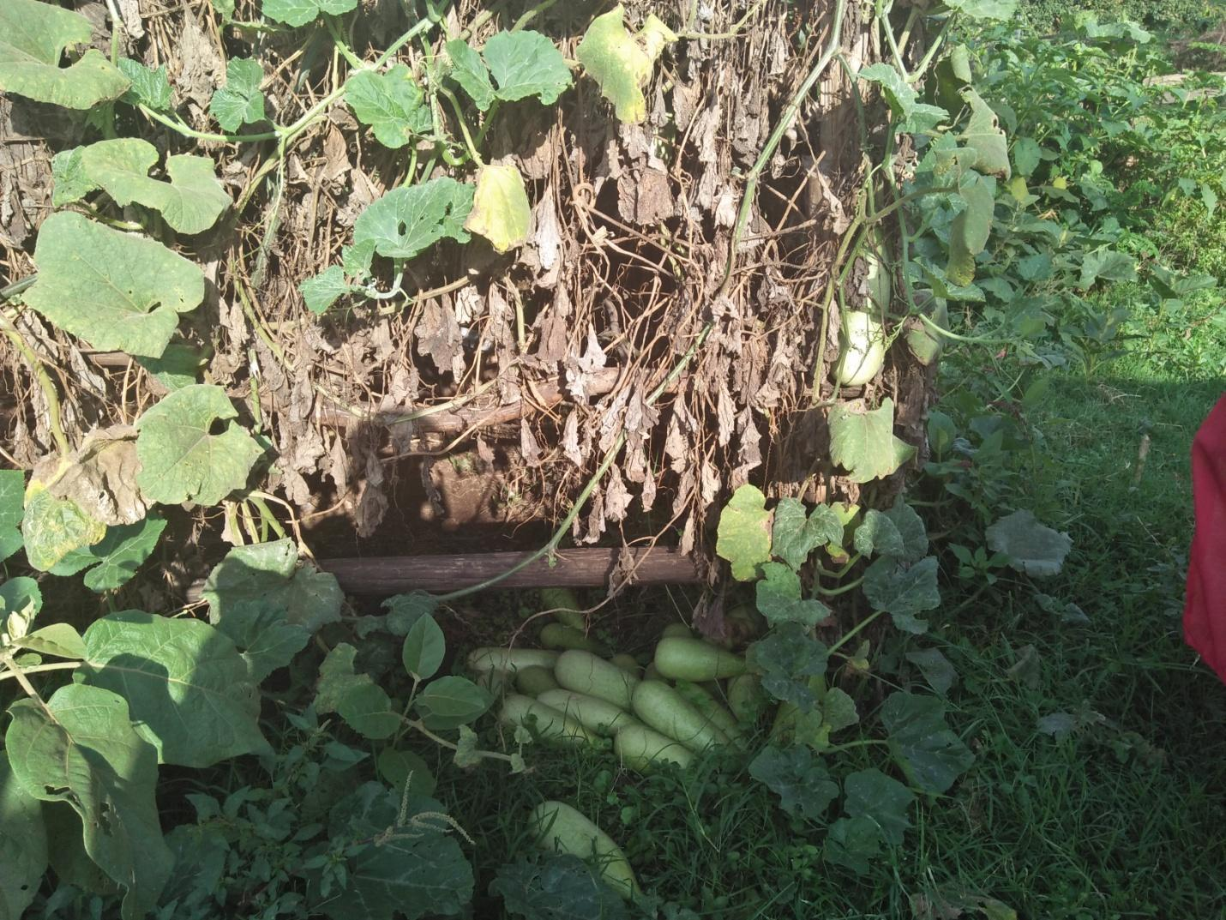
Photo: Mature gourd plant from collected seeds (Photo credit: Edna Kaptoyo)

ANNEX 4: CASE STUDY ON RIGHT TO WATER AND COMMUNITY-LED BIODIVERSITY CONSERVATION, BARNES HILLS, ANTIGUA AND BARBUDA

Information presented by Ms. Ruth Spencer, Women4Biodiversity Board Member and Ms. Sashagay Middleton, MEPA Trust Program Officer

The case study seeks to respond to and provide an example of good practices in preventing, reducing, or eliminating harm to biodiversity and ecosystems, or restoring and rehabilitating biodiversity and ecosystems in Antigua and Barbuda as a local community group restores an important water management site mentioned in our national archives which has numerous mentions with records of letters of communication in the Archives of Antigua and Barbuda.

The earliest records spoke to the village of Barnes Hill with 2500 persons suffered from having no water, and had to get pipe borne water twice per week but many times this was not available and the village tank had to be supplemented by a water truck weekly. The catchment at times could only supply 1-2 buckets daily to each person per week. The drought was so bad during this period that the water of other Ponds, although unfit for human consumption, was a great help as the water could be used for washing.
The reservoir was commissioned in 1893 and was used to store water for the community which numbered about 2500 persons. Even in those years’ water testing was done to track the quality of the water in the tanks, the size of the catchment area surveyed and a determination made that it holds about 70,000 gallons with the costing provided (Tomlinson 1953; 1961).

The reservoir and the surrounding areas gradually went into ruins was completely covered over by large trees with the spill ways all broken up and non-functional, and was forgotten until the ongoing 5-year drought impacted the island in 2015. to the extent where pipe borne water into homes was in short supply and the country’s ground water supply was totally exhausted. The Barnes Hill Community Development Organization (BHCDO) was established and embarked on the restoration of the reservoir.

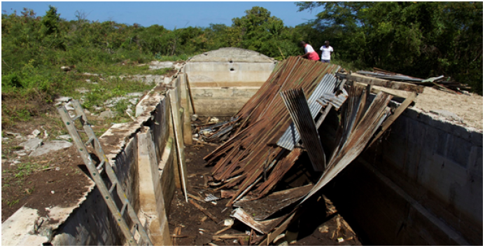

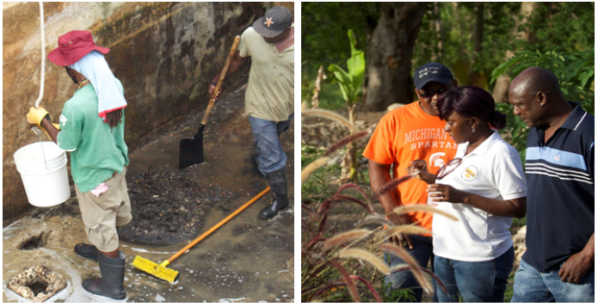

The past evidence gleaned in the Archives demonstrate and show that there was concern and understanding about people’s right to water as far back as the 1890’s and efforts made in spite of the ongoing drought conditions to provide relief by constructing 5 reservoirs across the island and they were well engineered, well designed and constructed so that today 127 years later there are no cracks and all still holding water with only the roof made of galvanize sheets rotten.

The questions that come to mind are why have such past innovations not being continued, expanded and replicated by our current government, why were the 5 reservoirs that were carefully built in specially chosen locations left in ruins to decay and in dilapidation. This example demonstrates, increases in Community Conserved Areas, with declining rates of deforestation and progress in the recovery of species that were previously threatened or endangered and in extinction. Plants and Flowers of all types being planted and attracting butterflies, bees and insects of all types having habitats in the area protect and save our pollinators. Plants provide food support livelihoods and provide medicines, herbs and teas. This shows good practices in preventing, reducing, or eliminating harm to biodiversity and ecosystems, and restoring and rehabilitating biodiversity and ecosystems.

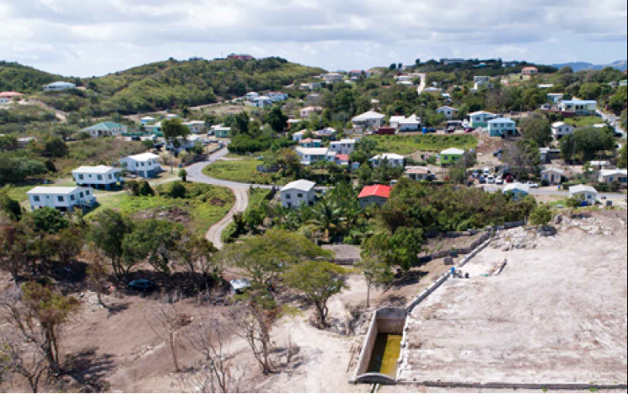

The site is now a living lab where ecosystems are being rejuvenated. Now, the loss and degradation of the biodiversity is taken over by food production and fruit tree planting, bringing back the lost history of a village once known as the “sugar apple bread basket of the island” which has led to the uncovering of an important heritage site. The people from different walks of life, who never worked together initiated the restoration of the derelict reservoir bringing back the culture and history which strengthened community cohesion, mutual respect, honoring each other and their various contributions which demonstrate a powerful commitment seen as marvelous in the eyes of everyone. The massive replanting efforts will lead to land degradation neutrality supporting and providing many other benefits to nature.

The restoration of the reservoir has revived and brought alive the traditional knowledge and practices and has led to the documentation of the processes once used in the past. The video stories and pictures shared by the elders all tell the stories of what communities endured in the past to obtain water and the sacrifices they made. The stone ponds help. There is now a design of a traditional stone pond in the area now holding water on its own without any liner. And more will be constructed since the land is sloped to catch and hold all the available run off ground water to support the agro ecology and agro forestry with gardens planted with local trees and plants using local see varieties that has adapted to local climatic conditions planting grasses local soil nitrification processes and using of composts producing local crops for food and fruit production.

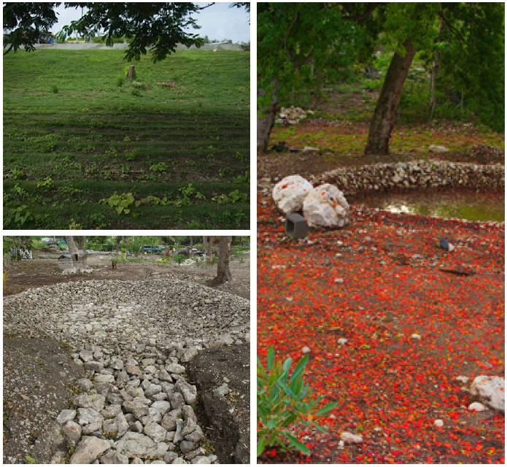

Annex 5: CASES FROM JAPAN
Submitted by the Japan Civil Network for the UN Decade on Biodiversity

In Japan, there are many cases of human rights impacts related to biodiversity loss and ecosystem degradation due to mega-developments planned and executed by national and local government. Constructions of dams, roads, bullet train tracks, airports, nuclear plants, and US/Japan military bases were all developed forcefully. These projects triggered the degradation of ecosystems and the loss of nature overall. Local people’s livelihoods were affected, their habitats destroyed and their cultural wealth and livelihoods supported by biodiversity were lost.

1. The Ihsiki Dam

There is an example of an ongoing dam construction called ’Ishiki-dam’ in the small village called ‘Koubaru’ located in Nagasaki prefecture in Southern Japan, which is attracting increasing attention from all over Japan as this construction is about to start. The construction plan of the ‘Ishiki-dam’ started with a field investigation in 1962. In 1975, the construction ministry at that time had approved the plan; however, this was stopped in the face of the vehement resistance of local people. In spite of this situation, the Japanese government approved this project in 2009 and in 2013, residents were forced out of their place.

The purpose of ‘Ishiki-dam’ was to ensure water supply for the cities around it and to prevent floods. However, the population of those cities are drastically decreasing and this causes the water demand to decrease. In terms of the flood prevention, researchers point out that this can be addressed without this dam by maintaining the river flow. The original justification of the dam construction is no longer valid, yet the development is pushed forcefully by taking away houses and lands of local people. 54 people (13 families) still live there, and their rights to livelihoods, environment, habitat, and private ownership are all in a precarious situation.

The Land Expropriation Act enables the nefarious activities by the authorities. This law allows the expropriation and use of land for public benefit. However, the fact is that the law was utilized to push this unjustified and inappropriate project in a rapid way. This was executed for the rights and interests of specific people, mostly the construction companies, in the name of the ‘public’ project designated by the government at that time. If people were against it, they were defined as law breakers who are preventing the ‘public’ benefit. There are many cases in which lands of local people were expropriated extremely violently by using police authority. The Land Expropriation committee consists of seven people who decide whether to expropriate the land or not. This committee must be independent from the national and local government, organize hearings and research from a fair and neutral standpoint, and hear the voices from the companies and local communities equally. Then they make a final decision on the benefit as a public project. However, when deciding the members of the committee, the right to nominate is only on the hands of the chief of the local government, who is usually on the side of the company pushing the projects. Due to this situation, the expropriation proposal is rarely ejected. Therefore, even when the local people and communities are against the projects that are obviously inappropriate, once the national and local government approve the project and the Land Expropriation Act is applied, any infringement of human rights is considered as legal.

The Land Expropriation Act has been applied for the ‘Ishiki-dam’, and the committee has already decided that the government can take away the rights of the local people under the legal protection. 54 people (13 families) living there have been against this project for more than 40 years. This resistance has been carried for three generations and now the grandchildren of those who first fought against it, are at the front line to protect the rich nature in their community. They stand in front of the heavy equipment and try to prevent the construction even under the rain. However, the national and local government, who is the business owner, surrounds their living spaces and properties by proceeding with the construction, and forcefully and violently exerts the expropriation of land. The purpose of this strategy is to isolate people and put them into difficult situations. Ishiki River is very small, and the rich nature has been protected by traditional ways of living. 138 endangered and near threatened species inhabit the area, and thousands of fireflies can be observed on summer nights. This beautiful landscape has been maintained, and it should be protected from going down to the bottom of a dam. Locals also insist that they cannot live without this rich nature and made up their mind to protect the inherited land for their life.

A revision and improvement of laws such as the Land Expropriation Act and the ones that promote the destruction of biodiversity and impact human rights are needed in Japan to protect biodiversity and promote its sustainable use.

2. The Fukushima disaster

The Fukushima Daiichi Nuclear Disaster impacted the health of many people by radioactive contamination. Agriculture, fishery, and forestry were destroyed through biodiversity degradation. It also caused a loss of homeland for many people, and led to suicides. These issues still remain unresolved in Japan. The Japanese government minimizes and hides the real impacts under the argument that ‘the impact of the nuclear disaster is under control.’ Yet, the fact is that the radioactive contamination is not resolved at all. The limit of containers for contaminated water has been exceeded, and the Japanese government is about to execute the draining of the contaminated water. The fishing industries are strongly against the draining of this water since it will not only affect fisheries in Japan but also the biodiversity of the entire ocean. People who work for nuclear decommissioning are in a tough situation and their health is threatened. Calculating a required period of time until radio contamination is resolved is difficult, and to remove the radioactive substances completely is almost impossible.

All nations and companies must learn from the Fukushima Daiichi Nuclear Disaster, and they should be responsible and obligated to withdraw from these types of high-risk industries.

3. The Takao Mount tunnel in Tokyo

One of the major challenges is in the imbalance of the power between ministries. The ultimate impediment in Japan is that the environmental ministry has less authority compared to other ministries.

An example of this is the tunnel built in Takao Mount in Tokyo. This mountain is a well-known biodiversity hotspot with about 1500 kinds of plants and trees which is the largest number in Japan. Also 5000 species of insects, and 160 kinds of birds are observed. It is the mountain with the richest biodiversity and specified as a conserved area by the government. As this place is close to the urban cities, it is a place of leisure and enjoyment for the city people. However, in 1987, the national government launched a project of a new tunnel for a highway, and even though local people resisted it for 25 years, the project was forcefully implemented (the Land Expropriation Act was applied). At that time, the environmental ministry understood well that they should protect Takao Mountain. However, they could not resist against the ministry of Land, Infrastructure, and Transport which has a huge authority, and approved the project.

It is also heard that even when companies understand the problems related to a project, once the companies receive the order of a mega construction from the government, they cannot resist. The weak authority held by the environmental department in the national government and companies is a huge impediment to conserve biodiversity.

Another huge impediment is that mass media is subordinated to the government. Although many journalists and reporters have tried several times the negative impacts of the construction of the tunnet in Takao Mountain, they were suppressed by the government and the companies involved. Thus, this issue was hardly reported to the public. This is violating the right to access to information.

Most mega developments that harm the ecosystem and biodiversity are owned by the government and large companies, but we still have the right to know about their impacts on our lives and decide if we want them or not. Utilizing social networks such as Facebook, Twitter is important but at the same time, the education of media literacy has to be provided to enhance the literacy of people.

4. Land and environmental defenders

An international watch system needs to be put in place when the government is not protecting the human rights of land and environmental defenders.

The Japanese government has not been working on protecting the human rights of environmental and land defenders. Environmental defenders are struggling under the fear of violence, threats and discrimination. Therefore, it is necessary to develop domestic laws in order to protect individuals and communities working on biodiversity issues. However, when biodiversity conservation is in conflict with the interests of the government, such as the construction of the Henoko U.S. Army Base in Okinawa Prefecture, as shown below, domestic law alone cannot solve the problem. This is because the government is the main body implementing domestic laws, these laws are often implemented arbitrarily. To solve these problems, we need an international watch system and an international environmental court on biodiversity. Investigations and reviews should be conducted by experts who are impartial third parties and where human rights of environmental defenders and local people who protect biodiversity are violated, strong recommendations and strict penalties should be imposed on the government. The system must also be designed so that any individual or community, including indigenous peoples, who conserves biodiversity can easily appeal without a heavy financial burden.

The following is an example of cases that cannot be dealt with only by improving domestic laws: Even though the developments are causing huge environmental destruction, the Japanese government never negotiated this aspect with the US government regarding military facilities such as the construction of the Henoko (Okinawa) US Base. Even worse, the environmental defenders are suppressed by police violence and slander. The local government opposed the plan of the base and repealed the approval of development by the national government. However, the Okinawa Defense Bureau, which is a part of the national government, demanded the investigation for the decision made by the local government based on an Administrative Appeal Act. This demand for investigation was based on a law which is supposed to be used by citizens in the case of opposition to government decisions. The Okinawa Defense Bureau filed against the ministry of Land, Infrastructure, Transport in order to overturn the decision made by the local government. This meant that one of the departments under the national government acted as a citizen and filed against the national government. The plaintiff (Defense Bureau) and the judge (national government / Ministry of Land, Infrastructure, Transport) are both national institutions. The judge who belongs to the national government approved the demands by the Okinawa Defense Bureau and the construction was restarted. Furthermore, in retaliation, the funds provided from the central to the local government were cut. When the national government is suppressing local authorities in order to proceed with their projects, international alert systems are required to stop the government´s abuses.

In the construction of a US military helipad in Takae village, Okinawa, SLAPP (Strategic Lawsuits Against Public Participants) were applied to the environmental defenders. To protect the biodiversity and ecosystem, SLAPP must be prohibited globally. The government of each country should make a law so that SLAPP is never accepted and policies are required that enable environmental defenders to file cases against the government when needed.

A/HRC/40/55
A/74/161
A/HRC/43/53
Please see for further details: https://swed.bio/wp-content/uploads/2020/02/Report-of-the-Thematic-Workshop-on-Human-Rights-as-enabling-condition-in-the-post-2020-Global-Biodiversity-Framework.pdf
PACOS Trust (n.d.) Who Are We. Sabah: Pacos Trust. Available at: https://pacostrust.com/about/who-are-we/
Indigenous Peoples Human Rights Defenders Network (2019) Country Celebration of The International Day of The World’s Indigenous Peoples. Chiang Mai: Indigenous Peoples Human Rights Defenders Network. Available at: https://iphrdefenders.net/the-international-day-worlds-indigenous-peoples-2019/
Indigenous Peoples Human Rights Defenders Network (2019) Country Celebration of The International Day of The World’s Indigenous Peoples. Chiang Mai: Indigenous Peoples Human Rights Defenders Network. Available at: https://iphrdefenders.net/the-international-day-worlds-indigenous-peoples-2019/ | Al Jazeera (2019) Which US States are celebrating Indigenous Peoples’ Day? Doha: Al Jazeera. Available at: https://www.aljazeera.com/news/2019/10/states-celebrating-indigenous-people-day-191014172801125.html | Fadel, L. (2019) Colombus Day Or Indigenous Peoples’ Day? Washington D.C.: NPR. Available at: https://www.npr.org/2019/10/14/769083847/columbus-day-or-indigenous-peoples-day
Russian News Agency TASS (2017) Russian Artic regions organize nomadic kindergartens, schools. Moscow: Russian News Agency TASS. Available at: https://tass.com/economy/941370 / Artic Council and Sustainable Development Working Group (n.d.) Artic Preschool Education. Artic Council and Sustainable Development Working Group. Available at: https://www.sdwg.org/activities/sdwg-projects-2017-2019/arctic-preschool-education/
Story contributed by Polina Shulbaeva, Russian Indigenous coordinator for the International Indigenous Forum on Biodiversity at the Convention on Biological Diversity process, and the Center for Support of Indigenous Peoples of the North.
M. M. Kansanga, I. Luginaah, R. Bezner Kerr, E. Lupafya & L. Dakishoni (2020) ‘Beyond ecological synergies: examining the impact of participatory agroecology on social capital in smallholder farming communities’, International Journal of Sustainable Development & World Ecology 27(1), pp. 1-14. Hilmi, A. (2018) Agroecology: Reweaving a New Landscape. London: Palgrave Macmillan.
Anderson, C., Bruil, J., Chappell, M. J., Kiss, C. and Pimbert, M. P. (2019) ‘From Transition to Domains of Transformation: Getting to Sustainable and Just Food Systems through Agroecology’, Sustainability 11(19).
Toledo, V. M. and Moguel, P. (2012) ‘Coffee and Sustainability: The Multiple Values of Traditional Shaded Coffee’, Journal of Sustainable Agriculture 36(3), pp. 353-377.
Grouwels (2018) Forest and Farm Facility Country Achievements: Liberia. Food and Agriculture Organization of the United States.
Pimbert, M. P. and Borrini-Feyerabend, G. (2019) Nourishing life – territories of life and food sovereignty. Policy brief of the ICCA Consortium no. 6. Various: ICCA Consortium, Centre for Agroecology, Water and Resilience at Coventry University and CENESTA.
The Sulagad system also highlights the importance of governance: in the practice of the sulagad system is their indigenous governance system, which is called the Teduray-Lambangian Timuay Justice and Governance. Their governance system actively asserts their right to self-determination, which includes the practice of their sulagad system. Aside from dealing with internal conflicts, the governance system has also sought out support from other actors for the strengthening and revival of their sulagad system. More info can be found here: Focus on the Global South (2018, Augusr 8). Sulagad: Our Life, Our Future. Video accessed at https://youtu.be/91wvcm4jgG8)
Senjuti Khisa, Maleya and the Women’s Resource Network. (2011). The Women of the Chittagong Hill Tracts and their Experiences on Climate Change in Indigenous Women, Climate Change and Forests. Tebtebba Foundation
Institut Dayakologi. (2018). Indigenous Territory Management System: Dayak Jalai Indigenous Community in Kampong BatuMenang in Enhancing indigenous peoples’ development through community-based monitoring and information systems (CBMIS). Tebtebba Foundation; p. 310
Forest Peoples Programme, the International Indigenous Forum on Biodiversity and the Secretariat of the Convention on Biological Diversity (2016) Local Biodiversity Outlook: Indigenous Peoples’ and Local Communities’ Contributions to the Implementation of the Strategic Plan for Biodiversity 2011-2020. A complement to the fourth edition of the Global Biodiversity Outlook. Moreton-in-Marsh, England. Available at: https://www.cbd.int/gbo/gbo4/publication/lbo-en.pdf
Bellis, K.X.T., Peel, R.T., Irvine, R.L., Howald, G., and Alsop, G.J. (2019) Beyond biodiversity: the cultural context of invasive species initiatives in Gwaii Haanas. In Veitch, C.R., Clout, M.N., Martin, A.R., Russell, J.C. and West, C.J. (Editors) Island invasives: scaling up to meet the challenge. Occasional Paper SSC no. 62. Gland: IUCN.
Secretariat of the Pacific Regional Environment Programme (2016) Battling Invasive Species in the Pacific: Outcomes of the Regional GEF-PAS IAS Project Prevention, control and management of invasive species in the Pacific islands. Apia: Secretariat of the Pacific Regional Environment Programme. Available at: https://www.sprep.org/attachments/Publications/BEM/battling-invasive-species-pacific.pdf
AsiaNews EN (2019) Cambodian indigenous group files lawsuit against French company over seized land. Milan: AsiaNews EN. Available at: http://asianews.it/news-en/Cambodian-indigenous-group-files-lawsuit-against-French-company-over-seized-land-46239.html | Kimmarita, L. (2019) Bunong group attends French court hearing over land dispute. Phnom Penh: The Phnom Penh Post. Available at: https://www.phnompenhpost.com/national/bunong-group-attends-french-court-hearing-over-land-dispute
Kimmarita, L. (2019) Bunong group attends French court hearing over land dispute. Phnom Penh: The Phnom Penh Post. Available at: https://www.phnompenhpost.com/national/bunong-group-attends-french-court-hearing-over-land-dispute
Torres, M. (2019) Maya Leaders Alliance (MLA), Belize. Equator Initaitve Case Study Series. New York: Equator Initiative. Available at: equatorinitiative.org/wp-content/uploads/2019/02/MLA-Belize.pdf
University of British Columbia (2019) Biodiversity highest on Indigenous-managed lands. ScienceDaily. Available at: https://www.sciencedaily.com/releases/2019/07/190731102157.htm | Schuster, R., Germain, R.R., Bennett, J.R. (2019) ‘Vertebrate biodiversity on indigenous-managed lands in Australia, Brazil and Canada equals that in protected areas’. Environmental Science & Policy 101.
Walker, W., Baccini, A., Schwartzman, S., Ríos, S., Oliveira-Miranda, M.A., Augusto, C., Ruiz, M.R., Arrasco, C.S., Ricardo, B., Smith, R., Meyer, C., Jintiach, J.C. and Vasquez Campos, E. (2014) ‘Forest carbon in Amazonia: the unrecognized contribution of indigenous territories and protected natural areas’. Carbon Management 5(5-6), pp. 479-485. | Persha, L., Agrawal, A. and Chhatre, A. (2011) ‘Social and Ecological Synergy: Local Rulemaking, Forest Livelihoods, and Biodiversity Conservation’. Science 331(6024), pp. 1606-1608.
Garnett, S. T. et al. (2018) ‘A spatial overview of the global importance of Indigenous lands for conservation’, Nature Sustainability 1(7), pp. 369–374.
Díaz, S., Settele, J. Brondízio, E., Ngo, H. T., Guèze, M., Trinidad, J. A., Arneth, A., et al. (2019) IPBES Global Assessment on Biodiversity and Ecosystem Services: Summary for Policy-Makers. Bonn: IPBES. Available at: https://ipbes.net/sites/default/files/inline/files/ipbes_global_assessment_report_summary_for_policymakers.pdf
Indigenous Navigator Philippines (2019). Indigenous peoples and sustainable development goals. Tebtebba. Accessed at https://www.indigenouspeoples-sdg.org/index.php/english/all-resources/ipmg-position-papers-and-publications/ipmg-reports/national-regional-reports/127-indigenous-peoples-and-the-sustainable-development-goals-philippines/file
BMB-DENR. (no date). 2015-2028 Philippine Biodiversity Strategy and Action Plan (PBSAP). Accessed at https://fasps.denr.gov.ph/images/filedocs/ph-nbsap-v3-en_opt.pdf.)
Available at: https://iphrdefenders.net/open-letter-appeal-aipp-iwgia-prime-minister-india-supreme-court-order-13th-february-2019-fra/
This is particularly evident through measures agreed at the IUCN World Parks Congress in 2003 and the CBD Programme of Work on Protected Areas in 2004, in the formation of the Conservation Initiative on Human Rights, and in multiple Resolutions passed in subsequent World Conservation Congresses.
See Cornered by Protected Areas: Rights and Resources Initiative (2018) Cornered by Protected Areas. Washington, D.C.: Rights and Resources Initiative. Available at: www.corneredbypas.com
See, for example: Tauli-Corpuz, V. (2016) A/71/229. Report of the Special Rapporteur of the Human Rights Council on the rights of indigenous peoples, Victoria Tauli-Corpuz. New York: United Nations General Assembly. Available at: https://www.un.org/en/ga/search/view_doc.asp?symbol=A/71/229 | McVeigh, K. (2019) WWF accused of funding guards who ‘tortured and killed scores of people’. London: The Guardian. Available at: https://www.theguardian.com/global-development/2019/mar/04/wwf-accused-of-funding-guards-who-allegedly-tortured-killed-scores-of-people | United Nations Department of Economic and Social Affairs (2019) EGM: Conservation and the Rights of Indigenous Peoples 23-25 January 2019 Nairobi, Kenya. New York: United Nations Department of Economic and Social Affairs. Available at: https://www.un.org/development/desa/indigenouspeoples/meetings-and-workshops/expert-group-meeting-on-conservation-and-the-rights-of-indigenous-peoples.html
One case, among many, is the eviction of the Batwa from the Kahuzi Biega National Park in DRC. Despite continued efforts at dialogue, violence, intimidation and - recently - imprisonment of the Batwa continues. See: http://www.forestpeoples.org/en/whakatane-mechanism-rights-based-conservation/news-article/2019/drc-batwa-need-avenue-peacefully and http://www.forestpeoples.org/en/lands-forests-territories-rights-based-conservation/news-article/2020/update-batwa-communities-and
http://www.forestpeoples.org/sites/default/files/documents/EU%20suspends%20its%20support%20for%20Water%20Towers.pdf
http://www.forestpeoples.org/en/rights-based-conservation/press-release/2018/eu-suspends-funding-kenya-government-over-indigenous
See: https://dlc.dlib.indiana.edu/dlc/bitstream/handle/10535/281/Eghenter_cristina_Wulandari_Hanif_Setiyaningrum.pdf
White, S. (2017) More than half of EU biodiesel made from imported crops, study finds. Brussels: EURACTIV. Available at: https://www.euractiv.com/section/agriculture-food/news/more-than-half-of-eu-biodiesel-made-from-imported-crops-study-finds/
Forest Peoples Programme (2016) EU tour by indigenous, community and NGO leaders highlights impacts of palm oil supply chains on communities and their lands and forests. Moreton-in-Marsh: Forest Peoples Programme. Available at: https://www.forestpeoples.org/en/enewsletters/fpp-e-newsletter-august-2016/news/2016/07/eu-tour-indigenous-community-and-ngo-leaders-
Forest Peoples Programme (2018) Indigenous peoples and forest defenders defy murder and intimidation to call on European governments to uphold their human rights commitments and tackle deforestation commodities. Moreton-in-Marsh: Forest Peoples Programme. Available at: https://www.forestpeoples.org/en/climate-forests-redd-and-related-initiatives-global-finance-trade-public-sector-european-union-and.
Kuhlmann, W. and Putt, P. (2018) Are Forests the New Coal? A Global Threat Map of Biomass Energy Development. Asheville: Environmental Paper Network. Available at: https://environmentalpaper.org/wp-content/uploads/2018/11/Threat-Map-Briefing-Are-Forests-the-New-Coal-01.pdf
LeBlanc, J. (2019) Indigenous-led movement to stop fossil fuels. Washington D.C.: The Hill. Available at: https://thehill.com/opinion/energy-environment/444574-indigenous-led-movement-to-stop-the-fossil-fuels. | Bassey, N. (2015) ‘We thought it was oil but it was blood: Resistance to the military-corporate wedlock in Nigeria and beyond’, in The Secure and the Dispossessed – How the Military and Corporations are Shaping a Climate-changed World. London: Pluto Press.
Lakhani, N. (2020) Dakota access pipeline: court strikes down permits in victory for Standing Rock Sioux. London: The Guardian. Available at: https://www.theguardian.com/us-news/2020/mar/25/dakota-access-pipeline-permits-court-standing-rock
Kuhlmann, W. and Putt, P. (2018) Are Forests the New Coal? A Global Threat Map of Biomass Energy Development. Asheville: Environmental Paper Network. Available at: https://environmentalpaper.org/wp-content/uploads/2018/11/Threat-Map-Briefing-Are-Forests-the-New-Coal-01.pdf Auciello, B. H. (2019) A Just(ice) Transition Is a Post-Extractive Transition: Centering the Extractive Frontier in Climate Justice. London: War on Want and London Mining Network. Available at: https://waronwant.org/sites/default/files/Post-Extractivist_Transition_WEB_0.pdf
Llanos, R. E. and Feather, C. (2011) The reality of REDD+ in Peru: Between theory and practice. Moreton-in-Marsh: Forest Peoples Programme. Available at: http://www.forestpeoples.org/sites/fpp/files/publication/2011/11/reality-redd-peru-between-theory-and-practice-november-2011.pdf
McFarland, W., Whitley, S. and Kissinger, G. (2015) Subsidies to key commodities driving forest loss: Implications for private climate finance. London: Overseas Development Institute. Available at: https://www.odi.org/sites/odi.org.uk/files/odi-assets/publications-opinion-files/9577.pdf
Mainhardt, H. (2017) World Bank development policy finance props up fossil fuels and exacerbates climate change: findings from Peru, Indonesia, Egypt and Mozambique. Washington D.C.: Bank Information Centre. Available at: https://www.re-course.org/wp-content/uploads/2017/11/Study-2-Executive-Summary-of-DPL-reports.pdf
https://ipbes.net/sites/default/files/2020-02/ipbes_global_assessment_report_summary_for_policymakers_en.pdf
http://www.katibainstitute.org/wp-content/uploads/2020/05/Defending-our-future-Ogiek-Report.pdf
See, for instance, https://www.thejakartapost.com/academia/2020/03/09/2020-super-year-for-women-in-biodiversity.html
Del Gatto, F. (2018) Mid-term review – Project GUY-16/0001: Protecting Forests Through Protecting Rights in Guyana. Rainforest Foundation US. Available at: http://www.rainforestfoundation.org/wp-content/uploads/2018/08/Protecting-Forests-Through-Protecting-Rights-in-Guyana.pdf
Forest Peoples Programme (2017) Prensa: Los Pueblos indígenas del Territorio de Vida enviamos un mensaje al mundo. Moreton-in-Marsh: Forest Peoples Programme. Available at: https://www.forestpeoples.org/es/global-environment-facility-gef/press-release/2017/prensa-los-pueblos-indigenas-del-territorio-de.
AIDESEP (Inter Ethnic Association for the Development of the Peruvian Amazon) and FPP (Forest Peoples Programme) (2018), The role of international climate finance in securing indigenous lands in Peru: Progress, setbacks and challenges. Moreton-in-Marsh, UK. Available at: https://www.forestpeoples.org/sites/default/files/documents/A_marathon_print.pdf
Macqueen, D., Bolin, A., Greijmans, M., Grouwels, S. and Humphries, S. (2020) ‘Innovations towards prosperity emerging in locally controlled forest business models and prospects for scaling up’, World Development. 125.
Macqueen, D. (2019) Vietnamese forest and farm producers work towards more resilient livelihoods and landscapes. London: International Institute for Environment and Development. Available at: https://www.iied.org/vietnamese-forest-farm-producers-work-towards-more-resilient-livelihoods-landscapes.
Food and Agriculture Organization of the United Nations (n.d.) FAO’s work with indigenous peoples in forestry. Rome: Food and Agriculture Organization of the United Nations. Available at: http://www.fao.org/3/ca4293en/ca4293en.pdf
Non-Timber Forest Products Exchange Programme (n.d.) Exchange News. Non-Timber Forest Products Exchange Programme. Available at: https://ntfp.org/
International Partnership for the Satoyama Initiative (n.d.) About IPSI. Tokyo: International Partnership for the Satoyama Initiative. Available at: https://satoyama-initiative.org/about/
https://naturaljustice.org/the-rooibos-access-and-benefit-sharing-agreement
Full text of the judgement : https://naturaljustice.org/wp-content/uploads/2019/06/26-June-2019-Judgment_NET_Save-Lamu.pdf
www.namati.org
Statistics on killings and violence against defenders is often inconsistent due to reporting challenges for communities, no centralised statistic gathering operation and inconsistencies in definitions. However all data sources show increased rates of violence (Frontline Defenders, Amnesty, Global Witness, Swedish Society for Nature Conservation (SSNC), Peace Brigades International, among many others
https://www.frontlinedefenders.org/sites/default/files/global_analysis_2019_web.pdf
https://www.iwgia.org/en/focus/global-governance/3276-violence-indigenous-women.html
https://www.indigenousrightsinternational.org/index.php/en/
https://www.landcoalition.org/en/explore/our-work/human-rights/defend-defenders-coalition/
https://www.zerotoleranceinitiative.org/
Indigenous Circle of Experts (2018) We Rise Together: Achieving Pathway to Canada Target 1 through the creation of Indigenous Protected and Conserved Areas in the spirit and practice of reconciliation. Indigenous Circle of Experts. Available at: https://static1.squarespace.com/static/57e007452e69cf9a7af0a033/t/5ab94aca6d2a7338ecb1d05e/1522092766605/PA234-ICE_Report_2018_Mar_22_web.pdf
Linnitt, C. (2018) Canada Commits Historic $1.3 Billion to Create New Protected Areas. Victoria: The Narwhal. Available at: https://thenarwhal.ca/canada-commits-historic-1-3-billion-create-new-protected-areas/
Indigenous Leadership Initiative (2017) RELEASE: National Indigenous Guardians Network Receives Funding in Federal Budget. Ottawa: Indigenous Leadership Initiative. Available: https://www.ilinationhood.ca/2017/03/22/release-federal-budget-indigenous-guardians/
Pimachiowin Aki (n.d.) Pimachiowin Aki. Winnipeg and Ontario: Pimachiowin Aki. Available at: https://pimaki.ca/
Bell, S. (2018) Cree Nation identifies 30 per cent of its territory in conservation wish list. Toronto: CBC News. Available at: https://www.cbc.ca/news/canada/north/conservation-cree-quebec-plan-nord-hunt-trap-1.4941383
Parks Canada (2019) National Marine Conservation Areas: Tallurutiup Imanga National Marine Conservation Area Inuit Impact and Benefit Agreement. Quebec: Parks Canada. Available at: https://www.pc.gc.ca/en/amnc-nmca/cnamnc-cnnmca/tallurutiup-imanga/entente-agreement
Forest Peoples Programme (n.d.) The struggle of Shipibo community of Santa Clara de Uchunya against the expansion of oil palm. Moreton-in-Marsh: Forest Peoples Programme. Available at: https://www.forestpeoples.org/en/featured-topic/struggle-shipibo-community-santa-clara-de-uchunya-against-expansion-oil-palm
Available at: https://www.iwgia.org/images/publications//0694_AIPPShifting_cultivation_livelihoodfood_security.pdf

