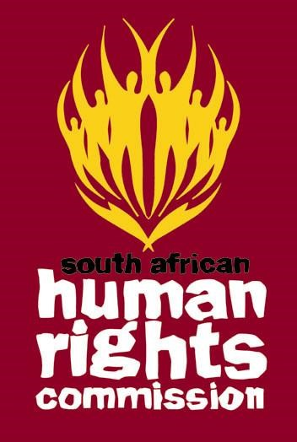

SOUTH AFRICAN HUMAN RIGHTS COMMISSION
Inputs on the Environment and the Rights of the Child
September 2017

- Introduction
The South African Human Rights Commission (SAHRC/Commission) welcomes the opportunity to respond to the queries posed by the UN Special Rapporteur (human rights and the environment) on the environment and the rights of the child.

- The Mandate of the South African Human Rights Commission
The SAHRC is an independent state institution established in terms of the Constitution of the Republic of South Africa, 1996 (Constitution). Section 184 of the Constitution stipulates that:
184. (1) The South African Human Rights Commission must —
- Promote, respect for human rights and a culture of human rights;
- Promote the protection, development and attainment of human rights; and
- Monitor and assess the observance of human rights in the Republic.
Section 13 of the South African Human Rights Commission Act 40 of 2013 expands on the powers and functions of the Commission.
Accordingly, section 13(1)(a)(iv) provides,
- The Commission is competent and is obliged to-
- Consider such recommendations, suggestions and request concerning the promotion and respect for human rights it may receive from any source
It is on this basis that the South African Human Rights Commission makes the following input.
- Please provide specific examples of legislation, policies and programmes in relation to the protection of children’s rights from environmental harm.
South Africa has no dedicated legislation or policies protecting children from environmental harm, however, children are generally protected by laws prohibiting environmental harm. Children are, however, often classified as a vulnerable group which will be adversely affected by environmental harm. This was specifically identified in the National Climate Change Response White Paper (2011). There is no guidance on how the different sectors should prioritise the specific needs and vulnerabilities of children.
South Africa has about 70 legislations and policies aimed at promoting environmental rights and protecting the environment. To mention but a few; the Constitution, Promotion of Access to Information Act 2 of 2000, Promotion of Administrative Justice, National Environmental Management Act 107 of 1998, National Water Act 36 of 1998, Environment Conservation Act 1989, National Policy on Food and Nutrition Security for the Republic of South Africa 2014, White Paper on National Environmental Management of the Ocean 2014, National Environmental Health Policy 2013, Carbon Tax Policy Paper 2014 and The National Climate Change Response Strategy for South Africa .

- Please provide specific examples of good practices in environmental-related matters in the fulfilment of obligations to protect and promote children’s rights. Such examples may include practices related to: promoting the enjoyment of children’s human rights in general (e.g., rights to life, food, housing, health, water and sanitation, cultural rights, etc.); guaranteeing procedural rights of children (e.g., rights to information, participation and access to remedy); protecting children’s freedom of association and expression in this context; monitoring children’s rights affected by environmental related legislation, programmes and projects (e.g., rights to life, food, housing, health, water and sanitation, cultural rights, etc.); protecting children from adverse impacts related to environmental degradation and, in particular, children of indigenous and other minority communities; promoting children’s rights to environmental education and to play.

In 2011 the then Department of Women, Children and People with Disabilities, Department of Environmental Affairs, Overseas Development Institute and UNICEF undertook a study to review the impact of climate change on children in South Africa. The study highlighted the need to consider the impact of climate change within the context of broader development challenges facing children and families, including high levels of poverty and inequality, changing demographics, HIV and AIDS.

Section 12(1) of the Children’s Act prohibits social, cultural and religious practices which are detrimental to children’s well-being. These practices include; forced marriage (ukuthwala), child marriages, genital mutilation and virginity testing.

Eco-Schools Project is an NGO developed to support environmental awareness in the classroom and communities. The programme is aimed at creating awareness and action around environmental sustainability in schools and their surrounding communities as well as supporting Education for Sustainable Development in the national curriculum.

Project 90 by 2030 is an NGO which aims at ensuring that there is 90 percent reduction in greenhouse gas emission by changing the way citizens engage with the earth. The organisation has identified children as one of the actors to engage with in achieving its objectives. The organisation creates Leadership Clubs in schools to teach children about how to reduce carbon emission within their school and community.

- Please specify, where relevant, challenges your Government has experienced in the integration of children’s rights protection in environmental-related matters (and vice-versa).

The fact that some laws and policies recognise children as a targeted vulnerable group has not translated to specific laws and policies specifically aimed at protecting children’s rights or ensure children’s full participation.

Reasons for this failure are lack of legislation on children’s full participation; insufficient provision within programmes for participatory processes; lack of budget allocations for facilitating participation; and insufficient attention by policymakers to the issue.

- Please provide specific examples related to the regulation of corporations and other non-State actors in relation to the protection of children’s rights from environmental harm and the fulfilment of their obligations in this regard.

The South African Supreme court in Arcelormittal South Africa Ltd Vs Vaal Environmental Justice Alliance stated that all environmental laws and policies apply to corporate decisions and activities that impact on the environment.

- Please specify, where relevant, any laws or policies referring to the rights of future generations in relation to environmental matters.

Same as in No 1 above

South Africa’s Periodic Country Report on the United Nations Convention on the Rights of the Child Reporting period: January 1998 - April 2013
http://wessa.org.za/what-we-do/schools-program/wessa-eco-schools/
https://90by2030.org.za/youth-leadership/
Exploring the Impact of Climate Change on Children in South Africa, 2011.

