Call for Inputs Healthy and Sustainable Food: Reducing the Environmental Impacts of the Global Food System on Human Rights

Authors:

YOUNGO Human Rights Working Group
- Serena Bashal, United Kingdom
- Moïse Mbimbe, Cameroon
- Johann Eickenbrock, Germany
- Kaime Silvestre, Brazil
- Lucy Jordan, United Kingdom
- Sunil Bashal, United Kingdom
- Giulia Gasparri, Italy

YOUNGO Agriculture Working Group
- Oluwatosin Ogunsola, Nigeria
- Lana Weidgenant, USA
- Pramisha Thapaliya, Nepal
- Chandelle O’Neil, Trinidad and Tobago

2. How has climate change affected the global food system?
By: Serena Bashal, Sunil Bashal
Increased greenhouse gas emissions due to human activity results in climate change, creating vast alterations to global food systems (Fig. 1, Appendix). Climate variability in turn contributes to approximately 30% of global agricultural yield variability, creating uncertainty for global food systems (Verschuur et al., 2021).
Increased temperatures can reduce soil moisture, particularly in tropical and mid-continental regions (Aydinalp and Cresser, 2008; Myers et al., 2017). Consequently, this decreases water availability for crop irrigation, thus hindering crop growth (Aydinalp and Cresser, 2008; Myers et al., 2017). Further, increased temperatures can decrease livestock weight gain and reproduction, and lower efficiency for feed-conversion, potentially resulting in a decline in dairy production (Aydinalp and Cresser, 2008).
Warmer temperatures can cause plants to flower earlier than usual. This can create loss of synchronisation between pollinator species with their food sources (Bellard et al., 2012). For example, mismatched timings between peavine (Lathyrus lanszwertii) and mason bees (Hoplitis fulgida) resulted in a decline of bee populations due to pollination starvation (Van Dyke and Lamb, 2020). Yet, pollinators provide essential ecosystem services to certain food crops, and reduced pollination leads to decreased crop yields (Myers et al., 2017).
Climate change can change rainfall patterns, directly causing events such as drought. In 2007, anthropogenic climate change-induced extreme drought caused maize crop failure in Lesotho and South Africa (Lesotho’s only trading partner) (Verschuur et al., 2021). This resulted in severe food insecurity in Lesotho, whereby maize prices doubled since the previous year, and 400,000 (approxiamately 20% of the population) required emergency assistance (FAO, 2007).
Climate change can trigger changes in pests and disease patterns. Reference found that annual crop losses as a result of fungal disease alone can reduce dietary energy globally by 8.5% (Fisher et al., 2012). Additionally, changing climate patterns can increase populations of disease vectors such as flies and ticks can harm livestock (Aydinalp and Cresser, 2008). For example, Nematode worm infections are influenced by changing climates, and can harm cattle, goat and sheep (Aydinalp and Cresser, 2008).
Climate change has several other impacts on global food systems, as displayed in Fig. 1. Furthermore, sea level rise has destroyed agricultural land, particularly in coastal areas and flood-prone countries such as China (Aydinalp and Cresser, 2008; Kulp and Strauss, 2019). Meanwhile, land area most suitable for cultivation of key crops is subject to geographical shifts in response to climate change (Aydinalp and Cresser, 2008; Donelson et al., 2019). Some Global South citizens, particularly in Asia and Africa are more likely to be dependent on agricultural systems. As climate change can create uncertainty and even decline in crop yields, this creates food insecurity and potentially subjects global south citizens to poverty and hardship (Aydinalp and Cresser, 2008). One study across 15 countries in Africa, Latin America and South Asia revealed that 71% of households encountered unexpected extreme weather events (flooding, drought etc.) whilst 54% experienced food insecurity for at least one month annually (Niles and Salerno, 2018).
Definitive climate change impacts are uncertain and require more research (Myers et al., 2017). Some positive climate change impacts on global food systems exist, such as warmer temperatures extending crop season, however these are not covered in this section (Aydinalp and Cresser, 2008).

6. Please provide specific examples of good practices in preventing, reducing, or eliminating environmental impacts caused by the unstainable production or consumption of food. These examples may occur at the international, regional, national, sub-national, or local level. Examples may involve monitoring food quality; guaranteeing procedural rights (e.g. public access to food information, public participation in decision-making about the environmental impacts of producing or consuming food, access to remedies); new technologies; legislation, regulations, standards, jurisprudence and policies that address the environmental impacts of the food system; and initiatives to achieve healthy and sustainably produced food (e.g. halting land conversion for agriculture, reducing greenhouse gas emissions, reducing air and water pollution, supporting agroecology, agroforestry, organic farming and closed-loop aquaculture, increasing efficiencies, promoting healthy and sustainable diets such as plant-based, and avoiding food waste). Where possible, please provide evidence related to the implementation, enforcement, and effectiveness of the good practices.
By: Johann Eickenbrock
The introduction of "climate labels" on food products. These are labels which highlight the CO2 and CO2e footprint of the product. Most EU consumers are open to eat more sustainably but don't know how. Climate labels can help consumers to easily identify climate friendly food. The oatly Germany GmbH e.g. started a petition in Germany to make CO2e labels a law for all food products. On September 14th 2020 was the official hearing of Tobias Goj (representing Oatly) in front of the Bundestag. Over 57 000 people signed the petition by Oatly. Only 16% of consumers in the EU feel that their government is doing enough to encourage food sustainability at production and consumption levels.
Secondly the introduction of nutritional labels, showing how healthy a product is. Multiple studies have demonstrated the helpfulness of FoPLs (front-of-package labels) in raising awareness or the consumer’s understanding of the nutritional quality of pre-packaged foods. One option is the Nutri-Score system, a straightforward labelling system that uses colour codes to guide consumers at a glance on the nutritional value of food products. A study that compared the validity of 5 different nutrient labelling systems concluded that the Nutri-score system clearly stood out as the most consumer-friendly scheme. Use of the label was also associated with a better nutritional profile of supermarket purchases. Evidence now from France and elsewhere shows that this type of labelling can contribute to informing healthy choices, meeting growing consumer demands for information on healthier options and limiting the consumption of foods high in energy, saturated fats, sugar or salt, in the context of an overall improvement in the nutritional quality of diets.

8. Please specify ways in which additional protection is provided (or should be provided) for small-holders and populations who may be particularly vulnerable to unhealthy and unsustainably produced food (e.g. women, children, persons living in poverty, members of Indigenous peoples and traditional communities, older persons, persons with disabilities, ethnic, racial, religious or other minorities, migrants and displaced persons). How can these populations be empowered to produce and consume healthy and sustainably produced food?
By: Oluwatosin Ogunsola, Pramisha Thapaliya, Chandelle O’Neil
- The problem with our current system is most of the grassroot level and marginalized people don’t know about how the current food habit is undermining healthy living. So, the first step should be awareness and capacity building.
- Knowing isn’t enough if we can’t go with the implementation. There should be proper availability of food followed by access. The best way to empower these communities towards food security is giving land rights and empowering them to produce their own food, independently. The government could support them with the provision of land through low interest, improved subsidies on farm inputs and lower taxation.
- In many countries, smallholder farmers are unable to compete with the commercial farmers. Commercial farmers have access to quality land, where they produce commodities for markets and export whereas smallholder farmers have access to low quality land, so the allocation of land should be controlled by states and property rights should be ensured for smallholder farmers.
- When it comes to food and farming, smallholder farmers, women and marginalized communities are the ones who are heavily hitted by the risks and uncertainties, including the impacts of climate change. So, climate change adaptation programs including risk management strategies, farm insurance policies should be implemented.
- For small-holders to produce healthy and sustainable food, there is a need for stakeholder engagement during the development of initiatives, from nascent. They also need access to materials/ workshops to get started-tools, seed to support the development of community gardens or food coalitions where farmers pool resources and also don't have to worry about competition/ market saturation. Other key measures include standardising knowledge about biopesticides, banning environmentally toxic chemicals, checking supply chains and divesting from markets that violate human rights or use unregulated chemicals/materials to encourage more local and community based initiatives for fair trade.

9. How do you ensure that the rights of environmentalists working on food issues (environmental human rights defenders) are protected? What efforts has your Government, business, or organization made to create a safe and enabling environment for them to freely exercise their rights without fear of violence, intimidation, or reprisal?
By: Lana Weidgenant, Lucy Jordan
How do we ensure the rights of environmental human rights defenders
- Developing capacity of local groups/ lawyers to; defend rights and resources of local and indigenous communities; employ advocacy and campaign techniques; protecting their own physical and digital security.
- Ensuring accountability for those who perpetrate attacks or threaten defenders.
- Speak out loudly to advocate solidarity with these groups and call for their protection and safety.
- Require the informed and explicit consent of environmental defenders for any business project to go ahead.
- Guarantee the informed and meaningful participation of affected communities in environmental, social and human rights impact assessments.
- Sanction corruption from government and other public services, such as the police.
- Prioritise land and resources rights of local and indigenous communities.
- Suspend business projects that have harmed defenders until they can prove they have gone to lengths to reverse these harms and protect those at risk.
- Create spaces for dialogue between defenders, businesses, governments and surrounding communities.
- Ensure that aid and investment are conditional upon whether specific measures for the security of environmental defenders are in place.
- Ensure that companies implement policies to protect human rights defenders and require supplies to put in place policies of zero threats, intimidation or attacks against human rights defenders and local communities.
- Ratify the Escazu Agreement.
What the government are doing
- Doc on UK Govt protection of environmental defenders here: https://assets.publishing.service.gov.uk/government/uploads/system/uploads/attachment_data/file/819299/UK-Support-for-Human-Rights-Defenders.pdf
- UK Gov: In Environmental Bill (2020), introduced a new law which requires greater due diligence from businesses + make it illegal for UK businesses to use key commodities if they have not been produced in line with local laws protection natural ecosystems.

10. There is substantial evidence that the actions of high-income States (e.g. high levels of meat consumption, excessive calories, and food waste) are linked to adverse effects on food availability, food quality and ecosystem health in low- and middle-income States. What are ways in which high-income States should assist low-income States in reducing the environmental impacts of food systems while promoting healthy and sustainably produced food?
By: Oluwatosin Ogunsola, Lucy Jordan
High income states should:
- Raise social awareness on excessive food waste and lead initiative to reduce household and business waste.
- Lead healthy eating campaigns to reduce excessive calorie intake + diet nutrition to reduce eating in excess.
- Awareness campaigns on the excessive consumption of meat and actively promote the use of meat alternatives and reducing meat intake.
- Implement taxes on foods known to have adverse or damaging effects on local or indigenous communities.
- Ensure greater information is provided on produce and food packaging pertaining to the source of the product’s ingredients and the resource used to make the product (e.g. water, land, chemicals) to provide greater transparency in food production processes.

11. For businesses, what policies or practices are in place to ensure that activities, products, and services across the entire food system (production, processing, distribution, marketing, retail, food loss and waste) achieve healthy and sustainably produced food and meet human rights standards, especially those articulated in the Guiding Principles on Business and Human Rights?
By: Kaime Silvestre, Giulia Gasparri

Circular economy policies and practices applied in the agri-food sector ensure that businesses deliver activities, products and services that are sustainable across the entire food system and meet human rights standards. A circular approach to the agri-food system means transforming the current linear supply chains of materials into closed loops ensuring that the entire system, including production, processing, distribution and waste production, reuses any waste or by-products created, reduces its carbon footprint and delivers more sustainable products. By adopting circular economy practices, businesses also aim to mimic food’s natural regeneration system, in fact food waste is reused in the system for other purposes, and organic resources free from chemical fertilizers are prioritized. Evidence shows that in the long term this can result in lower costs and higher resilience and economic competitiveness for the business.
Barilla, the Italian pasta manufacturer, has tried to integrate some circular economy practices. For instance, they have teamed with a paper company Favini to produce packaging and paper, named “Cartacrusca” integrating by-products of pasta production, namely brain residues, which would have instead been thrown as waste.
From a human rights perspective, implementing circular economy practices across the entire food system contributes to the achievement of the right to health, as it lowers the health risks associated with pesticides, reduces air pollution, water contamination and food borne diseases. Evidence also shows that circular economy practices increase employment and economic prosperity as it helps to save over 700 billion US dollars of food waste per year, which is instead used as resource inputted in new production cycles.

References
- References for question 2
Aydinalp, C. and Cresser, M. S. (2008) The Effects of Global Climate Change on Agriculture. American-Eursaion Journal of Agriculture and Environmental Science, 3(5), pp.672-676.
Bellard, C., Bertelsmeier, C., Leadley, P., Thuiller, W. and Courchamp, F. (2012) Impacts of climate change on the future of biodiversity. Ecology Letters, 15(4), pp.365-377.
Donelson, J., Sunday, J., Figueira, W., Gaitán-Espitia, J., Hobday, A., Johnson, C., Leis, J., Ling, S., Marshall, D., Pandolfi, J., Pecl, G., Rodgers, G., Booth, D. and Munday, P. (2019) Understanding interactions between plasticity, adaptation and range shifts in response to marine environmental change. Philosophical Transactions of the Royal Society B: Biological Sciences, 374(1768), pp.20180186.
FAO (2007) FAO/WFP Crop and Food Supply Assessment Mission to Lesotho. FAO, Rome.
Fisher, M., Henk, D., Briggs, C., Brownstein, J., Madoff, L., McCraw, S. and Gurr, S. (2012) Emerging fungal threats to animal, plant and ecosystem health. Nature, 484(7393), pp.186-194.
Kulp, S. and Strauss, B. (2019) New elevation data triple estimates of global vulnerability to sea-level rise and coastal flooding. Nature Communications, 10(1).
Myers, S., Smith, M., Guth, S., Golden, C., Vaitla, B., Mueller, N., Dangour, A. and Huybers, P. (2017) Climate Change and Global Food Systems: Potential Impacts on Food Security and Undernutrition. Annual Review of Public Health, 38(1), pp.259-277.
Niles, M. and Salerno, J., 2018. A cross-country analysis of climate shocks and smallholder food insecurity. PLOS ONE, 13(2), pp.e0192928.
Van Dyke, F. and Lamb, R.L. (2020) Conservation biology: foundations, concepts, applications. 3rd edition. Springer, Switzerland.
Verschuur, J., Li, S., Wolski, P. and Otto, F. (2021) Climate change as a driver of food insecurity in the 2007 Lesotho-South Africa drought. Scientific Reports, 11(1).

- References for question 6
Oatly petition to make climate labels a law in Germany (https://www.oatly.com/de/hey-bundestag)
Most EU consumers open to eat more sustainably but face hurdles, new survey shows (https://www.beuc.eu/publications/most-eu-consumers-open-eat-more-sustainably-face-hurdles-new-survey-shows/HTML)

Hawley KL, Roberto CA, Bragg MA et al. (2013) The science on front-of-package food labels. Public Health Nutr 16: 430–439

Hersey JC, Wohlgenant KC, Arsenault JE et al. (2013) Effects of front-of-package and shelf nutrition labeling systems on consumers. Nutr Rev 71: 1–14

Nutri-score system (https://en.m.wikipedia.org/wiki/Nutri-Score)

Comparison of front-of-pack labels to help German consumers understand the nutritional quality of food products (https://www.ernaehrungs-umschau.de/fileadmin/Ernaehrungs-Umschau/pdfs/pdf_2019/05_19/EU05_2019_WuF_Egnell_e02.pdf)

France becomes one of the first countries in Region to recommend colour-coded front-of-pack nutrition labelling system (https://www.euro.who.int/en/countries/france/news/news/2017/03/France-becomes-one-of-the-first-countries-in-Region-to-recommend-colour-coded-front-of-pack-nutrition-labelling-system)

- References for question 8
https://www.ohchr.org/EN/NewsEvents/Pages/DisplayNews.aspx?NewsID=20052&LangID=E
https://www.globalwitness.org/en/campaigns/environmental-activists/what-businesses-governments-can-do-defenders/
https://earthrights.org/blog/protecting-environmental-defenders-what-is-to-be-done/
https://s3.amazonaws.com/oxfam-us/www/static/media/files/Deforestation_Free_Food.pdf

- References for question 11
Jurgilevich, A., Birge, T., Kentala-Lehtonen, J. et al, “Transition towards circular economy in the food system”, Sustainability 8(1) (2016). Available at https://doi.org/10.3390/su8010069
Ellen MacArthur Foundation, “Food and The Circular Economy”, (2021). Available at https://www.ellenmacarthurfoundation.org/explore/food-cities-the-circular-economy
Favini, “Crush: The eco-friendly paper with agro-industrial waste” (2020). Available at https://www.favini.com/gs/en/fine-papers/crush/cartacrusca-case-history/ .
Ellen MacArthur Foundation, “Cities and Circular Economy for Food”, (2019), p.51-52

Appendix

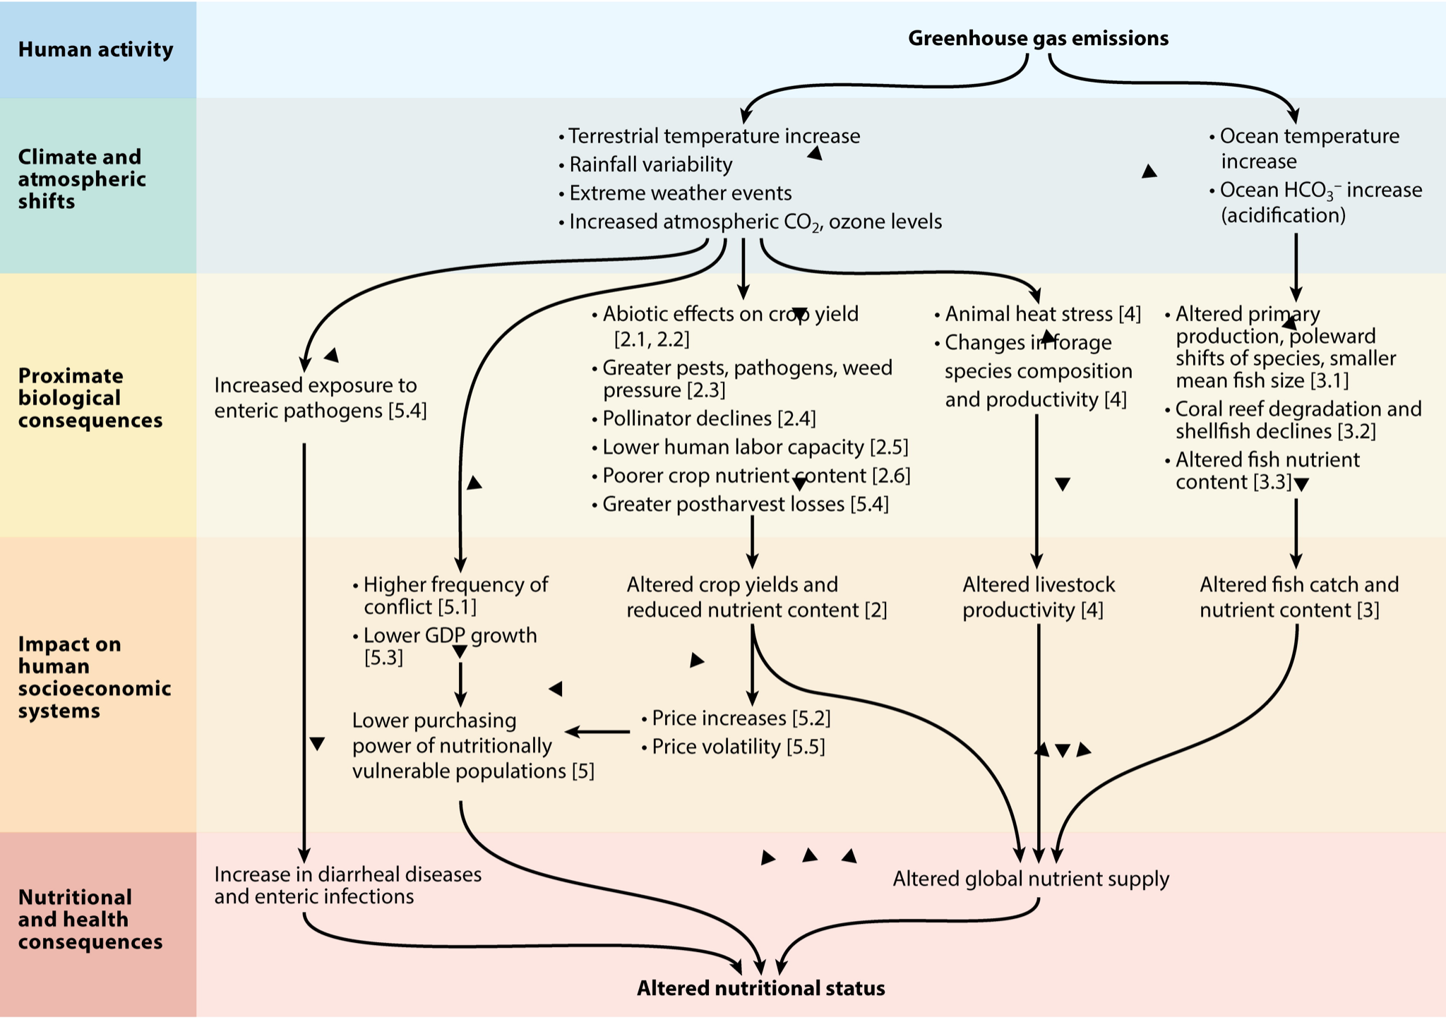
Figure 1. Pathways for impacts of climate change on food systems, food security and undernutrition. Human-caused greenhouse gas emissions result in climate change, which have biological consequences, thus impacting human socioeconomic systems. Source: M

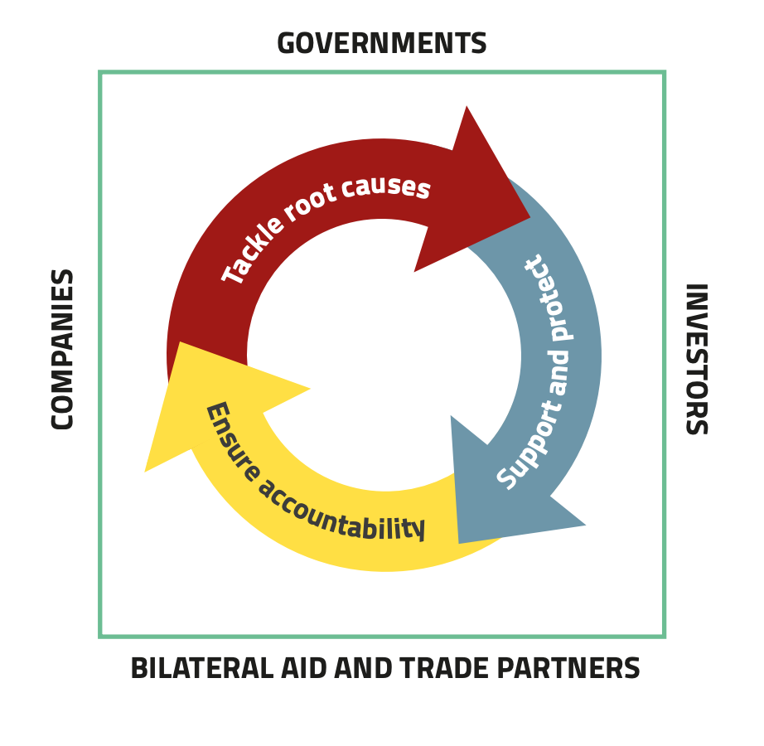
Figure 4

