Call for Inputs Healthy and Sustainable Food: Reducing the Environmental Impacts of the Global Food System on Human Rights

Authors:

YOUNGO Human Rights Working Group
- Serena Bashal, United Kingdom
- Moïse Mbimbe, Cameroon
- Sahana Kaur, Malaysia
- Kaime Silvestre, Brazil
- Patrick May, Democratic Republic of Congo

YOUNGO Agriculture Working Group
- Oluwatosin Ogunsola, Nigeria
- Elizabeth Gulugulu, Zimbabwe

- Please provide examples of ways in which the environmental impacts of the global food system are having adverse impacts on human rights. Adversely affected rights could include, among others, the rights to life, health, water and sanitation, food, culture, livelihoods, non-discrimination, a safe, clean, healthy and sustainable environment, and Indigenous peoples’ rights.
By: Sahana Kaur, Moïse Mbimbe, Elizabeth Gulugulu, Patrick May
The right to a safe, clean, healthy and sustainable environment
The global food system has adversely affected the right to a safe, clean, healthy and sustainable environment as a result of the staggering amount of greenhouse gases (“GHGs”) it emits. Food systems alone are the source of approximately 34% of greenhouse gas (“GHG”) emissions worldwide (Fig. 1, Appendix). Agricultural production and land use each contribute to more of these emissions than the supply chain and post-retail sector combined (Fig. 1). However, it should be noted that there is a significant disparity in the amounts of GHG emissions from different types of foods; animal-based foods largely emit more GHGs than their plant-based counterparts (Fig. 2, Appendix). Methane emissions and changes in biomass and soil carbon are two of the main causes of the GHG emissions — regardless of the type of food (Fig. 2).
At times farming is done on very sensitive land like wetlands affecting their ecological functions especially because of the use of chemicals. Some species are now endangered (e.g. Monarch butterflies, a pollinator)
The right to land
- Due to agribusiness many people have been displaced without compensation and this has affected livelihoods
- On issues to do with land in some countries women's rights are violated for they are not allowed to own land which they can use for an Agricultural practice. Therefore they end up renting land at times at unreasonable price. Widows, single women and strangers in villages are particularly vulnerable.
- In most cases food manufacturing plants and farming areas do not consult communities whose land will be grabbed. In most cases an Environmental Management Plan or Environmental Impact Assessment is needed and thorough public consultation should be done so that communities are aware of the project impacts. At times communities are affected by massive air pollution if it is a slaughterhouse / abattoir, which is a violation of human rights.
- In most cases when farming is being practiced hectares of trees are cleared with no replacement which has contributed to massive land degradation also affecting regulation of temperatures in that specific area. An EMP/ EIA will ensure people's voices are heard and there are minimum impacts to the Environment and people by suggesting mitigation measures.

The right to food
Paradoxically, the global food system, at times prevents local communities and IPs from producing the food they need. This goes with large-scale land acquisition, especially for monoculture purposes.

The right to health
The combination of factors like the growing demand for food and the will to make more profit, a growing number of low nutritional value food items can be found on the markets and consumed. Furthermore, the use of chemical products and pollution at all stages of the food system lead to many health issues for consumers and local communities.

Indigenous peoples’ rights
The global food system leads to land grabbing, forced displacement of IPs as well as the loss of their cultural identity.

The right to decent work
In several cases, the global food system leads to inhumane working conditions as people have low wages, are not insured, are not equipped enough, work overtime without compensation, are not protected by existing complaint mechanisms, and so on.

3. To protect a wide range of human rights, what are the specific obligations of States and responsibilities of businesses in terms of preventing, reducing, or eliminating environmental impacts caused by the unsustainable production or consumption of food? How can we shift to food systems that restore and regenerate nature rather than degrading ecosystems, while providing healthy diets for a global population that will exceed nine billion by 2050?
By: Oluwatosin Ogunsola, Moïse Mbimbe
World Resources Institute has categorically emphasized the adoption of climate-smart practices and regenerative agriculture as viable options for executing food production in line with nature. Several dialogues around Nature-based Solutions, Food systems and initiatives around landscape restoration, biodiversity conservation as well as shift from animal protein to plant-based protein in diets has since taken the centre stage in the quest for striking a balance between Food Security and Nature while having the teeming population in mind.
As for the States and businesses obligations/responsibilities, according to international law, the States have 03 obligations when it comes to human rights in general. These obligations include the obligation to respect the international human rights law by giving citizens freedom to enjoy their rights, the obligation to protect the citizens in a way their rights are not violated and the obligation to implement by adopting relevant legal systems at national levels as well as putting in place institutions that enable citizens to enjoy their rights. Unfortunately, such obligations are not imposed on businesses according to international hard law. This situation makes the ongoing process at the Human Rights Council for the adoption of an internationally binding instrument on transnational corporations and humans. This instrument should impose direct obligations to businesses so that they can be held accountable for violations of human rights.

4. Please provide specific examples of constitutional provisions, legislation, institutions, regulations, standards, jurisprudence, policies and programmes that apply a rights-based approach to ensuring healthy and sustainably produced food. Please include, inter alia, any instruments that refer directly to the right to a healthy environment.
By: Kaime Silvestre and Moïse Mbimbe
There are many regulations in the world that guarantee the right to a healthy environment and sustainable food.
In Brazil there is the National School Feeding Program (PNAE), one of the largest programs in the field of school feeding in the world, constituting an important strategy of food and nutritional security, and socioeconomic development of family farms and rural family entrepreneurs or their organizations. The program serves 36 million students.
This program foresees that at least 30% of the resources destined for the acquisition of food for educational institutions must come from family farming, that is, from small family groups that practice sustainable agriculture. The program contributes to offering healthy and adequate food, respecting local culture and traditions, forming healthy eating habits, achieving sustainable development and acquiring diversified foodstuffs.
Furthemore, one very interesting law is Bolivia’s Law of Rights of Mother Earth. This gives the planet legal rights just as any individual person would have. These rights include the right to biodiversity and clean air. Environmentalists hope that other countries will follow Bolivia and do the same.
In Brazil the article 225 of the Brazilian Federal Constitution provides the basis of environmental policy in Brazil, establishing that “all the people have the right to an ecologically balanced environment”. However, despite positive advancements in recent decades, Brazil is in a state of deep regression from human rights principles, laws, and standards, in violation of international law.
The strict environmental laws that the countries have enacted shows a dedication to save the planet from the current environmental crisis we are facing. However, the real issue is getting countries to actually follow them. We need to encourage better implementation and enforcement of the existing ones.
In Cameroon, the Preamble of the Constitution which is an integral part of the latter, recognizes the right of every individual to a healthy environment. According to the same Preamble, the protection of the environment shall be the duty of every citizen. The Preamble also requires the State to ensure the protection and improvement of the environment.
Article 24 of the African Charter on Human and Peoples’ Rights provides that “all people shall have the right to a general satisfactory environment favourable to development”.
The Water Charter of Lake Chad Basin in its article 7 has adopted principles like:
• The “sustainable development principle” by which the management of the basin shall balance the requirements of economic development, the protection of the environment and social development;
• The “abstractor pays principle” by which fees are levied for non-domestic usages of water as a contribution to the financing of water services;
• The “polluter pays principle” by which the cost of pollution prevention, control and abatement measures shall be entirely or partially covered by the polluter;
• The principle of precaution by which the absence of scientific certainty cannot be an excuse to delay measures planned to protect the quantity and quality of the water resources and the environment in the Lake Chad Basin.
The States Parties to the Water Charter of the Lake Chad Basin also have the obligations to utilise water in an equitable and reasonable manner, to prevent pollution, to ensure sustainable conservation and utilisation of the biological diversity, to prevent environmental harm, to control invasive aquatic species, to prevent soil degradation, to manage vegetation cover, to carry out environmental impact assessments, environmental audits and strategic environmental assessment when need be, to prevent the infringement of environment, water, fishing and navigation rights and regulations (articles 10, 21, 28, 29, 30, 31, 32, 45, 46, 47, 61)
The Water Charter of Lake Chad Basin recognizes in article 72 people’s rights to water and sanitation with special attention to gender, including women, youths and vulnerable social groups (article 74). The Charter in article 2 defines the right to water as “supplies of physically accessible, clean water of acceptable quality at an affordable cost, in sufficient amount to meet every person's personal and domestic needs. Adequate amounts of clean water are necessary to prevent dehydration-caused mortality and to reduce water-borne disease, as well as for cooking and for personal and domestic hygiene”.
The Charter acknowledges and protects the local and traditional knowledge and know-how on environmental protection as far as it is compatible with the sustainable management of the Lake Chad basin’s natural resources (article 75).
Article 77 of the Water Charter recognizes the right of civil society organisations and grassroots community organisations to bring actions and proceedings before a court to defend community interests regarding environment and water resources.
The Niger Basin Water Charter also recognizes people’s right to water; water being an environmental, social and economic good (Preamble and article 4). Article 12 also obliges States Parties to preserve and protect the environment.
Although these legal provisions exist, Cameroon fails to put the right to a healthy environment at the heart of the food production system as agro-industries activities lead to pollution and several forms of environmental degradation. The worst is that agro-industries are not those who feed the population.

5. If your State is one of the 156 UN Member States that recognizes the right to a safe, clean, healthy and sustainable environment, has this right contributed to preventing, reducing, or eliminating environmental impacts caused by the unstainable production or consumption of food? If so, how? If not, why not?
By: Moïse Mbimbe
The answer in Cameroon is unfortunately “no” for at least 02 reasons. Firstly, the law is not applied as corruption and poor governance favors the most powerful. Secondly, there is a lack of institutional cohesion as there are so many Ministries that can intervene in ensuring sustainable food systems: Ministry of agriculture, Ministry of fishing and animal husbandry, Ministry of environment, Ministry of water, etc.

Appendix

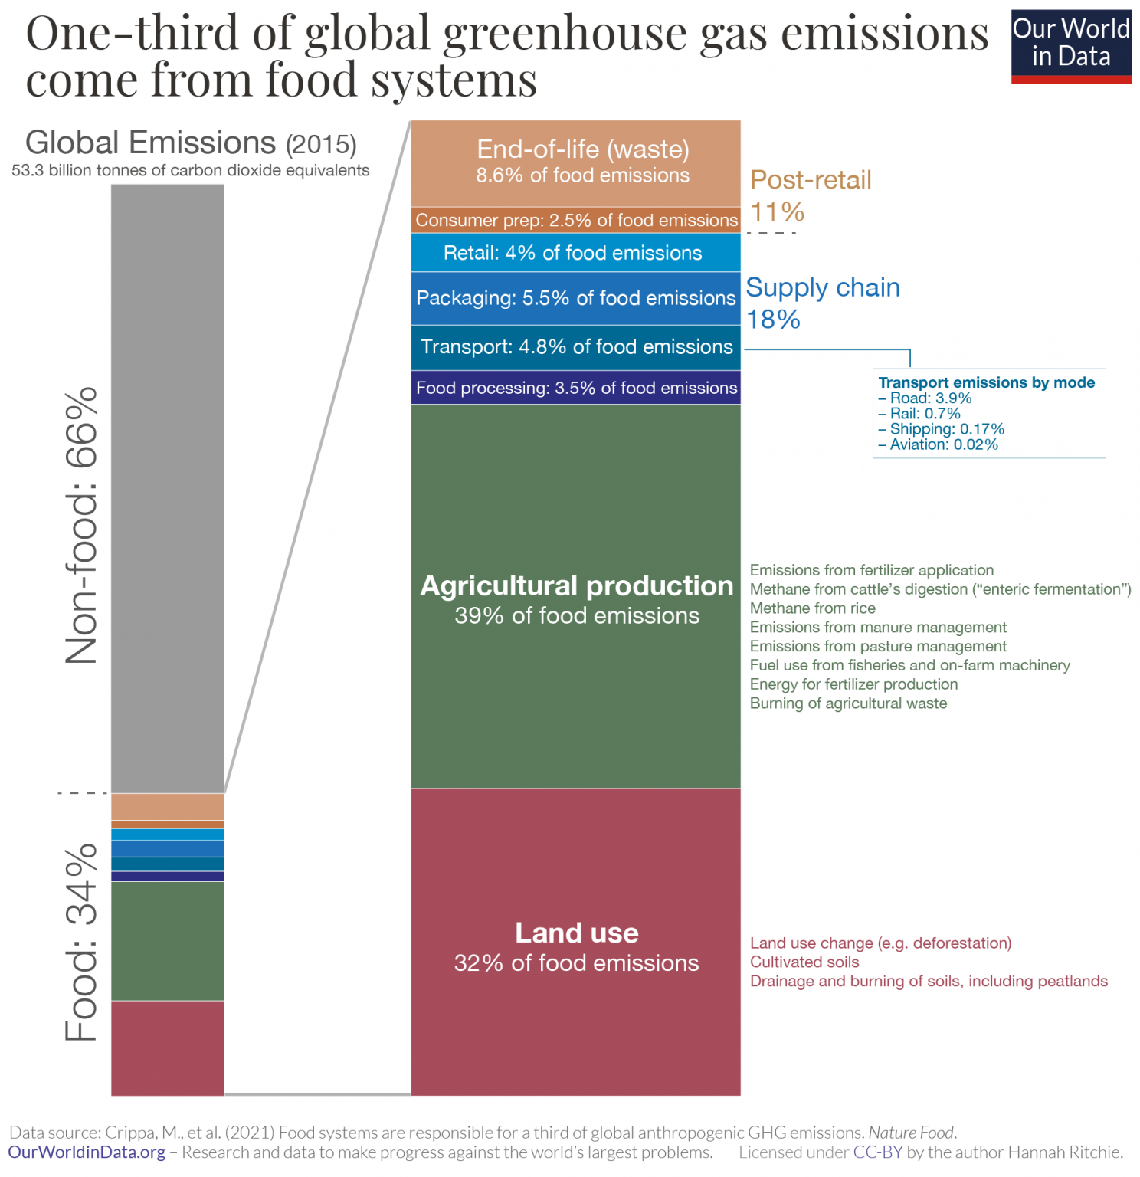
Figure 1
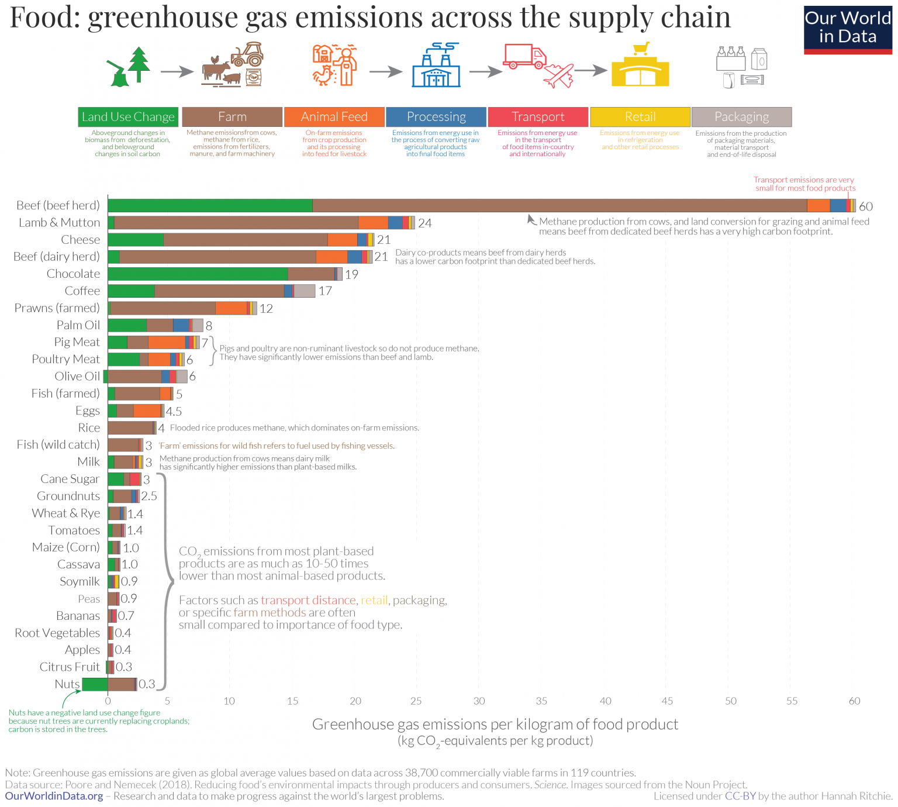
Figure 2
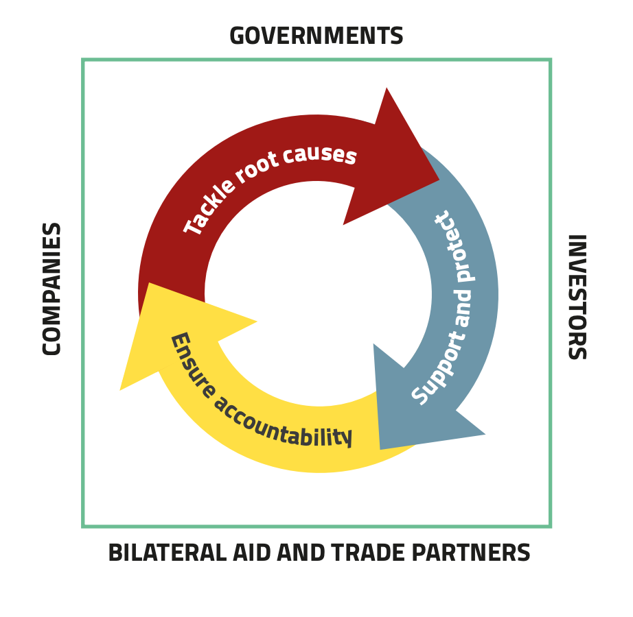
Figure 3

