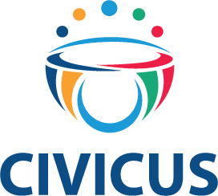
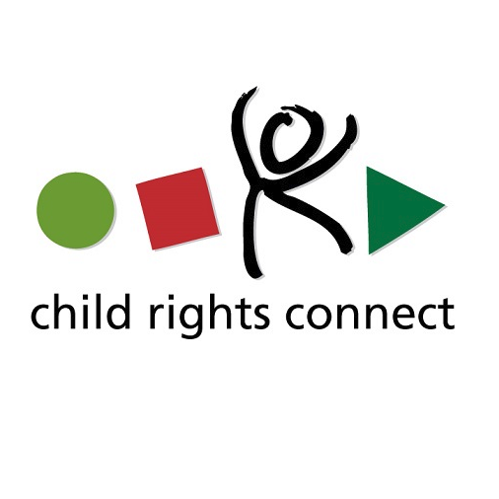

Draft Guidelines on the Right to Participate in Public Affairs

Submitted by

CIVICUS: World Alliance for Citizen Participation
Contact: Susan Wilding
Email: susan.wilding@civicus.org
Tel: +41 22 733 3435
Website: www.civicus.org

And

Child Rights Connect
Contact: Emma Grindulis

Email – grindulis@childrightsconnect.org

Tel: +41(0) 22 552 41 34

- Introduction and context
Despite the fact that equal participation in public affairs is a human right which must be adhered to, many face obstacles in their right to participate in public affairs in almost all countries around the world. It is the most vulnerable people in our society that face the greatest barriers in having their voices heard and taken into account. The right to participate in public affairs is guaranteed in the International Covenant on Civil and Political Rights, the Universal Declaration of Human Rights, the UN Convention on the Rights of the Child (UNCRC), and it is recognised in the 2030 agenda for sustainable development which notes that equal participation is a pre-requisite for achieving sustainable development. It is also guaranteed in the constitutions of most states. They require states to take measures to ensure that these rights are protected and that citizens enjoy these rights irrespective of their race, colour, gender, linguistic background, religion, social status or political affiliation. Participation in public affairs as defined in human rights standards include the right to elect political representatives, amend or develop constitutions or participation in a referendum on issues affecting citizens.
Unfortunately, states have openly violated this right by using policies and laws to prevent citizens or groups from participating in public affairs on the basis of their political affiliation, age, gender, beliefs or other status in society.
States have also used violence to disperse peaceful assemblies and prevent citizens from expressing their views on issues affecting them, to intimidate voters and they have used sophisticated means to restrict freedom of expression online. In many instances, women and children are not afforded the same opportunities to participate in public affairs due to social norms, traditional values or legal barriers. Those who belong to marginalised communities, minorities, or disadvantaged groups face the greatest obstacles in participating in public affairs. There are many long-standing practices and attitudes which prevent inclusive participation, such as the continued lack of recognition, protection and empowerment of children as equal rights holders and defenders as well as age barriers which prevent children from being heard in decisions affecting their lives.
The right to participate in public affairs is not limited to periodic elections but also covers the right to be consulted when drafting legislation or policies. As enshrined in the UNCRC, participation in public affairs relates to the right to be heard, the right to freedom of association and peaceful assembly, the right to privacy, the right to access appropriate information and the right to freedom of thought. These rights are often violated when human rights defenders, including children, journalists and citizens are targeted for simply expressing views that are different from those of the government.
- Why participation in public affairs is imperative
Public participation is a process and not a single event. It provides those involved with opportunities to influence decisions that affect their lives. It involves informing the public and providing citizens with requisite information to assist them to understand issues affecting them. It entails consulting the public to get feedback on decisions or alternatives and ensures that concerns of citizens are considered throughout decision-making processes. It empowers the public to ensure that final decision-making authority is in their hands. An explanation of child participation as a process rather than a one-off event is explicitly outlined in the UN Committee on the Rights of the Child General Comment No. 12 on the right to be heard and supported by 9 basic requirements for meaningful and effective participation.
Recommendations
- States should domesticate provisions of regional and international human rights mechanisms that create an enabling environment for citizens to participate in public affairs and respect these laws
- Similarly laws and policies that enhance the ability of civil society, associations, groups and communities should be enacted to enable these groups or associations to carry out their activities and engage with citizens freely.
- The implementation of international, regional and national laws must be done in a transparent manner without discriminating against anyone on the basis of their religion, gender, age, sexual orientation and gender identity, race, ethnicity, political affiliation. Domestics laws and policies should be drafted and implemented with a focus on protecting, promoting and fulfilling the rights of the most vulnerable groups, including children.

- The right to participate in public affairs goes beyond periodic elections
Elections provide key opportunities for citizens to make important decisions about who will lead them at different periods at national, provincial or local levels. This civic responsibility is supposed to be enjoyed by all in an environment that is free from intimidation and violence. Unfortunately, while a majority of countries hold elections regularly, high levels of violence and intimidation are obstacles to the participation of citizens. In certain countries rallies organised by the political opposition are violently dispersed, private media outlets are banned and sanctioned for airing the views of the opposition and citizens are disenfranchised on the basis of their political affiliations. Furthermore, it is important to note that, although the Committee on the Rights of the Child has commended States for lowering their voting age from 18 to 16, children are excluded from voting almost everywhere and this is one of the reasons why their views are not taken into account in decision-making.
Indeed, the right to participate in public affairs goes beyond periodic elections. Elected representatives have a responsibility to ensure that between elections citizens participate in decision-making processes. There is also a need to recognise the role played by civil society organisations and members of the political opposition to address government action, policies or performance. As recommended by the UN Committee on the Rights of the Child General Comment No. 20 on the rights of adolescents, States should ensure that adolescents are involved in the development, implementation and monitoring of all relevant legislation, policies, services and programmes affecting their lives, at school and at the community, local, national and international levels. The Committee emphasizes the importance of participation as a means of political and civil engagement through which adolescents can negotiate and advocate for the realization of their rights, and hold States accountable. States should adopt policies to increase opportunities for political participation, which is instrumental in the development of active citizenship. Adolescents can connect with peers, engage in political processes and increase their sense of agency to make informed decisions and choices, and therefore need to be supported in forming organizations through which they can participate in a variety of means, including digital media.

Recommendations
- States must ensure that independent institutions are in place to ensure that electoral processes and procedures are adhered to by all.
- Before during and after the elections individuals are able to speak freely about the elections, campaign without fear, organise peaceful rallies and that the media is not targeted for providing platforms for anyone to present the objectives of the political party they represent.
- Elected officials and representatives of the people must ensure that they consultant citizens on issues and decisions that affect them between elections.

- Creating public and political environments where children’s voices are valued by adults, their participation encouraged, regardless of gender, disability, religion, ethnicity, socioeconomic status, or any other status, and their recommendations given due weight. Political leaders at the highest-level need to support children and youth as civic actors.

- If States decide to lower the voting age to under 18 years, they should invest in measures that support adolescents to understand, recognize and fulfil their role as active citizens, including through citizenship and human rights education and by identifying and addressing barriers to their engagement and participation.

- Freedom of expression and access to information
In additional to more formal methods of participation in public affairs, journalists and citizens use different means to express the views on issues affecting them. For example, children forming child-led organisations to campaign on issues such as the environment. Unfortunately, in many countries states have used laws that charge those who express their views on sensitive issues and charge them with libel, sedition and spreading false information. Others have been arrested and jailed for expressing views that are contrary to those of the government. Recent restrictions on the internet and on social media curb the right to participation and prevents people from accessing information that may enable them make informed decisions.
As outlined in the UNCRC, children have the right to freedom of expression including the freedom to access, seek, receive and impart information and ideas of all kinds, in any form. Children must respect the rights of the child to freedom of association and to freedom of peaceful assembly. States also have the obligation to respect the right of the child to freedom of thought and importantly, the Convention highlights that no restrictions may be placed on the exercise of these rights other than those imposed in conformity with the law and which are necessary in a democratic society in the interests of national security or public safety, public order (ordre public), the protection of public health or morals or the protection of the rights and freedoms of others.
Access to information is a crucial prerequisite for the effective exercise of the right to be heard in public affairs. Information should be accessible in formats appropriate to all ages, capacities, languages, and on all issues of concern.

Recommendations
- Laws, policies, budgets and other necessary information should be made available to citizens at all times, in formats appropriate to all ages, capacities and languages to enable them make informed decisions.
- Legislation and government action on online means of communication should enable rather than curb freedom of expression online, promote safety online and prevent any unlawful interference with privacy.
- School curricula should be developed and implemented to encourage awareness and understanding of children’s rights and the wider human rights frameworks, including the right to participate in public affairs.
- Overarching Recommendations
- Public decision-making should be inclusive and representative. This means the process should fully involve women, children and young people, people with disabilities, ethnic and religious minorities, indigenous groups, older people and migrants (as the case may be).
- The process should be transparent and citizens should informed in advance in methods appropriate to all ages and the evolving capacities of children, about how the process is conducted with the media having access when necessary.
- Civil society and the public should be given the space to have a say in the process and outcomes. This means involving stakeholders at every stage of the process.
- Ensure that the contributions from the public influence final decisions that are made.
- A conscious decision must be made to always facilitates the involvement of all those who will potentially be affected by the decision.
- Ahead of the actual process of participation, people should be provided with the information they need to make informed decisions, to participate effectively and participants should be informed about how their contributions affect the final decisions.
- Where appropriate, technology should be used to ensure their effective and broad-based participation. Technology should be used to share information and for citizens to provide responses or feedback on issues at hand. However, the use of technology should take into account local conditions in terms of accessibility by all.
- States should ensure that domestic laws should define how state institutions provide spaces for all citizens to participate in their area of interest.
- National legislation should be reflective of international and regional human rights law.

