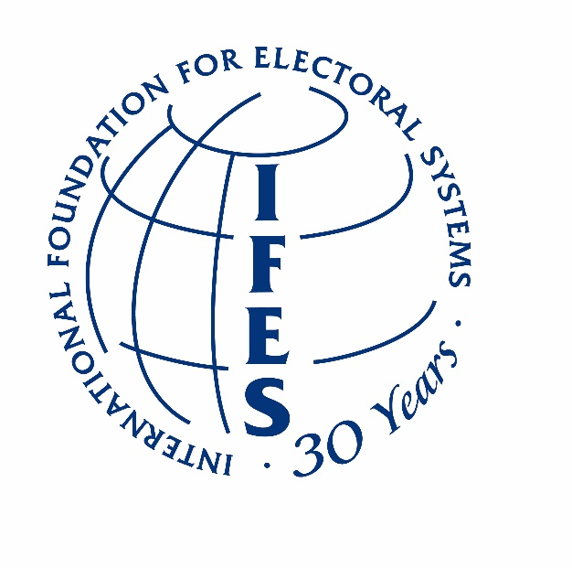

Submission by the International Foundation for Electoral Systems (IFES), an independent non-governmental organization dedicated to building sustainable democratic institutions and expanding participation in elections and political processes.

In response to the adoption of resolution 33/22, and the request put by the Human Rights Council to the High Commissioner for Human Rights “to prepare concise and action-oriented draft guidelines as a set of orientations for States on the effective implementation of the right to participate in public affairs…,” IFES offers the following commentary in preparation of guidelines.

General comments
1. IFES strongly supports the initiative to prepare detailed, yet concise, guidelines on the effective implementation of the right to participate in public affairs. The right to participate in public affairs, including participation in elections, set out in article 25 of the International Covenant on Civil and Political Rights (ICCPR) would benefit from further definition within the context of other international conventions and treaties that have become international public law in the past three decades.
2. IFES also supports the preparation of guidelines as an effort to support the implementation of the right to participate in public affairs in light of the continued need to support fuller participation. The guidelines may offer a constructive means by which to address the need for a more positive enabling environment for broader, meaningful participation in public affairs.
Recommendations for consideration
1. Elections provide a primary means of participation in public affairs. Properly-administered, efficient, and cost-effective electoral operations are critically important to the credibility, legitimacy and sustainability of an election process. Around the world, electoral operations take place in contexts that are affected by a unique confluence of political, social, historical, and cultural factors. IFES recommends that the guidelines include good practices regarding the use of electoral processes as a means of strengthening the right to participate in public affairs. This may include, but not be limited to, participation in referenda and public consultations, as well as formal and informal means by which public input can help to shape policies and inform legal frameworks to promote general welfare.
2. The ability of people to participate in elections free from the fear of harm is essential to inclusive, credible elections, and protected by the right to human security and universal suffrage as embedded in the Universal Declaration of Human Rights (UDHR). The UDHR guarantees all people the right to security of person (Article 3); the right to periodic and genuine elections by universal and equal suffrage, as well as secret vote (Article 21); and the right to assemble and associate peacefully (Article 20). Together, these articles underpin the right of all people to participate in the electoral process in a peaceful and safe environment. IFES recommends that the guidelines take into account the importance of an environment free of fear in contributing to participation in public affairs in all aspects of the electoral cycle.

3. A society is able to reach its full potential in a world in which men and women are fully engaged as equal partners in all aspects of public life. The Convention on the Elimination of All Forms of Discrimination Against Women (CEDAW), and UN Security Council Resolution 1325 on Women, Peace, and Security continue to signal a clear commitment to international norms and standards of equality between men and women. Measures to protect and promote the human rights of women and girls are an integral part of universal human rights, and institutions at all levels must be reoriented accordingly. IFES recommends that the guidelines emphasize that equal rights of women and men are essential to the implementation of the right to participation.
4. One out of every seven people in the world has a disability, yet persons with disabilities remain underrepresented in political and public life. Participation of persons with disabilities in the electoral process provides the basis for mainstreaming their inclusion in all aspects of society, by breaking down social stigmas and increasing the accountability of elected representatives. The Convention on the Rights of Persons with Disabilities (CRPD) contains relevant provisions to participation in public life. Guidelines may address the following areas in which the participation of persons with disabilities could be emphasized:
- People with disabilities have the right to participate in political life on an equal basis with other citizens. States should be working towards making participation in elections accessible so that people with disabilities can vote alongside their fellow citizens.
- Reasonable accommodation to facilitate participation in political life is critical. Specific reference to states’ duty to provide reasonable accommodations is recommended.
- Intersectionality should be referenced and states should acknowledge the compounded barriers people with multiple social identities, like women with disabilities, encounter and work to remove them.

5. Information and communications technologies (ICTs) serve as powerful tools for facilitating the transparency, integrity, and efficiency of electoral processes. The continued evolution of ICTs in elections and political processes, from electronic voter registration, electronic voting, and results systems to innovative uses of social media, apps and crowdsourcing presents both challenges and opportunities for genuine participation in public affairs through elections. When used appropriately, ICTs may improve election administration and management, empower and inform citizens, and enhance the transparency and integrity of election outcomes, and provide effective means for political and civic participation throughout the entire electoral cycle. IFES recommends that the guidelines acknowledge that technology provides a means by which participation can be realized as various ICTs enhance one’s ability to voice their views and influence public affairs, in addition to facilitating informed participation in elections.

About IFES
IFES is an independent, non-governmental organization that receives project funding from bi-lateral and multi-lateral donor agencies. For over 30 years, IFES has worked in over 145 countries to ensure there is a vote for every voice.
As a global leader in electoral assistance, IFES advances good governance and democratic rights by providing technical assistance to election officials; empowering the underrepresented to participate in the political process; and applying field-based research to improve every phase of the electoral cycle.

