Denial of freedom of expression is one dimension of disinformation when peoples are denied equal participation, the right of a fully informed vote process and by granting “white privilege’ that is instituted into law and policy in determining the status of peoples in their exercise of the right of self-determination. To exclude the free expression or the political of peoples who have the right to determine their status also violates the principle. This denial not only by race but by status as peoples. It is necessary to place conclusions and recommendations by the Special Procedures in the hope of drawing implementation of rights. Freedom of expression is not practiced for Indigenous Peoples at the United Nations regardless of their desire for internal or absolute right of external self-determination.
Freedom of Expression in law and practice does not exist in colonizing countries. Many peoples are denied since they cannot speak the language or are not informed to make a free choice on their status based on the fully informed consent principles in the United Nations Decolonization Process or by the Free, Prior and Informed Consent principle under the United Nations Declaration on the Rights of Indigenous Peoples. Existing United Nations human rights mechanisms do nothing to address this.
American democratic despotism as asserted by African States in adopting General Assembly resolution 1469 of 12 December 1959 I removing Alaska and Hawaii from the United Nations Decolonization process. This denied the full exercise of the right of self-determination for Alaska and Hawaii. The United States of America grants doctrines of superiority in the blatantly Tee-Hit-Ton and McIntosh cases, as presented in the Memo by Alfred Maurice de Zayas on the case of Alaska. He further declares this a crime against humanity. (attached)
The denial of freedom of expression also lies in the denial of Special Procedures to not only properly report, but also by the denial to recognize the denial of “freedom of expression” based on racial discrimination and grants of “white privilege” instituted in law and policy.
The fear or deliberate indifference or submitting information to a “blind eye” is also a deterrence by human rights victims who essentially do not believe they will obtain relief.

Report on disinformation
Deadline:
15 February 2021
Issued by:
Special Rapporteur on the promotion and protection of the right to freedom of opinion and expression
Purpose:
To inform the Special Rapporteur’s annual thematic report to be presented to the Human Rights Council at its 47th session in June 2021
The UN Special Rapporteur on the promotion and protection of the right to freedom of opinion and expression will focus on the issue of disinformation and freedom of opinion and expression in her upcoming report to the Human Rights Council, to be presented in June 2021.
Although there is no agreed universal definition of disinformation, it is commonly understood to be false information that is created and spread, deliberately or otherwise, to harm people, institutions and interests. The practice goes back to ancient times but has gained significant traction in the digital age with the advent of social media to amplify communications. Variously labelled as disinformation, misinformation or “fake news”, it has undermined human rights, eroded public trust in democratic elections, contributed to incitement of violence and hatred, challenged sustainable development and undercut effective responses to the COVID-19 pandemic, endangering the lives of millions of people.
While disinformation has a corrosive effect on democracy, development and human rights, measures to address it raise important challenges for the protection and promotion of the right to freedom of opinion and expression. Responses by state or corporate actors must be crafted carefully to ensure that they are in line with international human rights standards. Vague laws prohibiting “fake news”, internet shutdowns, blocking of websites or social media accounts, and indiscriminate content management of social media are just some examples of the ways in which freedom of expression is put at risk in the quest to eradicate disinformation. There is also increasingly concerns about the expanding role of digital tech companies in determining the boundaries of lawful speech or undermining freedom of opinion.
Building on the work of her predecessors¹, the Special Rapporteur will seek to clarify how human rights law applies to disinformation, identify key issues that would benefit from further consideration by the Human Rights Council and formulate recommendations to States and other stakeholders on the best way to tackle disinformation whilst protecting the right to freedom of opinion and expression.
To that end, the Special Rapporteur invites Member States, international organizations, national human rights institutions, digital technology companies, civil society organizations, representatives of the media and social media sector, scholars and other interested stakeholders to share their views. In particular, she would welcome contributions in response to the following questions:
- What do you believe are the key challenges raised by disinformation? What measures would you recommend to address them?
Disinformation does not identify the direct violation; it skews or omits the truth of facts to diminish the clear violation of the human rights norms and it prolongs and does not allow for the victims to address or to provide any form of relief.
The true historical facts that shine the light on the status of Alaska and Hawaii along with the violations of its Constitution and international law are never taught in school. In fact, as reported from the Tee-Hit-Ton case by Erica I. Daes, the racist premise that the land is for the white race in the Tee-Hit-Ton case is taken for granted and broadly accepted without a care in the world of the violation of our rights as is expressed in the Supreme Court Decision itself, “ “... Every American schoolboy knows that the savage tribes of this continent were deprived of their ancestral ranges by force and that, even when the Indians ceded millions of acres by treaty in return for blankets, food and trinkets, it was not a sale but the conquerors’ will that deprived them of their land.”
Just as the issue of Kashmir if being given special attention, Alaska and Hawaii need to be highlighted and given a special report on the violation of our rights as States of Peoples under the United Nations Charter.
There needs to be a complete study by several Rapporteurs and Mechanisms on the use of “national security” to cloak or deny freedom of expression but also the complicity by government with multi-national corporations to deny freely imparted information for participation and consent on issues that affects the whole population.

  - What legislative, administrative, policy, regulatory or other measures have Governments taken to counter disinformation online and offline?
Why should the USA want to counter disinformation online and offline when it continues to lie about the annexation of Alaska and Hawaii in history books, in encyclopedias or any other source of information. It is beneficial for USA and its allies, including its citizens to lie about history knowing it is a lie and the USA committed genocide and crimes against humanity against Indigenous Peoples. For United States NGOs and its citizens the first response is,” Isn’t that how we all treat Native American Indians?” – like it is perfectly acceptable behavior to lie and to exclude facts of history so they do not have to address the grave violations against Indigenous Peoples. European allies do the same as the banks and multi-national corporations benefit from the exploitation of Indigenous Peoples.
Prime example: I brought this to the follow-up of the Durban Review Conference and the EU spokesperson said on the floor, “We will not address violations of the right of self-determination or [crimes against humanity] associated crimes since we have our own problems”, so they do not have to implement their own violations of the rights of peoples. The direct benefit of not addressing these violations is the EU and its multi-national corporations can continue to directly exploit our territory and resources.
  - What has been the impact of such measures on i) disinformation; ii) freedom of opinion and expression; and iii) other human rights?
No one knows that the 1867 Treaty of Cession is reported as not granting title or jurisdiction to the United States of America. Nor do European know that we have the same right like Tunisia, Morocco or Indonesia but were denied our right as African States accused the EU States of granting Alaska and Hawaii as a gift to the United States of America for defeating the Axis Powers in World War II. The confiscation and denial we have registered at the United Nations is not taken seriously nor is the ability for us to have our issues fully reported with conclusions and recommendations placed in Special Procedure Reports.
  - What measures have been taken to address any negative impact on human rights?
Again, the OHCHR itself must do a Special Report to promote to annul General Assembly resolution 1469 on 12 December 1959 that granted an apartheid regime to United States of America.

  - What policies, procedures or other measure have digital tech companies introduced to address the problem of disinformation?
Yahoo, the email company, has noticed that a “Government” has been breaking into my account. I noticed that certain emails were missing or the emails storage Folders have disappeared. Yahoo has done an excellent job of letting me know and creating a safe way for only myself to enter my account [angull2002@yahoo.com]. I am attaching the notice to show Yahoo identifies that it is a government breaking into my account.
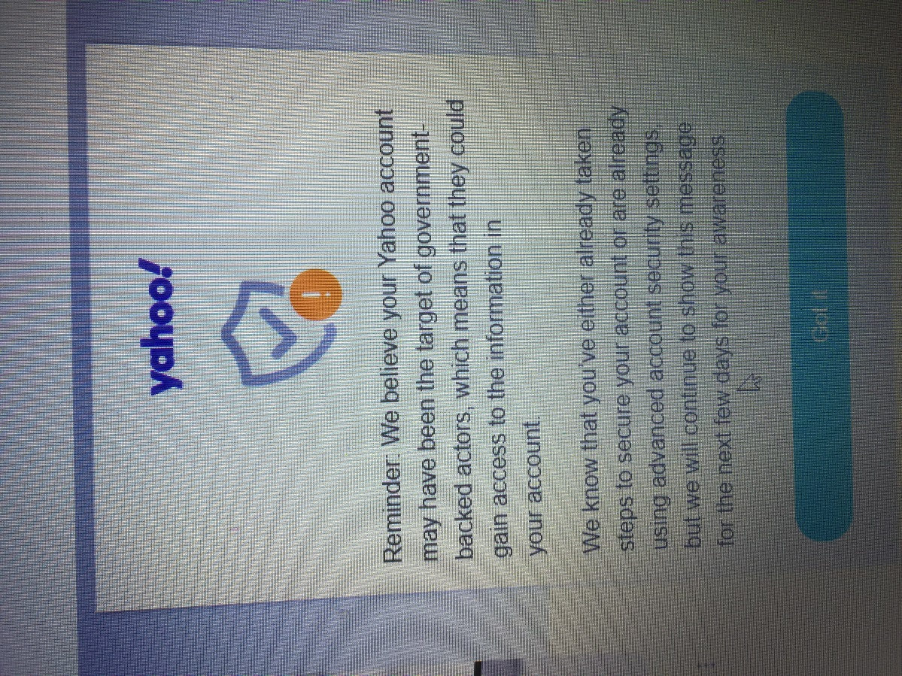

  - To what extent do you find these measures to be fair, transparent and effective in protecting human rights, particularly freedom of opinion and expression?
Just as apartheid and segregation exist for Indigenous Peoples, it continues in the United Nations system. The United Nations did after all grant an apartheid racist regime “State of Alaska” as the 49th state by the vote of the United States military and citizens the right based on the Tee-Hit-Ton and the McIntosh cases that are described in the Memo from Alfred de Zayas. Alaska and Hawaii have been recommended to be placed in the same status by former members of the Sub-Commission on Human Rights with a seat in the United Nations, but this is totally ignored and thrown under the rug. Freedom of opinion and expression cannot thrive when our historic rights are not reported by the mechanisms and special procedures that can report them.
  - What procedures exist to address grievances and provide remedies for users, monitor the action of the companies, and how effective are they?
Since Special Procedures and the Universal Periodic Review have responded and called for Alaska and Hawaii to be transmitted to the United Nations Decolonization Committee, States must step up to the plate to put pressure and to call on existing mechanisms to disseminate the status of our rights and to have them implemented within the United Nations system. Still, many Special Procedures and mechanism refuse for fear of retaliation have been reluctant or for lack of independence and courage to make direct conclusions and recommendations to address promote the freedom of expression that emanates from the many submissions we sent. We now have Special Procedures using the violations as examples of “best” or “good” practice, using the sycophants and puppets set up from Alaska being used as a “best” example when the root of the activity or action is a violation of human right itself. This was apparent when the Red Dog Mine in Alaska that destroyed a whole ecosystem in Alaska. Now Mining Companies along with the State and Federal United States Government use these to attempt to mine in Bristol Bay Alaska and in the Yukon Kuskokwim Delta and to open the Arctic National Wildlife Refuge (ANWR) for oil development that will destroy the Alaska Serengeti Caribou Herds. The OHCHR is guilty and complicit of this in a report from the Expert Mechanism on the Rights of Indigenous Peoples report.
- Please share information on measures that you believe have been especially effective to protect the right to freedom of opinion and expression while addressing disinformation on social media platforms.
- Please share information on measures to address disinformation that you believe have aggravated or led to human rights violations, in particular the right to freedom of opinion and expression.
The denial by the media and press in Alaska to report on the unresolved status of Alaska in Alaska and around the United States of America has led our peoples to believe that nothing will be implemented to address our claims of the grave violations. Some of our own peoples in the capacity of the puppet governments and institutions set up in Alaska are subservient to the misinformation, disinformation on myself, Ambassador Ronald F. Barnes and other legitimate representatives under the Article 73 under the “sacred trust obligation” and other principles such as “free political institutions” so we are free of the puppet institutions, individuals and representative believe they have standing to suppress and are forced to accept the lies and disinformation disseminated to our peoples.
Does “freedom of expression” include the right to lie and to create fake news then to call any real attempt to address this denial a privilege of the puppets assigned to attack the free political institution as “crazies” or “nobodies” and declare these free political institutions have no “standing” in the courts of occupation?
Wikipedia took advice from the Indian Reorganization Act (IRA) puppets placed by the United States Bureau of Indian Affairs to declare that the work of the Traditional Elders Council and its Ambassador Ronald F. Barnes that Mr. Barnes is not representative of the freely elected peoples of Tununak. The pressure place by the International Revenue Service (IRS) to disenfranchise the “free political institution” using the IRS as a propaganda weapon and machine is not acceptable.
The weaponization of the IRA as a surrogate military force under the Geneva Conventions needs to be addressed. Th adverse effects to “freedom of expression” by allowing the puppet governments and institutions and individuals a voice inside of the OHCHR by giving Wikipedia a voice when its consultation of the puppets is a violation of the right of self-determination and is a violation of the human rights and international law on its website. (See attachment) This is a prime example of violation “freedom of expression”.

- Please share any suggestions or recommendation you may have for the Special Rapporteur on how to protect and promote the right to freedom of opinion and expression while addressing disinformation.
The Special Rapporteur needs to suggest and joint report by the Special Rapporteur on Racism, Freedom of Assembly, Independent Expert on the promotion of a democratic and equitable international order, human rights defender. Unilateral and Coercive Measures and others to do a joint report on the situation of Alaska and Hawaii and also of other unresolved cases of peoples under colonial domination and foreign occupation. Bearing in mind that the Special Rapporteur on racism did say to the Follow-up of the World Conference Against Racism that denial of the right of self-determination on grounds of racism, apartheid and doctrines of superiority exist today and need to be addressed. Although other Special Procedures have reported and recommended that Alaska and Hawaii be sent to the United Nations Decolonization Committee, there needs to be other Special Procedures exacting courage to address these crimes against humanity being committed with impunity in Alaska and Hawaii and elsewhere.
The Special Rapporteur must consult with IPNC, Koani and IHRAAM to further elaborate on this submission so we can address the violations of human rights.
Please feel free to share any relevant documents, reports, news or academic articles that you believe should be considered by the Special Rapporteur in the preparation of her report.
IPNC, Koani and IHRAAM will submit a number of Expert Papers and Memorandums that justify Alaska and Hawaii having a Special Report from the OHCHR.
All submissions will be posted on the OHCHR website at the time of the report’s publication, except those containing a clear request not to be made public.
E-mail address:
freedex@ohchr.org
E-mail subject line:
Input for report on disinformation
Word limit:
None but it would be appreciated if inputs were concise
File formats:
Word, PDF
Accepted languages:
English, French, Spanish

1 2017 Joint Declaration on “Fake News”, Disinformation and Propaganda; Reports on disease pandemics and freedom of expression (A/HRC/44/49); online hate speech (A/74/486); online content moderation (A/HRC/38/35); and Artificial Intelligence technologies and implications for the information environment (A/73/348)

Ms. Irene Khan
Special Rapporteur on the promotion and protection of the right to freedom of opinion and expression
OHCHR-UNOG
8-14 Avenue de la Paix
1211 Geneve 10, Switzerland
Fax: +41 22 917 9006
Email: freedex@ohchr.org

