COVID-19 and the Right to Housing:
Renters Face a Housing State of Emergency in Florida
________________________________________________________________________________________________________________________________________________________________________
A Report to the Special Rapporteur on the Right to Adequate Housing
June 19, 2020
- Reporting Organizations
The Florida Housing Justice Alliance is a movement of renters, mobile homeowners, people experiencing homelessness, advocates, and allies calling for housing justice. We are coming together to protect renters, promote community stabilization, and ensure healthy, affordable housing for all. The Florida Housing Justice Alliance members include Miami Workers Center, Community Justice Project, MHAction, Organize FL, SEIU FL, New Florida Majority, Family Action Network Movement (FANM), Struggle for Miami’s Affordable and Sustainable Housing (SMASH), FL Student Power, Catalyst Miami and more.
Community Justice Project is a nonprofit movement lawyering firm that supports grassroots organizing for racial justice and human rights with innovative lawyering and creative strategy tools. Based in Miami, Florida, Community Justice Project is deeply and unapologetically committed to following the leadership of Black and brown organized communities throughout Florida.
- Response to Questions Posed by the Special Rapporteur
Has your country declared a prohibition on evictions? Have evictions continued to take place during the pandemic? If yes, when, where and who was affected and has adequate alternative accommodation been provided?
Formal and informal evictions have persisted throughout the pandemic. While the United States Federal Government issued a temporary eviction and foreclosure moratorium through the CARES Act on March 27, 2020, its protections extend only to properties with some form of federal assistance or federally-backed mortgage. Many covered by the law are not aware of or able to prove their status, particularly renters of single-family homes where access to mortgage information is largely restricted to the homeowner. This has left tens of millions of renters relying on a patchwork or absence of state and local interventions.
In Miami-Dade County, alone, there have been 1,038 eviction actions filed between March 1 and June 19, 2020. Despite a limited statewide moratorium in place since April 2, across Florida over 2,200 eviction actions were filed between April and June 15, 2020. While the final step of removal has been paused in specified categories of evictions, many courts continue to issue eviction orders and are failing to provide meaningful due process to renters. These filings impact renters who should be protected by both the federal and state moratoriums, but few courts have developed mechanisms to allow tenants to avail themselves of these protections.

Florida’s existing landlord-tenant law and court procedures present additional concerns in the context of the pandemic. State law requires renters to post the entirety of the alleged arrears within five business days of being served or face default judgement and eviction without a hearing before a judge. Previous studies have shown that only about 1 in 10 cases are ever seen by a judge, largely due to the rent posting requirement. Inability to pay in full also prevents a judge from sending the parties to mediation.

Despite stay at home orders and court shutdowns, many courts still require tenants to make monthly trips to the courthouse, regardless of medically vulnerabilities, to pay into the rent registry and prevent their cases from defaulting. Coupled with an unemployment insurance program that has failed dramatically and left thousands of qualifying applicants without a paycheck, yet another crisis is setting in.

Corporate landlords continue to seek evictions, and are responsible for an outsized portion of eviction efforts. In Orange County, a single landlord is responsible for 15% of all evictions filed during the pandemic. Families relying on motels for housing have faced displacement and have been forced to live out of their cars.

Reports of informal evictions and harassment by landlords have increased.

Florida’s moratorium is set to expire on July 1, 2020, but no meaningful interventions for the massive wave of evictions expected have been implemented by the state. NGOs like the Florida Housing Justice Alliance are demanding elected officials act to create permanent solutions, including a cancellation of rent and mortgage payments, a moratorium on evictions and foreclosures throughout the state of emergency plus ninety days, and housing for the homeless.
Please provide any information about other legal or financial measures aimed to ensure that households do not lose their home if they cannot pay their rent or mortgage?
State, local and federal funds meant to provide rental assistance during the pandemic have only shed further light on scope of the crisis renters face.
Cities have been forced to create lottery systems to sort through the applications. The City of Miami set up a fund and received twenty thousand applications, more than double the number they could assist, within hours of opening its $2.2 million assistance program.

Orange County’s first rental assistance program launched in April, after demands from renters and members of Organize Florida to address the growing need, but was shuttered “due to overwhelming response.” A second fund giving out $1,000 grants launched in June had to be closed in less than ten minutes. After reopening for two hours, the applications topped 50,000. Entering the fourth month of this crisis, the grant would cover barely cover one month’s rent in Orlando.

In Miami-Dade County, commissioners have delayed distribution of $10 million in rent assistance from the federal government until after the state eviction moratorium ends, putting residents in a precarious position.

What measures have been taken to protect persons living in informal settlements, refugee or IDP camps, or in situation of overcrowding from COVID-19? Have any measures been taken to provide safe accommodation for persons in situation of homelessness during the pandemic and in its aftermath?
While some federal funds have been designated to address homelessness during the pandemic, many remain unsheltered and without access to basic necessities. Much of the action taken to protect the interests of people experiencing homelessness have primarily been catalyzed by NGOs, direct action groups, and grassroots organizations. NGOs, such as the Dream Defenders, have had to act when governments failed to provide handwashing and access to testing.
Even when severe weather compounded risks, many remained without shelter. Destruction of encampments and evictions from informal settlements have also continued.
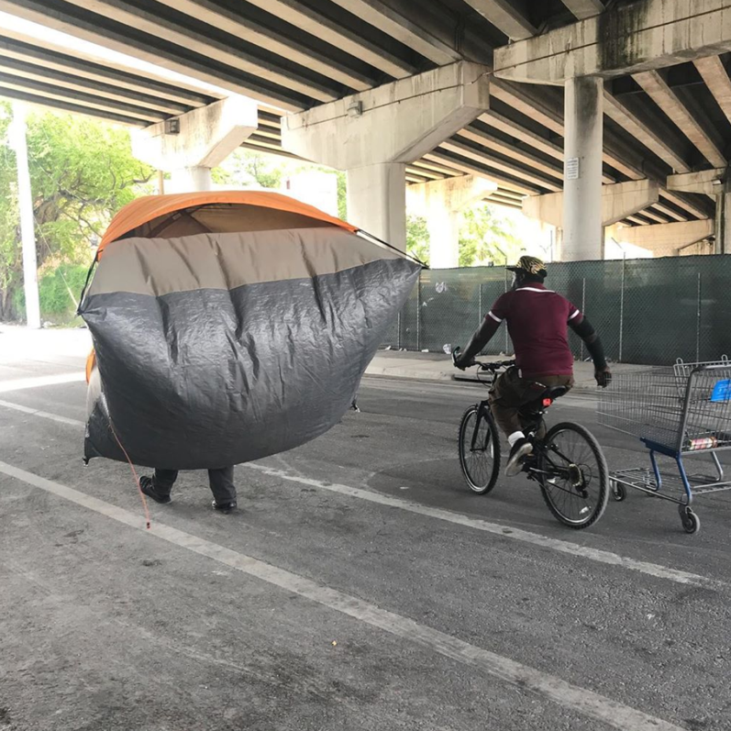
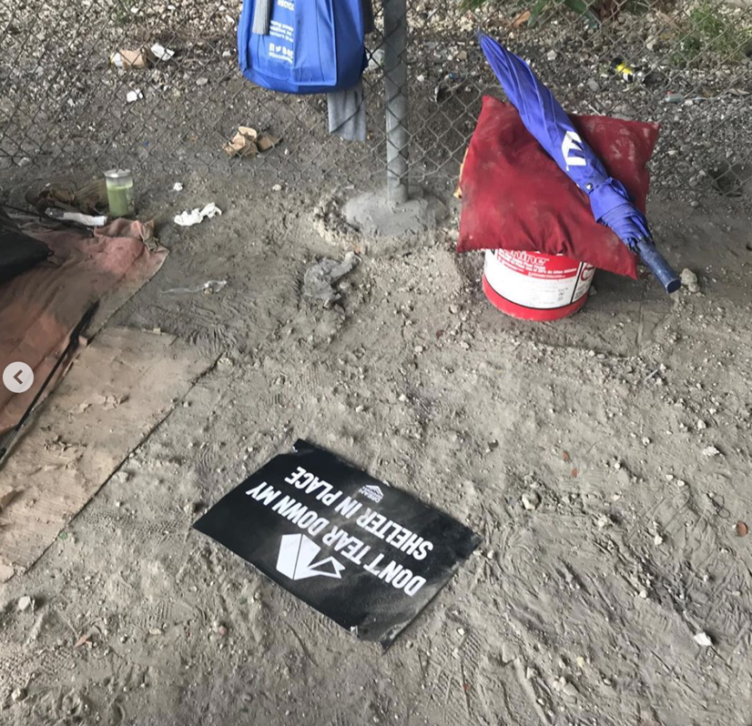
Photos courtesy of Vivian Azalia, Dream Defenders
Over-policing of homeless individuals have also persisted and exacerbated barriers to housing. According to reports, one of out three unsheltered people in Miami-Dade County have been arrested during the pandemic.
Concerningly, the pandemic has been used as an excuse to criminalize life-sustaining activities in several cities in South Florida. Fort Lauderdale attempted to criminalize camping, an effort stopped thanks to outcries from concerned residents and NGOs like New Florida Majority.
In the midst of some of the most severe food insecurity our country has seen, the City of Miami is considering limiting community feeding events and requiring permits, and the City of Miami-Beach has banned asking for food or money near a business.

What measures have been taken by authorities to ensure that migrant and domestic workers continue to have access to secure housing during the pandemic and in its aftermath?
Migrant farm workers, plant nursery workers, domestic workers and others in largely undocumented immigrant communities face severe threats to their housing security. Undocumented immigrants are ineligible for most government economic relief programs, including rental assistance and federally funded legal aid. Rather than offer support to these communities, Florida’s Governor has made them the scapegoat, stating “the No. 1 outbreak we’ve seen is in agricultural communities,” emphasizing that the “overwhelmingly Hispanic” farmworkers and day laborers were the leading source of new cases.
Domestic workers, in particular, have faced devastating rates of unemployment since the pandemic began and those that continue to work face unsafe conditions, lack of personal protective equipment, and other risks that force them to decide between their health and economic stability.

A study by the Institute for Policy Studies’ Black Worker Initiative, in partnership with the National Domestic Workers Alliance’s We Dream in Black program found that 90% of respondents from Miami-Dade’s Black domestic workers were “at risk of eviction or having their utilities shut off in the next three months. Among undocumented workers, 94% report being at risk as compared to 85% of documented workers.”

https://www.congress.gov/bill/116th-congress/house-bill/748/text#H303FBAD36251421BAF4BF3372105E9DA
https://www.tampabay.com/news/health/2020/05/23/landlords-lining-up-to-evict-hundreds-of-tampa-bay-tenants-once-moratorium-expires/
Analysis of court filings in Miami-Dade County. Data on file with Community Justice Project.
https://www.flgov.com/wp-content/uploads/orders/2020/EO_20-94.pdf
Analysis of court filings in 32 Florida counties. Data on file with Community Justice Project.
Florida Statutes Ch. 83.60(2) “In an action by the landlord for possession of a dwelling unit, if the tenant interposes any defense other than payment… the tenant shall pay into the registry of the court the accrued rent as alleged in the complaint or as determined by the court and the rent that accrues during the pendency of the proceeding, when due. … Failure of the tenant to pay the rent into the registry of the court or to file a motion to determine the amount of rent to be paid into the registry within 5 days, excluding Saturdays, Sundays, and legal holidays, after the date of service of process constitutes an absolute waiver of the tenant’s defenses other than payment, and the landlord is entitled to an immediate default judgment for removal of the tenant with a writ of possession to issue without further notice or hearing thereon….”
Analysis by Legal Services of Greater Miami and Community Justice Project.
Florida Statutes Ch. 83.56(5)(b) “…The court may not set a date for mediation or trial unless the provisions of s. 83.60(2) have been met, but must enter a default judgment for removal of the tenant with a writ of possession to issue immediately if the tenant fails to comply with s. 83.60(2).”
https://www.washingtonpost.com/graphics/2020/national/virus-family-homelessness/
https://www.orlandosentinel.com/coronavirus/jobs-economy/os-bz-coronavirus-evictions-20200526-ahksssr3qjfqfkwqwln5honmdi-story.html
https://www.mynews13.com/fl/orlando/news/2020/05/22/osceola-apartment-residents-say-they-re-being-targeted-for-eviction
https://www.typeinvestigations.org/investigation/2020/06/05/when-shelter-comes-down-to-the-luck-of-the-draw/
https://www.miamiherald.com/news/coronavirus/article242485761.html
https://newsroom.ocfl.net/media-advisories/press-releases/2020/03/orange-county-governments-covid-19-rental-assistance-program-applications-and-hotline-to-close-eod-april-1-2020/
https://www.orlandosentinel.com/coronavirus/jobs-economy/os-bz-coronavirus-family-grant-program-closes-20200609-oy5fq6tpmfbctgeclxnkhcooi4-story.html
https://www.miamiherald.com/news/local/community/miami-dade/article243631322.html
https://www.miamiherald.com/news/coronavirus/article241985951.html https://www.miamiherald.com/news/local/community/miami-dade/article242428421.html https://www.miamiherald.com/news/local/community/miami-dade/article242295771.html
https://www.miaminewtimes.com/news/dream-defenders-protest-homeless-trust-at-miami-red-roof-inn-11638659
https://www.miamiherald.com/opinion/editorials/article242724731.html https://twitter.com/dreamdefenders/status/1260580834656104455?lang=en
“Don’t tear down my shelter in place.” May 13, 2020.
https://theappeal.org/miami-police-arrest-homeless/
https://www.miaminewtimes.com/news/fort-lauderdale-fails-to-protect-homeless-population-from-coronavirus-11611403
https://newfloridamajority.org/broward-residents-oppose-fort-lauderdales-plans-to-prohibit-homeless-encampments/
https://www.miamitodaynews.com/breaking/miami-takes-steps-to-control-feeding-of-homeless/
https://www.miamiherald.com/news/local/community/miami-dade/miami-beach/article242787201.html
https://www.tampabay.com/news/health/2020/06/19/ron-desantis-blames-florida-farmworkers-for-covid-aid-groups-say-testing-help-came-late/
https://www.miamiherald.com/news/coronavirus/article241575821.html
“Rent for my apartment is $870 a month. It was due on April 1, but I wasn’t able to pay. I’ve never missed a payment before, and fortunately, my landlord has been understanding.” https://www.nytimes.com/2020/04/13/opinion/sunday/coronavirus-domestic-workers.html
https://ips-dc.org/black-immigrant-domestic-workers-covid-19/#miami

