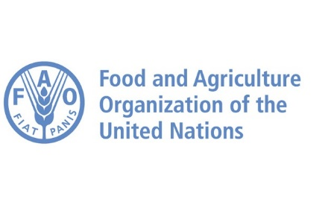
Call for input on
Internal displacement in the context of the slow-onset adverse effects of climate change
Report of the Special Rapporteur on the human rights of internally displaced persons
from the Food and Agriculture Organization of the United Nations (FAO)

On information on how slow-onset effects of climate change are inter-related with conflict, i.e. how climate change and conflict combine to act as drivers and causes of internal displacement, and what specific combined effects they have on internally displaced people.

Climate change is a macro-driver of significant transformation to the human system. Climate variability, drought and natural hazards can cause severe damages to livelihoods, mobility patterns and institutional stability. These events may alter the dynamics of interaction among individuals, which, in some instances, may turn violent. Migration is one of the potential indirect mechanisms through which climate change can increase the likelihood of civil conflict outbreak in developing countries. Slow-onset climatic events such as drought, soil degradation and sea-level rise have the potential to alter livelihood systems and influence individuals' decision to migrate

In agrarian societies, the climate-induced limited availability of natural resources and the consequent deterioration of livelihood conditions may lead people to move either to places where arable land and water are abundant or to urban areas to find new job opportunities and better living conditions. Climate migrants may have a destabilising effect on the level of social cohesion in the receiving areas, including the potential for the escalation of violence between natives and newcomers.

Drought-induced migration can contribute to conflict diffusion via four distinct channels. Firstly, the internal migration flow can increase the competition over decreasing economic and renewable resources. Secondly, population movements may trigger ethnic tensions when migrants and local belong to different ethnic groups. Thirdly, the wave of internally displaced people may create a sense of mistrust between sending and receiving areas, especially if hosting areas perceive maltreatment and violations of human rights. Finally, a climate-induced displacement may aggravate traditional fault lines that are rooted in pre-existing tensions.

For instance, in the West African Sahel, land-use disputes between migrant herders and sedentary farmers have been often driven by underlying socioeconomic issues and institutional failure. On the other hand, in the Horn of Africa pastoralist dropout trends are intertwined with increasingly erratic and unpredictable weather patterns in the region – contributing to the increase in numbers of climate induced IDPs in Ethiopia and Somalia. The mentioned examples highlight the need of mainstreaming climate-smart agriculture interventions that are conducive to sustainable livelihood diversification and resilience programmes, as well as mainstreaming internal displacement issues across relevant line ministries and development plans in a whole-of-government approach.

The FAO submission comprises two reports specific to the Eastern Africa context and its vulnerability to climate change. On annex one ‘Understanding conflict dynamics in Eastern Africa: A call for conflict-sensitive programming’ the report aims to provide a comprehensive understanding of the drivers of conflict in the region, where many are directly or indirectly linked to climate change and the subsequent fragility of livelihoods systems and food security. Lastly, on annex two ‘Conflict analysis in the Lower Jubba, Lower Shabelle and Middle Shabelle regions of Somalia’ conducted by Interpeace in partnership with the FAO Somalia, the report provides a grounded and locally informed analysis of the peace and conflict drivers in the mentioned areas, highlighting the correlation between climate change, natural resource management, and conflict.

ANNEXES

- ‘Understanding conflict dynamics in Eastern Africa: A call for conflict-sensitive programming’ The FAO Resilience Team for Eastern Africa, June 2020
- ‘Conflict analysis in the Lower Jubba, Lower Shabelle and Middle Shabelle regions of Somalia’ Interpeace, August - November 2019

