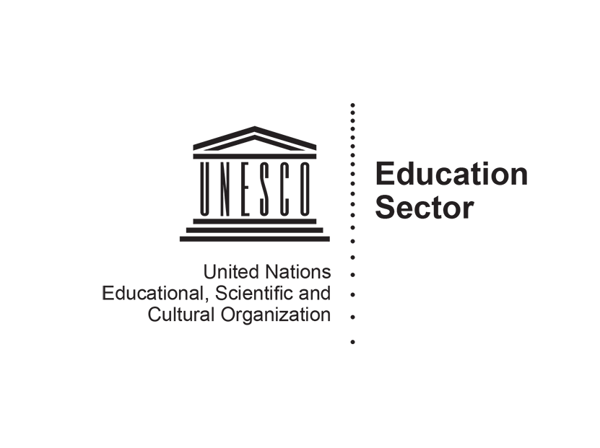

UNESCO contribution to the Report of the Special Rapporteur on the Human Rights of Internally Displaced Persons
Internal displacement in the context of the slow-onset adverse effects of climate change
UNESCO and Unicef UK are submitting evidence to the Special Rapporteur on the Human Rights of Internally Displaced Persons with the aim of highlighting the right to education for children displaced due to the slow-onset adverse effects of climate change. This submission is part of ongoing and specific collaboration in this focus area.

Introduction and Summary
  - The Universal Declaration of Human Rights established the right to education for everyone, in all circumstances, in 1948. The realisation of this right is the duty of the State within which children find themselves.
  - However, internal displacement is challenging the realisation of this right for children around the world. While much attention has been paid to the role of education for refugee children, particularly around the Global Refugee Forum in 2019, there remains a significant gap in the research and high-level discussions in relation to education for children affected by climate change-induced displacement and migration.

The Rights Framework
  - The international normative framework has established the inalienable universal right to education for all, based on the principles of non-discrimination and equality. The United Nations Convention on the Rights of the Child (1992) enshrines every child’s right to a quality education, regardless of gender, ethnicity, religion or any other status in article 28. The Convention against Discrimination in Education (1960) specifically requires States to take measures to ensure equality of opportunity and treatment in education, prohibiting any discrimination based on race, colour, sex, language, religion, political or other opinion, national or social origin, economic condition or birth. Many other international treaties and instruments reiterate this right.
  - In displacement situations there is an increased likelihood that the right to education will be violated, though the body of international human rights law places minimum core obligations on States as duty-bearers, such as the universal provision of free and compulsory primary education. The International Covenant on Economic, Social and Cultural Rights articulates that States are obligated to allocate the maximum level of available resources to education with a view to achieving progressively the right to education for all.
  - Several international policy frameworks outline targeted obligations with regard to Internally Displaced Persons (IDPs). The Guiding Principles on Internal Displacement call on States to ensure that education and training facilities are made available to IDPs, in particular adolescents and women, as soon as conditions permit. The Guiding Principles have been codified in the Kampala Convention by the African Union, thereby making it a legally binding obligation for signatories to provide adequate humanitarian assistance, including education, ‘with the least possible delay’. Aside from being free and compulsory at the primary level, education must also respect the cultural identity, language and religion of IDPs.
  - The 2030 Agenda for Sustainable Development is bound by a pledge to leave no one behind. Sustainable Development Goal (SDG) 4, devoted to education, recognises that ‘[n]atural disasters, pandemics and conflicts, and the resulting internal and cross-border displacement, can leave entire generations traumatized, uneducated and unprepared to contribute to the social and economic recovery of their country or region’. All countries have a responsibility to institute measures to develop inclusive, responsive and resilient education systems to meet the needs of children, youth and adults in crisis contexts.

Data, Gaps and Challenges in the Research
  - Despite the obligation placed on States to realise the right to education for all learners within their borders, 258 million children remain out of school around the world. No reliable figures exist for the number of IDP learners out of school, but given that only 24% of secondary school-aged refugees are in school, it is reasonable to assume that children affected by displacement face significant barriers to accessing education.
  - The total number of children internally displaced is similarly difficult to ascertain. Data from the Internal Displacement Monitoring Centre (IDMC) show 50.8 million people were internally displaced due to conflict and disasters at the end of 2019. Over half (55%) of these IDPs, or 28 million, are under the age of 25.
  - Despite progress on collecting better age-disaggregated data on IDPs, the exact number remains unknown. This effectively makes IDP learners invisible in education systems. Furthermore, a lack of quality disaggregated data makes understanding the specific obstacles and needs of IDP-learners very difficult. There is an urgent need to collect better age-disaggregated data for IDPs, including those affected by slow-onset climate change, in order to build more inclusive and resilient education systems.
- Intersecting barriers to accessing education for children internally displaced by the impacts of climate change
  - Systemic Barriers
    - The configuration of national education systems can create legal or administrative obstacles, which limit access to IDPs. Lack of documentation, such as birth certificates, can be an issue in States where students must demonstrate citizenship or residence in a region to gain access to services. Discrimination may also occur where schools and local authorities are reluctant to admit displaced children from different ethnic, linguistic or religious groups. Implicit discrimination can also occur and indigenous peoples and minorities that are typically unable to access culturally appropriate services (such as mother-tongue education) are likely to find their marginalised status compounded in periods of displacement.
    - Although there can be a gap between the legal framework and implementation on the ground, some countries have made positive steps by implementing national policy frameworks. For instance, Iraq’s National Policy on Displacement (2008) emphasises the right of IDP children to education and provides acceptance of students’ and teachers’ certificates earned abroad while Uganda’s National Policy for IDPs (2004) provides the adoption of ‘affirmative action’ programmes to assist and encourage their participation.
    - Furthermore, education systems may lack the preparedness to deal with displacement emergencies relating to climate change. It is foreseeable that in areas where education infrastructure is not robust, physical damage to school buildings or water, sewer and electrical systems will affect children who are displaced near to their homes. Where education spaces remain safe, they are often appropriated to provide shelter to communities. Education in displacement often suffers from overcrowded classrooms, challenges around curriculum and language of instruction and a lack of qualified teachers.
    - Education systems can lack the flexibility to manage complex patterns of displacement. Climate change is predicted to amplify a dominant pattern of urbanisation, compounding pressure in urban centres. Although access to education in camps is often limited, children living in urban centres frequently fare even worse due to lack of attention from donors and humanitarian interventions. Circular or temporary displacement may also become a common solution where areas become uninhabitable for periods of the year due to extreme weather. In countries where seasonal labour migration is already common, there is evidence that education is disrupted and children are often exposed to child labour, workplace hazards and exploitation.
  - Economic and Gender-based Barriers
    - For IDPs fleeing environmental degradation, education may be a low priority in the face of survival needs. In displacement communities children frequently contribute economically to the household. There is increasing evidence that gender plays a role in the educational opportunities offered to children in displacement, with girls often the first to be removed from school when finances are limited, or remaining in school but heavily burdened by household chores. For instance, data from the IDMC found that during the droughts in Somalia in 2017, school attendance of all children increased from 34.5% to 37% following displacement. However, this increase was exclusively driven by boys’ attendance, as the percentage of girls out of school increased from 55% to 71% following displacement.
    - Furthermore, child marriage and gender-based violence are known risk factors in displacement settings, where a lack of economic opportunities for girls leads to reliance on men, an increase in early pregnancy and marriage and related school drop-out.
  - Social Barriers
    - Xenophobia, intolerance and prejudice can exist within communities that are managing a large influx of IDPs. IDPs frequently suffer discrimination on the basis of their ethnicity, religion or simply due to being displaced.
    - Trauma may also affect schooling. Three years after Hurricane Katrina, for example, children were found to be negatively affected by displacement and issues with behaviour, impacts on attendance, suspension, expulsion and drop-out rates were also observed.

Lessons and Impacts of COVID-19
  - Although COVID-19 leaves few unaffected, those who are displaced are likely to be disproportionally affected by the pandemic. Displaced learners are already marginalised and vulnerable, with their right to education often unfulfilled and violated. The spread of COVID-19 further exacerbates their vulnerabilities, whilst the delivery of humanitarian assistance including for education in emergencies has been negatively impacted.
  - Despite progress on inclusion, barriers to education persist and could potentially worsen due to COVID-19. Displaced learners now face increasing precarity due to a lack of social safety nets and the hardening of migration policies, amongst other factors, affecting their ability to access and continue learning. In some contexts, displaced populations are already facing exposure to increasing levels of violence. This is occurring against the backdrop of nearly one third of those out of school being in crisis-affected countries.
  - During the pandemic, conflict, violence and disasters– including those linked to climate change – have not ceased and continue to disrupt education. Moreover, populations affected by these crises are more likely to find themselves in places of higher COVID-19 transmission, without access to any form of health services, let alone education. In some contexts, they are not even able to adopt the basic restrictive measures such as social distancing.
  - This overlapping of crises provides an insight into the potential implications of climate-induced displacement in education. As the impacts of climate change intensify, emergencies are likely to become increasingly complex and overlap posing complex challenges for the equitable delivery of quality education. Education stakeholders must use the lessons of COVID-19 to prepare, strengthen and build the resilience of education systems to ensure the right to education for IDP learners.

Guiding Principles and Recommendations
  - In order to ensure the right to education for all learners internally displaced by the impacts of climate change, education stakeholders should:
- Collect better disaggregated data to build a better understanding of the barriers to education, exclusion and inclusion, and the learning needs of IDPs. Such data should inform national education systems and be used to inform policy and decision making.
- Work to understand and address the intersecting barriers to IDP education, including gender, disability, and poverty. Social and financial barriers to education, with attention paid to the hidden costs of education, must be removed, notably through gender-responsive programming.
- Strengthen legislation to protect the right to education for all learners, regardless of residency, official documentation (such as birth certificates or school transcripts), or any other limiting factors for IDPs.
- Improve the preparedness and resilience of education systems as a matter of priority, including measures that can anticipate and mitigate risk and respond to the educational needs of IDP children. Resilience should be secured through planning to support learners adapt in place, enable mobility and recover after displacement.
- Strengthen cross-sector collaboration between local and national governments, donors, multilateral institutions, humanitarian and development actors and the private sector to develop inclusive and climate-resilient development policies and plans, and improve the harmonisation of action and resource mobilisation.
- Build education systems that promote and foster the inclusion of IDPs, ensuring IDP learners and their needs are included in key sector planning mechanisms and policies, teachers are adequately trained and qualified to deal with diverse needs of IDP learners, including psycho-social support and multilingual and multicultural classrooms.
- Strengthen national policies related to human mobility to include climate factors impacting mobility, in coordination with climate and environment stakeholders and supported with multi-year funding.
- Learn from COVID-19, using lessons learned to build alternative and accelerated learning programmes, flexible education systems, improved methods for integrating new learners, and mitigations for lost learning during short-term displacement.

UNESCO. 2019. Right to education handbook. pp. 51 – 60.
International Covenant on Economic, Social and Cultural Rights (1966), art. 2.
Guiding Principles Internal Displacement (1998), principle 23 (4).
African Union Convention for the Protection and Assistance of Internally Displaced Persons in Africa (2009), art. 9 (2) (b).
Guiding Principles Internal Displacement, principle 23 (2).
UNESCO. 2015. SDG4 - Education 2030: Framework for Action. Paris, para. 25.
UNESCO Institute for Statistics. 2019. New methodology shows that 258 million children, adolescents and youth are out of school (Fact sheet no. 56, UIS/2019/ED/FS/56). http://uis.unesco.org/sites/default/files/documents/new-methodology-shows-258-million-children-adolescents-and-youth-are-out-school.pdf (Accessed 12 June 2020).
UNHCR. 2019. Stepping up: Refugee education in crisis.
IDMC. 2020. Global report on internal displacement 2020.
The intersecting barriers have been summarised from a draft paper currently in the process of publication by UNESCO. See: UNESCO. 2020. The impact of climate displacement on the right to education: Examining the educational vulnerabilities linked to climate displacement and the implications for law and policy.
Special Rapporteur on the human rights of internally displaced persons. 2015. Report of the Special Rapporteur on the human rights of internally displaced persons, Chaloka Beyani (Doc. A/HRC/29/34), para. 59.
UNICEF. 2017. Education Uprooted: For every migrant, refugee and displaced child, education, p. 13. Ibid, p. 13.
In Bangladesh, for example, severe flooding in 2017 damaged 4,000 educational institutions and a further 1,700 schools were used as temporary flood shelters, leading to the interruption of education for three million children. See: Save the Children. 2017. Education disrupted, education denied (No. 3 in a Save the Children series): Bangladesh: Monsoon floods threaten children’s right to education. https://resourcecentre.savethechildren.net/node/14148/pdf/bangladesh_monsoon_advocacy_brief_eng_2017.pdf (Accessed 10 June 2020); UNICEF. 2018. No Place to Call Home: Protecting Children's Rights when the Changing Climate Forces them to Flee, p. 13.
Elizabeth Ferris and Rebecca Winthrop. 2010. Education and displacement: assessing conditions for refugees and internally displaced persons affected by conflict (Paper Commissioned for the EFA Global Monitoring Report).
IPCC. 2014. Human security. In: Climate Change 2014: Impacts, Adaptation, and Vulnerability. Part A: Global and Sectoral Aspects. Contribution of Working Group II to the Fifth Assessment Report of the Intergovernmental Panel on Climate Change. pp. 755-791, pp. 769 – 770; UK Government Office for Science. 2011. Foresight: migration and global environmental change, final project report, para. 4.2.1.
UNICEF / IDMC. 2019. Equitable access to quality education for internally displaced children, p. 5.
Global Education Monitoring Report / UNESCO. 2018. Global Education Monitoring Report 2018: Migration, displacement and education: building bridges, not walls, p. 20.
ibid, para. 60.
Global Education Monitoring Report / UNESCO. 2019. The intersections between education, migration and displacement are not gender neutral, p. 4.
IDMC. 2020. Measuring the costs of internal displacement on IDPs and Hosts: Case studies in Eswatini, Ethiopia, Kenya and Somalia.
Global Education Monitoring Report / UNESCO. The intersections between education, migration and displacement are not gender neutral, p. 4.
UNICEF / IDMC. 2019. Equitable access to quality education for internally displaced children, p. 8.
UNICEF. No Place to Call Home, p. 15.
The New Humanitarian. 2020. The COVID-19 excuse? How migration policies are hardening around the globe. https://www.thenewhumanitarian.org/analysis/2020/04/17/coronavirus-global-migration-policies-exploited (Accessed 12 June 2020).
The New Humanitarian. 2020. Greek island refugee camps face coronavirus ‘disaster’, aid groups warn. https://www.thenewhumanitarian.org/news/2020/03/27/greece-island-refugee-camps-coronavirus (Accessed 12 June 2020).
Overseas Development Institute. 2015. Education in emergencies and protracted crises: Towards a strengthened response.
Sally Hargreaves, Bernadette N Kumar, Martin McKee, Lucy Jones, Apostolos Veizis. 2020. Europe’s migrant containment policies threaten the response to covid-19. BMJ 2020; 368 :m1213.

