
UNITED
NATIONS
E
Economic and Social Council
y Social

Distr.
GENERAL
E/2004/CRP.12
25 June 2004
ENGLISH ONLY
Substantive session of 2004
New York, 28 June-23 July 2004
Item 14 (h) of the provisional agenda*
Social and human rights questions: Permanent Forum on Indigenous Issues

Report of the Secretary-General on the preliminary review by the Coordinator of the International Decade of the World's Indigenous People on the activities
of the United Nations system in relation to the Decade**

Information received from the United Nations Agencies,
Funds and other International organizations***

__________
* E/2004/100.
** E/2004/82.
*** All information received from departments and organizations of the United Nations system are
contained in documents E/2004/CRP.11-12 and are being circulated in the language of submission only.
Table of contents
Page

- Information received from the United Nations Children’s
Fund (UNICEF) ……………………………………………………. 3-18
- Information received from the United Nations Population
Fund (UNFPA) ……………………………………………………… 18-22
- Information received from the United Nations Development Fund
for Women (UNIFEM) and UNIFEM-Andean Region …………….. 23-29
- Information received from the International Labour
Organization (ILO) ………………………………………………….. 29-44
- Information received from the World Food Programme (WPF) ……. 44-56
- Information received from the Food and Agriculture
Organization (FAO) ………………………………………………….. 56-66
- Information received from the Convention on Biological
Diversity (CDB) ……………………………………………………… 67-71
- Information received from the United Nations Human
Settlements Program (UN-HABITAT) ……………………………….. 71-86
- Information received from the World Health Organization (WHO) …. 87-105
- Information received from the United Nations Institute for
Training and Research (UNITAR) ……………………………………. 105-111
- Information received from The Organisation for Economic
Co-operation and Development (OECD) …………………………….. 111

Information received from the United Nations Children’s Fund (UNICEF)

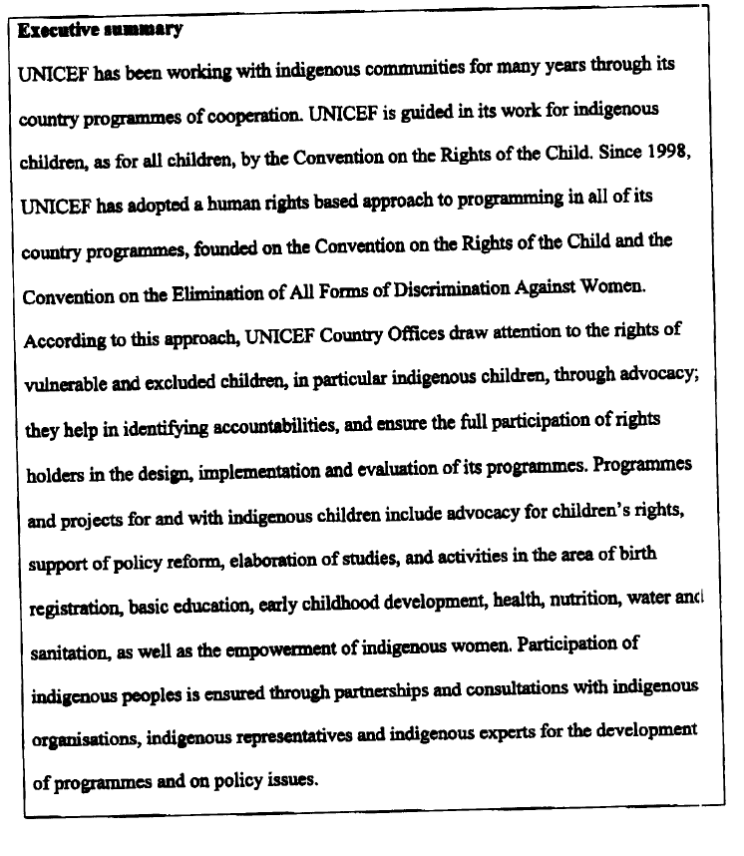
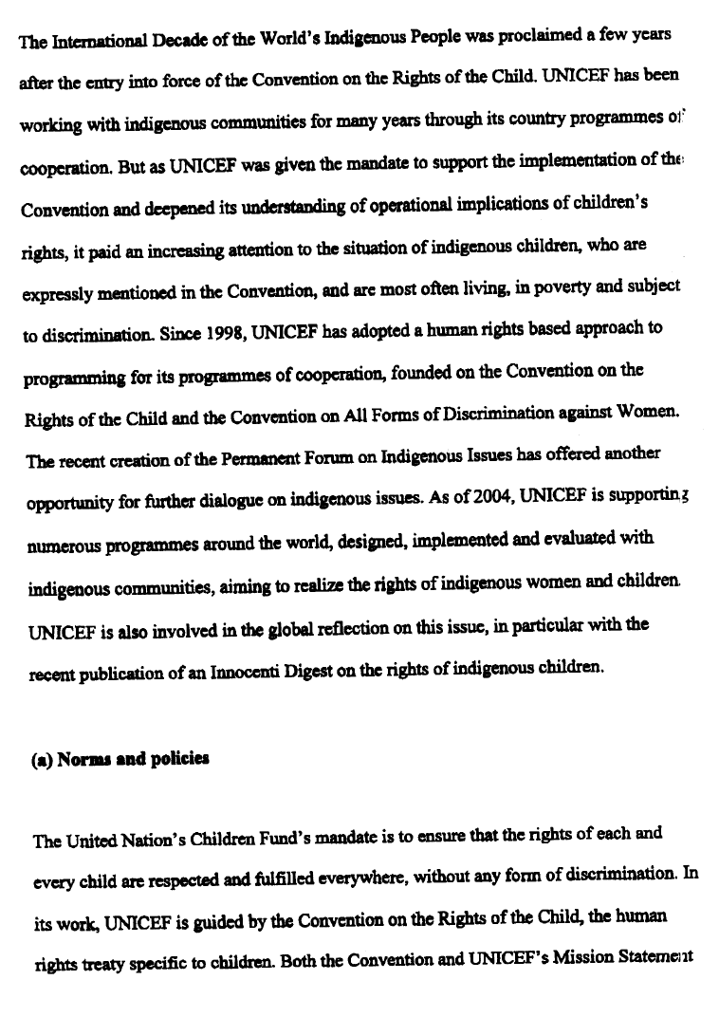
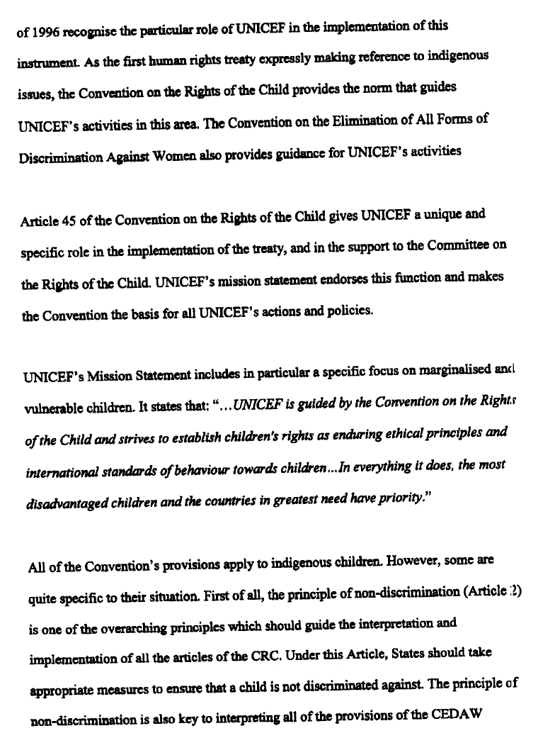
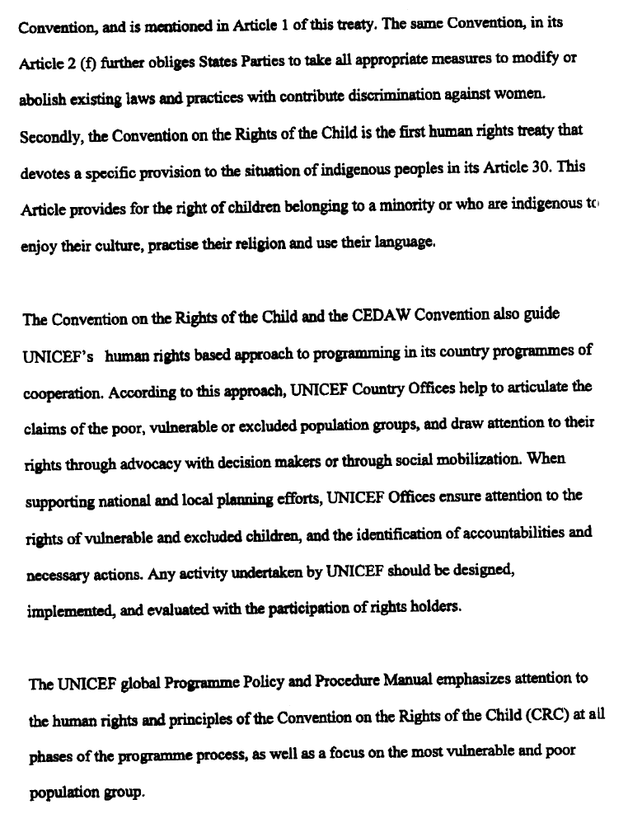
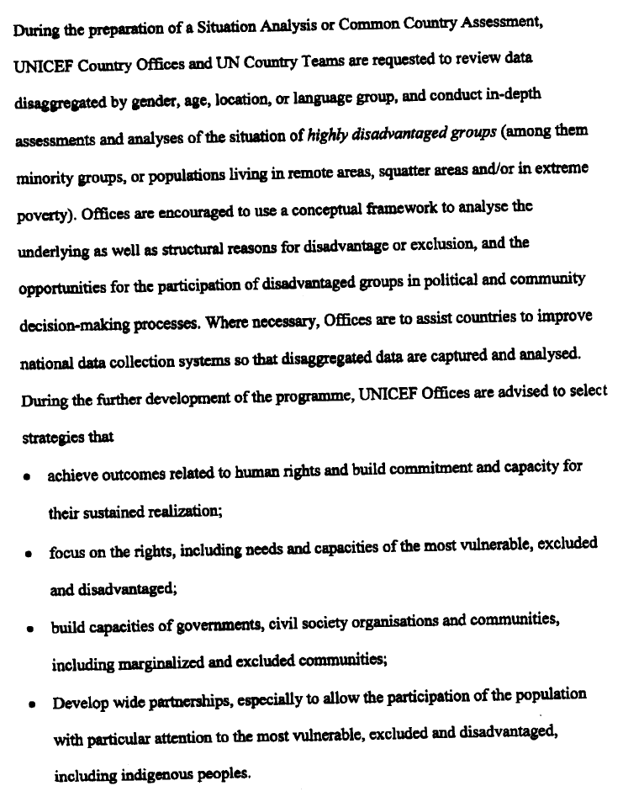

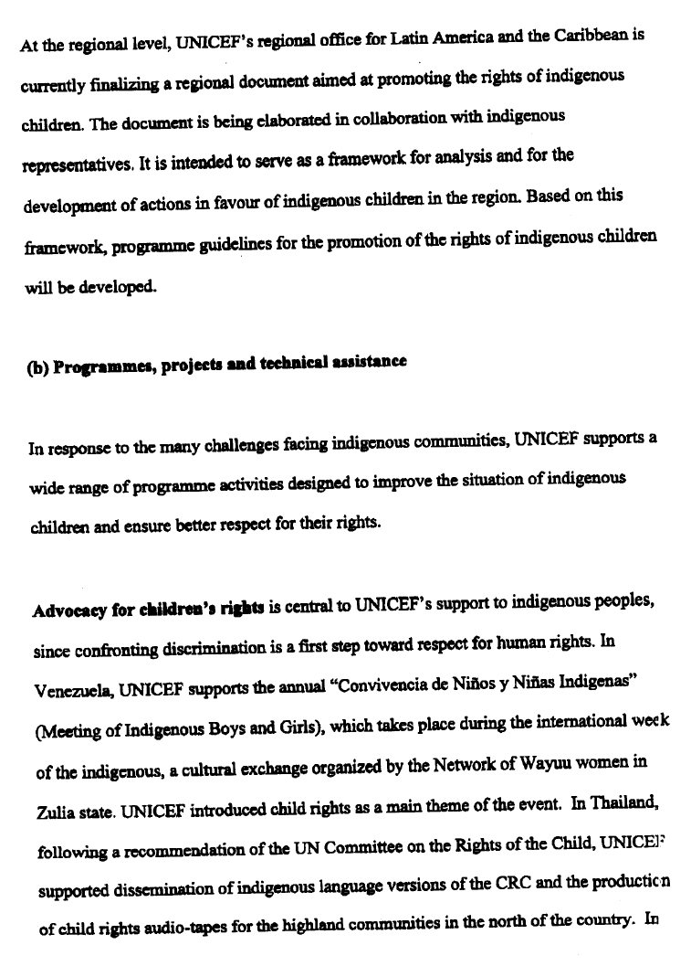
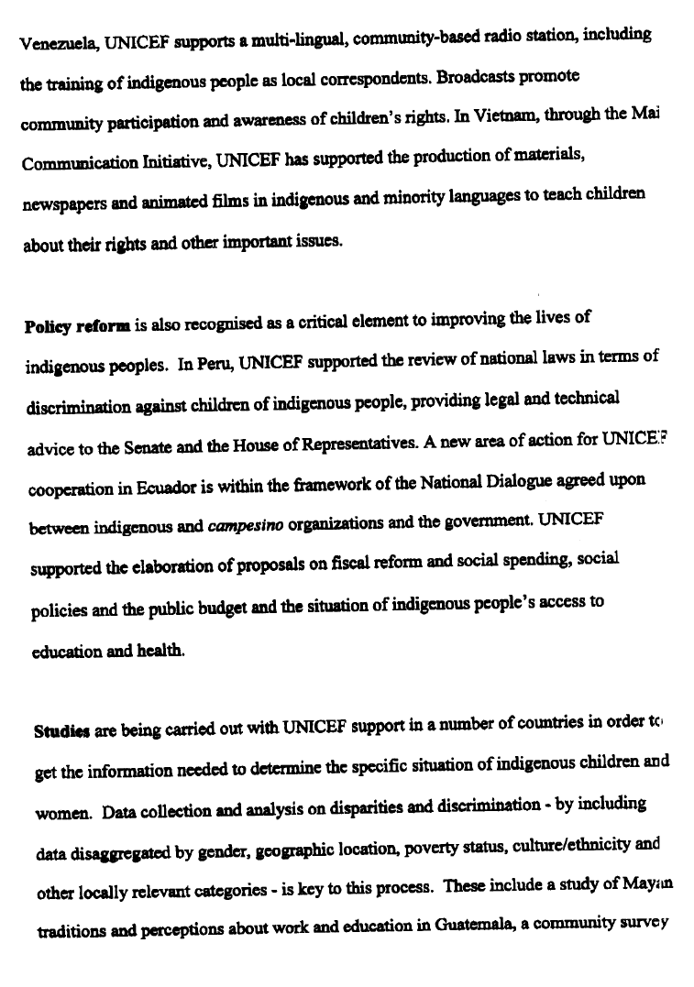
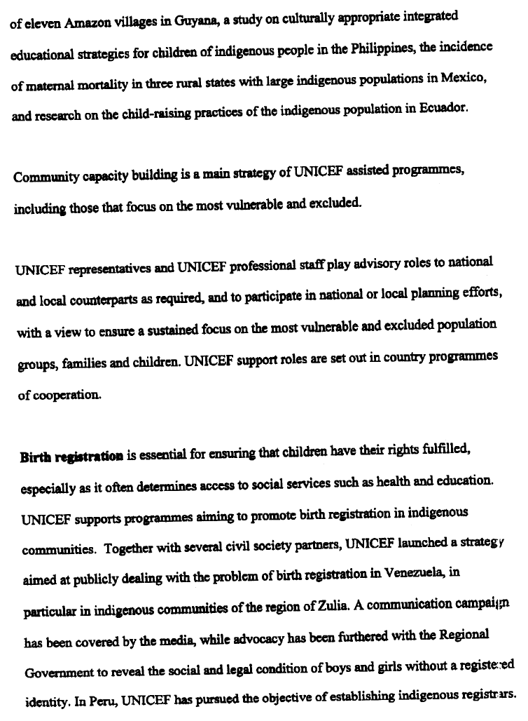
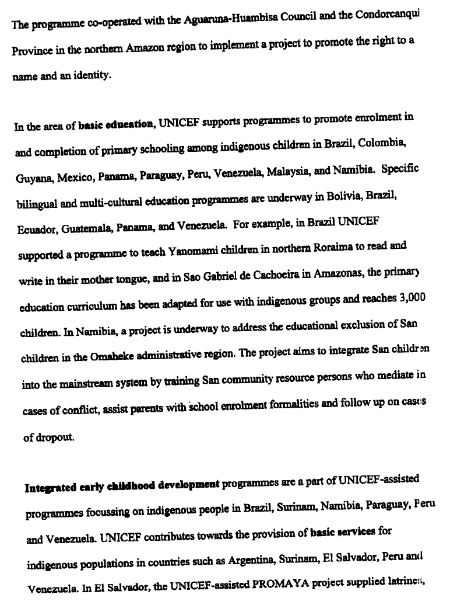
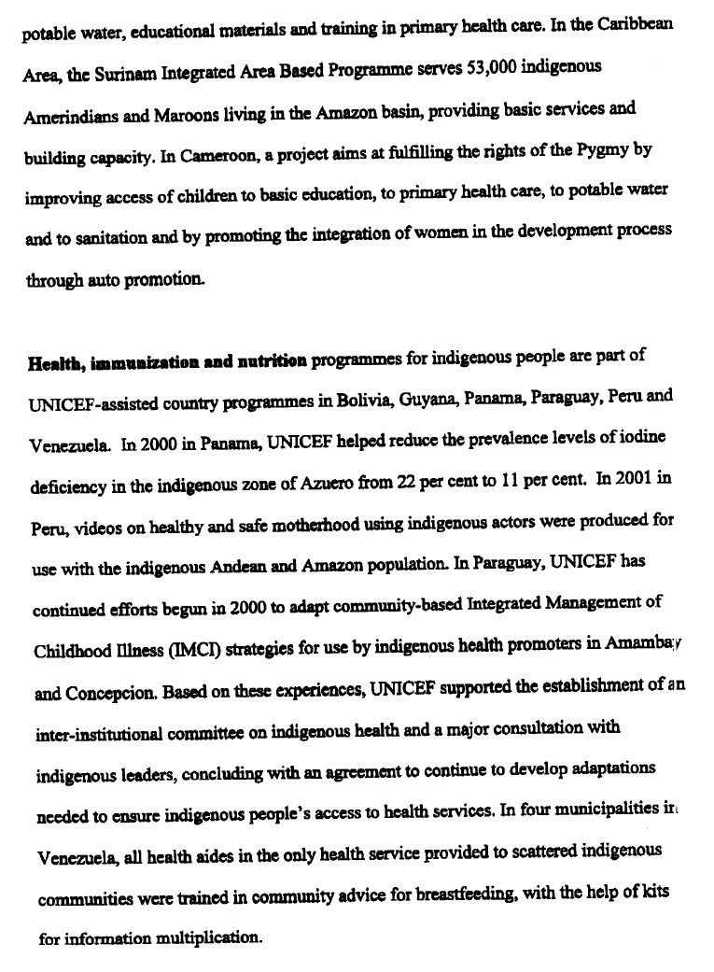
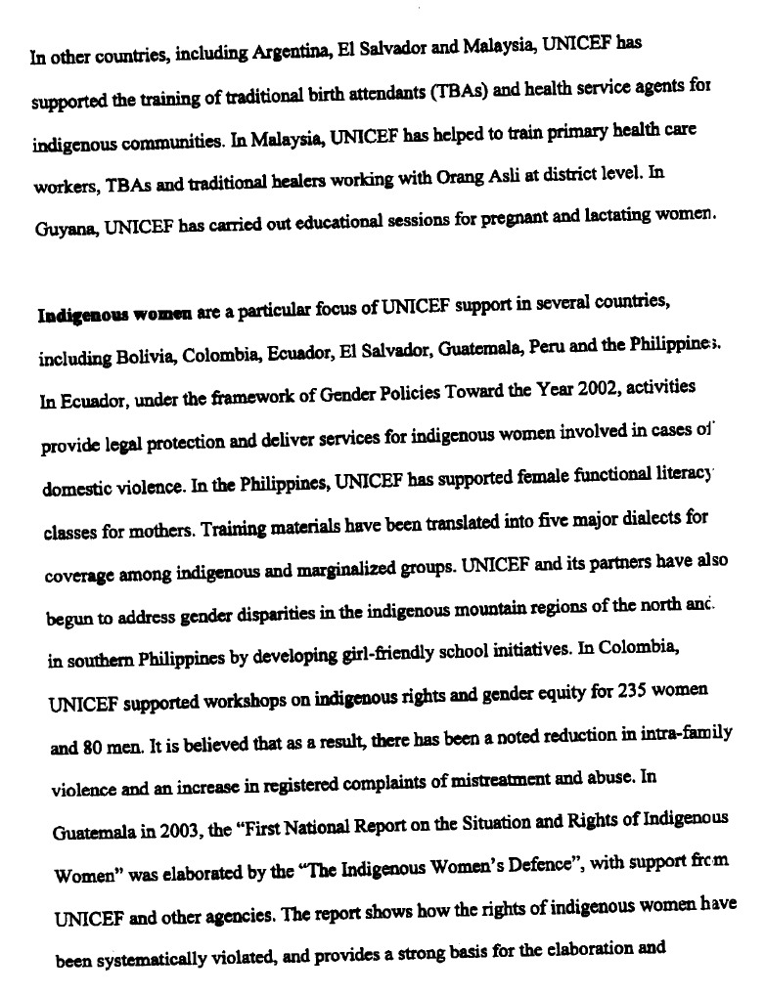
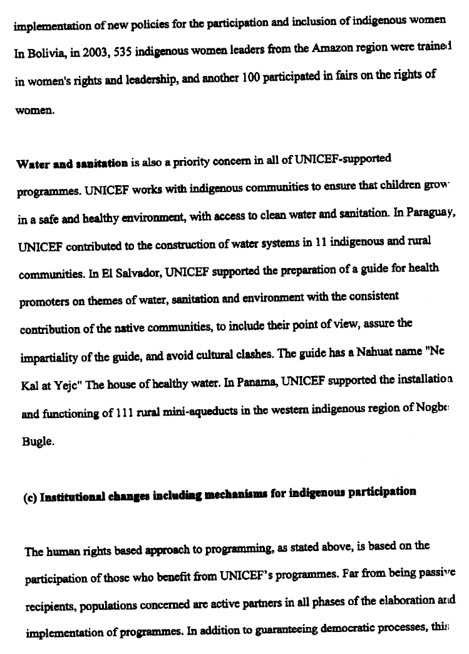
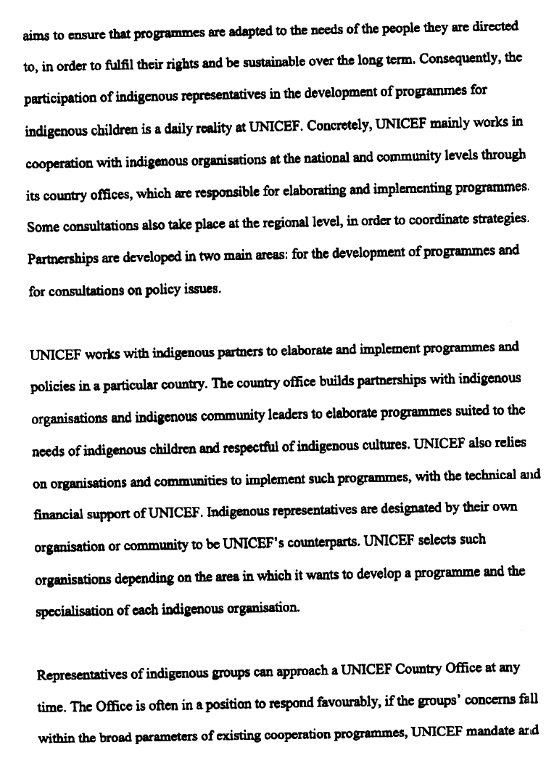
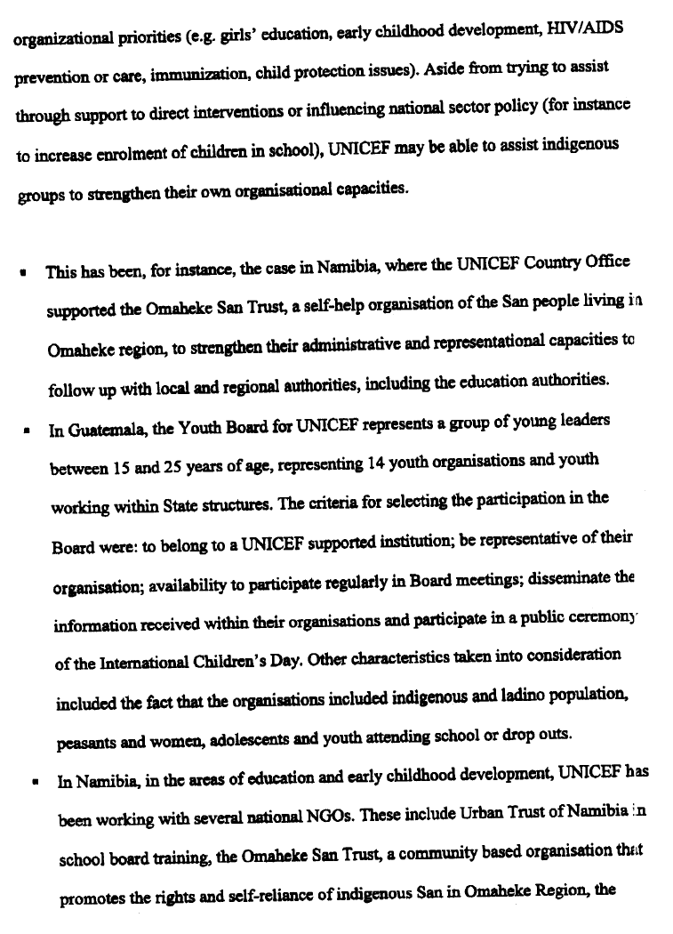
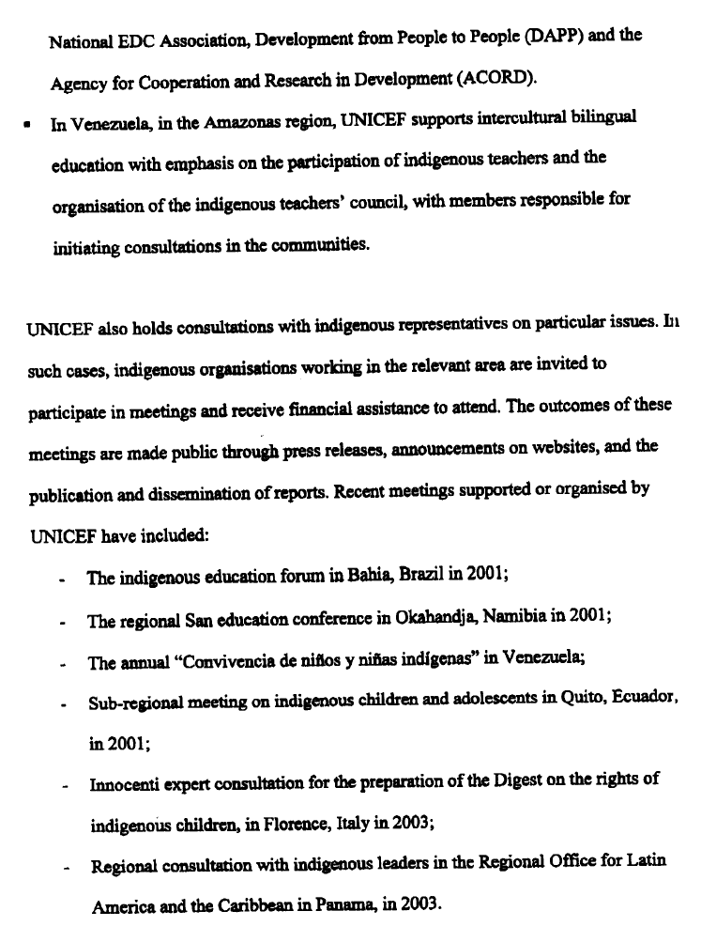
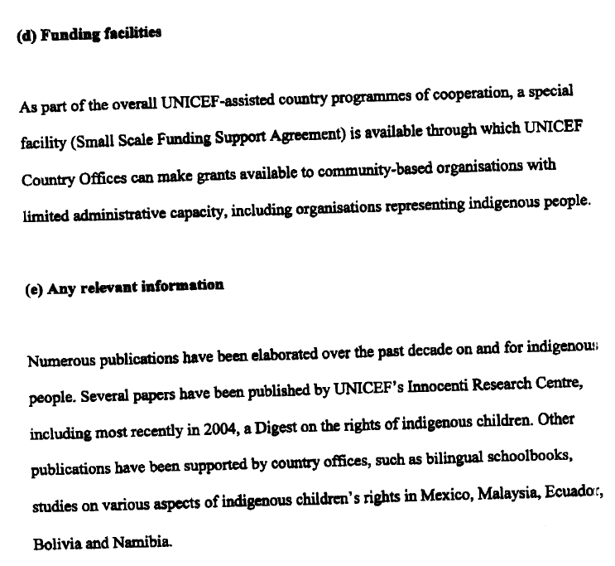

Information received from the United Nations Population Fund (UNFPA)

Executive Summary

UNFPA has been supporting initiatives and programmes to address the special needs of indigenous peoples, indigenous women in particular, through developing quality, culturally-sensitive reproductive health information, and education programmes and services that respond to the needs of indigenous peoples and with their full participation. UNFPA has been funding reproductive health-related programmes for indigenous peoples since the early 1990s, and efforts have increased through the provision of bi-literacy programmes. More specifically, UNFPA funds national and regional projects responding specifically to the needs of indigenous women, in particular in the Latin-American region. A focus on incorporating the gender perspective is at the core of UNFPA reproductive health programmes. These initiatives strive to build local capacity and ensure that the services and service providers are gender and age responsive and respectful of clients from all social and cultural backgrounds. To mention just a few concrete examples, in Ecuador, UNFPA supports an innovative project that combines traditional indigenous practices with modern medicine. In Bolivia and Peru, indigenous women were empowered through a methodology which provides bilingual literacy enabling women to read and write simultaneously learning about sexual and reproductive health and rights, and gender quality, with a view to improving their well being, health and income earning potentials.

- Norms and policies
Eradicating poverty, achieving universal primary education, empowering women, reducing maternal and child mortality, combating HIV/AIDS, ensuring environmental sustainability and establishing a strong partnership for development are common goals shared by the Millennium Development Declaration and the Programme of Action (POA) of the International Conference on Population and Development (ICPD) held in 1994 in Cairo. To make these goals a reality depends largely on their ownership by local communities and on efforts to sustain a “development enabling environment”, where local resources are tapped and mobilized to achieve these goals. The POA calls on Governments to address, in consultation with indigenous peoples and in collaboration with relevant NGOs and intergovernmental organizations, the rights and specific needs of indigenous populations, in particular, indigenous women’s right to reproductive health.

The approved “Key Actions for the further implementation of the Programme of Action of the International Conference on Population and Development”, a result of the five-year review of the ICPD, reaffirms that Governments should promote and respect the rights of indigenous people with particular regards to their cultures, resources, belief systems, land rights and languages, and should ensure that the human rights of women and girls are respected and promoted through development, implementation and effective enforcement of gender-sensitive policies and programmes.

Within the scope of its mandate, UNFPA has been supporting initiatives and programmes targeting the rights and specific needs of indigenous peoples, and in particular indigenous women, to ensure that their rights are fully respected and realized. In effect, indigenous peoples, and particularly indigenous women, often experience lack of access to reproductive health services and information. Several factors intervene to determine their access to these services, among others physical accessibility, affordability, cultural beliefs and discrimination, including gender-based discrimination.

In this respect, UNFPA encourages governments to promote and protect the human rights of the girl child and young women, which include economic, social and cultural rights, as well as freedom from coercion, discrimination and violence, including harmful practices and sexual exploitation.

UNFPA has been supporting initiatives and programmes to address the special needs of indigenous peoples, through developing quality, culturally-sensitive reproductive health information, and education programmes and services that respond to the needs of indigenous peoples and with their full participation. More specifically, UNFPA funds national and regional projects responding specifically to the needs of indigenous peoples, in particular in Latin America. These projects focus on improving access of indigenous peoples to primary health-care centres and to improving the quality of the reproductive healthcare received, as well as support to decentralized planning and decision making by indigenous leaders on community development needs and strategies. The projects take into account the importance of cultural values for quality of care and include training and counselling components for health workers, as well as the provision of reproductive health equipment and contraceptives.

UNFPA has been funding reproductive health-related programmes for indigenous peoples since the early 1990s, and efforts have increased through the provision of bi-literacy programmes. These programmes which involve providing literacy training in both the native language of the participants and Spanish - the official language of the country - are also excellent vehicles for transmitting information on reproductive health and gender issues to mostly illiterate indigenous peoples, as well as to non-indigenous communities, including community leaders, policy-makers, social and health workers and the media. UNFPA has been supporting such programmes in Bolivia, Guatemala, Mexico and Peru. UNFPA has also funded the production of a prize-winning documentary film on the bi-literacy programme in Peru, called “Así es esta historia”.

UNFPA’s efforts have been directed to incorporate the perspectives, needs and rights of indigenous women into the design, implementation, monitoring and evaluation of the population, development and environment programmes that affect them; to ensure that they receive reproductive health services, which are socially, culturally and ecologically appropriate; and to address social and economic factors that act to their disadvantage.

To address these challenges, UNFPA has been examining its programming approaches, with the view of refining its knowledge and tools to develop more inclusive culture sensitive programming and mobilizing communities to become active partners in development.

A central concern of UNFPA’s programmes focusing on indigenous peoples has been the incorporation of a gender perspective in order to respond to the very different needs of indigenous women and men and to address issues such as violence against women.

b) Programmes, projects and technical assistance; c) Institutional changes including mechanisms for indigenous participation; funding facilities

In Bolivia, UNFPA is implementing a project focusing on bilingual literacy among Quechua-speaking women in the departments of Potosi, Cochabamba and Chuquisaca, applying reproductive health and gender concepts. Literacy rates have increased as result of the project, which started in 1999. To date more than 100,000 persons are able to read and write, among them 76 per cent of them are women. Its innovative approach has won an award from UNESCO. Given its success, municipalities are allocating funds for project activities in their operational yearly plans. Activities will also be included in the National Educational Strategy in order to ensure institutionalisation and sustainability during the coming years.

UNFPA is also supporting the Government’s initiative to elaborate an Indigenous Identity Development Program. UNFPA will provide technical assistance in the development of indicators to ensure that from an intercultural perspective ethnicity is cross-cutting in all sectors, as well as research on gender equality issues. In this regard, UNFPA has funded research to determine cultural sensitive approaches to the provision of reproductive health services.

In Peru, UNFPA has funded the production of a prize-winning documentary film on the bi-literacy programme, called “Asi es esta historia”. Furthermore, UNFPA and the Center for Amazonian Research and Promotion organized a Reproductive Health Seminar for indigenous women in Pucallpa, as well as support for a number of socio-demographic studies in the Andean region. The seminar produced a follow-up plan addressing integrated health issues and focusing on the sexual and reproductive health and rights of South-American indigenous women. In January 2001, a new sexual and reproductive health programme was launched, focusing on the specific needs of the Hambisi-Aguaruna indigenous communities in the Peruvian Amazon, with special attention given to the spread of HIV/AIDS among these communities. Information, Education and Communication (IEC) activities were undertaken to promote HIV/AIDS prevention.

In Mexico, UNFPA supported a project that deployed an audience-segmentation approach in order to ensure indigenous people’s perspectives were reflected in messages. The Social Security Institute/Solidarity programme in Mexico produced culturally sensitive materials to reach indigenous rural populations. It emphasized interaction with indigenous communities and families, sensitivity to socio-cultural values and traditions, respect for traditional health practices and communication in the local language via bilingual residents.

In Ecuador, UNFPA has been strengthening local initiatives of indigenous groups. The “casas de la salud” or “Jambi-Huasi”, in the province of the Sierra and the Amazon, are places that combine ancestral wisdom healing practices with modern medicine. UNFPA supports the municipality of Guamote to integrate sexual and reproductive rights in its municipal agenda and in the concerted action of community organizations in order to better connect reproductive health services to the community. This has contributed to strengthening indigenous women’s self-esteem and rights. UNFPA is also strengthening capacity of indigenous groups to demand for quality services. The strategy includes promoters and birth attendants, community agents, and women leaders. Topics include: reproductive health services, obstetric emergency services, violence in the family, sexuality, and cancer prevention. Moreover, this project has been expanded to include the specific needs of adolescents. Low user fees have been introduced with the aim of achieving self-financing. In coordination with the Commissariat of Woman, action has been taken to address the issue of domestic violence among indigenous communities. Community-meetings have been organized to sensitize indigenous peoples on women's rights.

UNFPA emphasizes the importance of cultural values and their linkages with population and development, including democracy and good governance, as well as with human rights in all policies and programmes. UNFPA stresses the need to respect cultural values in the design and implementation of its assistance to activities and in its partnership with key national and international institutions.

Outstanding challenges for the future

- There is an urgent need to continue to expand efforts for comprehensive and accessible health services and programmes, including reproductive health, for indigenous communities. These programmes must be carefully developed so that they truly respond to the needs and reflect the rights of indigenous peoples, with particular considerations to their cultures and languages and based on socio-cultural studies.

- It is imperative that we place a gender perspective at the centre of all policies and programmes affecting women’s health, in particular indigenous women, and involve them in the planning, implementation and monitoring of such policies and programmes, and in the provision of health services.

- It may be particularly helpful to create permanent national and local working groups that include government officials, NGOs, women’s groups and indigenous peoples to ensure that reproductive rights are explicitly covered in policies and laws.

- There is also need for more reliable information. Governments, in collaboration with research institutions and NGOs, as well as with the assistance of the international community, should strengthen national information systems to produce reliable statistics. All information should be disaggregated by population subgroups, including indigenous peoples and by age and sex. This is particularly important for monitoring progress towards goals adopted internationally, at conferences of the 1990s and the Millennium Summit.

- Need to examine information system and national indicators to determine its capacity to capture data on indigenous populations.

- Need to assess situation of maternal mortality in the different indigenous territories (or with majority of indigenous populations and/or indigenous populations living outside their lands of origin), use of health services and coverage (including offer and demand), financing of services, obstacles to access services, research on causes which consider cultural, economic geographic, transportation, etc. factors.

- Establishment of specific legal provisions to protect the human rights of indigenous populations, in particular their health; epidemiology, in particular malaria, TB and HIV/AIDS.

- Labour/employment situation overall, in particular, and how consistent with indigenous women’s access to the labour market.

- Need to consider availability of census information and recent surveys on indigenous populations that is recognized by indigenous populations and their representatives.

- Need to have an inventory which takes into account the social organization of indigenous populations, their capacity to participate and decide on how to address and deal with indigenous issues.

Information received from the United Nations Development Fund
for Women (UNIFEM) and UNIFEM-Andean Region

Securing Indigenous Women’s Rights and Participation

In working to support the realization of indigenous women’s rights, UNIFEM has utilized a human rights-based approach which recognizes the need to build the capacity and awareness of the state to uphold these rights, while simultaneously increase knowledge and capacity among indigenous women. Since 1995, UNIFEM has worked with its partners to utilize local knowledge and mechanisms within the indigenous communities, build synergies with decision-makers, human rights activists and women’s associations, as well as foster leadership among indigenous women.

Over the past decade, UNIFEM’s most significant work in this area has been in the Andean Region, Mexico and Central America. In the Andean Region, UNIFEM’s work was carried out in large part under a regional campaign for the eradication of violence against women launched in 1998, as well as under a regional project, “The Promotion of Indigenous and Peasant women’s human rights in the Andean Region” (1995-2000). Through the support of the Norwegian government, UNIFEM’s Andean Regional Programme Office facilitated the empowerment and participation of indigenous women in decision-making processes, through financially and technically supporting research, awareness raising, and social mobilization activities, as well as the dissemination of information on a large scale.

In the Yucatan peninsula and in areas of Guatemala, UNIFEM’s work has focused on building leadership, organisational and entrepreneurial capacity. In particular, the Fund has worked in close collaboration with the UNDP/GEF Small Grant Programme. In Chiapas and other neighbouring areas where indigenous people are more marginalised, UNIFEM has worked to promote women’s leadership in an attempt to impact structures and traditions which limit their participation. To that end, the Fund has partnered with the Women’s National Program and the Public Education Ministry in promoting intensive literacy programmes which have a gender component.

The following are examples of key results and outputs of UNIFEM’s work in supporting indigenous women:

- Awareness Raising among society: Essential to ensuring the realization of indigenous women’s rights is the fostering of knowledge and understanding among society as a whole about the particular challenges and realities which these women face. There is a paucity of data on indigenous women and to bridge this gap, UNIFEM supported the development and dissemination of statistical publications in both Ecuador and Colombia (1998). These publications provide social indicators on the status of indigenous and non-indigenous rural women in each of the two countries, and were produced in cooperation with the Ecuadorian government’s Integrated System of Social Indicators (SIISE) program and the former National Directorate of Equity for Women (DINEM) of Colombia. UNIFEM also supported the production of a publication entitled Voces de Los Andes, which provides insight into the lifestyles and working conditions of indigenous women, often through their own voices;

- Knowledge Sharing and Capacity Building among rights holders: It is essential that indigenous women be made aware of their rights as contained within the legal frameworks of their countries. Overcoming initial resistance among male leaders and decision-makers within communities in Peru, Colombia and Ecuador and Bolivia, UNIFEM brought together indigenous women to build a comprehensive knowledge and understanding about their rights and the state’s obligation therein. Overall, approximately 4000 indigenous women were trained on women’s human rights and leadership in the Andean region. Capacity building workshops and “training of trainers” sessions were held targeting grassroots indigenous women’s NGOs, and indigenous associations/organizations. Many of the participating organizations replicated these trainings and awareness raising sessions at the community level. For most of the participants this was their first formal exposure to the concepts surrounding human rights and gender mainstreaming. In part as a result of these trainings, indigenous women’s participation in decision-making at the local level was increased, and women-specific mechanisms were institutionalized for the first time within existing organizations. For example:
    - In response to training in Ecuador, the Shuar Federation, an indigenous organisation working in the Amazon region, institutionalised a committee to deal specifically with issues pertaining to women;
    - In Bolivia, UNIFEM worked in partnership with UNICEF’s “Sub regional Amazon Programme”, the Women’s and Families’ Protection Brigade (Women’s Commissary Court), Integrated Legal Service in Women’s Favor (SLI), and the Central Committee of Indigenous Women from Beni. Under this programme, women from indigenous communities were offered awareness raising and “training of trainers” sessions and support was provided to facilitate replication of training by participants within their communities/organizations. A key result of this initiative was the emergence of women’s secretariats within existing indigenous organizations;
    - In Ecuador, UNIFEM’s activities facilitated the establishment of the first autonomous women indigenous organisation, CONMIE (The National Council of Indigenous Women of Ecuador)

- Participation, Networking and Partnership development: Recognising the need to
facilitate networking among marginalized indigenous women, UNIFEM supported a number of high level conferences. The purpose of these conferences was to raise awareness among society as a whole about the issues facing indigenous women, while at the same time promoting leadership and partnership. The discussions and linkages which emerged from these conferences laid the ground work for future interventions on the part of UNIFEM, UN agencies, NGOs and government:
    - In Brazil, UNIFEM, in partnership with GTZ, Canada, the Government of Brazil, and USAID, supported the First International Meeting of Women of the Amazon Forest in 1998, brining together over 200 women of different backgrounds and ethnic origins, ranging from forestry workers to midwives, artisans, teachers, and faith healers. The women came together to discuss issues of violence, health, sexuality and reproductive rights, networking and leadership. The event and follow up activities garnered considerable media attention and facilitated increased understanding among society and decision-makers. It also provided an opportunity for Amazon women organisations and partners to network and exchange information and experiences;
    - In Mexico, UNIFEM and the UNDP Small Grant Programme supported the First Congress of Mayan Women, as part of a larger initiative focused on highlighting Mayan women’s indigenous knowledge and experience, supporting their economic activities and facilitating gender mainstreaming throughout UNDP’s on-going community development projects. The First Congress included over 80 Mayan women, government officials, donor agencies and NGOs. As a result of the Congress, there was increased visibility of Mayan women and their needs; exchange and networking among participants; and increased capacity of Mayan women to organise and advocate for their rights;

- Capacity Building of decision-makers: UNIFEM supported the capacity building and awareness raising of lawyers, judiciary, and law enforcement officials, as well as female labor union leaders, and media on this issue. Training and awareness raising sessions were held in Bolivia, Columbia, Peru and Ecuador on gender mainstreaming and women’s human rights. The training program was designed in conjunction with ILANUD (International Centre for Criminal Law Reform Criminal Justice Policy) for judicial personal, including lawyers and judges;

- Mainstreaming Gender throughout Legal Frameworks: In Colombia, UNIFEM partnered with government agencies, the National Association of Rural and Indigenous Women of Colombia (ANMUCIC), and the Women’s House in Bogotá. Between 1996 and 2000, UNIFEM played a central role in advocating with state agencies to increase the allocation of resources in support of events pertaining to indigenous women. Legislative norms were amended regarding the granting of title to facilitate indigenous and rural women’s land ownership. In Bolivia, with UNIFEM’s financial and technical support, the national network of women working in information and communication (Red-ADA) played a fundamental role in motivating and organizing the national debate that resulted in these amendments.

- Increasing Economic security: In partnership with fair trade organizations, government and UN agencies, UNIFEM has worked to promote the recognition of women’s contribution to their families’ livelihoods:
    - In Peru, UNIFEM, in cooperation with the Manuela Ramos Movement, carried out a project focused on building indigenous women’s capacity in the area of business management, marketing, and crafts production from 1996 to 1999. Shows and fairs were organized to sell cotton, wool, pottery, silver, wood and paper crafts. By 1998, approximately 600 crafts and marketing workshops had been held and were attended by approximately 2000 women trainees. UNIFEM provided technical support in the trainings, as well as facilitated linkages between the participants, government and NGO partnerships;
    - In Honduras, UNIFEM, in close collaboration with the National Institute for Anthropology and History and the Federación Indígena Tawahka, supported an economic empowerment project for Tawahka women. Specifically, the project focused on the provision of leadership training, targeted crafts’ development and facilitating women’s access to national and export markets. The project was developed in response to the women artisans’ direct request for capacity building and marketing skills development. In implementing this project, UNIFEM and partners focused on ensuring that the production techniques utilized are environmentally friendly and reflect the culture and traditions of the Tawahka people;
    - In Mexico, UNIFEM supported a project with indigenous communities in Oaxaca which focused on building women’s networks, enabling them to have greater control of local economic resources and support the protection of the environment. After a series of training sessions, women in Oaxaca began cultivating vetiver grass, which is an important means of soil conservation particularly used in mountainous regions. Also as a result of the trainings, the women beneficiaries further developed and expanded their leadership skills and roles at the community level and actively shared the knowledge gained with neighbouring communities;

Through the above initiatives, UNIFEM supported and facilitated the integration of indigenous women into the women’s and peace movements at large, particularly in Ecuador, Mexico, Guatemala, and Peru. In working to achieve the above, UNIFEM supported partners in overcoming many obstacles. Historically, a loss of trust and lack of confidence within the indigenous communities towards outside institutions made initial contact and partnering difficult, particularly in the rural areas. Cultural mores and a patriarchal tradition also posed a challenge to increasing women’s participation in leadership roles. Through awareness raising and the building of trust, these perceptions have gradually changed. However, there still exists the need to develop greater understanding on the importance of addressing ethnic inequalities and gender discrimination in tandem.

Building on the achievements of the past, UNIFEM in Latin America is now focusing on supporting increased interagency cooperation among UNCTs on the issue of indigenous women, facilitating linkages among agencies and the national women’s machineries of the region. With the participation of various institutions and organization, UNIFEM will also support indigenous women’s groups in developing more targeted and strategic focus on key issues and will facilitate strengthened partnerships and alliances within the movement.

Such collaborative efforts are also taking place in preparation for the World Indigenous Forum in New York, 2004. To commemorate the last year of the International Decade of the World’s Indigenous People, in April 2004 UNIFEM is supporting an event in Lima, Peru entitled “Indigenous Leaders of the Americas”. This conference will provide a platform for reflection and analysis, dialogue and networking on critical themes and issues related to indigenous peoples’ living conditions, empowerment, collaboration and political participation. The results of this conference will assist UNIFEM in developing a comprehensive strategy for future programming in the area of Indigenous women’s rights.

UNIFEM-ANDEAN REGION

"... Hay discriminación hacia las mujeres, los hombres no quieren tener para hacer comida, lavar. Tenemos que ir al poder, ser cacicas, pero para eso debemos prepararnos. Parir es lindo, vamos a seguir pariendo para que nuestros pueblos crezcan, pero también vamos a prepararnos." (mujer wayuú, de Venezuela).
"... There is discrimination towards women, the men do not want to have to make food, to wash. We have to go to the power, the wife of the community’s indigenous chief, but for this we must prepare ourselves. To give birth is beautiful, we will continue giving birth so that our towns grows, but we will also prepare ourselves." (woman wayuú, of Venezuela). Voces de Los Andes. Testimonies of indigenous and rural women. Quito: UNIFEM & Concurso Mujer, 1998.

UNIFEM- AR has overcome the many obstacle to successfully train, empower, and strengthen Indigenous women in the region over the course of the last ten years. The projects and initiatives pursued by this office have taken various forms to cover a wide spectrum of development and human rights projects.

The barriers faced by UNIFEM-AR were culturally based, but also existed within the feminist movement of the region and, lack there of in the mixed indigenous movement. The successes of UNIFEM-AR have well surpassed the original goals and resulted in the office moving forward with the creation of future projects, strengthening of the Indigenous Women’s Movement, greater political participation, visibility, and empowerment of Indigenous Women.

Historically, a loss of trust and lack of confidence within the indigenous communities towards outside institutions made it difficult to reach indigenous women of civil society, especially in rural communities, in turn the culturally male dominated organizations made it difficult to reach the women of these communities. At some instances permission had to be granted by the male leaders for women to take part in activities.

The project “Promotion of Indigenous and Peasant women’s human rights in the Andean Region”, May 1995 – December 2000, was centered around the empowerment through analysis of living, working, health and educational conditions, dissemination of human rights, promotion of ethnic diversity, class and gender consciousness, and information and knowledge exchanges. These objectives were met through research training and social mobilization.

Research led to five major publications, which pulled together statistical data and people’s testimonies, as well as two training manuals: on human rights and on workers’ rights. Two of these publications, statistical manuals, have become standard reference material in their countries and elsewhere in the region:

Portraits of women. Social indicators on the status of indigenous and non-indigenous rural women in Ecuador (1998), published jointly with the government’s Integrated System of Social Indicators for Ecuador (SIISE) program, with statistics on population, education, work, health and housing; and Statistics on rural Colombian women (1998), published jointly with the former National Directorate of Equity for Women (DINEM), a government agency

One of the greatest success of this project was the work achieved with women whom previously had very little knowledge of human rights. Women’s organizations were formed in places where men had previously prevented the women from organizing, existing organizations were reinforced. Approximately 4000 Indigenous women were trained in management and human rights, many of which replicated their knowledge resulting in indirect coverage in four countries of 9196 persons trained.

The target audience for the training session were as follows: attorneys and justice-administration system personnel (judges, prosecutors, commissary-court judges, policewomen and –men); indigenous and rural women; female leaders of labor union and grassroots organizations; and radio station owners, producers and journalists.

There were two main subjects: human rights and gender. Other workshops covered management, leadership, and workers’ rights, especially in Colombia.

Programming Examples:

- During 1995 in Ecuador, two workshops were held, in the towns of Santiago and Bomboiza, on human rights for women from the Shuar Federation, an indigenous organization in the Amazon region. For most of the participants (a total of 48), this was their first training experience ever. An important outcome was the Federation’s creation of a Women’s Committee. These experiences have been portrayed in the video entitled “Training with Shuar women”

- In Bolivia Under UNICEF’s Subregional Amazonian Program, benefiting 22 ethnic groups, three sub-projects were implemented to promote indigenous women’s rights, strengthening the Women’s and Families’ Protection Brigade (Women’s Commissary Court), Integrated Legal Service in Women’s Favor (SLI), and the Central Committee of indigenous Women from Beni. The Beni Committee trained 15 women as trainers, and 60 people from four communities, 70% of them indigenous women leaders who replicated the training for another 450 people. In all, some 2700 people were reached indirectly.

- Through 1996 – 1999 in Peru, to generate stable economic income, through the Marketing Service of the Craftswoman’s House, the Manuela Ramos Movement carried out a project including training in business management and marketing, and crafts production techniques. The concepts of gender and women’s human rights were never neglected. Several shows and fairs were organized to sell cotton, wool, pottery, silver, wood and paper crafts. The greatest impact was achieved by the Craftswomen’s Hands Christmas Fair in 1996. By 1998, a total of 602 crafts and marketing workshops has been held (439 for women, 67 for men and 96 combined), attended by 2408 trainees (2080 women and 328 men). Considering that each trainee represented a household, and that families average 5.3 members, the number of indirect beneficiaries amounts to nearly 11 thousand.

- In Colombia, 53 women leaders were trained, representing indigenous and rural women from 28 departments of Colombia. In total, there have been an estimated 1600 direct beneficiaries, belonging to 80 grassroots organizations, with 20 to 30 thousand indirect ones. Support for the National Association of Rural and Indigenous Women of Colombia (ANMUCIC), with advisory assistance from the Women’s House in Bogotá, was decisive to attain such results, because the project worked with members of this apex organization. Addressing specific needs, training covered, in addition to women’s human rights, the topics of organizational management and political participation.

Legislative norms were amended regarding the granting of title so indigenous and rural women can own land between 1996- 2000. The national network of women working in information and communication (Red-ADA) played a fundamental role in motivating and organizing the national debate that resulted in these legal changes.

Specifically in Ecuador, the women’s indigenous movement plays an important role in the indigenous movement as a whole. Indigenous Women’s organizations and Leaders have been credited with organizing events and activities in support of the needs of the indigenous communities of the country. The influence, visibility and work of women’s organizations in Ecuador has become imperative and significant to the indigenous cause.

In more recent years UNIFEM – Andean Region has been working diligently towards greater interagency cooperation with other UN organization and with the National Women’s Machineries of the region. With the participation of various institutions and organization, UNIFEM anticipates that the indigenous women’s groups will define their priorities, set agendas and work plans, develop strategies for future initiatives and create and strengthen alliances within the movement. Such collaborative efforts are also taking place in preparation for the World Indigenous Forum in New York, 2004.

The challenges currently facing UNIFEM- Andean Region looking forth to the future in the sector of Indigenous women are grave in the sense that if not ratified it could obstruct development and progress. A lack of consensus, cooperation and coordination between participating organizations and institutions is greatly affecting the influence these groups have and the effectiveness of their initiatives. Politics must be considered with greater conscience within indigenous women’s movement.

Another challenge facing this sector is that Indigenous women lack a voice or power within the mixed indigenous movements of the region. The institutions that maintain the majority of the influence in this sector rarely put forth the issues facing women and do not place gender issues as a priority on their agendas.

Information received from the International Labour Organization (ILO)

I Overview

The ILO’s approach to indigenous and tribal peoples’ rights falls within two major areas: (i) supervision of the two Conventions relating to indigenous and tribal peoples, and (ii) technical assistance.

During the International Decade for the World’s Indigenous People, the ILO has contributed significantly to advance the debate on the rights of indigenous and tribal peoples at both national and international levels. Through its supervision of ILO Conventions of relevance to these peoples, and through its technical co-operation programmes, the influence of ILO Convention No. 169 on national, regional and international policies and legal instruments concerning indigenous and tribal peoples is clear. However, the debate remains less advanced in some regions than others, and considerable challenges still remain. These are outlined at the end of this document.

In its 1999 annual report, the ILO's Committee of Experts observed that Convention No. 169 is the most comprehensive instrument of international law for the protection in law and in practice of the right of indigenous and tribal peoples to preserve their own laws and customs within the national societies in which they live.
At the national level, ratification of the Convention has prompted the establishment, reform, or reinforcement of a number of government agencies responsible for co-ordinating policies relevant to indigenous and tribal peoples, and for monitoring projects and programmes pertaining to these peoples. Examples of such agencies include the National Indian Foundation in Brazil, the National Indian Institute in Mexico, and the General Directorate for Indigenous Affairs in Colombia. It has also been one of the factors behind the revision of national constitutions in several ratifying states, namely in Bolivia, Mexico and Peru.
Convention No. 169 also provides guiding principles for national policies and laws on indigenous peoples, and indigenous peoples' policies of international financial institutions such as the World Bank, and United Nations Specialised Agencies and UN Programmes such as UNDP. Convention No. 169 has guided a number of Supreme Court decisions in the Americas (especially in Colombia), illustrating the potential of the Convention to influence the positive law of these countries and ameliorate the relationship of power in the dialogues between national governments and indigenous and tribal peoples.
The ratification of Convention No. 169 has also been cited as a contributing factor to the settlement of the internal conflict in Guatemala, which, as stated in the preamble of the 1996 Peace Agreement, brought to an end more than three decades of armed confrontation in Guatemala. In its 1999 observation, the Committee of Experts noted the continuing role the ILO is playing in the implementation of this Agreement.
The influence of Convention No. 169 is also evident in a number of States that have not ratified it but have used it as a basis for examining their national situations as regards indigenous and tribal peoples. Convention No. 169 has also served as a background instrument informing the deliberations of a number of United Nations treaty bodies. For example, in its consideration of State reports under the International Convention on the Elimination of Racial Discrimination, the Committee on the Elimination of Racial Discrimination has recently paid particular attention to Convention No. 169, highlighting issues of consultation and participation of indigenous peoples in Argentina, and welcoming its ratification of the Convention. The Committee has also encouraged Japan and the United States to use Convention No. 169 as guidance regarding the rights of indigenous peoples, and in respect of securing their informed consent in decision-making processes that affect them.

II Summary of principal activities and challenges

  - Standards and policies

A primary aim of Convention No. 169 is to enhance dialogue between governments and indigenous and tribal peoples, and increase the capacity of those peoples to participate and take responsibility for development processes directly affecting them. It excludes the ‘top-down’ approach of the 1950s to 1970s, and relying instead on a determination of what indigenous peoples themselves indicate that they need.

During the last decade 11 (out of a total of 17 ratifications for the Convention) States have ratified Convention No. 169.

Argentina | 3.7.2000
Brazil | 25.7.2002
Denmark | 22.2.1996
Dominica | 25.6.2002
Ecuador | 15.5.1998
Fiji | 3.3.1998
Guatemala | 5.6.1996
Honduras | 28.3.1995
Netherlands | 2.2.1998
Peru | 2.2.1994
Venezuela | 22.5.2002

In both its regular and extraordinary supervisory procedures, the ILO has issued critical comments and recommendations on the application in law and in practise of the Convention by the ratifying countries. The main topics addressed by the supervisory bodies are related to land and natural resources rights; and to the consultation and participation of indigenous and tribal peoples in the adoption of policies, legislation and administrative measures which may have an impact on their lives. During recent years many governments have made significant improvements in the adoption of legislation specifically for indigenous and tribal matters. On the other hand, a greater effort has to be done to achieve the same progress in the application of these measures in practice.

2.1.1. Land

As examples, the 1991 Constitution of Colombia was one of the first in the world to articulate the concept of territorial rights for indigenous peoples and to specify the nature of indigenous rights to self-government and to the management of their natural resources. In 2002 the CEACR asked Costa Rica’s Government to report on the extent of the indigenous territories still in non-indigenous possession and on the procedures that currently exist within the national legal system so that indigenous peoples can claim land that they have lost, or of which the ownership has not yet been determined.

2.1.2. Natural resources

Under Convention No. 169 indigenous and tribal peoples have the right to be consulted before mineral or other resources on their lands are explored or exploited. Experience shows that conflicts have arisen between indigenous and tribal communities that occupy lands that had been leased or sold for prospecting or exploration activities, and the companies operating in those areas. Although indigenous and tribal peoples do not have the right under the Convention to veto exploitation, they can use their rights in negotiations to persuade companies or the government to adapt their techniques to minimize environmental damage, and to restore the environment afterwards. In this connection an ILO tripartite committee set up to examine a complaint against the Bolivian government concluded that indigenous communities should be promptly and adequately consulted on the extent and implications of exploration and exploitation activities, whether these are mining, oil or forestry activities. The same principle was recommended to the Colombian Government in relation to the U’wa indigenous people, and to the Government of Costa Rica, and has entered into the ILO supervisory bodies’ regular dialogue with all ratifying States.

2.1.3. Administration of Justice

During the last decade the ILO has remarked the following positive trends:

- The new Constitution of Bolivia recognizes that the authorities of indigenous peoples may exercise administrative functions in alternative procedures for the settlement of disputes.
- In Colombia the Penal and Penal Procedure Codes have adopted special conditions respecting the treatment, penalties, detention and rehabilitation of indigenous persons.
- In Costa Rica some of the Constitutional Court judgements confirm the possibility of invoking indigenous peoples’ customs and customary laws. It legal provisions also exist in this country establishing the safeguards of legal advice and interpreters for indigenous persons in legal proceedings.
- In Mexico a programme for the promotion and access to justice has been adopted, under the responsibility of the National Indian Institute (INI). The CEACR has requested the Government to provide information on the manner in which the Programme secures the participation of indigenous people.
- The Penal Code of Paraguay allows that a legal representative of a community of the ethnic group of the convicted person may submit to the judge an alternative to the execution of the penalty, when a sentence involves a period of detention of not more than two years

As has been already explained, the legislative recognition of the principles of the Convention, in most cases, is not enforced in practice. Thus the ILO is continuously providing recommendations, guidance, and assistance to improve capacity building; to launch awareness raising campaigns; and to influence governments to give priority in the elaboration of policies related to the development and protection of indigenous and tribal rights, with their consultation and participation.

2.1.4. Other relevant ILO Conventions

Convention No. 111 on discrimination (employment and occupation), 1958, is also relevant to the situation on indigenous and tribal people. Most of the comments of the CEACR refer to the particularly vulnerable situation of the members of these groups in the labour market. This precarious situation starts from their very first stage of their life: high mortality rate, deficient educational services – if any - and lack of professional training among other shortcomings. The consequences of these deficiencies are more critical due to the widespread prejudice of the non-indigenous population in respect of the social, cultural, religious and spiritual values and practises of indigenous and tribal peoples, as well as their social, economic and cultural institutions and traditions. The ILO supervisory bodies give particular attention of the application of Convention No. 111 to indigenous and tribal peoples in those countries that have not ratified Convention No. 169.

Indigenous children also constitute a typical example of “children at special risk” of worst forms of child labour, which the ILO’s Worst Forms of Child Labour Convention, 1999 (No. 182) obliges governments to identify and reach out to (Article 7(2)(c)). Other ILO Standards that are of particular relevance to indigenous and tribal peoples are: The Forced Labour Convention, 1930 (No. 29); and the ILO Declaration on Fundamental Principles and Rights at Work.

  - Programmes, projects and technical assistance

    - General technical assistance

Technical assistance benefiting indigenous and tribal peoples has assumed an increasingly recognized part of the ILO’s activities in all parts of the world. In the earlier part of the Decade, this remained concentrated in Central and South America, including in Costa Rica, Guatemala, Mexico, Honduras and Panama. This has included legal training and advice, gender awareness and training activities, and capacity-building at national and community levels. Many of these activities have focussed on issues brought up within the context of the supervision of these Conventions by the ILO’s Committee of Experts. It has gradually become an integral part of ILO’s technical co-operation around the world, with growing awareness that indigenous and tribal peoples are the poorest and most excluded part of virtually every nation in which they are found.

    - Technical co-operation projects focusing specifically on indigenous and tribal peoples

The increasing international emphasis on ILO Convention No. 169, following its adoption in 1989, led to an increasing number of requests to the ILO for further information regarding the Convention, as well as a need for additional technical assistance in the ILO’s work in the area of indigenous and tribal peoples. These constituted the main reasons for the establishment of the two main technical co-operation projects in the ILO that focus specifically on these peoples: The Project to Promote ILO Policy on Indigenous and Tribal Peoples (the C169 Project) and the INDISCO Programme (Support to Self-Reliance of Indigenous and Tribal Peoples through Co-operatives and other Self-help Organizations). The first of these projects – the C169 Project - has taken place specifically within the framework of the International Decade for the World’s Indigenous People, and was initiated in 1996. The INDISCO Programme was already operational at the start of the Decade, having begun in 1993. Both these projects are ongoing, following the accumulation of considerable momentum in Project activities, particularly in the understanding and awareness of the need for comprehensive policies and programmes, aimed at improving the living and working conditions of indigenous and tribal peoples worldwide.

There are a number of other technical co-operation projects and programmes that address indigenous peoples, in the context of ILO regular programmes of assistance.

A The C169 Project

This project works at the policy level, and its approaches to project design, development and implementation vary according to the specific circumstances of a given project country as well as the cultural specificities of the indigenous peoples and communities with which it works. The main objectives of this project are as follows:
- The development, adoption and implementation of policies that integrate the rights, as conveyed in the Indigenous and Tribal Peoples Convention, 1989 (No. 169), as well as the needs and priorities of indigenous and tribal peoples in the countries assisted by the project.
- The contents and principles of Convention No. 169, and where applicable Convention No. 107, will be better known and used, in particular in the countries in which the Project works;
- The capacity of indigenous and tribal peoples to participate in development processes and programmes, and to defend their own interests, will be strengthened.

Since 1996, this project has focused on Africa and Asia, and has worked in Argentina, Bangladesh, Cambodia, Cameroon, Democratic Republic of Congo, India, Kenya, Laos, Malaysia, Morocco, Philippines, South Africa, Thailand and Vietnam. It has also implemented a number of international level activities, including an indigenous and tribal peoples fellowship programme, which was initiated in 2003. The project works through research, capacity-building, training, policy and legislative advice, awareness-raising, and the facilitation of dialogue and establishment or support of sustainable mechanisms to ensure consultation and participation of indigenous peoples in the processes that affect them.

The Project has noted an increasing level of networking and awareness of Convention No. 169 among indigenous peoples’ organizations in most regions in which it has worked, in particular the Central and East African regions, and South-East Asia, where many indigenous organizations have developed their own training programmes on the Convention. The Project has also received an increased number of requests for advice and assistance from all regions, and from Africa in particular, where there was previously very little discussion of Convention No. 169 or of indigenous peoples’ rights. The Project has also noted an increasing interest in indigenous issues among governments in the countries and regions in which it has worked over the past 8 years. Since the Project began operations in 1996, it has directly influenced the development of new policies concerning indigenous peoples in several countries in Asia, as well as serving as a catalyst for discussions on indigenous issues in countries where previously the subject had not been approached.

Project activities in Cambodia, Kenya, the Philippines and Central Africa, although at different stages, are examples of ways in which the working methodologies of the project have begun to challenge the prevailing paradigm of development, encouraging some key players to change the way in which they approach questions pertaining to indigenous peoples, and most importantly, promoting the consultation and participation of indigenous and tribal peoples in the processes that affect them, so that they are respectful of their cultures and ways of life. It is hoped that the methodologies employed by the project will help to lend legitimacy to the aspirations of these peoples with key players in the policy process, and facilitate effective and constructive dialogue between indigenous peoples and governments.

B The ILO-INDISCO Programme
The objective of the INDISCO Programme is to strengthen the capacities of indigenous and tribal peoples, and to help them to design and implement their own development plans and initiatives - and to ensure that their traditional values and culture are safeguarded in accordance with their own aspirations. During the entire Decade, INDISCO has implemented more than 20 projects in 10 countries in Asia, Africa and Central America. These projects have been funded by DANIDA and other donors, including The Netherlands, CIDA, AGFUND, UNDP, UNV, WFP, Rabobank, the Philippine International Association, AUSAID, INWENT and GTZ.
The development objective of the first phase of the programme was to contribute to the improvement of the socio-economic conditions of indigenous and tribal peoples through demonstrative pilot projects and dissemination of best practices for policy improvement. Thus, it has demonstrated viable models of participatory development through selected pilot projects. Pilot projects have demonstrated tangible and viable examples of practical partnerships in the field of sustainable development. The second, and current, phase of the programme is primarily aimed at linking grassroots experiences, as developed mainly during the first phase, to policy improvement thereby supporting a more favourable policy environment for indigenous and tribal peoples. INDISCO and the Convention No. 169 Project complement each other in this field.
The INDISCO approach is based on a flexible country-specific methodology, meaning that projects are planned and carried out to suit local and national conditions. This is also the reason why the participatory aspect is crucial to all INDISCO activities. Both indigenous peoples themselves, local partner NGOs and government agencies are involved in the formulation and implementation of projects. This gives the ILO a mediating and facilitating role among the various involved stakeholders.

Most project activities address some of the core immediate needs as expressed by the communities themselves, and they often provide direct support to literacy training, cooperative management, skills and training in income generating activities. Critical issues dealt with during the INDISCO pilot projects have been: threatened subsistence economies, displacement, environmental deterioration, indigenous women, institution building and cooperatives. In most cases there has been a particular emphasis on the empowerment of indigenous women. Here are a few examples of how these issues have been addressed in different countries:

- Five pilot projects implemented in four States in India have helped tribal communities establish their own self-help organizations and develop new income generation activities on the basis of sustainable natural resource management. Indigenous children have received basic literacy training and non-formal education and micro credit schemes have been established by the community members themselves. Surveys and case studies have been carried out to assess tribal peoples’ natural disaster mitigation methodologies, and tribal cooperatives. In addition, guidelines on integrating indigenous knowledge in project planning and implementation have been tested in India. A recent study looks into the situation and challenges of the Bondo Highlanders in Orissa.

- In the Philippines, a total of 12 pilot projects have been implemented during the Decade. Main activities have been concentrated on supporting indigenous communities to improve their socio-economic conditions and supporting government agencies to improve the policy environment. Some of the issues addressed have been: preservation and promotion of indigenous knowledge systems and practices, ancestral domain management, employment and income generation, sustainable natural resource management and environmental protection. Recently, support has been given to the National Commission on Indigenous Peoples (NCIP) for its implementation of the Indigenous Peoples’ Rights Act (IPRA). Consequently, a medium-term development plan has been developed in light of the linkages established between grassroots level experiences of community-driven participatory development and policy improvement.

- Culture-specific local curricula have been developed in Thailand together with the ethnic minority communities. The curricula have been taken over by the Ministry of Education for finalization and replication in primary schools in tribal areas. Other issues, such as HIV/AIDS, have also been addressed in this context.

- A pilot project on sustainable development of ethnic minorities in Viet Nam was implemented in 1998-2000 with the objective of increasing the income and living standards of the ethnic minorities through the introduction of suitable agricultural development and employment generating activities. Through participatory methods, the capacities of the ethnic minorities to create basic social and economic activities for sustained development were strengthened through the establishment of cooperatives, community-based credit and savings institutions and other self-help groups. The project assisted four communes in two provinces in establishing 40 self-managed groups, representing 1,200 households, which in turn created 30 small enterprises and 6 cooperatives employing more than 250 workers.

- Local consultancy has been provided to Maasai communities in Northern Tanzania to establish their own multipurpose cooperative and revive their traditional livelihoods.

- In Cameroon, the Baka communities have been supported by INDISCO to establish their own self-help organization with the objective of strengthening their traditional livelihoods, reducing out-migration and eliminating discrimination in national employment policies.

C UNFIP Project

The United Nations Fund for International Partnerships (UNFIP) Legal Empowerment of Indigenous Peoples in Central America project was an ILO project, funded by UNFIP, and executed by the ILO (launched in June 1999). It had a sub-regional focus with originally a geographical coverage including Belize, Costa Rica, El Salvador, Guatemala, Honduras, Nicaragua and Panama. The objective of the Project was to strengthen the capacity of indigenous peoples and their organizations to secure and defend their legitimate rights within the framework of national legal systems. The project has supported successful litigation cases, negotiations to defend land and resource rights of indigenous peoples, and through training of legal teams, several court cases have been filed. Further information can be found at www.oit.or.cr/unfip. The project has recently been completed.

D REDTURS: Network for sustainable tourism development with indigenous and rural communities in Latin America

As a result of the new trends in global tourism, indigenous and rural communities in Latin America are facing pressures on their natural, cultural and social resources. The aim of REDTURS is to introduce the concept of sustainable development into the tourism sector, linking the objective of economic efficiency with social equity, respect for local cultures, community participation and natural resource preservation.

REDTURS has just completed its first phase, under which it has undertaken 19 case studies in Bolivia, Ecuador and Peru, and a working paper on the relevance of grassroots initiatives in tourism to new opportunities and benefits for the rural poor. The project has also implemented three national workshops and an international seminar to share knowledge and experiences. For its second phase, REDTURS’ strategy is to expand/ speed-up the provision of innovative business development strategies to rural communities, and plans to implement a training programme to improve technical and managerial skills of micro, small and community operators. Cuba, Guatemala and Nicaragua will be the first countries to benefit from technical advice to help communities to establish and operate micro and small enterprises.

E International Programme for the Elimination of Child Labour (IPEC)

In many cases, working children belong to the strata of society most discriminated against in terms of ethnicity and culture. Indigenous children thus constitute a typical example of “children at special risk” of worst forms of child labour, which ILO Convention No. 182 obliges governments to identify and reach out to (Article 7(2)(c)). Given the importance of free and good quality education in the elimination of child labour, many of the technical cooperation projects supported by the ILO International Programme on the Elimination of Child Labour (IPEC) touch upon the child labour situations of indigenous children and their education as measures of either prevention or reintegration. Even where the projects do not aim exclusively at indigenous children, many of them on specific issues such as child trafficking, or child domestic labour, as well as statistical surveys and researches on child labour, and especially its worst forms, do cover indigenous children, who are one of the most vulnerable groups of all. IPEC has recently begun to focus specifically on indigenous children in a number of countries including: Chile and Bolivia (teacher training among indigenous communities); China (Preventing and combating the trafficking of ethnic minority girls through education in Yunnan Province); and Kenya (combating child labour among Maasai communities in Kajiado district through education).

F In-Focus Programme to Promote the Declaration on Fundamental Principles and Rights at Work

During the Decade, a series of Global Reports have been prepared under the Declaration, on the subjects of Forced Labour, Child Labour, and the Elimination of Discrimination in Employment and Occupation. Within the context of these reports, and in particular with regard to the issues of racial discrimination and poverty, indigenous and tribal peoples constitute an integral component.

G Other activities

More specific activities have been undertaken, within the context of the Decade and under the impulse of Convention No. 169. Examples include recent work to clarify the situation of Dalits in India and Nepal. Many other such activities are also undertaken – for instance, consultations with Swedish and Swiss parliamentarians and government officials about the implications of ratifying Convention No. 169. This is a constant and necessary activity in the ILO’s work programme.

  - Institutional changes including mechanisms for indigenous participation

    - The ILO’s supervisory system

The ILO has a tripartite structure consisting of governments, and employers’ and workers’ organizations. Every country at the International Labour Conference is represented by four delegates: two government representatives, and one each from its employers’ and workers’ organizations. Indigenous and tribal peoples do not have a formal position within the ILO’s tripartite structure. However, they can participate in ILO meetings and other activities either as representatives of governments, or of workers’ or employers’ organizations, or as representatives of NGOs on the ILO’s Special List of NGOs. They can also send information directly to the ILO, either through workers’ or employers’ organizations, or they can send information themselves.

Article 22 of the ILO Constitution requires that member States report regularly to the International Labour Office on the measures they have taken to give effect to the provisions of a Convention to which they are party. Reports are requested every two years on a group of 12 high-priority Conventions, and every five years on other ILO Conventions, which includes Conventions Nos. 107 and 169. These reports must be sent to the most representative workers’ and employers’ organizations in the country for their comments, according to article 23 of the ILO Constitution. In the Report Form for Convention No. 169, there is a suggestion that in drafting their periodic reports, governments consult with indigenous and tribal peoples. Reports submitted by Member States are reviewed by the Committee of Experts on the Application of Conventions and Recommendations, which is made up of 20 independent experts and meets every year. This mechanism for the examination of reports constitutes an ongoing dialogue between the ILO and its member States.

Representations under article 24 of the ILO Constitution may be made by employers’ and workers’ organizations who claim that a State has failed to observe a ratified Convention. A tripartite committee of the Governing Body is set up to examine the matter, and its conclusions are adopted by the Governing Body. Complaints under article 26 of the ILO Constitution may be filed by: a) one member State against another, regarding the way in which a Convention is being applied; b) by a delegate to the International Labour Conference on the observance of a ratified Convention by a State; and c) by the Governing Body on its own initiative. No complaints have been filed in respect of Conventions Nos. 107 or 169, but a number of representations have in recent years.

    - Indigenous participation and consultation under ILO Convention No. 169

Convention No. 169 provides the guidelines for ILO projects concerning indigenous and tribal peoples. The central themes of Convention No. 169 are consultation and participation. The spirit of consultation and participation constitutes the cornerstone of Convention No. 169 on which all its provisions are based. The Convention requires that indigenous and tribal peoples be consulted on issues that affect them. It also requires that indigenous and tribal peoples be able to engage in free and informed participation in policy and development processes that affect them.

Article 6 of the Convention reads as follows (emphasis added):

- In applying the provisions of this Convention, governments shall:

(a) consult the peoples concerned, through appropriate procedures and in particular through their representative institutions, whenever consideration is being given to legislative or administrative measures which may affect them directly;
(b) establish means by which these peoples can freely participate, to at least the same extent as other sectors of the population, at all levels of decision-making in elective institutions and administrative and other bodies responsible for policies and programmes which concern them;
(c) establish means for the full development of these peoples' own institutions and initiatives, and in appropriate cases provide the resources necessary for this purpose.
2. The consultations carried out in application of this Convention shall be undertaken, in good faith and in a form appropriate to the circumstances, with the objective of achieving agreement or consent to the proposed measures.
Another important component of the concept of consultation is that of representativity. Whilst acknowledging that it is difficult in many circumstances to determine who represents any given community, if an appropriate consultation process is not developed with the indigenous and tribal institutions or organizations that are truly representative of the peoples in question, then the resulting consultations would not comply with the requirements of the Convention.

The obligation to consult should be read in the light of another fundamental principle of the Convention (Article 7.1):

“The peoples concerned shall have the right to decide their own priorities for the process of development as it affects their lives, beliefs, institutions and spiritual well-being and the lands they occupy or otherwise use, and to exercise control, to the extent possible, over their own economic, social and cultural development. In addition, they shall participate in the formulation, implementation of plans and programmes for national and regional development which may affect them directly.”

The second fundamental principle of the Convention is that of participation. This includes free participation at all levels of decision-making in elective, administrative and other bodies responsible for policies and programmes that concern indigenous and tribal peoples, and participation in the formulation, implementation and evaluation of plans and programmes for national and regional development. In order to facilitate this participation, the Convention also requires the establishment of means for the development of indigenous and tribal peoples’ own institutions and initiatives.

The statement of this principle does not mean, however, that a lack of consent will be sufficient grounds under the Convention to block a development programme or project. The Convention requires that procedures be in place whereby indigenous and tribal peoples have a realistic chance of affecting the outcome.

    - Establishment of co-ordinating committee, increasing awareness and in-house engagement on indigenous issues

Based on experiences in project implementation over the past 10 years, both DANIDA-funded projects in the ILO have developed a new common framework for co-ordinated action. This new framework aims to integrate policy work with grassroots empowerment, creating linkages between indigenous concerns at the grassroots level, at discussions on policy and legislation at the national level.

To this end, an inter-sectoral co-ordinating committee has been established, which will not only guide the work of the DANIDA-funded indigenous projects, but also seek to integrate indigenous concerns into ongoing ILO projects and programmes. This has, to some extent been achieved in respect of IPEC and DECLARATION activities, but this work is by no means complete, and work will continue not only at Headquarters but also with the ILO’s field offices to promote integration of indigenous issues into the ongoing work of the ILO. As regards field work, a recent consultation at the ILO’s regional office in Bangkok constituted the first step towards this in the Asian region. The co-ordinating committee will continue the work that the Task Force on Indigenous Issues began in 1999.

    - Indigenous participation under projects and other activities

A The C169 Project

Project countries are identified according to a number of considerations: the legislative and policy framework for the protection of the rights of indigenous and tribal peoples; requests from governments for assistance; requests from indigenous and tribal peoples for assistance; and the general situation of indigenous and tribal peoples in specific countries. In all cases, an initial assessment of the policy framework for the protection of the rights of indigenous and tribal peoples is undertaken as an initial step. The Project endeavours to ensure that indigenous and tribal peoples are informed about projects prior to their initiation, and to ensure their direct involvement in project design, implementation and monitoring. To this end, it is essential that the indigenous/tribal persons with whom the project works with are truly representative of their peoples or communities. Two examples of the process of project development are as follows:
- In Kenya, the Project was approached by indigenous and tribal peoples’ organizations for assistance concerning their participation in the Constitution review. An initial consultation workshop was held in November 2001 with representatives from the main indigenous communities in Kenya. This workshop served a dual purpose: to train the participants on national legislation and international human rights standards of relevance to them; and to gather the views of participants on their own priorities for a new Constitution. The workshop served to establish a consultative group of indigenous peoples’ representatives (the Pastoralists and Hunter-gatherers network), that has since served as the focal point for ongoing engagement with the Constitution review process. The project is ongoing, with technical and financial support from the ILO. A current aim of this network is to enter into a fruitful dialogue with their government, ensuring that they are consulted on matters of concern to them.
- In Cameroon, in August 2003, the Project initiated a study on the legislative framework for the protection of the rights of indigenous and tribal peoples in Cameroon and the impact of legislation at the grassroots level. This will form the basis for further activities. The study comprises regional consultations with indigenous and tribal peoples from the main indigenous/tribal peoples in Cameroon. The consultations serve a dual purpose: to inform indigenous and tribal representatives about current legislation that affects them, and to facilitate information exchange in order to gauge the impact of legislative provisions concerning them. Translation into indigenous languages is provided so that they can fully participate in the discussions and have an input to the study. Once the study is finalized, a workshop will be held in order to facilitate dialogue between the Government and indigenous and tribal peoples, and to develop joint recommendations for the ILO for project activities.

B The ILO-INDISCO Programme

This programme works primarily at the grassroots level, and aims to strengthen the capacities of indigenous and tribal peoples, helping them design and implement their own development plans and initiatives through their own organizations while safeguarding their traditional and cultural values. The development objective of the first phase was to contribute to the improvement of socio-economic conditions of indigenous and tribal peoples through demonstrative pilot projects and the dissemination of best practices for policy improvement. Thus, it was aimed at demonstrating viable models of indigenous peoples’ participatory development through selected pilot projects. Pilot projects have demonstrated tangible and viable examples of practical partnerships in the field of sustainable development. In the second phase, activities have been concentrated on linking grassroots level experiences with the policy environment. Good practices of community-driven participatory projects run by the indigenous peoples themselves have been disseminated and used to influence the policy environment, and to strengthen national policies and programmes aimed at protecting the rights and reducing poverty of indigenous and tribal peoples.

The methodology of the INDISCO Programme is based on a community-driven participatory approach to project design and implementation in which the participation and consultation of the indigenous and tribal peoples is a core principle. The design, development and implementation of project activities are undertaken by the indigenous peoples themselves, facilitated by local partner NGOs and associated with policy development at the government level. This gives the ILO a mediating and facilitating role between the various involved stakeholders.

Most projects address core immediate needs as expressed by the communities themselves, and the projects often provide direct support to literacy training, cooperative management, skills and training in income generating activities. In the various project countries, indigenous and tribal communities have been supported in establishing and managing legally recognized cooperatives or cooperative-like self-help organizations in order to strengthen their ability to address their problems, to access existing government structures (e.g. such as loans and credit, health and education) and to strengthen their ability to control their own development. The concept is based on full participation and control by the communities themselves. INDISCO experiences from India, the Philippines, Tanzania, Thailand and Vietnam in particular show that strengthening indigenous and tribal peoples’ own organizations has increased their ability to engage in a more informed and participatory dialogue with their respective governments, both at the local and national levels.

  - Funding facilities

Regular supervision of ILO Conventions and much technical assistance is funded by the ILO’s regular budget. In addition to this, a number of projects and programmes that address indigenous and tribal peoples are funded through external funding. DANIDA is the main donor of ILO activities that specifically focus on these peoples, and other ILO projects and programmes that affect indigenous and tribal peoples are funded by various donors.

There is a remaining need for increased integration of indigenous issues into the ongoing work of the ILO, and into its fundraising efforts.

  - Other relevant information

The Decade has seen an unprecedented level of inter-agency involvement in indigenous issues, most recently with the establishment of the Inter-Agency Support Group to the Permanent Forum on Indigenous Issues, in which the ILO has played a key role. Prior to this, the ILO and the OHCHR were the two main UN bodies to facilitate UN co-ordination at the international level through inter-agency meetings on an annual basis. At the national level, inter-agency co-ordination and collaboration varies, and could be improved in many places.

III Outstanding challenges for the future from the ILO perspective

Implementation of established standards and policies

There are a considerable number of ILO, UN, regional and national human rights treaties, other legal instruments and development policies that are of direct relevance to indigenous peoples. Notwithstanding the ongoing development of new standards in the field of indigenous rights, further efforts need to be made to ensure the application of existing standards in a more systematic and co-ordinated way. If the decision is taken to launch a new Decade, it should aim to examine the weaknesses and challenges for the implementation of existing standards that have emerged during the current Decade, and seek to develop ways to address these challenges in an effective manner.

Consultation and Participation

Experience in the supervision of Convention No. 169 and in the implementation of technical co-operation projects addressing indigenous peoples, has demonstrated that effective consultations with indigenous and tribal peoples are key to the effective functioning of any plans, programmes, policies or legislation that concerns them. In many countries, however, there is still no systematic effort to ensure consultation and participation of these peoples. This is a key question for a new Decade to address.

Indigenous and tribal peoples and development

Development activities and strategies need to take into account the cultural specificities of indigenous and tribal peoples. Even today, with the growing international consciousness of the need to address these peoples in a culturally appropriate way, many development models (in particular so-called replicable models), and development policies and projects still do not sufficiently take into account their specific needs and world-views. The imposition of alien structures on indigenous communities is most often detrimental to their cultures. Alternative development models, based on the needs of these peoples, as expressed by them, and implemented in consultation with them are more effective. The ILO has several examples of best practices in this respect, and will continue to build on these in its future work.

Data collection and disaggregation

Some work has been recently undertaken in the ILO to identify to what extent the data it already has in the fields of child labour and other relevant fields is disaggregated in a way that enables more precise identification of the extent and level at which indigenous and tribal peoples are represented in data on various social indicators. This preliminary work, whilst revealing that a great deal of ILO work that is not specifically aimed at indigenous and tribal peoples actually concerns these peoples (either directly or indirectly), also revealed an overall lack of systematic data that is sufficiently disaggregated to work with, and considerable discrepancies by region in the level of disaggregation of data by ethnicity, sex and other indicators. It is highly likely that if such disaggregation is undertaken, indigenous peoples will be at the bottom of most social indicators in the vast majority, of not all the countries in which they live.

The lack of disaggregated data is a question that the ILO Project has sought to raise not only within the UN system in general, but also within the ILO itself, in the context of ILO projects on child and forced labour, crisis situations, and discrimination in employment and occupation, among others. The ILO has also made significant contributions to the recent work of the Permanent Forum on Indigenous Issues in this respect, but more needs to be done in order to work towards identification of the specific problems facing indigenous peoples. The challenge for a new Decade would be to ensure that the theoretical discussions that have recently taken place concerning the need for disaggregated data are put into practice at the micro, meso and macro levels.

Information received from the World Food Programme (WPF)

REVIEW OF WFP’S EXPERIENCE WITH INDIGENOUS PEOPLE

A. INTRODUCTION

The World Food Programme (WFP) assists marginalized, food-insecure people in diverse locations throughout the world. Indigenous people represent a group of particular interest to WFP because they tend to be food insecure, live in remote areas that are not reached through traditional development mechanisms, and rely on marginal and degraded natural resources for their livelihood.

WFP generally assists indigenous people because they are food insecure rather than because they constitute a group with particular characteristics. In most countries indigenous people are highly vulnerable to food insecurity: they are among the poorest, live in areas with the highest incidence of poverty, depend heavily on low-potential and degraded natural resources and have limited opportunities for livelihood diversification. Although indigenous people often have distinct cultural and legal concerns, WFP assists them according to their food-security needs. This strategy helps to ensure that food assistance is properly targeted and reduces the possibility of creating tensions between indigenous and non-indigenous groups.

In response to the invitation by the United Nations General Assembly resolution to review and strengthen programming vis-à-vis indigenous people as part of the International Decade of the World’s Indigenous People (GA/RES/48/163), WFP undertook a comprehensive review of its experience with indigenous people in Asia and Latin America in 2000-2001. This review sought to develop a better understanding of the food security-related needs of indigenous people, document best practices in meeting these needs and identify operational lessons to be considered when designing and implementing WFP’s assistance programmes. It analyzed the suitability of WFP's development activities with indigenous people, the extent to which key elements of WFP’s policies were applied to these activities, and identified considerations for future programming. The review also provided staff with an overview of the definition and geographic distribution of indigenous people, the key factors affecting their food and nutritional security, activities underway to promote and protect their human rights, and the relevant policies of other international agencies and donors.

The review covered WFP development activities in Bolivia, China, Colombia, Ecuador, Guatemala, India, Mexico and Peru. With the exception of Mexico, where it no longer provides assistance, WFP continues to support the same types of activities in the same countries.

The following excerpt from the 2001 document focuses on the programme activities supported by WFP for indigenous people, within the policy framework extant at that time, and the key programming elements and challenges for assistance to these groups. All statistics provided below are based on information at the time the WFP review was conducted in 2000-2001. As WFP does not systematically collect separate data on its assistance to indigenous people, it cannot update these figures to reflect programme activities in 2003.

B. WFP’S EXPERIENCE WITH INDIGENOUS PEOPLE: POLICIES AND ACTIVITIES

WFP’s review identified that indigenous people represent one of its main beneficiary groups:

- WFP’s development programmes assisted approximately 2.4 million indigenous people, representing more than 13 percent of participants in these programmes and 12 percent of WFP’s development expenditures. Since indigenous people were not identified in all projects conducted in areas inhabited by them, and the review excluded Africa, it is likely that these figures considerably underestimate the importance of indigenous people in WFP’s programming.

- In several countries, indigenous people represented a majority of WFP’s beneficiaries. For example, over half of development resources in Bolivia, China, Colombia, Honduras and Peru were allocated to projects to assist indigenous people and in India over one third of participants in the development programme were indigenous people.

At the time of the review, the two main applicable policies in place were the “Enabling Development” policy adopted in 1999 to govern WFP’s development activities (WFP/EB.A/99/4-A), and WFP’s Policy Commitment to Women: 1996-2001 (1995). The former identified five objectives for food-assisted development and outlined several essential programming elements. The latter outlined positive measures to eliminate gender inequality in health, education, training, and access to resources. The following sections describe how WFP’s activities involving indigenous groups address (1) the five Enabling Development policy objectives and relevant gender commitments and (2) the crosscutting programming elements: targeting, participatory approaches and partnerships.
______
1. Enabling Development Policy Objectives

Objective 1: Enabling young children and expectant and nursing mothers to meet their special nutritional and nutrition-related health needs

Despite the paucity of disaggregated data, there is evidence of extreme disparity between the health status of indigenous and non-indigenous people. In 1999, the World Health Organization (WHO) reported that the life expectancy of indigenous people was 10-21 years lower than the global average and child mortality was 1.2 to 3 times higher. Poor health and nutrition was generally attributed to the limited access of indigenous people to health services and poor sanitation facilities.

WFP interventions to improve the health of indigenous people in China and India have focused on training women in health education, including hygiene and sanitation. In Bolivia, training was provided to stop the spread of “chagas” disease. Activities in support of health have also included the building of sanitation facilities. In China, food-for-work schemes allowed the construction of pit latrines, clean water facilities and village dispensaries for primary health care in villages.

Objective 2: Enabling poor households to invest in human capital through education
and training

Formal Education

Indigenous children generally do not perform well educationally compared with their non-indigenous peers, because the language of instruction is not the child’s mother tongue but the child’s second or third language. Bilingual education for indigenous children and using teachers from the same indigenous group are highly effective in increasing their learning capacity and reducing high repetition and drop-out rates among indigenous children. Moreover, indigenous people’s limited access to education and vocational training hampers their ability to find remunerative employment, participate effectively in civil society and defend their rights and interests. Thus, supporting access to adequate education in indigenous areas is key to increasing the human capital of indigenous people.

WFP’s school feeding activities increase the school attendance rates of indigenous people by providing meals as an incentive to attend school. In addition, the relief of short-term hunger has a positive impact on learning capacity. School feeding in areas where the majority of children are indigenous has been carried out in Bolivia, Ecuador, Mexico and Peru. WFP supported bilingual education in Ecuador: 70 percent of the programme budget was allocated to bilingual schools in poor areas inhabited by indigenous people. The provision of bilingual education was one of the criteria for selecting the schools legible for WFP support. In Peru, efforts were undertaken in collaboration with the Government to include bilingual education and use culturally relevant educational material in WFP’s school feeding project in Peru.

Training and literacy

Training and literacy can provide indigenous people with new income-generating opportunities and with the knowledge and communication skills to increase awareness of, and defend, their rights and interests. WFP’s policies underscore that training should be provided specifically for women, in accordance with their time constraints.

WFP supported training in natural resource management (e.g. technical aspects of production, the use of appropriate technologies, soil and water conservation and agro forestry activities) in several countries:

- In Guatemala, 30 percent of those who received training were women. When necessary, bilingual training was imparted.

- Indigenous communities in Peru were trained in applying improved practices for the management of Andean crops and in rehabilitating micro-watersheds.

- Women were the main beneficiaries of training in the use of modern technology and improved farming practices in China.

WFP also provided food for training in income-generating activities in Colombia, India and Peru:

- Training for indigenous women in Colombia aimed at facilitating their management of income-generating activities, thus ensuring their ability to access credit. However, women benefited less from training designed to build the capacity of indigenous people’s organizations since the project respected traditional community customs, whereby women do not generally hold positions of leadership. The training strategy used with indigenous people in Colombia is particularly appropriate since technical support teams include indigenous people. This overcame the linguistic and cultural obstacles to effective communication and provided an element of cultural sensitivity.

- In India, forest-dwelling tribal women were trained in productive activities, including beekeeping, mushroom cultivation and poultry raising. Although training was generally provided in Hindi, some NGOs were beginning to use local languages

- In Peru, beneficiaries were trained in the management and administration of revolving funds and the formation of agro-industrial enterprises. WFP required that women represent at least 90 percent of those taking part in these enterprises.

WFP also supported functional literacy programmes for indigenous adults in Bolivia, China, Ecuador, India and Peru, mainly for women. In Bolivia, in the context of efforts to combat “chagas” disease, beneficiaries were given bilingual literacy training. In Peru, women were provided with literacy training as a basic requirement for being granted credit, as well as training in citizenship rights, reproductive rights and coping with violence in the household.

Objective 3: Making it possible for poor families to gain and preserve assets

Indigenous people often inhabit marginal areas characterized by insufficient levels of natural, physical, financial, infrastructural, and political and institutional assets. Thus there are opportunities for asset creation, but activities must be demand-driven and reflect the interests of indigenous people.

WFP asset creation activities with indigenous people contribute to:
- providing them with structures for education and health services that they would not otherwise have access to;
- increasing the productivity of lands farmed by them;
- providing opportunities for livelihood diversification; and
- defending and promoting their interests.

Physical assets have been created in Colombia and India through livestock rearing and poultry raising and in Guatemala and Peru through the installation of irrigation facilities on indigenous people’s agricultural lands. Also, WFP facilitated access to credit in Colombia and China for purchasing productive assets.

WFP supported investments in infrastructure with and for indigenous people, including the construction and rehabilitation of schools in China and Peru; the establishment of a development fund in India that allows indigenous people to invest in infrastructural assets, improved housing in Bolivia and Mexico; basic sanitation in Ecuador, China and Peru; and roads in Bolivia, China and Peru.

WFP also put mechanisms in place to ensure that womenincluding those from indigenous groupsare guaranteed access to, and control over, land and natural assets and the benefits of productive assets.

Objective 4: Mitigating the effects of natural disasters in areas vulnerable to recurring crises of this kind

Growing population, poverty and hunger force poor people on marginal lands, including indigenous people, to adopt unsustainable farming practices, which degrade their productive base. Consequently, agricultural productivity declines and vulnerability to natural disasters increases.

WFP activities to sustainably increase the productivity of resources that indigenous people depend on enhance the ability of these people to cope with the occurrence of these hazards (see discussion under Objective 5).

Objective 5 Enabling households which depend on degraded natural resources for their food security to make a shift to more sustainable livelihoods

Sustainably increasing agricultural productivity

The marginal lands farmed by indigenous people generally have low agricultural potential and thus do not provide sufficient yields to satisfy their food needs. The depletion of natural resources surrounding the areas they inhabit, and in certain cases restrictions and limited rights to access these resources, means that hunting, gathering and fishing are inadequate to supplement the meager income derived from agriculture. A vicious circle develops as population pressure, poverty and unsustainable land use practices further degrade the land and other surrounding natural resources. A shift to more sustainable livelihoods involves increasing the productivity of marginal lands without degrading the environment and diversifying livelihoods so as to reduce dependence on a fragile natural resource base.

Food-for-work schemes for soil conservation and the installation of irrigation systems have been undertaken in Colombia, Guatemala, India and Peru. The restoration of land and other natural resources increases the level of natural assets:

- In Guatemala, training was provided in soil and water conservation and agro forestry activities; 30 percent of trainees were women. Yields of marginal lands were doubled or trebled, agricultural production was diversified and hunger and poverty were eradicated in the project area. Furthermore, indigenous people were able to stay on their lands without having to emigrate to urban areas to seek supplementary income.

- Indigenous communities in Peru were trained in improved practices for the management of Andean crops and in rehabilitating micro-watersheds. Women’s committees were set up to increase women’s participation in soil conservation work. Soil conservation activities, including the rehabilitation of traditional bench and stone terraces, gave positive results: the amount of improved farmland increased by 30 percent, productivity increased by 20 percent, and local farmers’ incomes rose by 15 percent.

- In Colombia, WFP’s support to food-for-work activities stimulated government investment in areas inhabited by indigenous people.

- In India, village development micro-plans were prepared in consultation with indigenous people for the investment of funds, generated from the sale of forest products, to create lasting community assets and human capital. Irrigation and water-harvesting facilities (e.g. irrigation tanks, check-dams, dug wells, hand-pumps and lift irrigation) were selected as investments. In the village of Koylivav, the construction of lift irrigation increased crop yields from 0.2 to 0.5 tons per hectare. However, WFP has encountered difficulties in ensuring that the benefits of investments in these assets, such as check-dams, are fully and exclusively appropriated by the group of people making the investments, i.e. indigenous people.

Livelihood diversification

Diversification of livelihoods is essential so that indigenous people can access food through income rather than solely through production. Livelihood diversification in marginal lands also reduces pressure on fragile natural resources, thus diminishing the risk of natural disasters occurring and increasing indigenous people’s ability to cope in the wake of a disaster.

Diversification of indigenous people’s livelihoods has been sought by WFP through the introduction of income-generating activities and by enabling people to invest in human capital, which increases their opportunities for seeking remunerative employment. These activities also promote indigenous people’s right to choose their livelihood freely, a right they could not exercise without adequate skill levels. The importance of building human capital to support income-producing activities is demonstrated in Peru, where high levels of illiteracy among indigenous women (who represented 90 percent of participants) threatened the sustainability of planned agro-industrial micro-enterprises.

Income-generating activities introduced by WFP in Colombia and Mexico included livestock production, poultry rearing and the processing and marketing of products:

- In Colombia, WFP provided loans for productive activities selected on the basis of socio-economic feasibility studies. One of the activities involved women in the rearing of cuy, a type of guinea pig, which is part of the normal diet of indigenous communities and thus culturally accepted. These activities have proved to be an excellent way of developing indigenous communities and improving women’s quality of life.

- In Mexico, the lack of gender sensitivity and participatory skills by WFP's partner resulted in the design of income-generating activities that did not respond to the needs of women.

2. Crosscutting Programming Elements

Targeting

The inclusion of indigenous people as project beneficiaries is the result of targeting based on verified needs rather than ethnic criteria. This ensures that WFP resources are targeted to the neediest and reduces the possibility of creating tensions between indigenous and non-indigenous groups, since targeting on the basis of ethnicity may be a cause of resentment for non-indigenous people living in proximity to indigenous people. In the countries investigated, no tensions have arisen between indigenous and non-indigenous groups as a consequence of activities focusing on indigenous people.

Identifying indigenous people as beneficiaries, or as part of the beneficiary group, is an important first step in developing and adopting an appropriate approach to project design. WFP identifies indigenous people as determined by the legislation of the recipient country. In India, state and central governments have prepared comprehensive lists of people included in the category "scheduled tribes". In Guatemala, the WFP project was originally conceived to conform with the Ministry of Agriculture's policy to restore degraded lands and increase production. Thus, although the project was in indigenous areas, it was based on geographic targeting and did not specifically identify indigenous people.

Participation and capacity-building

As increasingly recognized by the international community, the cultural distinctiveness of indigenous people makes their institutions, leadership patterns and lifestyles difficult for outsiders to understand. Participation helps ensure that projects, policies and legal and administrative frameworks adequately reflect the needs and interests of communities, as perceived by them, thus increasing the effectiveness of projects. Having realized that development efforts have limited impact, Indigenous People’s Organizations (IPOs) and non-governmental organizations (NGOs) representing indigenous people are beginning to focus efforts on their need to participate in the development process.

The participation of IPOs, and other local-level organizations with an indigenous constituency, in policy elaboration and programme and project design instills a more decentralized and people-centred approach. A people-centred approach helps ensure that development initiatives go beyond the provision of beneficiaries’ practical needs and address their strategic needs, thereby tackling the root causes of their food insecurity and promoting self-sustainability. Broad-based participation involving the Government and other stakeholders prevents conflicts by increasing the capacity to manage change without resorting to violent conflict. It also increases the cultural sensitivity of those participating.

An example of WFP-supported activities that contributed to preventing ethnic conflict is a food-for-training programme carried out in the Chittagong Hill Tracts of Bangladesh, which builds the capacities of indigenous NGOs to resolve ethnic tensions and consolidate the 1997 peace agreement. The participation of indigenous people in the project cycle enabled them to express and address their needs without resorting to violence, and was considered to have made an appreciable contribution to enhancing ethnic harmony. Other WFP interventions in Colombia and Guatemala helped reduce ethnic discontent and consequently the probability of conflict.

Consultation procedures with indigenous people are not much different from those used with other poor and marginalized groups. However, attention should be paid to language and methods of communication. Few indigenous people, particularly women and elders, speak the national language. Because the oral transmission of culture is an important characteristic of indigenous cultures, participatory development strategies need to be based upon these traditional forms of transmitting knowledge and values. Media such as songs, drama, proverbs and story-telling may be more appropriate than western-style pedagogical techniques.

A 1997 review of WFP activities with indigenous people in Latin America identified Colombia as a country with a high level of indigenous people's participation in planning and management of project activities at the national, regional and local levels. This took place through specially set up grass-roots organizations and in coordination with cabildos indígenas (indigenous authorities recognized by national legislation and created during the Spanish colonial era). The Panchayati Raj in India and village implementation groups (VIGs) in China include indigenous representatives. However, these were not created around indigenous people's traditional forms of community organization. Consequently, decision-making processes are not necessarily suited to such forms of community organization, consultation and decision-making.

As noted in section 1 above, WFP-supported education and training activities can enhance the capacities of indigenous people by providing them with the basic numerical and literacy skills required for project management. Likewise, the technical training in natural resource management, improved farming practices and productive activities enhance the ability of individuals to participate in future activities. In China, capacity-building for participation has also involved training project staff in the use of participatory rural appraisal techniques.

Partnerships

The geographic remoteness of indigenous people and their marginality with respect to public action may be such that partnerships are necessary in order to gain access to these communities. Partnerships with NGOs and IPOs are particularly suitable since they offer indigenous people the opportunity to increase control over their own development. For example, NGOs in Bolivia were the major implementing partners in activities to improve the housing of indigenous people. However, collaboration with IPOs and NGOs in project design was limited at the time of the review, which risked inhibiting effective programming for indigenous.

International organizations and bilateral donors also provide complementary activities or funding for WFP’s projects for indigenous people:

- ILO provided business training for productive activities among indigenous communities in Colombia. These give indigenous people an opportunity to increase their incomes.

- WFP and IFAD collaborate in land improvement activities in China. WFP provides food for training on the use of modern technologies and improved farming practices. IFAD provides credit to farmers to cover the costs of recommended inputs and investments.

- The World Bank and the Japanese Government provided complementary financial support to WFP’s watershed rehabilitation activities in Peru.

C. PROGRAMMING ELEMENTS AND CHALLENGES FOR ASSISTING INDIGENOUS PEOPLE

The following programming elements and challenges for assisting indigenous people effectively were identified. Many of them were linked specifically to the five objectives set out in WFP’s Enabling Development policy.

1. Health and Nutrition

- Health interventions could be adapted to indigenous people's holistic view of health. For many indigenous people, access to natural resources and traditional healers is an important element of health; and

- Collaboration could be sought with specialized agencies, NGOs and the World Health Organization (WHO) in designing and implementing activities related to indigenous people’s health.

2. Education and Training

Formal education

- Support could be continued for education in areas inhabited by indigenous people, while ensuring that at least 50 percent of resources are targeted to girls;

- Bilingual and multicultural education could be supported since this is effective in increasing indigenous children's learning capacity; and

- Collaboration could be increased with specialized agencies and financial institutions, including UNESCO, UNICEF, the Inter-American Development Bank (IADB) and the World Bank. This is timely in the context of the Globa School Feeding Initiative.

Training

- Training in improved farming practices, productive activities and literacy with a special focus on women should be prioritized. Future training could address indigenous people's rights;

- Where possible, training activities should be provided in the local language and employing indigenous trainers to increase their effectiveness; and

- Cooperation with IPOs could be promoted for delivery of extension and training.

3. Creating and Preserving Assets

- Activities for the creation of natural, human, physical, financial, infrastructural, political and institutional assets should be continued, in consultation with women and men. This is essential to ensure that asset investments are culturally appropriate and accurately reflect indigenous people's interests and priorities; and

- Issues of access to and control over benefits should be addressed.

4. Mitigating the Effects of Natural Disasters

- An understanding needs to be developed of the causes of natural disasters, in particular those related to floods and droughts affecting marginal lands; and

- Disaster prevention mechanisms should become an integral part of project design.

5. Shifting to More Sustainable Livelihoods

Agricultural productivity and environmental protection

- Activities that protect and increase the productivity of indigenous people’s lands and resources should be emphasized;

- Indigenous knowledge, especially of women, regarding natural resource management and agricultural practices needs to be incorporated into planning, monitoring and evaluation. This helps ensure that measures i) are adapted to local conditions; ii) protect indigenous people's culture, knowledge and traditional livelihood strategies; and iii) increase technical capacity to avoid environmental threats; and

- Continued collaboration with appropriate partners (e.g. the World Bank, IFAD) is essential to provide indigenous people, including women, with secure rights and entitlements to land and natural resources and equitable benefit-sharing arrangements. Such measures could reflect traditional customs and forms of land ownership (e.g. communal ownership). This will increase the incentives for indigenous people to make productivity-enhancing investments and to manage natural resources sustainably. The Joint WFP-IFAD Tribal Development Programme in India may provide a useful example of how to manage natural resources more sustainably and secure land rights.

Livelihood diversification

- Income-generating activities should be selected in consultation with indigenous women and men. Special care should be taken to ensure that these activities are environmentally and culturally sustainable; and

- Mechanisms need to be developed to ensure that indigenous people are able to negotiate and obtain fair prices for their produce. Cooperation could be sought with NGO partners and other United Nations agencies, for example the International Labour Organisation (ILO), which has experience in business training and setting up indigenous people’s cooperatives.

6. Gender

- Action is required to ensure that WFP’s gender policy commitments are met and that gender considerations are mainstreamed in all WFP programme design, implementation and monitoring activities. This includes positive measures to eliminate gender disparities in health and education, and to ensure that indigenous women benefit equally from assets created through food-for work and food-for training activities;

- Indigenous women should be consulted at all programme stages; ensuring that they have equal access to information (e.g. on their rights and entitlements to resources and basic services); and

- Community awareness-raising activities on the role of indigenous women in food security and natural resource management could be promoted.

7. Needs Assessment and Targeting

- Particular attention should be paid to the causes of indigenous people's food insecurity. Among the most important information requirements, to be disaggregated by gender, are: constraints to food security; food consumption habits; land rights and their conformity to traditional forms of land tenure; access and rights to natural resources; productivity of lands farmed by indigenous people and degree of degradation of the natural resources; access to appropriate education, training and health services; and labour and economic market conditions (e.g. wages and prices);

- Indigenous people should be targeted on the basis of food insecurity and not because of their status as indigenous people; and

- Indigenous people could be identified within the targeted food-insecure group n order to better meet their needs. This would involve consultation not only with the recipient government but also with local NGOs and national indigenous people’s institutes or research centres.

8. Participation

- As appropriate to each situation, participatory approaches and social assessments should be included in all programming stages to gain a better understanding of indigenous people’s priorities and community structures. Specific guidance may be sought from the Asian Development Bank (AsDB) and the World Bank;

- Vernacular languages and culturally appropriate communication methods (e.g. story-telling) could be incorporated in participatory approaches. This would help ensure the active and fruitful participation of all members of the indigenous community, including women and the elderly; and

- Capacity-building aimed at reducing the barriers to indigenous people's participation, such as negotiation and project design skills, could be supported. This recognizes the fact that the social structures of indigenous communities are not always sufficiently developed.

9. Capacity-building

- Efforts could be made to increase and facilitate the participation of IPOs, using food in ways that support and enhance the organizational capacities and promote their self-reliance. Capacity-building of IPOs involves training to enhance their project design and management skills and may include basic skills (e.g. literacy), together with technical skills such as accounting, land demarcation, natural resource management, skills related to agriculture, trade and community health, and knowledge of indigenous people's rights and recourse mechanisms;

- Efforts could be undertaken to increase the awareness of government counterparts working with indigenous people. Awareness-raising efforts should emphasize the importance of: bilingual and multicultural education and training; using a participatory approach based on appropriate communication methods; the contribution of indigenous knowledge to natural resource management and health practices; and recognizing and promoting indigenous people's rights. Sources of technical expertise among international agencies could also be indicated; and

- WFP staff in countries with significant populations of indigenous people could be sensitized on issues relevant to programming. This could include the importance of: bilingual and multicultural education, training and participatory techniques; indigenous knowledge; the indigenous people’s holistic concept of health; indigenous people’s participation in all project phases; the role of IPOs; and the role of indigenous women in attaining food security.

- Partnerships

- Synergistic partnerships with other international organizations working with indigenous people, including the World Bank and IFAD, could be enhanced. In some countries there may be other organizations that are working with indigenous people. Partnering may involve contacting agencies when their specialized skills are required (e.g. in project design) and participating in interagency fora on indigenous people, such as the Working Group on Indigenous Populations (WGIP); and

- Partnerships with NGOs and IPOs involved in indigenous people’s issues could be increased and strengthened. Memoranda of Understanding (MOUs) and Letters of Understanding (LOUs) with these organizations could specify the use of: approaches that fully respect and promote indigenous people's rights; participatory approaches using local languages; bilingual and multicultural education and training; measures to increase the self-management capacities of local IPOs; and indigenous people's knowledge in natural resource management and health.

- CONCLUSION

The types of activities to benefit indigenous people supported by WFP at the time of the review continue to be supported in 2004. These activities contribute to: enabling indigenous households to meet their nutritional and health needs, invest in human capital, gain assets, mitigate the effects of natural disasters and shift to more sustainable livelihoods. However, as emphasized above, WFP continues to target all persons on the basis of their food insecurity, and not on their status as members of indigenous groups.

Since the review was conducted, WFP has enacted a number of additional policies that strengthen its programming for all marginal, food-insecure people but in areas that are particularly relevant for assistance to indigenous people. These include:

- an updated Gender Policy (2003-2007): Enhanced Commitments to Women to Ensure Food Security (WFP/EB.3/2002/4-A), which inter alia calls for expanded support for life-skills training activities for women and adolescent girls, and for increasing women’s selection of, and benefiting from, physical assets created with WFP support; and
- a policy on partnership with NGO partners that includes capacity building of these partners when appropriate (WFP/EB.A/2001/4-B).

Information received from the Food and Agriculture Organization (FAO)

I. FAO Mandate Structure and Programme

FAO Mandate

FAO was founded in 1945 with a mandate to raise levels of nutrition and standards of living, to improve agricultural productivity, and to improve the condition of rural populations. Today, FAO is one of the largest specialized agencies in the United Nations system and the lead agency for agriculture, forestry, fisheries and rural development. As an intergovernmental organization, FAO has 183 member countries plus one member organization, the European Community. Since its inception, FAO has worked to alleviate poverty and hunger by promoting agricultural development, improved nutrition and the pursuit of food security - defined as the access of all people at all times to the food they need for an active and healthy life.

Structure

FAO is formed by eight departments Administration and Finance, Agriculture, Economic and Social, Fisheries, Forestry, General Affairs and Information, Sustainable Development and Technical Cooperation. At the operational level FAO works through five regional offices, five sub-regional offices, five liaison offices and 78 country offices in addition to the Rome based headquarter offices.

Strategic Framework

In 1999, the Conference approved a “Strategic Framework 2000-2015”. It was developed through extensive consultations with member nations and other FAO stakeholders and provides the blueprint for the Organization’s future programmes, progressively refined in the context of a rolling medium-term planning process covering six years.

According to the Strategic framework, in the next 15 years FAO will assist Members in: reducing food insecurity and rural poverty; ensuring and enabling policy and regulatory framework for food and agriculture, fisheries and forestry; securing sustainable increases in the supply and availability of food; conserving and enhancing the natural resource base; and generating knowledge of food and agriculture, fisheries and forestry.

The Strategic framework includes strategies to address Members’ needs as well as to address cross-organizational issues. The former cover what FAO is doing to help Members achieve their goals, while the latter deal with the way in which it will carry out its tasks.

Working Programme

From the financial point of view, the FAO works through two different financing sources: the regular programme funds and the project funds. The regular programme resources are those that fund mainly normative activities, as opposed to the operational ones which are funded by project funds.

Both normative and operational activities are delivered to member countries in the form of: development assistance, information services, advice to governments and neutral forum.

II. Indigenous Issues in FAO Programme

Rural populations and vulnerable groups are target people for FAO work, and indigenous peoples are amongst the most vulnerable groups in the world in terms of food and livelihood security.

FAO works with indigenous peoples and their organizations in many of its activities. Indigenous issues are an integral part of the work of numerous Organization Units, including those working in household food security and nutrition, fisheries, forestry, land, water, plant production, management and protection, livestock, agricultural support systems, legal advice (on normative frameworks for access to and use of natural resources), and Units dealing with participation, rural institutions and land tenure.

The programmes and activities involving indigenous peoples (including traditional communities) include:

- Biodiversity, including global programmes on plant and animal genetic resources for food and agriculture.
- Sustainable agriculture and rural development.
- Farmer field schools.
- Traditional knowledge systems in agriculture, forestry and fisheries.
- Farmers’ rights.
- Nutrition and household food security.
- Food insecurity and vulnerability profiling and mapping.
- Sustainable forest management.
- Small scale fisheries.
- Development law.
- Land tenure.
- Rural institutions and participation.
- Gender, population and indigenous knowledge.
- Research, extension and training.
- Measurement tools on sustainable agriculture and rural development practices in the interest of indigenous peoples.

Regardless of the type of financing sources (regular programme funds or project funds) for the purposes of this report we have organised the activities that FAO has been undertaking on indigenous issues, according to the main topics FAO has been developing in the fields addressed by the Permanent Forum recommendations in their first and second sessions.

Indigenous Peoples and Food Security in FAO

In 1994, FAO’s Director-General initiated a review of the Organisation’s priorities, programmes and strategies. The review concluded that:

- improving food security should be reaffirmed as the Organization’s top priority;

- that there was an urgent need for the Organization’s programmes to focus more sharply on increasing food production, improving stability of supplies and generating rural employment, thereby contributing to more accessible supplies.

This approach was endorsed by the World Food Summit held in Rome in November 1996, which called for concerted efforts at all levels, to raise food production and increase access to food in 86 LIFDCs, in order to decrease the number of malnourished people by half by the year 2015.

In working specifically with indigenous peoples and food security the FAO has been undertaking several activities. Some of them relate to:

- Nutrition and household food security FAO with the support of the Government of the Netherlands is working to build sustainable livelihoods for the food insecure and nutritionally vulnerable in coastal and riversides areas of Latin America, the African Great Lakes, and the Mekong Region. Activities in the Caribbean will support the National Poverty Reduction Strategy and National and Regional Food Security Programmes by:

  - improving national and donor understanding of the livelihoods of indigenous peoples and other vulnerable groups, for designing or reorienting programmes and projects to better meet their food security needs and livelihoods priorities;

  - drawing lessons about human, organizational and institutional capacities in rural communities and the effectiveness of participatory community-based approaches in responding to the needs and reducing the food insecurity of the poorest and most disadvantaged groups, including indigenous peoples;

  - Empowering indigenous peoples and other vulnerable groups by building their capacities, knowledge and skills to achieve their own livelihood objectives and improving the capacity of the service providers who work with them to support them in these efforts.

FAO together with the Centre for Indigenous peoples’ Nutrition and Environment (CINE) of McGill University in Canada, have been working on a methodology and procedures for documenting traditional food systems of indigenous peoples. Through this partnership, FAO has worked with indigenous peoples in Thailand, China and Bangladesh on the identification and re-introduction of the consumption of native foods with good potential for alleviating micronutrient deficiencies, and particularly vitamin A.

Together with the Belgian Survival Fund and the Government of Ethiopia, Zambia and Mozambique FAO is working on a program for the alleviation of malnutrition and poverty. The program strategy is centred on enhancing the involvement of indigenous peoples in decentralised planning decision-making, strengthening their resource base and social networks for greater self-reliance and determination. The program’s food security strategy emphasises the role of indigenous crops and foods for the improvement of nutrition among poor and marginal groups.

In 2003 FAO has published a paper on Household Food Insecurity and Nutrition in Mountain Areas. The paper draws together available information on food security and nutrition among indigenous peoples living in mountain areas. The paper focuses on specific diseases and malnutrition factors affecting the people who live in mountain areas.

- Food insecurity and vulnerability profiling In FAO’s country profiling work, sub-national nutrition and household food security information related to indigenous groups is systematically incorporated in the food insecurity and vulnerability profiles. FAO has carried out special vulnerable group profiling exercises in Nepal, Vietnam, Guatemala and Benin, which are largely inhabited by indigenous peoples. In addition the Food Insecurity and Vulnerability Information and Mapping System (FIVIMS) is a program currently developed by FAO which integrates in a mapping system, information on food insecure and vulnerable groups at the national and sub-national level. FIVIMS is designed to capture information on indigenous peoples as they are often amongst the most vulnerable and disadvantaged groups.

- Processing and storage FAO through the Information Network on Post Harvest operations (INPHO), has consolidated, documented and disseminated information on the traditional processing and storage of a number of foods which are locally grown in developing countries. Much of the information presented in INPHO relates to developing and improving traditional practices. The World Intellectual Property Organisation has supported this initiative on the principle that it provides a basis for the identification of indigenous technologies and their protection.
Indigenous Peoples, Biodiversity and Genetic Resources

- Standard-setting Under the FAO intergovernmental Commission on Genetic Resources for Food and Agriculture, several policy instruments have been negotiated involving indigenous communities and groups. With at present 164 members, the Commission has become a recognized international forum for discussion of all matters dealing with agricultural biodiversity, genetic resources for food and agriculture and related biotechnologies. The Commission develops major international technical and policy frameworks for the management of genetic resources for food and agriculture such as: the Leipzig Global plan of Action, the Report on the State of the World’s Plant Genetic Resources for Food and Agriculture, the Global Strategy for the Management of Farm Animal Genetic Resources or the first Report on the State of the World’s Animal Genetic Resources for Food and Agriculture. All these instrumental policies acknowledge the roles played by farmers, livestock keepers, indigenous and local communities in conserving and improving agricultural biodiversity, and seek for ways to improve their livelihoods.

An important achievement of the Commission was the negotiation of the International Treaty on Plant Genetic Resources for Food and Agriculture, which was adopted in November 2001. The Treaty is a new comprehensive international agreement. Its objective is to achieve the conservation and sustainable use of plant genetic resources for food and agriculture, and the fair and equitable sharing of benefits derived from their use, -in harmony with the Convention on Biodiversity-, for food security and sustainable agriculture. The Treaty recognizes the enormous contribution that farmers and local and indigenous communities have made -and continue to make- to the conservation and development of plant genetic resources. This is the basis for Farmers’ Rights, which include the protection of traditional knowledge, the right to participate equitably in benefit-sharing and in national decision-making about plant genetic resources.

The entering into force of the International Treaty during the present year 2004 will be a major milestone for international cooperation. Further negotiations and the implementation of the International Treaty would probably be of great relevance to indigenous peoples and their organizations.

- Globally Important Agricultural Heritage systems Together with UNDP, GEF and UNESCO, FAO is undertaking an initiative aimed at the global recognition, conservation and sustainable management of Agricultural Heritage Systems and their associated landscapes, biodiversity and knowledge systems over the world. Such Agricultural Heritage Systems have evolved as a result of farmers’ adaptive and innovative management strategies over millennia, and continue to contribute greatly to the food security of indigenous peoples and subsistence farming communities worldwide. They provide essential environmental goods and services and quality of life well beyond their geographical limits. This inter-Agency initiative will support and strengthen the sustainable agro-ecological and livelihood strategies of farming communities and indigenous peoples, it will conserve and value the goods and services they provide, and it will mobilise national and global recognition, as well as policy and institutional support.

- World Food Day 2004 On 16 October of every year the world celebrates the World Food Day. A special theme related to food and agriculture is usually selected as the topic of the day. FAO has selected the topic of “Agricultural Biodiversity for Food Security” as the topic of the World Food Day in 2004.

Support to the Implementation of Agenda 21

The FAO SARD initiative emerged from the CSD-8 Dialogue on land and agriculture reviewing Agenda 21 and from the subsequent SARD forum at the FAO Committee on Agriculture (COAG) meeting in 2001. SARD is a Civil Society, Government-supported and FAO-facilitated initiative. Some 55 organisations have already voiced interest and support for the initiative. They are organisations of: farmers, indigenous peoples, workers and trade unions, women, youth, non-government organisations, scientific and technological communities, business and industry, interested consumer and media groups, Governments and Inter-Governmental Organisations.

SARD is a multistakeholder umbrella framework designed to: support the transition to people-centred sustainable agriculture and rural development; and to strengthen participation in program and policy development. This will be carried out through the support of pilot efforts to improve access to resources by rural communities and disadvantaged groups; promote good practices and foster fairer conditions of employment in agriculture.

It is expected that the SARD initiative would provide catalytic support to strengthen the capacities, initiatives and innovations of indigenous peoples, farmers, fisher folk, pastoralists and other rural people. It will provide a framework through which local, national and regional initiatives related to SARD can be recognised, supported and if appropriate, replicated. The SARD initiative will link resources, expertise, knowledge and technologies to demands of rural communities and disadvantaged stakeholders. The initiative is to result in concrete and measurable improvements in the livelihoods and living conditions of the rural poor over the next 5 years, thus contributing to the implementation of Chapter 14 of Agenda 21 and achievement of the Millennium Declaration goals. Efforts are currently being made to define commitments of civil society actors, including indigenous people’s organizations, and to mobilize the resources needed to implement the Initiative.

Indigenous Peoples' input into the SARD dialogue process is facilitated by the International Indian Treaty Council (IITC), one of approximately 40 Indigenous Peoples' organizations and networks in the Indigenous Peoples' Major Group Caucus of the UN CSD. The IITC facilitates the direct participation of Indigenous Peoples from the South, Central and North America, Asia and Africa in the multistakeholder dialogues at CSD-8.

SARD has also been working with the Tebtebba Foundation, an Indigenous Peoples' International Centre for Policy Research and Education, on a less frequent basis. Tebtebba has been taking the lead on developing terms of engagement for the SARD Initiative that will provide a framework for the joint work of the diverse stakeholders involved in SARD.

III. Other Significant Information Regarding FAO Programmes and Projects Related to Indigenous Issues

Forestry and Indigenous Peoples

FAO is supporting through its regular programme and through the National Forestry Programmes Facility, the strengthening of stakeholder participation in policy processes. National forest programmes (NFPS) are the main vehicle for improving forest policy processes and therefore offer an opportunity to strengthen the rights of indigenous peoples, especially in decision making. Within the NFP framework, FAO support is mainly focusing on the need for participation and partnerships with all stakeholders in a shared effort for them to achieve and benefit from sustainable forest management. Participation of indigenous peoples in NFPS is enhancing their ownership into the processes, thus ensuring that their needs are taken into account during the formulation and implementation of forest policies and legislations.

Land Tenure and Indigenous Issues

Articles on ancestral domains claims and land rights are some of the issues on indigenous peoples that the Land Reform, Land Settlement and Cooperatives Bulletin includes in its semester publication.

Although ancestral rights to land are a corner stone into the livelihoods of indigenous peoples, their recognition is something that not many countries around the world have been ready to undertake. Lack of political will and obstacles like: lack of legal recognition of indigenous rights in national legal frameworks and tenure regimes, different forms of discrimination, and inappropriate policies towards indigenous peoples, are at the root of some of the limitations that are found in countries in the recognition of indigenous peoples land rights.

As a way to celebrate the end of the International Decade of the World’s Indigenous Peoples (1995 – 2004) and as a contribution to the particular interest of indigenous peoples on indigenous land, the 1^{st.} annual edition of the 2004 Land Reform, Land Settlement and Cooperatives Bulletin will address the main issues that are at the core of the recognition of indigenous land rights.

Technical Cooperation and Investment Projects

Through the FAO Unit working in the preparation of World Bank, IFAD and Regional Banks investment projects, FAO is engaged in a variety of activities that concern indigenous issues. These activities are mostly geared at improving the livelihoods of indigenous populations and aim at encouraging wider participation among indigenous communities in rural development initiatives. These initiatives involve:

- The Indigenous and Afro-Ecuadorian Peoples Development Project in Ecuador (Spanish acronym PRODEPINE), has been funded by the World Bank and IFAD, and has been designed and technically supported by FAO. The project aims at improving the quality of life of rural indigenous and afro-Ecuadorian communities by providing improved access to land and financing resources for investment projects which are planned and implemented by local organizations and communities. The project is managed and executed by Indian Ecuadorian groups.

- The Rural Poverty and Natural Resources Project in Panama (Spanish acronym PPRRN), is funded by the World Bank, and technical supported by FAO. The project objective is to test methodologies and channel financial resources to rural communities in order to foster sustainable production systems, and reduce rural poverty and degradation in natural resources. The project benefits poor rural districts in the central provinces of Panama including the indigenous territories of the Comarca Ngöbe Bugle.

- The Integrated Ecosystem Management in Indigenous Communities project was prepared with the Global Environmental Facility (GEF) funds. This regional project is presently under consideration for co-funding of several donors. FAO has provided support to the World Bank in the final preparation stages of this project and will also be involved in the technical support for the implementation. The objective of the project is to achieve integrated ecosystems management /sustainable land management in indigenous lands in Central America (Belize, Costa Rica, El Salvador, Guatemala, Honduras, Nicaragua, and Panama).

- The Carbon Capture and Development of Environmental Markets in Indigenous Cocoa Agro forestry Systems in Costa Rica is a project funded through a Japanese grant administered by the World Bank. FAO has been involved in the pre-implementation stages and will be supporting the implementation phase. The project aims at the implementation of a carbon sequestration market, based on cacao agro forestry and other multi strata perennial crop systems, in a selected pilot zone of Costa Rica (i.e. Talamanca-Caribe), as a means of: (i) facilitating a transition for poor indigenous communities towards sustainable land use and rural development in marginal areas; (ii) establishing a framework for developing private markets for sequestered carbon at a micro regional and/or (micro-) watershed level; and (iii) leveraging additional funding and attracting national and international clientele to a bio-carbon market linked to other service and social functions.

- The Small Farmers Development Project in Argentina (Spanish acronym PROINDER) is funded by the World Bank and supported technically by FAO. The project objective is to increase the productive and organisational capacity of rural poor communities through: a) improved production of food for family consumption; b) improved rural infrastructure; c) diversification of productive activities, and d) integration of informal beneficiary groups (including indigenous communities) into organisations. The project has had considerable achievements in building institutional capacity for community development in areas with high concentration of indigenous populations.

- The Pilot Community Development Project in Paraguay (Spanish acronym PRODECO) builds on the experience of PROINDER in Argentina. Funded by the World Bank and supported technically by FAO, the project objective is to reduce poverty among poor rural and urban households in the southern regions of Itapúa, Misiones and Neebucú which have an indigenous minority population (total of 1.5% in the whole country). Social inclusion of these populations is sought through encouraging active participation of indigenous organisations in local decision making structures and capacity building activities.

IV. Participation of Indigenous Peoples in FAO Meetings

Indigenous people’s organizations and networks are increasingly participating as observers in FAO intergovernmental meetings at global and regional levels. They are active participants of NGO/Civil Society (CSO) meetings, conferences and consultations taking place prior to and in conjunction with FAO technical Committees (particularly the Committee on Agriculture, the Committee on World Food Security, and the Committee on Forestry). They participated in the process of civil society preparations for and participation in the World Food Summit (1996) and the World Food Summit: five years later (2002), and in the NGO/CSO Fora held in parallel to the Summits.

Indigenous people’s organizations and networks are expected to participate in the forthcoming NGO/CSO regional consultations which will be taking place in conjunction with the FAO Regional Conferences, between March and May 2004.
Indigenous people’s organizations and networks are also participating as stakeholders in the intergovernmental working group (IGWG) process for the elaboration of a set of voluntary guidelines for the progressive realization of the right to adequate food in the context of national food security. They are involved directly in the process through their participation in the IGWG meetings as observers; and through their submission of proposals on the content and structure of the voluntary guidelines. They are involved indirectly through a self-organized and autonomous NGO/CSO working group which was set up in November 2002 at the NGO/CSO consultation in Mülheim, Germany.

The Commission on Sustainable Development on progress of Agenda 21 through their participation in multi-stakeholders dialogues on sustainable agriculture and rural development (SARD). Indigenous peoples have been present at formal Multi-stakeholder dialogues on SARD through the CSD and WSSD process. They also participate regularly in meetings, telephone conferences and electronic discussions on SARD and have been involved in the evolution of a civil society led Initiative for Sustainable Agriculture and Rural Development.

Indigenous Peoples networks participate as observers in relevant sessions of the intergovernemental Commission on Genetic Resources for Food and Agriculture. The Commission invites as observers to all their regular meetings to International Non Governmental Organizations developing work in the area of agricultural biodiversity, genetic resources for food and agriculture and related cultural knowledge.

During 2003 FAO also had contacts with the focal points for Indigenous peoples’ organizations within the International NGO/CSO Planning Committee (IPC). The Committee is a facilitating mechanism of communication between NGOs, civil society organizations and social movements and FAO on the range of issues that emerged from the Forum for Food Sovereignty, held in June 2002 in parallel to the World Food Summit: five years later. A series of meetings are expected to take place in the course of 2004 to enhance dialogue and strengthen cooperation between FAO and Indigenous people’s organizations on issues of common concern.

V. FAO Seminar on Indigenous Peoples in Food and Agriculture

A seminar on Indigenous Issues in Food and Agriculture was held at FAO Headquarters on December 16-17 with the participation of three representatives of the UN Permanent Forum on Indigenous Issues (PFII): Mr. Ole Henry Magi (Norway) chairman of the Forum, Mr. Ayitégan Kouevi (Togo), and Mr. Parshuram Tamang (Nepal).
The overall objective of the seminar was to promote mutual understanding of institutional mechanisms and mandates between the members of the Permanent Forum on Indigenous Issues (PFII) and FAO, and to jointly explore the issues of indigenous peoples related to food and agriculture.

In particular the Seminar tried:

- to promote awareness and understanding of indigenous issues and the mechanisms and mandates of the PFII and other UN processes related to indigenous peoples amongst FAO staff;
- to promote awareness of the mandates, mechanisms and activities of FAO relevant for indigenous peoples amongst the members of the PFII;
- to jointly identify and understand issues of indigenous peoples relating to Food and Agriculture and the mandate of FAO in the context of the work and mandate of other UN agencies;
- to identify and develop specific areas of work on indigenous issues and for co-operation with indigenous peoples for FAO;
- to introduce indigenous representatives to FAO, its mandate, mechanisms and key staff.

During the seminar several areas of collaboration were identified:

- the need for continuous FAO collaboration with UN Interagency Support Group to the PFII;
- the importance for FAO to participate in the next Permanent Forum session sharing the work that it is currently being done in the areas of indigenous women, forestry and biodiversity;
- the need to improve information channels through which indigenous peoples could have a better knowledge of FAO activities and in particular on those related to standard setting, as the International Treaty on Genetic Resources, and the Guidelines on the Right to Food;
- participation of representatives from the PFII in the IGWG III (June 2004) as well as that of other indigenous groups.

PFII representatives saw this Seminar as the starting point of an ongoing process, and they hope to continue this dialogue.

VI. FAO Activities related to the Special Theme of the Third Session of the Permanent Forum on Indigenous Issues: Indigenous Women

Gender is an FAO core Programme that cuts across all the activities in the Institution. Some of the activities related to indigenous peoples and gender involve issues on:

Gender and biodiversity

Together with the Netherlands Government, FAO is working on a project related to gender, biodiversity and local knowledge systems to strengthen agriculture and rural development in Southern Africa. The project focuses on local and indigenous knowledge systems and its important role for sustainable agro-biodiversity management and food security. The project aims at the improvement of rural people’s food security and promotion of sustainable management of agro-biodiversity, by strengthening the capacity of institutions to use participatory approaches that recognize men and women farmer’s knowledge in their programme and policies. Training and capacity building, support of research activities and communication and advocacy to enhance sharing and exchange of information about the value of local and indigenous knowledge are key activity areas of the project.

Gender policy and indigenous women

FAO is working in the development of a Regional Gender Strategy (Tools, Guidelines, and Policy Directions) in the Andes. The key objectives of the Project are to: a) design a set of regional gender policy guidelines that will help integrate gender equality in policies, planning, programmes and projects of agricultural/rural development in the Andean region; and to b) strengthen capacities (of government institutions, women’s organisations, indigenous organisations and NGOs involved in agricultural and rural development) to incorporate gender equality aspects in projects and programmes designed and implemented in the Andean Region. Special attention is drawn to the different conditions, needs and priorities of indigenous compared to non-indigenous Andean women.

VII. Focal Point on Indigenous Issues in FAO

FAO Director-General nominated a focal point for indigenous issues in 2001.

As a result a Focal Points Network group was formed. The group is led by the Land Tenure Service of the Rural Development Division, and in particular by the recently appointed FAO Focal Point on Indigenous Issues: Ms. Adriana Herrera Garibay.

The group is integrated by one focal point member designated by each FAO Technical Department; and one focal point designated by each of the FAO Regional Offices around the world. The network serves as an internal forum for information exchange and support of indigenous issues in FAO activities. It is the focal point for Inter-Agency collaboration and information exchange.

VIII. Challenges for the Future

Many factors determining food and agriculture cut across several important indigenous issues such as human rights, health and nutrition, biodiversity and traditional knowledge, access to natural resources and others. It remains a challenge to ensure effective information and communication where so many interlinked issues and determinants are involved. Another challenge in a period of scarce financial resources is the need to establish clear priorities to work effectively on indigenous issues within the FAO mandate and mechanisms.

Information received from the Convention on Biological Diversity (CDB)

The Convention on Biological Diversity and its work on traditional knowledge,
innovations and practices of indigenous and local communities

Introduction
The international community has recognized the close and traditional dependence of many indigenous and local communities on biological resources, notably in the preamble to the Convention on Biological Diversity and in Article 8, paragraph (j) of the Convention. There is also a broad recognition of the contribution that traditional knowledge can make to both the conservation and the sustainable use of biological diversity, two fundamental objectives of the Convention.
Parties to the Convention have undertaken to:
“ Subject to its national legislation, respect, preserve and maintain knowledge, innovations and practices of indigenous and local communities embodying traditional lifestyles relevant for the conservation and sustainable use of biological diversity and promote their wider application with the approval and involvement of the holders of such knowledge, innovations and practices and encourage the equitable sharing of the benefits arising from the utilization of such knowledge, innovations and practices;”
As part of a programme of work addressing the commitments embodied in Article 8(j) and other provisions of the Convention dealing with traditional knowledge, Governments and Contracting Parties have further undertaken:
- to establish mechanisms to ensure the effective participation of indigenous and local communities in decision-making and policy planning;
- to respect, preserve and maintain traditional knowledge relevant to the conservation and sustainable use of biological diversity;
- to promote its wider application with the approval and involvement of the indigenous and local communities concerned; and
- to encourage the equitable sharing of the benefits arising from the utilization of such traditional knowledge.
- Programmes, projects and technical assistance
The Conference of the Parties at its fifth meeting has adopted an ambitious programme of work for the group, which comprises seven elements, as follows:
- Element 1: Participatory mechanisms for indigenous and local communities.
- Element 2: Status and trends in relation to Article 8 (j) and related provisions.
- Element 3: Traditional cultural practices for conservation and sustainable use.
- Element 4: Equitable sharing of benefits.
- Element 5: Exchange and dissemination of information.
- Element 6: Monitoring elements.
- Element 7: Legal elements.
For each element a range of specific tasks to be undertaken by the Parties, the Secretariat and/or the Working Group is identified. Among the tasks of the Working Group is the elaboration of a number of sets of guidelines, including:
- Guidelines for the development of mechanisms, legislation or other initiatives to ensure benefit-sharing and prior informed consent.
- Guidelines or recommendations for the conduct of cultural, environmental and social impact assessments regarding proposed developments on sacred sites and on lands or waters occupied or used by indigenous and local communities.
- Guidelines to assist Parties and Governments in the development of legislation or other mechanisms to implement Article 8 (j).
- Guidelines for the respect, preservation and maintenance of traditional knowledge, innovations and practices and their wider application in accordance with Article 8 (j).
- Guiding principles and standards to strengthen the use of traditional knowledge and other knowledge for the conservation and sustainable use of biodiversity .
- Guidelines and proposals for national incentive schemes for indigenous and local communities to preserve and maintain their traditional knowledge .
- Guidelines to facilitate the repatriation of information .
- Standards and guidelines for the reporting and prevention of unlawful appropriation of traditional knowledge and related genetic resources .
b. Norms and policies

As previously mentioned, the Programme of Work on Article 8(j) and related provisions envisages the development of a series of guidelines and instruments addressing the respect, protection and maintenance of traditional knowledge, innovations and practices.

In this connection, the seventh meeting of the Conference of the Parties endorsed the Draft Akwé: Kon / Voluntary Guidelines for the Conduct of Cultural, Environmental and Social Impact Assessment regarding Developments Proposed to Take Place on, or which are Likely to Impact on, Sacred Sites and on Lands and Waters Traditionally Occupied or Used by Indigenous and Local Communities. The guidelines are contained in decision VII/16.
The Guidelines are intended to serve as guidance for Parties and Governments, subject to their national legislation, in the development and implementation of their impact-assessment regimes. The guidelines should be taken into consideration whenever developments are proposed to take place on, or which are likely to impact on, sacred sites and on lands and waters traditionally occupied or used by indigenous and local communities.
The objective of the Guidelines is to provide general advice on the incorporation of cultural, environmental, including biodiversity-related, and social considerations of indigenous and local communities into new or existing impact-assessment procedures, noting that some existing procedures may take these concerns into consideration in different ways.
More specifically, the purpose of the Guidelines is to provide a collaborative framework within which Governments, indigenous and local communities, decision makers and managers of developments can:
(a) Support the full and effective participation and involvement of indigenous and local communities in screening, scoping and development planning exercises;
(b) Properly take into account the cultural, environmental and social concerns and interests of indigenous and local communities, especially of women who often bear a disproportionately large share of negative development impacts;
(c) Take into account the traditional knowledge, innovations and practices of indigenous and local communities as part of environmental, social and cultural impact-assessment processes, with due regard to the ownership of and the need for the protection and safeguarding of traditional knowledge, innovations and practices;
(d) Promote the use of appropriate technologies;
(e) Identify and implement appropriate measures to prevent or mitigate any negative impacts of proposed developments;
(f) Take into consideration the interrelationships among cultural, environmental and social elements.

c. Institutional changes, including mechanisms for indigenous participation

A series of decisions were adopted by the seventh meeting of the Conference of the Parties in order to address the issue of participation of indigenous and local communities. In particular, the Conference of the Parties:
- Reiterated its invitation to Parties and Governments to increase the participation of representatives of indigenous and local communities in official delegations to meetings held under the Convention and urged them to further enhance such participation;
- Requested the Executive Secretary to incorporate practical measures to enhance the participation of indigenous and local communities, where appropriate, in the working groups of the Convention on Biological Diversity and the Subsidiary Body on Scientific, Technical and Technological Advice and the Conference of the Parties;
- Invited Parties and Governments, in consultation with indigenous and local communities to:
(a) Promote the effective participation of indigenous and local communities in the development of national mechanisms for participation in decision-making and implementation;
(b) Establish national, subregional and/or regional indigenous and local community biodiversity advisory committees, taking into account gender equity at all levels;
(c) Enhance the capacity of national institutions, governmental and civil organizations and organizations of indigenous and local communities to take into account the requirements of Article 8(j) and related provisions and to facilitate its implementation; and
(d) Build sufficient capacity to ensure that the national biodiversity focal point, in accordance with domestic law, is able to make information available to indigenous and local communities with regard to the circulation of documents and outcomes of meetings held under the Convention, with particular emphasis on providing the documents in appropriate and accessible languages of indigenous and local communities;
(e) Enhance the capacity of indigenous and local communities to collaborate with national research organizations and universities in order to identify research and training needs in relation to the conservation and sustainable use of biological diversity;
- Decided to establish a voluntary funding mechanism under the Convention to facilitate the participation of indigenous and local communities;
- Requested the Executive Secretary to further develop the role of the thematic focal point on Article 8(j) and related provisions of the Convention under the clearing-house mechanism;
- Requested the Executive Secretary, in consultation with indigenous and local communities, through the national focal points, to further assist in the development of communication networks and tools

  - Funding facilities
As briefly mentioned ins section d., the seventh meeting of the Conference of the Parties decided to establish a voluntary funding mechanism under the Convention to facilitate the participation of indigenous and local communities, giving special priority to those from developing countries and countries with economies in transition and small island developing States in meetings under the Convention, including meetings of the indigenous and local community liaison group and relevant meetings of ad hoc technical expert groups. The funding mechanism for the participation of indigenous and local communities shall operate according to criteria to be developed by the Conference of the Parties in consultation with indigenous and local communities and taking into account any United Nations practice in this field.
  - Other relevant information
The Conference of the Parties at its seventh meeting also adopted a set of Guidelines on Biodiversity and Tourism. The guidelines and represent a range of opportunities for local, regional, national governments, indigenous and local communities and other stakeholders to manage tourism activities in an ecological, economic and socially sustainable manner. They can be flexibly applied to suit different circumstances and domestic institutional and legal settings. The guidelines are contained in decision VII/14.

f. Outstanding challenges
One of the main challenges for the Convention is currently the need to ensure that any use of traditional knowledge is subject to the prior informed consent of indigenous and local communities and the need to ensure the fair and equitable sharing of the benefits of traditional knowledge, innovations and practices of indigenous and local communities relevant to the conservation and sustainable use of biological diversity and related genetic resources through effective mechanisms. The Convention in fact recognizes the importance of access and benefit-sharing arrangements in the conservation of genetic resources and the preservation and maintenance of traditional knowledge, innovations and practices of indigenous and local communities.

For this reason, the seventh meeting of the Conference of the Parties decided to continue to explore the issue of sui generis system for the protection of traditional knowledge, innovations and practices, which need to be developed taking into consideration customary law and practices with the full and effective involvement and participation of concerned indigenous and local communities. Also the Conference of the Parties decided that the Working Group on article 8(j) and related provisions should consider non-intellectual-property-based sui generis forms of protection of traditional knowledge, innovations and practices relevant for the conservation and sustainable use of biodiversity and further develop, as a priority issue, elements for sui generis systems for protection of traditional knowledge, innovations and practices of indigenous and local communities relevant for the conservation and sustainable use of biological diversity and ensure benefit-sharing arrangements for these communities when their traditional knowledge and associated genetic resources are accessed.

Information received from the United Nations Human
Settlements Program (UN-HABITAT)

Executive summary

UN-HABITAT works towards improving living conditions, development of adequate shelter for all and sustainable human settlements development, while focusing on the needs of the poor and other vulnerable and disadvantaged groups, including indigenous peoples. The Habitat Agenda and other relevant international instruments and framework related to economic and social development and human rights provide guidance to UN-HABITAT’s work in the human settlements development field. The main ongoing activities of UN-HABITAT relevant to the needs of indigenous peoples are related to the efforts to promote inclusiveness, social integration and the realization of housing rights in human settlements, e.g., activities related to the implementation of target 11 of the Millennium Development Goals; the Global Campaign on Urban Governance; the Global Campaign for Secure Tenure; and the United Nations Housing Rights Programme.
In response to the outcome and requests from the second session of the Permanent Forum on Indigenous Issues held in May 2003 – particularly related to actions requested in paragraphs 5 (a), 32 and 79 of the recommendations – UN-HABITAT has strengthened its focus on indigenous issues and the needs of indigenous peoples. Jointly with the Office of the United Nations High Commissioner for Human Rights and in response to the requests in the above mentioned paragraph 32, UN-HABITAT is undertaking a research project on “Indigenous Peoples and the Right to Adequate Housing: A Global Overview”. This research indicates that despite some focused policies and practices in a number of countries, indigenous peoples suffer from worse living and housing conditions than the population at large. The final report of this research initiative – including case studies from Australia, Canada, Ecuador, Finland, Kenya, Mexico, Norway, Sweden, the Philippines and the Russian Federation – is expected to be published towards the end of 2004. The highlights of the research findings, the preliminary observations and recommendations are summarized in section abajo of this report.

Table of contents
I. Background and general context of UN-HABITAT actives
regarding indigenous issues/peoples ……………………………………..
II. Overview of UN-HABITAT activities related to indigenous peoples ……
III. Summary of work in progress: “Indigenous peoples and
the right to adequate housing: A global overview” ……………………..
III.A. Context ………………………………………………………………..
III.A.1. Who is indigenous? ………………………………………………..
III.A.2. Current living conditions of indigenous peoples ………………….
III.A.3. Indigenous peoples and land ………………………………………
III.A.4. Self-determination, land and housing …………………………….
III.B. International human rights instruments and mechanisms ……….
III.B.1. Housing rights instruments and mechanisms ……………………..
III.B.1.a. The legal provisions of the ICESCR …………………………
III.B.1.b. Legal interpretations of the ICESCR ………………………...
III.B.1.c. Application of the legal provisions of the ICESCR:
Activities of the Committee on Economic, Social
and Cultural Rights (CESCR) …………………………………….
III.B.2. Human rights instruments and mechanisms specific
to indigenous peoples ………………………………………………..
III.B.2.a. ILO Convention No. 169 Concerning Indigenous and
Tribal Peoples in Independent Countries ………………………….
III.B.2.b. Draft Declaration on the Rights of Indigenous Peoples ……..
III.B.2.c. Special Rapporteur on the situation of human rights
and fundamental freedoms of indigenous people …………………
III.B.2.d. Beijing Declaration of Indigenous Women …………………
III.C. Concluding observations …………………………………………..
III.C.1. Colonization, self-determination and exclusion from
decision-making …………………………………………………….
III.C.2. Socio-economic disadvantage …………………………………...
III.C.3. Land rights ………………………………………………………
III.C.4. Discrimination against indigenous peoples (and
indigenous women in particular) …………………………………...
III.C.5. Violence against women ………………………………………..
III.C.6. Inadequate housing conditions ………………………………….
III.C.6.a. Overcrowding ………………………………………………
III.C.6.b. Cultural inadequacy ………………………………………..
III.C.6.c. Urban migration ……………………………………………
III.C.6.d. Evictions ……………………………………………………
III.C.6.e. Good laws and policies; and the disparity between
laws, policies and reality …………………………………………
III.D. Preliminary recommendations ……………………………………
III.D.1. International law ………………………………………………..
III.D.2. National law and institutions ……………………………………
III.D.3. Self-determination ………………………………………………
III.D.4. Discrimination and inequality ………………………………….
III.D.5. Housing adequacy ………………………………………………
III.D.6. Domestic violence
III.D.7. Development projects and evictions

Background and general context of UN-HABITAT actives regarding indigenous issues/peoples
- UN-HABITAT works towards development of adequate shelter for all and sustainable human settlements development with focus on increasing inclusiveness and social integration, eradication of poverty and the realization of housing rights as effective means to improving living conditions. The activities have a particular focus on protecting vulnerable and disadvantaged groups, including the urban poor and indigenous peoples, particularly through measures that aim to promote, protect and fulfil human rights. This work is guided by the Habitat Agenda and the Millennium Declaration as well as human rights instruments, treaties and their monitoring bodies.
- The Habitat Agenda addresses issues of indigenous peoples extensively, and 14 of its 241 paragraphs makes reference to this topic, elaborating on current conditions and needed actions. Paragraph 122 in particular provides extensive guidance to governments and leaders of indigenous communities in order to:
“Promote the continuing progress of indigenous peoples and to ensure their full participation in the development of the rural and urban areas in which they live, with full respect for their cultures, languages, traditions, education, social organizations and settlement patterns”.
- Based on these objectives and guidance UN-HABITAT, through its diverse activities, seeks to raise the awareness and to enhance the capacity of central and local government policy makers and stakeholders so that housing, land, property and other socio-economic issues can be dealt with more effectively. Actions of UN-HABITAT relevant to these contexts are implemented as part of and contribution its main initiatives related to indigenous peoples and issues, namely:
- The implementation of target 11 of the Millennium Development Goals, (MDGs) which aims to improve the lives of at least 100 million slum dwellers by the year 2020;
- The Global Campaign on Urban Governance;
- The Global Campaign for Secure Tenure; and
- The United Nations Housing Rights Programme.

Overview of UN-HABITAT activities related to indigenous peoples
- As explained above, UN-HABITAT is addressing issues related to indigenous peoples within its general activities aimed at improving living conditions of the poor, vulnerable and disadvantaged groups, including indigenous peoples. Within this framework, UN-HABITAT’S work on security of tenure provides scope for strategic partnership with indigenous people in addressing the complex nature of land issues. All indigenous people retain a strong sense of their distinct cultures, the most salient feature of which is a special relationship to land. UN-HABITAT’s work on poverty alleviation and MDGs has the potential to establish natural links with indigenous people’s livelihoods. UN-HABITAT seeks to promote the participation of civil society/NGOs in human settlements development and related decision-making processes. This is also very relevant to the needs and concerns of indigenous peoples. Despite the fact that urban settlements hold tremendous potential as engines of economic and social development, they can at the same time also generate and intensify social exclusion, denying the benefits of urban life to the poor, to women, youth and indigenous peoples, religious or ethnic minorities and other marginalized groups. UN-HABITAT's focus in this regard is to promote sustainable urbanization and urban poverty reduction with active engagement of civil society as well as broad-based participation, particularly by youth.
- The Habitat Agenda emphasizes the need to work in partnership with youth – including indigenous youth – in employment programmes and vocational skills development that enhance their capacity to participate fully in urban poverty reduction. Although it has no specific projects or programmes on indigenous children and youth, UN-HABITAT has the operational and normative experience of dealing with local authorities through its various programme activities. It is through this approach that innovative projects at local level related to urban youth including indigenous youth can be formulated and implemented.
- With a view to achieve synergy and optimization of the use of resources allocated to youth in several agencies, the active participation and contribution of United Nations agencies in joint programming has been considered necessary. UN-HABITAT thus intends to collaborate with other agencies in addressing the issues of youth, including indigenous youth, through the proposed Global Partnership Initiative for Youth in Africa. The agencies identified for such collaboration by the 19th session of UN-HABITAT’s Governing Council in 2003 are ILO, UNICEF, UNESCO, UNODC, and UNDESA.
- It is envisaged that the second World Urban Forum – which is part of the Universal Forum of Cultures that will take place in Barcelona in September 2004 – will bring young people from all over the world. This Forum will provide avenues for the involvement of indigenous communities, particularly the youth. UN-HABITAT has established links with organisations such as the Minority Rights Group for this purpose.
- UN-HABITAT has a specific organizational unit – the Gender Policy Unit – which aims at ensuring UN-HABITAT's effective implementation of its gender policy and to address the Habitat Agenda commitment to gender equality. UN-HABITAT’s gender policy has three overall objectives:
- To promote women’s equal rights and women’s empowerment internationally within the area of human settlements development;
- To support governments, NGOs and other partners in capacity building and development in order to mainstream gender equality in human settlements development;
- To mainstream a gender perspective throughout UN-HABITAT’s activities.
While working towards these objectives, UN-HABITAT focuses particularly on the needs of the most vulnerable and disadvantaged women groups, including indigenous women.
- The main method of outreach for the empowerment of women in human settlements is through the global women's networks that form part of the Huairou Commission. These networks include the Habitat International Council Women and Shelter Network (HICWAS), Grassroots Women Organizing Together in Sisterhood (GROOTS) and the International Council of Women (ICW). These networks aim to advance the capacity of grassroots women worldwide to strengthen and create sustainable communities. The Gender Task Force, an internal body in UN-HABITAT, aims to mainstream gender in all aspects of the Programme's work. This body meets regularly to develop a consolidated gender mainstreaming approach, methods, tools and instruments. It also has members who are the gender focal points in the three regional offices in Rio, Fukuoka and Nairobi.
- Working with the United Nations Office of the Special Adviser on Gender and the Advancement of Women (OSAGI); the Division for the Advancement of Women; the United Nations Secretariat Department of Economic and Social Affairs (DAW-DESA); the United Nations Inter-Agency Committee on Women and Gender Equality (IACWGE); and the Huairou Commission (HC), the umbrella body for international networks on women, homes and communities – UN-HABITAT and the women's networks partners are currently engaged in a wide range of activities to bring the concerns of grassroots women into public decision-making and policy at a variety of levels. Current Activities include the Grassroots Women's International Academy (GWIA) for peer-group learning among communities in the North and South, the “local-local dialogues” to activate grassroots women's participation in local authority decision-making. The Gender Policy Unit works closely with the Global Campaigns on Secure Tenure and Good Urban Governance. Extensive work on women's property rights is also underway. A draft policy paper on Women and Urban Governance was prepared in 2000 and is currently being reviewed by partners.
- The ongoing research on indigenous peoples and the right to adequate housing indicates that indigenous women are particularly affected from inadequate housing conditions and from other elements that violate or hinder realization of housing rights.
- Just as noted for indigenous youth above, the World Urban Forum – to be convened in Barcelona in September 2004 – provides avenues for the involvement of indigenous women, and opportunities for them to raise their concerns
- The most significant activity of UN-HABITAT specifically on indigenous peoples and issues is, however, the research initiative on “Indigenous Peoples and the Right to Housing: A Global Overview” undertaken within the United Nations Housing Rights Programme, which is implemented jointly with the Office of the United Nations High Commissioner for Human Rights (OHCHR). This initiative is developed in response to paragraphs 6(a), 25(e), 28(h) of the report of the first session of the Permanent Forum on Indigenous Issues (Part I), and is also contributing to the United Nations system-wide work as defined and requested in paragraphs 3(a), 3(b), 3(c), 8 and 24 of the same report and to the requirements of paragraph 5 of General Assembly Resolution 57/191. This initiative also provides a response to several recommendations of the second session of the Permanent Forum on Indigenous Issues, particularly to the needs specified in paragraph 32 of the report of that session.
- This recommendation (paragraph 32) draws the attention of all concerned – including the governments and related United Nations organizations – to the global trend of increasing urbanization, which affects substantially also indigenous populations, and invites in this relation, focused actions to improve living and housing conditions of indigenous peoples. This paragraph especially recommends that UN-HABITAT submits a report to the third session of the Permanent Forum on Indigenous Issues and participates in the dialogue on this topic. Since the research undertaken and the finalization of its report could not be completed in time to be submitted to the third session of the Permanent Forum on Indigenous Issues, the below summary of work in progress is submitted to present the highlights of the preliminary findings, observations and recommendations.

Summary of work in progress: “Indigenous peoples and the right to adequate housing: A global overview”
- The study is undertaken as an activity of the United Nations Housing Rights Programme and in close collaboration with the Office of the United Nations High Commissioner for Human Rights and the Secretariat of the Permanent Forum on Indigenous Issues. The methodology for the study was informed by its global scope and the fact that it is the first study of its kind. The study included a review of relevant literature, identification of case studies, and collection of primary data through direct contacts with organizations/networks of indigenous peoples.
- What is presented here is a summary of the preliminary findings of this study. The summary does not include a discussion of the case studies undertaken, but draws on the lessons learned from these studies. These experiences from Australia, Canada, Ecuador, Finland, Kenya, Mexico, Norway, Sweden, the Philippines and the Russian Federation will be elaborated upon in the final report, which will be published towards the end of 2004.
- In every region of the world, indigenous peoples constitute one of the most disadvantaged groups. Their disadvantage is experienced in all realms – economic, social, political, environmental and cultural – and is reflected in their living and housing conditions. The study provides a global overview of these conditions, and an assessment of the extent to which indigenous peoples’ housing rights are recognized and implemented. Where possible, the study focuses on the housing experiences of indigenous women, who often bear the brunt of poor housing conditions, and who experience gender specific forms of housing inequality. Despite the importance of housing in the everyday lives of indigenous peoples and the deep connection between housing and land rights, this study seems to be the first research report specifically devoted to the housing conditions of indigenous peoples.
- The summary follows the structure of the final report in progress, with the exception of the case studies which have been excluded from this summary. Section V.A provides the context for the discussion that follows. It outlines definitions, or rather characteristics of the term “indigenous” and provides a brief global overview of the living conditions of indigenous peoples, as well as an introduction to their relationship to land. Section V.B provides an overview of international legislation pertaining to housing rights in general and to international legislation pertaining specifically to indigenous peoples. Section V.C reflects on the case studies undertaken and highlights commonalities and emerging themes. Broad observations about the status of indigenous women’s and men’s housing rights are elaborated upon. These concluding observations form the basis for preliminary recommendations for international and national action (in section V.D) aimed at improving the housing conditions of indigenous peoples.

Context

Who is indigenous?
- It is estimated that there are over 300 million indigenous people in more than 70 countries worldwide. While there is no universally agreed upon definition of “indigenous”, the characterizations most relied upon internationally are those proposed in the “Martinez-Cobo report” and “ILO Convention (No. 169) concerning Indigenous and Tribal Peoples in Independent Countries”. Both definitions include an emphasis on self-identification.
- The Martinez-Cobo Report states that indigenous communities, peoples and nations are those that have a historical continuity with pre-invasion and pre-colonial societies that developed on their territories, and those that consider themselves distinct from other sectors of the societies now prevailing in those territories.
- The ILO Convention No. 169 states that people are considered indigenous either because they are the descendants of those who lived in the area before colonization, or because they have maintained their own social, economic, cultural and political institutions since colonization and the establishment of new states. It states that self-identification “shall be regarded as a fundamental criterion” for determining the groups to which the Convention applies.
- This study relied on both of these characterizations to determine the appropriateness of case studies, relying in particular on the concept of self-identification.

Current living conditions of indigenous peoples
- Indigenous peoples today live under conditions of severe disadvantage. Poverty is one of the characteristics that define the lives of many, if not most, indigenous peoples. In almost every country, indigenous peoples are more likely than the mainstream population to have low incomes, poorer physical living conditions (including overcrowding in poor quality housing), less valuable assets, less and poorer access to education, health care and related services. They are also subjected to worse access to markets for labour, land, credit and a range of other goods and services, and experience weaker political representation. Indigenous peoples in many countries experience widespread discrimination. Moreover, in some cases where education, health care and other facilities are available to indigenous peoples, they are often culturally inappropriate.

Indigenous peoples and land
- Lands, territories and resources are often of spiritual, social, cultural, economic and political significance to indigenous peoples and are inextricably linked to their identity and continued survival and vitality. The socio-economic disadvantage experienced by indigenous peoples across the world can be traced to both the historical and contemporary dispossession of indigenous peoples from their lands and the exclusion of indigenous peoples from economic activity.
- Today, dispossession of indigenous lands and resources occurs when, inter alia, States fail to acknowledge indigenous rights to lands, territories and resources, and/‌or when States expropriate indigenous lands for “national interests” including development. Whether in Australia, Canada, Ecuador, Mexico, Scandinavia, the Philippines, or the Russian Federation, indigenous peoples often lack security of tenure, living with the threat of forced eviction from their homes and/or lands.
- The expropriation of indigenous peoples’ lands for development purposes without adequate compensation measures is particularly harmful to the socio-economic status of indigenous peoples. In every part of the world, the lands and resources of indigenous peoples are desirable targets for large-scale development projects such as hydroelectric and multi-purpose dams, as well as for mining and logging operations, and tourism development projects. Such expropriations are driving indigenous peoples from rural to urban areas, where housing is scarce, expensive and – because of discrimination – often inaccessible.
- The loss of lands has particularly severe impacts on indigenous women. For example, it often results in an increased workload for women, who must walk long distances to find alternate sources of water. Moreover, women can lose their integral role in agricultural production, driving them out of income-earning productive activities and thus compel their dependence on men.

Self-determination, land and housing
- The dispossession of indigenous peoples from their lands has robbed them of the ability and opportunity to use their own resources to further their own development. This has deeply affected their ability to access and maintain adequate housing. Because the enjoyment of adequate housing is intertwined with indigenous peoples’ access to and control over resources, housing must be understood as an integral component of the rights to self-determination and land – the cornerstones of indigenous peoples’ struggles around the world. If indigenous peoples had secure land rights they could choose whether to migrate to cities. At the same time, secure land rights would provide an economic base that could be used to assist urban indigenous populations.

International human rights instruments and mechanisms
- Indigenous peoples’ right to housing is protected under two international human rights legal frameworks: e.g. international instruments pertaining to housing rights and instruments specific to indigenous peoples. The rights of indigenous women are protected within each of these frameworks through provisions on non-discrimination and equality.

Housing rights instruments and mechanisms
- There are several international human rights documents pertaining to the right to adequate housing. Treaties codify the right; treaty monitoring bodies apply the right and assess the extent to which State parties have implemented it; General Comments provide an interpretation of the right; Special Rapporteurs provide a detailed independent analysis of the right using specific country contexts to highlight their findings; and human rights resolutions and world conference documents reaffirm the right and political commitment to it. This study reviewed the various references to housing rights, highlighting relevant provisions for indigenous women and men, including, inter alia:
- The International Covenant on Economic, Social and Cultural Rights (ICESCR);
- The International Covenant on Civil and Political Rights (ICCPR);
- The Convention on the Elimination of All Forms of Racial Discrimination (CERD);
- The Convention on the Elimination of All forms of Discrimination Against Women (CEDAW);
- General Comments adopted by treaty monitoring bodies;
- Resolutions adopted by the United Nations Commission on Human Rights and the Governing Council of UN-HABITAT;
- Reports by the Special Rapporteur on adequate housing;
- The Beijing Platform for Action of the Fourth World Conference on Women; and
- The Habitat Agenda.
What follows is a brief overview of the most prominent among these instruments, namely the ICESCR, and its General Comments No. 4 and 7.

The legal provisions of the ICESCR
- The most significant codification of the right to housing is contained in the International Covenant on Economic, Social and Cultural Rights (ICESCR). States that ratify the ICESCR are legally bound by its provisions. Its Article 11(1) enshrines the right to “an adequate standard of living including food, clothing and housing” and to the “continuous improvement of living conditions”. All economic, social and cultural rights must be exercised in accordance with its Article 2(2) (non-discrimination) and Article 3 (equality between men and women). This means that indigenous peoples are entitled to enjoy the right to housing without discrimination and equally with the majority population. Similarly, indigenous women are entitled to enjoy the right to housing without discrimination and equally with both indigenous men and the majority population.
- The Committee on Economic, Social and Cultural Rights (CESCR) is the treaty monitoring body responsible for monitoring State Party compliance with the ICESCR. It is also responsible for elaborating on the rights codified in the ICESCR, and as part of this mandate, it has interpreted the meaning of the right to adequate housing in two General Comments. These General Comments, though not legally binding per se, provide guidance and are designed to assist Governments in fulfilling their legal obligations as State Parties to the ICESCR.

Legal interpretations of the ICESCR
- “General Comment No. 4 (1991) The Right to Adequate Housing”, outlines seven constituent elements required in order for housing to be considered adequate, e.g.: legal security of tenure; availability of services, materials, facilities and infrastructure; affordability; habitability; accessibility; location; and cultural adequacy. Analyzing the housing conditions of indigenous peoples against these seven elements provides a framework within which to understand the housing disadvantage experienced by indigenous peoples. It also assists in an assessment of the extent to which indigenous peoples enjoy the right to adequate housing.
- “General Comment No. 7 (1997), The right to adequate housing (Art. 11(1)) of the Covenant): forced evictions”, is the most comprehensive legal document pertaining to forced evictions under international law. It defines forced eviction as the permanent or temporary removal against the will of individuals, families and/or communities from their homes and/or land, without appropriate forms of legal or other protection.
- General Comment 7 recognizes that the practice of forced evictions has a very negative impact on indigenous peoples, and particularly on indigenous women. It stipulates that the State must refrain from implementing forced evictions and ensure that the law is enforced against its agents or third parties who carry out forced evictions. The General Comment also states that in addition to government, private landlords, developers and even international institutions, should not engage in the practice of forced evictions.
- The Comment provides States and other actors with direction as to acceptable actions before, during and after a planned eviction. For example, prior to executing the eviction, the State should explore “all feasible alternatives” with a view to avoiding the eviction.
- As several of the case studies reviewed by this research study reveal, forced eviction is one of the most pressing housing concerns facing indigenous peoples. Each instance of forced evictions affecting indigenous peoples must be regarded in light of the human rights principles laid out in General Comments 4 and 7.

Application of the legal provisions of the ICESCR: Activities of the Committee on Economic, Social and Cultural Rights (CESCR)
- The CESCR has raised the issue of indigenous housing in a number of instances. For example, in its 1997 review of Peru, the CESCR expressed its concern about the great number of forced evictions of people in the Amazon basin, resulting in the destruction of their habitat and way of life. In its 1998 review of Canada, the CESCR expressed its concern at the shortage of adequate housing for indigenous peoples, access to safe and adequate drinking water within indigenous communities on reserves, and the fact that almost a quarter of the dwellings of indigenous households required major repairs and lacked basic amenities. In its review of Australia in 2000, the CESCR expressed concern that the indigenous populations of Australia continue to be at a comparative disadvantage in the areas of housing, employment, health and education.

Human rights instruments and mechanisms specific to indigenous peoples
- A number of human rights documents pertaining specifically to indigenous peoples include important references to housing rights and related principles. The research study reviewed a number of such instruments. The highlights from some of these key instruments are summarized below.

ILO Convention No. 169 Concerning Indigenous and Tribal Peoples in Independent Countries
- Convention No. 169 is the most comprehensive and up-to-date international instrument on the conditions of life and work of indigenous and tribal peoples. As an international treaty, it becomes legally binding once ratified. By the end of 2003, the Convention had been ratified by 17 countries.
- The Convention emphasizes the right of indigenous and tribal peoples to control their own economic, social and cultural development. It also recognizes that indigenous and tribal peoples have a special relationship with the land and that this is the basis of their cultural and economic survival. In this regard, it calls for a number of special measures of protection with respect to indigenous land rights, including the need to protect indigenous and tribal peoples from unauthorized intrusion or use of their lands, and the need to protect indigenous and tribal peoples from being removed or evicted from their lands. It also includes an equality rights provision for indigenous women.

Draft Declaration on the Rights of Indigenous Peoples
- Although the draft Declaration on the Rights of Indigenous Peoples is still being negotiated by governments – and thus has no formal legal standing – it is already being used by indigenous organization in their struggles for human rights. With respect to housing, the draft Declaration includes several provisions relating to forced evictions. It asserts that indigenous people have the right not to be removed from their lands by force, and that no relocation should take place without their free and informed consent and only after adequate compensation is paid or the option of return is provided. It also sets out indigenous peoples’ rights to their own economic activities, to special measures to improve their economic and social conditions and to set their own priorities for development. Furthermore, it includes a provision for equality and non-discrimination between indigenous women and men.

Special Rapporteur on the situation of human rights and fundamental freedoms of indigenous people
- The first report of the Special Rapporteur (submitted in 2002 to the United Nations Commission on Human Rights) highlights the overall disadvantage suffered by indigenous peoples across the world, especially with respect to their economic, social and cultural rights. The second report (submitted in 2003) is devoted to an analysis of the human rights violations caused by the implementation of large-scale or major development projects, like hydro-electric dams. The report notes that these projects are of serious concern for indigenous peoples around the world and have grave consequences in terms of their housing. The report indicates that the practice of forced eviction or involuntary resettlement is commonplace in large-scale development projects and that this practice violates civil, cultural, economic, political and social rights of indigenous peoples. The report also notes that women and children are particularly affected by this practice.

Beijing Declaration of Indigenous Women
- Although not an official document of the Fourth World Conference on Women, the Beijing Declaration of Indigenous Women includes a number of provisions for the improved living and housing conditions of indigenous women. The document was adopted by indigenous women at the Conference in response to their disagreement with the official documents of the Conference, e.g. that the Beijing Platform For Action did not acknowledge the systemic causes of their disadvantage.
- The declaration calls on the international community and governments to respect indigenous people’s rights to decide what to do with their lands and territories, especially in the context of national governments opening-up of indigenous territories to foreign investors such as mining corporations. The document also demands that all internally displaced indigenous peoples be allowed to return to their own communities and that the necessary support services be provided to them.

Concluding observations
- The research study has revealed that while indigenous peoples and communities across the world are culturally distinct, their housing conditions and experiences are remarkably similar. This chapter provides an overview of some of the most prominent similarities.

Colonization, self-determination and exclusion from decision-making
- Most of the indigenous peoples reviewed in the study have experienced the effects of colonialism. In many cases, colonization and its effects has threatened the existence, identity, and autonomy of indigenous peoples.
- One of the implications of colonialism is the ongoing effects of lack of self-determination and the exclusion of indigenous people from decision-making structures and processes. With respect to housing, this has meant that indigenous people have been negatively effected in their access to and control over the resources needed to develop and manage their own housing. At the same time, many indigenous peoples have not been invited to meaningfully participate in the development and implementation of government housing policies and programmes, nor in discussions or negotiations with State and non-State actors regarding development projects on their lands.

Socio-economic disadvantage
- In almost all countries reviewed in this research study, indigenous communities have an inferior standard of living compared to the majority population. This disadvantage applies to health, education, employment as well as housing.

Land rights
- The case studies revealed strong connections between indigenous land rights and housing. These interconnections suggest that indigenous housing disadvantage can not be solved until indigenous land rights are recognized, land conflicts are resolved and the protection of the natural environment becomes a priority. Indigenous women’s rights to housing will continue to suffer until their rights to land ownership are realized. The right to self-determination also seems to be an important factor for the improvement of living conditions, eradication of poverty and housing disadvantage among indigenous peoples.

Discrimination against indigenous peoples (and indigenous women in particular)
- Indigenous peoples are subject to discrimination and inequality in almost all aspects of housing, including: laws and policies which have discriminatory effects, discriminatory allocation of resources for housing and discriminatory practices of private landlords in the rental market (which often prevents them from renting even the worst accommodation). In fact, housing and other development policies and programmes tend to either discriminate against indigenous peoples directly or to have discriminatory effects on their living conditions. Indigenous peoples are often confronted with rampant discrimination when attempting to access credit and loans to buy or build their own housing. When they are housed, they often lack access to basic services, like potable water, paved roads, and electricity. Health clinics and schools are often located at great distances from indigenous communities.
- The study indicate that these inadequate and discriminatory conditions prevail even in countries where there are domestic laws and mechanisms aimed at promoting equality and protection against discrimination in housing, and/or legislation recognizing land title rights for indigenous peoples. In many instances, indigenous peoples living in countries that have ratified international conventions or treaties that secure the housing and land rights of indigenous peoples, experience that these international legal obligations often fall on the wayside in the face of economic development interests.
- The study shows that indigenous women bear the brunt of these inadequate conditions. At the same time, they experience gender specific housing disadvantage, such as domestic violence, and discrimination as a result of customs, traditions and beliefs that often curtail or prohibit women’s access to, control over and the right to inherit land, property and housing. In many cases, the only way for indigenous women to access housing is to be or to stay married. Because of discriminatory customs, traditions and beliefs – including the devalued perception of women’s domestic work – upon marriage breakdown, it is not uncommon for indigenous women to be rendered homeless. Women are generally responsible for childcare, and upon marriage breakdown they have to choose between leaving the children with their families, share overcrowded dwellings, migrate to an alien and difficult urban environment in search of employment opportunities, or stay in the marriage, even if it is abusive.

Violence against women
- Indigenous women identify domestic violence as one of the most serious and pressing issues facing their communities. Although violence against women – and domestic violence more specifically – are broad issues with many causes and consequences, housing is invariably a central factor. For example, if indigenous women are prohibited from owning or renting housing, fleeing an abusive situation is next to impossible.

Inadequate housing conditions
- The case studies reveal that, in most countries, indigenous people live in extremely inadequate housing conditions and are not enjoying fully any one of the seven constituent elements of the right to adequate housing, e.g. legal security of tenure; availability of services, materials, facilities and infrastructure; affordability; habitability; accessibility; location; and cultural adequacy.
- Although the case studies reveal that indigenous peoples are, on the whole, not enjoying the right to adequate housing, this research has also noted several good practices within the development of housing projects or programmes. The most effective have been those that have directly and actively involved indigenous communities and have accounted for the specific needs and the realities of indigenous people. Successful projects have often involved multiple actors (i.e. NGOs, including faith-based organizations; local authorities; and international cooperation agencies) – especially indigenous community groups – during all or at least most stages of the process. The use of local or regional materials and appropriate technologies in the construction of housing has also been effective. It reduces costs, generates local employment, and ensures the housing is adapted to the environmental conditions of the indigenous area. Other important aspects of successful programmes and projects include: decentralized decision-making, the knowledge and recognition of human rights, and the inclusion of women in all stages of the development process, recognizing their important role at the household as well as community level.

Overcrowding
- In many of the case studies, overcrowding was identified as a specific housing problem facing indigenous people. An overcrowded house accelerates the deterioration of the dwelling and facilitates the transmission of diseases and the promulgation of domestic violence.

Cultural inadequacy
- Several of the case studies indicated that housing policies, programmes and built structures are often culturally inappropriate for indigenous people. This may occur because indigenous peoples are not included in the formulation (nor in the implementation) of housing policies, programmes and projects.

Urban migration
- It is often assumed that indigenous people are primarily rural dwellers. This is no longer the case. The research reveals that extreme poverty, the deterioration and dispossession of their lands, forced evictions, combined with the centralization of services and employment opportunities in urban areas, forces or compels thousands of indigenous peoples to migrate to cities and towns. This phenomenon has left indigenous ghost towns and settlements, or reduced its inhabitants to women, children and the elderly. In the cities, indigenous people often experience extreme poverty, rampant discrimination and a loss of spiritual, community and family ties as well as a loss of culture. Their housing conditions are usually very poor, and they are often left homeless.

Evictions
- Forced eviction is one of the most serious housing problems facing indigenous peoples across the world, in both rural and urban settings. In most instances, forced evictions are the result of development projects such as hydroelectric dams, mining, and logging. In other instances, forced evictions occur as a result of discriminatory housing policies, programmes and projects implemented by governments as well as private landlords. Forced evictions have devastating consequences for indigenous communities. It threatens their very existence. Most often, forced eviction results in the permanent displacement of families from their lands, and thus from their means of subsistence. It leads to relocation to places where they feel they do not belong, and often to urban centres, where poverty is endemic, and where it is difficult for indigenous culture to flourish. Having been dispossessed from their lands, they lack the economic resources and employment opportunities to address their basic needs. For women, who bear the brunt of forced eviction, it can mean an increased workload, increased poverty, instability, and domestic violence.

Good laws and policies; and the disparity between laws, policies and reality
- In many of the case studies reviewed by this research it has been observed that a solid and progressive legal foundation for the rights of indigenous peoples has been adopted or are in the process of being adopted. Many pieces of legislation recognize the land rights of indigenous peoples and protect them against forced relocation. In many instances, however, the laws are not being implemented in a proactive manner, to the benefit of indigenous peoples.

Preliminary recommendations
- Following the observations above, the following offers a summary of preliminary recommendations to improve the housing conditions of indigenous people.

International law
  - Member States should adopt the draft Declaration on the Rights of Indigenous Peoples as soon as possible – without weakening its provisions, especially those pertaining to land rights.
  - Member States should ratify ILO Convention No. 169 and other relevant international human rights treaties such as the ICESCR, CEDAW, CERD, as well as relevant regional instruments.
  - State Parties should effectively implement recommendations and concluding observations of relevant United Nations treaty bodies.

National law and institutions
  - Once ratified, the international legal instruments mentioned above must be incorporated into domestic law and jurisprudence to ensure its applicability in the domestic context.
  - Accessible and culturally appropriate legal and other mechanisms must be established to ensure that indigenous peoples can enforce their rights as established under international and national law.
  - National human rights institutions should promote the rights of indigenous people to non-discrimination and equality, land and an adequate standard of living, including housing.
  - Governments and indigenous community leaders must enact and implement laws and policies that legally protect indigenous women’s equal rights to land, property and inheritance, regardless of customs, tradition and tribal law.

Self-determination
  - The right to self-determination for indigenous peoples is an important factor for the realization of all human rights, including the right to housing. Self-determination can improve inclusiveness within and between communities and can increase the effective participation of indigenous peoples in decision-making processes and policy development that directly affects them.

Discrimination and inequality
  - In accordance with international human rights law, States must urgently address the discrimination and inequality experienced by indigenous peoples, and particularly that experienced by indigenous women. This requires that rights be interpreted, and that policies and programmes be designed in ways that take indigenous men and women’s socially constructed disadvantage into account, that secure for women and men the equal benefit, in real terms, of laws and measures, and that provide equality for indigenous women and men in their material conditions.
  - Indigenous communities must ensure that indigenous women are not subject to discrimination and inequality within their own communities, including through custom and tradition. As indigenous peoples achieve greater levels of participation in decision-making processes, the principles of equality and non-discrimination must guide this process, in particular with regard to the perspectives of indigenous women.

Housing adequacy
  - In recognition of the special needs of indigenous peoples, States must ensure that national budgets guarantee adequate resources for indigenous housing development and maintenance, and that these resources actually reach and benefit indigenous communities.
  - Governments should ensure that indigenous people have the means to provide for their own housing needs by restoring a land and economic base that will enable indigenous people to become economically self-reliant.
  - Within the overall framework of enabling shelter policies and programmes, indigenous communities should be empowered to actively participate and take a leading role in decision making and policy development that relates to their housing conditions – whether in urban or rural areas (e.g. to all aspects of housing adequacy as defined in international instruments, including cultural adequacy).
  - When needed, indigenous peoples must be assisted in developing their expertise in the full range of technical capabilities for effective housing programme design, delivery and management in both urban and rural settings.
  - Governments and NGOs must ensure that specific housing programmes and services are available for indigenous people who reside in urban areas. Ideally, to ensure cultural appropriateness, these programmes and services should be managed through the active participation of the indigenous people themselves.
  - Sustainable traditional and innovative technologies and networks must be developed to ensure all indigenous communities have access to potable water, sanitation services and electricity.
  - Governments must ensure that adequate health services and elementary and secondary schools are located near all indigenous communities. Such facilities should respect and promote indigenous languages and cultures.

Domestic violence
  - Governments, NGOs and indigenous communities must ensure the provision of ‘safe’ shelters and services specifically for indigenous women having to leave situations of domestic violence. It is imperative that these services are culturally appropriate. This includes ensuring that staff are indigenous or are trained to work effectively with indigenous women.

Development projects and evictions
  - International, regional and national financial institutions play a vital role in facilitating major development projects by providing various forms of financial support. As such projects have significant impact on the living and housing conditions of indigenous peoples, it is imperative that these institutions’ policies regarding development projects be tuned to the needs and conditions of the indigenous peoples; and applied in a manner that ensures consistency with contemporary international human rights instruments such as the ICESCR, CEDAW and CERD. It must also ensure that such policies are designed and implemented in a manner that complies with international human rights instruments particular to indigenous people such as ILO Convention No. 169, as well as with any relevant national laws, treaties, agreements or pending agreements regarding human rights and the rights of indigenous peoples.
  - States, in conjunction with international financial institutions and other lending agents, must undertake human rights impact assessments prior to initiating development projects in indigenous areas. If these assessments indicate that human rights violations may result – whether civil, cultural, economic, political or social – the projects must be reviewed and re-negotiated to address such concerns.
  - Economic development projects must be developed and implemented with the participation of indigenous peoples as equal partners in decision-making processes. This means that their voices must be heard and their demands and grievances be met when major decisions are taken regarding development priorities and the allocation of resources.
  - States and financial institutions must do everything possible to avoid the eviction of indigenous peoples from their homes and lands for development projects. When evictions are absolutely unavoidable, they must be undertaken in manner that conforms to international human rights standards as contained in CESCR’s General Comment No. 7 and the United Nations comprehensive human rights guidelines on development-based displacement.

Information received from the World Health Organization (WHO)

WORLD HEALTH ORGANIZATION
FIFTY-FIFTH WORLD HEALTH ASSEMBLY A55/35
Provisional agenda item 19 18 April 2002
International Decade of the World’s Indigenous People
Report by the Secretariat
1.In resolution WHA54.16 the Fifty-fourth World Health Assembly requested the Director-General “to complete, in close consultation with national governments and organizations of indigenous people, a framework for a global plan of action to improve the health of indigenous people, with particular emphasis on an approach geared to the needs of those in developing countries and the determinants of health ...” This report complies with a further request, namely, to submit the action plan to the Fifty-fifth World Health Assembly.
2.Evidence shows that ethnicity, particularly in conjunction with poverty, contributes strongly to disparities in health between population groups. However, the feasibility of designing and implementing a global strategy solely on indigenous people’s health 1 has to be considered for various reasons. First, Member States worldwide frame the issue of indigenous people’s health in very different ways. Secondly, the health sector focuses on the disparities in health between disadvantaged population groups and others, rather than on ethnic identity per se. Thirdly, even though WHO can identify broadly applicable general principles, an effective global plan requires close involvement by countries themselves.
3.Any global strategy on this topic will, therefore, be a general, multistakeholder instrument spanning widely disparate needs and interests. Its function will be to provide broad direction and guidance. Its evolution, with the agreement of all stakeholders, will take time. To be implemented, it must be refined and interpreted in country-specific context, particularly with respect to the needs, beliefs, and practices of marginalized ethnic populations.
4.Stakeholders in a global strategy will include governments, members of the United Nations family, representatives of ethnic populations, donors, and critical parties defined in local context. Action at both policy and technical levels will depend on the present health infrastructure, present ability within countries to collect data, and any existing work on health and ethnicity issues.
5.Last year, WHO undertook intensive organization-wide consultations to build on previous work and to develop a framework for consultation with other stakeholders. As a result, five major interrelated areas were identified that require strengthening if issues of ethnicity and health are to be dealt with successfully. This report outlines these areas and makes preliminary suggestions for specific actions. The list of potential actions is illustrative, neither exhaustive nor prescriptive.
ISSUES AND CHALLENGES
Health and demographic data and information
6.The goal of activities in this area will be to improve countries’ health and demographic information systems in order to provide more comprehensive information and analyses on demographic patterns, health trends and disparities, and emerging health issues among and between ethnic and other population groups.
7.Strong national information systems are crucial for evidence-based decision-making, to ensure optimal use of scarce resources, and to facilitate evaluation of interventions. The weak health and demographic information systems in most developing countries do not permit accurate, systematic and routine measurements and monitoring of demographic indicators or health trends and status of different population groups. Data and information on populations in remote areas or informal settlements – where marginalized populations are often concentrated - are particularly scant. Problems are compounded by the varied definitions and terminology in many countries. This information deficiency seriously impedes amelioration of health in marginalized and disadvantaged populations. Although implementing the necessary improvements will have financial and opportunity costs, the expected benefits include clearer knowledge of health trends among disadvantaged groups. Information systems should be regularly updated by new data and evidence from participatory and applied health research, in order to foster a mutual learning and capacity-building approach to the health problems of marginalized ethnic populations.
8.Potential activities. National actions could include identification of existing statistics and information on health and ethnicity at country, provincial and district levels, and examination of current constraints on the capability of national and subnational data-collection systems to measure and monitor ethnicity and of ways of overcoming them. Possible activities that could be undertaken with international assistance include:
•developing methods for identifying marginalized populations
•examining ways of systematically monitoring health trends among ethnic populations, and investigating their linkages to socioeconomic determinants of health (e.g. gender, age, income and rural or urban residence)
•strengthening generation of information through participatory and applied research on priority health issues, conditions and determinants identified in collaboration with marginalized ethnic populations
•building capacity through networks of research institutions and experts dealing with health and ethnicity issues in regional and country contexts.
Health promotion
9.The goal of health promotion activities will be to increase availability of, and access by marginalized ethnic populations to, high-quality health information and education, by drawing on and incorporating traditional health knowledge, so enabling such populations to participate more actively in national measures to protect and promote their health.
10.Closely linked to the need for good data and information described above is the issue of access to appropriate knowledge and information, which has been identified as a fundamental human right and a critical determinant of health. Generally, the capacity to access, adapt and apply information on the prevention, control and treatment of disease at community level in effective, culturally appropriate ways remains inadequate. Similarly, knowledge is lacking within the health sector on the positive influences of culture on health, effective indigenous medical systems, and designing programmes that meet the health needs of multicultural and marginalized populations. More effective methods of both acquiring and communicating traditional knowledge and health information are needed. Close collaboration at national and subnational levels between marginalized ethnic populations, the health sector and other agencies working on traditional knowledge will facilitate closer integration between traditional and allopathic medical systems, mutual learning, and greater decision-making capacity for disadvantaged populations.
11.Potential activities at national level could include: preparation and dissemination of culturally appropriate health materials in local languages; inclusion of traditional leaders/healers in health promotion approaches; and promotion of mutual learning, capacity building and information sharing through workshops on traditional knowledge, medicine and healing practices.
Health systems and access to care
12.The goal of activities relating to health systems and access to care will be to improve national and local health systems’ capacity to identify and meet the health needs of marginalized ethnic populations, particularly through targeted approaches, scaled-up responses, more equitable allocation of existing resources and more effective linkages with traditional health and knowledge systems.
13.The collective disadvantages of many marginalized ethnic populations provide additional justification for working towards health systems that favour the poor within an overall national perspective of poverty reduction. In many developing countries, health systems are in disarray because of long-standing underinvestment, and cannot provide even basic coverage, in particular at the periphery and for the most disadvantaged in terms of human development. Marginalized ethnic populations, often distanced both physically and culturally from mainstream society, face additional difficulties in accessing effective and culturally appropriate health care. In developing countries, marginalized ethnic groups are among those particularly susceptible to such conditions associated with poverty as malaria, tuberculosis, HIV/AIDS, diarrhoeal and respiratory diseases, malnutrition, high infant and maternal mortality rates, and low life expectancy at birth. These conditions and other specific health problems defined in collaboration with local communities could be targeted through initiatives such as the Global Fund to Fight AIDS, Tuberculosis and Malaria. Other initiatives aimed at scaling up responses to infectious disease should also be harnessed, with inclusion of the promotion of traditional medicine or other alternative medical systems.
14.Potential activities at the national level could include:
•mapping and documenting existing institutional arrangements for health care available to marginalized ethnic populations (traditional and allopathic medicine)
•identifying and exploring methods of overcoming cultural barriers to access to care
•encouraging closer links between traditional and allopathic health systems
•training community health workers from marginalized ethnic populations
•reducing financial barriers by decreasing or waiving charges for health care
•establishing appropriate staffed and equipped health centres in areas with large poor and underserved ethnic populations
•strengthening incentives for private service provision in underserved locations
•training health professionals in cultural sensitivity.
15.Activities that could be undertaken with international assistance include targeting identified health risks and conditions in marginalized ethnic populations, reallocating financial and human resources in favour of poorer geographical areas, and ensuring that national proposals made to the Global Fund to Fight AIDS, Tuberculosis and Malaria reflect the needs of marginalized ethnic populations.
Influencing the determinants of health
16.The goal of activities that work on determinants of health will be to improve the formulation and coordination of public policies outside the health sector relating to those determinants that affect the poor and marginalized, through poverty-reduction strategies and other national development plans.
17.Understanding the crucial role of health in national development is critical to the health of marginalized people. Health status depends on combined economic, social, environmental, cultural and political factors, and cannot be addressed in isolation from them. Reducing health inequities between various population groups relies on the actions and policies of sectors such as education and literacy, food and nutrition, water and sanitation, energy, and transport. Health needs a central place in national development strategies and in the thinking of marginalized ethnic populations themselves. In addition to the intersectoral technical planning and action required to identify and act on the determinants of health, national development policies and strategies need to be harmonized, taking into account ethnicity among other important variables such as age and gender. Support for this approach can be drawn from internationally agreed development objectives or frameworks such as the United Nations Millennium Development Goals, the World Bank’s Poverty Reduction Strategy process and WHO’s Country Cooperation Strategy.
18.Potential activities at national level could include:
•identifying determinants outside the health sector of the health status of marginalized ethnic populations (together with the participatory research described in paragraph 8)
•analysing existing health, social and development policies for relevance to issues of health and ethnicity, and identifying areas where cross-sectoral harmonization of policies could advance health goals for underserved and marginalized populations
•investigating ways of strengthening support for nutrition, environmental health and other preventive public health measures.
19.Potential activities with international assistance could include linking health and ethnicity initiatives with equity-oriented development initiatives such as the Poverty Reduction Strategy process, implementation of the United Nations Millennium Declaration, and other national and international mechanisms, and working with important international, regional, and national bodies to promote policies and strategies that meet the health needs of marginalized ethnic populations.
Political commitment and national capacity
20.The goal of activities in this area is to strengthen national commitment and capacity for creating and delivering policies and programmes aimed at reducing poverty and health inequity.
21.Despite considerable evidence that public services and public resource allocation in many countries favour better-off citizens and urban-based populations, and consistently fail to reach the poorest 20%, efforts to meet the health and development needs of poor and marginalized populations are still insufficient. This shortcoming stems from in part weak political commitment and financial constraints, but also restricted national capability to design and implement the policies, strategies and programmes needed to reduce the socioeconomic inequities often manifested in poor health outcomes. Increased commitment and national capacity are essential in order to satisfy the health and development needs of marginalized ethnic populations, but should be supported by international efforts to foster a more sensitive policy environment, including coordinated United Nations responses to the health and related problems of marginalized ethnic populations.
THE WAY FORWARD
22.The effectiveness of a global strategy will ultimately depend on the priority which the health of marginalized ethnic populations is given at national level. At international level, measures can be taken to create a more favourable political climate to support a global strategy, to advocate for it, and to assist in strengthening the regional and country-level mechanisms through which it can be implemented.
23.It is proposed that, on the basis of this generic outline, interested Member States, working with relevant WHO regional and country offices, should prepare more detailed plans reflecting the specific contexts of the countries concerned and drawing on existing WHO technical programmes of work. In this way, the calls of earlier Health Assembly resolutions for the preparation of regional plans of action would be answered. Recognized representatives of marginalized ethnic populations should participate in drawing up these plans, from which a more comprehensive global strategy can evolve.
ACTION BY THE HEALTH ASSEMBLY
24.The Health Assembly is invited to take note of this report and to comment on the outlined strategy.
= = =

Health of the Indigenous Peoples Initiative

International Decade of the Indigenous Peoples: 1995-2004

Achievements and Challenges in the Americas

April 2004 - Report to the Department of Ethics, Trade, Human Rights and Health Law (ETH)
Sustainable Development and Healthy Environments (SDE) World Health Organization
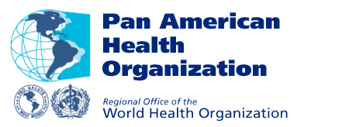

Contents

1. Introduction

2. Health of the Indigenous Peoples Initiative
2.1 Progress
2.2 Challenges

3. Strategic directions 2003-2007

4. Plan of Action 2003–2007

5. References

6. Annexes
6.1 Resolution CD37.R5
6.2 Resolution CD40.R6

1. Introduction

In 1992, in the context of the 500th anniversary of Columbus’ arrival to the Americas, the Pan American Health Organization (PAHO) Subcommittee on Planning and Programming proposed a more careful consideration of the health and well being of the indigenous peoples in the Americas. Thus, in 1993, when the world celebrated the Year of the Indigenous Peoples, PAHO embarked on a joint venture with indigenous peoples to consider how PAHO should respond. Following the First Hemispheric Workshop on Indigenous Peoples and Health held in Winnipeg, Canada, recommendations were incorporated into a proposal, the Health of Indigenous Peoples Initiative, which was subsequently presented to the Governing Bodies of the Organization and approved at the XXXVII Directing Council by the Resolution CD37.R5 (1993). This commitment to indigenous peoples was renewed in 1997 by the adoption of Resolution CD40.R6.

At the global level, in 1996, the World Health Assembly adopted Resolution WHA49.26 on Implementing the Decade of the World’s Indigenous Peoples, and the UN Working Group on Indigenous Populations, at its 14th session, included health as an agenda item. In both cases PAHO’s work under way in the Region of the Americas was acknowledged as having made progress in raising awareness about inequities in health status and access to care.

This document presents a summary of the work carried out by PAHO under the framework of the Health of the Indigenous Peoples Initiative since 1993, and emphasizes the achievements and challenges in the context of the implementation of the Decade of the World’s Indigenous Peoples as relates to health in the Americas.

Although progress has been made in addressing the health needs of indigenous peoples, a variety of studies support the need for renewed efforts to address the serious and pervasive inequities that still exist in health status and health service coverage. Therefore, PAHO within the process of contributing to attain the Millennium Development Goals is committed to make a significant impact in diminishing the health inequities faced by indigenous peoples in the Region. This document also includes the 2003 -2007 Health of the Indigenous Peoples Initiative Strategic Directions and Plan of Action to continue our work in the Region beyond 2004.

Health of the Indigenous Peoples Initiative

Cultural diversity in the Region of the Americas is evident and is determined, to a great extent, by the current presence of approximately 45 million people belonging to more than 400 different ethnic groups (OPS, 2002). No analysis of the health and living conditions can put aside the consideration of the multicultural, multi-ethnic and multilingual character of this continent.

In light of this reality, in 1992, the PAHO’s Subcommittee on Planning and Programming proposed a more careful consideration of the health and well being of the indigenous peoples in the Americas. Following a consultation workshop held in Winnipeg, Canada, with the participation of representatives of indigenous populations and governments and others from 18 countries, recommendations were incorporated into a proposal, the Health of Indigenous Peoples Initiative, which was subsequently presented to the Governing Bodies of the Organization and approved at the XXXVII Directing Council (1993).

The recommendations of Winnipeg and Resolution CD37.R5 established five principles when working with indigenous communities. These principles provided criteria for monitoring, and established the basis for evaluation at the end of the Decade of the World’s Indigenous Peoples in 2004.

Table 1. Principles

The need for a holistic approach to health
The right to self-determination of indigenous peoples
The right to systematic participation
Respect for and revitalization of indigenous cultures
Reciprocity in relations.
Resolution CD37.R5 (Annex 1) provides the framework for the efforts of PAHO and its Member States, in collaboration with the indigenous peoples themselves, to find realistic and sustainable solutions to the serious problems of poor health and substandard living conditions that are the reality of many of the indigenous peoples throughout the Region.

As its 120th Session in June 1997 the Executive Committee reviewed The Health of the Indigenous Peoples Initiative Progress Report (Document CE120/17) and expressed concern for the inequities in health status of the indigenous peoples of the Region of the Americas and reaffirmed the commitment to the Health of Indigenous Peoples Initiative created by Resolution CD37.R5 in 1993. In consideration of the economic, geographic, and cultural barriers to the efficient and effective delivery of health services, the XL Directing Executive adopted Resolution CD40.R6 (1997) (Annex 2) which addresses inequities as well as barriers to care, and which reaffirms the Organization’s commitment to the goals of the Decade of the World’s Indigenous Peoples.

2.1 Progress

Work to date has been concentrated in the following five areas: building capacity and alliances; working with Member States to implement national and local processes and projects including policy formulation; projects in priority programmatic areas; developing intercultural models of care and strengthening traditional health systems; and scientific, technical, and public information.

In 1994, participants in subregional workshops held in Santa Cruz, Bolivia, and Quetzaltenango, Guatemala, ratified the principles agreed to in Winnipeg and the goals of Resolution CD37.R5. By 1995, The PAHO 1995-1998 Plan of Action for Promoting the Initiative in the Region of the Americas was established with the objective of ensuring that the political will expressed by the Member States in Resolution CD37.R5 was translated into concrete and sustainable action. In 1997, the progress of the Initiative was evaluated. As a result, Resolution CD37.R5 was ratified through Resolution CD40.R6 and The Strategic Framework and 1999-2002 Action Plan of the Health of the Indigenous Peoples Initiative was formulated.

In 2003, after the evaluation of 1999 – 2002, The 2003 – 2007 Strategic Directions and Plan of Action was prepared.

Progress by each Plan of Action and current activities are summarized in the following sections.

Plan of Action - 1995-1998

Activities in this plan focused on 1) building capacity and alliances; 2) working with Member States to implement processes and projects at the national and local levels; 3) developing programs in priority programmatic areas; 4) strengthening traditional health systems; and 5) disseminating scientific, technical and public information.

The first area of work, building capacity and alliances, was the primary focus prior to developing the Plan of Action in 1995 and continues to be important as changes that need to be made in the Plan are identified on the basis of lessons learned. Subregional workshops provided training, and promotion efforts identified key people in PAHO offices, in Ministries of Health, and in indigenous organizations who would be responsible for the implementation of Resolution CD37.R5. Alliances have been developed with international agencies, indigenous organizations, Banks and other United Nations Agencies, and national organizations and technical institutes.

The second area of work, primarily supporting the countries’ efforts to implement the resolution, was to enable the development of national and local plans, policies, and processes to benefit the indigenous peoples of each country.

For this area of work a phased-in approach was used for the countries of the Region:

Phase 1: Bolivia, Colombia, Chile, Ecuador, Honduras, Nicaragua, Panama
Phase 2: Guatemala, Mexico, Peru, Venezuela
Phase 3: Argentina, Belize, Brazil, El Salvador, Guyana, Paraguay, Suriname
Phase 4: The rest of the countries

All countries received the benefit of subregional and regional efforts. From the beginning, the involvement of indigenous representatives, especially women, has been a major concern. This work in countries has been facilitated through the active involvement of PAHO Country Offices and national counterparts in the ministries of health, when designated, as well as representatives of the indigenous peoples.

The third area of work was to design and mobilize resources for projects which address priority health problems and vulnerable populations. Considering the recommendations from the indigenous communities through the ongoing consultative process, the Initiative promoted projects and activities in a number of program areas. Most progress has been related to basic water and sanitation, indigenous women, cholera, vaccine-preventable diseases, and NGOs for health development.

The fourth area of work has been to develop and strengthen traditional health systems. Part of the challenge in this area was to find a better articulation between the indigenous health system with its multiple health agents and practices and the official system offered by governments. It is likely that a majority of the 45 million indigenous peoples in the Region have no real access to basic primary health care offered through government-sponsored programs. Where there is physical access there are often financial, geographic, or cultural barriers to the use of the services. These communities depend upon traditional and spiritual healers to promote health, prevent illness, and provide treatment for common conditions; they are often the only provider available on a continuing basis. There have been several intercountry projects where traditional healers learn from each other. Some countries have established NGOs of traditional healers to address needs for quality improvement and national recognition. Legislation is an aspect of growing concern as practitioners find it more difficult to practice or to continue to have access to the products they use for healing. In some cases the objective is to restore knowledge which has been lost because of a devaluing of the use of traditional practices in the past and the lack of interest by young indigenous persons in becoming a traditional healer. An important aspect is the basic and continuing education of health workers who provide care in multicultural communities.

The fifth and final area of work was to identify and develop efficient mechanisms to coordinate, promote, disseminate, and exchange scientific and technical information. Documents and publications were prepared. A pamphlet about the Initiative and a video in English and Spanish were disseminated throughout the Region. In 1995, a work group on research was held to begin a process of priority-setting and development of collaborative research projects addressing priority problems.

Plan of Action - 1999-2002

The activities in this Plan have concentrated on three interrelated lines of action:

1. Strategic Planning and Alliances: Activities have been geared to support countries in the formulation and operationalization of integrated public policies and strategies for the development of health and social systems that provide for equitable access for indigenous peoples.

2. Intercultural Frameworks and Models of Care: Activities have been aimed at supporting countries in designing and implementing frameworks and models of care specifically targeted to address the barriers to equity in health and access to health services faced by indigenous peoples.

3. Information to Detect and Monitor Inequities: Activities have been directed towards improving information collection, analysis, and dissemination on the health and social conditions of indigenous peoples together with the use of information for policy and program development.

The concrete results of the Health of the Indigenous Peoples Initiative corresponding to each line of action are summarized in Table 2.

Table 2. Health of the Indigenous Peoples Initiative
Plan of Action 1999-2002: Progress

1. Strategic planning and alliances
11 countries have Technical Units in charge of the health of the indigenous peoples in the Ministries of Health (Argentina, Bolivia, Brazil, Canada, Chile, Ecuador, the United States, Guatemala, Honduras, Mexico, and Panama).
8 countries have directives that prioritize health care of the indigenous population (Argentina, Bolivia, Costa Rica, Dominica, El Salvador, Nicaragua, Paraguay, Peru).
Inventory of institutions that work in indigenous health in Central America has been developed and disseminated.
PAHO is participating in the United Nations Interagency Group for the support of the Permanent Forum on Indigenous Issues
6 informative sessions on indigenous health issues were organized at PAHO headquarters
Interinstitutional activities with the IDB, the US. Indian Health Service, and Canadian First Nations and Inuit Health Branch are underway.

2. Intercultural frameworks and models of care
6 Case studies on the incorporation of indigenous perspectives, therapies and medicines into primary health care in 6 different indigenous communities: Mapuche (Chile), Nahualt-Pipil (EL Salvador), Maya (Guatemala), Garífuna (Honduras), Nögbe Buglé (Panama), Quechuas (Peru).
Publication and dissemination of the strategic guidelines for the incorporation of the intercultural approach based on case studies in 6 countries.
Proposal to develop a course on cultural diversity and health for the Virtual Campus is under way.
Incorporation of the intercultural approach to health into the Integrated Management of Childhood Illness Strategy (IMCI), Roll Back Malaria Initiative, Reproductive Health, AIDS, among others.
14 countries are working with the intercultural approach.
Technical assistance was provided in the organization of the conference Indigenous Healing Traditions in the Americas, in Washington, DC during November 2002 with 300 participants from throughout the Region.
Management of resources, technical assistance, and logistical support in the assistance of 18 participants of 10 countries in the Healing our Spirits Worldwide Conference, in New Mexico, Albuquerque, in September, 2002.
Basic document and expert consultation on sexual health and prevention of AIDS-STI in indigenous communities.

3. Information to detect and monitor the inequities
6 countries have proposals for disaggregation of information on health services, according to ethnic group (Brazil, Colombia, Ecuador, México, Nicaragua, Venezuela).
3 countries (Guatemala, Ecuador and Peru) in the social exclusion project identified indigenous peoples within the excluded groups and pointed out that indigenous women and children were the most affected.
22 of 24 countries with indigenous population in the Region included information in Health in the Americas, Edition 2002.
In collaboration with the Public Policy Program and WHO a project was formulated to support the countries in the information disaggregation according to ethnic group in order to promote the use of information in the definition of policies.
The Initiative has a Web page
The first edition of the Indigenous Bulletin has been prepared and disseminated in the Region.
A database on documents on indigenous health with 919 entries is available on PAHO’s web page.

2.2 Challenges

Despite the progress and processes underway, there are existing challenges that should be addressed. It is important to point out the following:

The present epidemiological profile of the indigenous population is associated with high poverty indices, unemployment, illiteracy, migration, exclusion from the mainstream society, lack of land and territory, destruction of the ecosystem, alteration of the dynamic of life, and unmet basic needs.

The ethnic and cultural heterogeneity of the indigenous peoples emphasizes the need for identifying innovative forms in addressing their health needs, instead of adopting a single program or model of health care.

The lack of vital statistics or of service statistics disaggregated by ethnic group, gender, and age groups hinders the adequate evaluation of the health situation, living conditions, and health services coverage of the indigenous population.

Comprehension of the social and cultural factors which shape their knowledge, attitudes, and health practices, are as fundamental as the availability of quantitative data. The public health challenge is to be able to translate the sociocultural information into practical information in order to promote the well-being of indigenous individuals and communities.

Presence of similar problems among indigenous communities living in border areas urge coordinated efforts among countries and the development and/or application of international and subregional agreements.

Training of the health workers for the delivery of appropriate services to the sociocultural characteristics of the users, both at the level of the health authority and at subnational level is limited.

Although in several countries there are national health policies that assist indigenous peoples, their application, in general, is reduced, and an impact assessment system of these policies on the health of the peoples is absent.

The participation of indigenous peoples is a fundamental factor in the achievement of the well-being of the peoples. This participation should be strengthened in PAHO and among Member Countries.

Addressing the health needs of indigenous peoples and their living conditions is related to issues concerning: human rights, democracy, development, environment, and those related to the comprehension of indigenous culture, identity, and world vision. This requires the political commitment and the responsibility, of the countries in the Americas, of international cooperation agencies, and indigenous organizations. Full participation of all social actors is required for a multisectoral and multidisciplinary approach.

Table 3 shows the challenges that persist in addressing the needs of indigenous peoples.

Table 3. Challenges in addressing Health Needs of the Indigenous Peoples. Evidence

Poverty | Infant mortality
Ecuador: it is estimated that 76% of the children are poor in rural areas of the mountains and of the Amazon region, where indigenous population is located (OPS, 1998). | Mexico: the infant mortality rate among the indigenous children was 59 per 1,000 live births in 1997, twice higher than the national infant mortality rate (PAHO, 2002).
Illiteracy | Maternal mortality
Peru: in the Peruvian Amazon region 7.3% of the population is illiterate compared to 32% in the indigenous communities of this area (INEI-UNICEF, 1997). | Honduras: national maternal mortality rate is  147 x 100mil live births. In the departments of Colon, Copán, Intibucá, Lempira and La Paz,  areas with indigenous population, the maternal mortality rate ranges between 255 and 190 x 100,000 live births (OPS, 1999).
Unemployment | Infectious Diseases
El Salvador: 50% of the indigenous population was illiterate, and unemployment was 24% (PAHO, 2002). | Nicaragua: municipalities affected by plasmodium falciparum are localized in the Autonomous Regions of the Atlantic Coast, area of settlement of indigenous and afro- descendants peoples (OPS-NIC, 2003).
Malnutrition | Diabetes, obesity, alcoholism
Guatemala: 67.8% of the indigenous population suffered from chronic malnutrition compared with 36.7% of the non-indigenous population (PAHO, 2002). | The United States: Indigenous people are much more likely than the general population to die from diabetes mellitus related to obesity, and liver disease due to alcohol abuse. (PAHO, 2003)
HIV/AIDS | Suicide
Honduras: The Garífuna and English-speaking afro descendants are the groups most affected by HIV/AIDS. (PAHO, 2002) | Canada: the suicide rate is 2–7 times higher among the Aboriginal population than in the general Canadian population, and a cause of concern, especially among young men in  Inuit communities (PAHO, 2002).
Basic services | Location
El Salvador: only 33% of the indigenous population has the benefit of electrical service, and 64% use oil lamps or candles for lighting. Water is obtained by 91.6% of the indigenous population from wells, rivers, or both (PAHO, 2002). | Indigenous populations are scattered, in some cases mobile, located for the most part in remote areas, in urban fringe, and borders. There are several indigenous multinational peoples, such as the Miskito of Nicaragua and Honduras, the Quechuas of Colombia, Ecuador, Peru, Bolivia, Argentina, etc., (PAHO, 2002).
Ethnic and cultural heterogeneity | Cultural appropriate health care
Brazil: The indigenous population in Brazil is estimated at 350,000 people, who belong to some 210 groups and speak more than 170 languages. Although they make up only 0.2% of the total population, indigenous peoples are found in 24 of the 26 states. (PAHO, 2002). | In the evaluation of Public Health Essential Functions, Function 8: Human resources development and training in public health, including skills to provide culturally appropriate health care, had a low level of performance, with an average value of 38%, and 17% for culturally appropriate health care (OPS, 2002).

Strategic directions 2003-2007

Based on the experience gained during 1999 - 2002, four strategic directions are proposed for 2003 - 2007:

Promoting the development and/or application of the national and international health policies that favor the health and well-being of the indigenous peoples.
Strengthening the information systems and country capacity for analysis, management and prioritization of health care in indigenous population. This includes local capacity building in areas with indigenous population and the provision of necessary supplies and equipments.
Health personnel and community training in curative and preventive actions, as well as, in rehabilitation and health promotion strategies, taking into account the epidemiological profile, the sociocultural characteristics, and the community resources of the population. This implies the promotion of models of care adapted to the sociocultural contexts of the population.
Promoting the joint effort of the countries of the Region in addressing the health problems of the indigenous peoples.

4. Plan of Action 2003–2007

The goal of the Plan of Action 2003 – 2007 is supporting the countries of the Region in achieving the MDGs, by strengthening country technical capacity to evaluate and address inequities faced by indigenous peoples in the Region.

In this perspective, the work will be directed to four interrelated lines of action:

1.- National policies and international agreements

Formulation and/or implementation of national policies and international agreements
Development and/or monitoring and evaluation of the implementation of national and institutional programs
Analysis and evaluation of the existing policies in the Region favoring the well-being of the indigenous peoples and the prioritization of health actions among these peoples.
Promotion of strategies and policies that address the social exclusion among indigenous populations.

2.- Networks of interinstitutional and intersectoral collaboration

Regional, subregional, and national networks
Intersectoral associations
Cooperation agreements
Strengthening of the indigenous leadership
Cooperation among countries and mobilization of resources

3.-Primary health care and intercultural approach to health

Incorporating of the intercultural approach to health into the models of care and health personnel training.
Promotion of the indigenous participation in the management of services
Adapting of methodologies and integrating comprehensive strategies (IMCI, Roll Back Malaria, maternal and child health, water and sanitation, HIV/AIDS, diabetes, mental health, etc).
Guidelines for the sociocultural adaptation of clinical protocols
Incorporation of the indigenous perspectives, therapies and medicines in primary health care.

- Information, analysis, monitoring, and management

Incorporation of the variable of ethnicity into information and monitoring systems.
Analysis of the health determinants
Local management capacity building (Establishing priorities)
Creation of an observatory on health of the indigenous peoples in the Americas
Production and dissemination of public, scientific and technical information
Operational research
Systematization of indigenous knowledge

Much has been said and written about equity as a philosophical underpinning for PAHO"s work in public health. However, as long as some communities have less service a greater burden of disease, and fewer opportunities than others, there will not be equity, and the goal of health for all will not be realized. With the indigenous communities, we will advocate for change, be persistent in our efforts and bring these issues to the forefront for debate and resolution.

5. References

1. PNUD. Los Objetivos de Desarrollo del Milenio. Programa de las Naciones Unidas para el Desarrollo. 2003.
http://www.undp.org/spanish/mdgsp/
2. OPS. La Salud Pública en las Américas. Nuevos conceptos, análisis del desempeño y bases para la acción. Washington, DC, 2002
3. PAHO. Health in the Ameritas. Vol I. y VolII Washington, DC., USA, 2002
4. OPS. Plan Estratégico de la Oficina Sanitaria Panamericana para el Período 2003 – 2007. 26 Conferencia Sanitaria Panamericana. 54 Sesión del Comité Regional. Washington, DC., EUA, 23 al 27 de septiembre, 2002.
5. OPS. Iniciativa Salud de los Pueblos Indígenas. Evaluación de Mediano Plazo BPB 02-03. Informe de progreso. 31 – Dic – 2002
6. OPS. Marco Estratégico y Plan de Trabajo 1999-2002. Salud de los Pueblos Indígenas. Washington, D.C., 2000
7. PAHO. Health in the Americas. Vol I. y Vol II Washington, DC., USA, 1998
8. OPS. Iniciativa Salud de los Pueblos Indígenas. Informe de Progreso. Washington, DC., EUA, 1998
9. INEI-UNICEF. Perú: La población de las comunidades indígenas de la Amazonía. Lima, 1997

7. Annexes

7.1 Resolution CD37.R5

Resolution V. "HEALTH OF INDIGENOUS PEOPLES"
Adopted by THE XXXVII MEETING OF THE DIRECTING COUNCIL,

THE DIRECTING COUNCIL,

Having seen Document CD37/20 on the initiative "Health of the Indigenous Peoples of the Americas";

Taking into account the recommendations formulated by the participants at the Working Meeting on Indigenous Peoples and Health, held in Winnipeg, Manitoba, Canada, from 13 to 17 April 1993;

Recognizing that the living and health conditions of the estimated 43 million indigenous persons in the Region of the Americas are deficient, as reflected in excess mortality due to avoidable causes and in reduced life expectancy at birth, which demonstrates the persistence and even the aggravation of inequalities among indigenous populations in comparison with other homologous social groups;

Considering the aspiration of indigenous peoples to take charge of their own institutions and ways of life, the need for them to assert their own identity, and the need to respect their rights with regard to health and the environment;

Recognizing the unique contribution that indigenous peoples make to the preservation of ethnic and cultural diversity in the Americas, to biodiversity and a balanced ecology, and, most especially, to the health and nutrition of society;

Emphasizing the need to take a new look at, and respect the integrity of, the social, cultural, religious, and spiritual values and practices of indigenous peoples, including those related to health promotion and maintenance and the management of diseases and illnesses; and

Reiterating the importance of the strategy for the transformation of national health systems and the proposal for the development of alternative models of care at the level of local health systems as a valuable tactical resource and a fundamental requisite for dealing with current problems relating to insufficient coverage, inadequate access, and the lack of acceptability of health services on the part of indigenous populations,

RESOLVES:

1. To adopt Document CD37/20, which describes the initiative "Health of the Indigenous Peoples of the Americas," and the report of the Winnipeg Working Meeting containing the conclusions and recommendations on which the initiative is based.

2. To urge the Member Governments:

(a) To facilitate the establishment or strengthening of a high-level technical commission or other mechanism of consensus, as appropriate, with the participation of leaders and representatives of indigenous peoples, for the formulation of policies and strategies and the development of activities in the areas of health and the environment for the benefit of specific indigenous populations;

(b) To strengthen the technical, administrative, and managerial capacity of national and local institutions that are responsible for the health of indigenous populations with a view to progressively overcoming the lack of information in this area and ensuring greater access to health services and quality care, thus contributing to a higher degree of equity;

(c) To implement intersectoral actions, as appropriate in each case, in the areas of health and the environment both in the official sector and through nongovernmental organizations (NGOs), universities, and research centers that work in collaboration with indigenous organizations;

(d) To promote the transformation of health systems and support the development of alternative models of care, including traditional medicine and research into quality and safety, for indigenous populations within the local health system strategy;

(e) To promote the development of disease prevention and health promotion programs in order to address these problems and the most important areas relating to indigenous health in their countries.

3. To request the Director, within the limits of available resources:

(a) To promote the participation of indigenous persons and their communities in all aspects of PAHO's work on the health of indigenous persons;

(b) To identify technical cooperation resources within existing cooperation programs and provide support for the mobilization of additional resources at the international and national level for implementation and evaluation of the initiative "Health of the Indigenous Peoples of the Americas";

(c) To coordinate the regional effort by promoting the establishment of information and mutual cooperation networks between organizations, centers, and institutions whose activities are concerned with the health of indigenous peoples, organizations, and communities, enlisting the Organization's existing mechanisms, initiatives, and programs at the regional level and in the countries and also seeking the cooperation of other agencies and organizations;

(d) To expand the evaluation of living conditions and the health situation to include the indigenous peoples of the Region, with a view to gradually overcoming the current lack of information in this area at both the regional and the country level;

(e) To promote collaborative research at the regional level and in selected countries on high-priority health issues and health care for indigenous peoples

(Adopted at the fourth plenary session, 28 September 1993)

7.2 Resolution CD40.R6

THE XL DIRECTING COUNCIL,

- Having examined the report on the health of indigenous peoples (Document CD40/14);

- Recognizing the growing evidence of inequities in health status and access to basic health services for the estimated 43 million indigenous persons in the Region of the Americas; and

- Considering the economic, geographic, and cultural barriers to the efficient and effective delivery of public health and personal health care services in isolated rural and marginal urban areas in most countries,

RESOLVES:

- To take note of the report on progress in the implementation of Resolution CD37.R5, to reaffirm the commitment to the goals of the Decade of the World’s Indigenous Peoples, and to approve the activities proposed in Document CD40/14.

- To urge the Member States, in the process of the implementation of health sector reform, to be persistent in efforts to detect, monitor and reverse inequities in health status and access to basic health services for vulnerable groups, including indigenous peoples.

- To call to the attention of Member States that renewal of the goal of health for all requires that sustainable solutions are found to address the economic, geographic, and cultural barriers to adequate care for vulnerable groups.

- To request the Director to continue his efforts to implement the Health of Indigenous Peoples Initiative.

(Adopted at the eighth plenary session, 25 September 1997.)

Information received from the United Nations Institute for Training
and Research (UNITAR)

Executive Summary

THE UNITED NATIONS INSTITUTE FOR TRAINING AND RESEARCH

The United Nations Institute for Training and Research (UNITAR) was established in 1965 as an autonomous body within the United Nations with the purpose of enhancing the effectiveness of the United Nations through appropriate training and research. UNITAR is governed by a Board of Trustees and is headed by an Executive Director. The Institute is supported by voluntary contributions from Governments, inter-governmental organizations, foundations, and other non-governmental sources.

PROGRAMME IN PEACEMAKING AND PREVENTIVE DIPLOMACY

The Programme in Peacemaking and Preventive Diplomacy of the United Nations Institute for Training and Research has been conducting training for UN staff and diplomats on conflict prevention and peacebuilding since 1993, and for indigenous peoples’ representatives since 2000.

The UNITAR Training Programme to Enhance the Conflict Prevention and Peacebuilding Capacities of Indigenous Peoples’ Representatives was developed based on the requests of indigenous representatives at consultations in Geneva, and on the recommendations of UN Special Rapporteurs, to provide advanced training in conflict analysis and negotiation to representatives of indigenous peoples.

The main objectives of the UNITAR training are: to strengthen participants’ capacities to analyze conflict; to identify the needs, fears, concerns and aspirations of all the parties to a conflict; and based upon this and engaged in dialogue with partners, to formulate mutually beneficial options to address problems. The focus is on the process of analyzing and dealing with conflict in a constructive manner. With strengthened tools of conflict analysis, negotiation and relationship-building, indigenous representatives are further equipped to engage in dialogue on issues to address the priorities of their communities and to improve the lives of their peoples. The training aims to strengthen indigenous representatives’ abilities to negotiate to improve the situations of their peoples in all of the areas under the mandate of the Permanent Forum: health, education, culture, environment, economic and social development, and human rights.

Participants examine rights-based, and interest-based negotiation models and engage in negotiation simulations reflecting issues faced by their communities. Case studies and presentations are conducted on land and resource issues, on inclusive models for participation and consultation, and constructive dialogue processes, as well as other areas.

Senior indigenous experts, including Members of the Permanent Forum on Indigenous Issues, and other specialists, the Special Rapporteur on the Situation of Human Rights and Fundamental Freedoms of Indigenous People, and representatives of regional organizations are invited to serve as Resource Persons for the training programme. Senior indigenous women, including leaders in Government and academic institutions, and Members of the Permanent Forum, have served as Resource Persons for the UNITAR training programme.

The international training programme is conducted annually at the time of the UN Working Group on Indigenous Populations held at the United Nations in Geneva. A regional training programme is conducted in a different part of the world each year. Regional trainings have been held to date in Mexico for indigenous peoples’ representatives of the Americas, and in Thailand for indigenous representatives of the Asia-Pacific. The 2004 regional training programme is planned for Africa. Indigenous women compose 40% of training participants.

UNITAR was also asked to organize the Seminar for Members of the Permanent Forum on Indigenous Issues to help Members prepare for their important mandate in advance of the first session of the Permanent Forum in 2002. UNITAR has been involved in the UN Inter-Agency Support Group on Indigenous Issues since its formation, and has participated in each session of the Permanent Forum.

The UNITAR training programme, now entering its fifth year, has received support from: the Department of Foreign Affairs and International Trade of Canada, the Royal Ministry of Foreign Affairs of Denmark, the Federal Foreign Office of Germany, the Royal Ministry of Foreign Affairs of Norway, the Ministry for Foreign Affairs of Sweden, the Agency for Development and Cooperation of Switzerland and the Swiss Federal Department of Foreign Affairs.

UNITAR receives no funding from the regular UN budget and must raise all of the funding for its programmes and staff from Governments and foundations.

b. Programmes, Projects and Technical Assistance:

The UNITAR Training Programme to Enhance the Conflict Prevention and Peacebuilding Capacities of Indigenous Peoples’ Representatives was developed based on the requests of indigenous peoples’ representatives at consultations in Geneva, and on the recommendations of UN Special Rapporteurs to provide advanced training in conflict analysis and negotiation to representatives of indigenous peoples. The focus of the programme is on a problem-solving approach to strengthen participants’ capacities to more effectively negotiate to have their needs met, while also promoting constructive relationships between members of their communities and those in the dominant community.

Participants engage in identifying sources of conflict, and examine traditional negotiation, and rights-based negotiation approaches. Representatives are then trained in interest-based negotiation and practice this method in a number of simulations. This approach seeks to find a win-win solution to conflict situations by helping the parties become more effective at exploring one another’s needs, aspirations, fears and concerns, and working from these to create innovative solutions which can address the interests of all concerned.

The programme is designed to increase the effectiveness of indigenous representatives to engage in dialogue on decisions that affect them and to contribute to the constructive resolution of problems facing their communities in partnership with other concerned parties.

The programme also provides an overview of international and regional conventions and mechanisms for the promotion and protection of human rights conducted either by the UN Special Rapporteur on the Situation of Human Rights and Fundamental Freedoms of Indigenous People or by a senior indigenous expert.

UNITAR trainings have actively promoted gender balance, and invite representatives from diverse cultures to exchange experience and perspectives during the programme. Forty percent of indigenous participants in UNITAR trainings are women, including a number of gender representatives. In the most recent training, female representatives constituted the majority of participants. The training programme also examines mechanisms and processes that promote participation of diverse groups in order to counter marginalization and exclusion, two of the root causes of conflict.

The programme provides a forum for the exchange of information and experience among indigenous peoples through sessions conducted by indigenous Resource Persons presenting constructive cases in a number of sectors, and through the active exchange among participants both during the training, and outside of the formal training where participants dine and are accommodated together.

During the training, UNITAR invites 4 indigenous participants to speak in the Participants’ Forum. Representatives working in different sectors, and reflecting a gender and regional balance, present on initiatives they are undertaking in the areas of environment, development, education, gender, youth, culture, peacebuilding, and dialogue with Governments and the private sector to share strategies and remaining challenges. Each training programme concludes with a “Dialogue on a Common Vision for Peace” providing participants the opportunity to highlight key lessons from the training and their mutual exchange, and to articulate next steps towards building a common vision for peace and development.

Senior indigenous experts, including Members of the Permanent Forum on Indigenous Issues, UN Special Rapporteurs, and representatives of regional organizations and other experts are invited to serve as Resource Persons for the training programme. Regional organization members speak on mechanisms for the promotion and protection of human rights and the promotion of dialogue between States and indigenous peoples. Representatives who have participated to date have come from the OAS, the OSCE Office of the High Commissioner on National Minorities, and the OSCE Office of Democratic Institutions and Human Rights.

A Counselor from the Greenland Home Rule Government has conducted a session on a sub-regional organization entitled: “The Arctic Council and Its Permanent Participants: Securing Indigenous Participation in Regional Inter-Governmental Cooperation Between States.” A representative of the African Union will be invited to serve as a Resource Person for the regional training in Africa later this year. A World Bank representative focusing on indigenous issues served as a Resource Person in the UNITAR Asia-Pacific regional training on conflict prevention and peacebuilding. He spoke on World Bank policies and programmes in the region, a session highly appreciated by the group.

A participant handbook is prepared for each training programme which includes papers by indigenous experts, information on international human rights mechanisms, chapters from the United Nations Guide for Indigenous Peoples, and other relevant articles. Reports of the Permanent Forum, reports of the UN Special Rapporteurs focusing on indigenous issues, as well as information on the Millennium Development Goals are also provided to each participant as reference materials in their handbook for the training.

The international training programme is conducted annually at the time of the UN Working Group on Indigenous Populations held at the United Nations in Geneva. The first programme took place in 2000 and the second in 2001. The third international programme, which included 17 female representatives among participants, was held in July 2003. The next international training programme for 30 indigenous representatives from around the world is planned for July 2004. The programme is conducted in English.

As well, a regional training programme is organized in a different part of the world each year. The first regional programme was held in Mexico in 2001 for indigenous peoples’ representatives from North, Central and South America. The programme was conducted in Spanish and English. In April 2003, the UNITAR Training Programme to Enhance the Conflict Prevention and Peacebuilding Capacities of Indigenous Peoples’ Representatives of the Asia-Pacific was organized in Chiang Mai, Thailand. The programme involved 30 representatives, including 13 women, from the Asia and Pacific regions. The next regional training programme is planned for the latter part of 2004 in Africa.

In May 2002, the UNITAR Seminar for Members of the Permanent Forum on Indigenous Issues was organized in New York at the request of a number of Permanent Forum Members. The Seminar was planned to assist their efforts to prepare for and implement the first historic meeting of the Permanent Forum on Indigenous Issues at United Nations Headquarters, and to facilitate work on their important mandate. The former High Commissioner for Human Rights, the Special Rapporteur on the Situation of Human Rights and Fundamental Freedoms of Indigenous People, and representatives of 16 UN agencies and departments held briefing and dialogue sessions with the Forum Members during the Seminar.

The major objective of the UNITAR training is to enhance participants’ abilities to analyze the root causes of conflict, and to strengthen their capacities to negotiate with Governments and other actors in various sectors in order to better meet the needs of their communities. Feedback from participants from each region indicates they are applying these strategies in their communities and in dialogue with Governments and other partners at the local level and in international fora. Senior indigenous participants have called the UNITAR training programme “real partnership in action.”

c. Institutional changes including mechanisms for indigenous participation:

Indigenous experts and former participants are consulted in the design and planning of each UNITAR training to ensure that the programme is addressing key concerns and evolving issues faced by indigenous peoples. They advise on cases to include from respective regions, make recommendations on top Resource Persons as well as on participants and organizations who could best benefit from and contribute to the programme. Indigenous experts from various fields, including Members of the Permanent Forum on Indigenous Issues, serve as the primary Resource Persons for the UNITAR training programme.

The two indigenous Members of the Permanent Forum from the Asia and Pacific regions addressed the participants of the regional training in Thailand. They provided information on the background and mandate of the Forum, advised participants on the best ways to interact with the Forum, and consulted with participants on their respective areas of environment, health and human rights. When a Permanent Forum Member is not available to serve as a Resource Person for the training, a senior indigenous expert is invited to provide an overview of the mandate, goals and working methods of the Forum.

Senior former participants have also served as Resource Persons in subsequent training programmes with indigenous representatives. As well, one senior indigenous leader from Southern Africa was invited to serve as a Resource Person for the UNITAR Sub-Regional Training Programme to Enhance Conflict Prevention and Peacebuilding in Southern Africa organized for Government and military officials and civil society members from the Southern African Development Community region.

The international UNITAR Training Programme to Enhance the Conflict Prevention and Peacebuilding Capacities of Indigenous Peoples’ Representatives, which takes place at the time of the Working Group on Indigenous Populations, invites each year the new Indigenous Fellows of the Office of the High Commissioner for Human Rights to participate in the training programme. The goal is to build on their knowledge of the UN system and mechanisms, and to strengthen their capacity to make a constructive contribution through dialogue and negotiation when they return to their communities. The training has been consistently described as one of the highlights of the Fellowship Programme.

d. Funding facilities:

While UNITAR must raise all of the funds for its staff and training programmes, and does not have additional resources to support funding facilities, the costs for the training course, travel, accommodation and meals are covered by the programme budget. In addition, participants are provided with a small stipend to help cover additional personal costs.

To maximize resources, for the international training programme, UNITAR works closely with UN Voluntary Fund, IGWIA, the World Council of Churches Indigenous Programme and other organizations to identify participants who are already funded to travel to Geneva to participate in the Working Group on Indigenous Populations and who may best benefit from the UNITAR training programme.

Similarly, Permanent Forum Members who are already coming to Geneva for the Working Group on Indigenous Populations are contacted to see if they may be available to address the training participants. For the regional training programmes, the travel of Permanent Forum Members and all participants is covered by the UNITAR programme budget.

e. Other Relevant Information:

The demand for the programme exceeds the space available in each training. There is an ongoing need to make this capacity building programme available to indigenous representatives at the international and regional levels. As UNITAR receives no funds from the regular UN budget, all funds for training programmes and staff need to be raised through special purpose grants from Governments and foundations. Funds are needed to continue to make this much-needed training programme available to build the capacity of indigenous representatives to solve their problems and address conflict in a constructive manner.

Outstanding challenges:

One of the challenges raised by indigenous participants in the training is having the opportunity to talk with Government officials or with private sector representatives in order to raise concerns about decisions that affect them. Opportunities and mechanisms for dialogue and consultation to resolve issues of joint concern can lead to enhanced understanding among parties. This process can facilitate the peaceful and mutually beneficial resolution of problems, minimizing marginalization and exclusion, two sources of grievances that lead to conflict.

Information received from The Organisation for Economic
Co-operation and Development (OECD)
The Organisation for Economic Co-operation and Development (OECD) provided information about its Development Co-operation Directorate and the Development Assistance Committee (DAC) through which Member countries are assisted in the development activities. The DAC has developed guidelines for its Members in areas such as poverty reduction, sustainable development and conflict prevention which recognize the role of indigenous peoples in the development of their countries and the necessity of donors to address their specific realities.

-----

The UNIFEM Andean Regional Programme Office covers Bolivia, Colombia, Ecuador, Peru and Venezuela.
These comments can be found on http://www.ilo.org/public/english/indigenous
In the supervision of this Convention, the Committee of Experts has referred to the forced labour situation of indigenous peoples in a number of countries, and some of these comments can be cross-references with comments under Convention No. 169.
Report of the Tripartite Committee established to examine the Representation alleging non-observance by Ecuador of the Indigenous and Tribal Peoples Convention, 1989 (No. 169), made under article 24 of the ILO Constitution by the Confederación Ecuatoriana de Organizaciones Sindicales Libres (CEOSL), at para.44.
Although there is no internationally recognized definition of indigenous people, for purposes of the review the term was used as a blanket grouping for the indigenous people of Asia and Latin America, including groups identified as “indigenas” or “indios”, "hill tribes", "scheduled tribes", "tribals" or "ethnic minorities".
WFP 2001. Marginal People: Review of WFP Experience with Indigenous People. Note: owing to difficulties in identifying indigenous people in Africa, the report focused only on Asia and Latin America.
Low Income Food Deficit Countries.
According to the World Food Summit, food security exists when all people, at all times, have physical and economic access to sufficient, safe and nutritious food to meet their dietary needs and food preferences for an active and healthy life. Achieving food security means ensuring that sufficient food is available, that supplies are relatively stable and that those in need of food can obtain it.
The group was formed as a result of the NGO/CSO forum for Food Sovereignty, in order to coordinate and strengthen common positions among the various NGOs and other civil society organization global, regional, and constituency networks, such as farmers, Indigenous peoples, artisanal fisher folk and agricultural workers.
Ms Herrera is the Agrarian Analysis Officer of the Land Tenure Service in the Rural Development Division in FAO.
/ Pronounced {agway-goo}. A holistic Mohawk term meaning “everything in creation” provided by the Kahnawake community located near Montreal, where the guidelines were negotiated.
. The Habitat Agenda, paragraph 122. <http://www.unhabitat.org/declarations/habitat_agenda.asp>.
. Resolution 19/13: “Enhancing the engagement of youth in the work of UN-HABITAT”, paragraph 3. Report of the Nineteenth Session of the UN-HABITAT Governing Council, 2003. <http://www.unhabitat.org/governingbodies/gcreport_annex1_1913.asp>.
. Report on the first session of the Permanent Forum on Indigenous Issues, 13 to 24 May 2002. (E/2002/43/REV.1; E/CN.19/2002/3/Rev.1).
. General Assembly Resolution 57/191: “Permanent Forum on Indigenous Issues” (A/RES/57/191). <http://ods-dds-ny.un.org/doc/UNDOC/GEN/N02/550/88/PDF/N0255088.pdf?OpenElement>.
. Report on the second session of the Permanent Forum on Indigenous Issues, 12-23 May 2003) (E/2003/43; E/C.19/2003/22). <http://www.un.org/esa/socdev/pfii/documents/e200343.pdf>.
. Formulated by the Special Rapporteur of the United Nations Sub-Commission on Prevention of Discrimination and Protection of Minorities, José Martinez Cobo, in his study of the Problem of Discrimination against Indigenous Populations in 1986.
. Including those adopted prior to 2002 by the United Nations Commission on Human Settlements.

