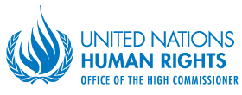
Share your Views on the situation of Indigenous Children with the Indigenous Experts of the United Nations!

What is the United Nations?
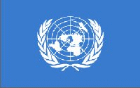
The United Nations (the “UN”) is an international organization founded in 1945 and it is made up of almost all countries in the world.
The UN has many Departments and Offices, including the UN Human Rights Office (OHCHR), which works to protect and promote all human rights around the world. OHCHR works with the Expert Mechanism on the Rights of Indigenous Peoples.

What is the Expert Mechanism on the Rights of Indigenous Peoples?
The Expert Mechanism or EMRIP, is a group of 7 experts from different regions of the world that provides the Human Rights Council, with expertise and advice on the rights of Indigenous Peoples. It helps countries to achieve the goals of the United Nations Declaration on the Rights of Indigenous Peoples.

What is happening?
Every year, the EMRIP has a session during which it listens to Indigenous Peoples and States, adopts reports it has written, holds various meetings, and makes decisions on its work for the next year.

From 12-16 July, the EMRIP will hold its session online. One of the main themes of the session is the Rights of Indigenous Children. This theme was chosen because EMRIP is currently writing a report on the rights of Indigenous Children. There will be Regional Meetings for different parts of the world. Participants will get to share their thoughts on the draft reports. After the session, the EMRIP will finalize the reports and present it to the Human Rights Council in September. In preparing this report, EMRIP is calling for your views!

Why to participate, and who can participate?
Indigenous Peoples, including Children, and States (countries) can submit in writing statements they would like to make during the Regional Meeting related to their country. The statements should not be longer than 3 minutes. If your statement is chosen, then you will get to give the statement during the Regional Meeting related to your country.

You can send your ideas to EMRIP to help make sure that they hear directly from you on the situation of indigenous children and what you think about their draft report on indigenous children. In helping to make the report focus on the most pressing issues and recommendations for indigenous children and adolescents, you can then use the report to push for positive change and action in your communities and countries.

Anyone can send their views to EMRIP/OHCHR. Many different organizations will send their views, and EMRIP is especially interested to hear directly from indigenous children and adolescents!
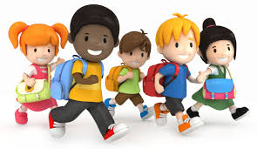

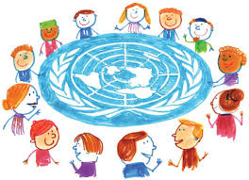
How can you participate? When?

You can send your statement by email to: expertmechanism@ohchr.org by June 25th 2021.

If your statement is chosen, you will be invited to give your statement during the EMRIP Regional Meeting for your region:
Africa and North America: Monday 12 July
Asia, Pacific, Arctic, Central and Eastern Europe, Russian Federation,
Central Asia and Transcaucasia: Tuesday 13 July
Central and South America and the Caribbean: Wednesday 14 July

What should go in your statement?

EMRIP would like to hear about the situation of indigenous children, what challenges they face, and what matters most to them. Some of the topics dealt with in the report that you could talk about include:

- Education
- Healthcare, Water, Housing
- The Environment
- Indigenous Territories and Communities
- Culture and Indigenous Languages
- Issues affecting Indigenous Girls

But the EMRIP wants to hear from you, so you can speak on what you feel is most important for indigenous children.

In deciding which statements to choose, the EMRIP will consider:

- Whether it focuses on the rights of indigenous children
- Whether the speaker is representing voices of several children
- Whether the statement was sent on time
- Whether the statement is within the 3-minute maximum

Keeping Safe
- We will not share any information you send to us with anyone else, nor your personal or contact details. It will only be used for the report on this topic.
- Please do not include your last name in any communications; only your first name is fine. This helps us to protect your right to privacy.
- If you feel at risk in sending your inputs to EMRIP/OHCHR or speaking at the session then you can get in touch with Allison or Child Rights Connect (details below) or share your concerns (along with this call) to any adult you trust.

Do you have any questions?
If you have any questions, please do not hesitate to contact Ms. Allison Thomas-McPhee.
Her email is: athomas-mcphee@ohchr.org
You can also contact Child Rights Connect at: gracia@childrightsconnect.org

Pictures: from the European Disability Forum

